Computer Communications and Networks (COMN)
2018/19, Semester 2

Assignment Part 2 Results Sheet

Forename and Surname: | Boyan Yotov
Matriculation Number: | s1509922

Question 1 – Experimentation with Go-Back-N. For each value of window size, run the experiments for 5 times and write down average throughput.

 | Average throughput (Kilobytes per second)
Window Size | Delay = 5ms | Delay = 25ms | Delay = 100ms
1 | 47.2 | 9 | 2
2 | 91.4 | 19.2 | 4
4 | 172.4 | 38.4 | 9.2
8 | 345 | 76.4 | 19.6
16 | 462.2 | 147.6 | 38.8
32 | 384.6 | 271.8 | 69.8
64 | 383 | 261.2 | 75.8
128 | 388.2 | 257.8 | 72.2
256 | 391.8 | 271.2 | 74.6
Create a graph as shown below using the results from the above table: 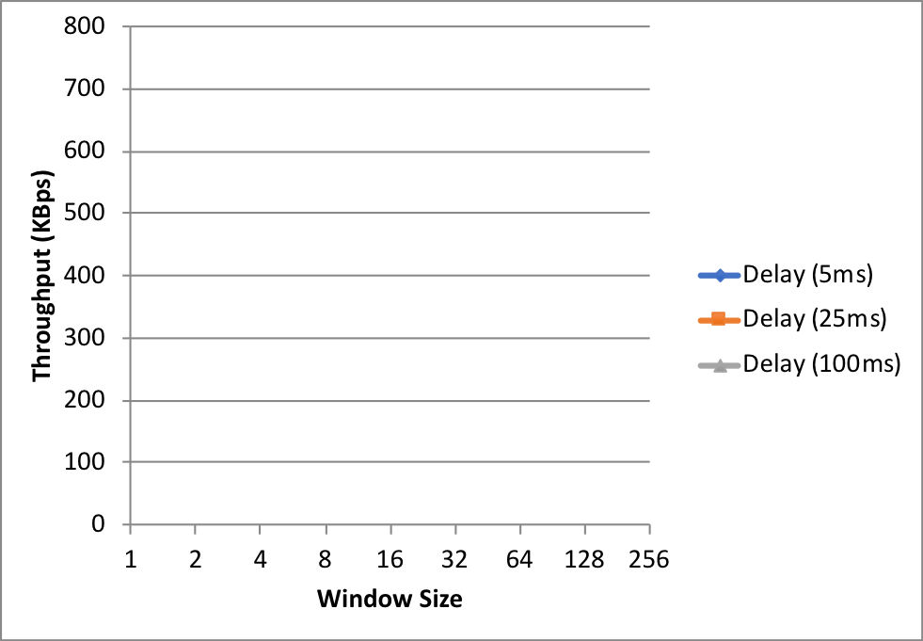

Question 2 – Discuss your results from Question 1.

Question 3 – Experimentation with Selective Repeat. For each value of window size, run the experiments for 5 times and write down average throughput.

 | Average throughput (Kilobytes per second)
Window Size | Delay = 25ms
1 | 9
2 | 19.2
4 | 37.8
8 | 72.2
16 | 136.2
32 | 224.4
(my own included rows)
64 | 362.2
128 | 466.8
256 | 476.4

Question 4 - Compare the throughput obtained when using “Selective Repeat” with the corresponding results you got from the “Go Back N” experiment and explain the reasons behind any differences.

Question 5 – Experimentation with iperf. For each value of window size, run the experiments for 5 times and write down average throughput.

 | Average throughput (Kilobytes per second)
Window Size (KB) | Delay = 25ms
1
2
4
8
16
32

Question 6 - Compare the throughput obtained when using “Selective Repeat” and “Go Back N” with the corresponding results you got from the iperf experiment and explain the reasons behind any differences.

IDK

