**WEB DEVELOPMENT ASSIGNMENT – 5**

Name : Aadarsh Agarwal

Roll: 01

Section: DS

Q1.Write the HTML code for the following Table and write some text in each cell.

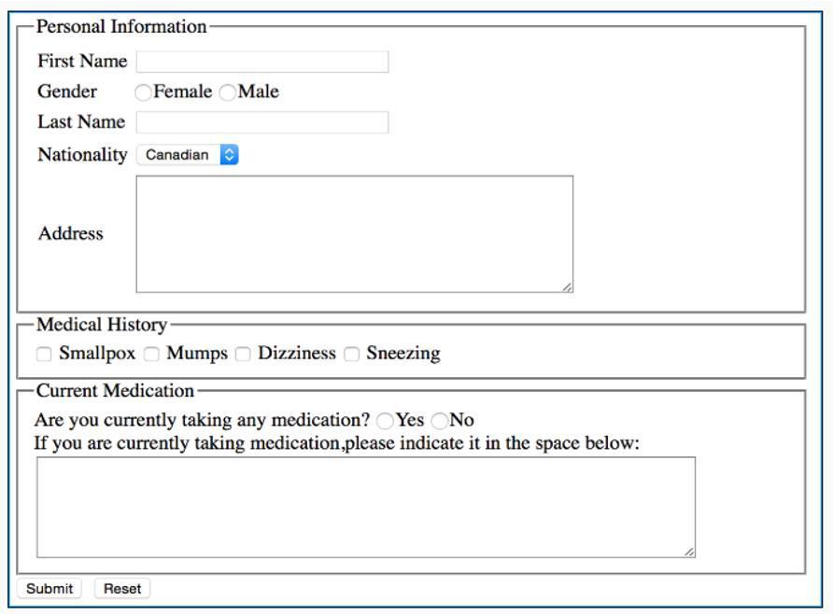a)

**Code-------**

<!DOCTYPE *html*>

<html>

<head>

    <title>Assignment</title>

    <style>

        fieldset{

            font-size: large;

            font-weight: 900;

        }

    </style>

</head>

<body>

    <fieldset>

        <fieldset>

            <legend >Personal Information</legend>

            <br>

            <form>

                <label>Firstname</label>

                <input *type*="text" *name*="firstname" *size*="20" /> <br><br>

                <label>Lastname</label>

                <input *type*="text" *name*="lastname" *size*="20" /> <br><br>

                <label>Gender</label>

                <input *type*="radio" *name*="male" />Male

                <input *type*="radio" *name*="female" />Female

                <br><br>

                <label>Nationality</label>

                <select>

                    <option *value*="Indian">Indian</option>

                    <option *value*="Canadian">Canadian</option>

                    <option *value*="American">American</option>

                    <option *value*="Russian">Russian</option>

                </select>

                <br><br>

                <label>Address :</label>

                <br>

                <textarea *cols*="50" *rows*="5" *value*="Address"></textarea> <br>

        </fieldset>

        <fieldset>

            <legend>Medical History</legend>

            <br>

            <input *type*="radio" *name*="smallpox" />Smallpox

            <input *type*="radio" *name*="mumps" />Mumps

            <input *type*="radio" *name*="dizziness" />Dizziness

            <input *type*="radio" *name*="sneezing" />Sneezing

        </fieldset>

        <br>

        <fieldset>

            <legend>Current Medication</legend>

            <br>

            <label>Are you currently taking any medication?</label> <input *type*="radio" *name*="yes" />Yes <input

*type*="radio" *name*="no" />No

            <br><br>

            <label>If you are taking medications, please indicate it in the space below:</label>

            <textarea *cols*="50" *rows*="5" *value*="medications"></textarea> <br>

        </fieldset>

        <br>

        <input *type*="button" *value*="Submit" />

        <input *type*="button" *value*="Reset" />

        </form>

    </fieldset>

</body>

</html>

<input *type*="button" *value*="Reset" />

</form>

</fieldset>

</body>

</html>

**OUTPUT:**

