**WEB DEVELOPMENT ASSIGNMENT – 1**

Name : Aadarsh Agarwal

Roll: 01

Section: DS

Q1.Write the HTML code for the following Table and write some text in each cell.

a)

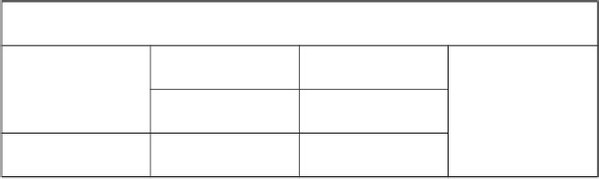

**Code-------**

<!DOCTYPE html>

<html>

<head>

<title> Q1.a </title>

<style>

table,th,td{

width: 500px;

border: 1px solid black;

border-collapse: collapse;

}

td{

text-align: center;

}

tr{

height: 100px;

}

</style>

</head>

<body>

<table>

<tr>

<th colspan = "4"> Demo Table </th>

</tr>

<tr>

<th rowspan="2"> Contact </th>

<td> 6256614 </td>

<td> 6669436 </td>

<td rowspan="3"> Empty block </td>

</tr>

<tr>

<td> 656944 </td>

<td> 566646 </td>

</tr>

<tr>

<td> Demo text </td>

<td> Demo text </td>

<td> Demo text </td>

</tr>

</table>

</body>

</html>

**OUTPUT:**

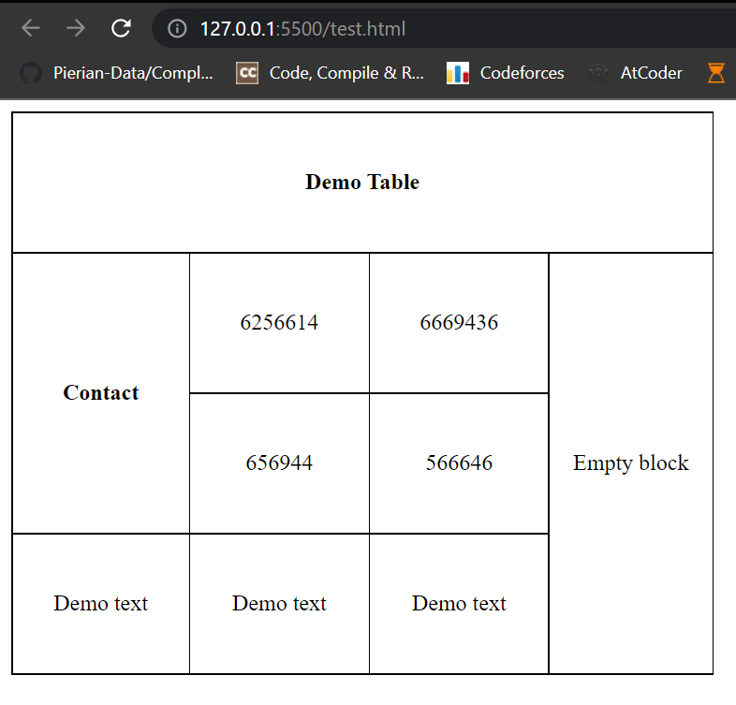

b)

|  |  |  |  |  |  |  |  |  |  |
| --- | --- | --- | --- | --- | --- | --- | --- | --- | --- |
|  | | | | | | | | | |
|  | | | |  | | | | | |
|  | |  | |  | |  | |  | |
|  | |  | |  | |
|  | |  | |  | |
|  |  | |  | |  | |  | |  |

**Code-------**

<!DOCTYPE html>

<html>

<head>

<title> Q1.B </title>

<style>

table,tr,td,th{

width: 500px;

height: 100px;

border: 1px solid black;

border-collapse: collapse;

text-align: center;

}

</style>

</head>

<body>

<table>

<tr>

<th colspan="10"> Demo Table </th>

</tr>

<tr>

<td colspan="4"> Text </td>

<td colspan="6"> Text </td>

</tr>

<tr>

<th colspan="2" rowspan="3"> Text </th>

<td colspan="2"> Text </td>

<td colspan="2"> Text </td>

<td colspan="2"> Text </td>

<td colspan="2" rowspan="3"> Text </td>

</tr>

<tr>

<td colspan="2"> Text </td>

<td colspan="2"> Text </td>

<td colspan="2"> Text </td>

</tr>

<tr>

<td colspan="2"> Text </td>

<td colspan="2"> Text </td>

<td colspan="2"> Text </td>

</tr>

<tr>

<td> Text </td>

<td colspan="2"> Text </td>

<td colspan="2"> Text </td>

<td colspan="2"> Text </td>

<td colspan="2"> Text </td>

<td> Text </td>

</tr>

</table>

</body>

</html>

**OUTPUT:**

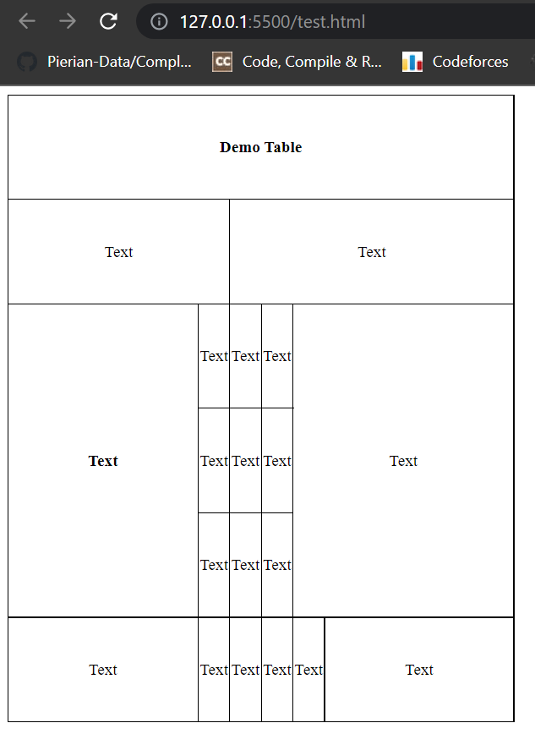

Q2.Write the HTML code for the following Table.

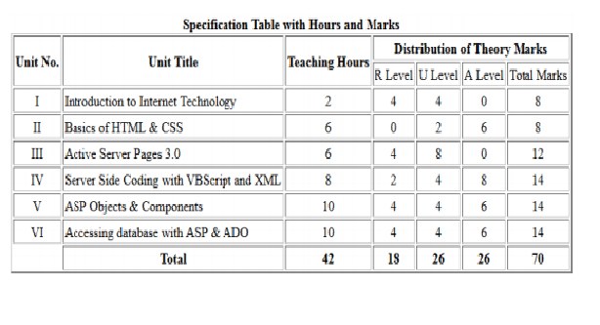

**Code-------**

<!DOCTYPE

<!DOCTYPE html>

<html>

<head>

<title> Q2 </title>

<style>

table,th,td{

border: 1px solid black;

text-align: center;

}

</style>

</head>

<body>

<table>

<caption> <b>Specification of Tables with Hours and marks</b> </caption>

<tr>

<th rowspan="2"> Unit No. </th>

<th rowspan="2"> Unit Title </th>

<th rowspan="2"> Teaching Hours </th>

<th colspan="4"> Distribution of Theroy Marks </th>

</tr>

<tr>

<td> R Level </td>

<td> U Level </td>

<td> A Level </td>

<td> Total Marks </td>

</tr>

<tr>

<td>I</td>

<td style="text-align: left">Introduction to Internet Technology</td>

<td>2</td>

<td>4</td>

<td>4</td>

<td>0</td>

<td>8</td>

</tr>

<tr>

<td>II</td>

<td style="text-align: left">Basics to HTML &amp; CSS</td>

<td>6</td>

<td>0</td>

<td>2</td>

<td>6</td>

<td>8</td>

</tr>

<tr>

<td>III</td>

<td style="text-align: left">Active Server Pages 3.0</td>

<td>6</td>

<td>4</td>

<td>8</td>

<td>0</td>

<td>12</td>

</tr>

<tr>

<td>IV</td>

<td style="text-align: left">Server Side Coding with VBScript and XML</td>

<td>8</td>

<td>2</td>

<td>4</td>

<td>8</td>

<td>14</td>

</tr>

<tr>

<td>V</td>

<td style="text-align: left">ASP Objects &amp; Components</td>

<td>10</td>

<td>4</td>

<td>4</td>

<td>6</td>

<td>14</td>

</tr>

<tr>

<td>VI</td>

<td style="text-align: left">Accessing database with ASP &amp; ADO</td>

<td>10</td>

<td>4</td>

<td>4</td>

<td>6</td>

<td>14</td>

</tr>

<tr>

<td> </td>

<td><b>Total</b></td>

<td><b>42</b></td>

<td><b>18</b></td>

<td><b>26</b></td>

<td><b>26</b></td>

<td><b>70</b></td>

</tr>

</table>

</body>

</html>

**OUTPUT:**

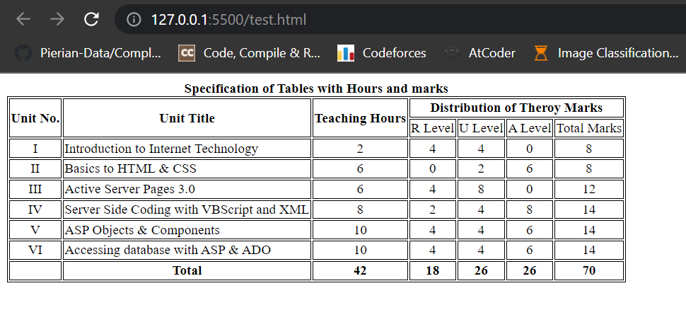

Q3.Write the HTML code, which defines all the formatting tags of HTML in tabular format.

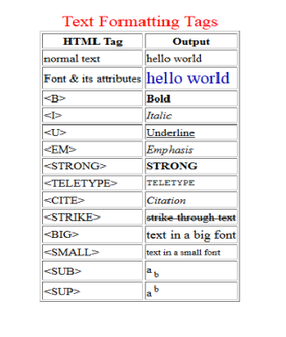

**Code-------**

<!DOCTYPE html>

<html>

<head>

<title>Q3</title>

<style>

table,th,td{

border: 1px solid black;

}

</style>

</head>

<body>

<table>

<tr>

<th style="text-align: center"> HTML Tag</th>

<th style="text-align: center">Output</th>

</tr>

<tr>

<td>normal text </td>

<td>hello world </td>

</tr>

<tr>

<td>Font &amp; its attributes </td>

<td style="color: aqua;font-family: monospace">hello world </td>

</tr>

<tr>

<td> &lt;B&gt; </td>

<td> <b> Bold</b></td>

</tr>

<tr>

<td> &lt;I&gt;</td>

<td> <i>Italic</i></td>

</tr>

<tr>

<td> &lt;U&gt;</td>

<td> <u>Underline</u></td>

</tr>

<tr>

<td> &lt;EM&gt;</td>

<td> <em>Emphasis</em></td>

</tr>

<tr>

<td> &lt;STRONG&gt;</td>

<td> <strong>Strong</strong></td>

</tr>

<tr>

<td> &lt;TELETYPE&gt;</td>

<td> <teletype>Teletype</teletype></td>

</tr>

<tr>

<td> &lt;CITE&gt;</td>

<td> <cite>Citation</cite></td>

</tr>

<tr>

<td> &lt;STRIKE&gt;</td>

<td> <strike>strike through text</strike></td>

</tr>

<tr>

<td> &lt;BIG&gt;</td>

<td><big>text in big font</big> </td>

</tr>

<tr>

<td> &lt;SMALL&gt;</td>

<td><small>text in small font</small> </td>

</tr>

<tr>

<td> &lt;SUB&gt;</td>

<td>a<sub>b</sub> </td>

</tr>

<tr>

<td> &lt;SUP&gt;</td>

<td> a<sup>b</sup></td>

</tr>

</table>

</body>

</html>

**OUTPUT:**

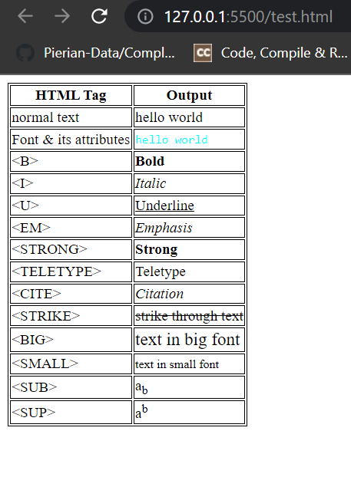

Q4. Write the HTML code to display Uttarakhand map.

and also display districts detail after clicking on a particular district.

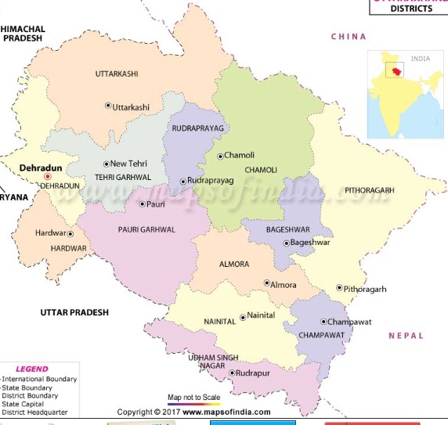

**Code-------**

<!DOCTYPE html>

<html>

<head>

<title>Q4</title>

</head>

<body>

<img src="uttarakhanddistrict-map.jpg" usemap="#image-map">

<map name="image-map">

<area target="_blank" alt="Chamoli" title="Chamoli" href="https://en.wikipedia.org/wiki/Chamoli_district" coords="354,341,361,325,364,316,364,303,376,285,389,268,405,251,413,236,398,211,389,192,396,175,401,157,409,141,424,131,432,140,448,141,454,155,465,165,477,158,494,154,505,152,516,156,524,159,529,168,538,176,546,179,557,188,566,194,572,204,574,215,560,214,549,221,549,228,555,235,560,246,553,261,554,276,560,291,556,305,550,322,537,325,526,329,510,327,509,340,506,351,504,365,504,378,512,386,500,398,472,394,454,393,437,393,426,408,406,408,383,393,375,367" shape="poly">

<area target="_blank" alt="Rudraprayag" title="Rudraprayag" href="https://en.wikipedia.org/wiki/Rudraprayag" coords="317,222,336,215,345,200,355,204,369,214,383,218,399,225,404,240,396,249,385,261,374,275,368,289,359,296,353,308,360,314,354,326,349,338,339,346,323,350,313,328,314,306,307,295,318,293,308,275,311,253,321,236" shape="poly">

<area target="_blank" alt="Pauri" title="Pauri" href="https://en.wikipedia.org/wiki/Pauri" coords="165,404,180,380,198,372,208,378,229,388,249,386,252,365,263,347,282,347,298,345,311,339,311,356,325,358,339,353,355,348,361,357,361,375,370,379,374,388,380,405,365,415,352,426,349,437,357,443,356,463,351,482,343,496,329,508,319,520,314,528,299,529,254,507,232,467,201,446" shape="poly">

<area target="_blank" alt="Tehri" title="Tehri" href="https://en.wikipedia.org/wiki/New_Tehri" coords="114,267,123,257,129,250,150,246,163,256,176,253,184,260,192,267,200,277,215,284,219,269,218,251,223,250,226,244,227,268,235,268,245,255,251,240,261,228,274,222,289,222,305,216,307,196,309,183,321,186,336,188,335,201,328,211,317,219,311,232,307,243,303,257,301,275,304,287,295,293,302,302,306,306,304,319,306,331,294,336,279,337,262,336,248,348,243,363,239,375,222,376,207,356,189,361,175,352,189,341,179,322,160,318,163,298,172,293,164,280,122,277" shape="poly">

<area target="_blank" alt="Uttarkashi" title="Uttarkashi" href="https://en.wikipedia.org/wiki/Uttarkashi" coords="83,132,106,112,131,108,152,101,183,91,203,88,217,94,234,101,253,99,269,104,289,110,304,121,322,127,339,119,331,98,323,81,335,62,348,45,356,34,365,49,375,59,391,98,405,118,409,130,397,142,388,169,385,183,390,212,368,203,345,189,329,175,307,175,295,186,300,201,293,211,282,212,267,215,253,222,240,230,240,242,234,262,227,242,217,240,207,254,208,262,206,268,191,256,184,243,175,239,166,246,154,235,139,235,125,243,135,224,142,210,128,200,117,184,132,154,114,153,90,159" shape="poly">

<area target="_blank" alt="Dehradun" title="Dehradun" href="https://en.wikipedia.org/wiki/Dehradun" coords="69,161,77,174,69,201,62,209,75,242,73,263,49,288,33,295,70,326,105,333,129,357,135,377,153,393,167,382,170,365,164,343,181,338,161,321,141,314,153,298,145,286,122,282,100,276,107,263,117,255,117,238,123,226,129,210,109,182,114,158,93,161" shape="poly">

<area target="_blank" alt="Haridwar" title="Haridwar" href="https://en.wikipedia.org/wiki/Haridwar" coords="106,343,87,367,70,389,65,413,67,446,77,472,96,473,116,466,117,488,121,506,131,490,165,473,176,455,191,452,173,420,155,402,129,382,114,355" shape="poly">

<area target="_blank" alt="Almora" title="Almora" href="https://en.wikipedia.org/wiki/Almora" coords="360,431,385,424,393,418,417,418,436,414,439,424,447,438,466,446,481,451,489,471,497,488,509,478,517,476,541,483,549,502,561,514,549,523,528,526,511,534,493,532,483,509,457,508,441,515,409,498,383,511,360,503,358,482,365,461" shape="poly">

<area target="_blank" alt="Nanital" title="Nanital" href="https://en.wikipedia.org/wiki/Nanital" coords="311,551,328,519,349,506,385,519,410,503,440,526,453,515,479,516,489,538,502,537,515,543,518,560,509,572,520,589,533,599,521,611,545,626,536,642,517,646,488,638,456,631,422,633,402,607,391,579,349,578" shape="poly">

<area target="_blank" alt="Bageshwar" title="Bageshwar" href="https://en.wikipedia.org/wiki/Bageshwar" coords="440,400,453,403,465,403,481,399,497,400,517,393,512,372,512,350,517,332,535,335,557,330,568,336,570,356,569,383,569,399,581,418,561,421,551,439,553,455,529,450,512,456,521,468,500,468,488,440,459,432,442,423" shape="poly">

<area target="_blank" alt="Champawat" title="Champawat" href="https://en.wikipedia.org/wiki/Champawat" coords="529,535,551,531,569,520,585,533,597,535,602,544,609,557,615,568,613,592,603,595,595,610,579,619,580,628,572,641,567,655,557,629,546,625,536,606,544,583,521,577,532,564,526,546" shape="poly">

<area target="_blank" alt="Pithoragarh" title="Pithoragarh" href="https://en.wikipedia.org/wiki/Pithoragarh" coords="581,215,598,209,589,233,601,255,636,271,661,283,681,286,696,292,728,311,741,323,769,337,762,345,736,347,734,364,718,379,702,397,673,414,661,440,629,456,641,486,633,504,610,535,580,514,555,504,545,473,526,461,544,461,559,455,568,446,558,435,569,428,584,428,596,420,578,405,575,384,579,360,587,341,572,324,558,312,562,283,559,257,564,237,554,220" shape="poly">

<area target="_blank" alt="US Nagar" title="US Nagar" href="https://en.wikipedia.org/wiki/Udham_Singh_Nagar_district" coords="277,568,293,567,308,556,313,559,325,565,339,572,353,580,363,588,378,588,385,592,393,606,403,619,417,632,431,641,449,641,468,641,482,638,501,646,509,646,525,654,536,648,553,632,561,646,562,675,563,693,557,709,541,709,525,689,511,678,491,681,461,683,444,680,426,682,424,656,395,652,378,632,368,611,347,606,337,610,321,612,315,583,301,584" shape="poly">

</map>

</body>

</html>

**OUTPUT:**

**WEB DEVELOPMENT ASSIGNMENT - 2**

Name : Aadarsh Agarwal

Roll: 01

Section: DS

1. WAP in HTML to implement a frame.

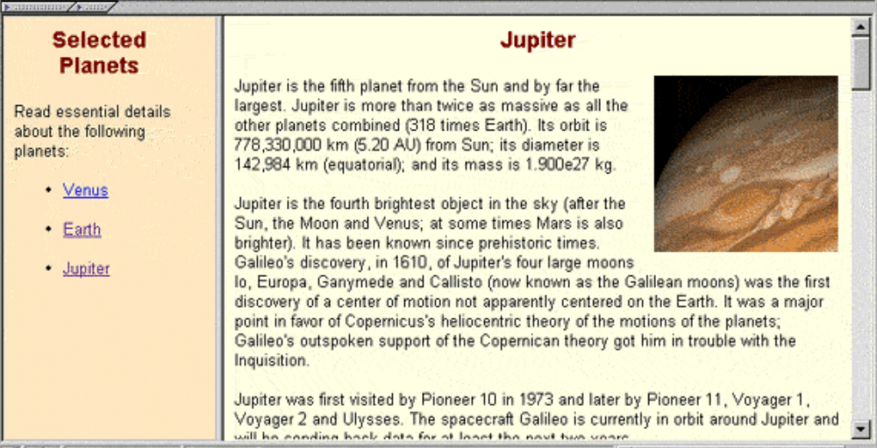

**Code-------**

<!DOCTYPE html>

<html>

<head>

<title>Q2</title>

</head>

<frameset cols = "20%,80%" noresize="noresize" border = "10">

<frame src = "menu.html" name = "menu_page">

<frame src = "main.html" name = "main_page">

</frameset>

</html>

<!DOCTYPE html>

<html>

<head>

<style>

body{

background-color = "#fee7c1";

}

h1{

color: #81130f;

text-align: center;

font-family: sans-serif;

font-size: 35px;

}

a:link{

color: blue;

background-color: transparent;

}

a:visited {

color: purple;

background-color: transparent;

}

a:hover {

color: red;

background-color: transparent;

}

</style>

</head>

<body >

<h1> Selected Planets</h1>

<p style="font-size: 20px"> Read essential details about following planets.<p>

<ul style="font-size: 20px">

<li ><u> <a href="https://en.wikipedia.org/wiki/Venus" target="main_page">Venus</a></u></li>

<br>

<li ><u> <a href="https://en.wikipedia.org/wiki/Earth" target="main_page">Earth</a></u></li>

<br>

<li ><u> <a href="https://en.wikipedia.org/wiki/Jupiter" target="main_page">Jupiter</a></u></li>

</ul>

</body>

</html>

<!DOCTYPE html>

<html>

<body>

<h1 > <marquee Scrollamount=20>Select planet for details. </marquee></h1>

</body>

</html>

**OUTPUT:**

1. WAP in HTML to implement a table.

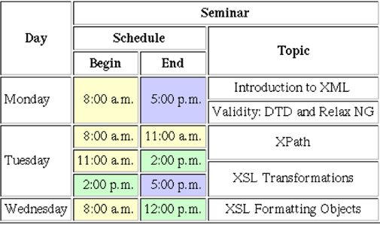

**Code-------**

<!DOCTYPE html>

<html>

<head>

<title> Q2 </title>

<style>

hr{

border: 1px solid black;

}

table,th,td,tr{

border: 1px solid black;

text-align: center;

}

</style>

</head>

<body>

<table>

<tr>

<th rowspan="3"> Day </th>

<th colspan="3"> Seminar </th>

</tr>

<tr>

<th colspan="2"> Schedule </th>

<th rowspan="2"> Topic </th>

</tr>

<tr>

<th> Begin </th>

<th> End </th>

</tr>

<tr>

<td rowspan="2"> Monday </td>

<td rowspan="2" style="background-color: mistyrose"> 8:00 a.m. </td>

<td rowspan="2" style="background-color: mediumpurple"> 5:00 p.m. </td>

<td> Introduction to XML </td>

</tr>

<tr> <td> Validity: DTD and Relax NG</td></tr>

<tr>

<td rowspan="3"> Tuesday </td>

<td style="background-color: mistyrose"> 8:00 a.m.</td>

<td style="background-color: mistyrose"> 11:00 a.m.</td>

<td rowspan="3">

<p>XPath

<hr>

XSL Transformations

</p>

</td>

</tr>

<tr>

<td style="background-color: mistyrose"> 11:00 a.m. </td>

<td style="background-color: palegreen"> 2:00 p.m. </td>

</tr>

<tr>

<td style="background-color: palegreen"> 2:00 p.m.</td>

<td style="background-color: mediumpurple"> 5:00 p.m.</td>

</tr>

<tr>

<td> Wednesday </td>

<td style="background-color: mistyrose"> 8:00 a.m.</td>

<td style="background-color: palegreen"> 12:00 p.m.</td>

<td> XLS Formatting Objects </td>

</tr>

</table>

</body>

</html>

**OUTPUT:**

**WEB DEVLOPMENT ASSIGNMENT - 3**

Name : Aadarsh Agarwal

|  |  |
| --- | --- |
| 1. | Write a program to implement form in HTML. |

Roll: 01

Section: DS

**Code-------**

<!DOCTYPE html>

<html>

<head>

<title> Form </title>

<style>

h2{

text-align: center;

}

</style>

</head>

<body>

<h2 > Student Registration Form </h2>

<form>

<table cellpadding="2" width="20%" bgcolor="99FFFF" align="center" cellspacing="2">

<tr>

<td colspan=2>

<center><font size=4><b>Student Registration Form</b></font></center>

</td>

</tr>

<tr>

<td>Name</td>

<td><input type=text name=textnames id="textname" size="30"></td>

</tr>

<tr>

<td>Father Name</td>

<td><input type="text" name="fathername" id="fathername" size="30"></td>

</tr>

<tr>

<td>Postal Address</td>

<td><input type="text" name="paddress" id="paddress" size="30"></td>

</tr>

<tr>

<td>Personal Address</td>

<td><input type="text" name="personaladdress" id="personaladdress" size="30"></td>

</tr>

<tr>

<td>Sex</td>

<td><input type="radio" name="sex" value="male" size="10">Male

<input type="radio" name="sex" value="Female" size="10">Female</td>

</tr>

<tr>

<td>City</td>

<td>

<select name="City">

<option value="-1" selected>select..</option>

<option value="New Delhi">NEW DELHI</option>

<option value="Mumbai">MUMBAI</option>

<option value="Goa">GOA</option>

<option value="Patna">PATNA</option>

</select>

</td>

</tr>

<tr>

<td>Course</td>

<td>

<select name="Course">

<option value="-1" selected>select..</option>

<option value="B.Tech">B.TECH</option>

<option value="MCA">MCA</option>

<option value="MBA">MBA</option>

<option value="BCA">BCA</option>

</select>

</td>

</tr>

<tr>

<td>District</td>

<td>

<select name="District">

<option value="-1" selected>select..</option>

<option value="Nalanda">NALANDA</option>

<option value="UP">UP</option>

<option value="Goa">GOA</option>

<option value="Patna">PATNA</option>

</select>

</td>

</tr>

<tr>

<td>State</td>

<td>

<select Name="State">

<option value="-1" selected>select..</option>

<option value="New Delhi">NEW DELHI</option>

<option value="Mumbai">MUMBAI</option>

<option value="Goa">GOA</option>

<option value="Bihar">BIHAR</option>

</select>

</td>

</tr>

<tr>

<td>PinCode</td>

<td><input type="text" name="pincode" id="pincode" size="30"></td>

</tr>

<tr>

<td>EmailId</td>

<td><input type="text" name="emailid" id="emailid" size="30"></td>

</tr>

<tr>

<td>DOB</td>

<td><input type="text" name="dob" id="dob" size="30"></td>

</tr>

<tr>

<td>MobileNo</td>

<td><input type="text" name="mobileno" id="mobileno" size="30"></td>

</tr>

<tr>

<td><input type="reset"></td>

<td colspan="2"><input type="submit" value="Submit Form" /></td>

</tr>

</table>

</form>

</body>

</html>

**OUTPUT:**

**WEB DEVLOPMENT ASSIGNMENT - 4**

Name : Aadarsh Agarwal

Roll: 01

Section: DS

**Q1. Write a JavaScript function to capitalize the first letter of each word in a string.**

***Test Data* :  
(capitalize_Words('js string exercises'));  
"Js String Exercises"**

**Code-------**

<!DOCTYPE html>

<html>

<body>

<script>

function capitalize_word() {

str = document.getElementById("string").value;

str = str.split(" ");

for (var i = 0, x = str.length; i < x; i++) {

str[i] = str[i][0].toUpperCase() + str[i].substr(1);

}

str = str.join(" ");

document.getElementById("ans").value = str;

}

</script>

Enter the word here: <input id="string">

Ans <input id="ans">

<input type="button" onclick="capitalize_word()" value="Capitalize" >

</body>

</html>

**Output:**

**Q2. Write a JavaScript function that takes a string which has lower and upper case letters as a parameter and converts upper case letters to lower case, and lower case letters to upper case.**

***Test Data* :  
(swapcase('AaBbc'));  
"aAbBC"**

**Code-------**

<!DOCTYPE html>

<html>

<body>

<script>

function swap_case() {

str = document.getElementById("string").value;

res = '';

for (var i = 0; i < str.length; ++i) {

c = str[i];

if (c == c.toUpperCase())

res += c.toLowerCase();

else if (c == c.toLowerCase())

res += c.toUpperCase();

else

res += c;

}

document.getElementById("ans").value = res;

}

</script>

Enter the word here: <input id="string">

Ans <input id="ans">

<input type="button" onclick="swap_case()" value="SwapCase" >

</body>

</html>

**Output:**

**Q3.Develop and demonstrate a HTML file that includes JavaScript script that uses functions for the following problems:**

**a) Parameter: A string**

**Output: The position in the string of the left-most vowel**

**b)Parameter: A number**

**Output: The number with its digits in the reverse order.**

**Code-------**

<!DOCTYPE html>

<html >

<body>

<script>

function leftMostVowel(){

var s = document.getElementById("first").value;

for(var i = 0 ; i < s.length ; i++ ){

var c = s.charAt(i).toLowerCase();

if(c == 'a' || c == 'e' || c == 'i' || c == 'o' || c == 'u'){

document.getElementById("ans").value = c;

break;

}

}

}

function rev(){

var a = document.getElementById("sec").value;

var b = a.split("");

b.reverse();

a = b.join("");

document.getElementById("ans1").value = a;

}

</script>

<table>

<tr>

<td>Enter the word here: </td>

<td><input id="first"> </td>

<td>Ans <input id="ans"></td>

<td><input type="button" onclick="leftMostVowel()" value="Vowel" /></td>

</tr>

<tr>

<td>Enter the number:</td>

<td><input id="sec"></td>

<td>Rev <input id="ans1"></td>

<td><input type="button" onclick="rev()" value="Reverse" /></td>

</tr>

</table>

</body>

</html>

**Output:**

**Q4: Write a JavaScript function that takes a string as a parameter and  
count occurrence of each alphabet in a given string.**

**Code-------**

<!DOCTYPE html>

<html >

<body>

<script>

function occur() {

var str = document.getElementById("first").value;

var s='';

for(var i=0;i<str.length;i++){

var count =0;

for(var j=0;j<str.length;j++){

if(str[i]==str[j] && i>j)

break;

if(str[i]==str[j])

count++;

}

if(count>0){

s+=str[i]+" - "+count+" times. ";

}

}

document.getElementById("ans").innerHTML = s;

}

</script>

Enter the word here: <input id="first">

<p id="ans"><p>

<input type="button" onclick="occur()" value="Occur" />

</body>

</html>

**OUTPUT:**

