**Regarding your feedback**

You seem to have a good start.

The periscope and one pedal seem to be implemented.

The tower rotation is visible and reflected in periscope view.

Thanks for your comment and checking

Feature 1: locomotion with a helper object (2 w.p.). Your tank is moving, but the tank tracks and wheels are not moving. You have a high-quality model that might not have that animation. So you can cheat a bit there, for example, by adding an animated texture in the relevant areas while moving.

What is a bit unclear is how you plan to control the motion if you have pedals. Does that mean controllers will have to be attached to the feet? What about the turning of the tank?

Feature 2: periscope (0.5 w.p.). It looks good, but the hair seems slightly off relative to the barrel, and the camera would fit better on top of it, not on the side. Unless it’s a more realistic view, of course.

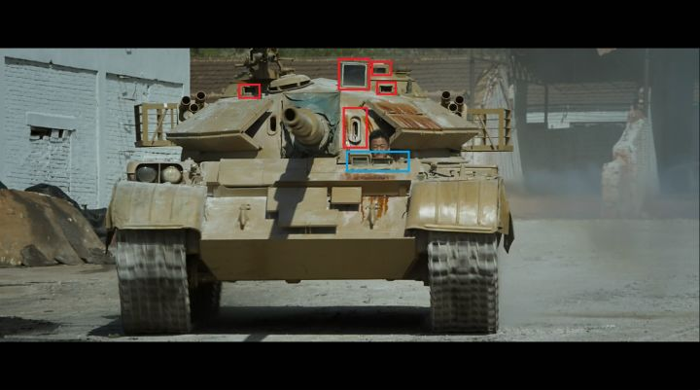

As we searched in the Internet. They said the middle vertical one is for Gunner observing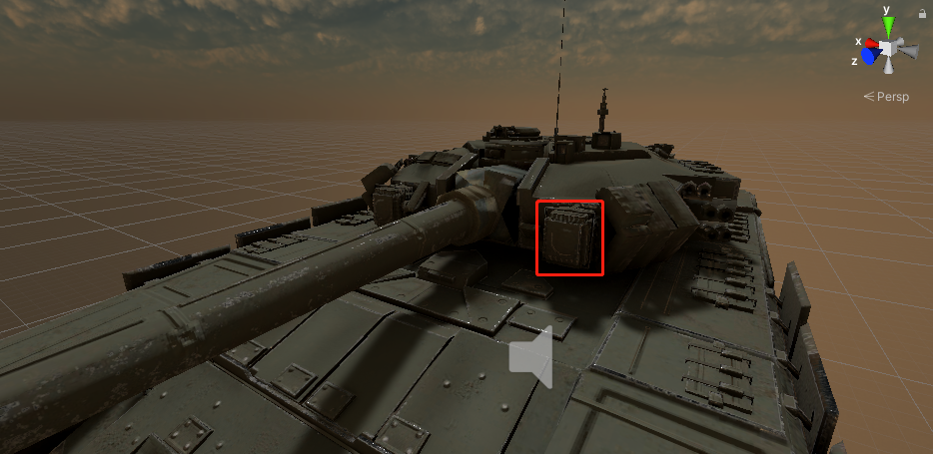. Luckily our model has a similar one so that we think it should be.

I also suggest adding a flare to the periscope camera. It will look excellent if you have a skybox with the sun visible in it.

Feature 3: environment change (1 w.p.). The skybox and light are just examples, and you are not limited to them here. Sorry for the confusion. Feel free to add fog and rain (particle systems, fog also uses lightning settings). You can also switch between flat and hilled terrains with different textures. And since typically there’s vegetation or buildings – you can add and remove them from this menu. That’s why it’s a world builder’s tweak. Skybox change counts as one change regardless of the variety of skyboxes. Typically you’ll need to change the light with the skybox for realism. You’ll need at least two more changes like precipitation (rain/fog/no rain, for example) and terrain.

Feature 4: spatial audio. To get maximum points here, you will need to extend the selection of the sounds in the scene. While you are in the cabin, you probably should hear the motors and shooting. If you have gloomy weather, you can add some thunder sound at random times. Have 3-5 different sounds. Water. Your current paddles on the ground look like a bit more complex texture. That won’t count as water. Since you have a nice firing particle system, I suggest adding the rain and fog to earn 0.5 w.p. for particle systems. Then you’ll have 1w.p. for a bonus. Good luck! We are looking forward to your tank simulation!

Besides the mandatory part. We have tried and implemented lots of features not only the bonus score but also our interests. As you can see the detail form below.

**Regarding our all project features and the requirement list**

The following are the mandatory requirements

|  |  |  |
| --- | --- | --- |
| Multi-user | Support 2+ users. The application task or scenario can be limited to two users. The other users will have to be “ghost” observers (with limited functionality, e.g. with ability to navigate, but not interact, semi-transparent avatars). On disconnection of the main user, one of the observers might get that role (optional). | Already Implemented |
| Users’ avatars | Each user should have an avatar: some sort of a networked representation of a head and hands, torso is optional. | Already Implemented |
| Environment: Skybox, Terrain/Indoor scene | The surroundings of the users should be represented with a complete and properly designed environment: no visible “end of the world” (unless required by concept) and other blank spaces. | Already Implemented |
| Lighting | The scene and all objects in it should be properly lit and visible, unless otherwise required by the concept. | Already Implemented |
| Basic UI | Provide the users with a basic UI and enable them to: connect, disconnect, reset, and exit. Feel free to add extra features if necessary. | Already Implemented |
| Clean networking | All connects/disconnects should be handled properly and leave no garbage in the scene. | Already Implemented |
| Minimum feature set | Choose a number of features listed below. Each feature has a weight associated with it. If the feature’s weight is set as a range – you can clarify the final value after the Milestone submission. The goal is to have the cumulative weight of all features equal 3 or more. | See Detail Below |

|  |  |  |
| --- | --- | --- |
| Weight | Feature | Remarks/Description |
| World builder tweaks | | |
| 1 | Change skybox & light parameters with UI (at least 3 different changes) |  |
| 1 | Create & modify objects with UI (at least 3 different objects) |  |
| 1-2 | Group operations with objects (at least 3 operations) |  |
| Avatar | | |
| 2-3 | Customize VR avatar runtime: choose hand, leg, hair... | We created the Player Avatar as same as our assignment3 and also including the hand model. We display the PlayerName obtain from the Player input at the login scene above the Avatar head. |
| 2-3 | Adjust VR avatar to fit runtime (rescale individual body parts) , UMA=2 |  |
| 2-3 | Inverse kinematics (upper body or lower body =2, or both=3) |  |
| 2 | Hand tracking with Leap Motion or Oculus hand tracking |  |
| 1 | Hand-controller animation beyond standard buttons |  |
| 0.5-1 | Inventory system |  |
| Locomotion | | |
| 2 | Locomotion metaphor with a helper object (moving parts should be moving somehow): car, scooter, magic carpet... | We adjust the moving direction by two sticks can be grabbed by hand(controller). |
| 1-2 | Locomotion metaphor without a helper object, bound to movement (7- league boots, flying, etc.), should not match Assignment 3 | We adjust the tower direction(up, down, left, right) by the primary2DAxis which is a 2D float both from [-1, 1]. Firing could be triggered by trigger button. |
| 1-3 | Redirected walking (freeze-reset =1, distractors =2, gains =3) | We can redirect the tank moving direction by grabbing the two sticks. |
| 0.5 | Teleportation | We implemented a portal system supports tank can move from one to another immediately. |
| Communication | | |
| 2 | Voice chat |  |
| 2 | Text chat between users (e.g. simplified UI - text like on a mobile or alike) |  |
| 1 | Sign exchange for communication (like smiles ϑ) |  |
| Interaction | | |
| 1-2 | Gesture recognition with hands or controllers (min. 3 gestures) |  |
| 2 | Haptics with real tracked object (e.g. using a vive tracker) |  |
| 1-2 | Complex interaction (two-handed = 1, multi-component /multi-tool [min 3 components/tools with different ways to interact with player/environment] = 2) |  |
| 1 | Networked object that can be passed hand to hand. A falling object should fall correctly for all users |  |
| 1 | 2-Player simultaneous collaborative interaction with environment (two players should do something simultaneously) | One player plays the role of Driver and the other player plays the role of Gunner. Tank can fire and move simultaneously. |
| Effects | | |
| 0.5-1 | Particle systems | We have implemented particle systems including tank firing and hitting object. |
| 0.5-1 | Water | There are few “lakes” on our terrain. |
| 0.5-1 | Spatial audio (background+ a couple sound effects = 0.5, more complex with multiple sounds in 3D space = 1) |  |
| 0.5-1 | Haptics with vibration (notifications = 0.5, more complex use like material simulation etc. = 1) | We set up 2 different level haptics for rotating the tower and firing |
| 0.5 | Camera manipulations (FOV, pose manipulations, spectator view...) | We have implemented a periscope in the driver environment, which use camera manipulations. |
| 0.5-1 | Mini-map of the virtual environment (should show your current location) |  |
| 1-2 | Complex physics interaction or simulation (similar to assignment #2, not #1 = 1), or advanced character physics (physics based puppet =2) | We have implemented several real physical system including the fire recoil, the bullet flying and making explosion. |
| 1-2 | Objects or NPCs animation (applying an existing animation, trigger it and stop without artifacts = 1, add smooth transitions between animations = 2 | We set up several targets, when the bullet collide with them they would be hit and move or fly away. |
| 1 | Custom shaders (1 complex or several simple), shader graph is allowed |  |
|  |  |  |
|  |  |  |