Foundations of Deep Learning Assignment Report
3-part report on glyph recognition
Patrick Wolf 19721081

1. Introduction
This report presents a three-part deep learning assignment for handwritten mathematical expression recognition. The assignment progresses from single glyph classification using CNNs (Part 1), to sequence-to-sequence learning for infix expressions using RNN/LSTM (Part 2), and finally to postfix notation recognition using Transformers (Part 3). All implementations use PyTorch and build on concepts from fundamentals from course labs as well as external resources listed.
================================================================================
PART 1: CNN FOR GLYPH CLASSIFICATION
================================================================================
+---------------------------+
| Stroke Input |
| (Flattened 1D coords) |
+---------------------------+
|
v
+---------------------------+
| Conv1D + BatchNorm + ReLU |
+---------------------------+
|
v
+---------------------------+
| Conv1D + BatchNorm + ReLU |
+---------------------------+
|
v
+---------------------------+
| MaxPool1D |
+---------------------------+
|
v
+---------------------------+
| Conv1D + BatchNorm + ReLU |
+---------------------------+
|
v
+---------------------------+
| Global Average Pooling |
+---------------------------+
|
v
+---------------------------+
| Dropout |
+---------------------------+
|
v
+---------------------------+
| Fully Connected |
+---------------------------+
|
v
+---------------------------+
| Output: 18 Classes |
| (CrossEntropyLoss) |
+---------------------------+

================================================================================
PART 2: LSTM ENCODER-DECODER WITH BAHDANAU ATTENTION
================================================================================

ENCODER DECODER
------- -------

+---------------------+ +---------------------+
| Stroke Input | | Target Embedding |
| (Flattened, -1 sep) | | (22 vocab) |
+---------------------+ +---------------------+
| |
v v
+---------------------+ +---------------------+
| Input Projection | | |
| (Linear Layer) | | LSTM Decoder |
+---------------------+ | Cell |
| | |
v | s_t = f(s_t-1, |
+---------------------+ | y_t-1, c_t) |
| Bidirectional | +---------------------+
| LSTM Encoder | ^
+---------------------+ |
| |
v +----------+
+---------------------+ |
| Encoder Outputs | |
| (h_1, h_2, ..., |-----+ |
| h_n) | | |
+---------------------+ | |
v |
+-------------------+ |
| Bahdanau Attention| |
| (Score+Softmax) |<------+---- (decoder state)
+-------------------+
|
v
+-------------------+
| Context Vector |-------+
| (Weighted Sum) |
+-------------------+
|
v
+---------------------+
| Output Projection |
| (Linear Layer) |
+---------------------+
|
v
+---------------------+
| Token Predictions |
| (CrossEntropyLoss) |
+---------------------+

Teacher Forcing: Train with ground truth
Infer with predictions

================================================================================
PART 3: TRANSFORMER ENCODER-DECODER (4 heads, 4 layers, d=128)
================================================================================

ENCODER DECODER
------- -------

+---------------------+ +---------------------+
| Stroke Input | | Target Tokens |
| (2D coordinates) | | (shifted right) |
+---------------------+ +---------------------+
| |
v v
+---------------------+ +---------------------+
| Linear Projection | | Token Embedding |
| (to d_model=128) | | (23 vocab) |
+---------------------+ +---------------------+
| |
v v
+---------------------+ +---------------------+
| Positional Encoding | | Positional Encoding |
| (Sinusoidal) | | (Sinusoidal) |
+---------------------+ +---------------------+
| |
v v
+-----------------------+ +-----------------------+
| | | |
| +------------------+ | | +------------------+ |
| | Multi-Head Self- | | | | Masked Self- | |
| | Attention (4 hd) | | | | Attention (4 hd) | |
| +------------------+ | | +------------------+ |
| | | | | |
| v | | v |
| +------------------+ | | +------------------+ |
| | Add & LayerNorm | | | | Add & LayerNorm | |
| +------------------+ | | +------------------+ |
| | | | | |
| v | | v |
| +------------------+ | | +------------------+ |
| | Feed-Forward | | | | Cross-Attention |<----+
| | Network (d=512) | | | | (4 heads) | | |
| +------------------+ | | +------------------+ | |
| | | | | | |
| v | | v | |
| +------------------+ | | +------------------+ | |
| | Add & LayerNorm | | | | Add & LayerNorm | | |
| +------------------+ | | +------------------+ | |
| | | | | |
| x4 Layers | | v | |
| | | +------------------+ | |
+-----------------------+ | | Feed-Forward | | |
| | | Network (d=512) | | |
| | +------------------+ | |
| | | | |
| | v | |
| | +------------------+ | |
| | | Add & LayerNorm | | |
| | +------------------+ | |
| | | |
| | x4 Layers | |
| | | |
| +-----------------------+ |
| | |
+----------------------------------------------+------------------+
|
v
+---------------------+
| Linear Projection |
| (to vocab size) |
+---------------------+
|
v
+---------------------+
| Output: 23 Tokens |
| (CrossEntropyLoss) |
+---------------------+

2. IMPORTANT: Transforming torchtext to Vocab
Due to the inability of using the GPU with older versions of Python and torchtext being incompatible with newer versions of pytorch. We found online resources to build on our own tokeniser into a SimpleVocab which was used in all 3 parts of the assignment.
This Vocabulary was provided by [4] in notebooks/src/text/vectorizing/vocab.py. This Vocabulary class was useful in using newer versions of pytorch packages without having to use torchtext.
The SELENE package proved useful in helping write the code for the models part II and III.

3. Part 1: CNN for Glyph Classification

3.1 Objective and Dataset
The objective was to build a CNN to classify individual handwritten digits (0-9) and mathematical symbols (+, -, *, /, ., (, ), =) into 18 classes. The glyph_80k.h5 dataset was used, containing 80,000 stroke-based samples.

3.2 Architecture
Our CNN had the following architecture:
- Input data

Convolution – Batchnorm – ReLU – Pool (step 1)

- Convolutional 2D neural network with 1 input and 16 outputs, kernel size of 3 and padding of 1
- Batch norm of 16
- Max Pooling with kernel size 2 and stride of 2

Convolution – Batchnorm – ReLU – Pool (step 1)

- Convolutional 2D neural network with 16 inputs and 32 outputs, kernel size of 3 and padding of 1
- Batch norm of 32
- Max Pooling with kernel size 2 and stride of 2

Flatten and create the fully connected layers

- Flatten to 1024
- Linear layer ReLU (1028, 128)
- Dropout layer of 0.6
- Linear layer (128,18) to produce output logits, i.e. the 18 classes.

3.3 Training Approach
For preprocessing, we used flattened 2D strokes with 128 batch size.
A Cross Entropy loss was used as the loss function while being optimised with the Adam optimiser with learning rate of 0.001 and weight decay of 1e-4 to minimise the validation loss.

3.4 Results
To test model performance for part I, we use two metrics: validation accuracy and validation loss.
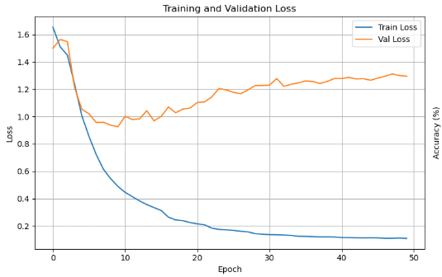
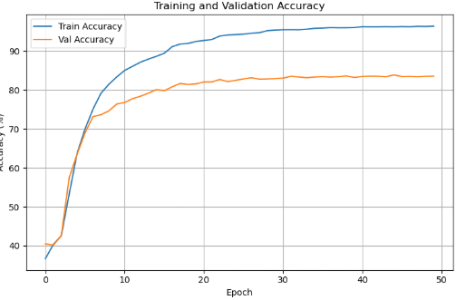
This was run for 50 epochs but we select the model with highest validation accuracy to prevent overfitting, as we can see in our loss metrics, this is happening as epochs are increasing.
Our selected model was found on the 24th epoch with
- train loss: 0.1962
- train accuracy: 93.31%,
- validation loss: 1.0892
- best validation accuracy: 83.34%
When evaluated on the test set, we obtain the following:
- Accuracy: 83.12%
- Precision: 0.8398
- Recall: 0.8330
- F1-Score: 0.8319
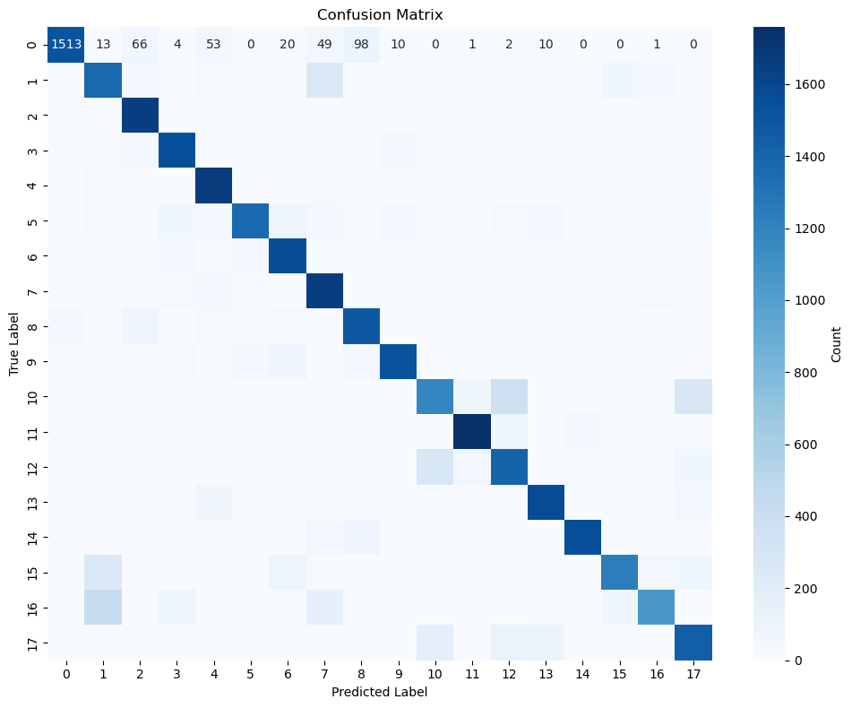
The confusion matrix shows the spread of predictions compared with ground truth. It has shown consistency with ground truth and only some errors such as (1 predicted,16 true label).

3.5 Challenges and Solutions
Reaching the target accuracy was quite difficult for the test set due to the number of components. This also leads to a risk of overfitting if trying to reach the target accuracy on the training set. Training took around 2 hours, although this can be reduced as we saw that 50 epochs are more than enough for this machine learning task.

4. Part 2: RNN/LSTM for Infix Expression Recognition

4.1 Objective and Dataset
The objective was to build an encoder-decoder RNN/LSTM to map stroke sequences to infix mathematical expressions (e.g., "4*(5.3+2)="). The infix_88k.h5 dataset was used with a vocabulary of 23 tokens (including special tokens: <unk>, <pad>, <bos>, <eos>).

4.2 Architecture

Our encoder-decoder model uses an attention-based sequence-to-sequence architecture. The encoder is a bidirectional LSTM with 1 layer and 128 hidden dimensions, which projects the 1-dimensional flattened stroke input into the hidden space. The bidirectional design is used for the encoder to capture both forward and backward context from input sequences to produce a 256-dimensional representation. The decoder is a unidirectional LSTM with 1 layer and 256 hidden dimensions, incorporating a Bahdanau (additive) attention mechanism. This attention module creates a context vector that focuses on relevant input positions at each step. The decoder uses a 64-dimensional embedding layer to convert target tokens into continuous representations. The model connects the encoder and decoder with linear transformation layers that place the concatenated bidirectional encoder states (256 dimensions) to match the decoder hidden dimension (256).

4.3 Training Approach

Training employed teacher forcing with a ratio of 0.9, meaning the ground truth token was used as the next decoder input 90% of the time during training, with the model's own predictions used otherwise. The model was trained with batch size 64 using the Adam optimizer with an initial learning rate of 0.001 and weight decay of 1e-4 for regularization. A ReduceLROnPlateau scheduler reduced the learning rate by factor 0.5 after 5 epochs without validation loss improvement. Gradient clipping with max norm 1.0 to prevent exploding gradients. The loss function was CrossEntropyLoss with ignore_index set to the padding token index (1), to stop padded positions of contributing to the loss computation. Training ran for 5 epochs (each epoch taking over 7 hours, more was not possible) with early stopping patience of 10, selecting the model checkpoint with lowest validation loss.

4.4 Results
In this part, there are 2 models, the first one was run for over 50 hours and has decent test accuracy, whereas the second one was run over multiple sessions and has the best test set accuracy but the progress metrics were lost due to computer crashes. The only difference between both models was training time.
Model 1:
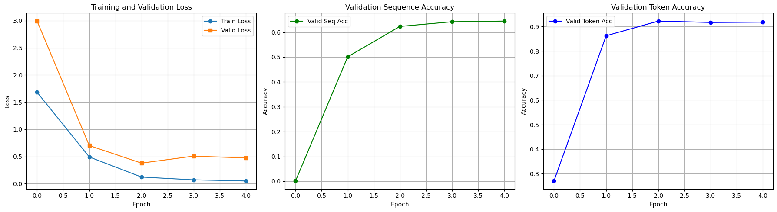
Token Accuracy: 92.21% Sequence Accuracy: 64.49% Validation loss: 0.3770
When checking performance on the test set, we observe the following results:
Test Loss: 0.4171 Test Seq Accuracy: 0.5322 (53.22%)
Test Token Accuracy: 0.9058 (90.58%) Sample Predictions: 20% (2/10)

Model 2:
Test Loss: 0.3851 Test Seq Accuracy: 0.6495 (64.95%)
Test Token Accuracy: 0.9315 (93.15%)
Sample predictions: 60% (6/10)
Example of error: Ground truth: 2.4/2.5*3/1= | Pred: 2.4/7.5*3/1=
We see that in the example the error is due to a small token error, so we are quite satisfied with the performance and results of our model.

4.5 Challenges and Solutions
Implementation of the Bahdanau attention was essential for the encoder-decoder bottleneck to capture forward and backward context necessary for this type of dataset as performance without the attention module did not improve. References [3] for the Bahdanau module implementation are available in the annex.
This section was very challenging to implement as training on the small dataset did not produce the expected results to debug correctly. Training times were very long as even with an RTX 3050 GPU, training took several days to produce decent results and good sequence to sequence accuracy on the test set.

5. Part 3: Transformer for Postfix Expression Recognition

5.1 Objective and Dataset
The objective was to build a Transformer encoder-decoder to convert stroke sequences to postfix notation (Reverse Polish Notation). For example, the infix "3+5*2=" becomes "3,5,2,*,+,=" in postfix. The postfix_208k.h5 dataset was used with a vocabulary of 23 tokens.

5.2 Architecture
The Transformer encoder-decoder architecture uses PyTorch's built-in nn.Transformer module. The model has 4 attention heads, 4 encoder layers, 4 decoder layers, and a model dimension of 128. The feedforward dimension is 512. Sinusoidal positional encoding was implemented to capture stroke order and token position information. The encoder processes flattened stroke sequences (with -1 separators between strokes), while the decoder generates output tokens autoregressively. Causal masking was applied to the decoder to prevent attending to future tokens, and padding masks were used for both encoder and decoder to ignore padded positions.

5.3 Training Approach
Training used the Adam optimizer with learning rate warm-up following the schedule from "Attention is All You Need": lr = d_model^(-0.5) * min(step^(-0.5), step * warmup_steps^(-1.5)). The model was trained with batch size 128 on the postfix_208k.h5 dataset (208,000 samples) for approximately 20 epochs over 24 hours of training. The loss function was CrossEntropyLoss with ignore_index set to the padding value (-5). Model checkpoints were saved based on lowest validation loss to preserve the best performing model across sessions.

5.4 Results
Test Set Token Accuracy: 93% Sequence Accuracy: 4.2%
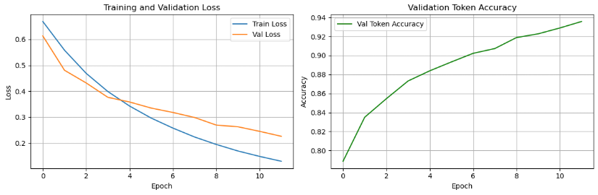

The gap between token and sequence accuracy is expected for sequence-to-sequence tasks. With 93% token accuracy on sequences averaging 15 tokens, the theoretical probability of a perfect sequence is approximately 0.93^15 ≈ 34%. The actual sequence accuracy is lower due to correlated errors. The training and validation loss curves showed consistent decrease without major overfitting, indicating the model was still improving when training was stopped due to time constraints.

5.5 Challenges and Solutions

Training time was the primary constraint, requiring over 24 hours on an RTX 3050 GPU. Debugging mask implementations was challenging as PyTorch's nn.Transformer expects specific mask formats (boolean masks for padding). Initial errors with CUDA and tensor shape mismatches required careful verification of mask dimensions and types. The 1k dataset was used for initial debugging before scaling to the full 208k dataset.

6. Conclusion

This assignment demonstrated a progression through fundamental deep learning architectures for handwritten mathematical expression recognition, achieving 83% test accuracy on single glyph classification with CNNs, 65% sequence accuracy on infix expressions with attention-based RNN/LSTMs, and 93% token accuracy on postfix expressions with Transformers. The key takeaways were the importance of attention mechanisms for encoder-decoder architectures, the need of large datasets for proper model generalisation, and the significant training time requirements for sequence-to-sequence tasks. Future improvements could include longer training times for Part II and III with much stronger GPU’s as this was the main issue in training these complicated neural networks.

7. References
[1] Course labs T3-T7 for foundational concepts
[2] PyTorch documentation
[3] Sean Robertson - seq2seq pytorch tutorial
[4] Christopher Von der Weth – VOCAB instead of torchtext - https://github.com/chrisvdweth/selene.git

