
IT Department (Solution Development)
Hybrid Market Intelligence System (MIS)
Functional Design Specification (FDS)
Project Code: KG-MIS-2026-DEV-PROPOSAL
Project Sponsor | Marketing Department, Kerchanshe Group
Requesting Officer | Mr. Tsegaye Nigusie — Marketing Intelligence Officer
Delivery Owner | IT Department (Solution Development)
CTO | Mr. Melkamu Alamerew
Project Manager | Mr. Estifanos Alemseged
Solution Author / Developer | Mr. Woluman Urgesa
QA / Test Engineer | Mr. Hirko Gemechu
Based On | User Requirement (Marketing), KG-MIS Phase 0 Project Planning Package v1.3.0, and KG-MIS Solution Design Document (SDD) v1.0
Companion Documents | Solution Design Document (SDD) · Technical Design Specification (TDS) · Integration Design · Security Matrix
Document Status | Draft v1.0 — For Review
Prepared Date | 06 August 2026

Table of Contents
1. Introduction 3
1.1 Purpose 3
1.2 Scope of This Document 3
1.3 References 3
1.4 Definitions & Acronyms 3
2. Functional Overview 4
2.1 Actors / Roles 4
2.2 Epic Summary 4
3. EPIC-01 — Survey & Questionnaire Builder 4
4. EPIC-02 — Competitor & Pricing Module 6
5. EPIC-03 — D365FO Integration 7
6. EPIC-04 — CUAS Integration (Login & Role-Based Access) 8
7. EPIC-05 — CNS Integration (Notifications) 9
8. EPIC-06 — Power BI Dashboards & Basic Reports 10
9. Traceability Matrix 11
10. Approval 11

1. Introduction

1.1 Purpose
This Functional Design Specification (FDS) is the companion to the Solution Design Document (SDD) that defines, epic by epic, the functional requirements, business rules, and workflows the Hybrid Market Intelligence System (KG-MIS) must implement. It elaborates the Functional Design and Workflow Design activities of the Solution Design phase; architecture, technology, and cross-cutting design decisions are defined in the SDD and are not repeated here.

1.2 Scope of This Document
This FDS covers the six epics approved in the Phase 0 backlog: Survey & Questionnaire Builder, Competitor & Pricing Module, D365FO Integration, CUAS Integration, CNS Integration, and Power BI Dashboards & Basic Reports. For each epic it states the actors, numbered functional requirements, business rules, and the primary workflow as a diagram and narrative. Database schema and API endpoint contracts that implement these requirements are defined in the TDS; integration message formats are defined in the Integration Design document; the role-to-permission matrix is defined in the Security Matrix.

1.3 References
Ref | Document | Description
REF-01 | User Requirement (Marketing Department) | Source business requirement submitted by Tsegaye Nigusie, Marketing Intelligence Officer
REF-02 | KG-MIS-Phase0_Project_Planning_v1.3.0 | Approved Project Charter, Business Case, Scope, Backlog, Sprint Roadmap
REF-03 | KG-MIS Solution Design Document (SDD) v1.0 | Architecture, technology stack, and design principles this FDS elaborates on

1.4 Definitions & Acronyms
Term | Definition
FDS | Functional Design Specification — this document
Epic | A grouping of related functional requirements delivered as one backlog item, per the Phase 0 sprint roadmap
FR | Functional Requirement — a numbered, testable statement of required system behavior
D365FO | Microsoft Dynamics 365 Finance & Operations — source ERP/CRM for customer, product, and sales master data
CUAS | Corporate User Access System — provides SSO login and role claims
CNS | Corporate Notification System — sends email, SMS, and WhatsApp notifications

2. Functional Overview

2.1 Actors / Roles
The following actors appear across the epics in this document. Their formal permissions are defined in the Security Matrix; roles are listed here only to scope who performs each functional requirement.
Actor | Description
Field / Marketing Officer | Submits market visit reports, survey responses, and competitor pricing
Marketing Analyst | Builds/edits surveys, views dashboards and price comparisons
Marketing Manager | Publishes surveys, reviews reports, receives alerts
System Administrator | Manages master data sync, role mapping, notification configuration
Viewer / Executive | Read-only access to dashboards and summary reports
System | Automated actor for scheduled jobs — D365FO sync, CNS notification triggers

2.2 Epic Summary
Epic | Purpose | FR Range
EPIC-01 — Survey & Questionnaire Builder | Structured surveys replacing ad-hoc paper/manual interviews | FR-01.1–FR-01.8
EPIC-02 — Competitor & Pricing Module | Competitor price capture and gap analysis vs. own D365FO pricing | FR-02.1–FR-02.6
EPIC-03 — D365FO Integration | Authoritative customer/product/sales master data sync | FR-03.1–FR-03.5
EPIC-04 — CUAS Integration | SSO login and role-based access control | FR-04.1–FR-04.5
EPIC-05 — CNS Integration | Automatic email/SMS/WhatsApp alerts on trigger events | FR-05.1–FR-05.4
EPIC-06 — Power BI Dashboards & Reports | KPI dashboards and scheduled reports for management | FR-06.1–FR-06.5

3. EPIC-01 — Survey & Questionnaire Builder
Lets Marketing build structured surveys and questionnaires per business unit, and lets field/marketing users respond to them through the portal, replacing ad-hoc paper/manual interviews.

3.1 Actors
- Marketing Analyst / Manager (builds and publishes surveys)
- Field / Marketing Officer (submits responses)

3.2 Functional Requirements
ID | Requirement
FR-01.1 | Authorized users shall create structured questionnaires tagged to a business unit.
FR-01.2 | The survey builder shall support question types: single choice, multiple choice, free text, numeric, and rating scale.
FR-01.3 | The survey builder shall support conditional (skip) logic between questions.
FR-01.4 | Users shall duplicate an existing survey as a starting template for a new one.
FR-01.5 | Field/marketing users shall submit survey responses through the web portal, linked to an outlet/distributor and respondent type.
FR-01.6 | The system shall track survey and response status: Draft, Published, Submitted, Reviewed.
FR-01.7 | Surveys shall support a satisfaction-scoring question type with a numeric scale.
FR-01.8 | Only a Marketing Manager or Administrator shall be able to publish or unpublish a survey.

3.3 Business Rules
- A survey cannot be edited once it has responses; it must be cloned instead.
- Mandatory questions must be answered before a response can be submitted.

3.4 Workflow
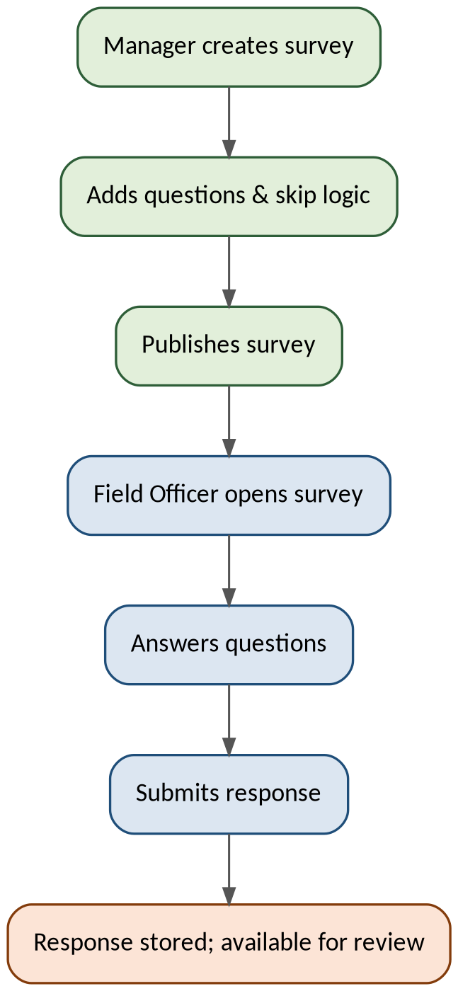
Figure 1 — EPIC-01 — Survey & Questionnaire Builder — Primary Workflow
The Manager builds the survey and defines question logic, publishes it, and the Field Officer then opens, answers, and submits it through the portal. The response is stored and becomes available for review and reporting immediately on submission.

4. EPIC-02 — Competitor & Pricing Module
Lets field staff record competitor prices in the market and lets analysts compare them against Kerchanshe's own prices (sourced from D365FO) to spot pricing gaps.

4.1 Actors
- Field / Marketing Officer (records competitor prices)
- Marketing Analyst / Manager (views comparisons and gap alerts)

4.2 Functional Requirements
ID | Requirement
FR-02.1 | Users shall record competitor product pricing by outlet, region, competitor name, and date.
FR-02.2 | The system shall retrieve Kerchanshe's own product pricing from D365FO for comparison.
FR-02.3 | The system shall calculate and display the price gap (own vs. competitor) per product and region.
FR-02.4 | The system shall flag a price gap that exceeds a configurable threshold.
FR-02.5 | Users shall filter price comparisons by product, region, competitor, and time period.
FR-02.6 | The system shall retain historical competitor pricing for trend analysis.

4.3 Business Rules
- A competitor price entry must reference a valid product (synced from D365FO) and region.
- Price gap thresholds are configurable per product category by an Administrator.

4.4 Workflow
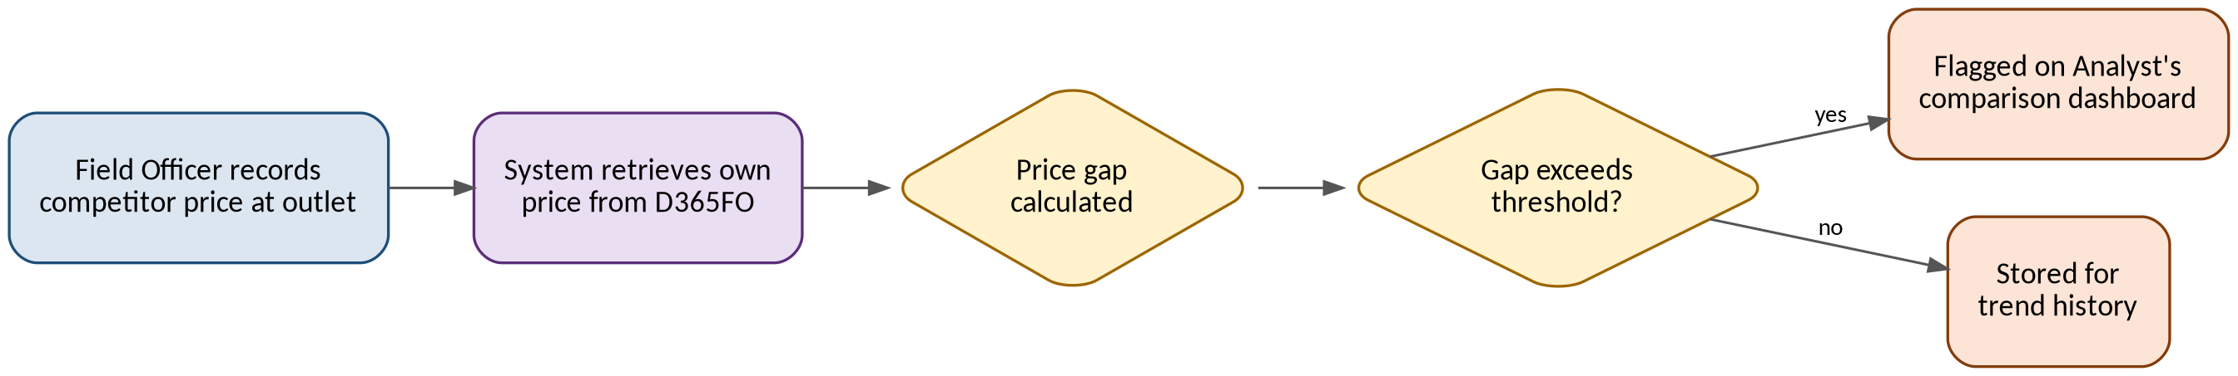
Figure 2 — EPIC-02 — Competitor & Pricing Module — Primary Workflow
The Field Officer records a competitor price at an outlet; the system matches it to the equivalent own product price pulled from D365FO and calculates the gap. If the gap exceeds the configured threshold it is flagged on the Analyst's comparison dashboard; otherwise it is simply retained for trend history.

5. EPIC-03 — D365FO Integration
Keeps KG-MIS supplied with authoritative customer, product, and sales data from D365FO so field data can be linked to real master records instead of being re-entered.

5.1 Actors
- System (scheduled sync job)
- Administrator (monitors sync, triggers manual sync)

5.2 Functional Requirements
ID | Requirement
FR-03.1 | The system shall retrieve customer, product, and sales master data from D365FO via OData/REST.
FR-03.2 | The system shall run a scheduled synchronization job at a configurable frequency to refresh cached master data.
FR-03.3 | The system shall log synchronization run status, record counts, and errors.
FR-03.4 | An Administrator shall be able to trigger an on-demand synchronization.
FR-03.5 | The system shall map D365FO entities (Customer, Product, Sales Order) to the internal data model.

5.3 Business Rules
- D365FO is the system of record for product and customer master data; KG-MIS never writes back to D365FO in this release.
- A failed sync run does not overwrite the last successful cache.

5.4 Workflow
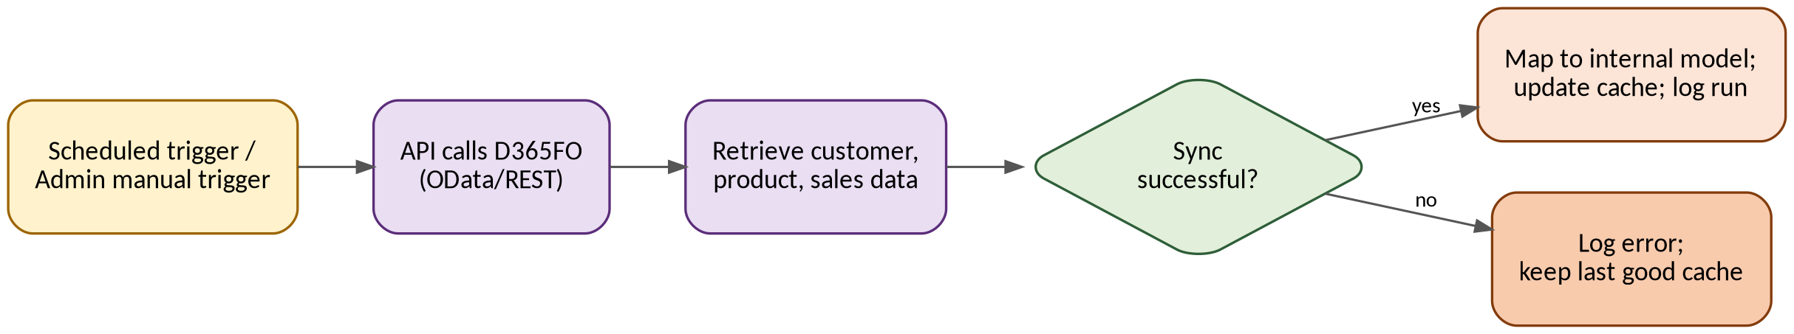
Figure 3 — EPIC-03 — D365FO Integration — Primary Workflow
A sync run starts on schedule or is triggered manually by an Administrator. The API calls D365FO's OData/REST endpoints to retrieve customer, product, and sales data. On success, the data is mapped to the internal model, the cache is updated, and the run is logged; on failure, the error is logged and the last good cache is retained unchanged.

6. EPIC-04 — CUAS Integration (Login & Role-Based Access)
Uses the corporate CUAS system for authentication and role mapping, so KG-MIS does not maintain a separate username/password store.

6.1 Actors
- All users (login)
- Administrator (role-to-permission mapping)

6.2 Functional Requirements
ID | Requirement
FR-04.1 | Users shall log in to KG-MIS using their existing CUAS company credentials (SSO).
FR-04.2 | The system shall enforce role-based access control based on the role/claims returned by CUAS.
FR-04.3 | The system shall map CUAS roles to internal application permissions (Administrator, Marketing Manager, Marketing Analyst, Field Officer, Viewer).
FR-04.4 | The system shall maintain secure session/token handling and expire sessions after a configurable period of inactivity.
FR-04.5 | A user without a mapped role shall be denied access with a clear message and no default elevated access.

6.3 Business Rules
- KG-MIS never stores passwords; all authentication is delegated to CUAS.
- Role mapping changes take effect on next login/token refresh, not retroactively.

6.4 Workflow
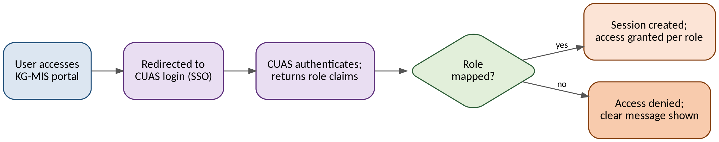
Figure 4 — EPIC-04 — CUAS Integration (Login & Role-Based Access) — Primary Workflow
A user accessing the portal is redirected to CUAS for SSO login. CUAS authenticates the user and returns role claims; if a mapped role is found, a session is created and access is granted per that role. If no mapped role is found, access is denied with a clear message and no default elevated access is given.

7. EPIC-05 — CNS Integration (Notifications)
Sends automatic alerts through the corporate CNS service instead of relying on manual follow-up.

7.1 Actors
- System (event-triggered notifications)
- Marketing Manager / Analyst (notification recipients)

7.2 Functional Requirements
ID | Requirement
FR-05.1 | The system shall send a notification via CNS when a defined trigger event occurs (e.g. new market visit report submitted, price-gap alert raised).
FR-05.2 | The system shall support CNS's available channels: email, SMS, and WhatsApp.
FR-05.3 | An Administrator shall configure which roles receive which notification event types and on which channel.
FR-05.4 | The system shall log the delivery status returned by CNS for each notification sent.

7.3 Business Rules
- Push and in-app notifications are out of scope for this release; only CNS's email, SMS, and WhatsApp channels are used.
- A failed CNS delivery is logged and retried once before being marked failed.

7.4 Workflow
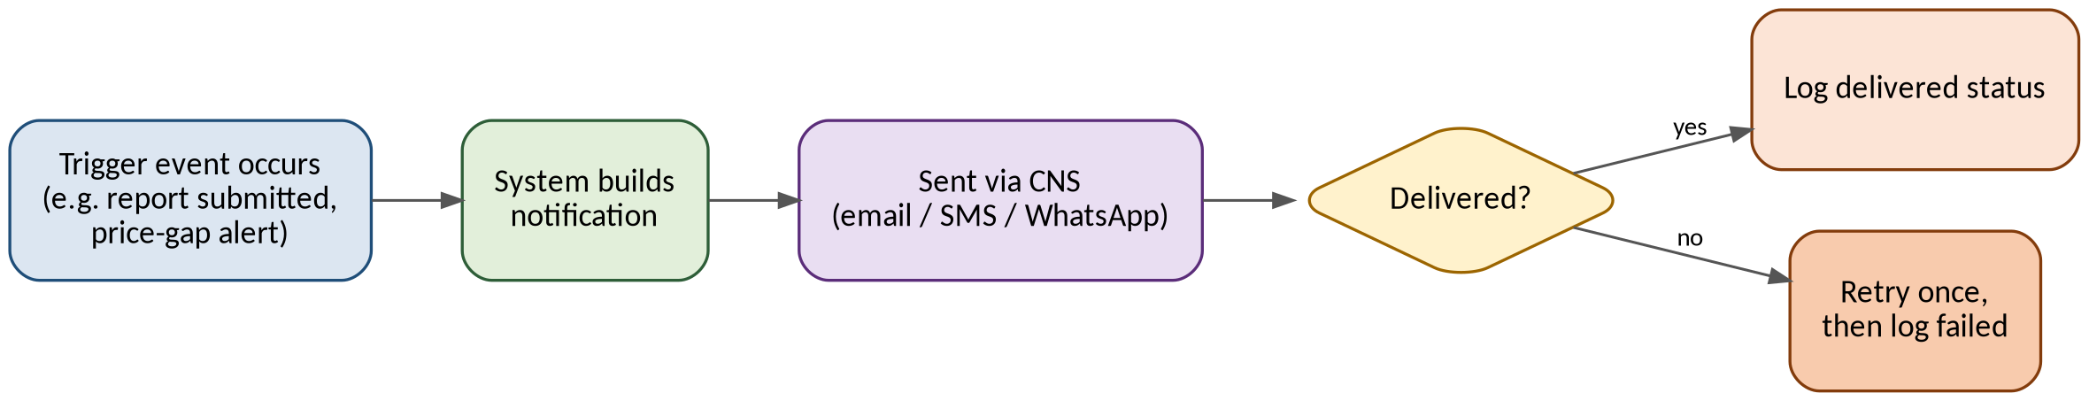
Figure 5 — EPIC-05 — CNS Integration (Notifications) — Primary Workflow
A trigger event (e.g. a report submitted or a price-gap alert raised) causes the system to build a notification and send it via CNS on the configured channel. CNS returns a delivery status, which is logged; a failed delivery is retried once before being marked failed.

8. EPIC-06 — Power BI Dashboards & Basic Reports
Turns collected field, survey, and pricing data (plus D365FO sales data) into dashboards and scheduled reports for management.

8.1 Actors
- Marketing Manager / Analyst / Viewer (consume dashboards)
- Administrator (manages report schedules)

8.2 Functional Requirements
ID | Requirement
FR-06.1 | The system shall expose a reporting data layer (views) that Power BI consumes as its data source.
FR-06.2 | Dashboards shall provide KPIs including sales growth, market share, and product availability rate.
FR-06.3 | Dashboards shall support drill-down from country → region → city → outlet.
FR-06.4 | The system shall support scheduled Power BI report refresh.
FR-06.5 | Selected Power BI reports shall be embeddable within the web portal using a secure embed token.

8.3 Business Rules
- Dashboard access follows the same role-based permissions as the rest of the portal.
- Custom drag-and-drop report building is out of scope; only the standard Power BI templates listed above are delivered in this release.

8.4 Workflow
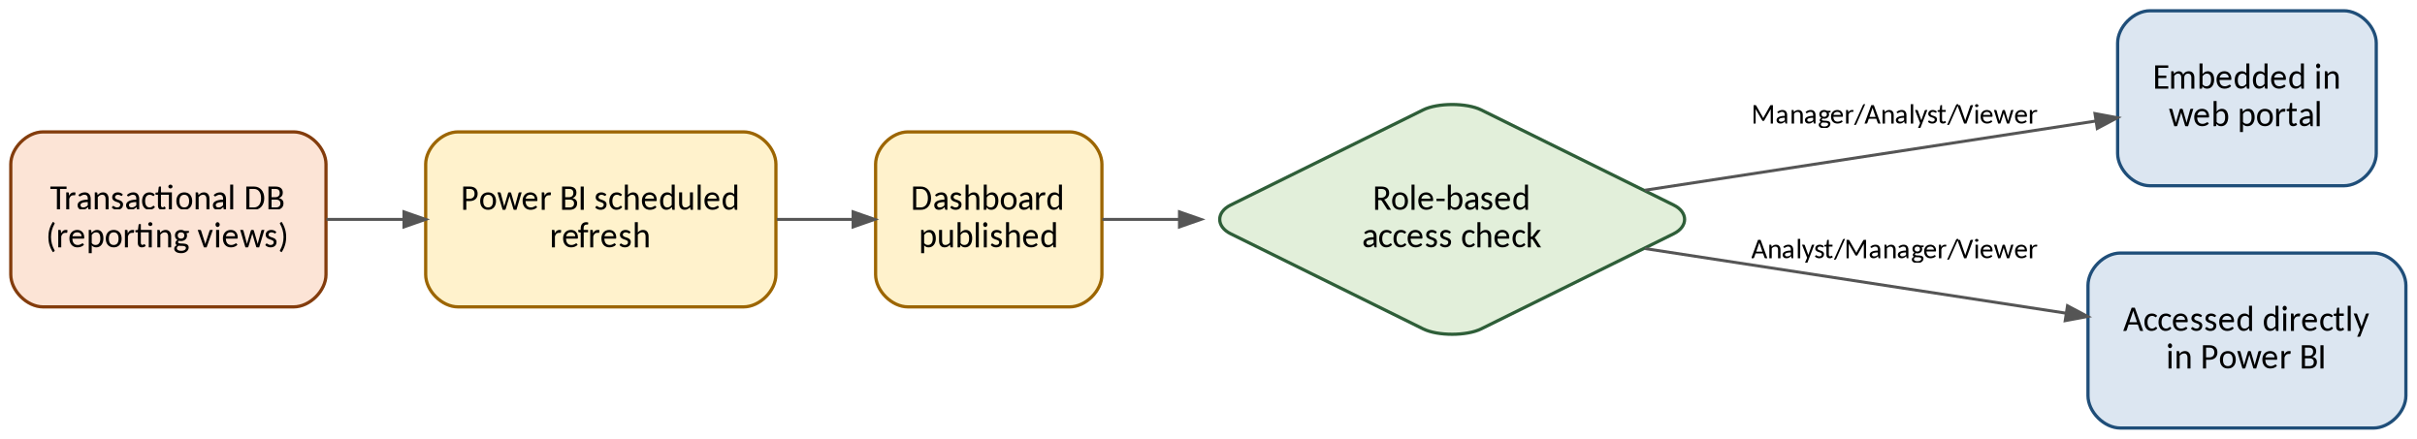
Figure 6 — EPIC-06 — Power BI Dashboards & Basic Reports — Primary Workflow
Power BI refreshes on a schedule from the reporting views built on top of the transactional database. Once a dashboard is published, a role-based access check determines whether a user sees it embedded in the web portal or accesses it directly in Power BI.

9. Traceability Matrix
Maps the User Requirement's key feature areas to the epic and functional requirements that deliver them in this release.
User Requirement Area | Epic | Functional Requirements
Field observations, market visit reports, interviews | EPIC-01 | FR-01.1 – FR-01.8
Structured questionnaires and surveys | EPIC-01 | FR-01.1 – FR-01.8
Sales and competitor data / comparative pricing analysis | EPIC-02 | FR-02.1 – FR-02.6
CRM integration, customer & distributor management (via D365FO) | EPIC-03 | FR-03.1 – FR-03.5
Role-based access and security | EPIC-04 | FR-04.1 – FR-04.5
Scheduled email reporting to management / alerts | EPIC-05 | FR-05.1 – FR-05.4
Real-time dashboards, KPI tracking, drill-down | EPIC-06 | FR-06.1 – FR-06.5
Items from the User Requirement not covered above (custom drag-and-drop report builder, audio recording/transcription, offline survey capability, automated recommendation engine) are captured in the Phase 0 Project Planning Package as Future Phase / out-of-scope for this release.

10. Approval
Role | Name | Signature | Date
Project Sponsor | Marketing Department
Requesting Officer | Mr. Tsegaye Nigusie
CTO | Mr. Melkamu Alamerew
Project Manager | Mr. Estifanos Alemseged
Solution Author | Mr. Woluman Urgesa

