
IT Department (Solution Development)
Hybrid Market Intelligence System (MIS)
Integration Design
Project Code: KG-MIS-2026-DEV-PROPOSAL
Project Sponsor | Marketing Department, Kerchanshe Group
Requesting Officer | Mr. Tsegaye Nigusie — Marketing Intelligence Officer
Delivery Owner | IT Department (Solution Development)
CTO | Mr. Melkamu Alamerew
Project Manager | Mr. Estifanos Alemseged
Solution Author / Developer | Mr. Woluman Urgesa
QA / Test Engineer | Mr. Hirko Gemechu
Based On | KG-MIS Solution Design Document (SDD) v1.0 and Functional Design Specification (FDS) v1.0
Companion Documents | Solution Design Document (SDD) · Functional Design Specification (FDS) · Technical Design Specification (TDS) · Security Matrix
Document Status | Draft v1.0 — For Review
Prepared Date | 06 August 2026

Table of Contents
1. Introduction 3
1.1 Purpose 3
1.2 Scope of This Document 3
1.3 References 3
2. Integration Overview 3
3. D365FO Integration 4
3.1 Design Summary 4
3.2 Entity Mapping 4
3.3 Sync Flow 4
4. CUAS Integration 4
4.1 Design Summary 5
4.2 Role Mapping 5
4.3 Login Flow 5
5. CNS Integration 5
5.1 Design Summary 6
5.2 Trigger Events 6
5.3 Notification Flow 6
6. Power BI Integration 6
6.1 Design Summary 6
6.2 Embedding Flow 7
7. Error Handling & Retry Summary 7
8. Approval 7

1. Introduction

1.1 Purpose
This Integration Design document defines the contract-level design for each of KG-MIS's four external integrations — D365FO, CUAS, CNS, and Power BI — elaborating the API & Integration Design activity of the Solution Design phase. It states protocol, direction, data exchanged, frequency, authentication, and error/retry handling for each integration, supplementing the functional behavior already defined in the FDS and the endpoint-level API design in the TDS.

1.2 Scope of This Document
This document covers KG-MIS's outbound and inbound integration contracts with D365FO (master data), CUAS (authentication), CNS (notifications), and Power BI (analytics). It does not define the internal /api/v1 endpoints KG-MIS itself exposes to its own web portal — those are defined in the TDS — nor the role-to-permission matrix, which is defined in the Security Matrix.

1.3 References
Ref | Document | Description
REF-01 | KG-MIS Solution Design Document (SDD) v1.0 | Architecture and integration layer design approach
REF-02 | KG-MIS Functional Design Specification (FDS) v1.0 | EPIC-03/04/05/06 functional requirements these integrations implement
REF-03 | KG-MIS Technical Design Specification (TDS) v1.0 | Internal API design and data dictionary referenced by these integrations

2. Integration Overview
KG-MIS integrates with four external systems, each isolated behind its own connector module per the SDD's integration layer design (SDD Section 4.4), so a change to one integration does not affect the others or the core business logic.
System | Direction | Protocol | Purpose
D365FO | Inbound to KG-MIS (read-only) | OData/REST over HTTPS | Customer, product, and sales master data
CUAS | KG-MIS redirects out; CUAS returns identity token | SSO/OAuth2 (or SAML) redirect flow | Authentication and role claims
CNS | Outbound only (KG-MIS → CNS) | REST API call with event payload | Email/SMS/WhatsApp notifications
Power BI | KG-MIS reporting views → Power BI (pull); embed token ← Power BI | Power BI REST API / embed SDK | Dashboards and scheduled reports

3. D365FO Integration
Keeps KG-MIS supplied with authoritative customer, product, and sales data from D365FO so field data can be linked to real master records instead of being re-entered (FDS EPIC-03).

3.1 Design Summary
Aspect | Design
Protocol | OData/REST over HTTPS
Direction | Inbound to KG-MIS (read-only in this release)
Data pulled | Customer/Distributor master, Product master, Sales transactions
Frequency | Scheduled sync job (configurable; daily by default), plus on-demand admin trigger
Auth | Service-to-service credentials issued by the D365FO team (OAuth2 client credentials, per D365FO API standard)
Error handling | Failed run is logged in SyncLog and does not overwrite the last good cache; alert sent to Administrator via CNS

3.2 Entity Mapping
D365FO Entity | KG-MIS Entity | Notes
Customer | Customer (cache) | Distributor/customer master, read-only
Product | Product (cache) | Product master, read-only
Sales Order | SalesRecord (cache) | Used for KPI calculation in Power BI

3.3 Sync Flow
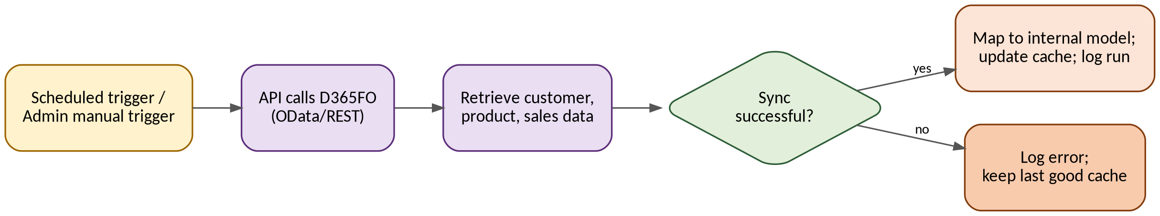
Figure 1 — D365FO Sync Flow
A sync run starts on schedule or is triggered manually by an Administrator. The API calls D365FO's OData/REST endpoints to retrieve customer, product, and sales data. On success, the data is mapped per the table above, the cache is updated, and the run is logged in SyncLog; on failure, the error is logged and the last good cache is retained unchanged, with an alert sent to the Administrator via CNS.

4. CUAS Integration
Uses the corporate CUAS system for authentication and role mapping, so KG-MIS does not maintain a separate username/password store (FDS EPIC-04).

4.1 Design Summary
Aspect | Design
Protocol | SSO/OAuth2 (or SAML, per CUAS standard) redirect flow
Direction | KG-MIS redirects unauthenticated users to CUAS; CUAS returns an identity token with role claims
Role mapping | CUAS role/claim values mapped to internal roles in a configuration table (see Section 4.2)
Session handling | KG-MIS issues its own short-lived session token after validating the CUAS token; session expires after configurable inactivity
Error handling | Login failure or missing role mapping returns an access-denied screen; no default access is granted

4.2 Role Mapping
CUAS Claim | Internal Role
(configured per CUAS group) | Administrator
(configured per CUAS group) | Marketing Manager
(configured per CUAS group) | Marketing Analyst
(configured per CUAS group) | Field Officer
(configured per CUAS group) | Viewer
Exact CUAS claim/group values are confirmed with the CUAS team during integration build and maintained in the role-mapping configuration table; the full role-to-permission matrix is defined in the Security Matrix.

4.3 Login Flow
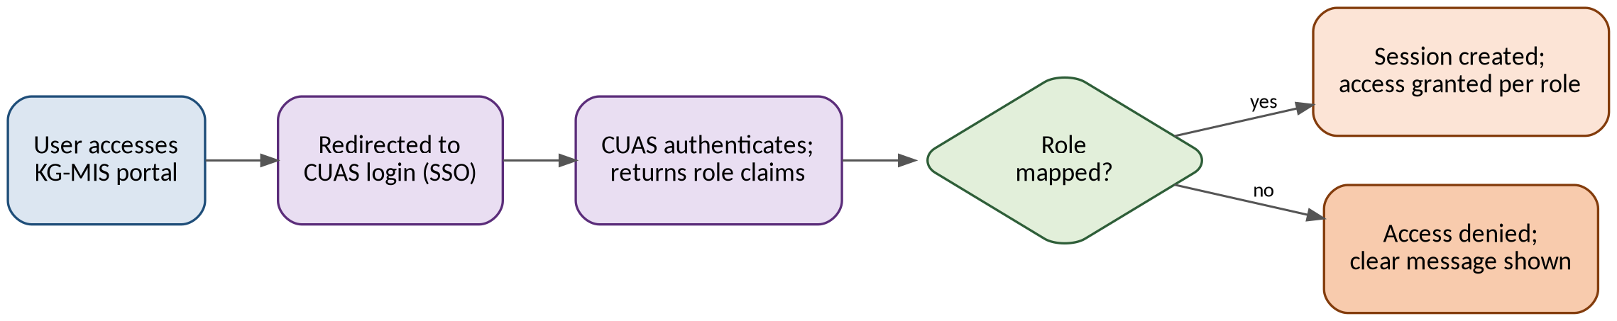
Figure 2 — CUAS Login Flow
A user accessing the portal is redirected to CUAS for SSO login. CUAS authenticates the user and returns role claims; if a mapped role is found, a session is created and access is granted per that role. If no mapped role is found, access is denied with a clear message and no default elevated access is given.

5. CNS Integration
Sends automatic alerts through the corporate CNS service instead of relying on manual follow-up (FDS EPIC-05).

5.1 Design Summary
Aspect | Design
Protocol | REST API call to CNS with event payload
Direction | Outbound only (KG-MIS → CNS)
Channels | Email, SMS, WhatsApp (per CNS capability)
Trigger events | New market visit report, survey published, price-gap alert, sync failure (admin only)
Retry policy | One retry on failure; final status logged in Notification.Status

5.2 Trigger Events
Event | Default Channel | Default Recipient Role
New market visit report submitted | Email | Marketing Manager
Survey published | Email | Field Officer
Price-gap alert raised | Email / SMS | Marketing Analyst, Marketing Manager
D365FO sync failure | Email | Administrator
Defaults are configurable by an Administrator via the notification configuration endpoint defined in the TDS (Section 4.7).

5.3 Notification Flow
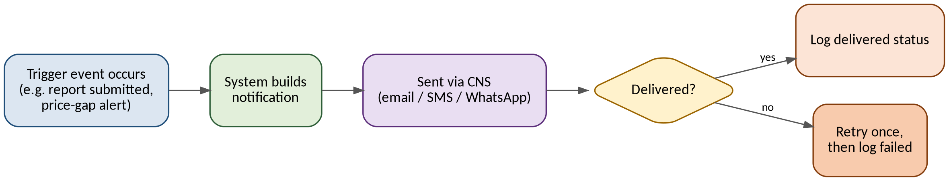
Figure 3 — CNS Notification Flow
A trigger event (e.g. a report submitted or a price-gap alert raised) causes the system to build a notification and send it via CNS on the configured channel. CNS returns a delivery status, which is logged; a failed delivery is retried once before being marked failed.

6. Power BI Integration
Turns collected field, survey, and pricing data (plus D365FO sales data) into dashboards and scheduled reports for management (FDS EPIC-06).

6.1 Design Summary
Aspect | Design
Connection | Power BI connects to dedicated reporting views in MS SQL Server (not raw transactional tables)
Refresh | Scheduled refresh aligned with D365FO sync and portal data updates
Embedding | Selected dashboards embedded in the web portal via Power BI embed token, requested by the API layer on behalf of the logged-in user
Access control | Row-level security in Power BI mirrors KG-MIS role-based access where applicable

6.2 Embedding Flow
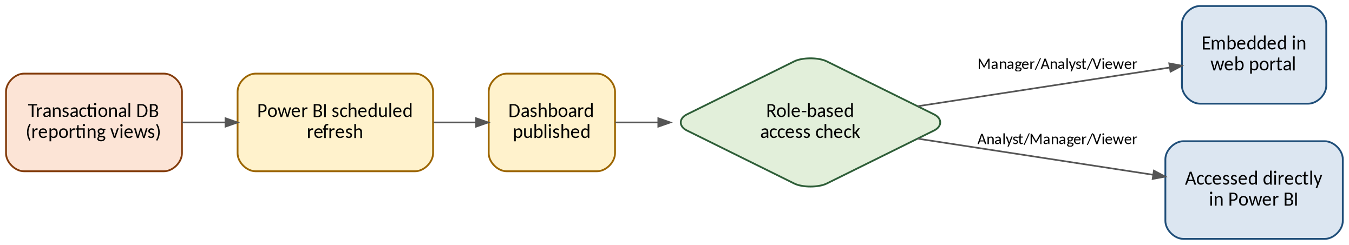
Figure 4 — Power BI Embedding Flow
Power BI refreshes on a schedule from the reporting views built on top of the transactional database. Once a dashboard is published, a role-based access check determines whether a user sees it embedded in the web portal (via a scoped embed token requested server-side) or accesses it directly in Power BI.

7. Error Handling & Retry Summary
Consolidated view of failure handling across all four integrations; each is detailed in its own section above.
Integration | Failure Behavior | Retry | Alerting
D365FO | Last good cache retained; run logged as failed in SyncLog | Next scheduled run (or manual trigger) | CNS alert to Administrator
CUAS | Access denied screen; no default access | User retries login | None (expected user-facing outcome)
CNS | Delivery marked failed after retry | One automatic retry | Logged in Notification.Status for admin review
Power BI | Stale dashboard data until next successful refresh | Next scheduled refresh | Refresh failure visible in Power BI service admin view

8. Approval
Role | Name | Signature | Date
Project Sponsor | Marketing Department
Requesting Officer | Mr. Tsegaye Nigusie
CTO | Mr. Melkamu Alamerew
Project Manager | Mr. Estifanos Alemseged
Solution Author | Mr. Woluman Urgesa

