
IT Department (Solution Development)
Hybrid Market Intelligence System (MIS)
Technical Design Specification (TDS)
Project Code: KG-MIS-2026-DEV-PROPOSAL
Project Sponsor | Marketing Department, Kerchanshe Group
Requesting Officer | Mr. Tsegaye Nigusie — Marketing Intelligence Officer
Delivery Owner | IT Department (Solution Development)
CTO | Mr. Melkamu Alamerew
Project Manager | Mr. Estifanos Alemseged
Solution Author / Developer | Mr. Woluman Urgesa
QA / Test Engineer | Mr. Hirko Gemechu
Based On | KG-MIS Solution Design Document (SDD) v1.0 and Functional Design Specification (FDS) v1.0
Companion Documents | Solution Design Document (SDD) · Functional Design Specification (FDS) · Integration Design · Security Matrix
Document Status | Draft v1.0 — For Review
Prepared Date | 06 August 2026

Table of Contents
1. Introduction 3
1.1 Purpose 3
1.2 Scope of This Document 3
1.3 References 3
2. Physical Data Model 3
2.1 Entity Overview 3
2.2 Entity Relationship Diagram 4
3. Data Dictionary 4
3.1 User & Access Entities 4
3.2 Region & Outlet 5
3.3 D365FO Cache Entities 5
3.4 Market Visit Report 5
3.5 Survey / SurveyQuestion 6
3.6 SurveyResponse / SurveyAnswer 6
3.7 CompetitorPrice / PriceGapAlert 6
3.8 Notification / SyncLog 7
4. API Design 7
4.1 Conventions 7
4.2 Authentication 7
4.3 Market Visit Reports 8
4.4 Surveys 8
4.5 Competitor Pricing 8
4.6 D365FO Sync (Internal/Admin) 8
4.7 Notifications (Internal/Audit) 9
4.8 Reports / Power BI 9
5. Module-Level Technical Notes 9
6. Technical Conventions 9
7. Approval 10

1. Introduction

1.1 Purpose
This Technical Design Specification (TDS) defines the physical data model, data dictionary, and API endpoint specifications that implement the functional requirements in the Functional Design Specification (FDS), within the architecture defined in the Solution Design Document (SDD). It is the primary reference for developers building the database and API layers.

1.2 Scope of This Document
This TDS covers the MS SQL Server physical schema for all KG-MIS-owned entities and the cached D365FO entities, and the REST API surface exposed by the Express/Node.js application layer. Integration-specific message formats and payloads for D365FO, CUAS, and CNS are defined in the Integration Design document; the role-to-permission matrix and control detail are defined in the Security Matrix; this TDS references both rather than repeating them.

1.3 References
Ref | Document | Description
REF-01 | KG-MIS Solution Design Document (SDD) v1.0 | Architecture, technology stack, layer design approach
REF-02 | KG-MIS Functional Design Specification (FDS) v1.0 | Functional requirements and business rules this schema and API implement

2. Physical Data Model

2.1 Entity Overview
Entities marked “(D365FO cache)” are read-only copies of D365FO master data, refreshed by the sync job (FDS EPIC-03) — KG-MIS does not own or write to them.
Entity | Description
User | An application user, linked to a CUAS identity
Role | Application role, mapped from CUAS claims
Region | Geographic hierarchy (country → region → city)
Outlet | A market location visited or surveyed
Product (D365FO cache) | Cached product master data
Customer (D365FO cache) | Cached customer/distributor master data
SalesRecord (D365FO cache) | Cached sales transactions used for KPIs
MarketVisitReport | A field visit report
Survey / SurveyQuestion | A questionnaire definition and its questions
SurveyResponse / SurveyAnswer | A respondent's submission and individual answers
CompetitorPrice / PriceGapAlert | A recorded competitor price observation and any flagged gap
Notification | A CNS notification event and its delivery status
SyncLog | A D365FO synchronization run record
AuditLog | A record of user actions for traceability

2.2 Entity Relationship Diagram
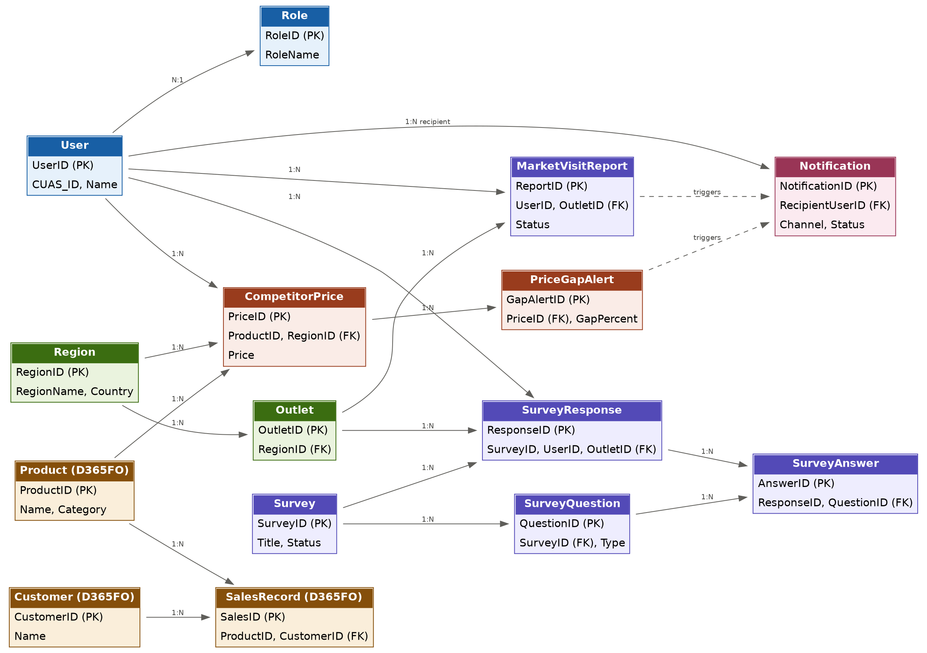
Figure 1 — KG-MIS Entity Relationship Diagram

3. Data Dictionary
Primary/foreign keys and core attributes for each entity. Columns not listed here (e.g. standard CreatedAt/UpdatedAt audit columns) follow the naming conventions in Section 6.

3.1 User & Access Entities

User
Attribute | Type | Notes
UserID | INT, PK | Auto-generated
CUAS_ID | VARCHAR(100) | Identity reference returned by CUAS
Name | NVARCHAR(150) | Display name
RoleID | INT, FK → Role | Current mapped role

Role
Attribute | Type | Notes
RoleID | INT, PK | Auto-generated
RoleName | VARCHAR(50) | Administrator / Marketing Manager / Marketing Analyst / Field Officer / Viewer

3.2 Region & Outlet
Attribute | Type | Notes
RegionID | INT, PK | Auto-generated
RegionName | NVARCHAR(100)
Country | VARCHAR(100)
OutletID | INT, PK | Auto-generated
RegionID | INT, FK → Region | Outlet's region

3.3 D365FO Cache Entities
Attribute | Type | Notes
ProductID | INT, PK | D365FO product identifier (cached)
Product.Name / Category | NVARCHAR(150) / VARCHAR(100) | Cached from D365FO
CustomerID | INT, PK | D365FO customer identifier (cached)
Customer.Name | NVARCHAR(150) | Cached from D365FO
SalesID | INT, PK | D365FO sales record identifier (cached)
SalesRecord.ProductID / CustomerID | INT, FK | Links to cached Product / Customer

3.4 Market Visit Report
Attribute | Type | Notes
ReportID | INT, PK | Auto-generated
UserID | INT, FK → User | Submitter
OutletID | INT, FK → Outlet | Visited location
VisitDate | DATE | Required
Notes | NVARCHAR(MAX) | Free-text observations
Status | VARCHAR(20) | Draft / Submitted / Reviewed
CreatedAt | DATETIME2 | Audit timestamp

3.5 Survey / SurveyQuestion
Attribute | Type | Notes
SurveyID | INT, PK
Title | NVARCHAR(200)
BusinessUnit | VARCHAR(100) | Tags survey to a business unit
Status | VARCHAR(20) | Draft / Published / Closed
CreatedBy | INT, FK → User
QuestionID | INT, PK | Belongs to SurveyQuestion
SurveyID | INT, FK → Survey | Parent survey
QuestionType | VARCHAR(20) | SingleChoice / MultiChoice / Text / Numeric / Rating
LogicRuleJSON | NVARCHAR(MAX) | Conditional/skip-logic definition

3.6 SurveyResponse / SurveyAnswer
Attribute | Type | Notes
ResponseID | INT, PK | Auto-generated
SurveyID | INT, FK → Survey
UserID | INT, FK → User | Respondent
OutletID | INT, FK → Outlet
AnswerID | INT, PK | Belongs to SurveyAnswer
ResponseID | INT, FK → SurveyResponse | Parent response
QuestionID | INT, FK → SurveyQuestion

3.7 CompetitorPrice / PriceGapAlert
Attribute | Type | Notes
PriceID | INT, PK
ProductID | INT, FK → Product (D365FO cache)
CompetitorName | NVARCHAR(150)
Price | DECIMAL(18,2)
RegionID / OutletID | INT, FK
RecordedBy / RecordedDate | INT / DATE
GapAlertID | INT, PK | Belongs to PriceGapAlert
PriceID | INT, FK → CompetitorPrice
GapPercent | DECIMAL(5,2) | (Own price − Competitor price) / Own price
ThresholdBreached | BIT

3.8 Notification / SyncLog
Attribute | Type | Notes
NotificationID | INT, PK
TriggerEvent | VARCHAR(100) | e.g. NewReport, PriceGapAlert
Channel | VARCHAR(20) | Email / SMS / WhatsApp
RecipientUserID | INT, FK → User
Status | VARCHAR(20) | Sent / Failed / Retried
SyncLogID | INT, PK | Belongs to SyncLog
Entity | VARCHAR(50) | Product / Customer / Sales
RecordsProcessed / ErrorCount | INT / INT

4. API Design

4.1 Conventions
All endpoints are served by the Express/Node.js API under the base path /api/v1, secured by the session token issued after CUAS login. Endpoints are grouped by module below.
- Requests/responses use JSON; dates are ISO 8601.
- A valid session token is required on every request (Authorization header); requests without one return 401.
- A user whose role lacks permission for an endpoint receives 403, per the Security Matrix.
- List endpoints support standard pagination and the filters noted per endpoint below.
- Errors return a structured JSON body with a status code, error code, and message, per SDD Section 7.3.

4.2 Authentication
Method | Endpoint | Description
GET | /api/v1/auth/login | Redirects to CUAS login
GET | /api/v1/auth/callback | Handles CUAS redirect, issues KG-MIS session token
GET | /api/v1/auth/me | Returns current user profile and mapped role
POST | /api/v1/auth/logout | Invalidates the current session

4.3 Market Visit Reports
Method | Endpoint | Description
GET | /api/v1/market-visits | List reports (filterable by outlet, region, date, status)
POST | /api/v1/market-visits | Create a new market visit report
GET | /api/v1/market-visits/{id} | Get a single report
PUT | /api/v1/market-visits/{id} | Update a report (Draft status only)
POST | /api/v1/market-visits/{id}/submit | Change status from Draft to Submitted

4.4 Surveys
Method | Endpoint | Description
GET / POST | /api/v1/surveys | List / create surveys
GET / PUT / DELETE | /api/v1/surveys/{id} | Get, update, or delete a survey (Draft only)
POST | /api/v1/surveys/{id}/publish | Publish a survey
POST | /api/v1/surveys/{id}/responses | Submit a response to a published survey
GET | /api/v1/surveys/{id}/responses | List responses to a survey

4.5 Competitor Pricing
Method | Endpoint | Description
GET / POST | /api/v1/competitor-prices | List / record competitor price observations
GET | /api/v1/competitor-prices/compare | Own vs. competitor comparison, filterable by product/region/period
GET | /api/v1/competitor-prices/alerts | List active price-gap alerts

4.6 D365FO Sync (Internal/Admin)
Method | Endpoint | Description
POST | /api/v1/sync/d365fo | Trigger an on-demand sync (Administrator only)
GET | /api/v1/sync/logs | List sync run history and status

4.7 Notifications (Internal/Audit)
Method | Endpoint | Description
GET | /api/v1/notifications | List notification delivery history (Administrator)
POST | /api/v1/notifications/config | Configure which roles receive which event/channel (Administrator)

4.8 Reports / Power BI
Method | Endpoint | Description
GET | /api/v1/reports/embed-token | Get a scoped Power BI embed token for the current user
GET | /api/v1/reports | List available dashboards/reports for the current user's role

5. Module-Level Technical Notes
Brief technical approach per module, supplementing the functional behavior already defined in the FDS.
Module | Technical Notes
Survey Builder | Skip logic stored as JSON (LogicRuleJSON) and evaluated client-side for UX, re-validated server-side on submit
Competitor Pricing | Gap calculation is a server-side computed value, recalculated on read rather than stored redundantly, except where flagged as a PriceGapAlert
D365FO Sync | Runs as a scheduled background job (node-cron or equivalent); each run is idempotent and transactional per entity type
CUAS Auth | Session token issued as a signed JWT after CUAS token validation; middleware enforces role checks per route
CNS Notifications | Outbound calls queued and retried once on failure; delivery status polled or received via CNS callback per its API contract
Power BI Reporting | Reporting views are the only objects Power BI reads; embed tokens requested server-side and scoped to the user's role

6. Technical Conventions
- Table names: PascalCase, singular (e.g. MarketVisitReport); primary keys named <Entity>ID.
- All tables include CreatedAt (DATETIME2) audit column; mutable entities also include UpdatedAt.
- API routes: kebab-case, versioned under /api/v1; resource-oriented (REST) naming.
- Schema changes are applied via versioned migrations, never direct production schema edits.
- Environment-specific configuration (connection strings, integration credentials) is externalized per SDD Section 7.4, never hard-coded.

7. Approval
Role | Name | Signature | Date
Project Sponsor | Marketing Department
Requesting Officer | Mr. Tsegaye Nigusie
CTO | Mr. Melkamu Alamerew
Project Manager | Mr. Estifanos Alemseged
Solution Author | Mr. Woluman Urgesa

