UNO Rulebook RAG Chatbot
Technical report: architecture, data flow, APIs, front end, security, deployment, setup and evaluation

Item | Details
Live site | https://uno-chatbot.buildwithmayank.tech (chat page: /uno-rules-chat/)
Backend | Google Cloud Run service uno-rag-backend (us-central1)
Stack | Python 3.13 · FastAPI · LangGraph · ChromaDB + BM25 · pdfplumber · Gemini on Vertex AI · WordPress plugin · Caddy · Cloudflare · Langfuse
Version | 2.0 (supersedes the first, Ollama-based report of 29 October 2026, kept in docs/archive/)
Prepared by | Mayank Bisht
Date | 1 November 2026
Evaluation | Local run 2026-11-01 03:00, production run 2026-11-01 03:06, security checks 2026-11-01 02:54

Contents
1. Executive summary 4
2. System architecture 5
2.1 How data flows 6
3. Project structure 8
3.1 Role of each file 8
3.2 Generated and local-only folders 10
4. Data ingestion 11
4.1 Steps 11
4.2 Corpus 12
4.3 Vector database schema 12
5. Retrieval 13
6. Conversation flow (LangGraph) 15
6.1 State, memory and safeguards 16
7. What happens when someone starts a chat 17
7.1 Step by step 17
7.2 Feedback 21
7.3 Typical timings (deployed) 21
8. Front end (WordPress) 22
8.1 How the site was built 22
8.2 Plugin internals 23
8.3 Chat widget behaviour (chatbot.js) 23
8.4 Plugins, modules and libraries used 23
9. Front-end ↔ back-end communication and APIs 25
9.1 WordPress REST API (namespace uno-chat/v1) 25
9.2 Backend API (FastAPI on Cloud Run) 25
9.3 Status codes across the layers 26
10. Security 27
10.1 How API keys and secrets are protected 28
10.2 Network and DDoS protection 29
10.3 Rate limiting 29
10.4 Real visitor IPs and spoofing 30
10.5 Application hardening 30
10.6 Identity and least privilege 30
10.7 Privacy 31
10.8 Threats and mitigations 31
10.9 Security test results 31
10.10 Known limitations and recommendations 32
11. Deployment 33
11.1 Backend on Cloud Run 34
11.2 WordPress on Compute Engine 36
11.3 Cloudflare configuration 37
11.4 Updates and rollback 37
11.5 Cost 37
12. Monitoring and observability 38
13. Evaluation 39
13.1 Retrieval 39
13.2 End-to-end accuracy 39
13.3 Latency 40
13.4 Project evolution 40
14. Setting up the project from scratch 41
14.1 Prerequisites 41
14.2 Local backend 43
14.3 Local WordPress 43
14.4 Backend on Cloud Run 43
14.5 WordPress on Compute Engine with Cloudflare 43
14.6 Verify 43
15. Operations and troubleshooting 44
Appendix A. Configuration reference (.env) 45
Appendix B. Per-question results 46
Appendix C. Diagram sources 48

1. Executive summary
The UNO Rulebook RAG Chatbot answers natural-language questions about five UNO rulebooks: Classic UNO, UNO Flip, UNO Dare, UNO No Mercy and UNO All Wild. It answers only from the rulebook PDFs and shows the rulebook and page behind each answer. Questions outside the rulebooks are politely refused, and small talk is answered without searching.
Visitors use a WordPress site. A custom WordPress plugin provides the chat widget and forwards each question server-side to a Python backend (FastAPI + LangGraph) on Google Cloud Run. The backend runs a retrieval-augmented generation (RAG) flow:
- Route: a small Gemini model classifies the message and rewrites follow-ups into a standalone question.
- Retrieve: a hybrid keyword and vector search picks the 6 most relevant rulebook passages.
- Answer: a larger Gemini model answers from those passages only.
Every turn is traced in Langfuse, and visitors can rate answers with thumbs up/down.
Headline results, all measured on the actual system (section 13):
Measure | Result | Notes
Rulebook answers correct (local / deployed) | 31/31 / 31/31 | Answer contains every required fact
Correct rulebook cited | 100% / 100% | Source chips name the right PDF
Off-topic refused, small talk, follow-ups | 6/6, 16/16, 4/4 | Same results on the deployed API
Correct rulebook ranked first by retrieval | 96.8% | Answer passage in the top 6: 96.8%
Median answer time, rulebook question | 2.4 s local, 2.5 s deployed | First version (local Ollama model): 8.9 s
Automated security checks | 26 passed, 0 failed | 4 informational findings (section 10.9)
Running cost | about $18/month + Gemini usage | VM, static IP and disk; Cloud Run stays in its free tier

The system has six layers of protection:
- Cloudflare in front of the site.
- A firewall that admits only Cloudflare.
- Per-IP rate limits in Caddy.
- WordPress nonce checks and question limits.
- A secret API key between WordPress and the backend.
- A least-privilege Google service account for the Gemini calls.
API keys never reach the browser.

2. System architecture
The system has four runtime parts. The front end is WordPress on a Compute Engine VM, behind Cloudflare and Caddy. The backend is FastAPI + LangGraph on Cloud Run. The models are Gemini on Vertex AI. Monitoring is Langfuse Cloud. Figure 1 shows how they connect.
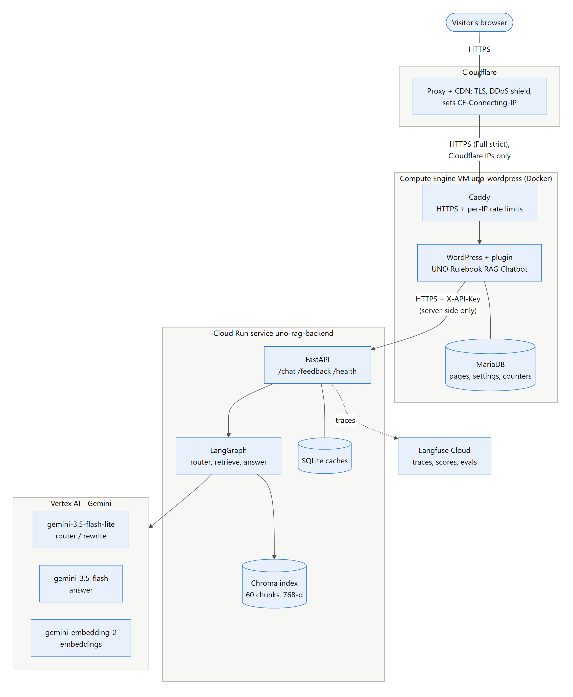
Figure 1. System architecture
Component | Technology | Runs on | Responsibility
Edge | Cloudflare (free plan) | Cloudflare network | DNS, TLS to visitors, DDoS protection, caching of static files, real visitor IP header
Web server | Caddy 2 + caddy-ratelimit | VM (Docker) | HTTPS certificate (Let's Encrypt), per-IP rate limits, reverse proxy to WordPress
Website | WordPress 6 (PHP 8.3), theme Twenty Twenty-Five | VM (Docker) | Home page, chat page, admin; hosts the plugin
Chat plugin | Custom plugin uno-rag-chatbot 1.6.0 | Inside WordPress | Chat widget (JS), REST proxy to the backend, nonce check, question limits, settings page
Database | MariaDB 11 | VM (Docker) | WordPress content, plugin settings, rate-limit counters
API | FastAPI + Uvicorn | Cloud Run | /chat, /feedback, /health; API-key check, validation, answer cache, tracing
RAG flow | LangGraph | Cloud Run | Routing, retrieval, grounded answering, query rewrite, conversation memory
Search index | ChromaDB (cosine HNSW) + rank_bm25 | Cloud Run (baked into the image) | 60 rulebook chunks with 768-d embeddings; keyword index built in memory
Models | gemini-3.5-flash-lite, gemini-3.5-flash, gemini-embedding-2 | Vertex AI (global) | Router/rewrite, answers, embeddings
Monitoring | Langfuse Cloud (Hobby) | SaaS (EU) | Traces, user-feedback scores, evaluation datasets and experiments

2.1 How data flows
Data moves in two phases (Figure 2):
- Indexing runs offline when the rulebooks change. It turns the PDFs into embedded chunks in Chroma.
- Answering runs for every question. It reads the index and produces an answer with its sources.
Each answer also feeds the answer cache, so a repeated first question costs no model calls. It also produces a Langfuse trace, which later receives the visitor's thumbs up/down.
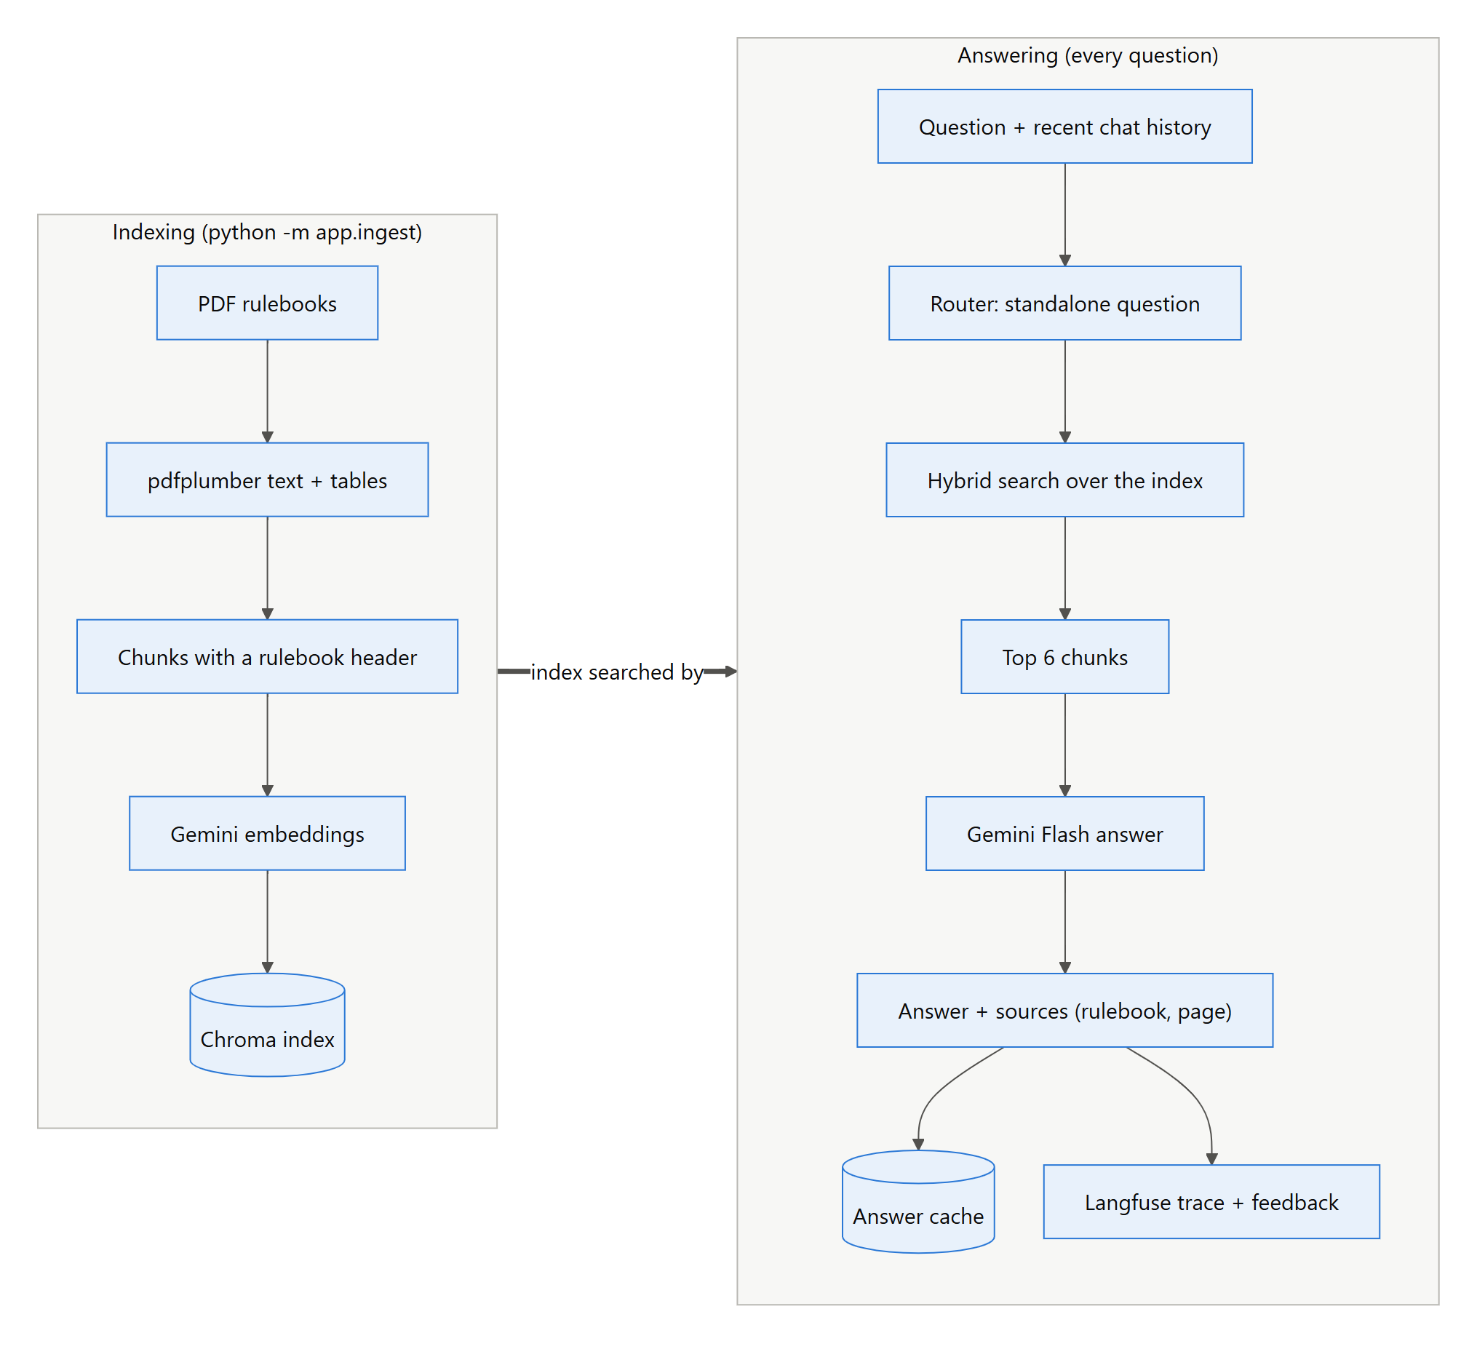
Figure 2. Data flow: indexing and answering
Where data is stored:
Data | Stored in | Lifetime
Rulebook PDFs | Data/ in the repository and in the backend image | Permanent
Chunks + embeddings | chroma_db/ locally; copied into the Cloud Run image | Until the next ingest
Conversation memory | LangGraph MemorySaver (RAM of the Cloud Run instance), keyed by session_id | Until the instance stops (about 15 minutes idle) or New chat
Answer cache, query-embedding cache, usage counter | SQLite/JSON in CACHE_DIR (/tmp on Cloud Run) | Per instance on Cloud Run; persistent locally
Session id | Browser localStorage key uno_chat_session | Until New chat or cleared storage
Plugin settings, rate-limit counters, daily question count | WordPress options/transients in MariaDB | Settings permanent; counters 1 hour / 1 day
Traces and feedback | Langfuse Cloud | Per Langfuse plan retention

3. Project structure
The repository holds the backend, the WordPress plugin, both deployments, the evaluation suite and this documentation. Cloud Run builds the backend image from the repository root, so the files that control that build sit at the root.
RAG Practice project/
├── app/ FastAPI + LangGraph backend (Python package)
├── Data/ the five rulebook PDFs
├── eval/ evaluation: dataset, runners, results
├── wordpress/
│ ├── uno-rag-chatbot/ WordPress plugin (PHP + JS + CSS)
│ ├── setup/pages.php creates Home page, chat page, menu
│ ├── setup.ps1 local WordPress in Docker
│ └── build_zip.py packages the plugin
├── deploy/
│ ├── cloudrun/ backend deployment scripts
│ └── wordpress/ VM deployment (Docker, Caddy, scripts)
├── docs/ this report, diagrams, report tooling, archive
├── Dockerfile backend image
├── .dockerignore / .gcloudignore what goes into the image / upload
├── docker-compose.yml local WordPress stack
├── requirements.txt Python dependencies
├── .env.example configuration template (.env is git-ignored)
└── README.md quick-start guide

3.1 Role of each file

Backend: app/
File | Role
app/main.py | FastAPI app. Routes /, /health, /chat, /feedback, DELETE /chat/{id}, /ingest. Request/response schemas, X-API-Key check, answer cache, one Langfuse trace per turn, startup (graph, cache, auto-ingest) and per-request trace flush on Cloud Run.
app/graph.py | LangGraph state machine: analyze → respond_direct or retrieve → answer → optional rewrite_query. Holds the state schema, routing functions, follow-up guard and the MemorySaver checkpointer.
app/prompts.py | Prompt templates: ANALYZE (route + standalone question + small-talk reply, JSON), ANSWER (grounded JSON answer, quote numbers verbatim), REWRITE; fixed refusal texts.
app/llm.py | Gemini integration: Vertex AI client, chat models per role (router/answer), retries on 429/5xx, auth error help, daily request budget (UsageTracker), SQLite key-value caches, gemini-embedding-2 embeddings with prefixes and parallel requests, JSON parsing, health status.
app/vectorstore.py | Chroma vector store, in-memory BM25 index, rulebook alias detection (detect_sources), hybrid search with reciprocal rank fusion.
app/ingest.py | Indexing: pdfplumber extraction (text + tables), cleaning, duplicate-page removal, chunking, contextual header, ids, writing to Chroma. CLI: python -m app.ingest --reset.
app/observability.py | Langfuse client, LangChain callback handler, trace_turn (one root trace per chat turn with tags), embedding traces, scores, auth check, flush.
app/formatting.py | Removes Markdown from model output so the widget shows clean plain text.
app/model_status.py | CLI that lists the Gemini models available to the project and checks the configured ones (metadata only, no cost).
app/config.py | All settings (pydantic-settings) loaded from .env, with path helpers.

Evaluation: eval/
File | Role
eval/dataset.py | Hand-labelled test set: 31 rulebook questions (required facts, source PDF, evidence text), 6 off-topic, 16 small-talk, 4 two-turn follow-ups.
eval/run_eval.py | Retrieval metrics for 5 search methods and end-to-end accuracy/latency on the local graph (Langfuse experiment); --backend-url runs the same questions against the deployed API.
eval/security_checks.py | Automated checks of the live security measures (auth, firewall, Cloudflare, nonce, rate limits, secret exposure).
eval/results_gemini.json | Latest local results (retrieval + end-to-end).
eval/results_production.json | Latest results against Cloud Run.
eval/results_security.json | Latest security-check results.

WordPress plugin: wordpress/uno-rag-chatbot/
File | Role
uno-rag-chatbot.php | Plugin main file: settings page (Settings → UNO Chatbot), [uno_chatbot] shortcode, floating bubble, script/style loading with REST URL + nonce, REST routes uno-chat/v1/ask|feedback|reset, nonce check, per-IP and site-wide limits, server-side calls to the backend with X-API-Key.
includes/home.php | [uno_chatbot_home] landing page: hero, rulebooks covered, how it works, features, link to the chat page.
assets/chatbot.js | Chat widget: session id in localStorage, welcome text, suggestion buttons, sending questions, typing indicator, answer bubbles (textContent only), source chips, thumbs up/down, New chat.
assets/chatbot.css | Widget styles: dark ember theme, inline/page/floating layouts.
assets/home.css | Landing page styles.
uninstall.php | Deletes the plugin settings and daily counters when the plugin is deleted.
readme.txt | WordPress plugin readme and changelog.

WordPress setup and packaging: wordpress/
File | Role
wordpress/setup/pages.php | Creates/updates the chat page, the Home page (front page) and the Home-only navigation menu. Used by both the local and the cloud setup (wp eval-file).
wordpress/setup.ps1 | Local setup: starts Docker WordPress, installs it, activates the plugin, saves settings, runs pages.php.
wordpress/build_zip.py | Packages the plugin to dist/uno-rag-chatbot.zip for upload to any WordPress site.
docker-compose.yml (root) | Local development stack: WordPress, MariaDB and a wp-cli tool container; the plugin folder is mounted live.

Deployment: deploy/
File | Role
deploy/cloudrun/deploy.ps1 | Backend deployment: enables APIs, service account + Vertex AI User role (skippable), prepares index and env file, gcloud run deploy --source ., deletes the env file.
deploy/cloudrun/prepare_index.py | Copies only the active Chroma collection (with its embeddings) into deploy/build/chroma_db for the image.
deploy/cloudrun/make_env.py | Turns .env into the Cloud Run env-vars file with Cloud Run overrides (cache in /tmp, production tracing).
deploy/wordpress/deploy.ps1 | VM deployment: static IP, firewall, VM, Cloudflare checks, bundle upload, runs vm-setup.sh, firewall lock to Cloudflare, fetches admin credentials.
deploy/wordpress/vm-setup.sh | Runs on the VM: Docker, swap, DB passwords, docker compose up --build, WordPress install, plugin settings, pages.
deploy/wordpress/docker-compose.yml | Production stack: MariaDB (memory-tuned), WordPress (no public port), Caddy (80/443), wp-cli; log caps; real-IP config.
deploy/wordpress/Caddyfile | HTTPS site, trusted Cloudflare ranges, per-IP rate-limit zones, xmlrpc block, reverse proxy with X-Real-IP.
deploy/wordpress/caddy/Dockerfile | Builds Caddy with the caddy-ratelimit module.
deploy/wordpress/plugin-options.php | Saves the backend URL and key (read from stdin) into the plugin settings, keeping admin changes.

Root files and documentation
File | Role
Dockerfile | Backend image: python:3.13-slim, dependencies, app + PDFs + pre-built index, non-root user, Uvicorn on $PORT.
.gcloudignore / .dockerignore | Keep secrets and unrelated folders (.env, .venv, WordPress, docs, eval) out of the Cloud Run upload and image.
requirements.txt | Python dependencies (section 8.4).
.env.example | Template of every setting with comments; copy to .env.
.gitignore | Excludes secrets, virtualenv, generated index/caches, build output, credentials.
README.md | Quick start, deployment commands, API and configuration reference.
docs/ | This report (.docx/.pdf), diagrams (Mermaid sources + PNG), tools to regenerate them, archive of the first report.

3.2 Generated and local-only folders
Folder / file | Created by | In git?
.venv/ | python -m venv | No
.env | copied from .env.example | No (secrets)
chroma_db/ | python -m app.ingest | No (rebuildable)
cache/ | backend at runtime (answer + embedding caches, usage counter) | No
deploy/build/ | prepare_index.py during a Cloud Run deploy | No
dist/ | wordpress/build_zip.py | No
wordpress/admin-credentials*.txt | setup.ps1 / deploy.ps1 | No (passwords)
docs/tools/node_modules/ | npm install (report tooling) | No

4. Data ingestion
python -m app.ingest --reset turns the PDFs in Data/ into searchable chunks (Figure 3). Ingestion runs locally. The finished index is copied into the Cloud Run image, so the deployed backend never re-embeds the PDFs on start-up.
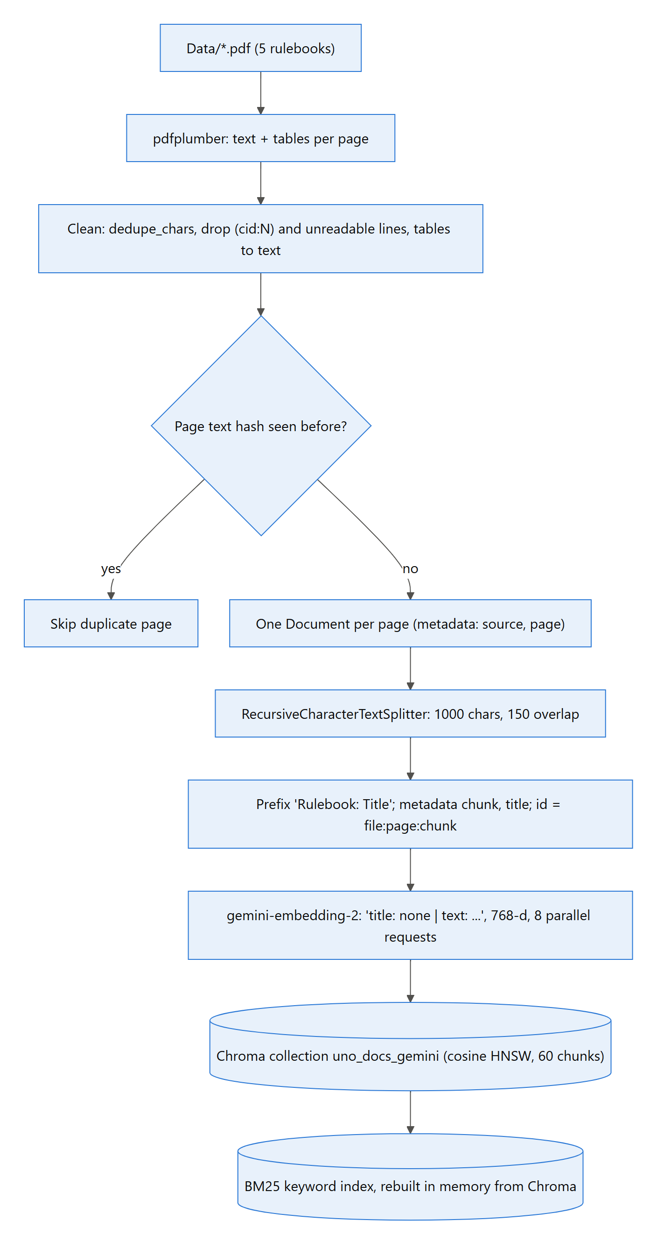
Figure 3. Ingestion pipeline

4.1 Steps
- Extract: pdfplumber reads each page's text and tables. Tables become text rows joined with |.
- Clean: extraction noise is removed (details below the list).
- Drop duplicates: a page whose cleaned text hashes to one already seen is skipped (some PDFs repeat pages).
- Chunk: RecursiveCharacterTextSplitter with 1000 characters and 150 overlap. Chunks average about 860 characters.
- Add context: every chunk starts with Rulebook: <Title>, so both the embedding and the answer model know which edition it belongs to. Each chunk gets the id file:page:chunk and the metadata source, page, chunk and title.
- Embed: gemini-embedding-2 at 768 dimensions. This model takes one text per request and ignores the task type, so the task is given as a text prefix (title: none | text: for documents) and 8 requests run in parallel.
- Store: Chroma collection uno_docs_gemini (cosine distance, HNSW index). The BM25 keyword index is built in memory from the same chunks when the backend starts.
The cleaning in step 2 does three things:
- Collapses doubled glyphs (dedupe_chars).
- Removes (cid:N) font codes.
- Drops lines that are mostly unreadable symbols.

4.2 Corpus
Rulebook (file) | Pages kept | Chunks | Alias used for filtering
UNO Flip (uno flip.pdf) | 1 | 29 | flip
UNO No Mercy (Uno No mercy.pdf) | 1 | 11 | no mercy
UNO Dare (Uno Dare.pdf) | 1 | 10 | dare
UNO All Wild (uno-all-wild-rules-…pdf) | 3 | 7 | all wild
Classic UNO (uno classic.pdf) | 1 | 3 | classic
Total | 7 | 60

4.3 Vector database schema
Chroma stores everything in chroma_db/chroma.sqlite3 plus one HNSW index folder for the collection:
Field | Type | Example | Purpose
id | string | uno flip.pdf:1:4 | Stable chunk id (file:page:chunk); re-ingest overwrites
document | text | Rulebook: Uno Flip\nSKIP EVERYONE: … | Chunk text with contextual header
embedding | float[768] | [0.012, -0.044, …] | gemini-embedding-2 vector (cosine)
metadata.source | string | uno flip.pdf | Source file; shown to users as the citation
metadata.page | int | 1 | Page number in the PDF (shown as p.1)
metadata.chunk | int | 4 | Position of the chunk within its page
metadata.title | string | Uno Flip | Rulebook title; basis for the alias used by the title filter
collection metadata | map | hnsw:space = cosine | Distance function of the HNSW index

5. Retrieval
Retrieval combines two searches, because each catches what the other misses (Figure 4). Vector search finds passages that mean the same thing as the question. BM25 keyword search finds exact card names and numbers, such as "Wild Draw Color" or "25 cards".
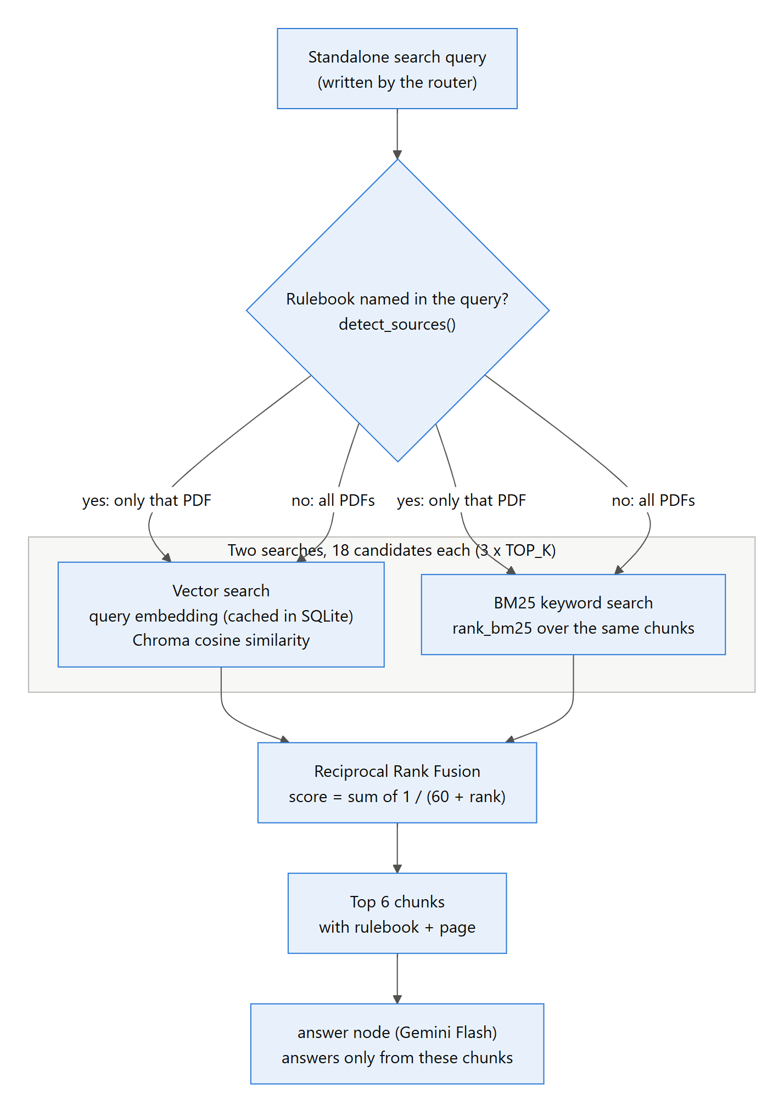
Figure 4. Hybrid retrieval with reciprocal rank fusion
- Rulebook filter: if the standalone question names an edition (an alias such as "flip", "no mercy" or "classic"), both searches are restricted to that PDF.
- Two searches: each returns up to 18 candidates (3 × TOP_K). The query embedding uses the prefix task: search result | query: and is cached in SQLite, so repeated questions cost no embedding request.
- Reciprocal rank fusion: every chunk scores Σ 1 / (60 + rank) over the two result lists. Chunks found by both searches rise to the top.
- Top 6 chunks (TOP_K) go to the answer node with their rulebook and page.
RETRIEVAL_MODE=bm25 turns off the vector search, which saves the embedding request.
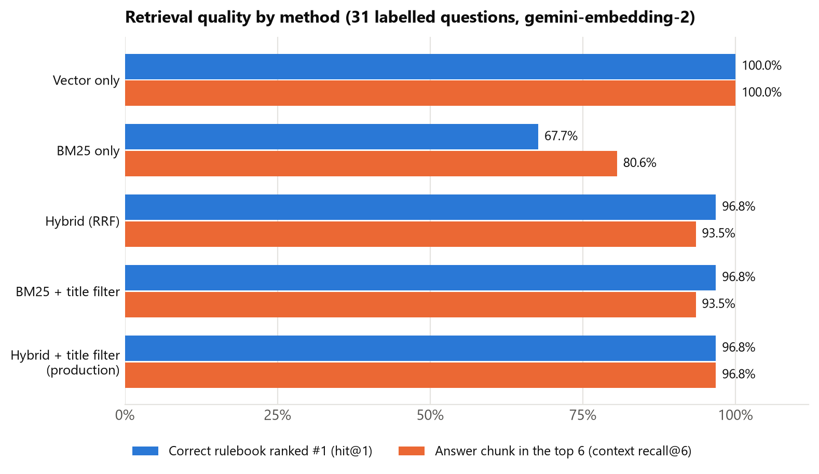
Figure 5. Retrieval quality by method (31 labelled questions)
Method | Hit@1 | Recall@3 | Recall@6 | MRR | Avg time
Vector only | 100% | 100% | 100% | 0.952 | 4.4 ms
BM25 only | 67.7% | 61.3% | 80.6% | 0.526 | 0.3 ms
Hybrid (RRF) | 96.8% | 87.1% | 93.5% | 0.798 | 1.6 ms
BM25 + title filter | 96.8% | 77.4% | 93.5% | 0.663 | 0.2 ms
Hybrid + title filter (production) | 96.8% | 93.5% | 96.8% | 0.836 | 1.5 ms

The column headings mean:
- Hit@1: the correct rulebook is ranked first.
- Recall@k: the passage that contains the answer is among the first k results.
- MRR: the mean of 1 / rank of that passage.
Finding: pure vector search with gemini-embedding-2 reaches 100% recall@6 and MRR 0.952, above the production hybrid (96.8%, 0.836). End-to-end accuracy is already 100%, so the hybrid stays for robustness on exact card names. A vector-first fusion weight is a candidate improvement.

6. Conversation flow (LangGraph)
Each message runs through a small LangGraph state machine (Figure 6). The graph is compiled once at start-up with a MemorySaver checkpointer. The visitor's session_id is the thread id, so a conversation keeps its history across turns.
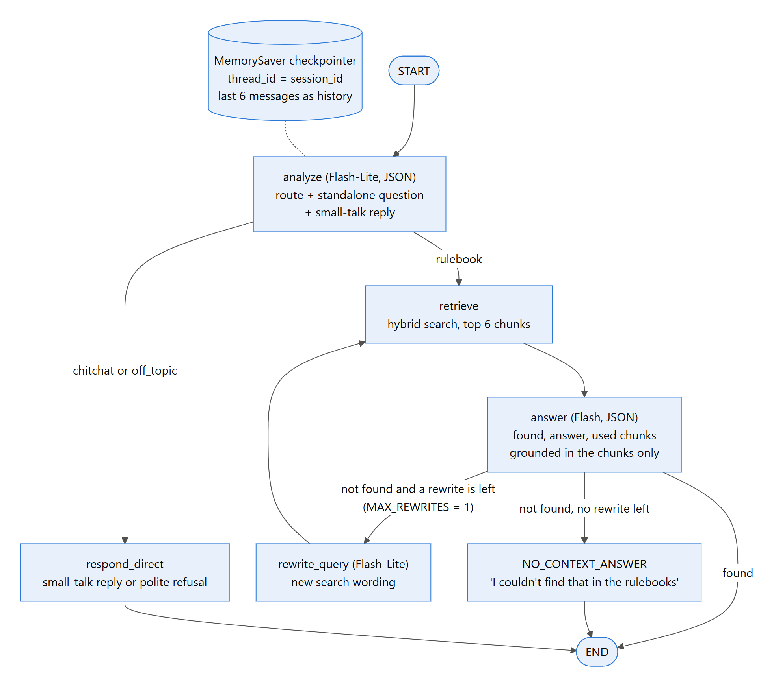
Figure 6. LangGraph conversation flow
Node | Model | What it does | Model requests
analyze | gemini-3.5-flash-lite (thinking: minimal), JSON output | Classifies the message as chitchat, rulebook or off_topic; rewrites follow-ups into a standalone question ("what about in Flip?" → full question); drafts the small-talk reply. Unknown routes default to rulebook. | 1
respond_direct | – | Returns the small-talk reply, or the fixed off-topic refusal. | 0
retrieve | gemini-embedding-2 (query) | Hybrid search for the standalone question (section 5). | 0–1 (cached)
answer | gemini-3.5-flash (thinking: low), JSON output | Answers only from the 6 chunks, returns found/answer/used chunk numbers; the used chunks become the sources. Numbers are quoted verbatim; Markdown is stripped. | 1
rewrite_query | gemini-3.5-flash-lite | If nothing relevant was found, rephrases the search once (MAX_REWRITES = 1) and retrieves again. | 1 (rare)

6.1 State, memory and safeguards
The graph state holds the following fields:
- messages: the chat history.
- question and standalone_question.
- route and reply.
- search_query.
- documents and used_documents.
- found and rewrites.
Safeguards in the flow:
- History: the last 6 messages (HISTORY_WINDOW) are given to the router, so follow-ups are understood.
- Follow-up guard: a regular expression catches follow-ups ("it", "that", "what about…") that the router failed to rewrite, and keeps the previous topic in the search.
- No guessing: if no chunk answers the question, the reply is the fixed text "I couldn't find that in the rulebooks…" rather than an invented answer.
- Off-topic: questions unrelated to UNO get a fixed polite refusal, with no search and no answer model.
- Cost: small talk and off-topic messages cost 1 request; rulebook questions cost 3; a repeated first question costs 0 (answer cache).

7. What happens when someone starts a chat
Figures 7 and 8 (on the following landscape pages) trace one question from the visitor's browser to Gemini and back. The front-end half covers the browser, Cloudflare, Caddy and WordPress. The back-end half covers WordPress, FastAPI, LangGraph, Gemini and Langfuse.

7.1 Step by step
- Page load: WordPress renders the chat page. The plugin loads chatbot.js and passes it the REST URL, a fresh REST nonce, the title, welcome text and three suggested questions (wp_localize_script). The backend URL and key are not included.
- Session: the widget reads or creates a random session id in localStorage (uno_chat_session) and shows the welcome message and suggestion buttons.
- Ask: the visitor types a question (or clicks a suggestion). The widget POSTs {question, session_id} to /wp-json/uno-chat/v1/ask with the X-WP-Nonce header and shows a typing indicator.
- Cloudflare: terminates TLS, applies its DDoS protection and forwards the request to the VM over HTTPS, adding CF-Connecting-IP with the visitor's real IP.
- Caddy: takes the visitor IP from that header (only because the request came from a Cloudflare IP range), applies the per-IP limits (300 requests/minute overall, 20/minute for the chat API) and proxies to WordPress with X-Real-IP.
- WordPress plugin: checks the nonce and the question limits, then calls the backend server-side (checks listed below).
- Backend: checks the API key, the request body and the daily budget, or answers from the cache (checks listed below).
- Graph: analyze (Flash-Lite) → retrieve (hybrid search; the query embedding usually comes from the cache) → answer (Flash). Each step and model call is recorded in the turn's Langfuse trace, which is sent before the response ends.
- Response: FastAPI returns {answer, sources[], cached, trace_id}. The plugin passes it to the browser unchanged except for validation of the trace id.
- Display: the widget shows the answer as plain text (textContent, never HTML), source chips such as "Uno No mercy.pdf · p.1" and thumbs up/down buttons.
- Follow-up: the next question carries the same session id, so the router sees the history and rewrites the follow-up into a standalone question.
- New chat: creates a new session id and calls /reset, which makes the backend forget the old conversation (DELETE /chat/{id}).
Checks made by the WordPress plugin (step 6):
- The nonce must be valid (otherwise 403).
- At most 10 questions per hour per visitor IP.
- At most 300 questions per day for the whole site.
- The question must be 1–1000 characters, and the session id must contain only A–Z a–z 0–9 _ -.
The plugin then calls POST {backend}/chat with X-API-Key and an anonymous visitor id: the first 16 characters of a salted hash of the IP.
Checks made by the backend (step 7):
- The API key must match (otherwise 401).
- Pydantic validates the body (otherwise 422).
- The daily request budget must not be exhausted (otherwise 429).
If this is the first turn of the session and the question was answered before, the cached answer is returned with no model calls.
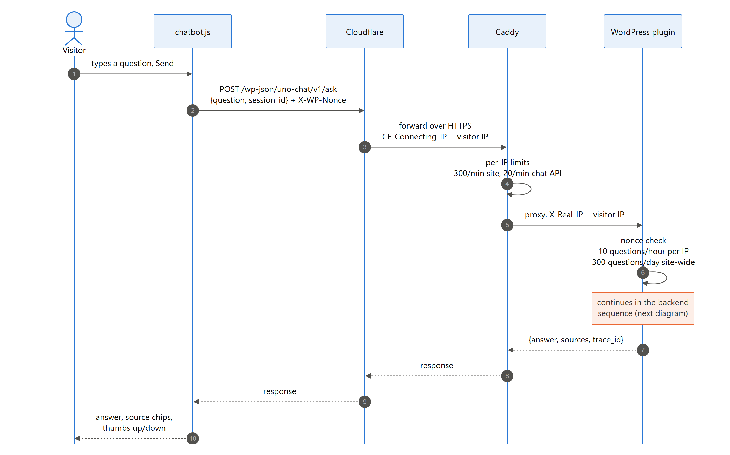
Figure 7. Chat request: browser to WordPress
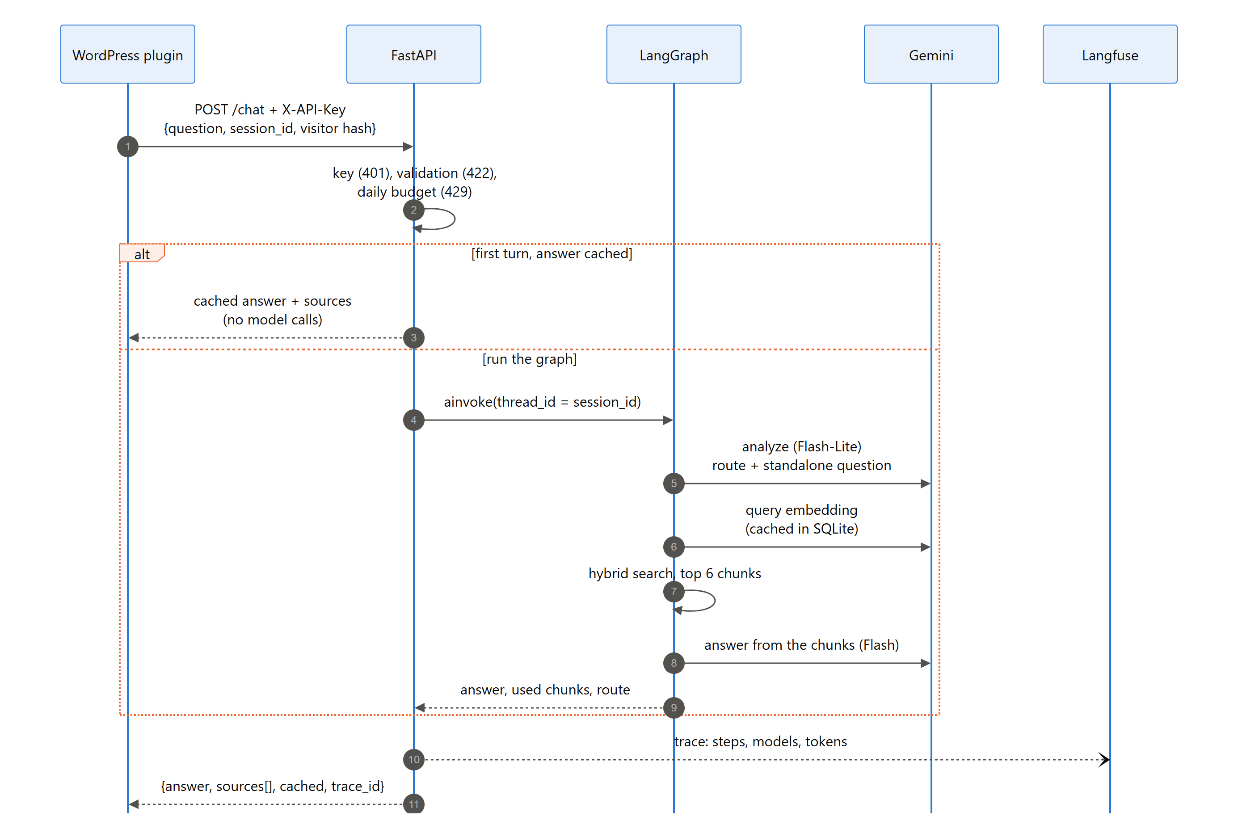
Figure 8. Chat request: WordPress to the backend and Gemini

7.2 Feedback
Clicking thumbs up or down sends the answer's trace_id through the same proxy. The backend stores it in Langfuse as the BOOLEAN score user-feedback on that answer's trace (Figure 9).
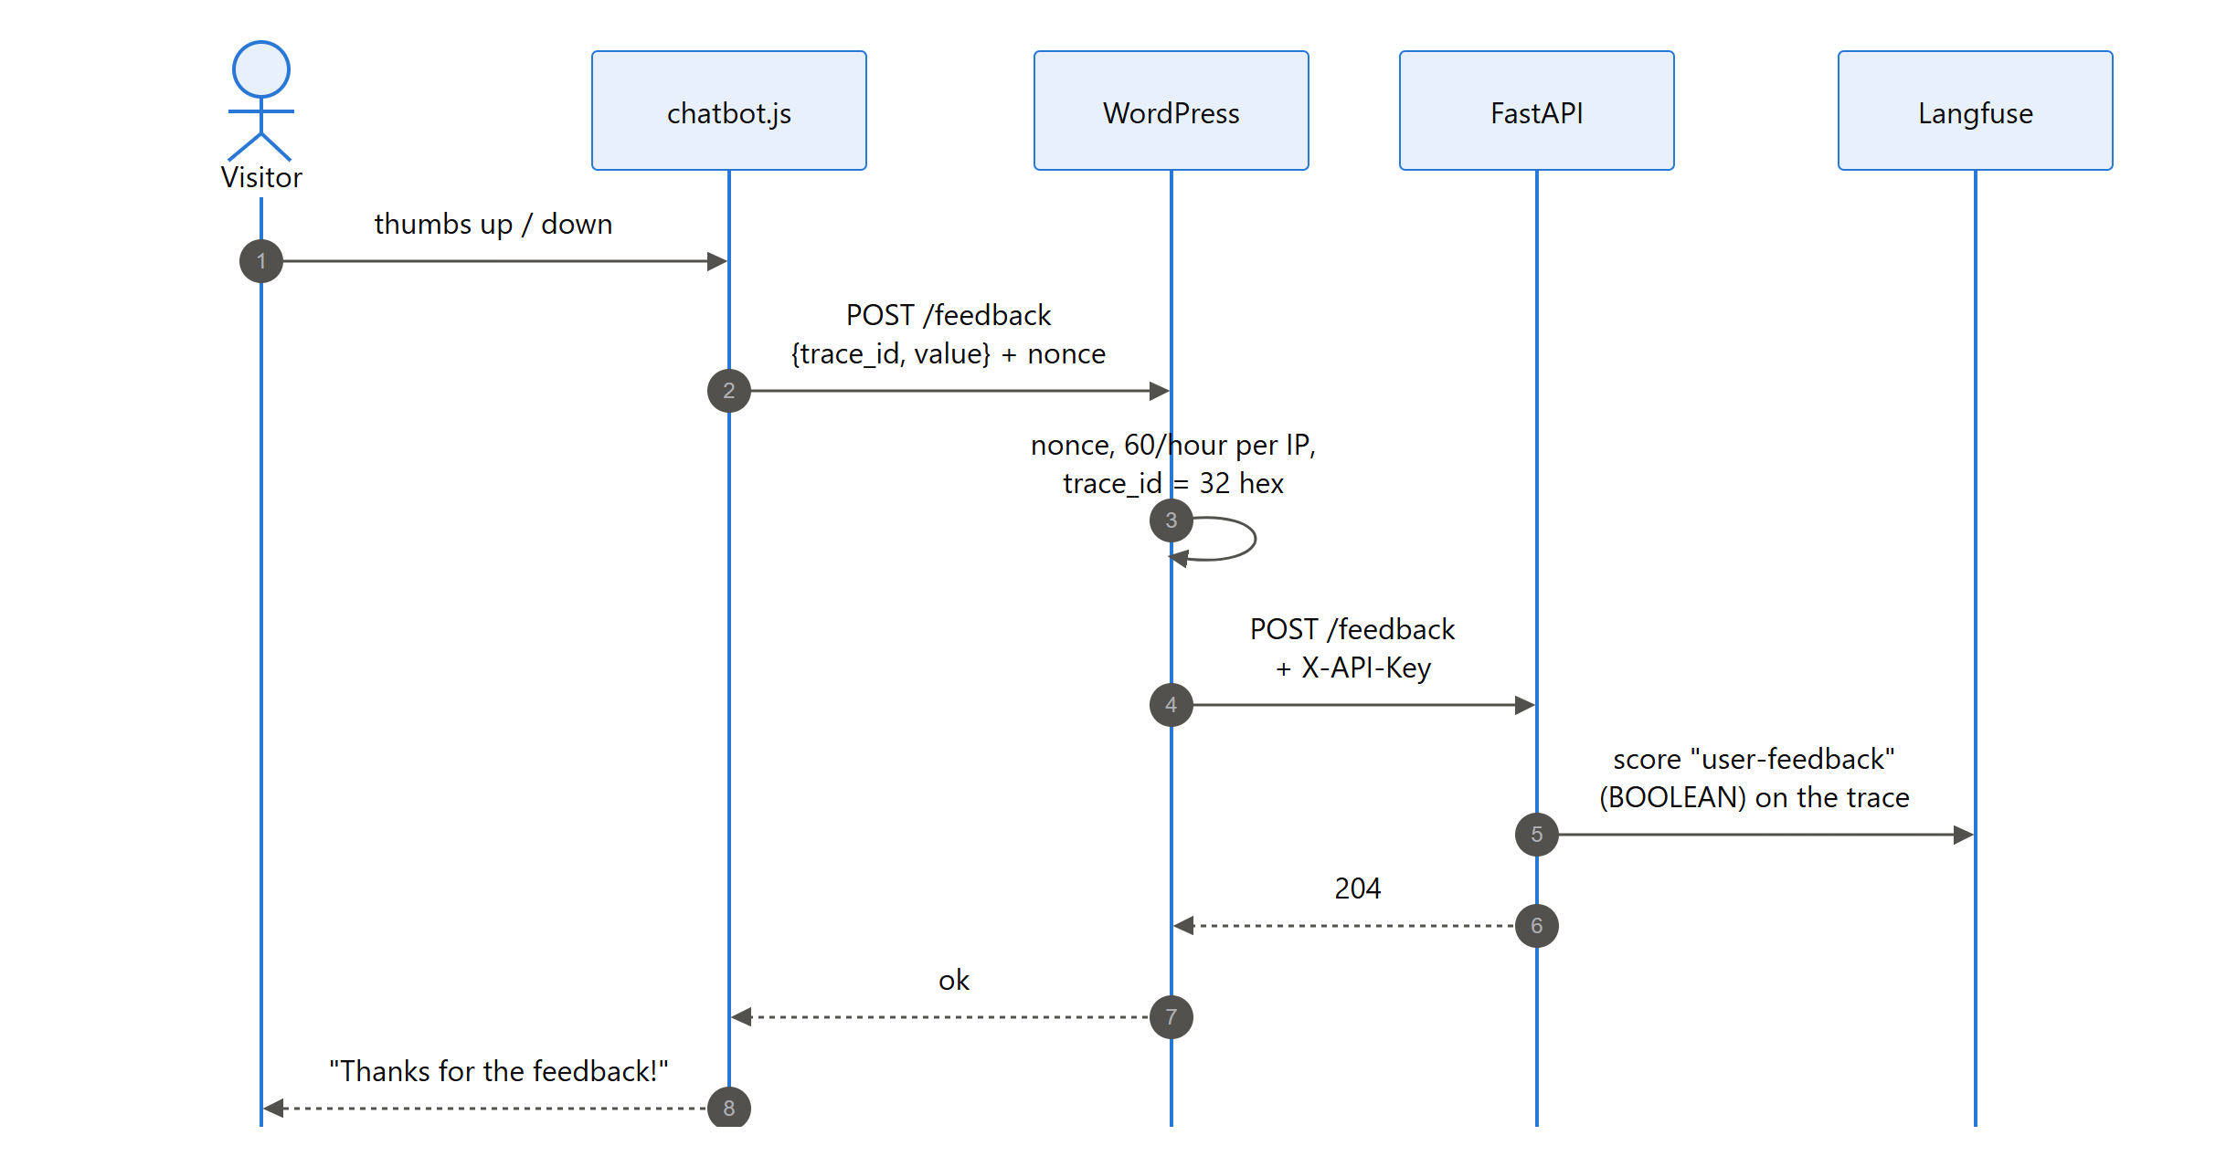
Figure 9. Feedback flow

7.3 Typical timings (deployed)
Message type | Median | 95th percentile | Model requests
Small talk | 1.1 s | 9.7 s | 1
Off-topic | 1.0 s | 10.3 s | 1
Rulebook question | 2.5 s | 7.5 s | 3
Follow-up (second turn) | 2.5 s | 3.0 s | 3

These are measured at the Cloud Run API. Through WordPress and Cloudflare, add about 0.3–1 s. After about 15 idle minutes, Cloud Run starts a new instance, and the first request takes a few seconds longer.

8. Front end (WordPress)
The public site is a standard WordPress installation. It uses the default block theme Twenty Twenty-Five, and all chatbot functionality comes from one custom plugin, UNO Rulebook RAG Chatbot. There are no third-party WordPress plugins. Figure 10 shows how the pieces fit together.
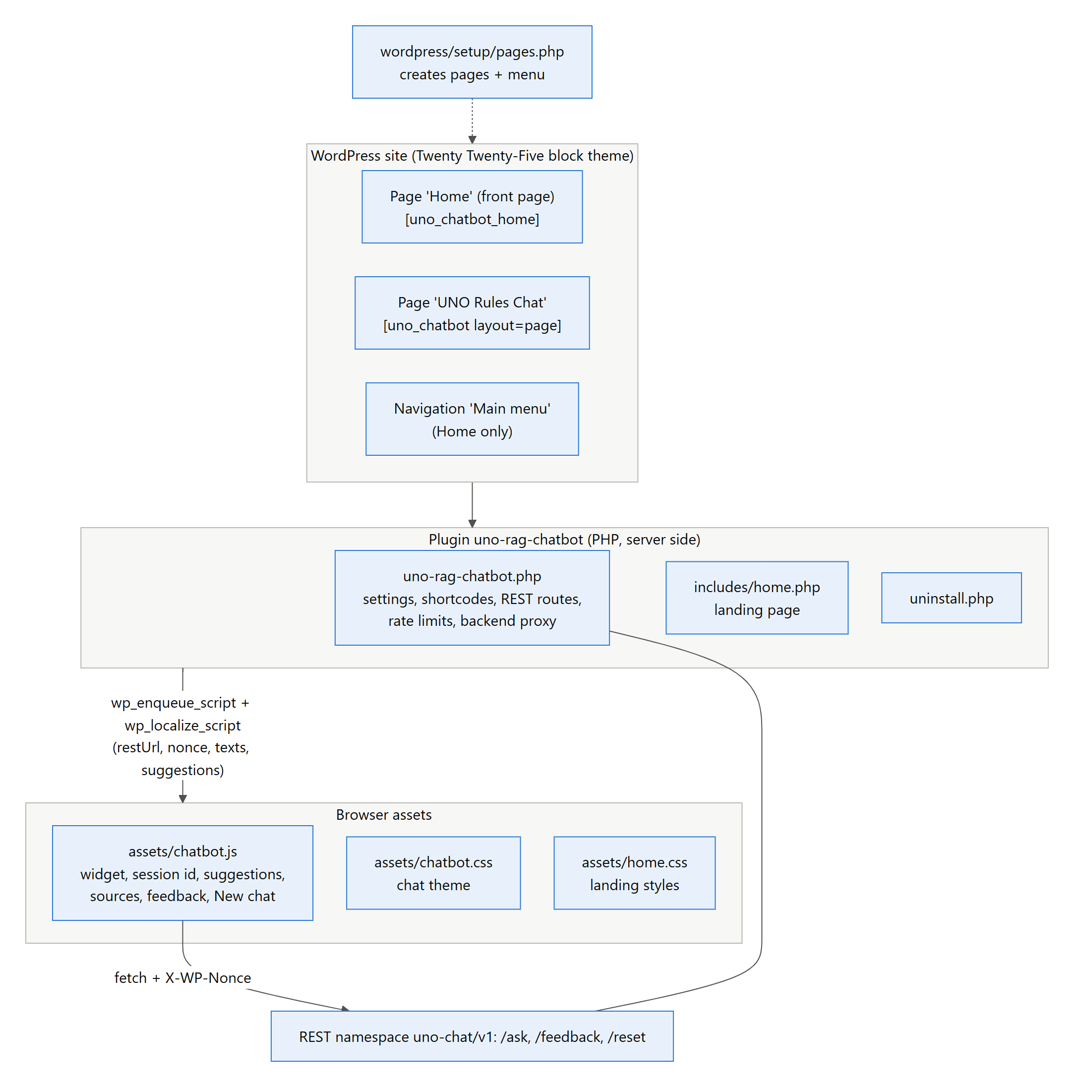
Figure 10. Front-end components

8.1 How the site was built
- Plugin: the plugin (PHP, JavaScript and CSS, no build step) was written in wordpress/uno-rag-chatbot/, and its widget and landing page were designed to match.
- Install: WordPress was installed and configured by script (wp-cli), locally in Docker and on the VM, so both sites are reproducible.
- Pages: wordpress/setup/pages.php creates the two pages below and the navigation menu.
- Plugin settings: the backend URL and API key are saved server-side by the deploy script.
The pages and menu:
- Home ([uno_chatbot_home]), set as the front page. It's a landing page that explains what the assistant does, which rulebooks it knows and how it works, with a "Start chatting" button.
- UNO Rules Chat (/uno-rules-chat/, [uno_chatbot layout="page"]). It uses the full-width "page-no-title" template with the chat box.
- Main menu, which contains only Home, so the theme doesn't list every page.

8.2 Plugin internals
Part | Implementation
Settings page | Settings → UNO Chatbot: backend URL, API key (password field), title, welcome text, floating bubble, questions per visitor per hour, questions per day (site). Shows backend health and today's usage.
Shortcodes | [uno_chatbot] (inline box; layout="page" adds the page header), [uno_chatbot_home] (landing page).
Floating bubble | Optional chat bubble on every page except pages that already show the inline chat.
Script data | wp_localize_script passes restUrl, nonce, texts and suggestions; never the backend URL or key.
REST routes | uno-chat/v1/ask, /feedback, /reset, all POST, all protected by the WordPress REST nonce, with argument validation.
Limits | Per-IP transients (10 questions/hour, 60 ratings/hour) and a site-wide daily counter in its own option, incremented atomically in SQL.
Backend calls | wp_remote_request with X-API-Key, 90 s timeout; backend errors are mapped to friendly messages (502/429).
Privacy | The backend and Langfuse only get a salted hash of the visitor IP.
Uninstall | Removes the settings and the daily counters.

8.3 Chat widget behaviour (chatbot.js)
- Mounting: mounts on every [data-uno-chat] element. The inline, page and floating layouts share one code path.
- Header: an avatar, the title and the subtitle "Answers from 5 UNO rulebooks", plus a New chat button.
- Before the first question: suggestion buttons; they disappear after the first question.
- While waiting: a typing indicator. Errors (rate limit, expired session, backend down) are shown as a red message bubble.
- Rendering: answers are inserted with textContent, so model output can never inject HTML or scripts.
- Feedback: source chips (rulebook · page) and thumbs up/down. Feedback is sent once per answer and confirmed with "Thanks for the feedback!".

8.4 Plugins, modules and libraries used
Component | Version / source | Used for
UNO Rulebook RAG Chatbot (custom WordPress plugin) | 1.6.0, this repository | All chatbot features on the site
Twenty Twenty-Five (WordPress theme) | Bundled with WordPress | Site layout, header, footer
WordPress / PHP / Apache | wordpress:php8.3-apache image | Website runtime
MariaDB | mariadb:11 image | WordPress database
wp-cli | wordpress:cli-php8.3 image | Scripted install and configuration
Caddy + caddy-ratelimit (github.com/mholt/caddy-ratelimit) | caddy:2, built with xcaddy | HTTPS, reverse proxy, per-IP rate limits
Cloudflare (free plan) | SaaS | DNS, proxy, DDoS protection, TLS
fastapi, uvicorn[standard] | requirements.txt | HTTP API and ASGI server
langgraph, langchain-core | requirements.txt | Conversation graph, messages, prompts, checkpointer
langchain-google-genai, google-genai | ≥ 4.4 / ≥ 2.20 | Gemini chat models and embeddings on Vertex AI
chromadb, langchain-chroma | requirements.txt | Vector store
rank_bm25 | requirements.txt | Keyword search
pdfplumber, langchain-text-splitters | requirements.txt | PDF extraction, chunking
pydantic-settings | requirements.txt | Configuration from .env
httpx | requirements.txt | HTTP client (evaluation, security checks)
langfuse | ≥ 5 | Tracing, scores, datasets
docx, mermaid (npm); playwright, matplotlib (Python) | docs/tools only | Building this report and its diagrams

9. Front-end ↔ back-end communication and APIs
The browser never talks to the backend. All communication follows one path: browser → Cloudflare → Caddy → WordPress REST API → (server-to-server) → FastAPI. As a result:
- the backend URL and its key stay on the WordPress server
- the site can apply its own limits before any model is called
- the backend needs no CORS configuration
Header | Set by | Purpose
X-WP-Nonce | chatbot.js (value from the page) | Proves the request comes from a page WordPress served recently (CSRF protection)
CF-Connecting-IP | Cloudflare | Real visitor IP; Caddy trusts it only from Cloudflare's ranges, and Cloudflare rejects client-supplied values
X-Real-IP | Caddy | Visitor IP passed to WordPress (overwrites any client value); used for per-IP limits
X-API-Key | WordPress plugin (server-side) | Shared secret required by every backend data endpoint

9.1 WordPress REST API (namespace uno-chat/v1)
Endpoint | Request body | Validation and limits | Response
POST /ask | {question, session_id} | Nonce; question 1–1000 chars; session_id [A-Za-z0-9_-]{1,100}; 10/hour per IP; 300/day site-wide | {answer, sources[{source,page}], cached, trace_id}
POST /feedback | {trace_id, value} | Nonce; trace_id 32 hex chars; value 1 or -1; 60/hour per IP | {ok: true}
POST /reset | {session_id} | Nonce; session_id format | {ok: true} (backend forgets the conversation)

9.2 Backend API (FastAPI on Cloud Run)
Endpoint | Auth | Request | Response
GET / | – | – | {service, health, docs}
GET /health | – | – | status, Gemini status and models, requests_today, daily_request_budget, documents_in_collection, Langfuse status (no secrets)
POST /chat | X-API-Key | {question: 1–1000 chars, session_id ≤ 100, visitor? ≤ 64} | {answer, sources[{source, page}], cached, trace_id}
POST /feedback | X-API-Key | {trace_id: 32 hex, value: 1 | -1, comment? ≤ 500} | 204 No Content (Langfuse score user-feedback)
DELETE /chat/{session_id} | X-API-Key | – | {cleared: session_id}
POST /ingest | X-API-Key | {reset: bool} | {files, pages, chunks, collection_count}
GET /docs, /openapi.json | – | – | Interactive API documentation (schema only)

Example
POST /chat X-API-Key: <secret> Content-Type: application/json
{"question": "What is the Mercy rule in UNO No Mercy?", "session_id": "7f3c…", "visitor": "a91be2…"}

200 OK
{"answer": "According to the Uno No Mercy rulebook, if a player ever has 25 or more cards in their hand, they are out of the game …",
"sources": [{"source": "Uno No mercy.pdf", "page": 1}], "cached": false, "trace_id": "5d0c…e41a"}

9.3 Status codes across the layers
Code | Returned by | Meaning | What the visitor sees
403 | Cloudflare | Forged CF-Connecting-IP (error 1000) or a Cloudflare security rule | Cloudflare error page
429 | Caddy | Per-IP limit (300/min site, 20/min chat API, 5/min login), with Retry-After | Error message in the widget
403 | WordPress | Missing/expired nonce | "Your session expired. Please reload the page."
429 | WordPress | 10 questions/hour per IP, or 300/day site-wide | "You have reached the question limit for this hour…" / "…today's question limit…"
401 | Backend | Missing or wrong X-API-Key | Generic "could not answer" (logged in WordPress)
422 | Backend | Invalid request body | Generic error
429 | Backend | Daily model-request budget reached | "The daily usage cap…"
502 | Backend / WordPress | Gemini failure or backend unreachable | "The chat service could not answer right now…"

10. Security
Security is layered, so no single control has to be perfect (Figure 11). An attacker would have to get past Cloudflare, the firewall, Caddy's limits, WordPress's nonce and limits, and the backend's key before any model is called. Even then, the backend's daily budget caps the cost.
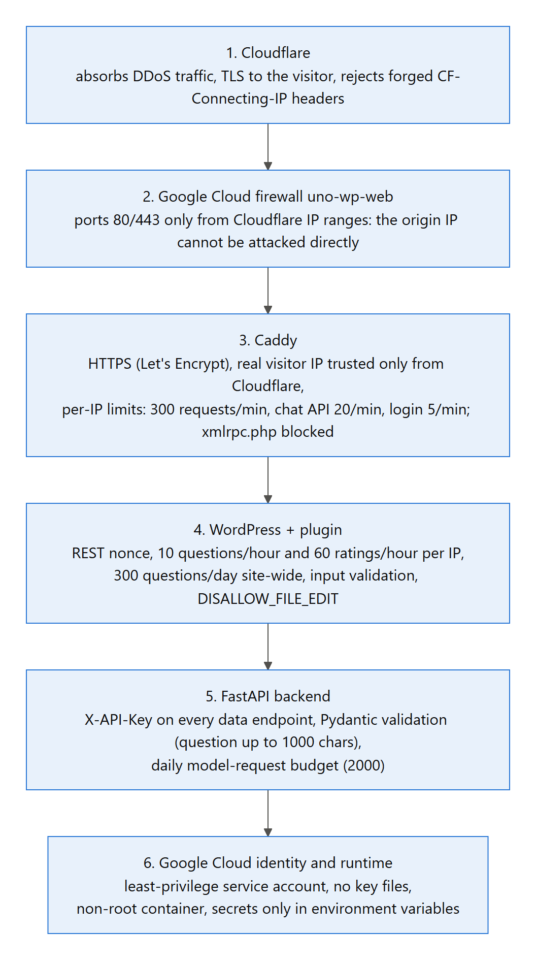
Figure 11. Security layers from the edge to the model

10.1 How API keys and secrets are protected
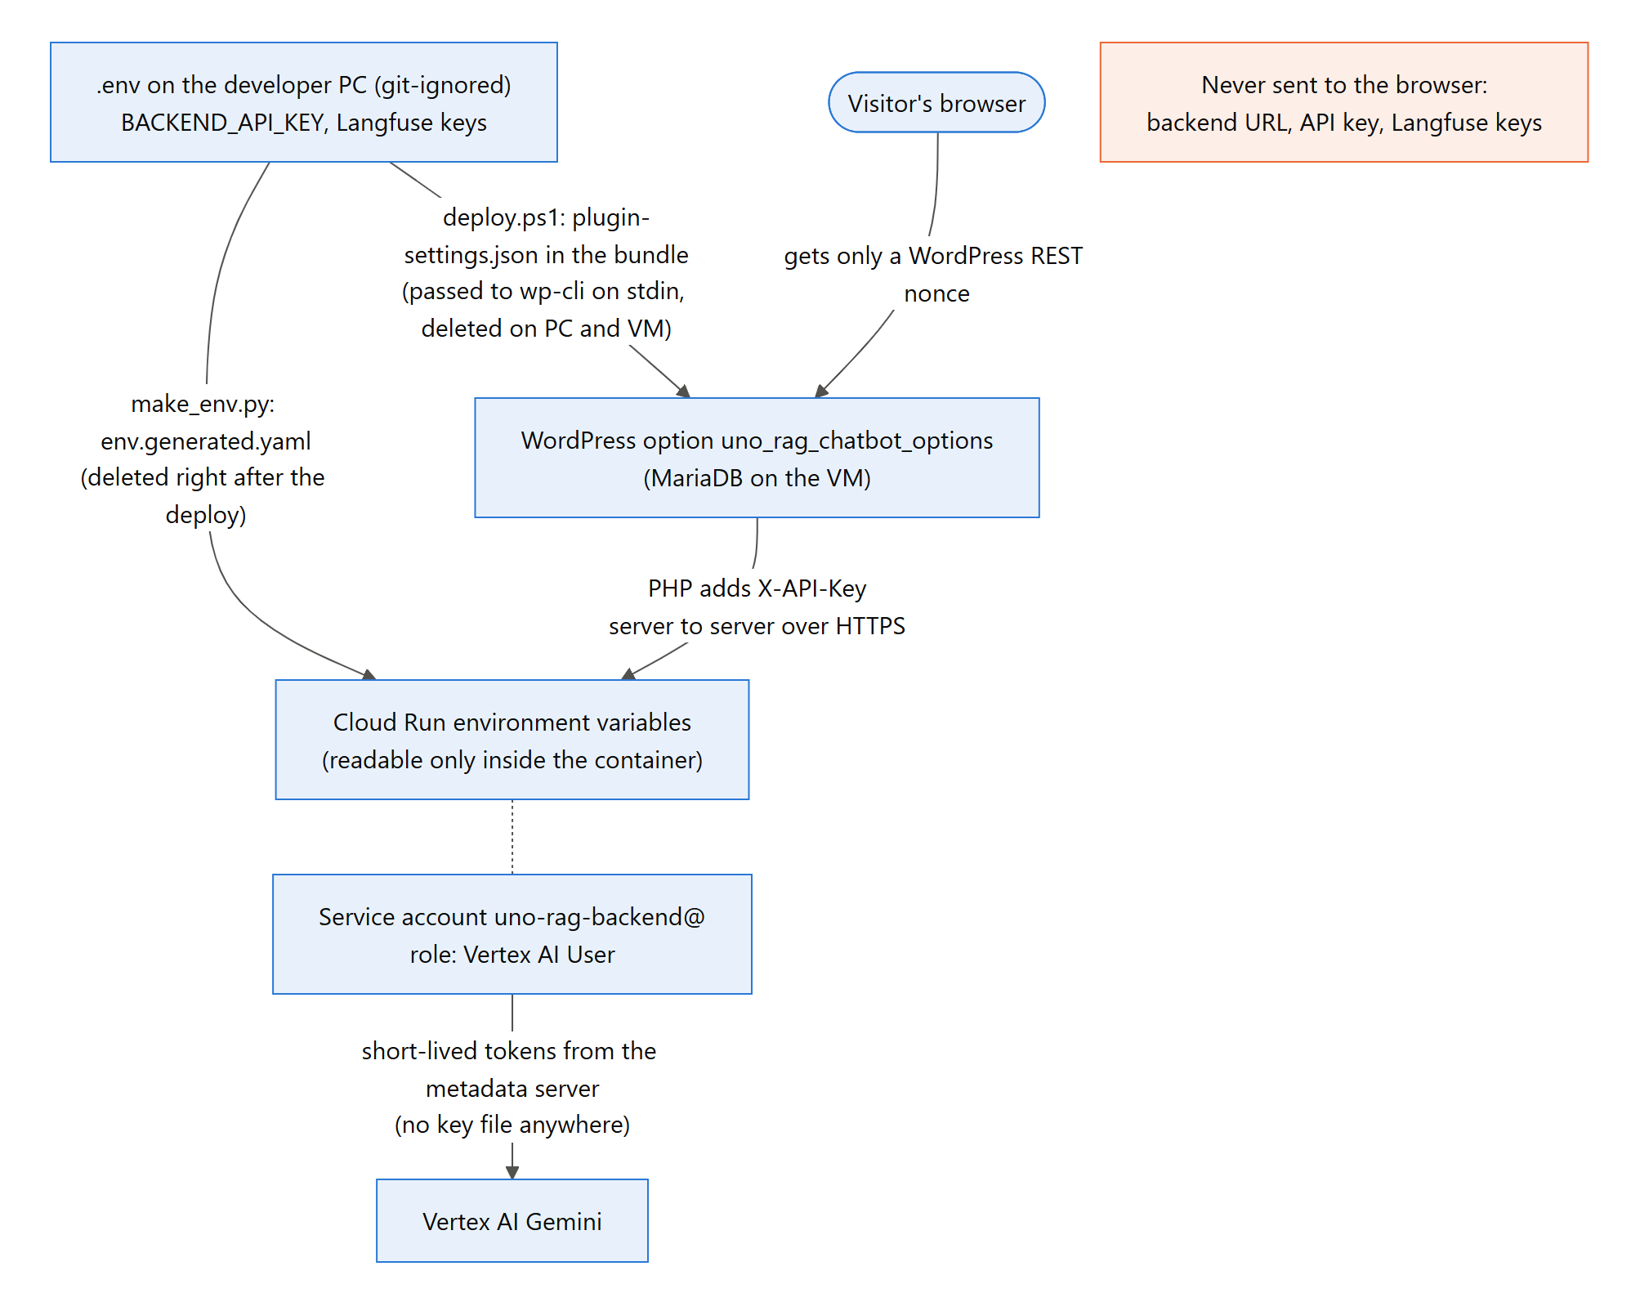
Figure 12. Where secrets live and how they move
Secret | Stored in | Readable by | How it gets there
BACKEND_API_KEY | .env (git-ignored); Cloud Run env vars; WordPress option in MariaDB | The developer; the Cloud Run container; WordPress PHP | make_env.py file (deleted after deploy); deploy bundle (deleted on PC and VM, key passed to wp-cli on stdin, never on a command line)
Langfuse public/secret key | .env; Cloud Run env vars | The developer; the container | Same env file as above
Google credentials | None stored: Cloud Run uses the service account's short-lived tokens from the metadata server; locally gcloud auth application-default login | Google infrastructure | Attached service account uno-rag-backend@ (role Vertex AI User only)
Database passwords | /opt/uno-wp/.env on the VM (mode 600, root only) | Root on the VM; containers | Generated on the VM with openssl, never leave it
WordPress admin password | Hashed in WordPress; plain copy in /opt/uno-wp/admin-credentials.txt (root only) and wordpress/admin-credentials-gcp.txt (git-ignored) | Root on the VM; the developer | Generated on the VM at install

Additional safeguards:
- Browser: the browser only ever receives a WordPress nonce. The page HTML contains neither the key nor the backend address, which the security checks verify.
- /health: returns model and status information but never configuration secrets, which is also verified.
- Evaluation config: the evaluation results store the configuration without any setting whose name contains KEY.
- Uploads: .gcloudignore and .dockerignore keep .env and .venv out of the Cloud Run upload and the image. The upload list was checked: 24 files.

10.2 Network and DDoS protection
- Cloudflare proxy: the DNS record is proxied (orange cloud), so visitors connect to Cloudflare's network. Volumetric attacks are absorbed there.
- Origin lock-down: the firewall rule uno-wp-web admits ports 80/443 only from Cloudflare's published IP ranges, fetched at deploy time. The VM's own IP doesn't answer web requests from anywhere else, so the protection can't be bypassed.
- Encryption end to end: Cloudflare SSL/TLS mode is Full (strict), so Cloudflare verifies the origin certificate. Caddy obtains and renews a Let's Encrypt certificate (HTTP-01 validation passes through Cloudflare). http requests are redirected to https.
- Backend: Cloud Run is a Google-managed HTTPS endpoint. It's public, but every data endpoint requires the API key, and it runs at most one instance, which caps cost.

10.3 Rate limiting
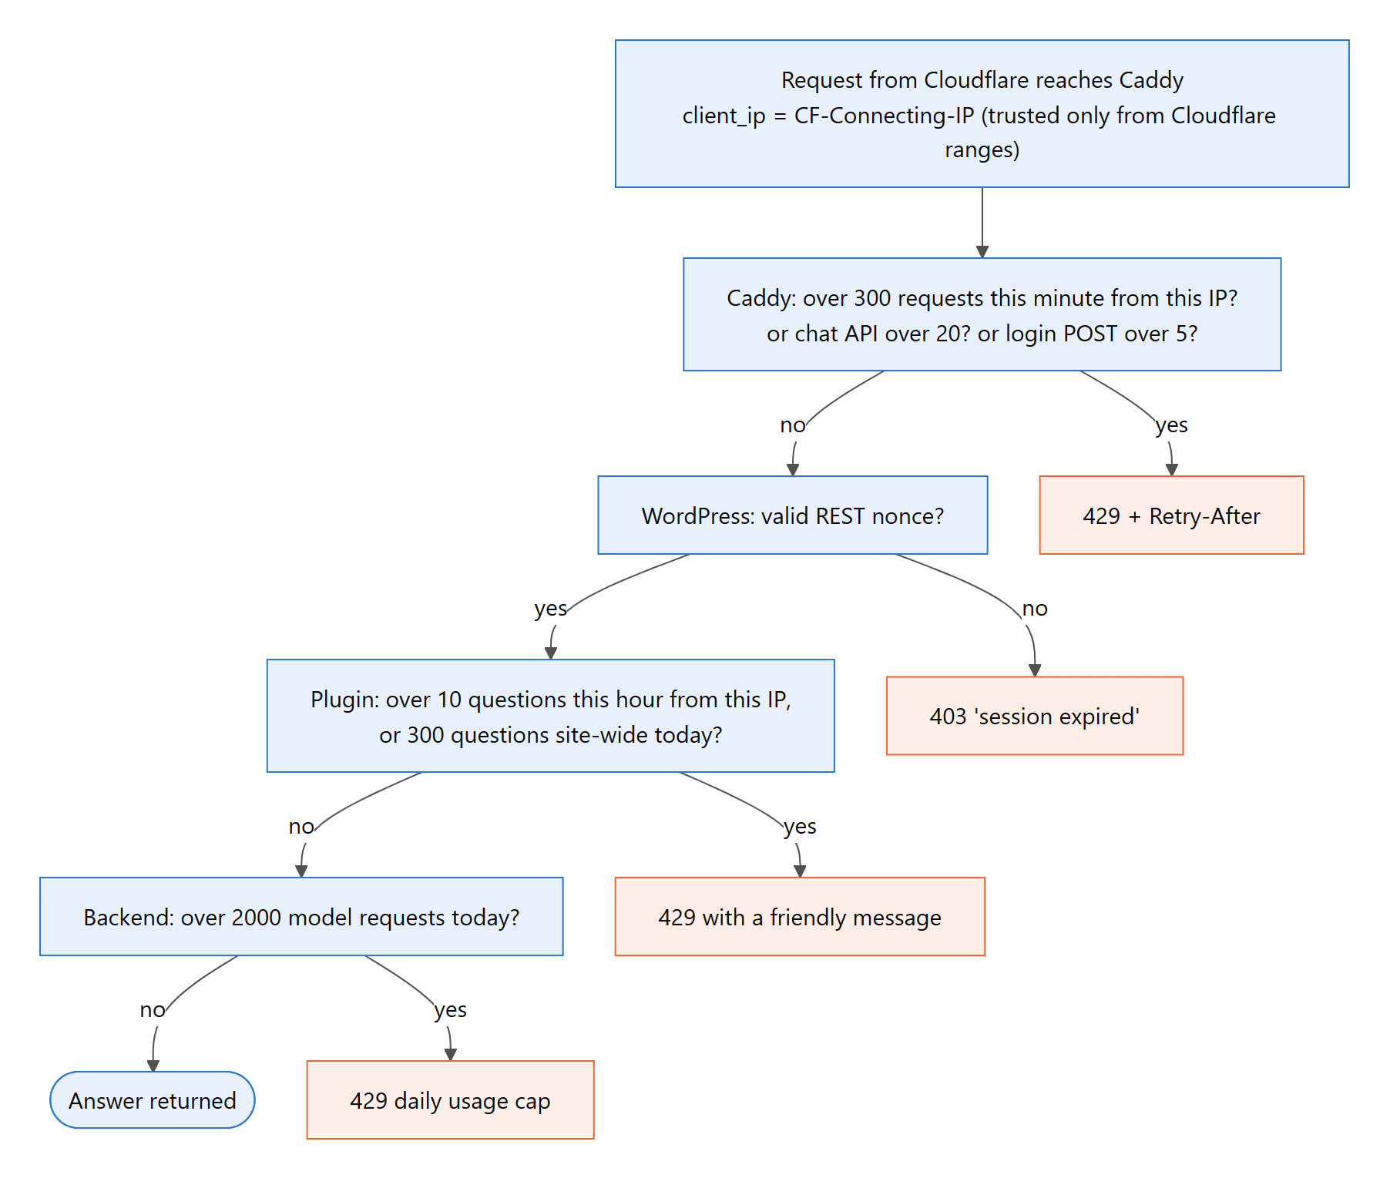
Figure 13. Rate-limiting decisions for one request
Layer | Limit | Key | Response
Caddy zone site | 300 requests / minute | Visitor IP | 429 + Retry-After
Caddy zone chat | 20 requests / minute to /wp-json/uno-chat/* | Visitor IP | 429 + Retry-After
Caddy zone login | 5 POST /wp-login.php / minute | Visitor IP | 429 + Retry-After
Plugin | 10 questions / hour (setting) | Visitor IP | 429 friendly message
Plugin | 60 ratings / hour | Visitor IP | 429
Plugin | 300 questions / day, whole site (setting) | UTC date | 429 "today's limit"
Backend | 2000 model requests / day | Instance | 429 daily cap

The backend's daily counter lives in the Cloud Run instance's temporary storage. It resets when the instance restarts, about 15 minutes after the last request. The site-wide daily cap in WordPress is kept in MariaDB, so it is the limit that really holds; 300 questions a day is about 900 model requests at most.

10.4 Real visitor IPs and spoofing
Per-IP limits only work if the IP can't be faked. Behind proxies there are three possible sources:
- The TCP connection: always Cloudflare.
- CF-Connecting-IP: set by Cloudflare.
- X-Forwarded-For / X-Real-IP: these can be sent by anyone.
The defences:
- Caddy's trusted_proxies lists only Cloudflare's ranges, and client_ip_headers is CF-Connecting-IP. A request that doesn't come from Cloudflare can't choose its IP.
- Cloudflare itself rejects requests that try to send their own CF-Connecting-IP (error 1000).
- Caddy sets X-Real-IP to the resolved visitor IP and overwrites any client value. WordPress copies it to REMOTE_ADDR, so the plugin's limits use the real IP.
- This was tested: 25 chat-API calls with random spoofed X-Forwarded-For, X-Real-IP and True-Client-IP values still hit the 429 at the 21st request in the minute.

10.5 Application hardening
- WordPress REST nonce on every chat route (CSRF protection), plus strict argument validation (length, character set, enum).
- Output encoding: the widget renders model answers with textContent. Admin settings are escaped (esc_attr, esc_html) and sanitized on save.
- WordPress hardening: DISALLOW_FILE_EDIT (no theme/plugin editor), xmlrpc.php blocked by Caddy, the plugin folder mounted read-only, the WordPress container not published to the internet (only Caddy is).
- Backend validation: Pydantic schemas reject oversized or malformed input before any model call (question ≤ 1000 chars, trace id format, feedback value).
- Containers: the backend runs as a non-root user on python:3.13-slim. Container logs are capped (10 MB × 3) so floods can't fill the disk. MariaDB is reachable only on the internal Docker network.
- Grounding: the answer prompt allows only the retrieved passages, and off-topic requests get a fixed refusal. This limits prompt-injection impact to the rulebook domain.

10.6 Identity and least privilege
- Cloud Run service account: uno-rag-backend@uno-rag-chatbot.iam.gserviceaccount.com has only Vertex AI User. No service-account key exists.
- VM: uses the default compute account with the minimal scopes logging-write and monitoring-write, so the VM can't call other Google APIs.
- Deploy-time permission grants (IAM) are a separate, skippable step (-SkipIamGrants), so routine updates never change permissions.

10.7 Privacy
- Backend and Langfuse: visitors are identified only by a 16-character salted hash of their IP. Raw IPs never leave the VM.
- Caddy logs: the access log contains IPs for abuse investigation and is size-capped.
- Content: no account, name or email is collected from visitors. Chat content is stored in Langfuse traces for quality monitoring.

10.8 Threats and mitigations
Threat | Mitigation
Stolen backend key from the browser | Key never sent to the browser; only server-to-server
Direct calls to the backend | X-API-Key required; 401 otherwise; daily budget caps cost
DDoS / traffic floods on the site | Cloudflare proxy; firewall admits only Cloudflare; Caddy 300 requests/min per IP; log caps
Bypassing Cloudflare via the origin IP | Firewall rule limited to Cloudflare ranges (origin unreachable, verified)
Credit exhaustion by scripted questions | Caddy 20/min, plugin 10/hour per IP, 300/day site-wide, backend 2000/day, max 1 Cloud Run instance
IP spoofing to escape limits | Trusted-proxy configuration, header overwrite, Cloudflare error 1000 (verified)
Password guessing on wp-admin | 5 login POSTs/minute per IP; strong random admin password; xmlrpc blocked
Cross-site request forgery on chat routes | WordPress REST nonce
HTML/script injection via model output | textContent rendering; Markdown stripped
Secrets leaking through deploy artefacts | Generated env files and bundles deleted; ignore files checked; .env git-ignored
Cloud credential theft | No key files; least-privilege service account; minimal VM scopes

10.9 Security test results
python -m eval.security_checks ran against the live system on 2026-11-01 02:54: 26 passed, 0 failed, 4 informational.
Result | Area | Check | Observed
PASS | backend | root is a JSON service description (no web page) | 200 application/json
PASS | backend | /health is public and contains no secrets | 200, leaked: none
PASS | backend | POST /chat with no key is rejected | 401
PASS | backend | POST /chat with wrong key is rejected | 401
PASS | backend | POST /ingest with no key is rejected | 401
PASS | backend | POST /ingest with wrong key is rejected | 401
PASS | backend | POST /feedback with no key is rejected | 401
PASS | backend | POST /feedback with wrong key is rejected | 401
PASS | backend | DELETE /chat/{session_id} with no key is rejected | 401
PASS | backend | DELETE /chat/{session_id} with wrong key is rejected | 401
PASS | backend | question over 1000 characters is rejected before any model call | 422
PASS | backend | malformed feedback trace id is rejected | 422
INFO | backend | OpenAPI docs page | 200 (public schema only; every data endpoint still needs the key)
PASS | site | valid HTTPS certificate, served through Cloudflare | 200, server=cloudflare, cf-ray=yes
PASS | site | http redirects to https | 308 -> https://uno-chatbot.buildwithmayank.tech/
PASS | network | origin 34.57.222.238:443 not reachable directly (Cloudflare-only firewall) | no answer within 5s
PASS | network | origin 34.57.222.238:80 not reachable directly (Cloudflare-only firewall) | no answer within 5s
PASS | site | xmlrpc.php blocked | 403
INFO | site | security header: HSTS | not set
INFO | site | security header: nosniff | not set
INFO | site | security header: frame options | not set
PASS | plugin | chat page does not expose the backend API key | absent
PASS | plugin | chat page does not expose the backend address | absent
PASS | plugin | REST /ask without a nonce is rejected | 403
PASS | plugin | REST /ask with a forged nonce is rejected | 403
PASS | plugin | REST /ask with the page's nonce is answered (WordPress -> backend proxy works) | 200
PASS | rate-limit | forged CF-Connecting-IP header is rejected at Cloudflare's edge | 403 Cloudflare error 1000
PASS | rate-limit | chat API: per-IP burst limit (20/min) holds even with spoofed IP headers | first 429 at call 18 of this burst (+3 earlier), Retry-After 53s, statuses [403, 429]
PASS | rate-limit | login: 5 attempts/min per IP, then 429 with Retry-After | attempt statuses [200, 200, 200, 200, 200, 429], Retry-After 59s
PASS | rate-limit | login page itself still loads while POSTs are limited | 200

10.10 Known limitations and recommendations
- Security headers: HSTS, X-Content-Type-Options and X-Frame-Options aren't set yet. Add them in Caddy (or as a Cloudflare transform rule).
- Secrets: they are plain environment variables (by choice). For stricter control, move BACKEND_API_KEY and the Langfuse keys to Secret Manager.
- SSH: port 22 on the VM is open to the internet (default rule; key-based login only). Restrict it to Google's IAP range and use gcloud compute ssh --tunnel-through-iap.
- Backend budget: it resets per instance (section 10.3); a persistent counter (Firestore) would make it exact.
- IPv6 visitors: an IPv6 visitor can rotate addresses within their /64 block. Keying the Caddy limits on the /64 prefix would close this.
- API docs: /docs is public (schema only). Disable it in production if the API surface should not be advertised.
- Backups: schedule weekly snapshots of the VM disk.

11. Deployment
Production runs in the Google Cloud project uno-rag-chatbot behind the Cloudflare zone buildwithmayank.tech (Figure 14). Two idempotent PowerShell scripts deploy everything from the developer's Windows PC. They are safe to re-run, and each run is also an update.
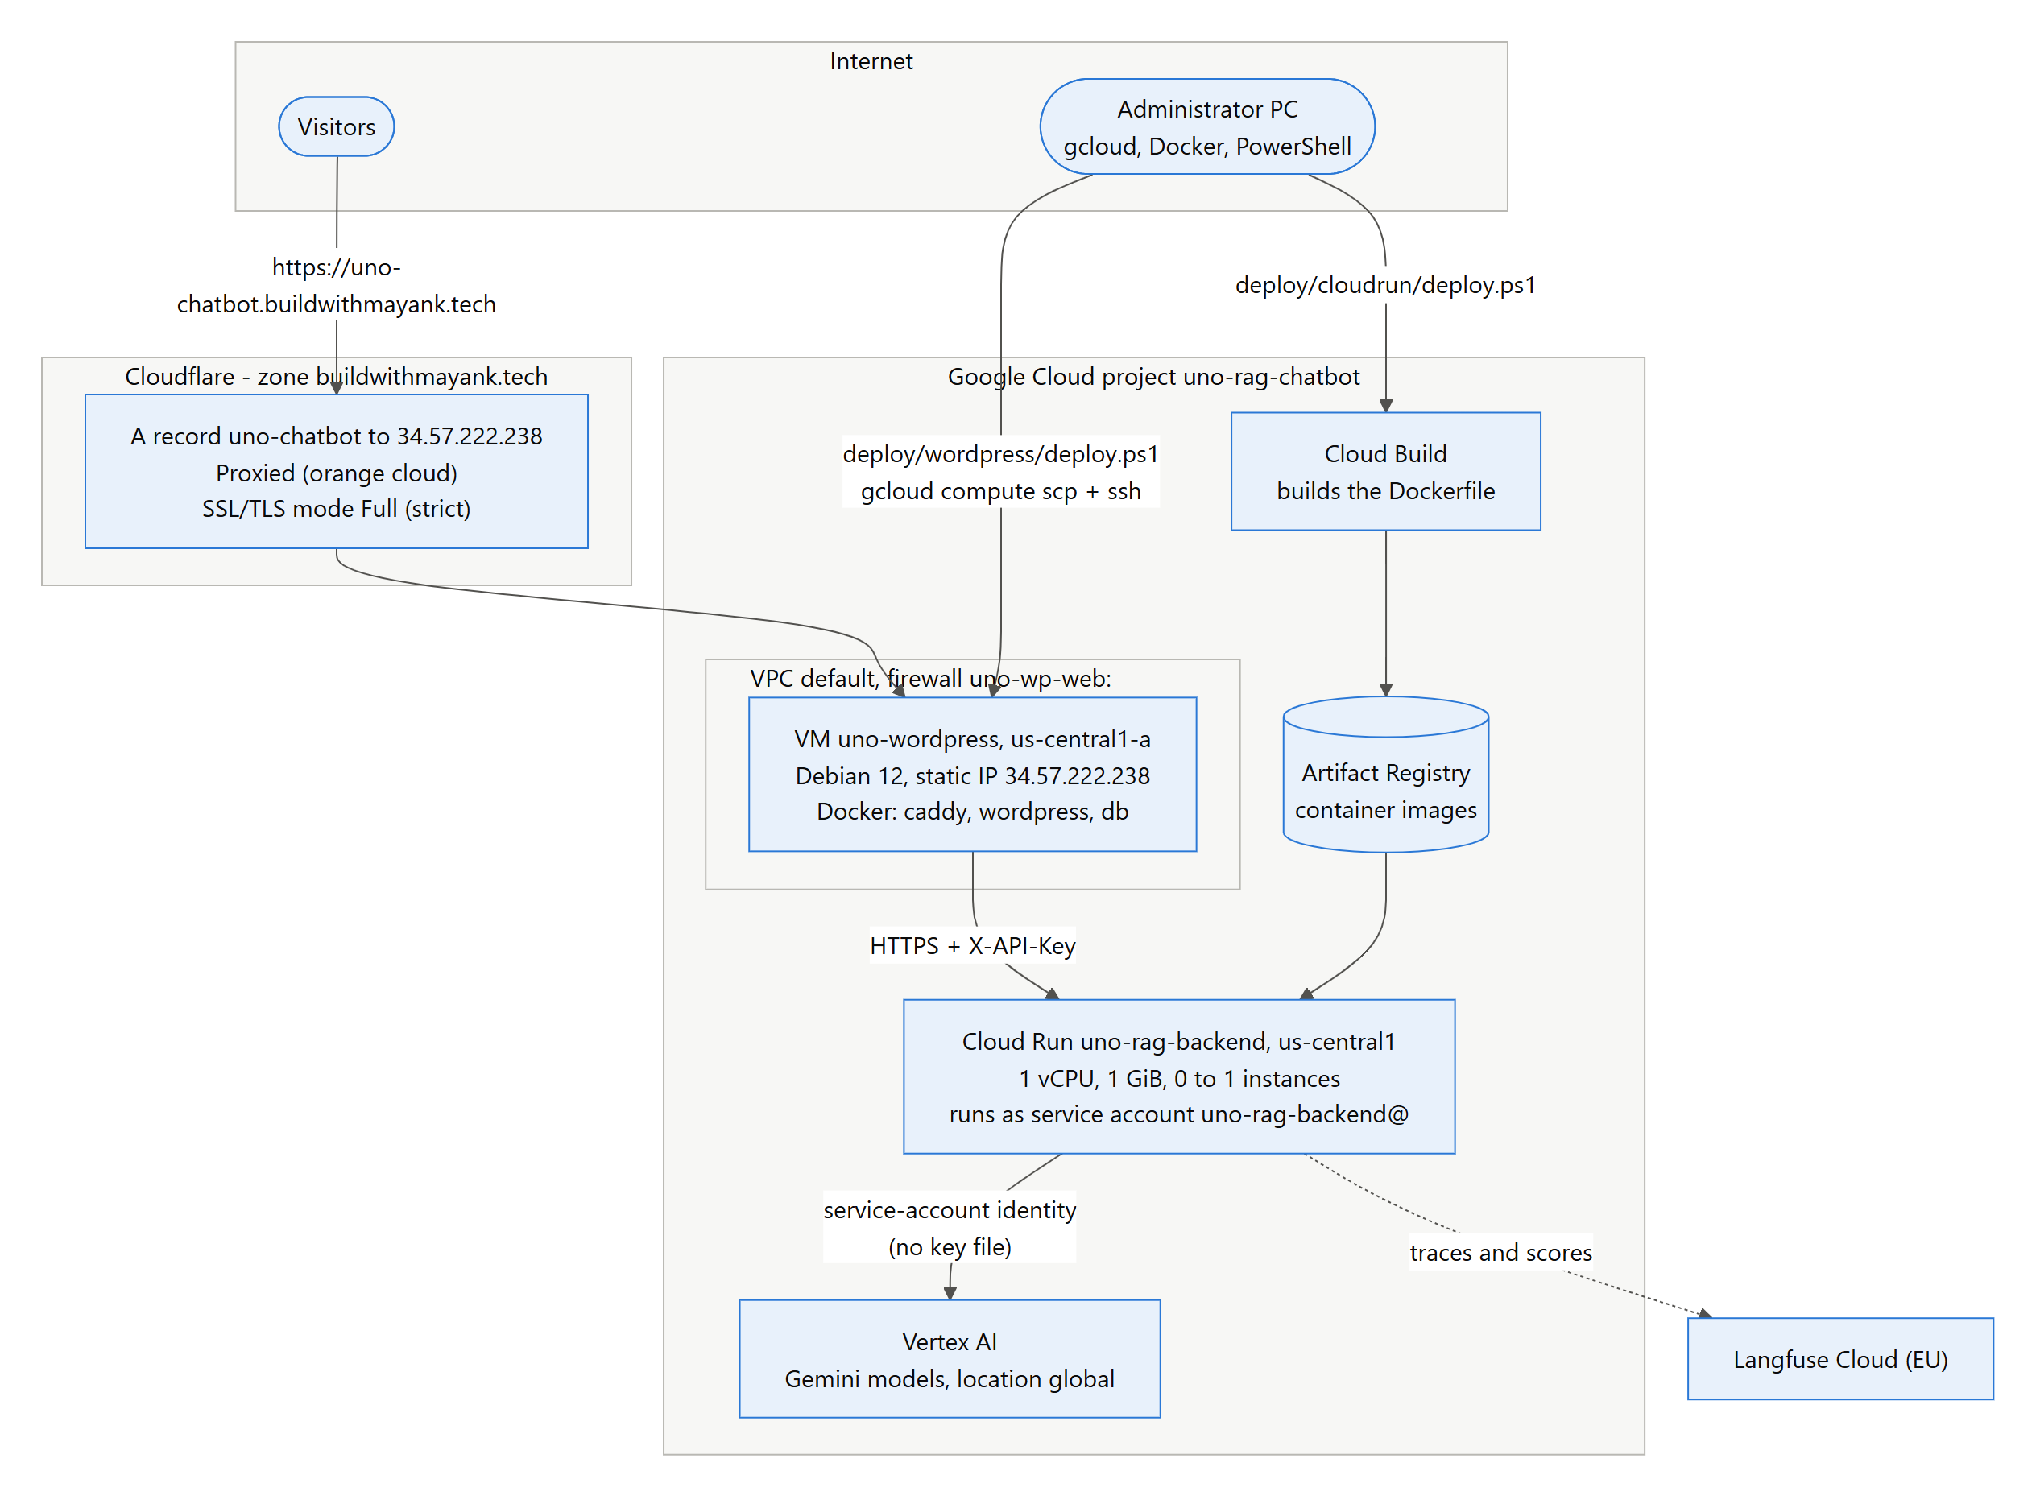
Figure 14. Deployment topology

11.1 Backend on Cloud Run
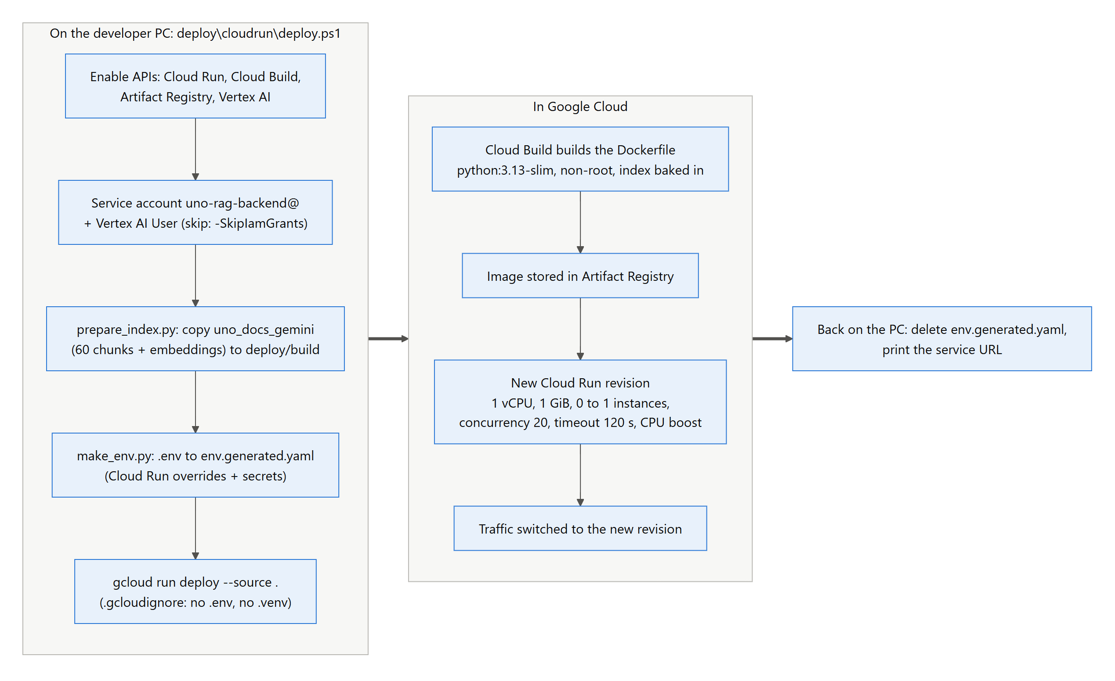
Figure 15. Backend deployment workflow (deploy/cloudrun/deploy.ps1)
Setting | Value | Why
Region | us-central1 | Low latency to the VM; Vertex AI location is global
CPU / memory | 1 vCPU / 1 GiB | Enough for FastAPI + Chroma with 60 chunks
Instances | min 0, max 1 | Free when idle; one instance caps cost and keeps memory/caches consistent
Concurrency / timeout | 20 requests / 120 s | Model calls are I/O-bound; 120 s covers retries
CPU boost | on | Faster cold starts
Identity | service account uno-rag-backend@ (Vertex AI User) | No key file needed
Ingress / auth | public, --allow-unauthenticated | Protected by X-API-Key instead of Google IAM (WordPress isn't a Google identity)
Image | python:3.13-slim, non-root user, index + PDFs baked in | Fast, deterministic start-up; no re-embedding
Env overrides | CACHE_DIR=/tmp/uno-cache, CHROMA_DIR=/app/chroma_db, LANGFUSE_ENVIRONMENT=production, LANGFUSE_FLUSH_EACH_REQUEST=true | Writable temp storage; traces sent before the response ends (CPU is throttled afterwards)

11.2 WordPress on Compute Engine
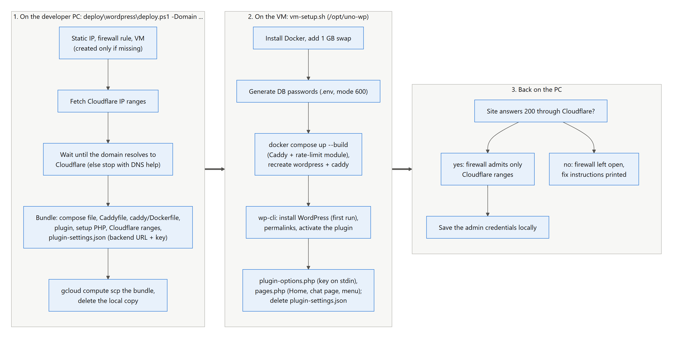
Figure 16. WordPress deployment workflow (deploy/wordpress/deploy.ps1)
Item | Value
VM | uno-wordpress, e2-small (2 vCPU burst, 2 GB) + 1 GB swap, Debian 12, 20 GB pd-balanced, shielded secure boot, us-central1-a
Network | Static IP 34.57.222.238; firewall uno-wp-web: tcp 80/443 (+udp 443) from Cloudflare ranges only; tag uno-wp
Containers (/opt/uno-wp) | caddy (built with caddy-ratelimit, ports 80/443), wordpress:php8.3-apache (internal only), mariadb:11 (innodb buffer 128 MB, performance schema off), wpcli (tools profile)
Volumes | db_data, wp_data, caddy_data (certificates), caddy_config
Configuration | WORDPRESS_CONFIG_EXTRA: REMOTE_ADDR from X-Real-IP, DISALLOW_FILE_EDIT, WP_MEMORY_LIMIT 128M
Updates | Re-run deploy.ps1 -Domain …: new plugin files, settings kept, wordpress + caddy recreated (data in volumes)

11.3 Cloudflare configuration
- DNS → Records: an A record uno-chatbot → 34.57.222.238 with Proxy status Proxied (orange cloud).
- SSL/TLS → Overview: encryption mode Full (strict). Flexible causes a redirect loop, because Caddy redirects http to https.
- Optional: Security → Bots → Bot Fight Mode, and a WAF rate-limiting rule (the free plan includes one).

11.4 Updates and rollback
Change | Command / action
Backend code or settings | deploy\cloudrun\deploy.ps1 -SkipIamGrants (new revision)
New or changed PDFs | python -m app.ingest --reset, run the evaluation, then deploy the backend
Plugin or site setup | deploy\wordpress\deploy.ps1 -Domain uno-chatbot.buildwithmayank.tech
Backend rollback | gcloud run services update-traffic uno-rag-backend --region us-central1 --to-revisions <revision>=100
Site rollback / recovery | Restore the VM disk snapshot, or redeploy the previous plugin version

11.5 Cost
Item | Monthly cost (approx.)
VM e2-small | $13
Static IP | $3 (also billed while the VM is stopped)
20 GB balanced disk | $2
Cloud Run | $0 (free tier at this traffic)
Cloud Build + Artifact Registry | a few cents
Gemini (pay per use) | a fraction of a cent per question; a full evaluation run of ~100 requests costs a few cents
Cloudflare free plan, Langfuse Hobby | $0

12. Monitoring and observability
When the Langfuse keys are set, the backend records one trace per chat turn. Without them, the chat works the same and nothing is sent.
- Trace chat, one per turn:
  - Grouping: the session (the conversation) and the user (the anonymous visitor hash).
  - Input and output: the question as input; the answer and sources as output.
  - Metadata: route, found, rewrites, standalone question, cached, the models, and the requests used today.
- Child observations: every graph node, every Gemini call (with the actual model, tokens and latency), the query embedding and the retrieved chunks, via the LangChain callback handler.
- Tags: route:rulebook, route:chitchat, route:off_topic, cached, refused, daily-limit and error, for filtering and dashboards.
- Environments: local (development), production (Cloud Run) and eval (evaluation runs).
- Scores: user-feedback (BOOLEAN) from the widget's thumbs. The evaluation adds answer_correct, citation_correct, route_correct and requests_used in experiments on the dataset uno-rulebook-qa, plus per-method retrieval scores.
- Serverless delivery: on Cloud Run each request flushes its trace before returning, because the CPU is throttled after the response.
Operational logs:
- Cloud Run: gcloud run services logs read uno-rag-backend --region us-central1.
- VM: sudo docker compose logs caddy|wordpress|db (Caddy logs JSON access lines with the visitor IP and status).
- Usage: the plugin settings page shows backend health, requests used today and site questions today.

13. Evaluation
The evaluation uses a hand-labelled test set written against the extracted rulebook text (eval/dataset.py):
- 31 rulebook questions: each lists the facts the answer must contain (for example "25" for the Mercy rule) and the correct source PDF.
- 6 off-topic questions: these must be refused without sources.
- 16 small-talk messages: these must be answered without retrieval.
- 4 two-turn conversations: the second question only makes sense with the first.
Three runs measure the system:
- Local: retrieval metrics and end-to-end answers on the local graph, also logged as a Langfuse experiment.
- Production: the same questions over HTTPS against the deployed Cloud Run API.
- Security: automated checks of the live security measures (section 10.9).
python -m eval.run_eval # -> eval/results_gemini.json
python -m eval.run_eval --backend-url URL # -> eval/results_production.json
python -m eval.security_checks # -> eval/results_security.json

13.1 Retrieval
See section 5 for the method comparison. With the production hybrid search and rulebook filter, the correct rulebook is ranked first for 96.8% of questions, and the passage containing the answer is in the top 6 for 96.8%.

13.2 End-to-end accuracy
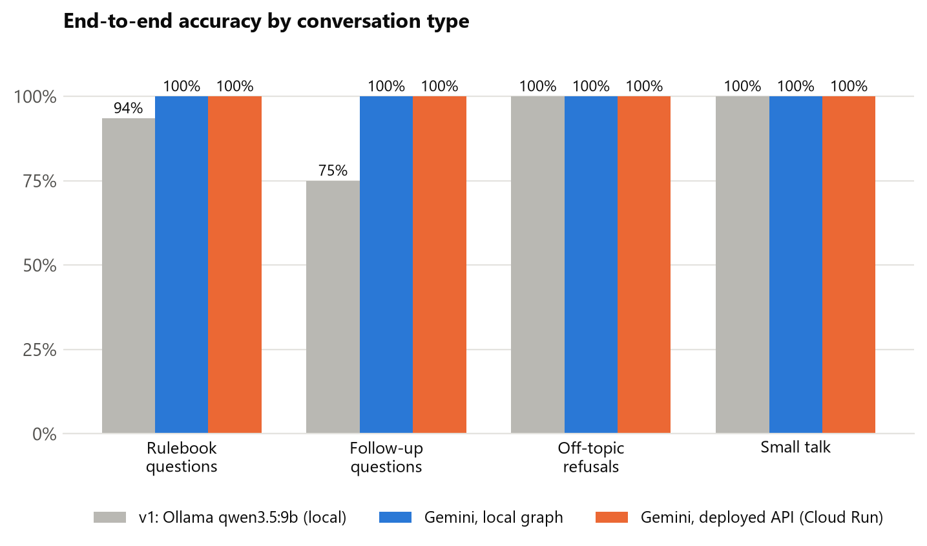
Figure 17. End-to-end accuracy: first version vs. current system (local and deployed)
Group | Local graph | Deployed API | How it is scored
Rulebook questions | 31/31 (100%) | 31/31 (100%) | Every required fact appears in the answer
Correct citation | 100% | 100% | A source chip names the correct PDF
Off-topic | 6/6 | 6/6 | Refusal text and no sources
Small talk | 16/16 | 16/16 | Answered without retrieval or refusal
Follow-ups | 4/4 | 4/4 | Second answer contains the required facts
Routing (local only) | 100% | – | Router chose the expected route

13.3 Latency
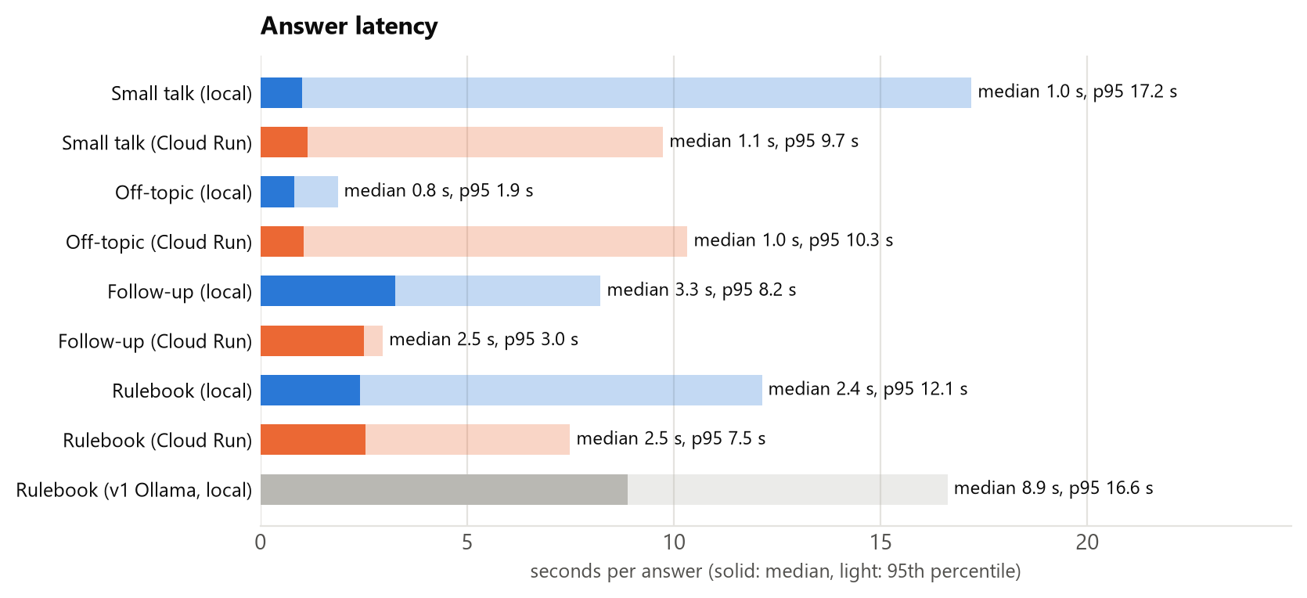
Figure 18. Answer latency by message type
Medians are stable: 2.4 s locally and 2.5 s on Cloud Run for rulebook questions, and about 1 s for small talk. Only 1 of the 57 production answers came from the answer cache, so these are real model latencies.
The 95th percentiles are dominated by a few slow calls on the model side. The slowest answers took 21.4 s locally and 32.4 s on Cloud Run. During the local run, Vertex AI answered one request with HTTP 429 (shared capacity), and the backend retried it after 5 seconds; other slow calls were queued at Vertex AI. The backend's retry logic absorbs these without failing the answer.

13.4 Project evolution
The first version (October 2026) ran entirely on the developer's PC with Ollama (qwen3.5:9b for answers, nomic-embed-text for embeddings). The current version uses Gemini on Vertex AI and was redesigned in two ways:
- One router call replaced the separate classify, contextualize and grade steps.
- Retrieval gained the contextual rulebook header and query caching.
Measure | v1 Ollama (local) | v2 Gemini (local) | v2 Gemini (deployed)
Rulebook answers correct | 93.5% | 100% | 100%
Correct rulebook cited | 96.8% | 100% | 100%
False refusals | 1 | 0 | 0
Follow-ups correct | 75% | 100% | 100%
Off-topic refused | 100% | 100% | 100%
Median time, rulebook question | 8.9 s | 2.4 s | 2.5 s
Answer chunk in top 6 (production retrieval) | 93.5% | 96.8% | same index
MRR of the answer chunk | 0.528 | 0.836 | same index

14. Setting up the project from scratch
Figure 19 (after the prerequisites) shows the order of the setup steps; the commands below are complete.

14.1 Prerequisites
Need | Notes
Windows 10/11 PC with PowerShell | The deploy scripts are PowerShell; the VM script is bash and runs on the VM
Python 3.13 | Backend, ingest, evaluation
Docker Desktop | Local WordPress (and optional local container test)
Google Cloud SDK (gcloud) | Logged in with gcloud auth login and gcloud auth application-default login
Google Cloud project with billing | Trial credits work; the deploy script enables the needed APIs
A domain on Cloudflare (free plan) | For the public site; a subdomain is enough
Langfuse Cloud account (optional) | Free Hobby plan; project API keys
Node.js (optional) | Only to rebuild this report

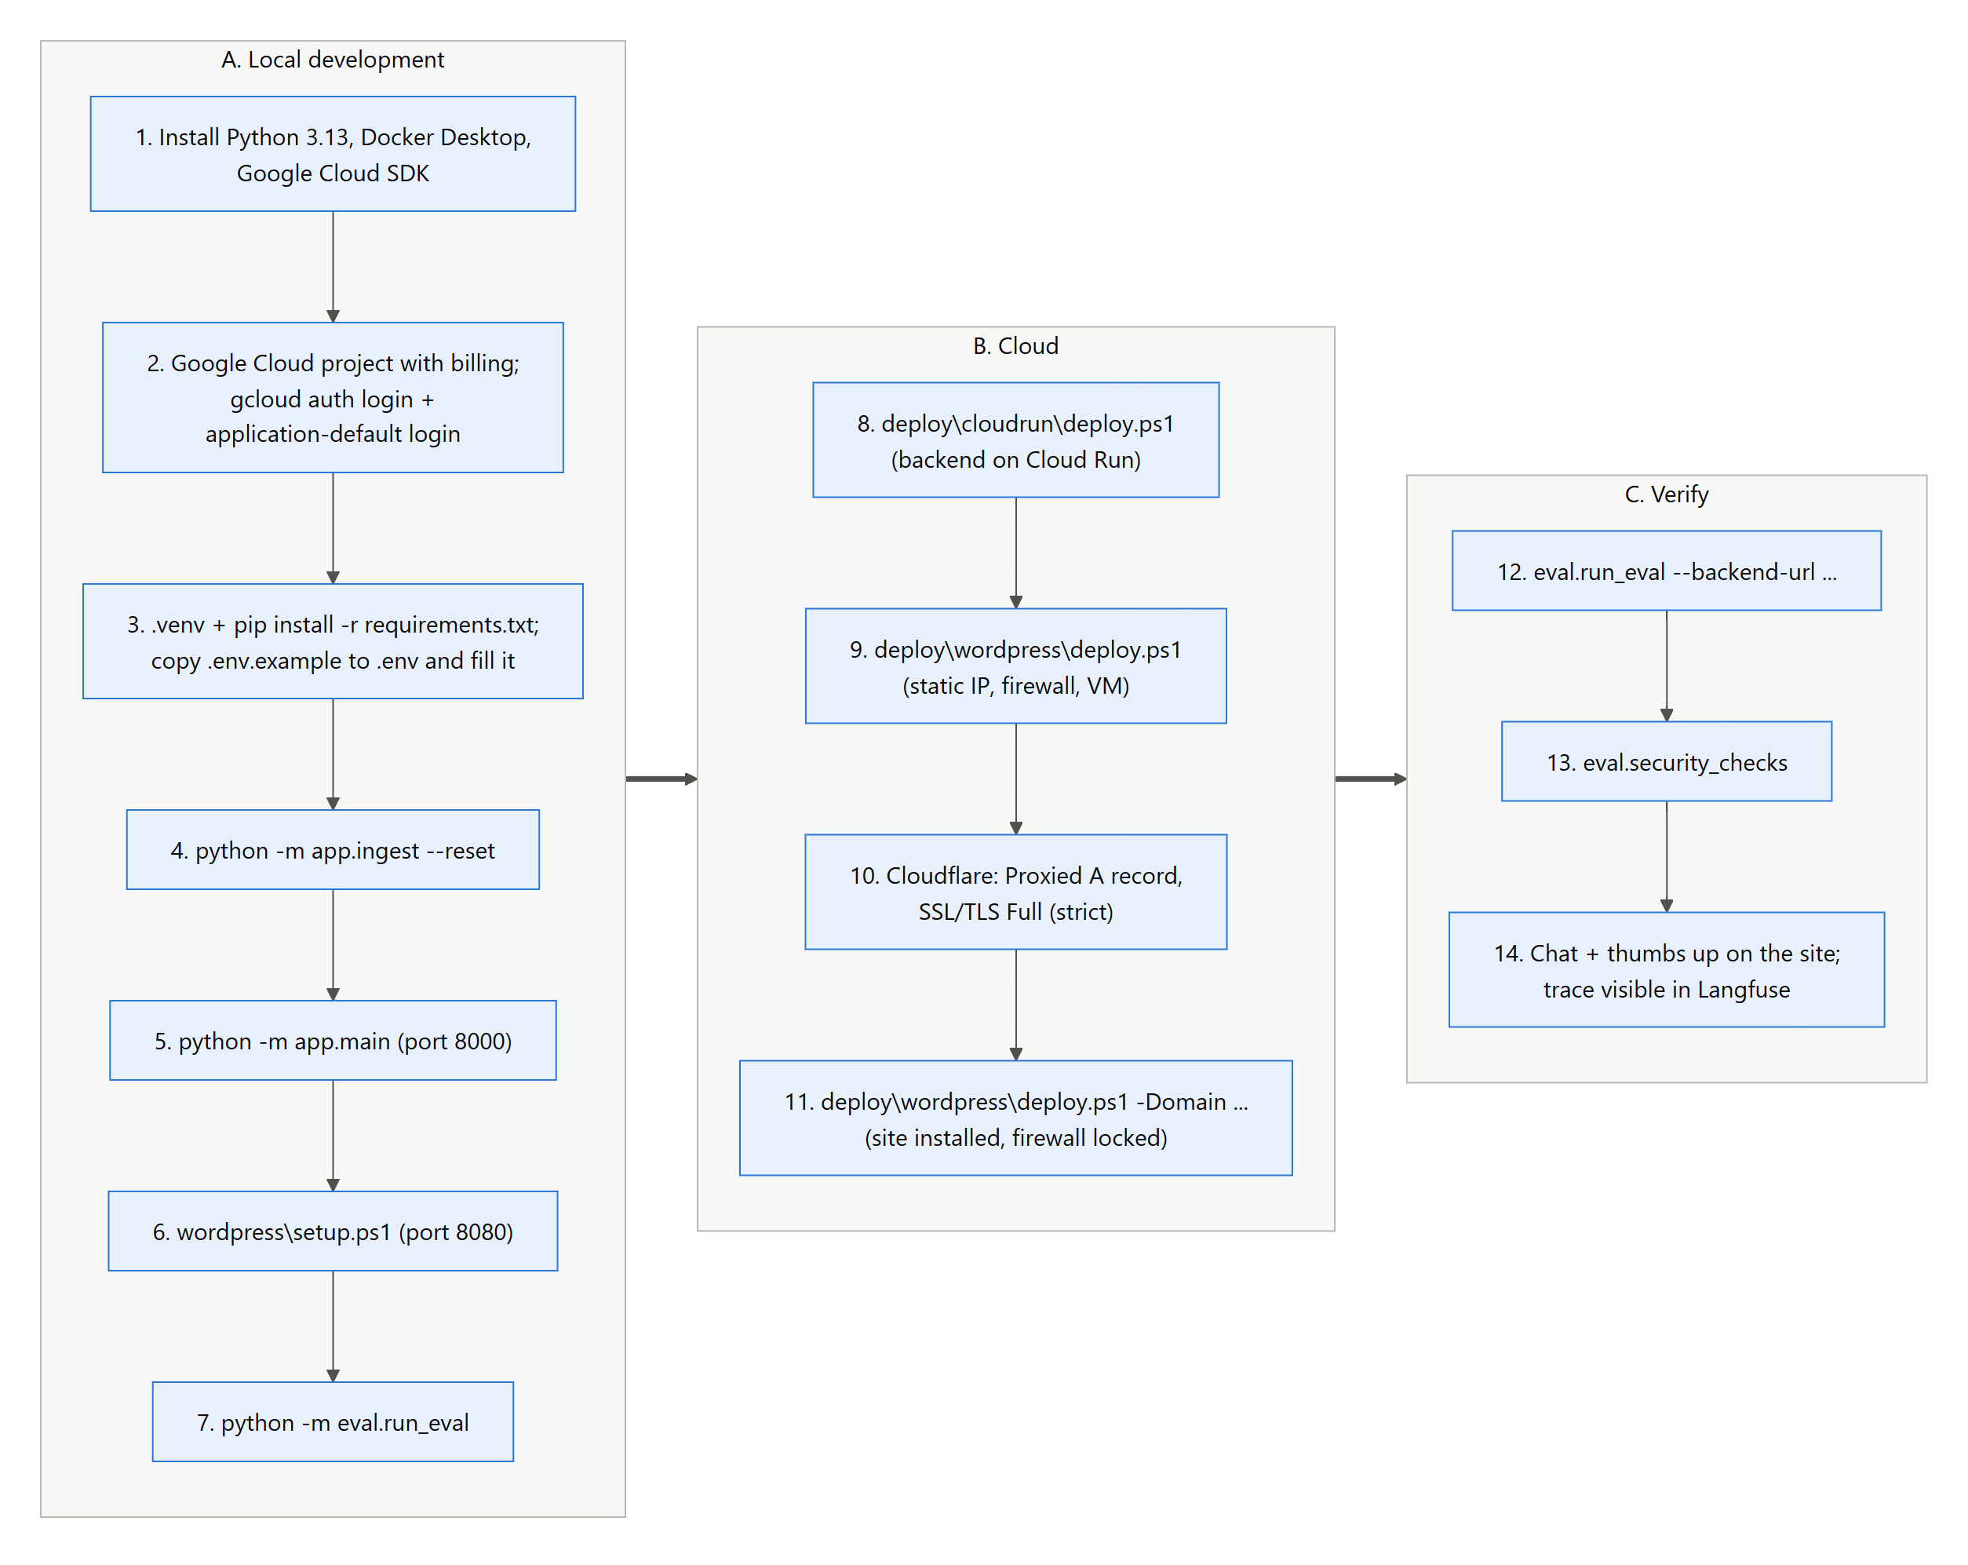
Figure 19. Setup from scratch

14.2 Local backend
python -m venv .venv
.venv\Scripts\activate
pip install -r requirements.txt
copy .env.example .env
# edit .env: GOOGLE_CLOUD_PROJECT=<project id>
# BACKEND_API_KEY=<long random string>
# LANGFUSE_* keys (optional)
gcloud auth application-default login
gcloud services enable aiplatform.googleapis.com --project <project id>
python -m app.model_status # checks the Gemini models (free)
python -m app.ingest --reset # builds chroma_db/ from Data/*.pdf
python -m app.main # http://localhost:8000/health

14.3 Local WordPress
# Docker Desktop running
powershell -ExecutionPolicy Bypass -File wordpress\setup.ps1
# -> http://localhost:8080, chat at /uno-rules-chat/
# admin login in wordpress\admin-credentials.txt
python -m eval.run_eval # optional: accuracy check (~100 Gemini requests)

14.4 Backend on Cloud Run
gcloud config set project <project id>
powershell -ExecutionPolicy Bypass -File deploy\cloudrun\deploy.ps1
# prints the service URL; check https://<service>/health
# later updates: deploy\cloudrun\deploy.ps1 -SkipIamGrants
The first deploy creates the service account and grants it Vertex AI User. On new projects it also lets the default compute account run source builds. If the first build fails with a permission error, wait two minutes for the grant to apply and run the script again.

14.5 WordPress on Compute Engine with Cloudflare
powershell -ExecutionPolicy Bypass -File deploy\wordpress\deploy.ps1
# creates static IP + firewall + VM and prints the IP
# Cloudflare: DNS A record <name> -> <IP>, Proxied; SSL/TLS mode Full (strict)
powershell -ExecutionPolicy Bypass -File deploy\wordpress\deploy.ps1 -Domain <domain>
# installs everything, then locks the firewall to Cloudflare
# admin login saved to wordpress\admin-credentials-gcp.txt

14.6 Verify
python -m eval.run_eval --backend-url https://<service>.run.app
python -m eval.security_checks --site https://<domain> \
--backend https://<service>.run.app --origin-ip <VM IP>
Then open the site, ask a question and rate the answer. Check that the trace and the user-feedback score appear in Langfuse.

15. Operations and troubleshooting
Task | Command
Backend health | curl https://<service>/health
Backend logs | gcloud run services logs read uno-rag-backend --region us-central1
SSH to the VM | gcloud compute ssh uno-wordpress --zone us-central1-a
Site logs / status | cd /opt/uno-wp && sudo docker compose ps / logs -f caddy
Blocked requests | sudo docker compose logs caddy | grep '"status":429'
Stop / start the VM | gcloud compute instances stop|start uno-wordpress --zone us-central1-a
Plugin limits and usage | WordPress → Settings → UNO Chatbot

Symptom | Cause | Fix
"Your session expired" (403) | Old nonce in a cached page | Reload; exclude the chat page from full-page caching
"question limit for this hour / today" (429) | Plugin limits reached | Wait, or raise them in the settings
429 with Retry-After on pages | Caddy per-IP limit | Wait one minute
Too many redirects | Cloudflare SSL mode Flexible | Set Full (strict)
Cloudflare 521/522 | VM stopped or firewall wrong | Start the VM; re-run the WordPress deploy
Raw shortcode text on the site | Plugin files not visible in the container | Re-run the WordPress deploy (recreates the containers)
"Backend not reachable" in settings | Wrong URL or cold start | Check the URL; retry after a few seconds
Backend 401 in WordPress logs | Keys differ | Re-run the WordPress deploy (copies the key from .env)
Backend 502 | Gemini auth/quota | /health → gemini.ok; check credentials and quotas

Appendix A. Configuration reference (.env)
Setting | Default | Description
GOOGLE_CLOUD_PROJECT | – | Google Cloud project for Vertex AI
GOOGLE_CLOUD_LOCATION | global | Vertex AI location
GOOGLE_APPLICATION_CREDENTIALS | empty | Optional key file; empty = Application Default Credentials
ROUTER_MODEL / ROUTER_THINKING | gemini-3.5-flash-lite / minimal | Routing, follow-up rewriting, small talk, query rewrite
ANSWER_MODEL / ANSWER_THINKING | gemini-3.5-flash / low | Grounded answers
LLM_TEMPERATURE / LLM_MAX_TOKENS | 0.1 / 2000 | Sampling (ignored by Flash-Lite) and output limit incl. thinking
EMBED_MODEL / EMBED_DIMENSIONS | gemini-embedding-2 / 768 | Embedding model and vector size
EMBED_QUERY_PREFIX / EMBED_DOC_PREFIX | task: search result | query: / title: none | text: | Task prefixes for gemini-embedding-2
EMBED_CONCURRENCY | 8 | Parallel embedding requests during ingest
DAILY_REQUEST_BUDGET | 2000 | Model requests per UTC day before 429
ANSWER_CACHE / CACHE_DIR | true / cache | First-turn answer cache and its folder
DATA_DIR / CHROMA_DIR / COLLECTION_NAME | Data / chroma_db / uno_docs_gemini | Inputs and index
CHUNK_SIZE / CHUNK_OVERLAP | 1000 / 150 | Chunking
TOP_K / MAX_REWRITES / HISTORY_WINDOW | 6 / 1 / 6 | Chunks per answer, query retries, history messages
RETRIEVAL_MODE | hybrid | hybrid or bm25 (no query embedding)
BACKEND_API_KEY | – | Shared secret for X-API-Key
LANGFUSE_PUBLIC_KEY / SECRET_KEY / BASE_URL | empty / empty / https://cloud.langfuse.com | Monitoring (off when keys are empty)
LANGFUSE_ENVIRONMENT / LANGFUSE_FLUSH_EACH_REQUEST | local / false | production / true on Cloud Run
API_HOST / API_PORT | 0.0.0.0 / 8000 | Local server (Cloud Run uses $PORT)
AUTO_INGEST_ON_STARTUP / LOG_LEVEL | true / INFO | Ingest when the collection is empty; logging

Appendix B. Per-question results
Every end-to-end test case, run on the local graph and against the deployed API (✔ correct, ✘ wrong; times in seconds). Follow-ups show both turns.
# | Question | Local | s | Deployed | s
1 | How many cards are in the UNO Dare deck? | ✔ | 2.0 | ✔ | 2.6
2 | What are the Dare List categories in UNO Dare? | ✔ | 2.4 | ✔ | 2.5
3 | What happens when a Dare card is played in UNO Dare? | ✔ | 3.1 | ✔ | 3.0
4 | How many points is a Wild Dare card worth in UNO Dare? | ✔ | 21.3 | ✔ | 2.4
5 | What happens if a player fails a dare in UNO Dare? | ✔ | 12.1 | ✔ | 2.6
6 | How many points do you need to win UNO Dare? | ✔ | 2.4 | ✔ | 32.4
7 | How many cards are in UNO No Mercy? | ✔ | 1.9 | ✔ | 2.3
8 | What is the Mercy rule in UNO No Mercy? | ✔ | 2.6 | ✔ | 2.8
9 | How does stacking work in UNO No Mercy? | ✔ | 3.1 | ✔ | 3.8
10 | What happens when you play a 7 in UNO No Mercy? | ✔ | 2.1 | ✔ | 2.6
11 | What happens when a 0 is played in UNO No Mercy? | ✔ | 1.8 | ✔ | 2.3
12 | What does the Wild Color Roulette card do? | ✔ | 4.2 | ✔ | 2.7
13 | How many points do you get for knocking out a player in UNO No Mercy? | ✔ | 2.3 | ✔ | 2.4
14 | How many points are needed to win UNO No Mercy when keeping score? | ✔ | 2.2 | ✔ | 2.5
15 | What does the Discard All card do in UNO No Mercy? | ✔ | 2.3 | ✔ | 2.5
16 | How many cards are in UNO Flip? | ✔ | 1.8 | ✔ | 2.5
17 | What does the Flip card do in UNO Flip? | ✔ | 2.7 | ✔ | 4.0
18 | What does the Draw Five card do in UNO Flip? | ✔ | 2.2 | ✔ | 3.1
19 | What does the Skip Everyone card do in UNO Flip? | ✔ | 2.7 | ✔ | 0.5
20 | How many points is the Wild Draw Color card worth in UNO Flip? | ✔ | 2.6 | ✔ | 2.4
21 | In UNO Flip, what happens if you challenge a Wild Draw 2 and the player is innocent? | ✔ | 2.2 | ✔ | 2.0
22 | What colors are on the dark side of UNO Flip? | ✔ | 3.1 | ✔ | 3.0
23 | How many points is the Skip Everyone card worth in UNO Flip? | ✔ | 2.3 | ✔ | 2.4
24 | How many cards are dealt to each player in UNO All Wild? | ✔ | 1.9 | ✔ | 3.0
25 | What does the Wild Skip Two card do in UNO All Wild? | ✔ | 2.5 | ✔ | 2.5
26 | What does the Wild Forced Swap card do? | ✔ | 2.4 | ✔ | 2.8
27 | What does the Wild Targeted Draw Two card do? | ✔ | 2.1 | ✔ | 2.2
28 | In UNO All Wild, do you need to match the color or number? | ✔ | 2.5 | ✔ | 2.3
29 | How many points do you need to win UNO All Wild? | ✔ | 2.3 | ✔ | 2.5
30 | What is the penalty for forgetting to call UNO? | ✔ | 2.9 | ✔ | 7.5
31 | Which card makes the next player draw until they get a chosen color? | ✔ | 5.0 | ✔ | 2.7
32 | What is the capital of France? | ✔ | 1.9 | ✔ | 1.1
33 | Who won the 2018 FIFA World Cup? | ✔ | 0.8 | ✔ | 1.1
34 | Write a Python function to reverse a string. | ✔ | 0.9 | ✔ | 1.0
35 | How do I bake a chocolate cake? | ✔ | 0.8 | ✔ | 1.0
36 | How does castling work in chess? | ✔ | 0.7 | ✔ | 10.3
37 | What is the boiling point of water? | ✔ | 0.8 | ✔ | 0.9
38 | hi | ✔ | 1.0 | ✔ | 1.1
39 | hello there | ✔ | 1.0 | ✔ | 1.2
40 | hey! | ✔ | 1.1 | ✔ | 1.1
41 | good morning | ✔ | 1.0 | ✔ | 1.1
42 | how are you? | ✔ | 17.2 | ✔ | 9.7
43 | how's it going? | ✔ | 1.1 | ✔ | 1.2
44 | thanks! | ✔ | 1.2 | ✔ | 1.0
45 | thank you so much | ✔ | 0.8 | ✔ | 1.1
46 | bye | ✔ | 1.0 | ✔ | 0.9
47 | see you later | ✔ | 1.2 | ✔ | 1.1
48 | who are you? | ✔ | 0.9 | ✔ | 1.5
49 | what can you do? | ✔ | 1.1 | ✔ | 1.1
50 | what is your name? | ✔ | 0.9 | ✔ | 1.2
51 | nice to meet you | ✔ | 1.2 | ✔ | 5.2
52 | ok cool | ✔ | 0.9 | ✔ | 1.2
53 | you're awesome | ✔ | 0.9 | ✔ | 1.1
54 | What does the Skip Everyone card do in UNO Flip? -> How many points is it worth? | ✔ | 2.4 | ✔ | 2.5
55 | How many cards are dealt in UNO No Mercy? -> Is it the same in UNO Dare? | ✔ | 3.7 | ✔ | 2.5
56 | What is the Mercy rule in UNO No Mercy? -> How many points do you get for knocking someone out? | ✔ | 2.8 | ✔ | 3.0
57 | What does the Wild Draw Color card do in UNO Flip? -> What happens if I challenge it and the player was innocent? | ✔ | 8.2 | ✔ | 2.5

Appendix C. Diagram sources
All diagrams are Mermaid files in docs/diagrams/, rendered to PNG by docs/tools/render_diagrams.py. The charts come from docs/tools/charts.py and the evaluation JSON files. To rebuild this report, run node docs/tools/build_report.js.
File | Figure | Shows
01_architecture.mmd | 1 | Components and how they connect
02_deployment_topology.mmd | 14 | Cloudflare, Google Cloud resources, deploy paths
03_ingestion_pipeline.mmd | 3 | PDF to Chroma indexing steps
04_retrieval_pipeline.mmd | 4 | Hybrid search and reciprocal rank fusion
05_langgraph_flow.mmd | 6 | LangGraph nodes, routes and memory
06a_chat_sequence_frontend.mmd | 7 | Chat request from the browser to WordPress
06b_chat_sequence_backend.mmd | 8 | Chat request from WordPress to Gemini
07_feedback_sequence.mmd | 9 | Thumbs up/down to a Langfuse score
08_api_key_flow.mmd | 12 | Where secrets live and how they move
09_security_layers.mmd | 11 | The six security layers
10_rate_limiting_flow.mmd | 13 | Rate-limit decisions per request
11_frontend_components.mmd | 10 | WordPress pages, plugin files and assets
12_deploy_backend.mmd | 15 | Cloud Run deployment workflow
13_deploy_wordpress.mmd | 16 | VM deployment workflow
14_setup_from_scratch.mmd | 19 | Setup order from a new machine
15_data_flow.mmd | 2 | Indexing and answering data flow

