UNO Rulebook RAG Chatbot
Technical report: architecture, workflow, retrieval design and evaluation results

Item | Details
Project | RAG Practice project: local chatbot over 5 UNO rulebook PDFs
Stack | LangGraph · FastAPI · ChromaDB · pdfplumber · Ollama (qwen3.5:9b, nomic-embed-text)
Prepared by | Mayank Bisht
Date | 29 October 2026
Evaluation run | eval/run_eval.py: 31 rulebook questions, 6 off-topic, 58 router messages, 4 follow-up conversations (13.6 min run)

Contents
1. Executive summary 3
2. System overview 4
2.1 Technology stack 4
2.2 Architecture 4
2.3 Project structure 5
3. Application flow 6
3.1 Startup 6
3.2 Lifecycle of one chat message 6
4. Ingestion pipeline: PDF extraction and cleaning 7
5. Chunking process 8
6. Embedding process 9
7. Database schema (ChromaDB) 10
7.1 Logical schema 10
7.2 Physical storage 10
8. Retrieval process 12
8.1 Methods used 12
8.2 Step-by-step: hybrid_search() 12
8.3 Grading, rewriting and generation 12
9. LangGraph workflow 14
9.1 Graph state 14
9.2 Nodes 14
9.3 Routing rules 15
10. Chat flow examples 16
11. API reference 17
12. Configuration (.env) 18
13. Evaluation and accuracy 19
13.1 Method 19
13.2 Retrieval accuracy 19
13.3 Relevance grader 20
13.4 Router 20
13.5 End-to-end results 21
13.6 Failure analysis 21
14. Limitations and recommendations 22
15. How to run 23
Appendix A. Per-question results 24

1. Executive summary
The chatbot answers natural-language questions about five UNO rulebooks (UNO, UNO Flip, UNO Dare, UNO No Mercy and UNO All Wild). Everything runs locally: PDFs are parsed with pdfplumber, chunked and embedded with nomic-embed-text, stored in ChromaDB, and answered by the qwen3.5:9b model through Ollama. A LangGraph state machine routes each message, retrieves and grades evidence, retries with a rewritten query when nothing relevant is found, and returns a cited, plain-text answer through a FastAPI endpoint and a browser chat page.
All numbers in this report were measured on the actual system with a hand-labelled test set (section 13). Headline results:
Metric | Result | Meaning
Answer accuracy (rulebook questions) | 93.5% (29/31) | Answer contains every required fact
Citation accuracy | 96.8% | Correct rulebook listed in the sources
Correct rulebook ranked #1 by retrieval | 96.8% | Hybrid search with rulebook filter
Answer chunk in the top 6 results | 93.5% | Context recall@6 (vector-only search: 41.9%)
Router accuracy (small talk vs. question) | 100% (58/58) | No misrouted messages
Off-topic questions refused | 100% (6/6) | No invented answers outside the rulebooks
Small talk answered without retrieval | 100% (8/8) | Greetings, thanks, 'what can you do?'
Follow-up questions (2-turn) | 75% (3/4) | Uses chat memory to resolve 'it', 'that'
Response time, rulebook question | median 8.88 s, p95 16.62 s | Small talk 3.96 s; off-topic refusal 17.76 s
Answers containing markdown symbols | 0 of 31 | Output is cleaned before it is sent

Key takeaways
- Retrieval design matters most. Plain vector search found the answer chunk for only 41.9% of questions because all five rulebooks describe the same game. Adding BM25 keyword search, rank fusion and a rulebook-name filter raised this to 93.5%.
- The relevance grader is precise but slow. It kept the answer chunk every time it was retrieved (100%) and rejected 100% of off-topic chunks, but it takes 5.07 s of the 9.74 s average response.
- The three failures have two root causes: a scoring table split across chunks (retrieval miss, which also caused the follow-up failure) and one counting error by the model. Both have concrete fixes (section 14).
- One rulebook (uno.pdf) is image-like and yields almost no text without OCR; the base rules are still covered by the other four rulebooks.

2. System overview

2.1 Technology stack
Layer | Technology (version) | Role
API server | FastAPI 0.162.0 + Uvicorn 0.54.0 | REST endpoints, serves the chat page
Orchestration | LangGraph 1.2.18 (langchain-core 1.7.1) | State machine for routing, retrieval, grading, generation
Chat LLM | qwen3.5:9b via Ollama 0.19.0 | 9.7B parameters, Q4_K_M quantisation, reasoning disabled
Embedding model | nomic-embed-text (Ollama) | 137M parameters, F16, 768 dimensions, 2,048-token input
Vector database | ChromaDB 1.5.9 via langchain-chroma 1.1.0 | Persistent store (SQLite + HNSW index), cosine distance
Keyword search | rank-bm25 0.2.2 (BM25Okapi) | In-memory keyword index over all chunks
PDF parsing | pdfplumber 0.11.10 | Text and table extraction per page
Chunking | langchain-text-splitters 1.1.3 | RecursiveCharacterTextSplitter
Configuration | pydantic-settings 2.16.2 | Typed settings loaded from .env
Front end | Static HTML + JavaScript | Chat UI served at /
Runtime | Python 3.13.7, Windows 11 | NVIDIA RTX 4060 Laptop GPU (8 GB), 15.6 GB RAM

2.2 Architecture
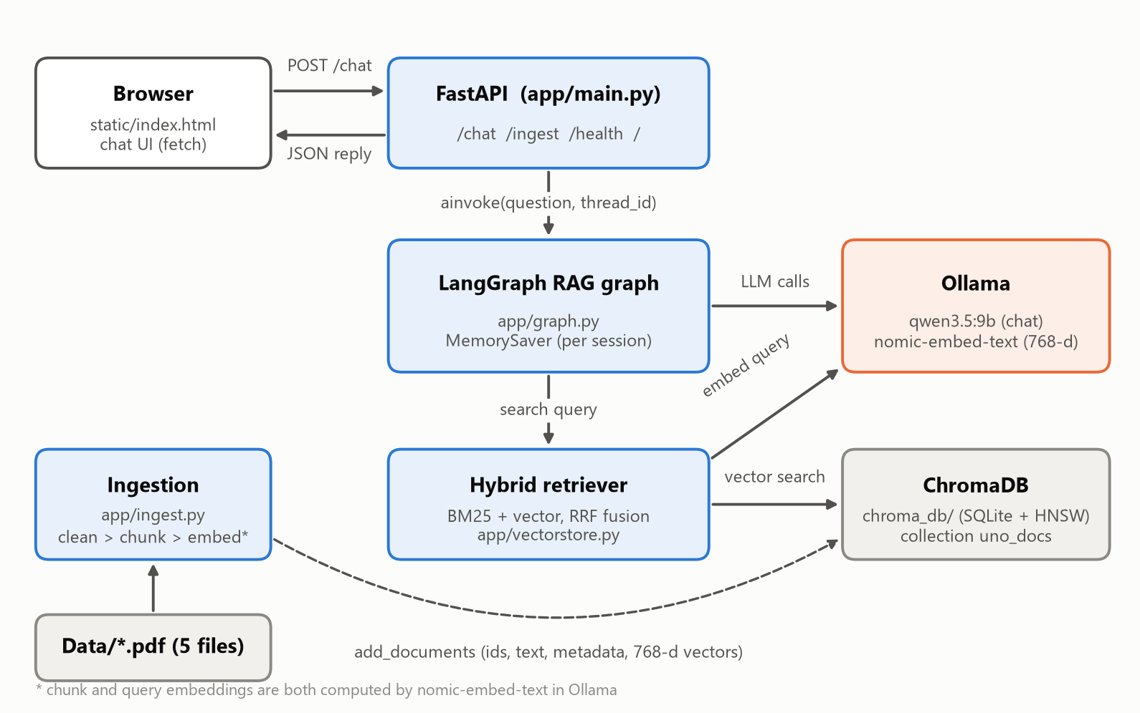
Figure 1. Components and data flow
The browser sends each message to FastAPI, which runs the LangGraph graph for that session. The graph calls the hybrid retriever (BM25 plus Chroma vector search) and makes LLM calls to Ollama. Ingestion is a separate path: PDFs are cleaned, chunked, embedded through Ollama and written to Chroma. Nothing leaves the machine.

2.3 Project structure
Path | Purpose
app/config.py | Settings class; every tunable value is read from .env
app/ingest.py | PDF loading, cleaning, chunking, writing to Chroma; CLI python -m app.ingest --reset
app/vectorstore.py | Embeddings (with nomic task prefixes), Chroma client, BM25 index, hybrid_search()
app/prompts.py | Prompts for router, small talk, contextualiser, grader, rewriter, generator
app/graph.py | LangGraph state, nodes, routing edges, compiled graph with memory
app/formatting.py | clean_markdown(): converts model markdown to plain text
app/main.py | FastAPI app, startup ingest, /chat, /ingest, /health endpoints
app/static/index.html | Browser chat interface
eval/dataset.py, eval/run_eval.py | Labelled test set and evaluation harness; writes eval/results.json
Data/ | Source PDFs (5 files)
chroma_db/ | Persisted vector database
.env, .env.example | Configuration values and template

3. Application flow

3.1 Startup
- Settings loads values from .env (defaults apply if a key is missing).
- FastAPI's lifespan hook compiles the LangGraph graph with an in-memory checkpointer (MemorySaver).
- If AUTO_INGEST_ON_STARTUP=true and the Chroma collection is empty, the PDFs are ingested automatically.
- The static chat page is mounted and the server listens on API_HOST:API_PORT (default 0.0.0.0:8000).

3.2 Lifecycle of one chat message
- The user types a message. The page sends POST /chat with {question, session_id}; the session id is a random UUID kept in the browser's localStorage.
- FastAPI validates the body (question must be non-empty) and calls graph.ainvoke() with the new message and thread_id = session_id.
- LangGraph restores that session's earlier state (chat history) from the checkpointer and appends the new message.
- The graph runs: route → (small talk) or (contextualise → retrieve → grade → optional rewrite loop → generate). See section 9.
- The endpoint takes the final AI message as the answer and de-duplicates the (file, page) pairs of the chunks that passed grading as the sources.
- The JSON reply {answer, sources} is rendered in the page with a 'Sources: file (p.N)' line.
- 'New chat' calls DELETE /chat/{session_id} to forget the history and starts a new session id.
Errors inside the graph (for example Ollama not running) are returned as HTTP 500 with a message, and the page shows them in a red error bubble.

4. Ingestion pipeline: PDF extraction and cleaning
app/ingest.py turns every PDF in Data/ into clean page documents. Run it with python -m app.ingest --reset (or POST /ingest). Each page goes through these steps:
- De-duplicate glyphs: page.dedupe_chars() removes overlapping duplicate characters (fixes text such as 'CCaarrd' → 'Card').
- Extract text: page.extract_text().
- Remove unmapped glyphs: tokens like (cid:17) come from fonts without a Unicode map and are deleted.
- Readability filter: a line is kept only if at least 80% of its characters are letters, digits, spaces or common punctuation and it contains a word of 3+ letters.
- Tables: page.extract_tables() rows are joined with ' | ', cleaned the same way and appended under 'Tables:'.
- Duplicate pages: an MD5 hash of the cleaned page text skips repeated pages (three PDFs repeat page 1 as page 2).
- Empty pages are dropped; each remaining page becomes a document with metadata source (file name) and page (1-based).

Extraction results per file
File | Size | Pages | Kept | Raw chars | Clean chars | Chunks
Uno Dare.pdf | 123.3 KB | 2 | 1 | 16,420 | 8,182 | 10
uno flip.pdf | 3,356.2 KB | 1 | 1 | 25,273 | 24,790 | 29
Uno No mercy.pdf | 270.6 KB | 2 | 1 | 17,820 | 8,853 | 11
uno-all-wild-rules-…_.pdf | 327.2 KB | 3 | 3 | 3,312 | 3,195 | 7
uno.pdf | 283 KB | 2 | 1 | 212,106 | 2,069 | 3
Total | 4,360.3 KB | 10 | 7 | 274,931 | 47,089 | 60

Cleaning removed 82.9% of the raw extracted characters. Most of that is uno.pdf: 212,106 raw characters, almost all unmapped-glyph noise; only its consumer-information footer is readable, so its rules are not searchable without OCR.

5. Chunking process
Clean pages are split into overlapping chunks so each retrieved unit is small enough to be specific but large enough to carry context.
Setting | Value | Notes
Splitter | RecursiveCharacterTextSplitter | Splits on paragraph, then line, then word, then character boundaries
Chunk size | 1000 characters | CHUNK_SIZE in .env
Overlap | 150 characters (15%) | CHUNK_OVERLAP; keeps sentences that cross a boundary
Split unit | One page at a time | Chunks never span two pages, so page citations are exact
Contextual header | Rulebook: <Title> on the first line | Added after splitting, so every chunk names its game (e.g. 'Rulebook: Uno No Mercy')
Chunk ID | <file>:<page>:<index> | Deterministic, so re-running ingest updates rows instead of duplicating them
Metadata | source, page, chunk, title | Used for citations and rulebook filtering

Chunk statistics
Measure | Value
Total chunks | 60
Chunk length (characters) | min 59 · median 948 · mean 859 · max 1020
Chunk length (words) | min 7 · mean 157 · max 261
Approximate tokens per chunk | ~215 (estimate: characters ÷ 4)
Chunks per file | Uno Dare.pdf: 10 · uno flip.pdf: 29 · Uno No mercy.pdf: 11 · uno-all-wild-rules-…_.pdf: 7 · uno.pdf: 3

The maximum is slightly above 1,000 characters because the 'Rulebook:' header is added after splitting. The header was introduced because, without it, chunks from different rulebooks looked almost identical to the retriever and questions such as 'in UNO No Mercy' often returned UNO Dare text.

6. Embedding process
Each chunk is converted into a 768-number vector that captures its meaning; questions are embedded the same way at query time, and Chroma finds the chunks whose vectors are closest.
Property | Value
Model | nomic-embed-text:latest (served by Ollama)
Size / precision | 137M parameters, F16
Vector dimensions | 768
Maximum input | 2,048 tokens (chunks average ~215 tokens)
Task prefixes | search_document: added to chunks, search_query: added to questions (custom NomicEmbeddings class). nomic-embed-text is trained with these prefixes.
Similarity metric | Cosine (hnsw:space = cosine on the collection)
Embedding all chunks | 1.38 s for 60 chunks (23.1 ms per chunk, batched)
Embedding one question | 39.2 ms on average
When it runs | Ingest: once per chunk (batch). Chat: once per retrieval attempt.

7. Database schema (ChromaDB)

7.1 Logical schema
Collection uno_docs holds 60 records. Each record has:
Field | Type | Example / description
id | string | Uno Dare.pdf:1:0 (file : page : chunk index)
document | string | Chunk text, starting with 'Rulebook: Uno Dare'
embedding | float[768] | nomic-embed-text vector of the prefixed chunk text
metadata.source | string | PDF file name, e.g. Uno No mercy.pdf
metadata.page | integer | 1-based page number
metadata.chunk | integer | Chunk index within the page
metadata.title | string | Readable rulebook title, e.g. Uno No Mercy (used for rulebook detection)

Collection configuration: hnsw:space = cosine; embedding dimension fixed at 768 (stored in the collections table).

7.2 Physical storage
Everything lives in chroma_db/ (6.11 MB on disk), split into a SQLite metadata segment and an HNSW vector segment:
Table / file | Contents
collections | id, name (uno_docs), dimension (768), configuration
collection_metadata | Key/value collection settings, e.g. hnsw:space = cosine
segments | Two segments per collection: VECTOR (hnsw-local-persisted) and METADATA (sqlite)
embeddings | One row per record: internal id, segment_id, embedding_id (the record id), seq_id, created_at
embedding_metadata | Key/value rows per record (string_value / int_value / float_value / bool_value). The chunk text is stored under key chroma:document; source, page, chunk and title are separate keys.
embedding_fulltext_search* | SQLite FTS5 full-text index over document text
embeddings_queue, max_seq_id | Write-ahead log and sequence tracking for the vector segment
tenants, databases, migrations, … | Chroma internals
<segment-uuid>/ folder | HNSW graph files: data_level0.bin, header.bin, length.bin, link_lists.bin (~318 KB)

Example stored record (from chroma.sqlite3)
Key | Value
embedding_id | Uno Dare.pdf:1:0
chroma:document | Rulebook: Uno Dare / Card Game / Contents / 108 Cards as follows: 19 Blue cards - 0 to 9 …
source | Uno Dare.pdf
page | 1
chunk | 0
title | Uno Dare

Housekeeping: chroma_db/ also contains three unused HNSW folders left behind by earlier --reset runs (about 0.9 MB). They are harmless and can be deleted.

8. Retrieval process

8.1 Methods used
Method | How it works | Strength
Vector search (semantic) | Question embedding compared with chunk embeddings by cosine similarity using Chroma's HNSW index | Finds paraphrases and meaning matches
BM25 keyword search | BM25Okapi scores over lower-cased word tokens of all chunks (in memory) | Exact card names and numbers ('Skip Everyone', '+4')
Reciprocal Rank Fusion (RRF) | score(chunk) = Σ 1 / (60 + rank) over both result lists | Combines both rankings without tuning weights
Rulebook-name filter | Detects game names in the question and restricts both searches to those PDFs | Stops near-identical rules from other games crowding out the right one
LLM relevance grading | qwen3.5:9b answers yes/no (JSON) for each retrieved chunk | Removes off-topic chunks before generation
Query rewriting | If nothing is relevant, the LLM rewrites the search query (up to 2 times) | Recovers from poorly worded questions

8.2 Step-by-step: hybrid_search()
- Build the search text: the current search query plus the standalone question, e.g. 'How many cards are dealt in UNO Dare? (How many cards are dealt in UNO Dare?)'. Including the standalone question means a rewrite can never drop the game name.
- Detect rulebooks: aliases are derived from chunk titles (remove 'Uno' and 'Rules'): dare, flip, no mercy, all wild. Each alias is matched as a whole word in the lower-cased query.
- Vector search: Chroma returns the 18 nearest chunks (3 × TOP_K), with a source $in [...] filter if any rulebook was detected.
- Keyword search: BM25 scores every chunk, drops zero scores and chunks from other rulebooks (when filtered) and keeps the top 18.
- Fuse: RRF combines the two lists; the top 6 chunks (TOP_K) are returned.
Average retrieval time: 39.4 ms per query, including the question embedding. The BM25 index is built from Chroma on first use and rebuilt after each ingest.

8.3 Grading, rewriting and generation
- Grading: all 6 chunks are graded concurrently against the standalone question (not the rewritten query, so a rewrite cannot make unrelated text look relevant). On average 1.65 of 6 chunks survive.
- Rewrite loop: if no chunk survives and fewer than 2 rewrites have been made, the query is rewritten and retrieval runs again (at most 3 retrieval attempts). Then the graph goes to generation.
- Generation: surviving chunks are joined as '[file p.N] text' blocks. The prompt tells the model to answer only from this context, name the rulebook and write plain text. If no chunk survived, a fixed reply is returned without calling the model: "Sorry, I couldn't find information about that in the UNO rulebooks…"
- Model settings: temperature 0.1 for answers and 0 for grading/routing; context window 8192 tokens; reasoning ('thinking') disabled; last 6 chat messages included.
- Output cleaning: clean_markdown() removes bold/italic markers, headings and code marks and turns list items into • bullets before the answer is stored and sent.

9. LangGraph workflow
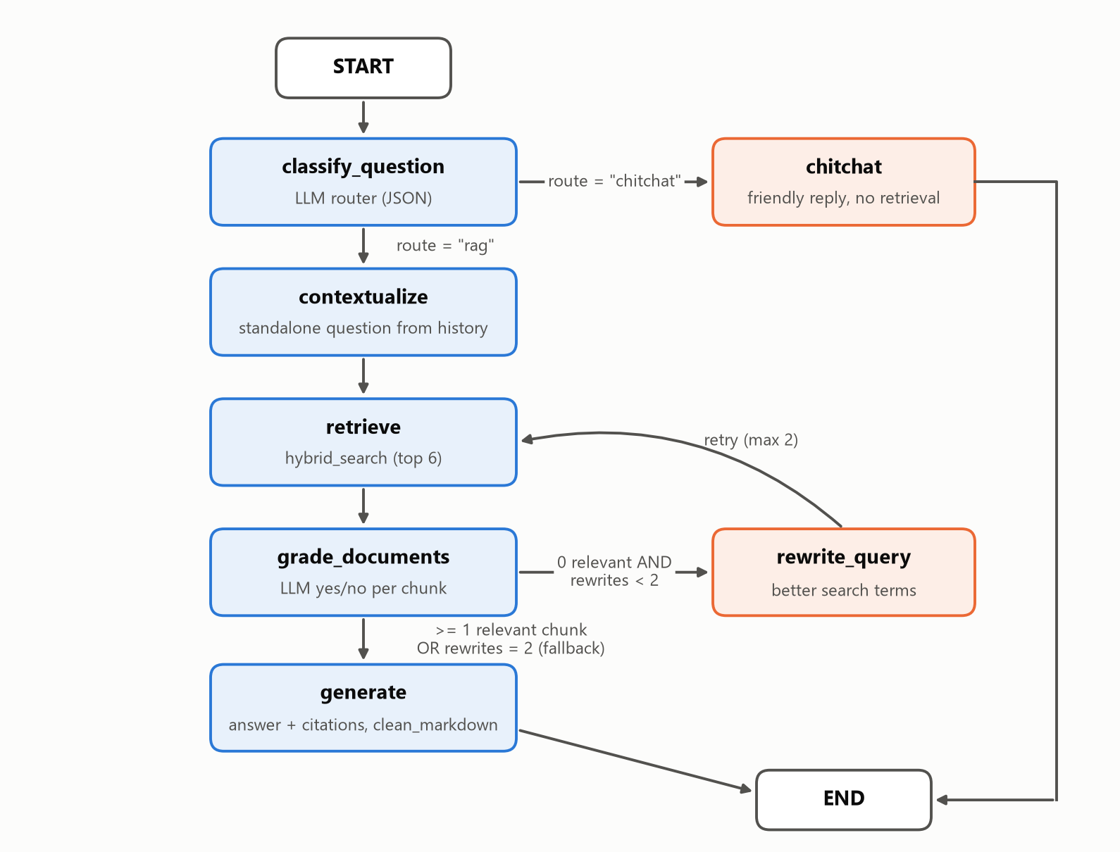
Figure 2. LangGraph nodes and routing

9.1 Graph state
Field | Type | Purpose
messages | list[BaseMessage] (append reducer) | Full chat history of the session; persisted by the checkpointer
question | str | The user's latest message, unchanged
route | str | 'chitchat' or 'rag', set by the router
standalone_question | str | Latest question rewritten to make sense without history; never changes during the turn
search_query | str | Text sent to the retriever; may be rewritten
documents | list[Document] | Retrieved chunks, then only the ones graded relevant
rewrites | int | Number of query rewrites in this turn (max 2)

9.2 Nodes
Node | What it does | LLM call | Avg time
classify_question | Classifies the message as small talk or a rulebook question (JSON output); clears old sources | Yes | 0.98 s
chitchat | Short friendly reply that lists the available rulebooks; no retrieval | Yes | ~3.0 s
contextualize | Rewrites follow-ups ('is it the same in Dare?') into a standalone question; falls back to 'previous + current question' if the model answers instead | Only when there is history | 0 s (first message)
retrieve | Runs hybrid_search() and returns the top 6 chunks | No (embedding only) | 0.05 s
grade_documents | Keeps only chunks the LLM marks relevant | Yes, 6 in parallel | 5.07 s
rewrite_query | Produces better search terms when nothing was relevant | Yes | 1.27 s (6.5% of questions)
generate | Writes the cited answer, or the fixed 'not found' reply | Yes (unless no chunks) | 3.56 s

9.3 Routing rules
- After classify_question: route 'chitchat' → chitchat → END; anything else → contextualize. If the router's output can't be parsed, the message goes to the rulebook path.
- After grade_documents: at least one relevant chunk → generate; none and rewrites < 2 → rewrite_query → retrieve; otherwise → generate (fallback reply).
- Memory: MemorySaver keeps state per thread_id (= session id) in server memory. The last 6 messages are given to the LLM. History is lost when the server restarts.
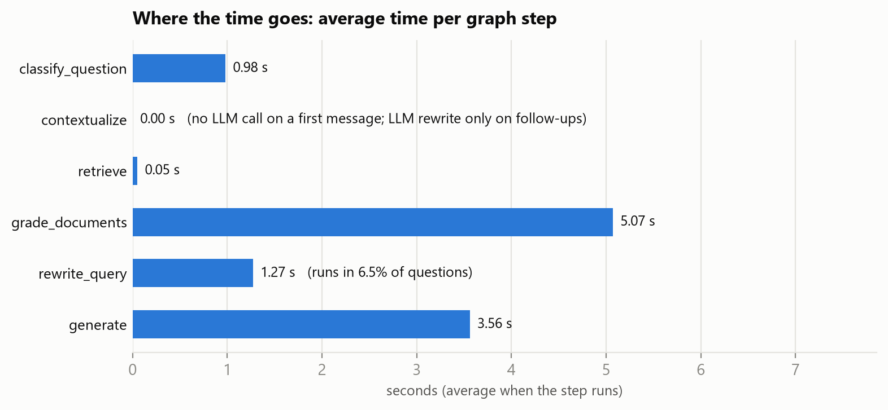
Figure 3. Average time per node for rulebook questions

10. Chat flow examples
How typical messages travel through the graph (taken from test runs):
Message | Route and path | Outcome
"hi" | chitchat: classify → chitchat | Friendly greeting listing the rulebooks, no sources (~3.96 s)
"How many cards are dealt in No Mercy?" | rag: classify → contextualize → retrieve (filtered to No Mercy) → grade → generate | '7 cards', cites Uno No mercy.pdf p.1
Follow-up: "Is it the same in UNO Dare?" | rag: contextualize turns it into 'How many cards are dealt in UNO Dare?' → retrieve → grade → generate | 'Yes, 7 cards', cites Uno Dare.pdf
"thanks!" | chitchat | 'You're welcome…'; sources from the previous answer are cleared
"What is the capital of France?" | rag: retrieve → grade (0 relevant) → rewrite → retrieve → grade (0) → rewrite → retrieve → grade (0) → generate | Fixed 'couldn't find this in the UNO rulebooks' reply, no sources (~17.76 s)

11. API reference
Method | Path | Request body | Response
GET | / | – | Chat page (index.html)
GET | /health | – | {status, ollama, llm_model, embed_model, documents_in_collection}
POST | /chat | {question: str, session_id: str} | {answer: str, sources: [{source, page}]}
DELETE | /chat/{session_id} | – | {cleared: session_id}; forgets that session's history
POST | /ingest | {reset: bool} | {files, pages, chunks, collection_count}
GET | /docs | – | Interactive Swagger UI (FastAPI built-in)

12. Configuration (.env)
Variable | Value | Purpose
OLLAMA_BASE_URL | http://localhost:11434 | Ollama server address
LLM_MODEL | qwen3.5:9b | Chat / grading / routing model
EMBED_MODEL | nomic-embed-text:latest | Embedding model
LLM_TEMPERATURE | 0.1 | Answer randomness (grader and router use 0)
LLM_REASONING | false | qwen3.5 'thinking' mode; off for speed and clean JSON
LLM_NUM_CTX | 8192 | Context window in tokens; limits RAM/VRAM use
DATA_DIR | Data | Folder with source PDFs
CHROMA_DIR | chroma_db | Vector database folder
COLLECTION_NAME | uno_docs | Chroma collection
CHUNK_SIZE / CHUNK_OVERLAP | 1000 / 150 | Chunking (characters)
TOP_K | 6 | Chunks returned per retrieval
MAX_REWRITES | 2 | Query rewrites before giving up
HISTORY_WINDOW | 6 | Past messages given to the LLM
API_HOST / API_PORT | 0.0.0.0 / 8000 | Server bind address
AUTO_INGEST_ON_STARTUP | true | Ingest PDFs at startup if the DB is empty
LOG_LEVEL | INFO | Logging verbosity

13. Evaluation and accuracy

13.1 Method
A labelled test set was written by hand from the extracted rulebook text (eval/dataset.py). For each rulebook question it records the correct rulebook, a phrase that identifies the chunk containing the answer (the 'gold chunk'), and the facts the answer must contain. eval/run_eval.py runs every test against the live system (each question in a fresh session) and saves eval/results.json.
Test group | Count | What is checked
Rulebook questions | 31 | Answer facts, citations, latency. Per rulebook: UNO Dare 6, UNO No Mercy 9, UNO Flip 8, UNO All Wild 6, Any / not named 2
Off-topic questions | 6 | Must be refused with no sources
Router messages | 58 | 16 small-talk + 42 question messages (incl. mixed ones like 'thanks, and what does the Skip card do?')
Small-talk end to end | 8 | Routed to chitchat, no sources
Follow-up conversations | 4 | Second turn depends on the first (e.g. 'How many points is it worth?')

Metric definitions
Metric | Definition
Source Hit@k | The correct rulebook appears among the top k retrieved chunks
Context recall@k | The gold chunk (the one containing the answer) appears among the top k chunks
MRR | Mean of 1 / rank of the gold chunk (0 if not retrieved)
Source precision@k | Share of the k retrieved chunks that come from the correct rulebook
Answer accuracy | The answer contains every required fact (numbers matched as whole numbers, e.g. '5' does not match '50')
Citation accuracy | The returned sources include the correct rulebook

13.2 Retrieval accuracy
Method | Hit@1 | Hit@3 | Hit@6 | Src prec. | Recall@1 | Recall@3 | Recall@6 | MRR
Vector only | 38.7% | 61.3% | 80.6% | 29% | 22.6% | 32.3% | 41.9% | 0.289
BM25 only | 67.7% | 90.3% | 100% | 58.1% | 38.7% | 61.3% | 80.6% | 0.526
Hybrid (RRF) | 48.4% | 74.2% | 80.6% | 44.1% | 29% | 38.7% | 64.5% | 0.393
Hybrid + rulebook filter (production) | 96.8% | 100% | 100% | 91.4% | 32.3% | 67.7% | 93.5% | 0.528

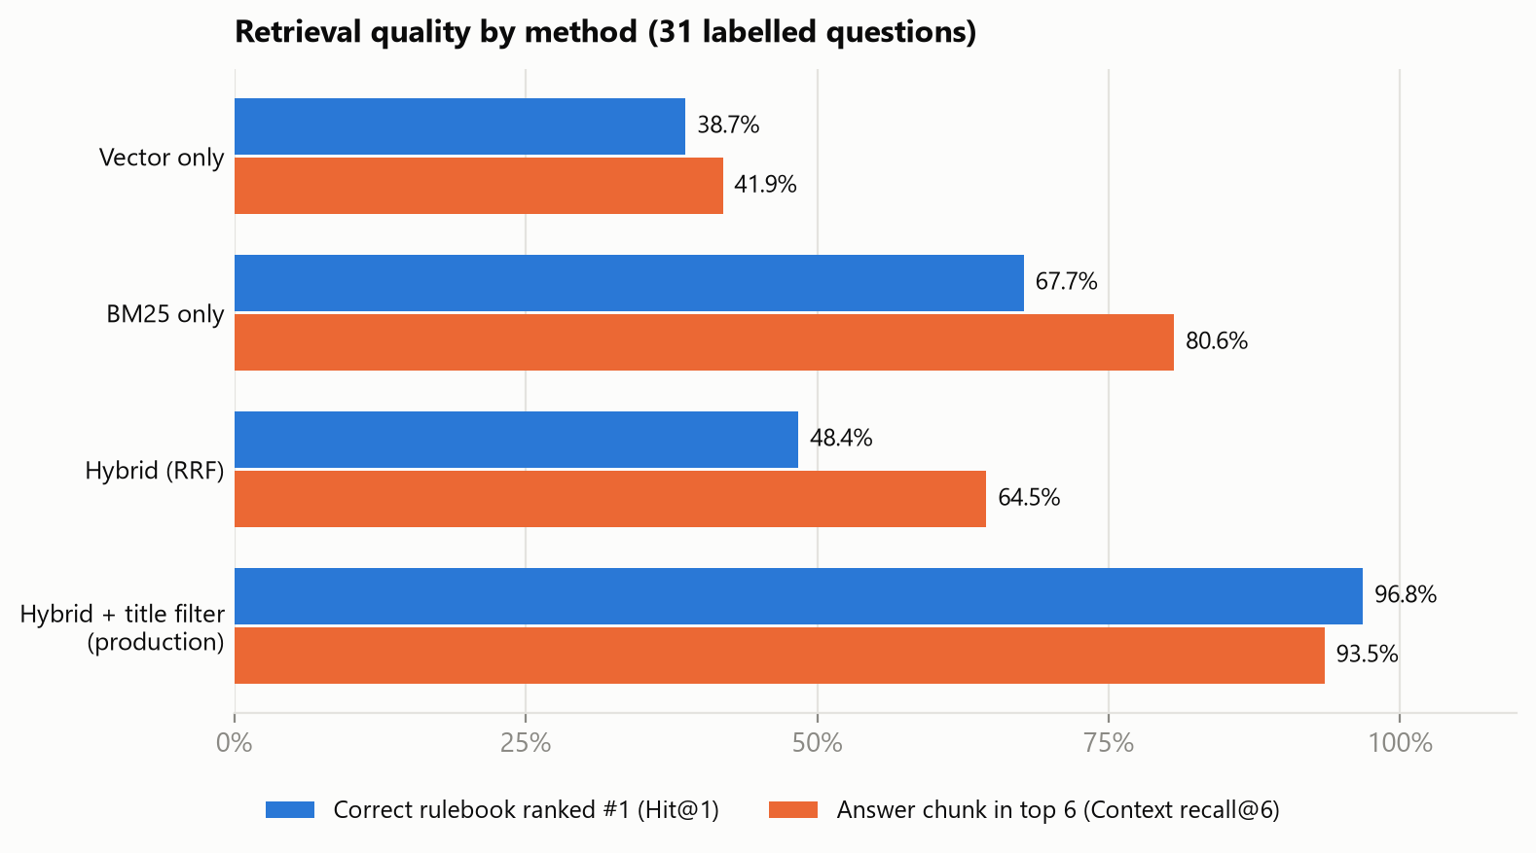
Figure 4. Retrieval quality of the four methods
- Vector search alone ranks the correct rulebook first only 38.7% of the time: the rulebooks share most of their vocabulary, and the bilingual UNO Flip text dilutes its embeddings.
- BM25 is much stronger here (80.6% recall@6) because questions use exact card names.
- Plain fusion (64.5%) is weaker than BM25 alone, because RRF rewards chunks that both lists agree on and the vector list is noisy.
- The rulebook filter fixes this: 96.8% Hit@1 and 93.5% recall@6, with 91.4% of retrieved chunks from the right rulebook. The two misses are explained in 13.6.

13.3 Relevance grader
Measure | Result
Chunks retrieved / kept per question (average) | 6 / 1.65
Share of retrieved chunks filtered out | 72.6%
Gold chunk kept when it was retrieved | 100%
Kept chunks that come from the correct rulebook | 100%
Questions with at least one chunk kept | 93.5%
Off-topic chunks rejected | 100% (36 chunks)

13.4 Router
Actual \ predicted | chitchat | rag
chitchat (small talk) | 16 | 0
rag (questions) | 0 | 42

Accuracy 100% on 58 messages; average routing time 0.98 s (p95 1.08 s).

13.5 End-to-end results
Group | Result | Mean | Median | p95
Rulebook questions | 93.5% correct · 96.8% cited correctly | 9.74 s | 8.88 s | 16.62 s
Off-topic questions | 100% refused (avg 2 rewrites) | 17.76 s | 17.62 s | 19.5 s
Small talk | 100% handled correctly | 3.96 s | 4 s | 4.27 s
Follow-ups (2nd turn) | 75% correct | 12.01 s | 9.99 s | 18.66 s

Accuracy by rulebook
Rulebook | Correct | Accuracy
UNO Dare | 6 / 6 | 100.0%
UNO No Mercy | 9 / 9 | 100.0%
UNO Flip | 6 / 8 | 75.0%
UNO All Wild | 6 / 6 | 100.0%
Any / not named | 2 / 2 | 100.0%

Other checks: 1 false refusal, 2 rulebook questions needed the rewrite loop, 0 answers contained markdown symbols, and 96.8% of answers cited only the correct rulebook.

13.6 Failure analysis
Question | Expected | Got | Root cause
How many cards are in UNO Flip? | 112 | 108 | Generation error. The gold chunk ('112 cards as follows') was retrieved and kept, but the model added up the card list itself instead of quoting the total. The chunk also contains print-specification noise.
How many points is the Skip Everyone card worth in UNO Flip? | 30 | Refusal | Retrieval miss. The scoring table is split across three chunks; the row 'Skip Everyone … 30 Points' (chunk 23) has no 'Scoring' heading and was not in the top 6. The grader correctly rejected the six chunks it did get, and two rewrites did not recover it.
Follow-up: 'How many points is it worth?' (after Skip Everyone) | 30 | Refusal | Same retrieval miss as above. The follow-up itself was rewritten correctly.

14. Limitations and recommendations
Issue | Impact | Recommendation
Tables split across chunks | Scoring rows lose their heading (1 question + 1 follow-up failed) | Keep each table in one chunk, or repeat the section heading at the top of every chunk
Model computes instead of quoting | 1 wrong total | Tell the prompt to quote totals verbatim; check numbers in the answer against the context
uno.pdf has no text layer for its rules | Classic UNO rules are only covered indirectly | Add OCR (e.g. Tesseract / OCRmyPDF) during ingest
Grader is the slowest step | 5.07 s of 9.74 s average | Grade all chunks in one prompt, use a small cross-encoder reranker, or a smaller grading model
Off-topic questions take longest | 17.76 s because of two rewrites | Have the router also detect clearly off-topic questions and refuse immediately
Rulebook filter uses keywords | 'flip the top card' could wrongly filter to UNO Flip | Require 'UNO Flip' / title-case match, or let the LLM pick the rulebook
Chat memory is in server RAM | History is lost on restart; not shared across workers | Use LangGraph's SQLite or Postgres checkpointer
Noise chunks remain | ~10 chunks are legal addresses / print specs | Filter address and spec blocks during cleaning
Memory use on a 16 GB laptop | qwen3.5:9b needs ~7.5 GB; a second Ollama server or a 16k context caused out-of-memory errors during testing | Keep LLM_NUM_CTX=8192, run a single Ollama server, or switch to a smaller model
Small, keyword-scored test set | Results are indicative, not statistically strong | Grow the test set; add LLM-as-judge or human review

15. How to run
# 1. Start Ollama (desktop app) and make sure the models exist
ollama pull qwen3.5:9b
ollama pull nomic-embed-text

# 2. Install dependencies
python -m venv .venv
.venv\Scripts\activate
pip install -r requirements.txt

# 3. Build the index and start the server
python -m app.ingest --reset
python -m app.main # chat UI: http://localhost:8000/ API docs: /docs

# 4. Re-run the evaluation (about 14 minutes)
python -m eval.run_eval # writes eval/results.json

Appendix A. Per-question results
Result of every end-to-end test in the evaluation run (✔ correct, ✘ wrong).
# | Type | Question | Rulebook | Result | Time | Rewrites
1 | Rulebook | How many cards are in the UNO Dare deck? | UNO Dare | ✔ | 7.6 s | 0
2 | Rulebook | What are the Dare List categories in UNO Dare? | UNO Dare | ✔ | 8 s | 0
3 | Rulebook | What happens when a Dare card is played in UNO Dare? | UNO Dare | ✔ | 16.9 s | 0
4 | Rulebook | How many points is a Wild Dare card worth in UNO Dare? | UNO Dare | ✔ | 7.9 s | 0
5 | Rulebook | What happens if a player fails a dare in UNO Dare? | UNO Dare | ✔ | 10.9 s | 0
6 | Rulebook | How many points do you need to win UNO Dare? | UNO Dare | ✔ | 11.2 s | 0
7 | Rulebook | How many cards are in UNO No Mercy? | UNO No Mercy | ✔ | 7.6 s | 0
8 | Rulebook | What is the Mercy rule in UNO No Mercy? | UNO No Mercy | ✔ | 10.3 s | 0
9 | Rulebook | How does stacking work in UNO No Mercy? | UNO No Mercy | ✔ | 14.3 s | 0
10 | Rulebook | What happens when you play a 7 in UNO No Mercy? | UNO No Mercy | ✔ | 9.4 s | 0
11 | Rulebook | What happens when a 0 is played in UNO No Mercy? | UNO No Mercy | ✔ | 8.9 s | 0
12 | Rulebook | What does the Wild Color Roulette card do? | UNO No Mercy | ✔ | 10.1 s | 0
13 | Rulebook | How many points do you get for knocking out a player in UNO No Mercy? | UNO No Mercy | ✔ | 7.9 s | 0
14 | Rulebook | How many points are needed to win UNO No Mercy when keeping score? | UNO No Mercy | ✔ | 9.8 s | 0
15 | Rulebook | What does the Discard All card do in UNO No Mercy? | UNO No Mercy | ✔ | 9.4 s | 0
16 | Rulebook | How many cards are in UNO Flip? | UNO Flip | ✘ | 11.2 s | 0
17 | Rulebook | What does the Flip card do in UNO Flip? | UNO Flip | ✔ | 10.8 s | 0
18 | Rulebook | What does the Draw Five card do in UNO Flip? | UNO Flip | ✔ | 8.5 s | 0
19 | Rulebook | What does the Skip Everyone card do in UNO Flip? | UNO Flip | ✔ | 8.7 s | 0
20 | Rulebook | How many points is the Wild Draw Color card worth in UNO Flip? | UNO Flip | ✔ | 7.7 s | 0
21 | Rulebook | In UNO Flip, what happens if you challenge a Wild Draw 2 and the player is innocent? | UNO Flip | ✔ | 8.8 s | 0
22 | Rulebook | What colors are on the dark side of UNO Flip? | UNO Flip | ✔ | 13.7 s | 1
23 | Rulebook | How many points is the Skip Everyone card worth in UNO Flip? | UNO Flip | ✘ | 16.6 s | 2
24 | Rulebook | How many cards are dealt to each player in UNO All Wild? | UNO All Wild | ✔ | 7.5 s | 0
25 | Rulebook | What does the Wild Skip Two card do in UNO All Wild? | UNO All Wild | ✔ | 7.7 s | 0
26 | Rulebook | What does the Wild Forced Swap card do? | UNO All Wild | ✔ | 9.1 s | 0
27 | Rulebook | What does the Wild Targeted Draw Two card do? | UNO All Wild | ✔ | 8.5 s | 0
28 | Rulebook | In UNO All Wild, do you need to match the color or number? | UNO All Wild | ✔ | 8.9 s | 0
29 | Rulebook | How many points do you need to win UNO All Wild? | UNO All Wild | ✔ | 7.3 s | 0
30 | Rulebook | What is the penalty for forgetting to call UNO? | Any / not named | ✔ | 8.2 s | 0
31 | Rulebook | Which card makes the next player draw until they get a chosen color? | Any / not named | ✔ | 8.9 s | 0
32 | Off-topic | What is the capital of France? | - | ✔ | 16.8 s | 2
33 | Off-topic | Who won the 2018 FIFA World Cup? | - | ✔ | 17.3 s | 2
34 | Off-topic | Write a Python function to reverse a string. | - | ✔ | 17.8 s | 2
35 | Off-topic | How do I bake a chocolate cake? | - | ✔ | 17.5 s | 2
36 | Off-topic | How does castling work in chess? | - | ✔ | 17.7 s | 2
37 | Off-topic | What is the boiling point of water? | - | ✔ | 19.5 s | 2
38 | Follow-up | What does the Skip Everyone card do in UNO Flip? >> How many points is it worth? | UNO Flip | ✘ | 18.7 s | 2
39 | Follow-up | How many cards are dealt in UNO No Mercy? >> Is it the same in UNO Dare? | UNO Dare | ✔ | 9.4 s | 0
40 | Follow-up | What is the Mercy rule in UNO No Mercy? >> How many points do you get for knocking someone out? | UNO No Mercy | ✔ | 9.7 s | 0
41 | Follow-up | What does the Wild Draw Color card do in UNO Flip? >> What happens if I challenge it and the player was innocent? | UNO Flip | ✔ | 10.3 s | 0

