# Metamask Setup

1. Download Metamask Extension at <https://metamask.io/>

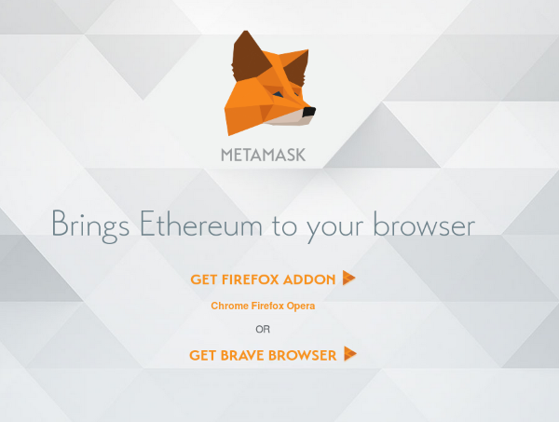

2. Create an Account

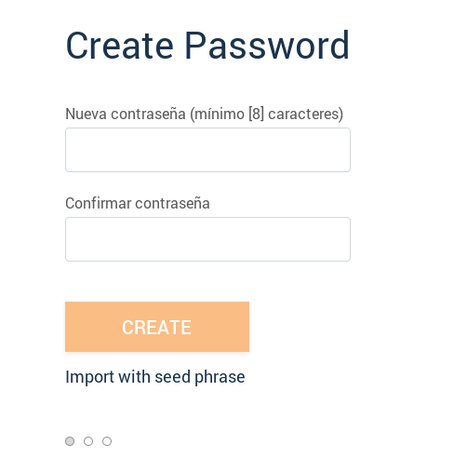

3. Download or save in a safe place your secret backup phrase

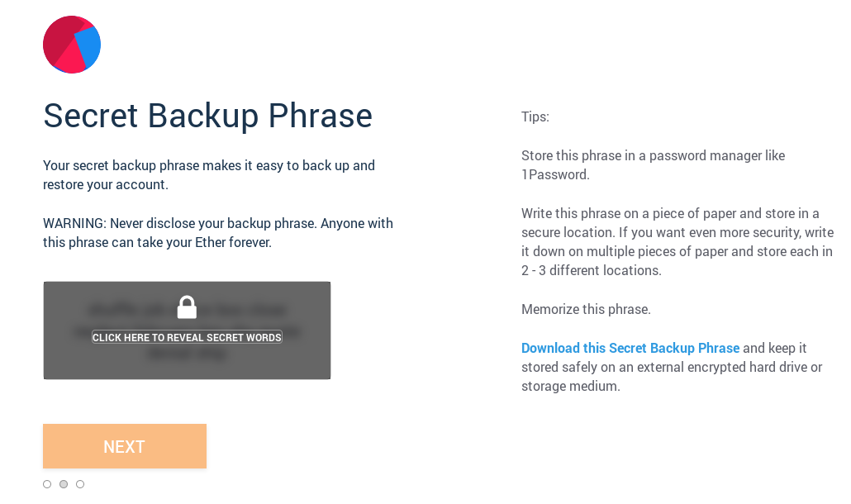

4. Log in to Metamask and select Rinkeby Testnet

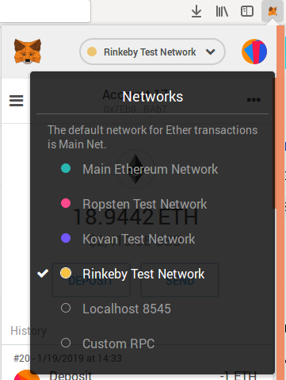

6. Copy address to clipboard

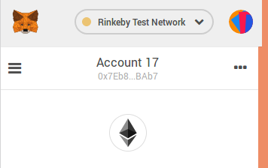

7. Send your address via twitter DM @wiblockchainbcn or meetup group “Women in Blockchain Barcelona (WIBB) and wait for your WIBB token transaction in the following hours/days

# WIBB DAO

1. Open WIBB DAO: [https://rinkeby.aragon.org/#/wibb.aragonid.eth/](https://rinkeby.aragon.org/" \l "/wibb.aragonid.eth/)

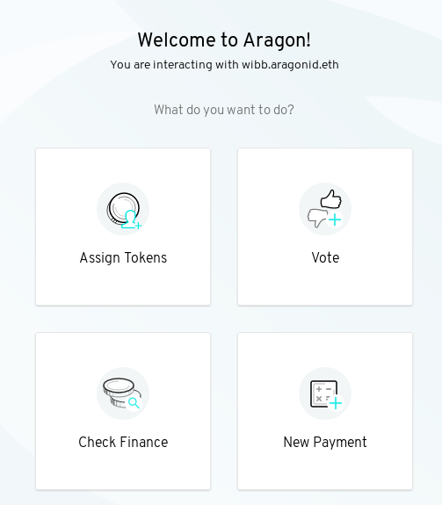

2. Select “Token Manager” on the left menu or “Assign Tokens” on the main page

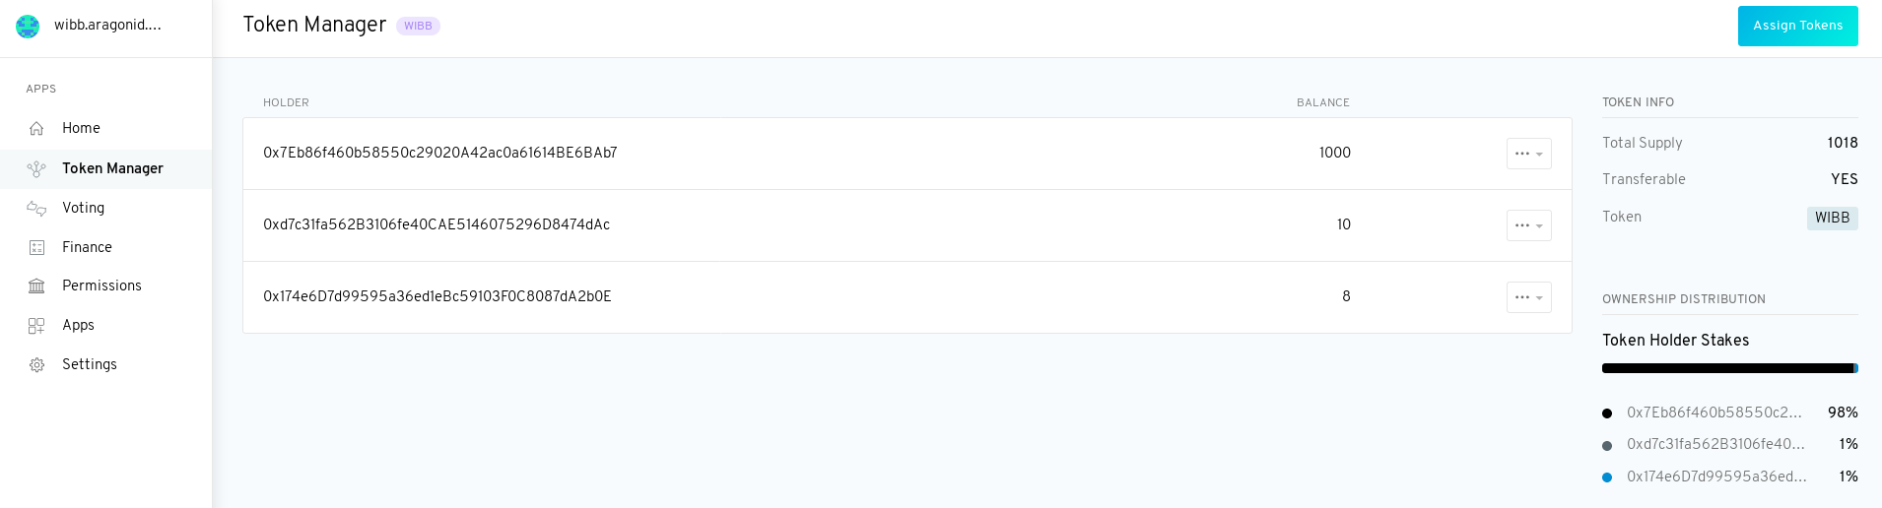

3. Check if your address is already with the token holders and see how many tokens you have. On your right menu you can also see the %of your stake and the rest of the member’s stakes.