House Price Regression

Suzanne

25 June 2017

## R Markdown

## Loading required package: lattice

##   
## Attaching package: 'caret'

## The following object is masked from 'package:purrr':  
##   
## lift

## [1] "PLOTTING character variables"

## [1] "1 plotting MSZoning"

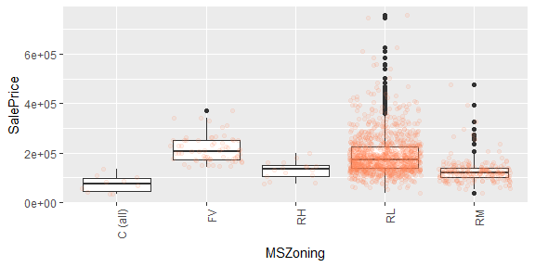

## [1] "2 plotting LotShape"

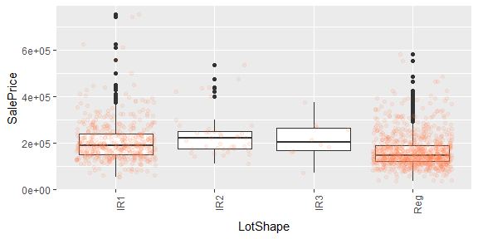

## [1] "3 plotting LotConfig"

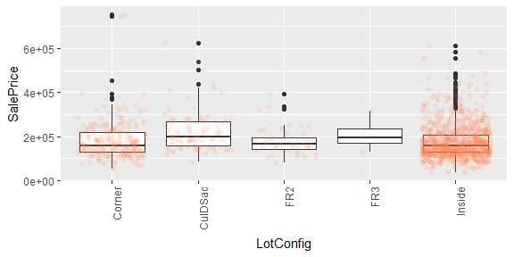

## [1] "4 plotting Neighborhood"

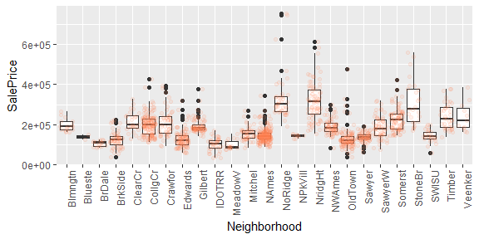

## [1] "5 plotting Condition1"

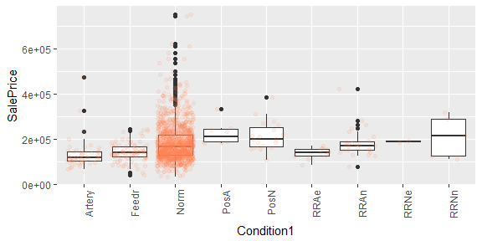

## [1] "6 plotting BldgType"

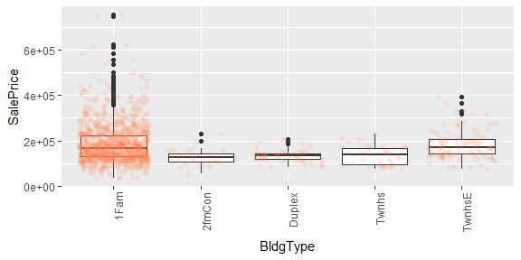

## [1] "7 plotting HouseStyle"

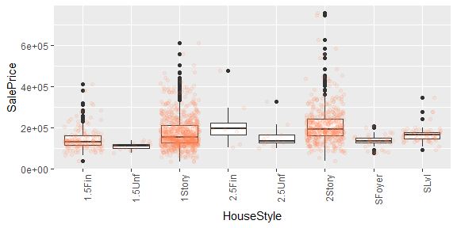

## [1] "8 plotting RoofStyle"

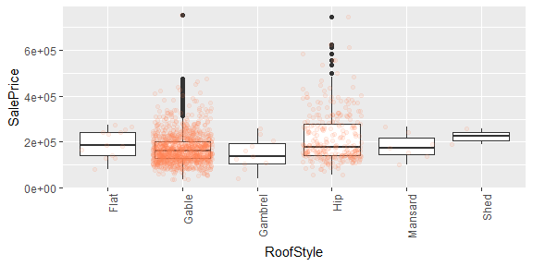

## [1] "9 plotting Exterior1st"

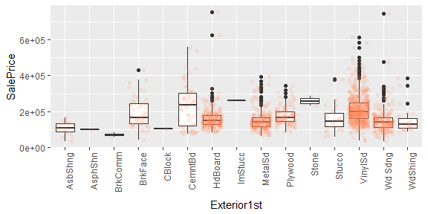

## [1] "10 plotting Exterior2nd"

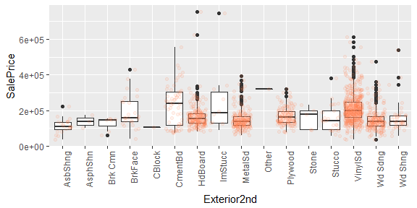

## [1] "11 plotting MasVnrType"

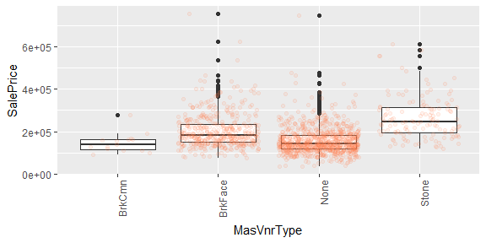

## [1] "12 plotting ExterQual"

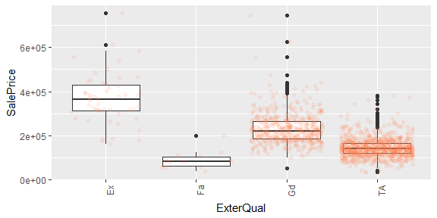

## [1] "13 plotting ExterCond"

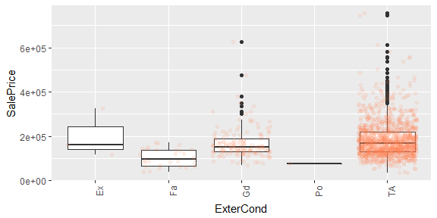

## [1] "14 plotting Foundation"

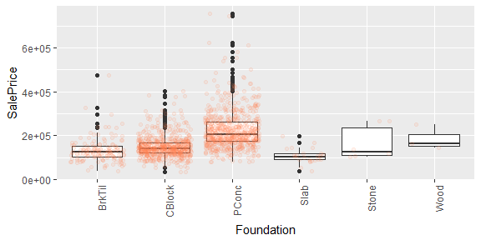

## [1] "15 plotting BsmtQual"

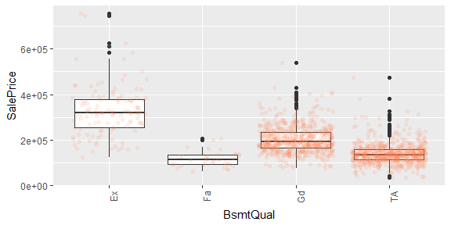

## [1] "16 plotting BsmtExposure"

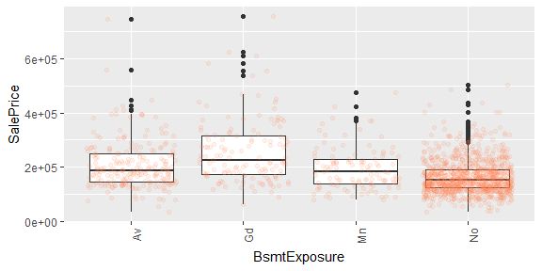

## [1] "17 plotting BsmtFinType1"

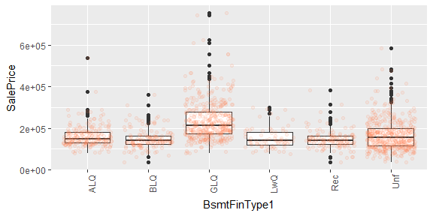

## [1] "18 plotting HeatingQC"

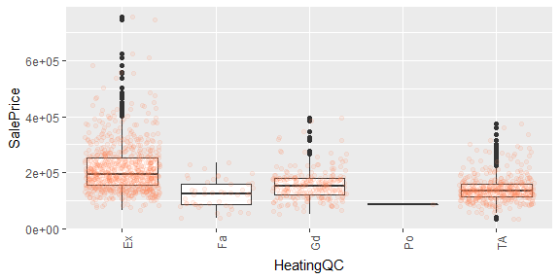

## [1] "19 plotting CentralAir"

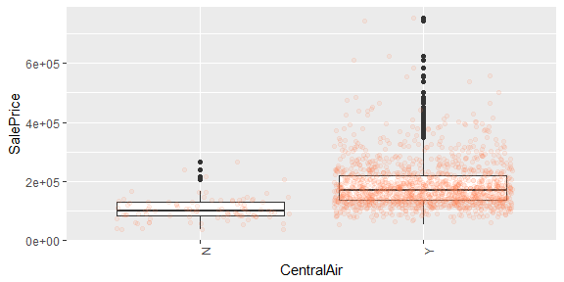

## [1] "20 plotting Electrical"

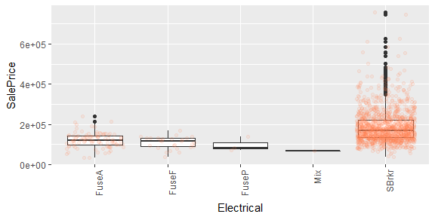

## [1] "21 plotting KitchenQual"

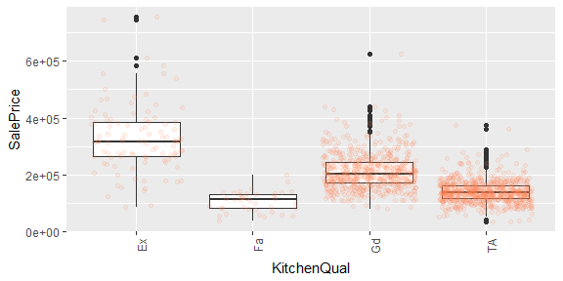

## [1] "22 plotting GarageType"

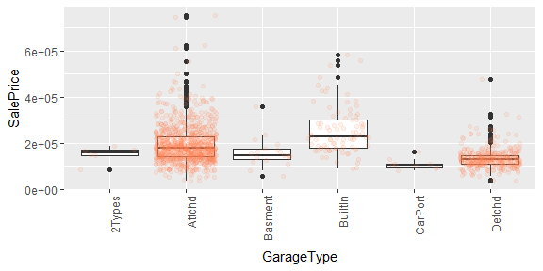

## [1] "23 plotting GarageFinish"

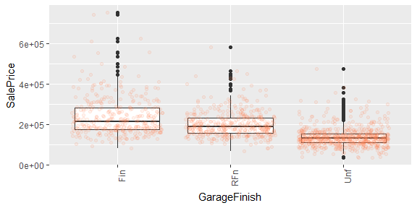

## [1] "24 plotting PavedDrive"

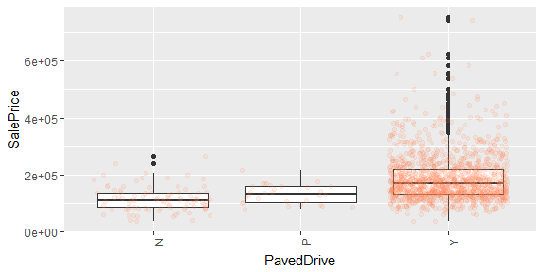

## [1] "25 plotting SaleType"

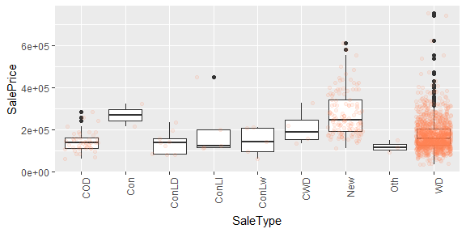

## [1] "26 plotting SaleCondition"

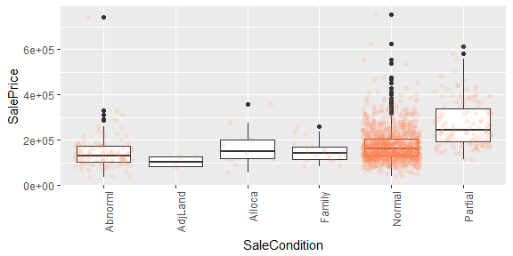

## [1] "PLOTTING numeric variables"

## [1] "1 plotting X"

## `geom_smooth()` using method = 'gam'

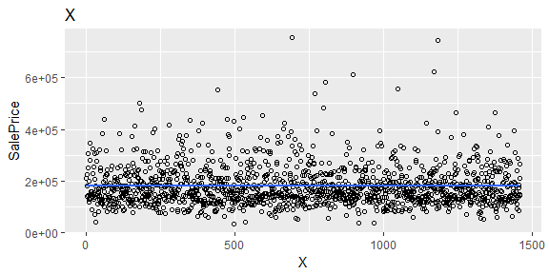

## [1] "2 plotting MSSubClass"

## `geom_smooth()` using method = 'gam'

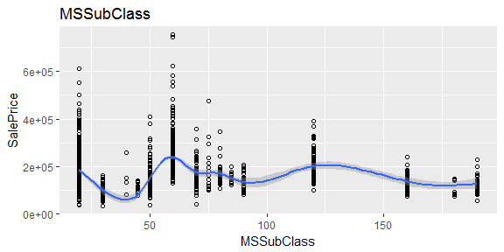

## [1] "3 plotting LotArea"

## `geom_smooth()` using method = 'gam'

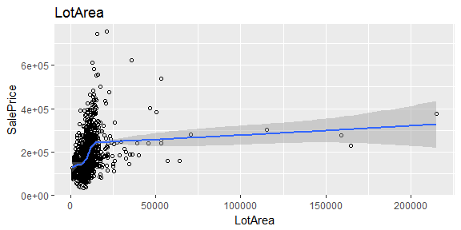

## [1] "4 plotting OverallQual"

## `geom_smooth()` using method = 'gam'

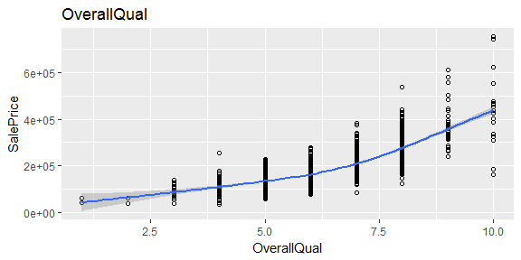

## [1] "5 plotting OverallCond"

## `geom_smooth()` using method = 'gam'

## Warning: Computation failed in `stat_smooth()`:  
## x has insufficient unique values to support 10 knots: reduce k.

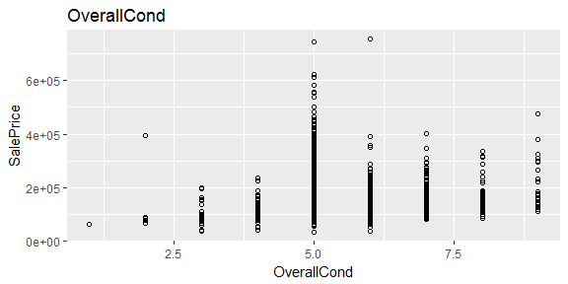

## [1] "6 plotting YearBuilt"

## `geom_smooth()` using method = 'gam'

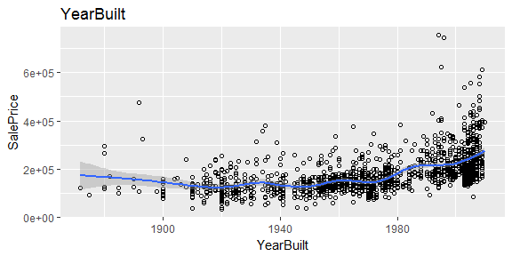

## [1] "7 plotting YearRemodAdd"

## `geom_smooth()` using method = 'gam'

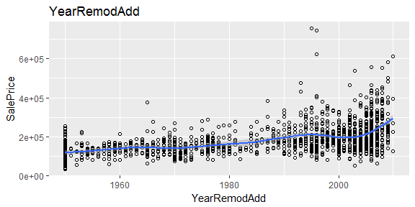

## [1] "8 plotting MasVnrArea"

## `geom_smooth()` using method = 'gam'

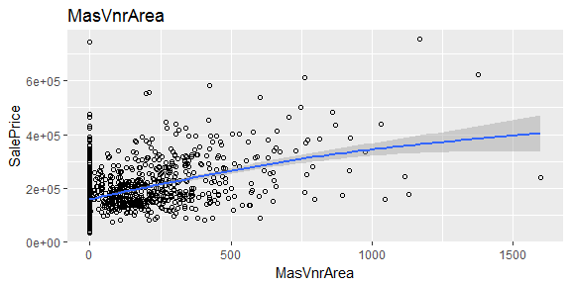

## [1] "9 plotting BsmtFinSF1"

## `geom_smooth()` using method = 'gam'

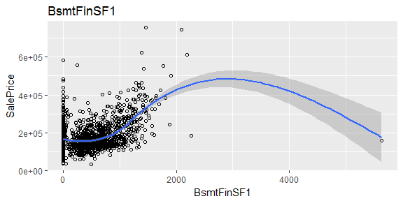

## [1] "10 plotting BsmtUnfSF"

## `geom_smooth()` using method = 'gam'

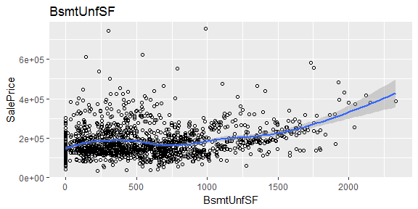

## [1] "11 plotting TotalBsmtSF"

## `geom_smooth()` using method = 'gam'

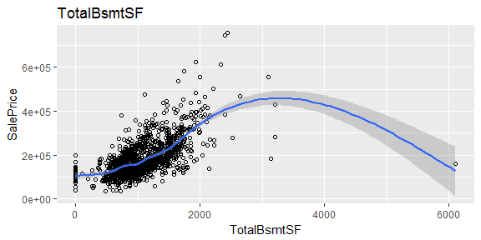

## [1] "12 plotting X1stFlrSF"

## `geom_smooth()` using method = 'gam'

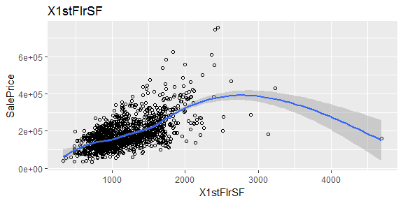

## [1] "13 plotting X2ndFlrSF"

## `geom_smooth()` using method = 'gam'

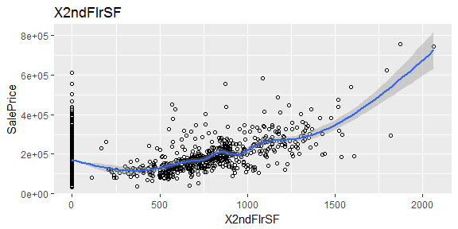

## [1] "14 plotting GrLivArea"

## `geom_smooth()` using method = 'gam'

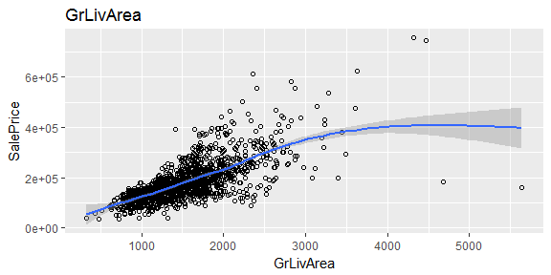

## [1] "15 plotting BsmtFullBath"

## `geom_smooth()` using method = 'gam'

## Warning: Computation failed in `stat_smooth()`:  
## x has insufficient unique values to support 10 knots: reduce k.

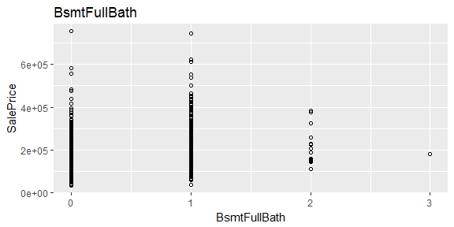

## [1] "16 plotting BsmtHalfBath"

## `geom_smooth()` using method = 'gam'

## Warning: Computation failed in `stat_smooth()`:  
## x has insufficient unique values to support 10 knots: reduce k.

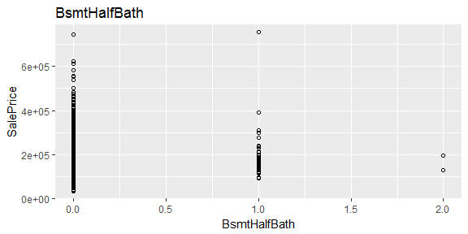

## [1] "17 plotting FullBath"

## `geom_smooth()` using method = 'gam'

## Warning: Computation failed in `stat_smooth()`:  
## x has insufficient unique values to support 10 knots: reduce k.

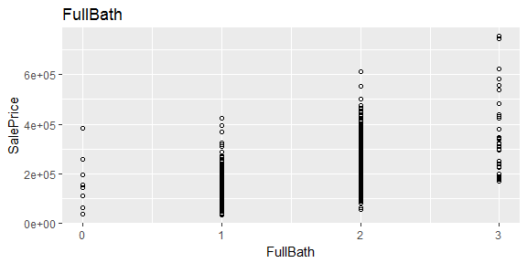

## [1] "18 plotting HalfBath"

## `geom_smooth()` using method = 'gam'

## Warning: Computation failed in `stat_smooth()`:  
## x has insufficient unique values to support 10 knots: reduce k.

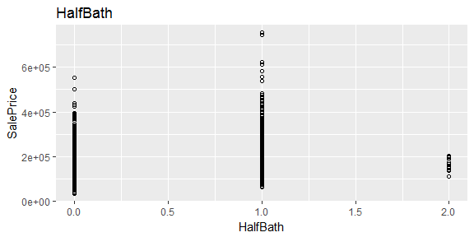

## [1] "19 plotting BedroomAbvGr"

## `geom_smooth()` using method = 'gam'

## Warning: Computation failed in `stat_smooth()`:  
## x has insufficient unique values to support 10 knots: reduce k.

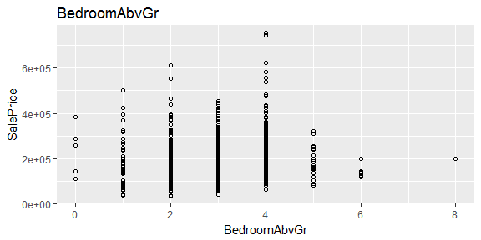

## [1] "20 plotting TotRmsAbvGrd"

## `geom_smooth()` using method = 'gam'

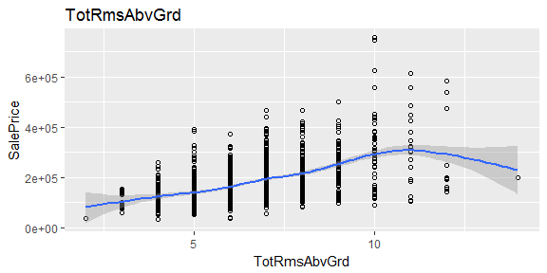

## [1] "21 plotting Fireplaces"

## `geom_smooth()` using method = 'gam'

## Warning: Computation failed in `stat_smooth()`:  
## x has insufficient unique values to support 10 knots: reduce k.

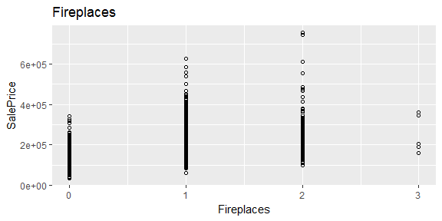

## [1] "22 plotting GarageCars"

## `geom_smooth()` using method = 'gam'

## Warning: Computation failed in `stat_smooth()`:  
## x has insufficient unique values to support 10 knots: reduce k.

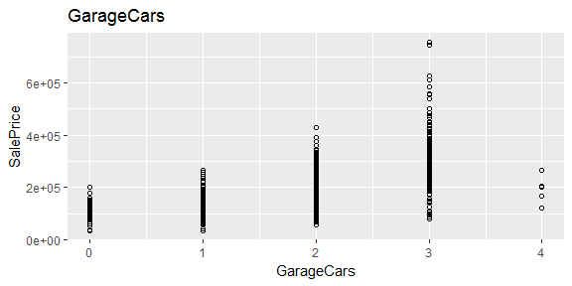

## [1] "23 plotting GarageArea"

## `geom_smooth()` using method = 'gam'

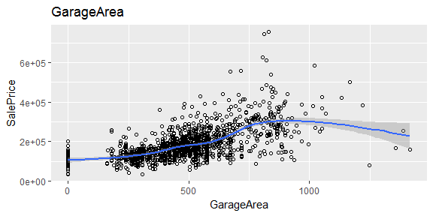

## [1] "24 plotting WoodDeckSF"

## `geom_smooth()` using method = 'gam'

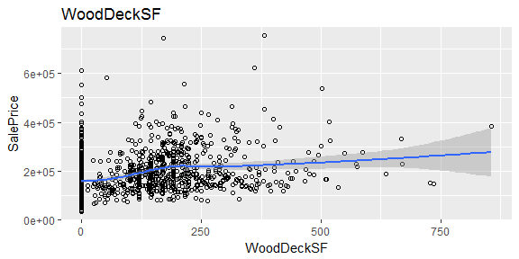

## [1] "25 plotting OpenPorchSF"

## `geom_smooth()` using method = 'gam'

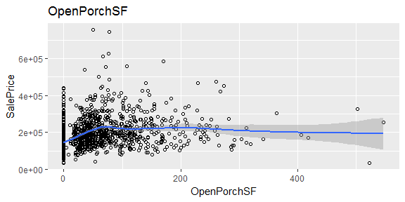

## [1] "26 plotting MoSold"

## `geom_smooth()` using method = 'gam'

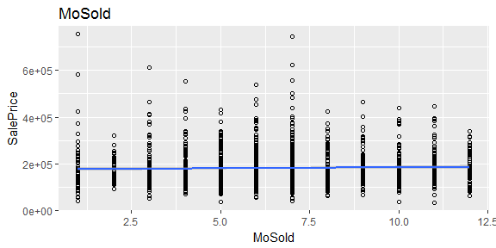

## [1] "27 plotting YrSold"

## `geom_smooth()` using method = 'gam'

## Warning: Computation failed in `stat_smooth()`:  
## x has insufficient unique values to support 10 knots: reduce k.

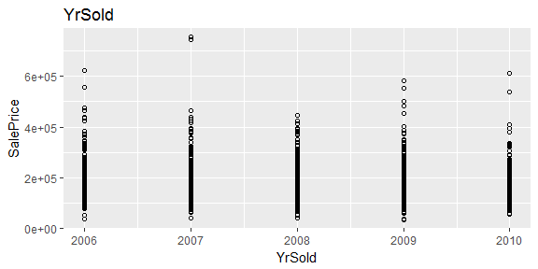

## [1] "28 plotting SalePrice"

## `geom_smooth()` using method = 'gam'

