FOR : **PERLITA V. PANGANIBAN**

Officer-In-Charge

Disaster Response and Management Bureau (DReMB)

IBP Road, Batasan Pambansa Complex, Constitution Hills

Quezon City

FROM : **THE OIC-REGIONAL DIRECTOR**

DSWD Field Office Caraga

R. Palma Street, Capitol Site, Butuan City

SUBJECT : **Terminal Report re: Tropical Storm (TS) “Basyang”**

DATE : **March 22, 2018**

Respectfully submitting herewith the above-mentioned subject to wit:

1. **Situation Overview**

Last **February 12, 2018**, **Tropical Storm (TS) “Basyang**” entered the Philippine Area of Responsibility (PAR), which affected the eastern part of Mindanao including **Caraga Region.** This opted some municipalities, especially in the province of Surigao del Sur to conduct a pre-emptive evacuation in order to ensure their peoples’ safety from impending disaster. However, the effect even intensifies when the storm made landfall in **Cortes, Surigao del Sur** last **February 13, 2018** at around **9:15 in the morning**, causing flashfloods and landslides to some municipalities in the region. This unfortunate event resulted to the displacement of thousands of families, damage to houses, properties and livelihood as well as took lives of few “Caraganons”.

1. **Number of Affected Local Government Units (LGUs)**

A total of four (**4**) provinces, thirty-five (**35**) municipalities, one (**1**) city and two-hundred six (**206**) barangays were affected by the onslaught of TS “Basyang”. With this, a total of one-hundred ninety-one (**191**) evacuation centers (EC) were activated. **(See table below)**

|  |  |  |  |
| --- | --- | --- | --- |
| **Province** | **Number of Affected City/Municipality** | **Number of Affected Barangays** | **Number of Activated ECs** |
| Agusan del Norte | 6 | 16 | 11 |
| Surigao del Norte | 13 | 137 | 140 |
| Surigao del Sur | 12 | 40 | 22 |
| Dinagat Islands | 5 | 13 | 18 |
| **TOTAL** | **36** | **206** | **191** |

1. **Status of Displacement**

TS “Basyang” has brought so much flooding in some of the cities/municipalities in the region. This lead the families to seek temporary shelter in nearby evacuation centers in their locality, others also temporarily stayed with their friends/relatives’ houses.

Per data gathered, a total of twenty-one thousand five-hundred-five (**21,505**) families or ninety-two-thousand nine-hundred-seven (**92,907**) persons were displaced. Twelve-thousand eight-hundred five (**12,805**) families or fifty-three thousand five-hundred eighty-one (**53,581**) persons were served inside evacuation centers and eight-thousand seven-hundred (**8,700**) families or thirty-nine thousand three-hundred twenty-six (**39,326**) persons were served outside evacuation centers. **(See attached DROMIC Statistical Report)**

At present, one (**1**) evacuation center is still open in the municipality of **Carrascal, Surigao del Sur** with two-hundred thirteen (**213**) families or eight-hundred five (**805**) persons. According to the information coming from the SWAD-Team Leader (SWAD-TL) of Surigao del Sur, it would take two – three months before the families can leave the evacuation center since their houses were damaged and they can’t find any place to stay. In addition, their LGU is already looking for a resettlement site to transfer the evacuees temporarily and advised them not to go back to their place due to landslide.

Moreover, as per report of the SWAD-TL of Surigao del Sur, the LGU of Carrascal, Surigao del Sur shoulders the needs of the evacuees since they have the capacity and resources to assist the affected families who are still inside the evacuation center.

1. **Status of Damages**

TS “Basyang”, on the other hand, did not only resulted to the displacement of thousands of families. Due to flashfloods and landslides, hundreds of houses in the region were reported as damaged.

Per data gathered, a total of one-thousand nine-hundred thirty-six (**1,936**) were reported as damaged houses with three-hundred seventy-eight (**378**) as totally damaged and one-thousand five-hundred fifty-eight (**1,558**) as partially damaged. **(See attached DROMIC Statistical Report)**

1. **Status of Augmentation and Cost of Assistance**

The affected LGUs provided a total of **PhP 3,677,267.25** worth of assistanceto support the needs of the affected families in their respective municipalities. **(See attached DROMIC Statistical Report)**

On the other hand, DSWD FO Caraga has augmented a total of **PhP 6,253,053.00** worth of food and non-food assistance to the affected families in different municipalities. This includes **11,163 Family Food Packs (FFPs)** amounting to **PhP 3,333,372.98** and other food and non-food items such as **1Liter Distilled Water, Blankets, Laminated Sacks (cut), Plastic Mats, Mosquito Nets, “Malongs”** and **Dignity Kits** amounting to **PhP 2,919,680.02**. **(See table below)**

|  |  |  |  |
| --- | --- | --- | --- |
| **Province/City/Municipality** | **Food and Non-Food Assistance** | **Quantity** | **Amount (PhP)** |
| **SURIGAO DEL NORTE** | | | **3,866,858.00** |
| Bacuag | Blanket | 16 | 960.00 |
| Laminated Sack (cut) | 16 | 6,956.00 |
| Plastic Mat | 16 | 2,404.00 |
| Mosquito Net | 16 | 2,639.52 |
| Malong | 210 | 52,500.00 |
| Gigaquit | **Family Food Pack** | **1,350** | **391,608.00** |
| Dignity Kit | 300 | 187,140.00 |
| Malong | 990 | 247,500.00 |
| Plastic Mat | 990 | 148,747.50 |
| Mainit | **Family Food Pack** | **1,000** | **290,080.00** |
| Malong | 1,000 | 250,000.00 |
| Plastic Mat | 1,000 | 150,250.00 |
| Dignity Kit | 1,000 | 623,800.00 |
| Blanket | 1,000 | 60,000.00 |
| Malimono | **Family Food Pack** | **1,699** | **521,830.86** |
| Blanket | 500 | 30,000.00 |
| Sison | **Family Food Pack** | **1,364** | **395,669.12** |
| Laminated Sack (cut) | 120 | 52,170.00 |
| 1 Liter Distilled Water | 2,000 | 29,100.00 |
| Dignity Kit | 240 | 149,712.00 |
| Blanket | 500 | 30,000.00 |
| Plastic Mat | 500 | 75,125.00 |
| Malong | 500 | 125,000.00 |
| Dignity Kit | 70 | 43,666.00 |
| **SURIGAO DEL SUR** | | | **2,386,195.00** |
| Cantilan | **Family Food Pack** | **4,250** | **1,305,345.00** |
| Carrascal | **Family Food Pack** | **1,500** | **428,840.00** |
| Blanket | 500 | 57,500.00 |
| Mosquito Net | 500 | 82,485.00 |
| Malong | 500 | 125,000.00 |
| Dignity Kit | 500 | 311,900.00 |
| Plastic Mat | 500 | 75,125.00 |
| **FFPs (Number and Cost)** |  | **11,163** | **3,333,372.98** |
| **OTHER FNFI (Cost)** |  |  | **2,919,680.02** |
| **GRAND-TOTAL** |  |  | **6,253,053.00** |

In addition, DSWD FO Caraga has provided **13,845 FFPs** worth **PhP 4,252,353.30** to the affected communities to support their Food-for-Work activities as part of early recovery and rehabilitation efforts in lieu of rendering community service such as cleaning the surroundings, declogging of canals and repairing some damages brought by TS Basyang. **(See table below)**

|  |  |  |  |
| --- | --- | --- | --- |
| **City/Municipality** | **Number of Families** | **Number of FFPs** | **Amount (PhP)** |
| Kitcharao, Agusan del Norte | 1,348 | 4,044 | 1,242,074.16 |
| Bacuag, Surigao del Norte | 2,143 | 6,429 | 1,974,603.06 |
| Malimono, Surigao del Norte | 58 | 174 | 53,442.36 |
| Cantilan, Surigao del Sur | 3,198 | 3,198 | 982,233.72 |
| **TOTAL** | **6,747** | **13,845** | **4,252,353.30** |

1. **Graph of Affected LGUs with Reported Displacement**

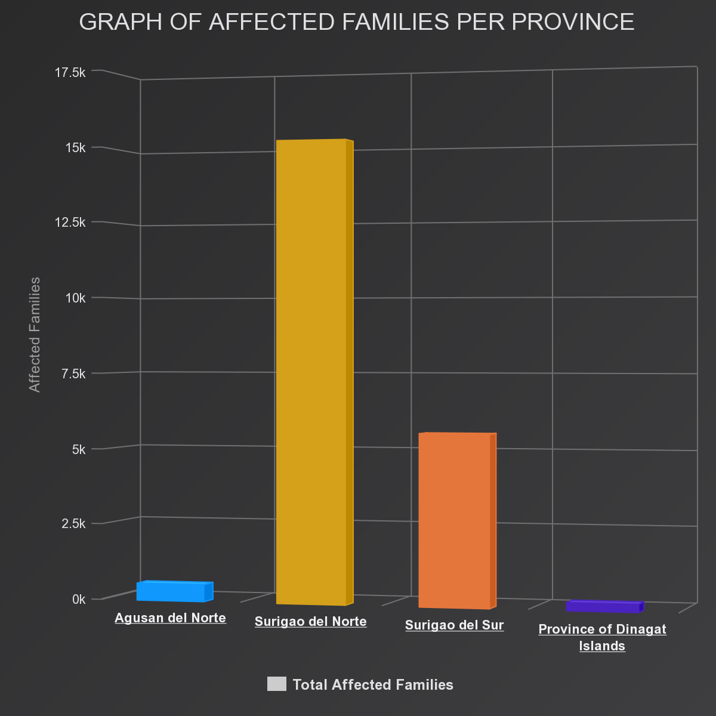

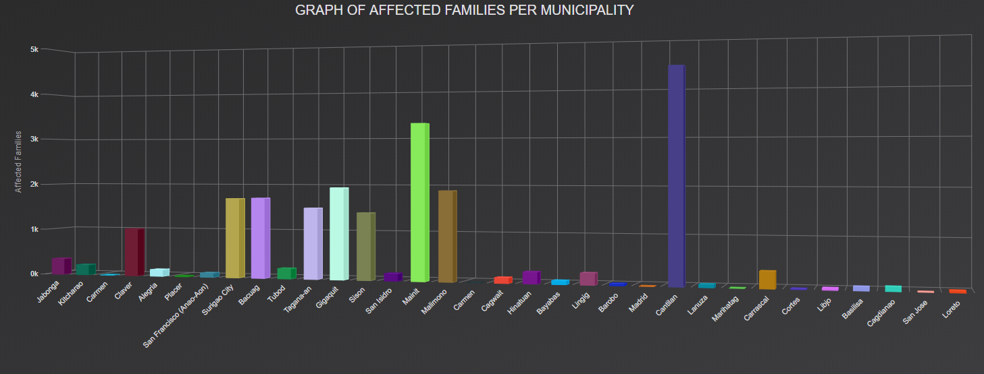

1. **Map of Affected LGUs with Reported Displacement**

The image below shows the map of affected LGUs with reported displacement.

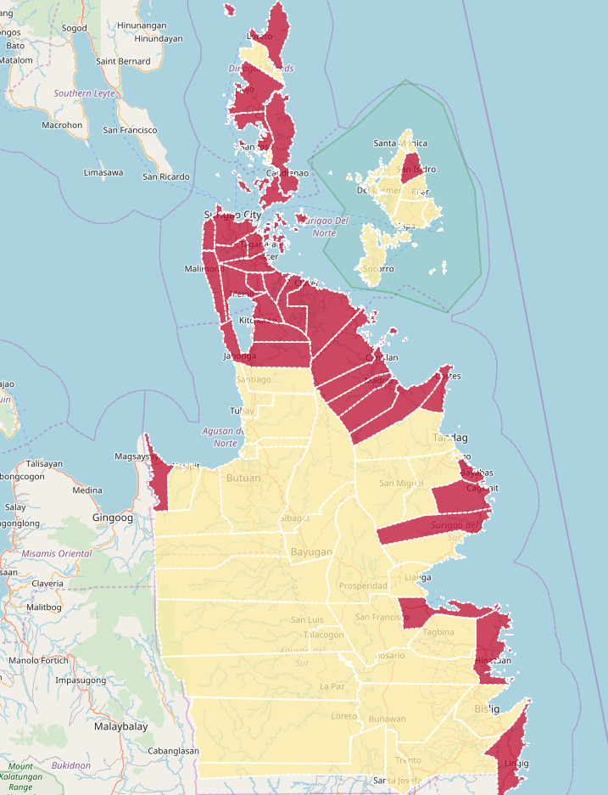

**-** **With Displacement** **- No Displacement**

1. **Ways Forward**

The following are the next steps and actions to be conducted by the Field Office to the TS “Basyang” victims under the rehabilitation phase.

* Finalization of the submission of the Project Proposals by the affected LGUs for Emergency Shelter Assistance (ESA) and Cash-for-Work (CFW) Assistance.
* Conduct an orientation on ESA and CFW to the host LGUs.
* Conduct ESA and CFW implementation based on the agreed schedules.
* Conduct monitoring to ESA and CFW beneficiaries.

For your information and ready reference.

**MITA CHUCHI GUPANA- LIM**