A
PROJECT REPORT
ON
Shihui’s Garbage recovery
SYSTEM
For
Partial Fulfillment of Degree
Master of computer application
Submitted
By
(Team Name | Wonder Four)
(leader)Zhang Zeyao8J94MTCJ103
Zhang YinfanR8J9400190
Cheng ZhongR8J9400193
Li ShihuiR8J9400176

Internal Guide External Guide BLESSY THAKACHAN Mr. Peter Parker
Head of IT Department Head of Computer Science
MIT IIT


Indian Institute of Technology Delhi

项目指标

S no. | Particulars | Page no.
1 | Team description
2 | Software requirements analysis
3 | External development of software
4 | Internal development of software
5 | Login module
6 | Registration module
7 | Information query module
8 | Waste inquiry module
9 | Waste recycling module
10 | Waste sale module
11 | Database and flow chart introduction
12 | Source code

Project indicator
S no. | Particulars | Page no.
1 | Team description
2 | Software requirements analysis
3 | External development of software
4 | Internal development of software
5 | Login module
6 | Registration module
7 | Information query module
8 | Waste inquiry module
9 | Waste recycling module
10 | Waste sale module
11 | Database and flow chart introduction
12 | Source code

Team description:
Our team's overall strength is not very strong, but we are also using our own efforts to complete this project little by little, everyone has paid their own sweat.
Software requirements analysis
Nowadays, with the improvement of people's living standards, daily garbage and industrial waste are also increasing. However, traditional paper waste sorting cannot be classified quickly and easily. The projects we developed are designed to be good for recycling, reselling, etc. It has two functions of selling and buying, and supports two major categories of metal and non-metallic garbage. At the same time, you can customize the purchase or sale of the specified garbage according to the user's needs. It can be said that it greatly facilitates the efficiency of successful reuse of recyclable waste.
1. Time savings: Traditional garbage collection systems can only be sorted by garbage, but when people need to reuse them, it is difficult to screen out the specified types of recycled goods that they need. This is very time consuming. And our project stores information through the database, which means that the original cumbersome information can be processed faster, saving more time.
2. Online transactions between sellers and sellers: Our project supports the sellers and sellers in the platform, they can find the news posted by the other party on the platform, such as the number of contacts or the number of transactions.
3. Simple operating system: When we log in to the app, we only need to perform a simple registration and can use it.

Software Design
In our products, there are several designs:
External design
2. Internal design
External design: We have added systems such as purchase and sale to our products, which makes our products more optimized and more comprehensive.
Internal design: We use JDBC and many of the features in JAVA to implement functionality.

Module introduction
We use the following modules in our products:

Login module
2. Registration module
3. Information query module
4. Waste recycling module
5. Waste Selling Module

Login module
This module ensures that all access to the system is correct and authenticated. All links and navigation paths can be used to manipulate any type of information only after the authorized person enters a valid set of user IDs and passwords. Therefore, this module serves as the entry point to the system and only authorized personnel can access it.

Registration module
When the user has not been authorized to log in, the user can be authorized by the registration module. If the username and password are saved to the database, then the next time the user needs to log in, they can log in directly using their authorized username and password.

Information query module
After the user successfully logs in to the interface, the user can see an information query module. The module includes information from existing databases and stored information. In this way, the user can directly see the addition and information of various recyclable garbage.

Waste recycling module
Our users can also make purchases when they access the information. Because the user is in the previous module and has access to the information of the garbage he is interested in, such as price and quantity. So in this module, users can purchase directly according to their needs. After the payment is successful, the purchase record will also be saved in the database.

Waste sale module
The module corresponding to the garbage collection, the user can also play the role of a seller, selling their own garbage according to their own needs and market conditions, of course, these two functions do not interfere with each other for the same user.
一. Database view introduction
- metal
Field | Type | Null | Key | Default | Extra
Id | int(11) | NO | PRI | NULL | auto_increment
GarbageName | varchar(50) | YES |  | NULL
UnitPrice_gram | double | YES |  | NULL
Quantity_kilogram | double | YES |  | NULL
Seller | varchar(50) | YES |  | NULL
SellTime | date | YES |  | NULL
About | varchar(255) | YES |  | NULL
- Nonmetal
Field | Type | Null | Key | Default | Extra
Id | int(11) | NO | PRI | NULL | auto_increment
GarbageName | varchar(50) | YES |  | NULL
UnitPrice_gram | double | YES |  | NULL
Quantity_kilogram | double | YES |  | NULL
Seller | varchar(50) | YES |  | NULL
SellTime | date | YES |  | NULL
About | varchar(255) | YES |  | NULL
- Login
Field | Type | Null | Key | Default | Extra
UserName | varchar(20) | YES |  | NULL
Password | varchar(20) | YES |  | NULL
PhoneNumber | varchar(20) | YES |  | NULL
Email | varchar(20) | YES |  | NULL
- logindnt
Field | Type | Null | Key | Default | Extra
LoginDate | date | YES |  | NULL
LoginTime | timestamp | YES |  | NULL
- metalloid
Field | Type | Null | Key | Default | Extra
GarbageName | varchar(50) | YES |  | NULL
UnitPrice_gram | double | YES |  | NULL
Quantity_kilogram | double | YES |  | NULL
Seller | varchar(50) | YES |  | NULL
SellTime | date | YES |  | NULL
About | varchar(255) | YES |  | NULL
- user
Field | Type | Null | Key | Default | Extra
UserName | varchar(20) | NO | PRI | NULL
Password | varchar(20) | YES | UNI | NULL
Age | int(11) | YES |  | NULL
DateOfBirth | date | YES |  | NULL
Email | varchar(20) | YES | UNI | NULL
Country | char(11) | YES |  | NULL
Address | varchar(40) | YES |  | NULL
Salary | double | YES |  | NULL
二.数据库介绍
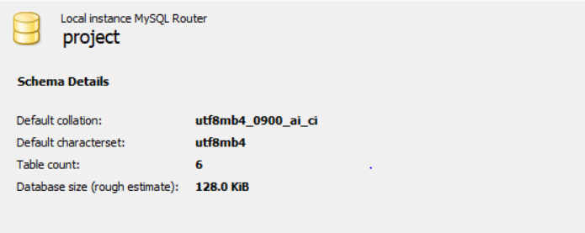
三.use case diagram
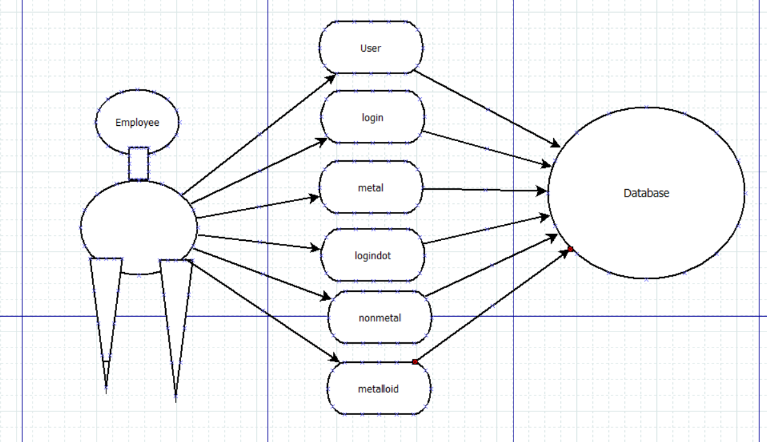
四. Run screenshot
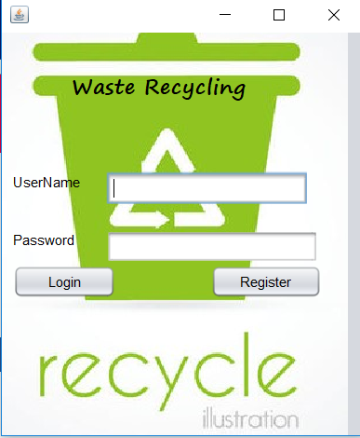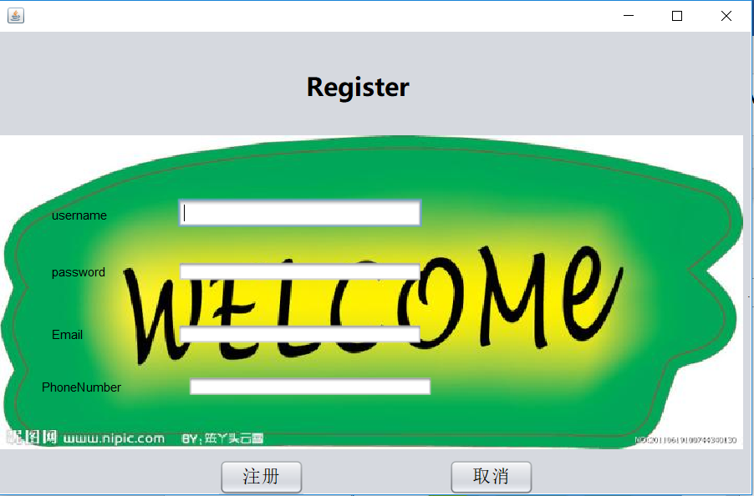

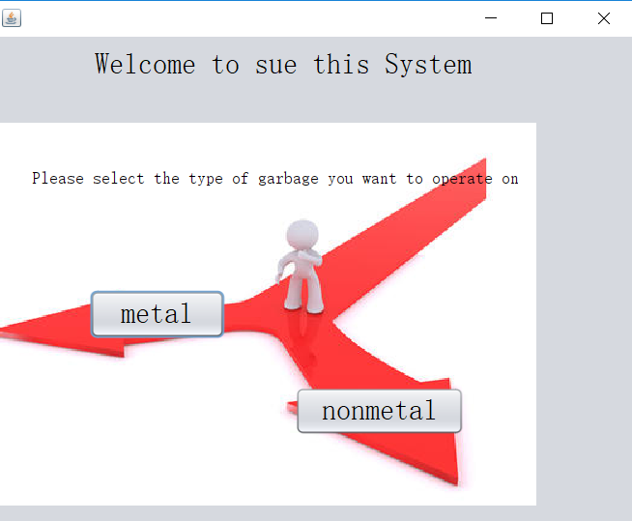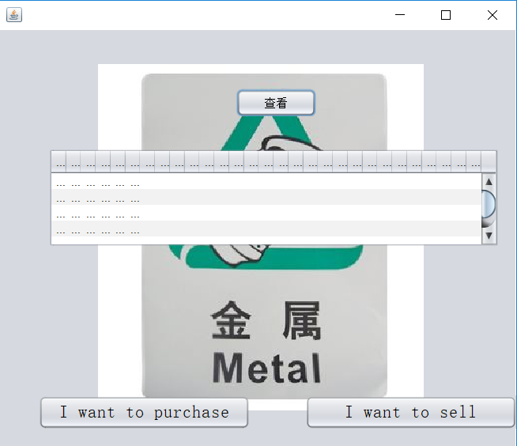

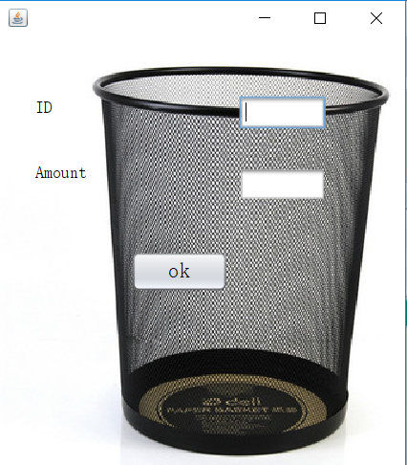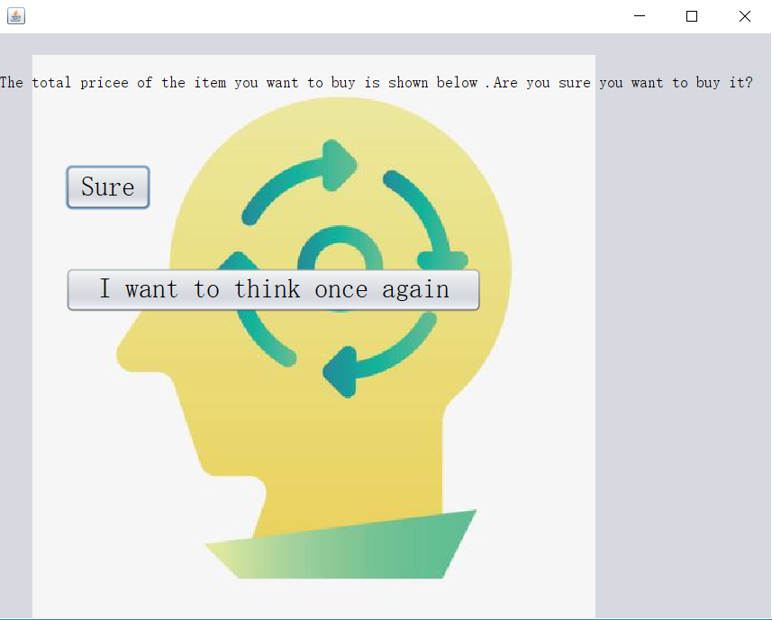
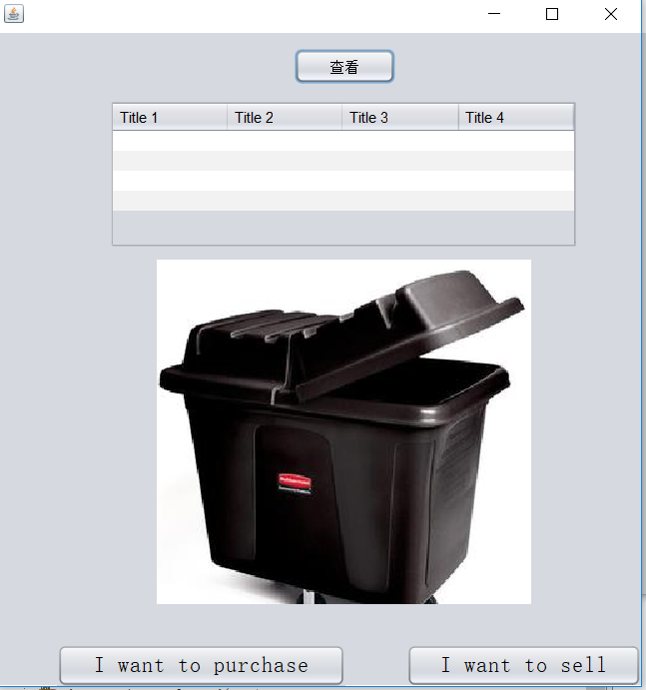
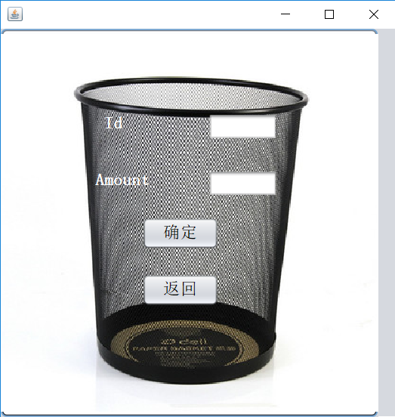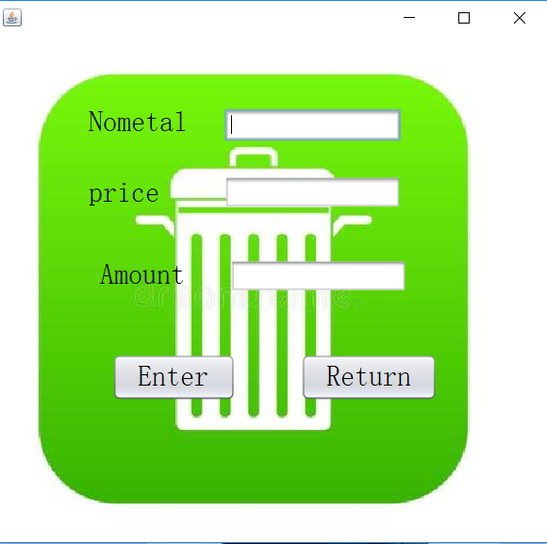
五.CODE
Code of Login.java
package wasterecycling;
import java.sql.*;
import javax.swing.JOptionPane;
public class Login extends javax.swing.JFrame {
PreparedStatement pst;
ResultSet rs;

public Login() {
initComponents();
}
@SuppressWarnings("unchecked")
// <editor-fold defaultstate="collapsed" desc="Generated Code">
private void initComponents() {

jLabel1 = new javax.swing.JLabel();
jLabel2 = new javax.swing.JLabel();
jLabel3 = new javax.swing.JLabel();
u1 = new javax.swing.JTextField();
p1 = new javax.swing.JPasswordField();
btn1 = new javax.swing.JButton();
jButton2 = new javax.swing.JButton();
jLabel4 = new javax.swing.JLabel()
setDefaultCloseOperation(javax.swing.WindowConstants.EXIT_ON_CLOSE);
getContentPane().setLayout(new org.netbeans.lib.awtextra.AbsoluteLayout());
jLabel1.setFont(new java.awt.Font("Segoe Print", 1, 18)); // NOI18N
jLabel1.setText("Waste Recycling");
getContentPane().add(jLabel1, new org.netbeans.lib.awtextra.AbsoluteConstraints(60, 30, 185, -1));

jLabel2.setText("UserName");
getContentPane().add(jLabel2, new org.netbeans.lib.awtextra.AbsoluteConstraints(10, 120, 77, -1));
jLabel3.setText("Password");
getContentPane().add(jLabel3, new org.netbeans.lib.awtextra.AbsoluteConstraints(10, 170, 58, -1));
getContentPane().add(u1, new org.netbeans.lib.awtextra.AbsoluteConstraints(90, 120, 173, -1));
p1.addActionListener(new java.awt.event.ActionListener() {

public void actionPerformed(java.awt.event.ActionEvent evt) {
p1ActionPerformed(evt);
}
});
getContentPane().add(p1, new org.netbeans.lib.awtextra.AbsoluteConstraints(90, 170, 182, -1));

btn1.setText("Login");
btn1.addActionListener(new java.awt.event.ActionListener() {
public void actionPerformed(java.awt.event.ActionEvent evt) {
btn1ActionPerformed(evt);
}
});
getContentPane().add(btn1, new org.netbeans.lib.awtextra.AbsoluteConstraints(10, 200, 88, -1));
jButton2.setText("Register");
jButton2.addActionListener(new java.awt.event.ActionListener() {
public void actionPerformed(java.awt.event.ActionEvent evt) {
jButton2ActionPerformed(evt);
}
});
getContentPane().add(jButton2, new org.netbeans.lib.awtextra.AbsoluteConstraints(180, 200, 95, -1));
jLabel4.setIcon(new javax.swing.ImageIcon(getClass().getResource("/picture/登陆.jpg"))); // NOI18N
getContentPane().add(jLabel4, new org.netbeans.lib.awtextra.AbsoluteConstraints(0, -20, 310, -1));
pack();
}// </editor-fold>
private void p1ActionPerformed(java.awt.event.ActionEvent evt) {
}
private void jButton2ActionPerformed(java.awt.event.ActionEvent evt) {
RegisterJFrame re=new RegisterJFrame();
re.setVisible(true);
dispose();
}
private void btn1ActionPerformed(java.awt.event.ActionEvent evt) {
if(evt.getSource()==btn1)
{
try
{
jdbc a=new jdbc();
Connection con=a.getConnection()
String sql = "select * from Login where UserName=? and Password=?";
pst=con.prepareStatement(sql);
pst.setString(1,u1.getText());
pst.setString(2,p1.getText());
rs=pst.executeQuery();
if(u1.getText().length()==0)
{
JOptionPane.showMessageDialog(this, "Empty User Name","Warning",JOptionPane.WARNING_MESSAGE);
}
else if(p1.getPassword().length==0)
{
JOptionPane.showMessageDialog(this, "Empty Password","Warning",JOptionPane.WARNING_MESSAGE);
}
else if (rs.next())
{
Selection s= new Selection();
s.show();
//s.setVisible(true);
//dispose();
}
else
{
JOptionPane.showMessageDialog(this, "Incorrect User Name or Password","Error",JOptionPane.ERROR_MESSAGE);
}
}
catch(Exception e)
{
JOptionPane.showMessageDialog(this, e);
}
}
}
/**
* @param args the command line arguments
*/
public static void main(String args[]) {
/* Set the Nimbus look and feel */
//<editor-fold defaultstate="collapsed" desc=" Look and feel setting code (optional) ">
/* If Nimbus (introduced in Java SE 6) is not available, stay with the default look and feel.
* For details see http://download.oracle.com/javase/tutorial/uiswing/lookandfeel/plaf.html
*/
try {
for (javax.swing.UIManager.LookAndFeelInfo info : javax.swing.UIManager.getInstalledLookAndFeels()) {
if ("Nimbus".equals(info.getName())) { javax.swing.UIManager.setLookAndFeel(info.getClassName());
break;
}
}
} catch (ClassNotFoundException ex) { java.util.logging.Logger.getLogger(Login.class.getName()).log(java.util.logging.Level.SEVERE, null, ex);
} catch (InstantiationException ex) { java.util.logging.Logger.getLogger(Login.class.getName()).log(java.util.logging.Level.SEVERE, null, ex);
} catch (IllegalAccessException ex) {
java.util.logging.Logger.getLogger(Login.class.getName()).log(java.util.logging.Level.SEVERE, null, ex);
} catch (javax.swing.UnsupportedLookAndFeelException ex) { java.util.logging.Logger.getLogger(Login.class.getName()).log(java.util.logging.Level.SEVERE, null, ex);
}
//</editor-fold>

/* Create and display the form */
java.awt.EventQueue.invokeLater(new Runnable() {
public void run() {
new Login().setVisible(true);
}
});
}
// Variables declaration - do not modify
private javax.swing.JButton btn1;
private javax.swing.JButton jButton2;
private javax.swing.JLabel jLabel1;
private javax.swing.JLabel jLabel2;
private javax.swing.JLabel jLabel3;
private javax.swing.JLabel jLabel4;
private javax.swing.JPasswordField p1;
private javax.swing.JTextField u1;
// End of variables declaration
}
Code of metal.java
package wasterecycling;
import java.sql.Connection;
import java.sql.DriverManager;
import java.sql.ResultSet;
import java.sql.ResultSetMetaData;
import java.sql.SQLException;
import java.sql.Statement;
import java.util.logging.Level;
import java.util.logging.Logger;
import javax.swing.JOptionPane;
import javax.swing.table.DefaultTableModel;
public class Metal extends javax.swing.JFrame {
public String[] a;
public Metal() {
initComponents();
try {
jdbc j4 = new jdbc();
Connection connect = j4.getConnection();
Statement statement = connect.createStatement();
ResultSet rs = statement.executeQuery("select * from Metal ");
ResultSetMetaData rsmd = rs.getMetaData();
int columnCount = rsmd.getColumnCount();
DefaultTableModel tm = (DefaultTableModel) jt.getModel();
tm.setColumnCount(0);
tm.setRowCount(0);
while (rs.next()) {
for (int i = 1; i <= 6; i++) {
tm.addColumn(rsmd.getColumnName(i));
a = new String[columnCount];
for (int s = 0; s < columnCount; s++) {
a[s] = rs.getString(s + 1);
}
}
tm.addRow(a);
}
tm.fireTableDataChanged();
rs.close();
statement.close();
connect.close();
} catch (SQLException e) {
e.printStackTrace();
}
}
@SuppressWarnings("unchecked")
// <editor-fold defaultstate="collapsed" desc="Generated Code">
private void initComponents() {

jButton1 = new javax.swing.JButton();
jButton2 = new javax.swing.JButton();
jScrollPane2 = new javax.swing.JScrollPane();
jt = new javax.swing.JTable();
jButton3 = new javax.swing.JButton();
jLabel1 = new javax.swing.JLabel();
jLabel2 = new javax.swing.JLabel();

setDefaultCloseOperation(javax.swing.WindowConstants.EXIT_ON_CLOSE);
getContentPane().setLayout(new org.netbeans.lib.awtextra.AbsoluteLayout());

jButton1.setFont(new java.awt.Font("宋体", 0, 18)); // NOI18N
jButton1.setText("I want to purchase");
jButton1.setToolTipText("");
jButton1.addActionListener(new java.awt.event.ActionListener() {
public void actionPerformed(java.awt.event.ActionEvent evt) {
jButton1ActionPerformed(evt);
}
});
getContentPane().add(jButton1, new org.netbeans.lib.awtextra.AbsoluteConstraints(40, 370, 214, -1));

jButton2.setFont(new java.awt.Font("宋体", 0, 18)); // NOI18N
jButton2.setText("I want to sell");
jButton2.addActionListener(new java.awt.event.ActionListener() {
public void actionPerformed(java.awt.event.ActionEvent evt) {
jButton2ActionPerformed(evt);
}
});
getContentPane().add(jButton2, new org.netbeans.lib.awtextra.AbsoluteConstraints(310, 370, 214, -1));

jt.setModel(new javax.swing.table.DefaultTableModel(
new Object [][] {
{null, null, null, null, null, null, null},
{null, null, null, null, null, null, null},
{null, null, null, null, null, null, null},
{null, null, null, null, null, null, null}
},
new String [] {
"Title 1", "Title 2", "Title 3", "Title 4", "Title 5", "Title 6", "Title 7"
}
));
jt.addAncestorListener(new javax.swing.event.AncestorListener() {
public void ancestorAdded(javax.swing.event.AncestorEvent evt) {
jtAncestorAdded(evt);
}
public void ancestorMoved(javax.swing.event.AncestorEvent evt) {
}
public void ancestorRemoved(javax.swing.event.AncestorEvent evt) {
}
});
jScrollPane2.setViewportView(jt);

getContentPane().add(jScrollPane2, new org.netbeans.lib.awtextra.AbsoluteConstraints(50, 120, -1, 100));

jButton3.setText("查看");
jButton3.addActionListener(new java.awt.event.ActionListener() {
public void actionPerformed(java.awt.event.ActionEvent evt) {
jButton3ActionPerformed(evt);
}
});
getContentPane().add(jButton3, new org.netbeans.lib.awtextra.AbsoluteConstraints(240, 60, 81, -1));
getContentPane().add(jLabel1, new org.netbeans.lib.awtextra.AbsoluteConstraints(286, 754, 42, -1));

jLabel2.setIcon(new javax.swing.ImageIcon(getClass().getResource("/picture/Metal.jpg"))); // NOI18N
jLabel2.setText("jLabel2");
getContentPane().add(jLabel2, new org.netbeans.lib.awtextra.AbsoluteConstraints(100, 20, 330, 380));

pack();
}// </editor-fold>

private void jButton1ActionPerformed(java.awt.event.ActionEvent evt) {
Metalpurchase mp = new Metalpurchase();
mp.show();
}

private void jButton2ActionPerformed(java.awt.event.ActionEvent evt) {
metalsell2 ms = new metalsell2();
ms.show();
ms.setVisible(true);
}

private void jButton3ActionPerformed(java.awt.event.ActionEvent evt) {
try {
jdbc j4 = new jdbc();
Connection connect = j4.getConnection();
Statement statement = connect.createStatement();
ResultSet rs = statement.executeQuery("select * from Metal ");
ResultSetMetaData rsmd = rs.getMetaData();
int columnCount = rsmd.getColumnCount();
DefaultTableModel tm = (DefaultTableModel) jt.getModel();
tm.setColumnCount(0);
tm.setRowCount(0);
while (rs.next()) {
for (int i = 1; i <= 6; i++) {
tm.addColumn(rsmd.getColumnName(i));
a = new String[columnCount];
for (int s = 0; s < columnCount; s++) {
a[s] = rs.getString(s + 1);
}
}
tm.addRow(a);
}
} catch (SQLException e) {
e.printStackTrace();
}
}

private void jtAncestorAdded(javax.swing.event.AncestorEvent evt) {

}
public void main(String args[]) {
/* Set the Nimbus look and feel */
//<editor-fold defaultstate="collapsed" desc=" Look and feel setting code (optional) ">
/* If Nimbus (introduced in Java SE 6) is not available, stay with the default look and feel.
* For details see http://download.oracle.com/javase/tutorial/uiswing/lookandfeel/plaf.html
*/
try {
for (javax.swing.UIManager.LookAndFeelInfo info : javax.swing.UIManager.getInstalledLookAndFeels()) {
if ("Nimbus".equals(info.getName())) {
javax.swing.UIManager.setLookAndFeel(info.getClassName());
break;
}
}
} catch (ClassNotFoundException ex) {
java.util.logging.Logger.getLogger(Metal.class.getName()).log(java.util.logging.Level.SEVERE, null, ex);
} catch (InstantiationException ex) {
java.util.logging.Logger.getLogger(Metal.class.getName()).log(java.util.logging.Level.SEVERE, null, ex);
} catch (IllegalAccessException ex) {
java.util.logging.Logger.getLogger(Metal.class.getName()).log(java.util.logging.Level.SEVERE, null, ex);
} catch (javax.swing.UnsupportedLookAndFeelException ex) {
java.util.logging.Logger.getLogger(Metal.class.getName()).log(java.util.logging.Level.SEVERE, null, ex);
}
java.awt.EventQueue.invokeLater(new Runnable() {
public void run() {
new Metal().setVisible(true);
}
});
}
// Variables declaration - do not modify
private javax.swing.JButton jButton1;
private javax.swing.JButton jButton2;
private javax.swing.JButton jButton3;
private javax.swing.JLabel jLabel1;
private javax.swing.JLabel jLabel2;
private javax.swing.JScrollPane jScrollPane2;
public javax.swing.JTable jt;
// End of variables declaration
}
Code of Metalpurchase.java
package wasterecycling;
import java.sql.*;
import java.util.logging.Level;
import java.util.logging.Logger;
import javax.swing.JTextField;
public class Metalpurchase extends javax.swing.JFrame {
static PreparedStatement ps;
static ResultSet rs;
JTextField text =new JTextField();
public Metalpurchase() {
initComponents();
}
@SuppressWarnings("unchecked")
// <editor-fold defaultstate="collapsed" desc="Generated Code">
private void initComponents() {

jLabel1 = new javax.swing.JLabel();
jLabel2 = new javax.swing.JLabel();
m1 = new javax.swing.JTextField();
m2 = new javax.swing.JTextField();
jButton1 = new javax.swing.JButton();
jLabel3 = new javax.swing.JLabel();

setDefaultCloseOperation(javax.swing.WindowConstants.EXIT_ON_CLOSE);
getContentPane().setLayout(new org.netbeans.lib.awtextra.AbsoluteLayout());

jLabel1.setFont(new java.awt.Font("宋体", 0, 14)); // NOI18N
jLabel1.setText("ID");
getContentPane().add(jLabel1, new org.netbeans.lib.awtextra.AbsoluteConstraints(30, 40, 60, 40));

jLabel2.setFont(new java.awt.Font("宋体", 0, 14)); // NOI18N
jLabel2.setText("Amount");
getContentPane().add(jLabel2, new org.netbeans.lib.awtextra.AbsoluteConstraints(30, 90, 60, 50));

m1.addActionListener(new java.awt.event.ActionListener() {
public void actionPerformed(java.awt.event.ActionEvent evt) {
m1ActionPerformed(evt);
}
});
getContentPane().add(m1, new org.netbeans.lib.awtextra.AbsoluteConstraints(200, 50, 73, -1));
getContentPane().add(m2, new org.netbeans.lib.awtextra.AbsoluteConstraints(200, 110, 73, -1));

jButton1.setFont(new java.awt.Font("宋体", 0, 18)); // NOI18N
jButton1.setText("ok");
jButton1.addActionListener(new java.awt.event.ActionListener() {
public void actionPerformed(java.awt.event.ActionEvent evt) {
jButton1ActionPerformed(evt);
}
});
getContentPane().add(jButton1, new org.netbeans.lib.awtextra.AbsoluteConstraints(110, 180, 81, -1));

jLabel3.setIcon(new javax.swing.ImageIcon(getClass().getResource("/picture/Metalpurchase.jpg"))); // NOI18N
jLabel3.setText("jLabel3");
getContentPane().add(jLabel3, new org.netbeans.lib.awtextra.AbsoluteConstraints(0, 0, 340, 360));

pack();
}// </editor-fold>

private void jButton1ActionPerformed(java.awt.event.ActionEvent evt) {

Surepurchase1 as=new Surepurchase1();
as.setVisible(true);

String drivername="com.mysql.cj.jdbc.Driver";
String url="jdbc:mysql://localhost:3306/Project?characterEncoding=utf8&serverTimezone=UTC";
String username="root";
String password="niit1234";
Connection con = null;
PreparedStatement ps;
ResultSet rs = null;
try{
Class.forName(drivername);
// System.out.println("数据库驱动加载成功");

} catch (ClassNotFoundException ex) {
ex.printStackTrace();
}
try{
con = DriverManager.getConnection(url, username, password);
// System.out.println("数据库连接成功");

} catch (SQLException ex) {
ex.printStackTrace();
}
String str=m1.getText();
int i=Integer.parseInt(str);
String str2=m2.getText();
int i2=Integer.parseInt(str2);
try {

PreparedStatement ps1=con.prepareStatement("select GarbageName from metal where Id=i");
ResultSet rs1=ps1.executeQuery();
String str3=rs1.getString("GarbageName");

PreparedStatement ps2=con.prepareStatement("select Quantity_kilogram metal where Id=i");
ResultSet rs2=ps2.executeQuery();
String str4=rs2.getString("Quantity_kilogram");

PreparedStatement ps3=con.prepareStatement("select Unitprice_gram from metal where Id=i");
ResultSet rs3=ps3.executeQuery();
String str5=rs3.getString("Unitprice_gram");
int i3=Integer.parseInt(str4);
int i4=Integer.parseInt(str5);
int sum;
sum=i2*i4;
int cha=i3-i2;
PreparedStatement ps4=con.prepareStatement("Update Metal set Quantity_kilogram=cha where Id=i");
ResultSet rs4=ps4.executeQuery();

if(cha==0)
{
PreparedStatement ps5=con.prepareStatement("delete from metal where id=i");
ResultSet rs5=ps5.executeQuery();
}

ps4.setString(1,text.getText());
int result= ps4.executeUpdate();
System.out.println(result);

} catch (SQLException ex) {
Logger.getLogger(Metalpurchase.class.getName()).log(Level.SEVERE, null, ex);
}
}

private void m1ActionPerformed(java.awt.event.ActionEvent evt) {
// TODO add your handling code here:
}

public static void main(String args[]) {
java.awt.EventQueue.invokeLater(new Runnable() {
public void run() {
new Metalpurchase().setVisible(true);
}
});
}

// Variables declaration - do not modify
private javax.swing.JButton jButton1;
private javax.swing.JLabel jLabel1;
private javax.swing.JLabel jLabel2;
private javax.swing.JLabel jLabel3;
private javax.swing.JTextField m1;
private javax.swing.JTextField m2;
// End of variables declaration
}
Code of Nomepurchase.java
package wasterecycling;
import static java.awt.SystemColor.text;
import java.sql.*;
import java.sql.Connection;
import java.sql.DriverManager;
import java.sql.PreparedStatement;
import java.sql.ResultSet;
import java.sql.SQLException;
import java.util.logging.Level;
import java.util.logging.Logger;
public class Nomepurchase extends javax.swing.JFrame {
static PreparedStatement ps,ps2;
static ResultSet rs,rs2;
public Nomepurchase() {
initComponents();
}

@SuppressWarnings("unchecked")
// <editor-fold defaultstate="collapsed" desc="Generated Code">
private void initComponents() {

jLabel3 = new javax.swing.JLabel();
jLabel1 = new javax.swing.JLabel();
m1 = new javax.swing.JTextField();
jLabel2 = new javax.swing.JLabel();
m2 = new javax.swing.JTextField();
jButton1 = new javax.swing.JButton();
jButton2 = new javax.swing.JButton();
jButton3 = new javax.swing.JButton();

jLabel3.setIcon(new javax.swing.ImageIcon(getClass().getResource("/picture/Money.jpg"))); // NOI18N
jLabel3.setText("jLabel3");

setDefaultCloseOperation(javax.swing.WindowConstants.EXIT_ON_CLOSE);
getContentPane().setLayout(new org.netbeans.lib.awtextra.AbsoluteLayout());

jLabel1.setFont(new java.awt.Font("宋体", 1, 18)); // NOI18N
jLabel1.setForeground(new java.awt.Color(255, 255, 255));
jLabel1.setText("Id");
getContentPane().add(jLabel1, new org.netbeans.lib.awtextra.AbsoluteConstraints(110, 90, 90, -1));
getContentPane().add(m1, new org.netbeans.lib.awtextra.AbsoluteConstraints(220, 90, 73, -1));

jLabel2.setFont(new java.awt.Font("宋体", 1, 18)); // NOI18N
jLabel2.setForeground(new java.awt.Color(255, 255, 255));
jLabel2.setText("Amount");
getContentPane().add(jLabel2, new org.netbeans.lib.awtextra.AbsoluteConstraints(100, 150, 320, -1));
getContentPane().add(m2, new org.netbeans.lib.awtextra.AbsoluteConstraints(220, 150, 73, -1));

jButton1.setFont(new java.awt.Font("宋体", 0, 18)); // NOI18N
jButton1.setText("确定");
jButton1.addActionListener(new java.awt.event.ActionListener() {
public void actionPerformed(java.awt.event.ActionEvent evt) {
jButton1ActionPerformed(evt);
}
});
getContentPane().add(jButton1, new org.netbeans.lib.awtextra.AbsoluteConstraints(150, 200, 81, -1));

jButton2.setFont(new java.awt.Font("宋体", 0, 18)); // NOI18N
jButton2.setText("返回");
jButton2.addActionListener(new java.awt.event.ActionListener() {
public void actionPerformed(java.awt.event.ActionEvent evt) {
jButton2ActionPerformed(evt);
}
});
getContentPane().add(jButton2, new org.netbeans.lib.awtextra.AbsoluteConstraints(150, 260, 81, -1));

jButton3.setIcon(new javax.swing.ImageIcon(getClass().getResource("/picture/Metalpurchase.jpg"))); // NOI18N
getContentPane().add(jButton3, new org.netbeans.lib.awtextra.AbsoluteConstraints(0, 0, 400, -1));

pack();
}// </editor-fold>

private void jButton1ActionPerformed(java.awt.event.ActionEvent evt) {
Surepurchase2 s=new Surepurchase2();
s.setVisible(true);
String drivername="com.mysql.cj.jdbc.Driver";
String url="jdbc:mysql://localhost:3306/Project?characterEncoding=utf8&serverTimezone=UTC";
String username="root";
String password="niit1234";
java.sql.Connection con = null;
try{
Class.forName(drivername);
// System.out.println("数据库驱动加载成功");

} catch (ClassNotFoundException ex) {
ex.printStackTrace();
}
try{
con = DriverManager.getConnection(url, username, password);
// System.out.println("数据库连接成功");
} catch (SQLException ex) {
ex.printStackTrace();
}
String str=m1.getText();
int i=Integer.parseInt(str);
String str2=m2.getText();
int i2=Integer.parseInt(str2);
try {

PreparedStatement ps1=con.prepareStatement("select GarbageName from metal where Id=i");
ResultSet rs1=ps1.executeQuery();
String str3=rs1.getString("GarbageName");
PreparedStatement ps2=con.prepareStatement("select Quantity_kilogram metal where Id=i");
ResultSet rs2=ps2.executeQuery();
String str4=rs2.getString("Quantity_kilogram");

PreparedStatement ps3=con.prepareStatement("select Unitprice_gram from metal where Id=i");
ResultSet rs3=ps3.executeQuery();
String str5=rs3.getString("Unitprice_gram");

int i3=Integer.parseInt(str4);
int i4=Integer.parseInt(str5);
int sum;
sum=i2*i4;

int cha=i3-i2;
PreparedStatement ps4=con.prepareStatement("Update Metal set Quantity_kilogram=cha where Id=i");
ResultSet rs4=ps4.executeQuery();
if(cha==0)
{
PreparedStatement ps5=con.prepareStatement("delete from metal where id=i");
ResultSet rs5=ps5.executeQuery();
}
} catch (SQLException ex) {
Logger.getLogger(Metalpurchase.class.getName()).log(Level.SEVERE, null, ex);
}
}

private void jButton2ActionPerformed(java.awt.event.ActionEvent evt) {
// TODO add your handling code here:
Nonmetal2 N2=new Nonmetal2();
N2.setVisible(true);
}

/**
* @param args the command line arguments
*/
public static void main(String args[]) {
java.awt.EventQueue.invokeLater(new Runnable() {
public void run() {
new Nomepurchase().setVisible(true);
}
});
}

// Variables declaration - do not modify
private javax.swing.JButton jButton1;
private javax.swing.JButton jButton2;
private javax.swing.JButton jButton3;
private javax.swing.JLabel jLabel1;
private javax.swing.JLabel jLabel2;
private javax.swing.JLabel jLabel3;
private javax.swing.JTextField m1;
private javax.swing.JTextField m2;
// End of variables declaration
}
Code of Nomesell.java

package wasterecycling;
import java.sql.Connection;
import java.sql.PreparedStatement;
import javax.swing.JOptionPane;
/**
*
* @author 15591
*/
public class Nomesell extends javax.swing.JFrame {

/**
* Creates new form NOmesell
*/
public Nomesell() {
initComponents();
}

@SuppressWarnings("unchecked")
// <editor-fold defaultstate="collapsed" desc="Generated Code">
private void initComponents() {

jLabel1 = new javax.swing.JLabel();
jLabel2 = new javax.swing.JLabel();
jLabel3 = new javax.swing.JLabel();
t1 = new javax.swing.JTextField();
t2 = new javax.swing.JTextField();
t3 = new javax.swing.JTextField();
jButton1 = new javax.swing.JButton();
jButton2 = new javax.swing.JButton();
jLabel4 = new javax.swing.JLabel();

setDefaultCloseOperation(javax.swing.WindowConstants.EXIT_ON_CLOSE);
addComponentListener(new java.awt.event.ComponentAdapter() {
public void componentHidden(java.awt.event.ComponentEvent evt) {
formComponentHidden(evt);
}
});
getContentPane().setLayout(new org.netbeans.lib.awtextra.AbsoluteLayout());

jLabel1.setFont(new java.awt.Font("宋体", 0, 24)); // NOI18N
jLabel1.setText("Nometal");
jLabel1.setToolTipText("");
getContentPane().add(jLabel1, new org.netbeans.lib.awtextra.AbsoluteConstraints(80, 60, 90, -1));

jLabel2.setFont(new java.awt.Font("宋体", 0, 24)); // NOI18N
jLabel2.setText("price");
getContentPane().add(jLabel2, new org.netbeans.lib.awtextra.AbsoluteConstraints(80, 120, 90, -1));

jLabel3.setFont(new java.awt.Font("宋体", 0, 24)); // NOI18N
jLabel3.setText("Amount");
getContentPane().add(jLabel3, new org.netbeans.lib.awtextra.AbsoluteConstraints(90, 190, 91, -1));
getContentPane().add(t1, new org.netbeans.lib.awtextra.AbsoluteConstraints(195, 62, 150, -1));
getContentPane().add(t2, new org.netbeans.lib.awtextra.AbsoluteConstraints(195, 119, 150, -1));
getContentPane().add(t3, new org.netbeans.lib.awtextra.AbsoluteConstraints(200, 190, 150, -1));

jButton1.setFont(new java.awt.Font("宋体", 0, 24)); // NOI18N
jButton1.setText("Enter");
jButton1.addActionListener(new java.awt.event.ActionListener() {
public void actionPerformed(java.awt.event.ActionEvent evt) {
jButton1ActionPerformed(evt);
}
});
getContentPane().add(jButton1, new org.netbeans.lib.awtextra.AbsoluteConstraints(100, 270, 105, -1));

jButton2.setFont(new java.awt.Font("宋体", 0, 24)); // NOI18N
jButton2.setText("Return");
jButton2.addActionListener(new java.awt.event.ActionListener() {
public void actionPerformed(java.awt.event.ActionEvent evt) {
jButton2ActionPerformed(evt);
}
});
getContentPane().add(jButton2, new org.netbeans.lib.awtextra.AbsoluteConstraints(260, 270, 116, -1));

jLabel4.setIcon(new javax.swing.ImageIcon(getClass().getResource("/picture/nomesell.jpg"))); // NOI18N
jLabel4.setText("jLabel4");
getContentPane().add(jLabel4, new org.netbeans.lib.awtextra.AbsoluteConstraints(-30, 0, 500, 430));

pack();
}// </editor-fold>

private void formComponentHidden(java.awt.event.ComponentEvent evt) {

}

private void jButton1ActionPerformed(java.awt.event.ActionEvent evt) {

try
{
jdbc j2=new jdbc();
Connection cn=j2.getConnection();
String sql="INSERT INTO Metal VALUES (?,?,?,?,?,?,?)";
PreparedStatement pdt = cn.prepareStatement(sql);
pdt.setString(1,null);
pdt.setString(2, t1.getText());
pdt.setString(3, t2.getText());
pdt.setString(4, t3.getText());
pdt.setString(5,null);
pdt.setString(6,null);
pdt.setString(7,null);
int n1=pdt.executeUpdate();
if(n1>0)
{
JOptionPane.showMessageDialog(this,"Inserted Successfully!");
}
}
catch (Exception ex)
{
JOptionPane.showMessageDialog(this,ex);
}
}

private void jButton2ActionPerformed(java.awt.event.ActionEvent evt) {

// TODO add your handling code here:

Nonmetal2 no1=new Nonmetal2();
no1.setVisible(true);

}

/**
* @param args the command line arguments
*/
public static void main(String args[]) {
/* Set the Nimbus look and feel */
//<editor-fold defaultstate="collapsed" desc=" Look and feel setting code (optional) ">
/* If Nimbus (introduced in Java SE 6) is not available, stay with the default look and feel.
* For details see http://download.oracle.com/javase/tutorial/uiswing/lookandfeel/plaf.html
*/
try {
for (javax.swing.UIManager.LookAndFeelInfo info : javax.swing.UIManager.getInstalledLookAndFeels()) {
if ("Nimbus".equals(info.getName())) {
javax.swing.UIManager.setLookAndFeel(info.getClassName());
break;
}
}
} catch (ClassNotFoundException ex) {
java.util.logging.Logger.getLogger(Nomesell.class.getName()).log(java.util.logging.Level.SEVERE, null, ex);
} catch (InstantiationException ex) {
java.util.logging.Logger.getLogger(Nomesell.class.getName()).log(java.util.logging.Level.SEVERE, null, ex);
} catch (IllegalAccessException ex) {
java.util.logging.Logger.getLogger(Nomesell.class.getName()).log(java.util.logging.Level.SEVERE, null, ex);
} catch (javax.swing.UnsupportedLookAndFeelException ex) {
java.util.logging.Logger.getLogger(Nomesell.class.getName()).log(java.util.logging.Level.SEVERE, null, ex);
}
//</editor-fold>
//</editor-fold>

/* Create and display the form */
java.awt.EventQueue.invokeLater(new Runnable() {
public void run() {
new Nomesell().setVisible(true);
}
});
}

// Variables declaration - do not modify
private javax.swing.JButton jButton1;
private javax.swing.JButton jButton2;
private javax.swing.JLabel jLabel1;
private javax.swing.JLabel jLabel2;
private javax.swing.JLabel jLabel3;
private javax.swing.JLabel jLabel4;
private javax.swing.JTextField t1;
private javax.swing.JTextField t2;
private javax.swing.JTextField t3;
// End of variables declaration
}
Code of Nometal2.java

package wasterecycling;
import java.sql.*;

public class Nonmetal2 extends javax.swing.JFrame {
public String[] a;

public Nonmetal2() {
initComponents();
}

@SuppressWarnings("unchecked")
// <editor-fold defaultstate="collapsed" desc="Generated Code">
private void initComponents() {

jButton1 = new javax.swing.JButton();
jScrollPane1 = new javax.swing.JScrollPane();
jt = new javax.swing.JTable();
jButton2 = new javax.swing.JButton();
jButton3 = new javax.swing.JButton();
jLabel1 = new javax.swing.JLabel();

setDefaultCloseOperation(javax.swing.WindowConstants.EXIT_ON_CLOSE);
getContentPane().setLayout(new org.netbeans.lib.awtextra.AbsoluteLayout());

jButton1.setText("查看");
jButton1.addActionListener(new java.awt.event.ActionListener() {
public void actionPerformed(java.awt.event.ActionEvent evt) {
jButton1ActionPerformed(evt);
}
});
getContentPane().add(jButton1, new org.netbeans.lib.awtextra.AbsoluteConstraints(240, 13, 81, -1));

jt.setModel(new javax.swing.table.DefaultTableModel(
new Object [][] {
{null, null, null, null},
{null, null, null, null},
{null, null, null, null},
{null, null, null, null}
},
new String [] {
"Title 1", "Title 2", "Title 3", "Title 4"
}
));
jScrollPane1.setViewportView(jt);

getContentPane().add(jScrollPane1, new org.netbeans.lib.awtextra.AbsoluteConstraints(92, 54, 375, 119));

jButton2.setFont(new java.awt.Font("宋体", 0, 18)); // NOI18N
jButton2.setText("I want to purchase");
jButton2.setToolTipText("");
jButton2.addActionListener(new java.awt.event.ActionListener() {
public void actionPerformed(java.awt.event.ActionEvent evt) {
jButton2ActionPerformed(evt);
}
});
getContentPane().add(jButton2, new org.netbeans.lib.awtextra.AbsoluteConstraints(50, 490, 231, -1));

jButton3.setFont(new java.awt.Font("宋体", 0, 18)); // NOI18N
jButton3.setText("I want to sell");
jButton3.addActionListener(new java.awt.event.ActionListener() {
public void actionPerformed(java.awt.event.ActionEvent evt) {
jButton3ActionPerformed(evt);
}
});
getContentPane().add(jButton3, new org.netbeans.lib.awtextra.AbsoluteConstraints(330, 490, 188, -1));

jLabel1.setIcon(new javax.swing.ImageIcon(getClass().getResource("/picture/nonmetal2.jpg"))); // NOI18N
getContentPane().add(jLabel1, new org.netbeans.lib.awtextra.AbsoluteConstraints(130, 140, 360, 360));

pack();
}// </editor-fold>

private void jButton2ActionPerformed(java.awt.event.ActionEvent evt) {
Nomepurchase mp=new Nomepurchase();
mp.show();
}

private void jButton1ActionPerformed(java.awt.event.ActionEvent evt) {
// TODO add your handling code here:
}

private void jButton3ActionPerformed(java.awt.event.ActionEvent evt) {
Nomesell ms=new Nomesell();
ms.show();
ms.setVisible(true);

}

public static void main(String args[]) {

java.awt.EventQueue.invokeLater(new Runnable() {
public void run() {
new Nonmetal2().setVisible(true);
}
});
}

// Variables declaration - do not modify
private javax.swing.JButton jButton1;
private javax.swing.JButton jButton2;
private javax.swing.JButton jButton3;
private javax.swing.JLabel jLabel1;
private javax.swing.JScrollPane jScrollPane1;
private javax.swing.JTable jt;
// End of variables declaration
}
Code of RegisterJfram.java
package wasterecycling;
import java.sql.*;
import java.util.logging.Level;
import java.util.logging.Logger;
import javax.swing.JOptionPane;
public class RegisterJFrame extends javax.swing.JFrame {
public RegisterJFrame() {
initComponents();
}
@SuppressWarnings("unchecked")
// <editor-fold defaultstate="collapsed" desc="Generated Code">
private void initComponents() {

jLabel1 = new javax.swing.JLabel();
jLabel2 = new javax.swing.JLabel();
jLabel3 = new javax.swing.JLabel();
jLabel4 = new javax.swing.JLabel();
jLabel5 = new javax.swing.JLabel();
u = new javax.swing.JTextField();
E = new javax.swing.JTextField();
pn = new javax.swing.JTextField();
p = new javax.swing.JPasswordField();
jButton1 = new javax.swing.JButton();
jButton2 = new javax.swing.JButton();
jLabel6 = new javax.swing.JLabel();

setDefaultCloseOperation(javax.swing.WindowConstants.EXIT_ON_CLOSE);
addComponentListener(new java.awt.event.ComponentAdapter() {
public void componentHidden(java.awt.event.ComponentEvent evt) {
formComponentHidden(evt);
}
});
getContentPane().setLayout(new org.netbeans.lib.awtextra.AbsoluteLayout());

jLabel1.setFont(new java.awt.Font("微软雅黑", 1, 24)); // NOI18N
jLabel1.setText("Register");
getContentPane().add(jLabel1, new org.netbeans.lib.awtextra.AbsoluteConstraints(293, 27, 150, 50));

jLabel2.setText("username");
getContentPane().add(jLabel2, new org.netbeans.lib.awtextra.AbsoluteConstraints(50, 160, 65, 30));

jLabel3.setText("password");
getContentPane().add(jLabel3, new org.netbeans.lib.awtextra.AbsoluteConstraints(50, 220, 65, 20));

jLabel4.setText("Email");
getContentPane().add(jLabel4, new org.netbeans.lib.awtextra.AbsoluteConstraints(50, 280, 42, 20));

jLabel5.setText("PhoneNumber");
getContentPane().add(jLabel5, new org.netbeans.lib.awtextra.AbsoluteConstraints(40, 330, -1, 20));

u.addActionListener(new java.awt.event.ActionListener() {
public void actionPerformed(java.awt.event.ActionEvent evt) {
uActionPerformed(evt);
}
});
getContentPane().add(u, new org.netbeans.lib.awtextra.AbsoluteConstraints(170, 160, 234, -1));

E.addActionListener(new java.awt.event.ActionListener() {
public void actionPerformed(java.awt.event.ActionEvent evt) {
EActionPerformed(evt);
}
});
getContentPane().add(E, new org.netbeans.lib.awtextra.AbsoluteConstraints(170, 280, 234, 20));

pn.addActionListener(new java.awt.event.ActionListener() {
public void actionPerformed(java.awt.event.ActionEvent evt) {
pnActionPerformed(evt);
}
});
getContentPane().add(pn, new org.netbeans.lib.awtextra.AbsoluteConstraints(180, 330, 234, 20));

p.addActionListener(new java.awt.event.ActionListener() {
public void actionPerformed(java.awt.event.ActionEvent evt) {
pActionPerformed(evt);
}
});
getContentPane().add(p, new org.netbeans.lib.awtextra.AbsoluteConstraints(170, 220, 234, 20));

jButton1.setFont(new java.awt.Font("宋体", 0, 18)); // NOI18N
jButton1.setText("注册");
jButton1.addActionListener(new java.awt.event.ActionListener() {
public void actionPerformed(java.awt.event.ActionEvent evt) {
jButton1ActionPerformed(evt);
}
});
getContentPane().add(jButton1, new org.netbeans.lib.awtextra.AbsoluteConstraints(210, 410, 81, -1));

jButton2.setFont(new java.awt.Font("宋体", 0, 18)); // NOI18N
jButton2.setText("取消");
jButton2.addActionListener(new java.awt.event.ActionListener() {
public void actionPerformed(java.awt.event.ActionEvent evt) {
jButton2ActionPerformed(evt);
}
});
getContentPane().add(jButton2, new org.netbeans.lib.awtextra.AbsoluteConstraints(430, 410, 81, -1));

jLabel6.setIcon(new javax.swing.ImageIcon(getClass().getResource("/picture/welcome.jpg"))); // NOI18N
jLabel6.setText("jLabel6");
getContentPane().add(jLabel6, new org.netbeans.lib.awtextra.AbsoluteConstraints(0, 90, 720, 320));

pack();
}// </editor-fold>

private void uActionPerformed(java.awt.event.ActionEvent evt) {
// TODO add your handling code here:
}

private void EActionPerformed(java.awt.event.ActionEvent evt) {
// TODO add your handling code here:
}

private void pnActionPerformed(java.awt.event.ActionEvent evt) {
// TODO add your handling code here:
}

private void pActionPerformed(java.awt.event.ActionEvent evt) {
// TODO add your handling code here:
}

private void jButton1ActionPerformed(java.awt.event.ActionEvent evt) {
try
{
jdbc j2=new jdbc();
Connection cn=j2.getConnection();
String sql="INSERT INTO Login VALUES (?,?,?,?)";
PreparedStatement pdt = cn.prepareStatement(sql);
pdt.setString(1, u.getText());
pdt.setString(2, p.getText());
pdt.setString(3, E.getText());
pdt.setString(4, pn.getText());
int n1=pdt.executeUpdate();
if(n1>0)
{
JOptionPane.showMessageDialog(this,"Inserted Successfully!");
}
}
catch (Exception ex)
{
JOptionPane.showMessageDialog(this,ex);
}
}

private void formComponentHidden(java.awt.event.ComponentEvent evt) {
// TODO add your handling code here:
}

private void jButton2ActionPerformed(java.awt.event.ActionEvent evt) {
Login l=new Login();
l.setVisible(true);
dispose();

}

public static void main(String args[]) {
java.awt.EventQueue.invokeLater(new Runnable() {
public void run() {
new RegisterJFrame().setVisible(true);
}
});
}

// Variables declaration - do not modify
private javax.swing.JTextField E;
private javax.swing.JButton jButton1;
private javax.swing.JButton jButton2;
private javax.swing.JLabel jLabel1;
private javax.swing.JLabel jLabel2;
private javax.swing.JLabel jLabel3;
private javax.swing.JLabel jLabel4;
private javax.swing.JLabel jLabel5;
private javax.swing.JLabel jLabel6;
private javax.swing.JPasswordField p;
private javax.swing.JTextField pn;
private javax.swing.JTextField u;
// End of variables declaration
}
Code of Selection.java
package wasterecycling;
import java.sql.*;

public class Selection extends javax.swing.JFrame {

public Selection() {
initComponents();
}

/**
* This method is called from within the constructor to initialize the form.
* WARNING: Do NOT modify this code. The content of this method is always
* regenerated by the Form Editor.
*/
@SuppressWarnings("unchecked")
// <editor-fold defaultstate="collapsed" desc="Generated Code">
private void initComponents() {

jButton1 = new javax.swing.JButton();
jButton2 = new javax.swing.JButton();
jLabel1 = new javax.swing.JLabel();
jLabel2 = new javax.swing.JLabel();
jLabel3 = new javax.swing.JLabel();

setDefaultCloseOperation(javax.swing.WindowConstants.EXIT_ON_CLOSE);
getContentPane().setLayout(new org.netbeans.lib.awtextra.AbsoluteLayout());

jButton1.setFont(new java.awt.Font("宋体", 0, 24)); // NOI18N
jButton1.setText("metal");
jButton1.addActionListener(new java.awt.event.ActionListener() {
public void actionPerformed(java.awt.event.ActionEvent evt) {
jButton1ActionPerformed(evt);
}
});
getContentPane().add(jButton1, new org.netbeans.lib.awtextra.AbsoluteConstraints(80, 210, 112, -1));

jButton2.setFont(new java.awt.Font("宋体", 0, 24)); // NOI18N
jButton2.setText("nonmetal");
jButton2.addActionListener(new java.awt.event.ActionListener() {
public void actionPerformed(java.awt.event.ActionEvent evt) {
jButton2ActionPerformed(evt);
}
});
getContentPane().add(jButton2, new org.netbeans.lib.awtextra.AbsoluteConstraints(250, 290, 140, -1));

jLabel1.setFont(new java.awt.Font("宋体", 0, 24)); // NOI18N
jLabel1.setText("Welcome to sue this System");
getContentPane().add(jLabel1, new org.netbeans.lib.awtextra.AbsoluteConstraints(84, 10, 327, -1));

jLabel2.setFont(new java.awt.Font("宋体", 0, 14)); // NOI18N
jLabel2.setText("Please select the type of garbage you want to operate on");
getContentPane().add(jLabel2, new org.netbeans.lib.awtextra.AbsoluteConstraints(32, 110, 411, -1));

jLabel3.setIcon(new javax.swing.ImageIcon(getClass().getResource("/picture/choice.jpg"))); // NOI18N
getContentPane().add(jLabel3, new org.netbeans.lib.awtextra.AbsoluteConstraints(-50, 10, 580, 440));

pack();
}// </editor-fold>

private void jButton1ActionPerformed(java.awt.event.ActionEvent evt) {
Metal me =new Metal();
me.show();//jingshubiaodediaoyong

}

private void jButton2ActionPerformed(java.awt.event.ActionEvent evt) {
Nonmetal2 nome=new Nonmetal2();
nome.show();
}

/**
* @param args the command line arguments
*/
public static void main(String args[]) {
/* Set the Nimbus look and feel */
//<editor-fold defaultstate="collapsed" desc=" Look and feel setting code (optional) ">
/* If Nimbus (introduced in Java SE 6) is not available, stay with the default look and feel.
* For details see http://download.oracle.com/javase/tutorial/uiswing/lookandfeel/plaf.html
*/
try {
for (javax.swing.UIManager.LookAndFeelInfo info : javax.swing.UIManager.getInstalledLookAndFeels()) {
if ("Nimbus".equals(info.getName())) {
javax.swing.UIManager.setLookAndFeel(info.getClassName());
break;
}
}
} catch (ClassNotFoundException ex) {
java.util.logging.Logger.getLogger(Selection.class.getName()).log(java.util.logging.Level.SEVERE, null, ex);
} catch (InstantiationException ex) {
java.util.logging.Logger.getLogger(Selection.class.getName()).log(java.util.logging.Level.SEVERE, null, ex);
} catch (IllegalAccessException ex) {
java.util.logging.Logger.getLogger(Selection.class.getName()).log(java.util.logging.Level.SEVERE, null, ex);
} catch (javax.swing.UnsupportedLookAndFeelException ex) {
java.util.logging.Logger.getLogger(Selection.class.getName()).log(java.util.logging.Level.SEVERE, null, ex);
}
//</editor-fold>
//</editor-fold>
//</editor-fold>
//</editor-fold>

/* Create and display the form */
java.awt.EventQueue.invokeLater(new Runnable() {
public void run() {
//new Selection1().setVisible(true);
}
});
}

// Variables declaration - do not modify
private javax.swing.JButton jButton1;
private javax.swing.JButton jButton2;
private javax.swing.JLabel jLabel1;
private javax.swing.JLabel jLabel2;
private javax.swing.JLabel jLabel3;
// End of variables declaration
}
Code of Surepurchase.java

package wasterecycling;

import com.sun.jdi.connect.spi.Connection;

public class Surepurchase1 extends javax.swing.JFrame {

public Surepurchase1() {
initComponents();
}

@SuppressWarnings("unchecked")
// <editor-fold defaultstate="collapsed" desc="Generated Code">
private void initComponents() {

jLabel1 = new javax.swing.JLabel();
jButton1 = new javax.swing.JButton();
jButton2 = new javax.swing.JButton();
jLabel2 = new javax.swing.JLabel();

setDefaultCloseOperation(javax.swing.WindowConstants.EXIT_ON_CLOSE);
getContentPane().setLayout(new org.netbeans.lib.awtextra.AbsoluteLayout());

jLabel1.setFont(new java.awt.Font("宋体", 0, 14)); // NOI18N
jLabel1.setText("The total pricee of the item you want to buy is shown below .Are you sure you want to buy it?");
getContentPane().add(jLabel1, new org.netbeans.lib.awtextra.AbsoluteConstraints(0, 36, 687, -1));

jButton1.setFont(new java.awt.Font("宋体", 0, 24)); // NOI18N
jButton1.setText("Sure");
jButton1.addActionListener(new java.awt.event.ActionListener() {
public void actionPerformed(java.awt.event.ActionEvent evt) {
jButton1ActionPerformed(evt);
}
});
getContentPane().add(jButton1, new org.netbeans.lib.awtextra.AbsoluteConstraints(59, 117, -1, -1));

jButton2.setFont(new java.awt.Font("宋体", 0, 24)); // NOI18N
jButton2.setText("I want to think once again");
jButton2.addActionListener(new java.awt.event.ActionListener() {
public void actionPerformed(java.awt.event.ActionEvent evt) {
jButton2ActionPerformed(evt);
}
});
getContentPane().add(jButton2, new org.netbeans.lib.awtextra.AbsoluteConstraints(59, 208, 370, -1));

jLabel2.setIcon(new javax.swing.ImageIcon(getClass().getResource("/picture/thinking.jpg"))); // NOI18N
getContentPane().add(jLabel2, new org.netbeans.lib.awtextra.AbsoluteConstraints(30, 20, 570, -1));

pack();
}// </editor-fold>

private void jButton1ActionPerformed(java.awt.event.ActionEvent evt) {
Metal me=new Metal();
me.setVisible(true);

}

private void jButton2ActionPerformed(java.awt.event.ActionEvent evt) {
Metalpurchase Me=new Metalpurchase();
Me.setVisible(true);

// TODO add your handling code here:
}

public static void main(String args[]) {
java.awt.EventQueue.invokeLater(new Runnable() {
public void run() {
new Surepurchase1().setVisible(true);
}
});
}

// Variables declaration - do not modify
private javax.swing.JButton jButton1;
private javax.swing.JButton jButton2;
private javax.swing.JLabel jLabel1;
private javax.swing.JLabel jLabel2;
// End of variables declaration
}
Code of Surepurchase2.java

package wasterecycling;

import com.sun.jdi.connect.spi.Connection;

public class Surepurchase2 extends javax.swing.JFrame {

public Surepurchase2() {
initComponents();
}

@SuppressWarnings("unchecked")
// <editor-fold defaultstate="collapsed" desc="Generated Code">
private void initComponents() {

jLabel1 = new javax.swing.JLabel();
jButton1 = new javax.swing.JButton();
jButton2 = new javax.swing.JButton();
jLabel2 = new javax.swing.JLabel();

setDefaultCloseOperation(javax.swing.WindowConstants.EXIT_ON_CLOSE);
getContentPane().setLayout(new org.netbeans.lib.awtextra.AbsoluteLayout());

jLabel1.setFont(new java.awt.Font("宋体", 0, 14)); // NOI18N
jLabel1.setText("The total pricee of the item you want to buy is shown below .Are you sure you want to buy it?");
getContentPane().add(jLabel1, new org.netbeans.lib.awtextra.AbsoluteConstraints(0, 36, 687, -1));

jButton1.setFont(new java.awt.Font("宋体", 0, 24)); // NOI18N
jButton1.setText("Sure");
jButton1.addActionListener(new java.awt.event.ActionListener() {
public void actionPerformed(java.awt.event.ActionEvent evt) {
jButton1ActionPerformed(evt);
}
});
getContentPane().add(jButton1, new org.netbeans.lib.awtextra.AbsoluteConstraints(59, 117, -1, -1));

jButton2.setFont(new java.awt.Font("宋体", 0, 24)); // NOI18N
jButton2.setText("I want to think once again");
jButton2.addActionListener(new java.awt.event.ActionListener() {
public void actionPerformed(java.awt.event.ActionEvent evt) {
jButton2ActionPerformed(evt);
}
});
getContentPane().add(jButton2, new org.netbeans.lib.awtextra.AbsoluteConstraints(59, 208, 370, -1));

jLabel2.setIcon(new javax.swing.ImageIcon(getClass().getResource("/picture/thinking.jpg"))); // NOI18N
getContentPane().add(jLabel2, new org.netbeans.lib.awtextra.AbsoluteConstraints(30, 20, 570, -1));

pack();
}// </editor-fold>

private void jButton1ActionPerformed(java.awt.event.ActionEvent evt) {
jdbc jdb=new jdbc();
java.sql.Connection cow=jdb.getConnection();

}

private void jButton2ActionPerformed(java.awt.event.ActionEvent evt) {
// TODO add your handling code here:
}

public static void main(String args[]) {

java.awt.EventQueue.invokeLater(new Runnable() {
public void run() {
new Surepurchase2().setVisible(true);
}
});
}

// Variables declaration - do not modify
private javax.swing.JButton jButton1;
private javax.swing.JButton jButton2;
private javax.swing.JLabel jLabel1;
private javax.swing.JLabel jLabel2;
// End of variables declaration
}
Code of jdbc.java

package wasterecycling;

import java.sql.*;

public class jdbc {
String drivername="com.mysql.cj.jdbc.Driver";
String url="jdbc:mysql://localhost:3306/Project?characterEncoding=utf8&serverTimezone=UTC";
String username="root";
String password="niit1234";
Connection con;
PreparedStatement ps;
ResultSet rs;
public Connection getConnection() {
try{
Class.forName(drivername);
// System.out.println("数据库驱动加载成功");

} catch (ClassNotFoundException ex) {
ex.printStackTrace();
}
try{
con = DriverManager.getConnection(url, username, password);
// System.out.println("数据库连接成功");

} catch (SQLException ex) {
ex.printStackTrace();
}
return conn;
}
}
Code of metalsell2.java

package wasterecycling;

import java.sql.Connection;
import java.sql.PreparedStatement;
import javax.swing.JOptionPane;

public class metalsell2 extends javax.swing.JFrame {

public metalsell2() {
initComponents();
}

@SuppressWarnings("unchecked")
// <editor-fold defaultstate="collapsed" desc="Generated Code">
private void initComponents() {

jLabel6 = new javax.swing.JLabel();
jLabel1 = new javax.swing.JLabel();
jLabel2 = new javax.swing.JLabel();
jLabel3 = new javax.swing.JLabel();
t1 = new javax.swing.JTextField();
t2 = new javax.swing.JTextField();
t3 = new javax.swing.JTextField();
jButton1 = new javax.swing.JButton();
jButton2 = new javax.swing.JButton();
jLabel4 = new javax.swing.JLabel();
t4 = new javax.swing.JTextField();
jLabel5 = new javax.swing.JLabel();
t5 = new javax.swing.JTextField();
jLabel7 = new javax.swing.JLabel();

jLabel6.setText("jLabel6");

setDefaultCloseOperation(javax.swing.WindowConstants.EXIT_ON_CLOSE);
addComponentListener(new java.awt.event.ComponentAdapter() {
public void componentHidden(java.awt.event.ComponentEvent evt) {
formComponentHidden(evt);
}
});
getContentPane().setLayout(new org.netbeans.lib.awtextra.AbsoluteLayout());

jLabel1.setFont(new java.awt.Font("宋体", 0, 24)); // NOI18N
jLabel1.setText("metal");
getContentPane().add(jLabel1, new org.netbeans.lib.awtextra.AbsoluteConstraints(34, 56, -1, -1));

jLabel2.setFont(new java.awt.Font("宋体", 0, 24)); // NOI18N
jLabel2.setText("price");
getContentPane().add(jLabel2, new org.netbeans.lib.awtextra.AbsoluteConstraints(34, 115, -1, -1));

jLabel3.setFont(new java.awt.Font("宋体", 0, 24)); // NOI18N
jLabel3.setText("Amount");
getContentPane().add(jLabel3, new org.netbeans.lib.awtextra.AbsoluteConstraints(34, 185, -1, -1));
getContentPane().add(t1, new org.netbeans.lib.awtextra.AbsoluteConstraints(226, 63, 73, -1));

t2.addActionListener(new java.awt.event.ActionListener() {
public void actionPerformed(java.awt.event.ActionEvent evt) {
t2ActionPerformed(evt);
}
});
getContentPane().add(t2, new org.netbeans.lib.awtextra.AbsoluteConstraints(226, 122, 73, -1));

t3.addActionListener(new java.awt.event.ActionListener() {
public void actionPerformed(java.awt.event.ActionEvent evt) {
t3ActionPerformed(evt);
}
});
getContentPane().add(t3, new org.netbeans.lib.awtextra.AbsoluteConstraints(226, 192, 73, -1));

jButton1.setFont(new java.awt.Font("宋体", 0, 24)); // NOI18N
jButton1.setText("Enter");
jButton1.addActionListener(new java.awt.event.ActionListener() {
public void actionPerformed(java.awt.event.ActionEvent evt) {
jButton1ActionPerformed(evt);
}
});
getContentPane().add(jButton1, new org.netbeans.lib.awtextra.AbsoluteConstraints(91, 342, 113, -1));

jButton2.setFont(new java.awt.Font("宋体", 0, 24)); // NOI18N
jButton2.setText("Return");
jButton2.addActionListener(new java.awt.event.ActionListener() {
public void actionPerformed(java.awt.event.ActionEvent evt) {
jButton2ActionPerformed(evt);
}
});
getContentPane().add(jButton2, new org.netbeans.lib.awtextra.AbsoluteConstraints(274, 342, 123, -1));

jLabel4.setFont(new java.awt.Font("宋体", 0, 24)); // NOI18N
jLabel4.setText("Seller");
getContentPane().add(jLabel4, new org.netbeans.lib.awtextra.AbsoluteConstraints(34, 246, -1, -1));

t4.addActionListener(new java.awt.event.ActionListener() {
public void actionPerformed(java.awt.event.ActionEvent evt) {
t4ActionPerformed(evt);
}
});
getContentPane().add(t4, new org.netbeans.lib.awtextra.AbsoluteConstraints(226, 246, 191, -1));

jLabel5.setFont(new java.awt.Font("宋体", 0, 24)); // NOI18N
jLabel5.setText("SellTime");
getContentPane().add(jLabel5, new org.netbeans.lib.awtextra.AbsoluteConstraints(34, 308, -1, -1));

t5.addActionListener(new java.awt.event.ActionListener() {
public void actionPerformed(java.awt.event.ActionEvent evt) {
t5ActionPerformed(evt);
}
});
getContentPane().add(t5, new org.netbeans.lib.awtextra.AbsoluteConstraints(226, 308, 200, -1));

jLabel7.setIcon(new javax.swing.ImageIcon(getClass().getResource("/picture/seller.jpg"))); // NOI18N
jLabel7.setText("jLabel7");
getContentPane().add(jLabel7, new org.netbeans.lib.awtextra.AbsoluteConstraints(-10, 0, 470, -1));

pack();
}// </editor-fold>

private void formComponentHidden(java.awt.event.ComponentEvent evt) {

}

private void jButton1ActionPerformed(java.awt.event.ActionEvent evt) {

try
{
jdbc j2=new jdbc();
Connection cn=j2.getConnection();
String sql="INSERT INTO Metal VALUES (?,?,?,?,?,?,?)";
PreparedStatement pdt = cn.prepareStatement(sql);
pdt.setString(1,null);
pdt.setString(2, t1.getText());
pdt.setString(3, t2.getText());
pdt.setString(4, t3.getText());
pdt.setString(5,t4.getText());
pdt.setString(6, t5.getText());
pdt.setString(7,null);
int n1=pdt.executeUpdate();
if(n1>0)
{
JOptionPane.showMessageDialog(this,"Inserted Successfully!");
}
}
catch (Exception ex)
{
JOptionPane.showMessageDialog(this,ex);
}

}

private void t2ActionPerformed(java.awt.event.ActionEvent evt) {
// TODO add your handling code here:
}

private void t3ActionPerformed(java.awt.event.ActionEvent evt) {
// TODO add your handling code here:
}

private void t4ActionPerformed(java.awt.event.ActionEvent evt) {
// TODO add your handling code here:
}

private void t5ActionPerformed(java.awt.event.ActionEvent evt) {
// TODO add your handling code here:
}

private void jButton2ActionPerformed(java.awt.event.ActionEvent evt) {
Metal me=new Metal();
me.setVisible(true);
}

/**
* @param args the command line arguments
*/
public static void main(String args[]) {
/* Set the Nimbus look and feel */
//<editor-fold defaultstate="collapsed" desc=" Look and feel setting code (optional) ">
/* If Nimbus (introduced in Java SE 6) is not available, stay with the default look and feel.
* For details see http://download.oracle.com/javase/tutorial/uiswing/lookandfeel/plaf.html
*/
try {
for (javax.swing.UIManager.LookAndFeelInfo info : javax.swing.UIManager.getInstalledLookAndFeels()) {
if ("Nimbus".equals(info.getName())) {
javax.swing.UIManager.setLookAndFeel(info.getClassName());
break;
}
}
} catch (ClassNotFoundException ex) {
java.util.logging.Logger.getLogger(metalsell2.class.getName()).log(java.util.logging.Level.SEVERE, null, ex);
} catch (InstantiationException ex) {
java.util.logging.Logger.getLogger(metalsell2.class.getName()).log(java.util.logging.Level.SEVERE, null, ex);
} catch (IllegalAccessException ex) {
java.util.logging.Logger.getLogger(metalsell2.class.getName()).log(java.util.logging.Level.SEVERE, null, ex);
} catch (javax.swing.UnsupportedLookAndFeelException ex) {
java.util.logging.Logger.getLogger(metalsell2.class.getName()).log(java.util.logging.Level.SEVERE, null, ex);
}
//</editor-fold>

/* Create and display the form */
java.awt.EventQueue.invokeLater(new Runnable() {
public void run() {
new metalsell2().setVisible(true);
}
});
}

// Variables declaration - do not modify
private javax.swing.JButton jButton1;
private javax.swing.JButton jButton2;
private javax.swing.JLabel jLabel1;
private javax.swing.JLabel jLabel2;
private javax.swing.JLabel jLabel3;
private javax.swing.JLabel jLabel4;
private javax.swing.JLabel jLabel5;
private javax.swing.JLabel jLabel6;
private javax.swing.JLabel jLabel7;
private javax.swing.JTextField t1;
private javax.swing.JTextField t2;
private javax.swing.JTextField t3;
private javax.swing.JTextField t4;
private javax.swing.JTextField t5;
// End of variables declaration
}

