About Topology Checking
Topology models topological relations between adjacent point, line or polygon geometries. Topology rules ensure data integrity, that only correct features are inserted into the geodatabase. This is achieved by using set of rules that describe spatial relationship. Tests can be created to verify these rules and thus identify possible colliding geometries.

Common topological tests are checking for intersecting geometries (such as some administrative areas), dangling lines (lines not connected to any other) or geometries inside a polygon.

Topology validating is a CPU-consuming task, requires many geometries to be processed.
Therefore, it's preferred to check smaller areas of interest instead of entire layers.

Test Result Dock
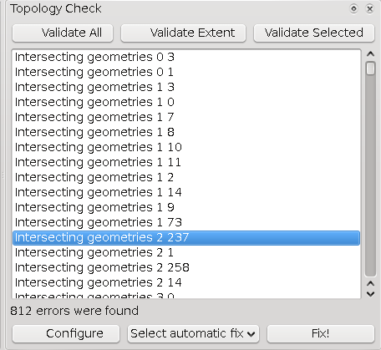
Error Table
The Error Table lists errors found during validation. Each row represents a single topology error. The line shows the type of the error and the incident features Ids. Using them, it's trivial to find the corresponding features in the Attribute Table.
When the user clicks on a row in the table, the map zooms to the error's immediate neighbourhood. The topology conflict's boundary is coloured yellow, colliding features are shown with blue and red border.
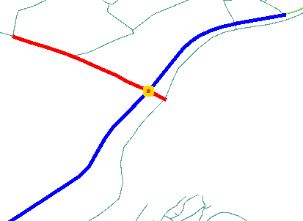
Example illustrating topology error in the map – two intersecting lines.

Controls
Validate Extent – Runs tests specified in the Test Configuration Dialog against features in the current extent.
Validate All – Runs tests against all features in specified layers.
Validate Selected – Runs tests against selected features from the first specified layer.
Configure button – launches Test Configuration Dialog.
Select Automatic Fix – This combobox contains possible fixing operations for the current error.
Fix! – Attempts to execute a fixing operation.

Validating topology
Before topology can be validated, the user have to configure a set of tests, that will be performed on the opened layers.
There are three validating buttons for launching the tests.

Validate All button causes the tests to check every feature in the specified layer. Because topology testing requires quite an amount of computing time, the latter two ways are often preferred.
Validate Extent tests only features in current layer extent, aka the part of the layer currently visible in the map window.
Validate Selected checks only features from the layer, that are selected at the test's launch time.

At this time, all tests are validated using a single specified test method (Extent / All / Selected) together, so it is not possible to configure this on per-test basis yet.

Fixing errors
After selecting an error from the Error Table, possible automatic fixes are listed in the bottom combobox. These vary from test to test, including: deleting faulty feature, moving erroneous feature, joining colliding features together or snapping to other geometry.
A fix can be executed by clicking on the Fix! Button.

Test Configuration Dialog
<insert a better picture>
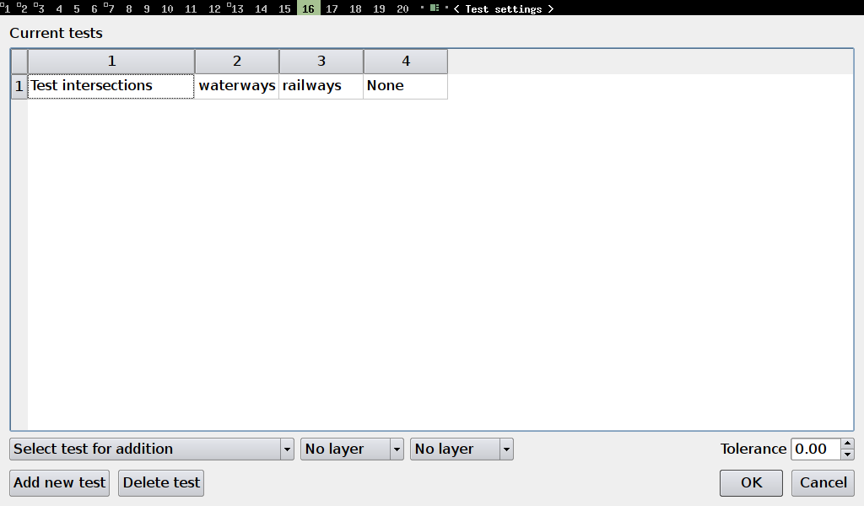
In this dialog users can add or delete new tests. Test settings are automatically saved to the current project and later can be loaded via opening the project. A new test is added when Add New Test button or OK button is pressed. More tests can be added by Add New Test button, OK button adds current test and closes the dialog. Delete Test button removes selected test from the table.

Available Tests
Tests differ in using one layer (eg. geometry validity, segment length) or two layers (eg. close features, features inside polygon). Some two-layers tests can also be used to check one layer against itself (intersections, close features).
A short desription of every topology test follows:

Intersections
Requires that no two distinct geometries from the selected layers intersect each other. Useful for mutually exclusive areas, for example administrative borders, buildings, etc.
Test requires two layers.
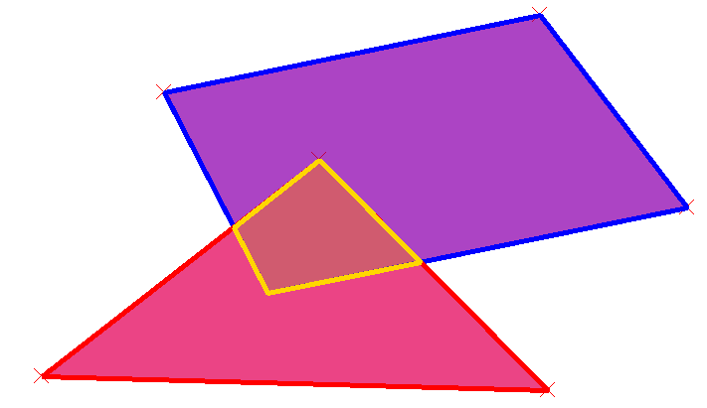
Example of two intersecting polygons. (Conflicting area is shown with yellow boundary

Geometry Validity
Scans layer for geometries which are not valid. This can mean crossing itself or containing one or less point for a line geometry. Not valid polygon could have no inner ring, be self intersecting, or contain less than three points in any ring.
Test uses just one layer.
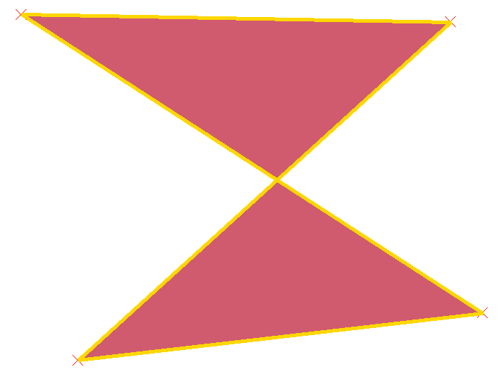
Example of invalid geometry – a self intersecting polygon.

Geometry Duplicity
This test finds any features with exactly the same geometry and marks them as a conflict.
Test uses just one layer.

Polygon Containment
Requires that a polygon does not contain any geometry from the second tested layer. The whole conflicting geometry must be within tested polygon.
Test uses two layers. (First layer must be of a polygon type)
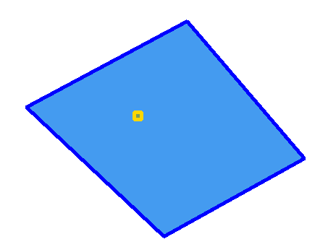
Example of point contained in a polygon.

Dangling lines
Detects lines which are not connected to any other line in the layer. Geometries with one unconnected endpoint are considered valid in this test.
Test uses just one layer.
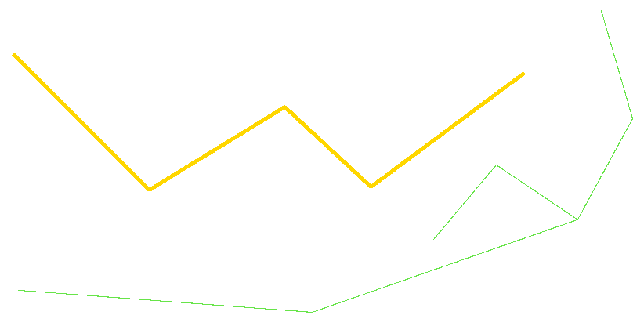
Example of a dangling line (coloured yellow).

Minimal Segment Length
All segments in a line geometry must be larger than tolerance specified in this test. Test also applies (for polygon layers) to all segments in every polygon ring.
Test uses just one layer. (Layer must be of either a line or a polygon type)
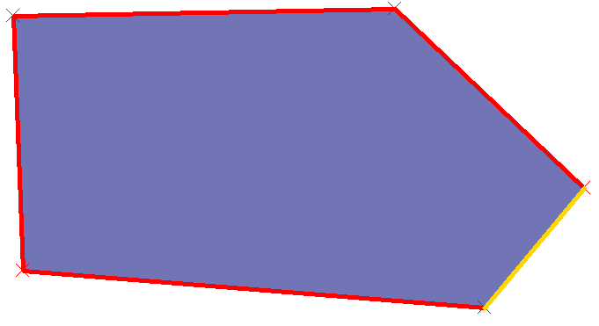
Example of a polygon with a too short segment.

Points Covered By Segment
All points in the first specified layer must be covered by a segment from the second layer.
Test uses two layers. (First layer must be of a point type, second either a line or a polygon type)
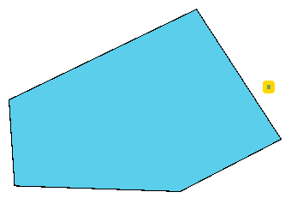
Example showing a point not covered by polygon segment boundary.

Features Too Close
All geometries in two specified layers must not be closer than the tolerance specified in the test settings.
Test uses two layers.

