Topologys Checker Developer Info
This QGIS plugin is written in the C++ language, using Qt framework version 4. The used naming convention requires that all major classes are stored in files with names corresponding to their classnames. (For example the checkDock class is stored in checkDock.cpp, its header file is checkDock.h and it is using UI data from the checkDock.ui file).

Classes used in the Topology Checker
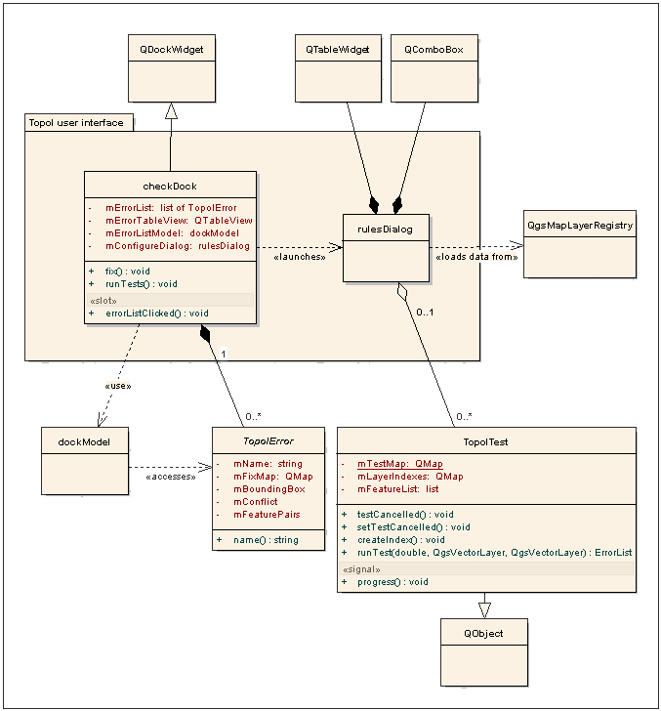
dockModel
dockModel is the model that provides data to the mErrorTableView. It accesses data from the overloaded TopolError classes gathered by topology tests in mErrorList.

checkDock
checkDock is this plugin's main user interface. It is derived from QDockWidget. Its UI is set up in the file checkDock.ui. This widget contains controls for lauching the validation process, fixing found errors and opening the dialog for setting the tests.
mErrorListModel private variable contains the pointer to the dockModel instance, which provides data for the error table.
mErrorTableView holds the pointer to the QtableView, which is used to present errors, that were found during topology checking. The conflicting features are visualized in the layer using QgsRubberBand.
mConfigureDialog points to the configuration dialog, where tests are managed.

The runTests method calls all test routines configured to run in the Configuration Dialog.
When the tests finish, the mErrorTableView loads its data from mErrorList, where errors are stored and displays them in the table.
When the user clicks on an error in the view, the errorListClicked slot is called. It sets the QgsRubberBands for colliding features and their conflict.
fix function is used to attempt to fix the currently selected error.

rulesDialog
rulesDialog is the configuration dialog, where new tests can be added or deleted.
It uses QTableWidget for displaying the tests and QComboBoxes for displaying configuration possibilities.
The object gets available tests, passed by checkDock, and loads available layers from the QgsMapLayerRegistry.
The dialog attempts to load configuration data (test name, layers and possibly tolerance for each test) from the current project data. When a new test is added or deleted in the table, the change is immediately stored to the current project.
When a new layer is opened or a layer is removed from the legend, it is reflected in rulesDialog's comboboxes.

TopolError
Errors are represented by classes derived from the TopolError class.
The TopolError class contains several virtual functions which can be rewritten and protected variables that should be set to get error's desired behavior.
mName private variable holds the error's name and it is accessible by the name method.
mFixMap is a QMap containing available automatic fixes for this particular topology error. The fixes are private functions, that are selected from mFixMap by the public method fix.
mBoundingBox is the bounding box around conflicting features.
mConflict represents the topology conflict's geometry.
mFeaturePairs are the colliding features for this error.

The fix method is used to call selected fix function, when automatic fix was launched in the checkDock.

TopolTest
TopolTest class holds all testing routines. It is derived from QObject, because of the need to communicate with dockWidget progress dialog and informing it about current test status.
The progress signal, the testCancelled and setTestCancelled functions are used to achieve this behaviour.
In the class constructor, all tests are registered in the mTestMap.
mTestMap is a QMap indexed by QString test name. It contains test structures, which consist of a test function and boolean variables, telling whether the test uses some kind of tolerance or if it needs two layers or just one.
mLayerIndexes is a QMap of spatial indexes, indexed by a layer ID, which are used for topology testing.
The createIndex method is used to create spatial index for easy finding possible colliding features. It builds index from all features in the specified layer.
The runTest works as follows:
If there isn't a spatial index for the second layer, it builds one. Then it adds features from the first layer to the mFeatureList. And then it calls the test specified in the parameter, passing it the tolerance and both layer Ids.

Test functions
Each test method walks through the selected features in the first layer. Depending on the invoked method (using all features in the layer, features in the current extent or selected features only). Then it walks through the features in the first layer. For each one it, using the spatial index, marks features from the second layer, that are crossing its bounding box. Then it performs the test against the marked features.

Creating new tests
Creating a new test involves following three tasks:

Creating a new error class
Writing the test routine
Registering the test routine

Creating a new error class
Derive the new error class from the generic TopolError class. Set the error's name.
Register possible automatic fixes.

Writing the test routine
Write the code of the test routine, that actually finds the errors in the layer. All test routines are supposed to return ErrorList type and take three parameters (double, QgsVectorLayer, QgsVectorLayer). The first one is allowed tolerance, the rest are layer pointers.

Registering the test routine
Insert the test to the test map and configure it. The configuration consists of setting the test function, and specifying whether the test uses two layers and if it uses some kind of tolerance.
Insert the test function to the TopolTest's mTestMap.

Dummy test example
topolError.h:

class TopolErrorDummy : public TopolError {
public:
TopolErrorDummy(QgsRectangle theBoundingBox, QgsGeometry* theConflict, QList<FeatureLayer> theFeaturePairs);
};

topolError.cpp:

TopolErrorDummy::TopolErrorDummy(QgsRectangle theBoundingBox, QgsGeometry* theConflict, QList<FeatureLayer> theFeaturePairs) : TopolError(theBoundingBox, theConflict, theFeaturePairs) {
mName = “Dummy Error”;
}

topolTest.h:

ErrorList checkDummy(double tolerance, QgsVectorLayer* layer1, QgsVectorLayer* layer2);

topolTest.cpp:
to topolTest constructor add:
mTestMap[“Dummy Test”].f = &topolTest::checkDummy;

ErrorList topolTest::checkDummy(double tolerance, QgsVectorLayer* layer1, QgsVectorLayer* layer2) {
return ErrorList();
}

and you have a brand new useless topology test.

