About Topology Checking
Topology models topological relations between adjacent point, line or polygon geometries. Topology rules ensure data integrity, that only correct features are inserted into the geodatabase. This is achieved by using set of rules that describe spatial relationship. Tests can be created to verify these rules and thus identify possible colliding geometries.

Common topological tests are checking for intersecting geometries (such as some administrative areas), dangling lines (lines not connected to any other) or geometries inside a polygon.

Topology validating is a CPU-consuming task, requires many geometries to be processed.
Therefore, it's preferred to check smaller areas of interest instead of entire layers.

Test Result Dock

Error Table

Controls

Configure button – launches Test Configuration Dialog.
Validate Extent – Runs tests specified in the Test Configuration Dialog against features in the current extent.
Validate All – Runs tests against all features in specifed layers.
Select Automatic Fix – This combobox contains possible fixing operations for the current error.
Fix – Attempts to execute a fixing operation.

Fixing errors
After selecting an error from the Error Table, possible automatic fixes are listed in the bottom combobox. These vary from test to test, including: deleting faulty feature, moving erroneous feature, joining colliding features together or snapping to other geometry.
A fix can be executed by clicking on the Fix! Button.

Test Configuration Dialog

In this dialog users can add or delete new tests. Test setting is automatically saved to the current project and later can be loaded via opening the project. A new test is added when “Add New Test“ button or “OK“ button is pressed. More tests can be added by “Add New Test“ button, “OK“ button adds current test and closes the dialog. “Delete Test“ button removes selected test from the table.

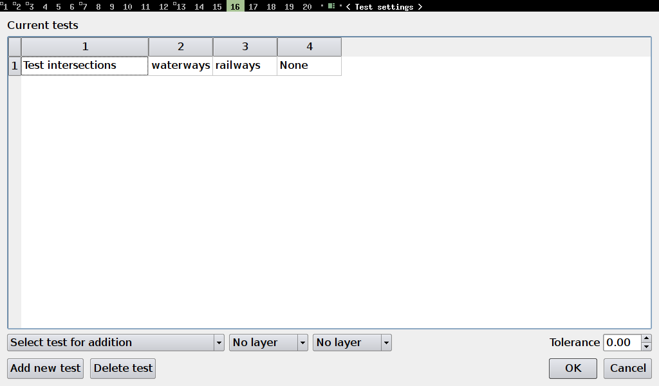
Tests
Tests differ in using one layer (eg. geometry validity, segment length) or two layers (eg. close features, features inside polygon). Some two-layers tests can also be used to check one layer against itself (intersections, close features).
A short desription of every topology test follows:

Intersections
Requires that no two distinct geometries from the selected layers intersect each other. Useful for mutually exclusive areas, for example administrative borders, buildings, etc.
Test requires two layers.
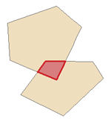
Example of two intersecting polygons. (Conflicting area is shown in red)

Geometry Validity
Scans layer for geometries which are not valid. This can mean crossing itself or containing one or less point for a line geometry. Not valid polygon could have no inner ring, be self intersecting, or contain less than three points in any ring.
Test uses just one layer.

Geometry Duplicity
This test finds any features with exactly the same geometry and marks them as conflict.
Test uses just one layer.

Polygon Containment
Requires that a polygon does not contain any geometry from the second tested layer. The whole conflicting geometry must be within testede polygon.
Test uses two layers. (First layer must be of a polygon type)
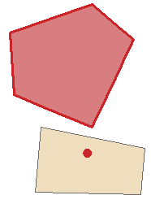
Example of two polygons. The one in the bottom contains a point, thus creates a test conflict.

Unconnected lines
Detects lines which are not connected to any other line in the layer. Geometries with one unconnected endpoint are considered valid in this test.
Test uses just one layer.
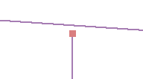
Example of a not connected line endpoint.

Minimal Segment Length
All segments in a line geometry must be larger than tolerance specified in this test. Test also applies (for polygon layers) to all segments in every polygon ring.
Test uses just one layer. (Layer must be of either a line or a polygon type)

Points Covered By Segment
All points in the first specified layer must be covered by a segment from the second layer.
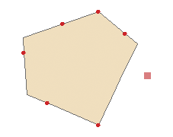
Test uses two layers. (First layer must be of a point type, second either a line or a polygon type)
Example showing a point not covered by polygon segment boundary.

Features Too Close
All geometries in two specified layers must not be closer than the tolerance specified in the test settings.
Test uses two layers.

