Subject: Marketing Management
Title: Services Marketing
Page Length: Estimated ~20 pages
Duration: Around ~20 Minutes

.SCENE 1.1 - 00:00-01:30 [SLIDE 1]
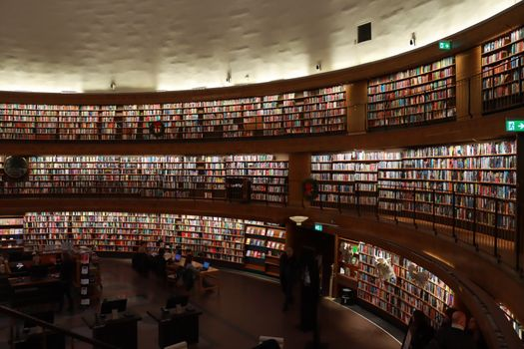
Scene 1.1 — Modern University Library [Slide 1]

INT. MODERN UNIVERSITY LIBRARY - DAY
AUDIO:
Background:
Voice:
Sound Effects:
PROFESSOR
Welcome back! I am so glad you've returned to continue our Marketing Management journey.
In Video 1, we spent a lot of time talking about tangible items. We talked about Guntur chillies, textiles in Brodipet, and steel from Vizag. These are physical things. You can drop them on your foot, and it hurts. That makes it easy to understand. It has weight, dimensions, and you can see it and inspect its quality before spending a single rupee.
But today, we are going to look at something much more fascinating, and frankly, a bit trickier: Services Marketing.
Services dominate our modern economy. In fact, if you look at the GDP of most developing and developed countries, services represent well over fifty percent of the total output. Think about the apps on your phone, the banking facilities you use, the schools we go to, and the healthcare we receive.
In this video, we're going to dive headfirst into what makes service marketing completely different from product marketing. We will look at a famous case study, Uber, to understand how services build trust. Then, we will break down the six unique characteristics of services, and finally, look at why the traditional four Ps of marketing just aren't enough, which is why we must expand them to the seven Ps.
So, let's step into the world of the intangible. Sit back, take notes, and let's get started.

.SCENE 2.1 - 01:30-05:30 [SLIDE 9]
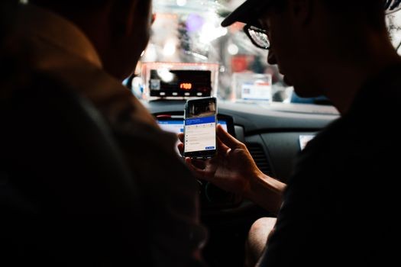
Scene 2.1 — Streets of Vijayawada / Guntur [Slide 9]

INT. STREETS OF VIJAYAWADA/GUNTUR - DAY

AUDIO:
Background:
Voice:
Sound Effects:
FEMALE NARRATOR
Let's kick things off with a simple definition. What exactly is service marketing?
At its core, service marketing is the process of promoting and selling an intangible transaction or experience to a target audience. You are selling a process or a performance rather than a physical object.
Think about this: when you buy a smartphone, you walk out of the store with a box. You own that phone. You can show it off. But when you buy a hair styling service, or book a flight ticket, or get a medical check-up, what do you actually own at the end of the day? Nothing physical. You own the memory, the benefit, or the state of well-being. You are buying an experience.
Now let's talk about one of the most successful service brands in the world: Uber.
If we look at Slide 9, Uber is an on-demand transportation technology that connects riders with driver-partners. But here is the impromptu classroom question: Is Uber really just selling a car ride?
No. Absolutely not. If they were just selling car rides, they would be no different from a regular taxi. What Uber is actually marketing is convenience, flexibility, and most importantly, a temporary "trust architecture."
Think about the sheer audacity of the business model. You open an app on your phone, you request a ride, a stranger pulls up in a private car, you get into the back seat, and they drive you to your destination. Ten years ago, if your parents saw you doing this, they would have panicked. How did Uber make this normal?
They built credibility and trust.
Uber builds credibility using a double-sided rating system. After every ride, the driver rates the rider, and the rider rates the driver. This gamifies good behavior. It ensures that bad actors are weeded out.
Let's go impromptu here. Have you ever checked your driver's rating and hesitated because it was a 4.2 instead of a 4.9? That rating tells you a story about service quality before you even open the car door. It's a psychological guarantee. If it's a 4.2, you wonder what went wrong. Did they drive too fast? Were they rude? That score is the brand's reputation condensed into a single digit.
Uber builds trust by implementing strict safety protocols—GPS tracking of every ride, driver background checks, in-app emergency buttons, and incident response teams. For drivers, they market flexibility—being their own boss. For riders, they market peace of mind. You can share your live location with your family.
So, when you see an Uber driving down the streets of Vijayawada or Guntur, remember that they aren't just selling transport. They are selling trust. And in services marketing, trust is the ultimate currency.

.SCENE 3.1 - 05:30-10:30 [SLIDE 11]
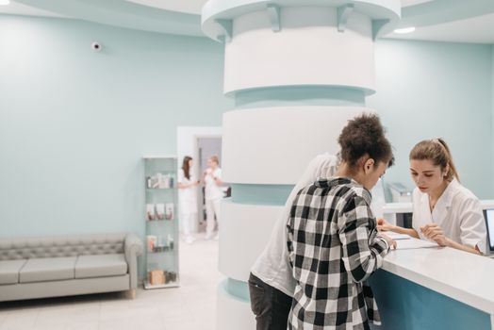
Scene 3.1 — KIMS Hospital / AP Tourism [Slide 11]

INT. KIMS HOSPITAL / AP TOURISM DESK - DAY
AUDIO:
Background:
Voice:
Sound Effects:
FEMALE NARRATOR
Now, let's turn to Slide 11. To truly master service marketing, you must understand the six fundamental characteristics that make services unique.
The first characteristic is Intangibility. Services cannot be seen, tasted, felt, or heard before they are purchased.
Imagine you are going to KIMS Hospital in Guntur. You cannot "sample" the surgery before you buy it. You cannot test-drive the doctor's diagnosis. Because of this intangibility, customers face high levels of uncertainty.
Here's a quick insight: we value what we can see. If an IT consultant fixes your network in two minutes by clicking one button, you sometimes feel cheated because you didn't see them work hard. But you are paying for twenty years of experience, not the two minutes. That is the paradox of intangibility. Customers want to see the labor.
So, how do marketers solve this? We must "tangibilize the intangible." We use physical cues—clean marble floors, professional uniforms, high-tech looking medical equipment, and clear signage. If the lobby of a hospital is dirty, you immediately assume the doctors are incompetent, even if they are world-class. The physical environment becomes the proxy for service quality.
The second characteristic is Perishability. Services cannot be stored for future sale or use.
Let's say an APSRTC bus leaves Guntur for Visakhapatnam with ten empty seats. Can the bus depot store those ten empty seats and sell them tomorrow? No. Once the bus departs, that inventory, that potential revenue, is gone forever. This is why service industries are obsessed with capacity management and yield pricing—like hotels charging cheaper rates during the off-season to fill rooms.
The third characteristic is Inseparability. In product marketing, the factory makes the product, the retailer sells it, and the consumer eats it later. But in services, the service is produced and consumed at the very same time.
Think about a classroom lecture. I, the teacher, am producing the service of education, and you, the student, are consuming it at the exact same moment. We co-create the value. If you are sleeping, the service fails. You cannot separate the provider from the service itself. This co-creation is crucial. In fitness coaching or weight-loss programs, if the client doesn't eat right, the service fails despite the trainer's best efforts.

.SCENE 3.2 - 10:30-15:30 [SLIDE 11]

Scene 3.2 — Mee Seva Center / Araku Valley [Slide 11]

INT. MEE SEVA CENTER / ARAKU TOUR CONGO - DAY
AUDIO:
Background:
Voice:
Sound Effects:
FEMALE NARRATOR
This leads us to the fourth characteristic: Variability. Services are highly variable because they depend on who provides them, when they are provided, and where they are provided.
Let's use a funny, relatable example. You go to your favorite biryani point in Guntur on a Tuesday night. The biryani is absolutely delicious, perfectly spiced. You go back on Friday night, and it's too salty. Why? Because the chef was having a bad day, or there was a rush, or a different cook was on duty. Humans are not machines. We have moods, energy levels, and varying skills. Standardizing services to reduce this variability is one of the toughest challenges in business. That is why brands use detailed training manuals and standard operating procedures.
The fifth characteristic is Changing Demand. The demand for services is rarely stable. It fluctuates wildly based on seasons, days of the week, or even hours of the day.
Take Araku Valley tourism. During winter and the holiday season, hotels are packed. During the hot summer, they are empty. Service marketers must design strategies to cope with these peaks and valleys—like offering special monsoon discounts or hiring temporary staff.
The sixth and final characteristic is Pricing. Since services are intangible and cannot be standardized, pricing is highly subjective. It is rarely based on a simple cost-plus formula. Instead, service pricing is determined by competition, perceived value, and demand.
Think about a lawyer. Why does one lawyer charge one thousand rupees for an hour of advice, while another charges fifty thousand rupees? You aren't paying for their time; you are paying for their reputation, expertise, and the probability of winning your case.
Understanding these six characteristics is what separates rookie marketers from seasoned professionals.

.SCENE 4.1 - 15:30-19:00 [SLIDES 12-13]
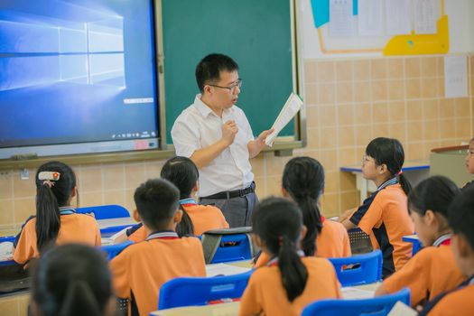
Scene 4.1 — Airtel Office / Coaching Center [Slides 12-13]

INT. AIRTEL OFFICE / COACHING CENTER - DAY
AUDIO:
Background:
Voice:
Sound Effects:
FEMALE NARRATOR
Now that we understand the characteristics, let's look at how we market them.
If you've studied basic marketing, you know the traditional four Ps: Product, Price, Place, and Promotion. But for services, the four Ps are simply not enough. We need to expand them to the Seven Ps.
Let's break down the first four Ps in a service context.
P1: Product. In services, the product is a bundle of intangible benefits. When you enroll in an IIT coaching center in Guntur, the product is not the physical classroom or the printed textbooks. The product is the transfer of knowledge, the problem-solving skills, and the career counseling. It is a transformational experience. In services, we also separate the core service, which is the education, from secondary services, like transport and online portal access.
P2: Price. Services pricing is highly dynamic. We see subscription models, where you pay monthly for Netflix or Airtel postpaid data packages. We see value-based pricing, where premium coaching centers charge higher fees because they have a track record of producing top rankers. The price must reflect the perceived value, because customers cannot inspect the service beforehand.
P3: Place. Place in services is all about accessibility and speed. In the digital age, place has moved from physical branches to our smartphones. Think about Swiggy and Zomato. They transformed the place utility of restaurants in Vijayawada and Guntur. The restaurant's kitchen is physical, but the distribution point is an app in your palm.
P4: Promotion. Because services are intangible, you cannot show pictures of the product. Instead, promotion must focus on tangibilizing the experience. This is why educational institutions do not just advertise their curriculum. They advertise pictures of smiling toppers, modern laboratory buildings, and lists of corporate recruiters. They sell the dream and show social proof. Word-of-mouth is crucial here; we trust our friends' dentist recommendations more than any billboard.

.SCENE 4.2 - 19:00-22:30 [SLIDES 12-13]
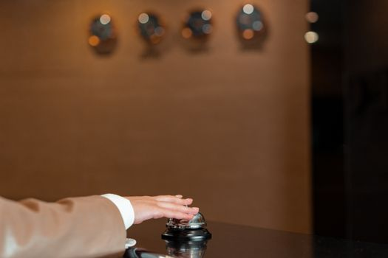
Scene 4.2 — Novotel Hotel / Mee Seva Center [Slides 12-13]

INT. NOVOTEL HOTEL / MEE SEVA CENTER - DAY
AUDIO:
Background:
Voice:
Sound Effects:
FEMALE NARRATOR
Now, let's look at the three extra Ps that are absolutely crucial for services.
P5: People. In a service business, people are the service. The customer's perception of your brand is completely determined by the behavior of your frontline employees.
Imagine checking into the Novotel in Visakhapatnam. The rooms might be beautiful, the view of the sea spectacular. But if the receptionist at the front desk is rude, ignores you, and makes you wait, your entire experience is ruined.
Here's an impromptu classroom insight: service employees perform "emotional labor." They must smile and be polite even when they are exhausted or dealing with a difficult client. This is why service brands invest heavily in employee training, motivation, and empowerment. Ritz-Carlton famously allows employees to spend up to two thousand dollars per day to resolve a guest complaint without manager approval. That is how much they value their people.
P6: Process. Process is the flow of activities and systems used to deliver the service. A bad process creates friction, and friction kills customer satisfaction.
Think about going to a Mee Seva center to get a certificate. If the process requires you to fill out five paper forms, stand in three different lines, and wait for weeks, the service delivery is broken. Modern service companies design seamless, frictionless customer journeys. Amazon's one-click checkout is a classic example of process as a competitive advantage.
P7: Physical Evidence. As we discussed earlier under intangibility, physical evidence is the environment in which the service is delivered, along with any tangible elements that facilitate the service.
Why do modern banks and corporate coaching offices in Guntur invest in fancy glass facades, air-conditioned lobbies, clean restrooms, and well-designed websites? Because these are physical proof of quality.
Here's an impromptu design secret: did you know that hotels design olfactory environments? They create signature scents for their lobbies, and cafes use specific lighting and acoustic playlists to make you stay longer and buy more coffee. It is all physical evidence designed to impact your behavior.
All seven Ps must align. You cannot have a premium price if your people are rude, your process is slow, and your physical evidence looks cheap.
When you orchestrate these seven elements harmoniously, you create service excellence.

.SCENE 5.1 - 22:30-24:30 [SLIDE 1]
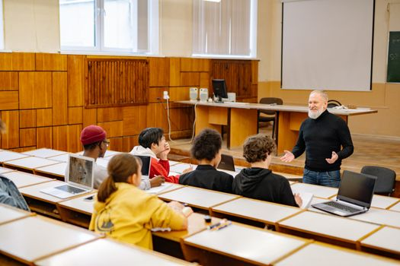
Scene 5.1 — Modern University Library [Slide 1]

INT. MODERN UNIVERSITY LIBRARY - DAY
AUDIO:
Background:
Voice:
Sound Effects:
PROFESSOR
Wonderful job! We have covered a massive amount of ground today in Video 2.
Let's do a quick recap:We defined services marketing, looked at how Uber uses technology to build trust and credibility, and examined the six unique characteristics of services—intangibility, perishability, inseparability, variability, changing demand, and pricing.
Finally, we explored the extended seven Ps framework, showing how Product, Price, Place, Promotion, People, Process, and Physical Evidence work together to define service quality in our local markets.
I hope you can now see why services marketing requires a completely different mindset compared to selling physical goods.
In our third and final video, we are going to step across borders. We will explore Global Marketing, examine the balance between standardization and adaptation, look at Nike and Domino's, and break down the eight massive challenges companies face when they decide to go global.
Until then, keep observing the services around you—whether you're ordering food, visiting a clinic, or boarding a bus. Think about how they apply the seven Ps.
Thank you, and Namaste!

