Splits

In Splits application have-
- Create view as per the attached design
- Use static json to load and save all data: Title, Created Date, Location, Writers
- User should be able to change values of Title, Created Date, Location.
- "Invite New Writer" will add new Writer.
- Write can click on their picture to change picture by selecting picture from phone library or by taking picture with camera.
- Split Equally" will assign equal percentage to all writers.

1.Create view as per the attached design

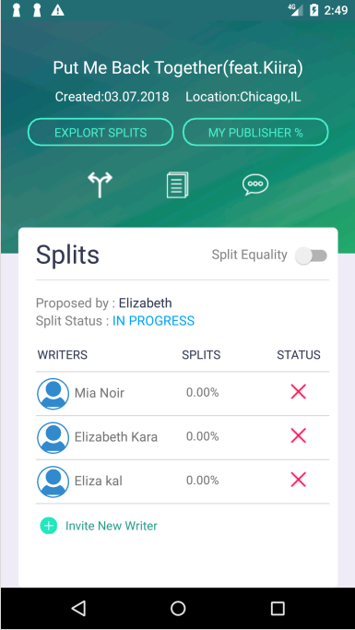

    - Add New Writer
    - "Invite New Writer" will add new Writer.

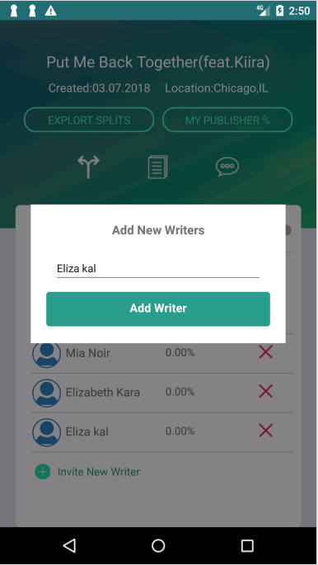

3.Change Profile Photos
- Write can click on their picture to change picture by selecting picture from phone library or by taking picture with camera.

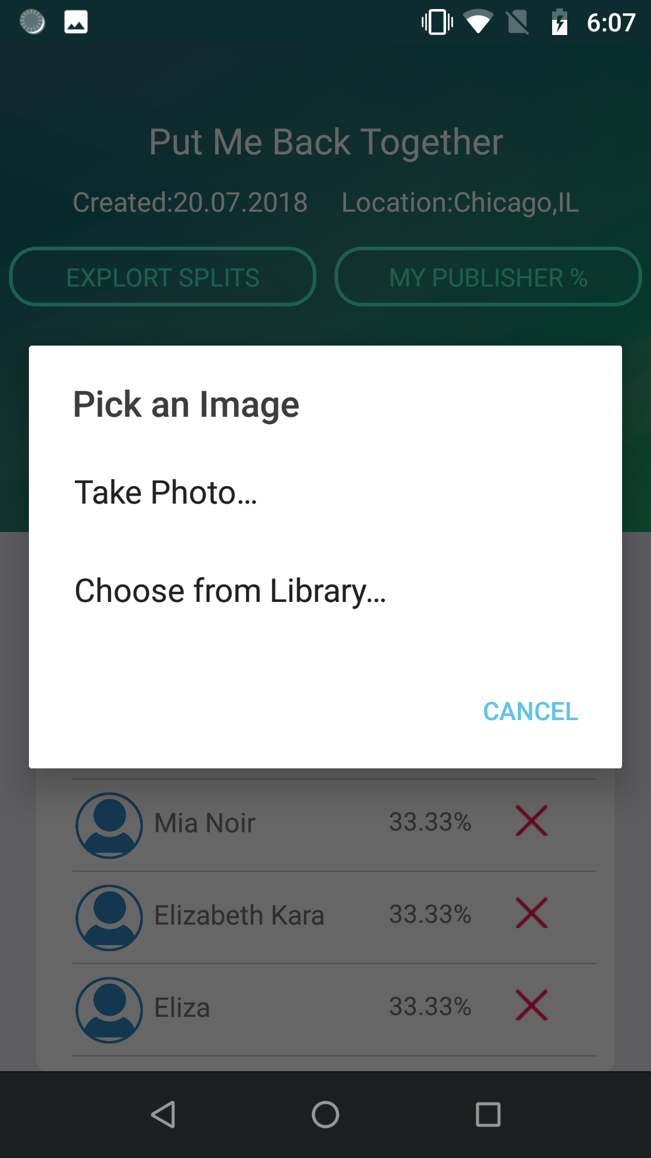
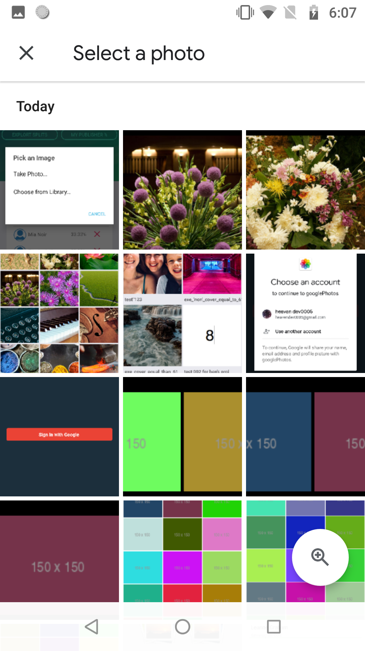

- Change User Profile
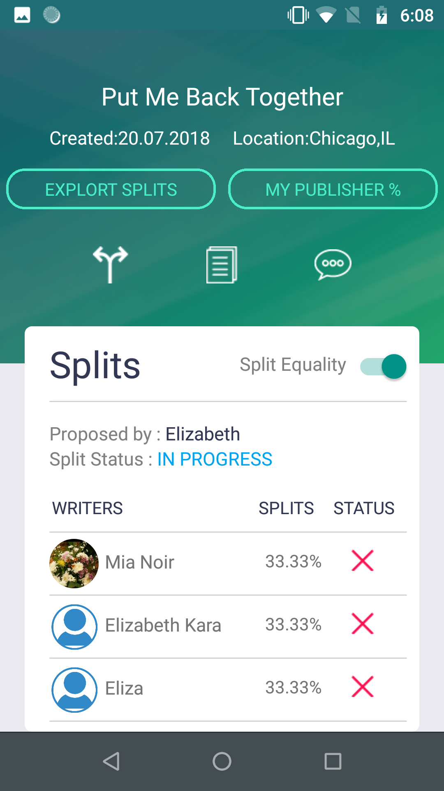

4.Update Splits Title
- User should be able to change values of Title, Created Date, Location.
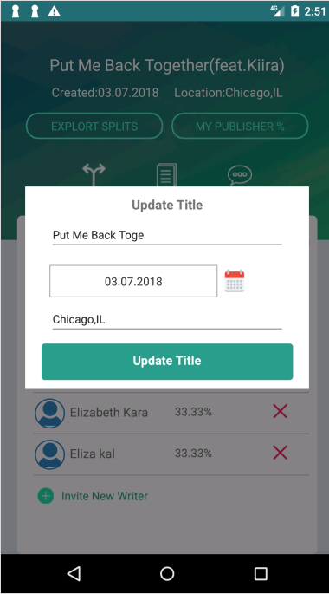
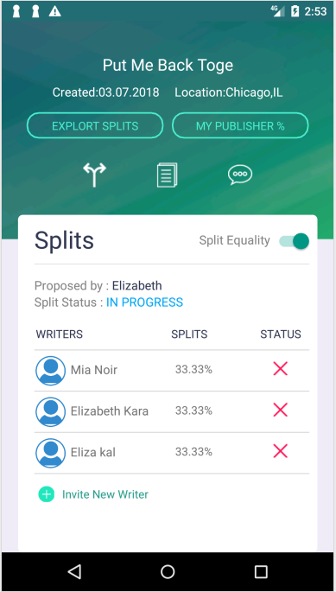

5.Splits Equality
- Split Equally" will assign equal percentage to all writers.

