

Islamic Economic Simulation

Software Functional Specifications

Group member-1 Ozair Shafiq 094197

Group member-2 Dilawar Rizwi 09-4088

Group member-3 Umair Baig 09-4111

Group member-4 Haider Ali 09-4129

Supervisor: Farooq Ahmad

Co-Supervisor: Waqas Zayed

BS (CS) Final Year Project

Date: Oct ,20th ,2012

National University Of Computer and Emerging Sciences

Department of Computer Science

Lahore, Pakistan

Contents

Software Functional Specifications 1

1. Introduction 3

1.1 Purpose of this Document 3

2. General Description 3

2.1 Concept History 3

2.2 Motivating Factor of this movement 3

2.3 Motivation 4

2.4 Entities 5

3. Functionality 6

3.1 Functional Requirements 6

3.1.1 Farm 6

3.1.2 Shop 6

3.1.3 Bait ul Maal 7

3.1.4 System 7

3.2 Non-Functional Requirements 8

3.3 User Interface 8

3.4 Menu 8

4. System Architecture 9

5. Use Case Information 11

5.1 Use Case Diagram 11

11

5.2 Actors 12

5.2.1 Farmer 12

5.2.2 Shopkeeper 12

5.3 Use Case Descriptions 13

5.3.1 Create Farm 13

5.3.2 Seed Farm 14

5.3.3 Irrigate Farm 15

5.3.4 Cultivate Farm 17

5.3.5 Buy Seed 18

5.3.6 Update Farm Info 19

5.3.7 Buy Food 20

5.3.8 Buy Farm 21

5.3.9 List Item Price 22

6. Graphical User Interfaces 24

6.1 Sign In page 24

6.2 Registration page 25

6.3 Shop 26

6.4 Farm 26

6.5 Food Options 27

6.6 Custom Options 28

6.7 Bus Ride 28

6.8 Transaction Options 29

# Introduction

## Purpose of this Document

The purpose of the document is to explain of the Islamic Economic Simulation. It explains the history and motivation behind this simulation. This document contains all functional and non-functional requirements. It also contains all the entities and business rules of the simulation. All the assumptions are also listed in the document. Important use cases are explained and others are just listed.

# General Description

## Concept History

Occupy Wall Street movement started on September 17th 2011 in response to an ad in the 97th issue of a Canadian magazine called Adbusters. The advertisement was motivated by the public uprisings in M

iddle Eastern countries, particularly those of Egypt where Tahrir square in Cario became the center of the uprising. The people behind this movement wanted to replicate Tahrir square in Manhattan, NY. Detailed history of the movement is beyond the scope of this document, but can be found at nadeemchaudhry.blogspot.com.

## Motivating Factor of this movement

The primary motivating factor of the movement is the huge economic disparity between the majority of people and an elite group of extremely wealthy people. The people in this movement make the point that 1% of the population is hoarding resources while the remaining 99% of the population is being deprived and they represent the 99%.

This charge is fully backed by published data. In 1983 the top 1% of the population owned 33.8% of the wealth while the bottom 80% owned 18.7%. This lopsided distribution has become even worse. In 2007 the share of wealth of the top 1% increased to 34.6% while that of the bottom 80% dropped to 15%.

These people have realized that the root cause of this disparity is the capitalistic system and it is not working for them. In fact it is working against them. It is causing the wealth to flow from poor to rich. They want an alternate economic system.

## Motivation

We believe that Islamic economic system is the alternative system that can cure this problem of huge wealth disparity. The problem is that Islamic economic system is not known in the world, partly because at the moment it is not being practiced anywhere in the world. No state in the world is running its economic system based on **Shariat**. As a result there is no model state that can demonstrate the benefits of Islamic Economic system and it seems unlikely that any time soon we will have a state where this system will be implemented. So how do we tell the world that we have a system that can fix this problem of huge wealth disparity without a country/state practicing it in reality?

The next best thing that is done in situations where reality is not possible is to simulate reality. And that is what we are inshallah going to do in this project. We are going to develop a web based, massively parallel social game to simulate a society running on principals of Islam. More specifically economic principals of Islam. The game will be similar in nature to other social games like FarmVille, SimCity and SecondLife. It is a massive undertaking and will involve people from many other fields, like economics, Islamic jurisprudence ( Fiqh ), law, graphics design just to name a few.

## Entities

All the entities used in the game are listed below

**Farmer**

A mean of earning in the game, players will work on the farm like a farmer and earn credit

**Shopkeeper**

Shop keeping is also a mean of earning in the game. Play will run a shop (manage shop supply demand, list prices of the goods etc.) and earn credit

**Bait ul Maal**

Most important entity of the game which will act like a center point of the game. New player request Bait ul Maal for resources. Zakat and tax would be managed by Bait ul Maal.

**Virtual Player**

Virtual players are players which will be handled by the system not by the game players and any game players can hire virtual player to get there job done early

**Virtual irrigation system**

Virtual irrigation system acts like upgrading of farms, farms with virtual irrigation system installed will produce better and quick yield

**Virtual machinery**

Virtual machinery is also up gradation of farm, farms with virtual machinery installed will produce better and quick yield

**Transportation**

Transport of the city. Player can use transport to move from one place to another. The basic motivation behind transporting is to facilitate famers to the market.

**Fertilizers**

Fertilizers are required for farms and available at shops, these fertilizers should be of different quality which will eventually yield different quality of product

**Seeds**

Seeds are required for farms and available at shops, seeds would be of different type and different quality

**Foods**

Food is basic and essential for players, the type and amount of the food will determine the level of energy of the player, and the energy of the player is directly related to the performance of the player

**Super Market**

The model Super Market contains the different features which reflect the model real time Super Market.

* A super market maintains a list of product items along with their prices.
* It will be possible to move items from one place to other within the super market.
* Consumers may come to the store and chose items of their choice and purchase them.
* A market may be opened and closed.
* A market will have multiple sections offering variety of products such as vegetables, fruits, meat, and other grocery items.
* A market will have sound effect.
* Factor of uncertainty will be involved in the model that makes the model more interesting. Uncertainty is defined as the risk.

# Functionality

## Functional Requirements

Functional requirements are listed below

### Farm

1. Player must be able to create farm
2. Player must be able to seed farm with different seeding options (wheat, fruit)
3. Player must be able to irrigate and fertilize farm
4. Player must be able to cultivate the farm (a visual animation of player while cultivating farm would be show on the main scene)
5. Player can buy seed and fertilizer
6. Player could hire virtual players
7. Player could buy virtual machinery
8. Farm owners could sell their property
9. farm owner can update farm info
10. only farm owner of the farm can sell the farm
11. only farm owner can update the farm info (price)
12. Farm Owner could sell his product to the super market

### Shop

1. Player can view a list of products in any shop
2. Player can buy any product from the owner of that shop
3. Shop owners can list the prices of the products that they have in their shop
4. Player can buy food from shop
5. only shop owner can sell the shop
6. only shop owner can set the price of the shop
7. Shop owners could buy products from the super market
8. Players can make request of zakat from Bait ul Maal

### Bait ul Maal

1. Bait ul Maal should be able to collect zakat from players
2. Bait ul Maal should be able to distribute zakat to players
3. Bait ul Maal should be able to collect charity from players
4. Bait ul Maal should be able to distribute charity to players
5. Bait ul Maal should be able to allocate resources to the players

### System

1. System should control the weather of the city
2. System should display energy level of players on their main screen
3. System should manage transport system of the city
4. System should provide a mean of limited chatting among players (so that players can take load from each other)
5. System should able to create natural disasters randomly
6. System could reboot the economy of the city
7. Player could buy any property
8. Players can chat with one and each other for loan just using finite set of phrases provided by the system
9. System should ensure that a player cannot sale his property below what was given to him initially by Bait ul Maal

## Non-Functional Requirements

## User Interface

User interface should be simple and easy to learn, easy to use

## Menu

Menu’s should be simple and should be of at least 3 navigations.

# System Architecture

The system has been divided into three tiers

1. Front End
2. Data Base
3. Rules / Expert Engine
4. Web server

The front end consists of HTML and Flash implemented client side that is going to run on the client side on the respective browser. The design of the front end has been shown in the sample GUIs presented below. The interface basically consists of three divisions i.e. two of which provide menus/tool bars for performing specific actions while one of the divisions is the main screen on which the player is supposed to move and perform multiple particular tasks and achieve particular milestones. The specifics of the division on which the player is supposed to move will be controlled by the movement of the mouse.

The actions performed on the front end would be continuously registered in the data base and also will be judged by the Expert Engine. The role of the expert Engine is quite dynamic as it is supposed to perform tasks such as evaluating the extent of a deed that a person has performed, another module of the Expert system will judge the economic stability of the so called virtual city of players, different actions that are supposed to be system generated such as allocation of resources between the players, import of fertilizers and other goods are all controlled by the Expert engine.

The actions performed by the Expert Engine will be stored in the database which also contains user profiles and status of the economy for the purpose of logging and generating a criterion for evaluating the fluctuations in the economy. If the graph of economy generated by the Expert System has a positive slope and suggests that a stable economy has been established, one could propose that the principles of Islam can be implemented in real time scenarios but even then the scope of the project is still limited due to time and team strength limitations, the future increments of this virtual world require different occupations implemented in this game so that a comprehensive evaluation could be made to further strengthen the efficacy and efficiency of these economic principles.

**Rules / Expert**

**Engine**

Front End

WEB -SERVER

DB

# 

# Use Case Information

## Use Case Diagram

## C:\Users\HAIDER\Downloads\use case diagram.png

## Actors

### Farmer

Farmer is an occupation in the game. Player can play the game as a farmer

### Shopkeeper

Shopkeeper is the owner of the shop entity in the game. Shopkeeper will run the shop

## Use Case Descriptions

### Create Farm

|  |  |  |  |  |  |
| --- | --- | --- | --- | --- | --- |
|  | |  | | | |
| *Name:* | | Create Farm | | | |
| *Actors:* | | Player | | | |
| *Summary:* | | When a player wants to start farming in his/her property he has to create the farm in his/her property. The parameters for the system will be the area of the farm and the position where the farm is to be created. | | | |
|  | |  | | | |
| Pre-Conditions | | Player has to be logged in and must have minimum area owned by him to create the farm in it. | | | |
| Successful Post-Conditions | | The farm will be created on the selected area and will be ready to grow seeds on it. | | | |
| Typical Course of Events | | | | | |
| Actor Action | | | | System Response | |
| 1 | Player selects Create Farm option. | | | 2 | System asks for the area on which the farm has to be created. |
| 3 | Player graphically highlights the area on which he wants to create farm. | | | 4 | System checks the correctness of parameters. |
|  |  | | | 5 | System creates a farm graphically identifiable on the land. |
|  | | |  | | |
| Alternative Course | | |  | | |
| *Step 4:* | | | Invalid selection of the Area on the field or other parameters. | | |
| *Step 5:* | | | System displays error message and the farm is not created. | | |

### Seed Farm

|  |  |  |  |  |  |
| --- | --- | --- | --- | --- | --- |
|  | |  | | | |
| *Name:* | | Seed Farm | | | |
| *Actors:* | | Player | | | |
| *Summary:* | | When a player wants to start farming he has to start seeding his/her farm in order to get yeild from the land. The parameters for the system will be (i)Area of farm (ii) Type of the seed (iii) Quality of the seed etc. | | | |
|  | |  | | | |
| Pre-Conditions | | Player has to be logged in and must have an already created farm in his owned space of land. A player must have bought seeds in his account of goods. | | | |
| Successful Post-Conditions | | The seeds will be planted on the selected area of the farm which will be represented graphically. | | | |
| Typical Course of Events | | | | | |
| Actor Action | | | | System Response | |
| 1 | Player selects Plant Seeds option. | | | 2 | System asks for the area on the farm where the seeds are to be planted. |
| 3 | Player highlights the area on his owned farm on which he wants to plant seeds. | | | 4 | System checks the correctness of parameters and displays the set of seeds owned by the player as options. |
| 5 | Player selects a particular type of seed and confirms. | | | 6 | System graphically represents the plantation of seeds on the targeted area. |
|  | | |  | | |
| Alternative Course | | |  | | |
| *Step 4:* | | | There can be empty set of seeds. | | |
| *Step 5:* | | | System displays error message and the seeds are not planted. | | |

### Irrigate Farm

|  |  |  |  |  |  |
| --- | --- | --- | --- | --- | --- |
|  | |  | | | |
| *Name:* | | Irrigate Farm | | | |
| *Actors:* | | Player | | | |
| *Summary:* | | In order to achieve the goal of greater productivity and getting fruit from the seeds planted in the farm a player must irrigate the farm after regular intervals of time so that his seeds may not get wasted. (i) Manual Irrigation( Player’s health will be the factor to be considered). or (ii) Irrigation through machine(Cost will be the factor) are two types from which a player will decide. Area of land to be irrigated will be the parameter for the system. | | | |
|  | |  | | | |
| Pre-Conditions | | Player has to be logged in. Player must have planted seeds in his farm.  In case of Irrigation through machine a user must have a planted machine. | | | |
| Successful Post-Conditions | | The farm will be irrigated and the farm’s status will be upgraded. | | | |
| Typical Course of Events | | | | | |
| Actor Action | | | | System Response | |
| 1 | Player selects Irrigate Farm option. | | | 2 | System asks for the area on the farm which has to be irrigated. |
| 3 | Player highlights the area on his farm to be irrigated and confirms. | | | 4 | System checks the correctness of parameters. |
|  |  | | | 5 | System displays type of irrigation to be used as options on the menu. |
| 6 | Player Selects an option of irrigation type and confirms. | | | 7 | System represents the procedure graphically through animation of the player’s body in land. |
|  |  | | | 8 | System upgrades the status of farm up to some level. |
|  |  | | | 9 | System notifies the player that the farm is irrigated. |
|  | | |  | | |
| Alternative Course | | |  | | |
| *Step 4:* | | | Invalid selection of the Area or insufficient amount or energy. | | |
| *Step 5:* | | | System displays error message and the farm is not irrigated. | | |

|  |  |  |  |  |  |
| --- | --- | --- | --- | --- | --- |
|  | |  | | | |
| *Name:* | | Fertilize Farm | | | |
| *Actors:* | | Player | | | |
| *Summary:* | | In order to achieve the goal of greater productivity getting fruit from the seeds planted in the farm a player must fertilize the farm after regular intervals of time so that his seeds may not get wasted. (i) Manual Fertilization (Player’s health will be the factor to be considered). Or (ii) Fertilization through machine (Cost will be the factor) are two types from which a player will decide. Area of land to be irrigated will be the parameter for the system. | | | |
|  | |  | | | |
| Pre-Conditions | | Player has to be logged in. Player must have planted seeds in his farm. Player must have already bought the fertilizers.  In case of Fertilization through machine a user must have a planted machine. | | | |
| Successful Post-Conditions | | The farm will be irrigated and the farm’s status will be upgraded. | | | |
| Typical Course of Events | | | | | |
| Actor Action | | | | System Response | |
| 1 | Player selects Fertilize Farm option. | | | 2 | System asks for the area on the farm which has to be fertilized |
| 3 | Player highlights the area on his farm to be fertilized and confirms. | | | 4 | System checks the correctness of parameters. |
|  |  | | | 5 | System prompts for the type of fertilization and fertilizer to be used by displaying options in menu. |
| 6 | Player Selects an option of fertilizer and fertilization type and confirms. | | |  |  |
|  |  | | | 7 | System represents the procedure graphically through animation of the player’s body in land. |
|  |  | | | 8 | System upgrades the status of farm up to some level. |
|  |  | | | 9 | System notifies the player that the farm is fertilized. |
|  | | |  | | |
| Alternative Course | | |  | | |
| *Step 4:* | | | Invalid selection of the Area or insufficient amount or energy. | | |
| *Step 5:* | | | System displays error message and the farm is not fertilized. | | |

### Cultivate Farm

|  |  |  |  |  |  |
| --- | --- | --- | --- | --- | --- |
|  | |  | | | |
| *Name:* | | Cultivate Farm | | | |
| *Actors:* | | Player | | | |
| *Summary:* | | A player has to cultivate his farm when the farm is ready for the cultivation. The cultivated product is of money worth and it is the source of income for the farmer. The final product has quantity and quality(Based upon seeds and the whole farming procedure) as parameters. | | | |
|  | |  | | | |
| Pre-Conditions | | Player has to be logged in. The farm must be ready for the cultivation (A player will get to know this through notification mechanism). | | | |
| Successful Post-Conditions | | The farm will be cultivated and the final product will be saved as an entity in his products of ownership. | | | |
| Typical Course of Events | | | | | |
| Actor Action | | | | System Response | |
| 1 | Player selects Cultivate Farm option. | | | 2 | System asks for the area on the farm which has to be cultivated. |
| 3 | Player highlights the area on his farm to be cultivated and confirms. | | | 4 | System checks the correctness of parameters.(Selected area , ready-to-be-cultivated). |
|  |  | | | 5 | System represents the cultivation graphically on the land. |
|  |  | | | 6 | System upgrades the list of “ownership of goods” of the player by adding the product with its parameters. |
|  |  | | | 7 | System notifies the player that the farm is cultivated. |
|  | | |  | | |
| Alternative Course | | |  | | |
| *Step 4:* | | | Invalid selection of the Area. Immature cultivation. | | |
| *Step 5:* | | | System displays error message and the farm is not fertilized. | | |

|  |  |  |  |  |  |
| --- | --- | --- | --- | --- | --- |
|  | |  | | | |
| *Name:* | | Buy Fertilizer | | | |
| *Actors:* | | Player | | | |
| *Summary:* | | A player fertilizes his land to achieve the better quality of end product. The fertilizers are available on the shops. Parameters will be (i)Fertilizer type(Based upon the seed type). (ii)Fertilizer quality (Price factor). | | | |
|  | |  | | | |
| Pre-Conditions | | Player has to be logged in. Player enters the shop. | | | |
| Successful Post-Conditions | | The fertilizer bought will be added to the list of items of a player. | | | |
| Typical Course of Events | | | | | |
| Actor Action | | | | System Response | |
| 1 | Player selects buy fertilizer option. | | | 2 | System asks for the type of seed by displaying options. |
| 3 | Player selects type of seed of his interest and confirms. | | | 4 | System displays the available fertilizers for the respective seed type with the price and quality scale. |
| 5 | Player selects a particular fertilizer and confirms. | | | 6 | System adds the fertilizer into the list of items of the player and shows a confirmation message. |
|  | | |  | | |
| Alternative Course | | |  | | |
| *Step 5:* | | | A player may select an item out of his money range. | | |
| *Step 6:* | | | System displays error message and the fertilizer is not purchased. | | |

### Buy Seed

|  |  |  |  |  |  |
| --- | --- | --- | --- | --- | --- |
|  | |  | | | |
| *Name:* | | Buy Seed | | | |
| *Actors:* | | Player | | | |
| *Summary:* | | A player has to buy a seed in order to start the farming cycle. Seed parameters are (i)Seed type(e.g. fruit ,wheat) (ii)quality (iii)quantity (iv)price(price/kg). A player buys the seed of his interest from the shop considering the mentioned parameters. | | | |
|  | |  | | | |
| Pre-Conditions | | Player has to be logged in. Player enters the shop. | | | |
| Successful Post-Conditions | | The seed bought will be added to the list of items of a player with all parameters. | | | |
| Typical Course of Events | | | | | |
| Actor Action | | | | System Response | |
| 1 | Player selects buy seed option. | | | 2 | System asks for the type of seed by displaying options. |
| 3 | Player selects type of seed of his interest and confirms. | | | 4 | System displays the available list of seeds of the selected type with the variety of prices (price/kg) and quality scale and the available quantity. |
| 5 | Player selects a particular seed and confirms. | | | 6 | System asks for the quantity. |
| 7 | Player enters the quantity. | | |  |  |
|  |  | | | 8 | System adds the seed into the list of items of the player and shows a confirmation message. |
|  | | |  | | |
| Alternative Course | | |  | | |
| *Step 7:* | | | A player may select an item out of his money range or enters quantity more than the available one. | | |
| *Step 6:* | | | System displays error message and the seed is not purchased. | | |

### Update Farm Info

|  |  |  |  |  |  |
| --- | --- | --- | --- | --- | --- |
|  | |  | | | |
| *Name:* | | Update Farm info | | | |
| *Actors:* | | Player | | | |
| *Summary:* | | A player may raise his cost of+ farm according to his desires which may base upon the productivity of his land and the seeds grown on it and the factors of the kind. This change will appear to the other players who may be interested to buy the piece of land from the player. | | | |
|  | |  | | | |
| Pre-Conditions | | Player has to be logged in. A player must have a created farm. | | | |
| Successful Post-Conditions | | The farm info will be updated. | | | |
| Typical Course of Events | | | | | |
| Actor Action | | | | System Response | |
| 1 | Player selects the update farm info option. | | | 2 | System asks for the farm whose info has to be updated. |
| 3 | Player selects farm and confirms. | | | 4 | System displays the recent info in the text boxes which can be updated. |
| 5 | Player updates the info and confirms. | | | 6 | System updates the data and shows a confirmation message. |
|  | | |  | | |
|  | | |  | | |
|  | | |  | | |
|  | | |  | | |

### Buy Food

|  |  |  |  |  |  |
| --- | --- | --- | --- | --- | --- |
|  | |  | | | |
| *Name:* | | buy food | | | |
| *Actors:* | | farmer , shop keeper | | | |
| *Summary:* | | *Summary: food is essential to eat for every player in the game to maintain the energy level. Food should be bought from shops.* | | | |
|  | |  | | | |
| Pre-Conditions | | *shop keeper has already set the prices of the items placed in the shop and buyer (farmer ,shopkeeper) is on the shop.* | | | |
| Typical Course of Events | | | | | |
| Actor Action | | | | System Response | |
| 1 | *Player click on shop(shop image)* | | | 2 | *System would show a list of items in the shop* |
| 3 | *Player click on a single item* | | | 4 | *System would show description of that item along with price and energy level of that food and a buy option* |
| 5 | *Player click buy* | | | 6 | *System will checks credit of player*  *If player has enough credit system will give that product to the player, after giving product balance of player would be decreased and balance of shop owner would be increased*  *else*  *buy request would be declined by the system* |
|  | | |  | | |
|  | | |  | | |
|  | | |  | | |

### Buy Farm

|  |  |  |  |  |  |
| --- | --- | --- | --- | --- | --- |
| *Name:* | | buy farm | | | |
| *Actors:* | | farmer , shop keeper | | | |
| *Summary:* | | *Summary:* farm owners can sell their property to other players. But farm owner can not sell that property that was given to them buy the Bait ul Maal. | | | |
|  | |  | | | |
| Pre-Conditions | | farm owner must declare his farm as **for sale** | | | |
| Typical Course of Events | | | | | |
| Actor Action | | | | System Response | |
| 1 | *Buyer click on farm* | | | 2 | *Farm info (description ,fertilization level ,cost) would be shown to the buyer along with but option* |
| 3 | *Buyer check the description ,fertilization level, cost and click on buy farm option* | | | 4 | *System will check whether the farm is available for sale or not*  *if it is for sale*  *buy request would be sent to the owner of the farm*  *if farm owner accept buy request system will show a final agreement to the buyer and farm owner*  *else*  *buyer request would be declined by the system* |
| 5 | *Buyer sign (click) final agreement* | | | 6 | *System will check whether both farm owner and farm buyer have sign agreement then system would assign farm to the buyer*  *else*  *agreement would be declined and a message would be sent to both parties by the system* |
|  | | |  | | |
|  | | |  | | |
|  | | |  | | |

### List Item Price

|  |  |  |  |  |  |
| --- | --- | --- | --- | --- | --- |
| *Name:* | | List item price | | | |
| *Actors:* | | shop keeper | | | |
| *Summary:* | | Shopkeeper has right to sell a product on his desired rates. System allow to the shopkeeper to change rates of the products. | | | |
|  | |  | | | |
| Pre-Conditions | | farm owner must declare his farm as **for sale** | | | |
| Typical Course of Events | | | | | |
| Actor Action | | | | System Response | |
| 1 | *Player(farm owner) click on shop items* | | | 2 | *System would show a list of all the items in the shop* |
| 3 | *Player click on a single item* | | | 4 | *System would check whether the player is owner of this shop or not*  *if*  *Yes then System would show description of that item along with price and energy level of that food and a change rate option*  *else*  *system simply show description and items along with buy option* |
| 5 | *Player click on change rate option* | | | 6 | *System prompt for price* |
| 7 | *Player enter price of that item* | | | 8 | *System change the price of that item and return* |
|  | | |  | | |
|  | | |  | | |
|  | | |  | | |

# Graphical User Interfaces

## Sign In page

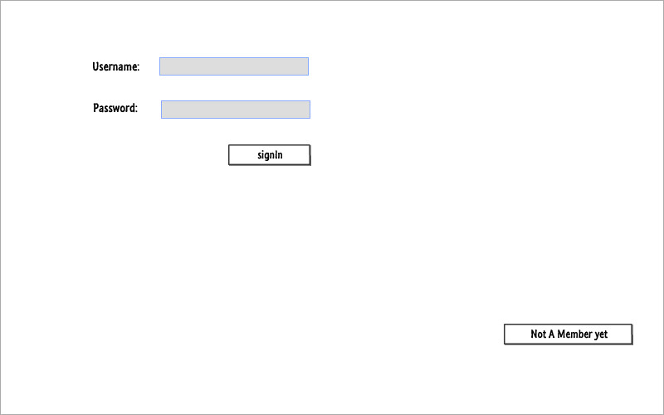

The main sign in page which will navigate the user to the home page of his/her last saved stage.

## Registration page

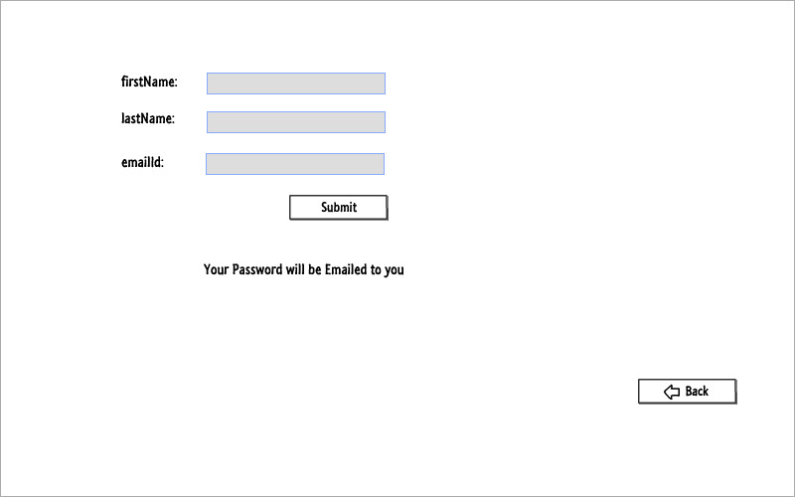

The registration page which would require a valid email address, the password of the created account would be emailed at the specific account.

## Shop

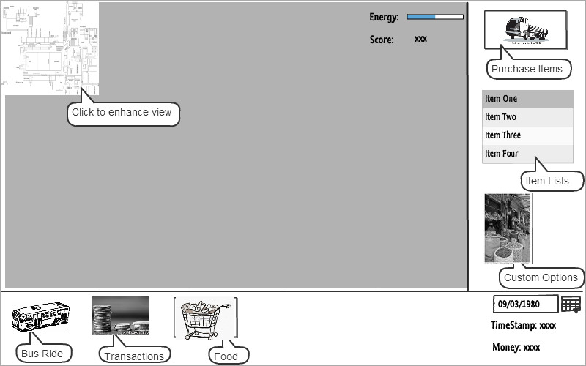

The right division would change on the specific occupation chosen by the player i.e. the right division is altering with each navigation.

## Farm

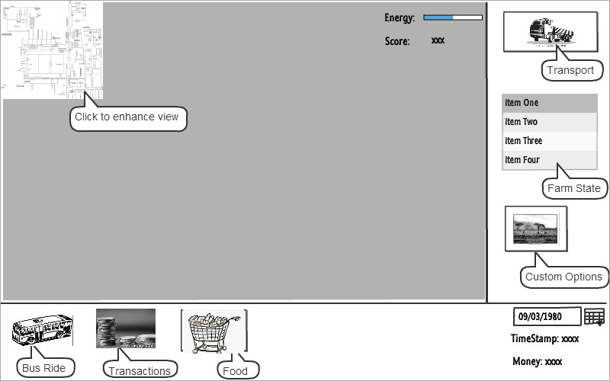The right division is different from the shop view as the navigations would perform different functions related to farm as the tool tips suggest.

## Food Options

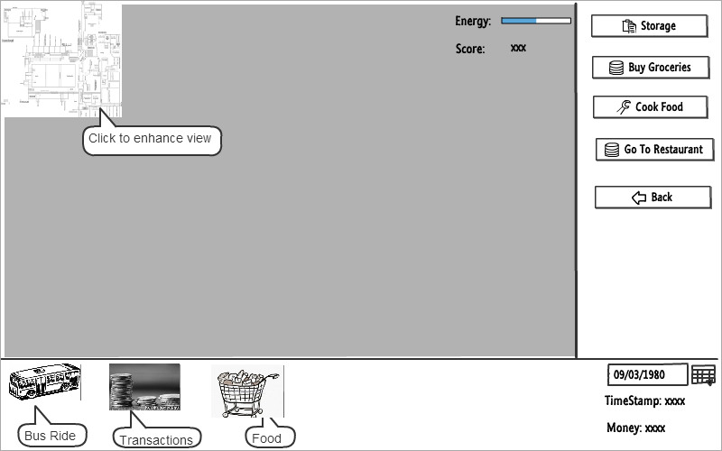

The options present in the bottom are static and would remain there through each navigation, in this specific navigation of food, the right division has changed accordingly.

## Custom Options

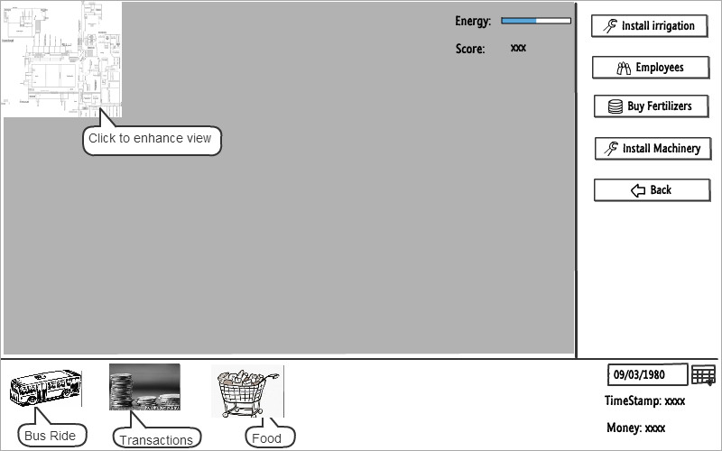

The custom options of farm and shop are different, this one is an example of the farm custom options that the player can act upon or can view stages.

## Bus Ride

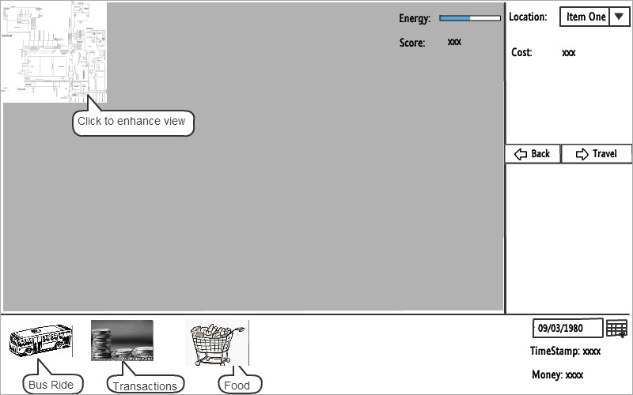

The bus ride is an option for travelling from one place to another, the location would be selected in the right division and the related cost would be system generated.

## Transaction Options

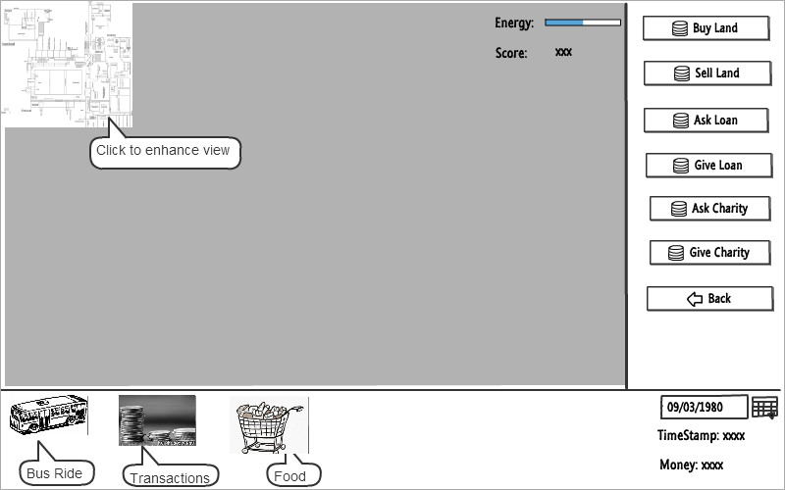

These options include the transactions of money that can be loan, charity or business related.

**Transport Options**

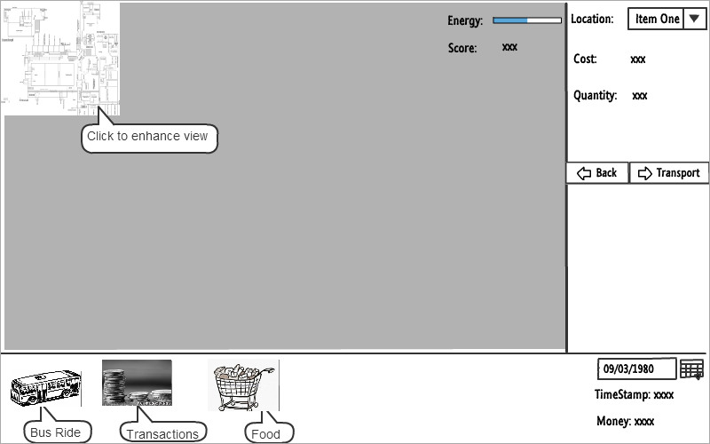The transport of the crops from one place to another requires the usage of resources and would have a specific cost depending upon the distance travelled. These specifications are given in the right division.