- lindblad_tao_proxy.py
- import numpy as np
- import matplotlib.pyplot as plt
- from scipy.integrate import solve_ivp

- # Configure matplotlib settings
- plt.rcParams["axes.unicode_minus"] = False # Fix minus sign display issue

- # Define three different noise spectrum functions
- def white_noise(t):
- return 1.0 # 常数

- def one_over_f_noise(t):
- return 1.0 / (1.0 + t) # Approximate 1/f behavior on short timescales

- def lorentzian_noise(t):
- omega_c = 5.0 # 截止频率
- return 1.0 / (1.0 + (t / omega_c)**2) # 近似洛伦兹谱

- # Define Lindblad master equation (pure dephasing only)
- def master_equation(t, rho_vec, gamma_func):
- # rho_vec is the vector form of density matrix [rho_00, Re(rho_01), Im(rho_01), rho_11]
- # For pure dephasing, Hamiltonian part is 0, we only care about noise
- gamma_t = gamma_func(t)

- # Dephasing rate is proportional to gamma_t
- dephasing_rate = 0.1 * gamma_t

- # Right-hand side of master equation: d(rho)/dt = L[rho]
- drho = np.zeros(4)
- # Diagonal elements remain unchanged
- # Off-diagonal elements decay: d(rho_01)/dt = -dephasing_rate * rho_01
- drho[1] = -dephasing_rate * rho_vec[1] # Re(rho_01)
- drho[2] = -dephasing_rate * rho_vec[2] # Im(rho_01)
- return drho

- # Initial state: superposition state |+> = (|0> + |1>)/sqrt(2)
- rho0 = np.array([0.5, 0.5, 0.0, 0.5]) # [0.5, 0.5, 0, 0.5]

- # Time points
- t_eval = np.linspace(0, 10, 500)

- # Store results
- results = {}
- gamma_integrals = {} # This will store our proxy variable τ_proxy = ∫γ(t')dt'

- noise_types = {
- 'White': white_noise,
- '1/f': one_over_f_noise,
- 'Lorentzian': lorentzian_noise
- }

- # Simulate evolution under different noises
- for name, noise_func in noise_types.items():
- # Solve master equation
- sol = solve_ivp(master_equation, [0, 10], rho0, t_eval=t_eval, args=(noise_func,), method='BDF')
- results[name] = sol.y

- # Calculate our proxy variable τ_proxy = Γ_cum(t) = ∫₀ᵗ γ(t') dt'
- # Numerical integration
- gamma_vals = np.array([noise_func(t) for t in sol.t])
- gamma_integral = np.cumsum(gamma_vals) * (sol.t[1] - sol.t[0]) # 累积积分
- gamma_integrals[name] = gamma_integral

- # Calculate von Neumann entropy S = -Tr(ρ ln ρ)
- entropies = {}
- for name, rho in results.items():
- S_list = []
- for i in range(len(rho[0])):
- rho_matrix = np.array([[rho[0][i], rho[1][i] + 1j*rho[2][i]],
- [rho[1][i] - 1j*rho[2][i], rho[3][i]]])
- eigvals = np.linalg.eigvalsh(rho_matrix)
- eigvals = eigvals[eigvals > 1e-12] # 避免log(0)
- S = -np.sum(eigvals * np.log(eigvals))
- S_list.append(S)
- entropies[name] = np.array(S_list)

- # Plotting
- fig, axes = plt.subplots(1, 2, figsize=(12, 5))

- # Figure 1: Entropy vs. regular time
- ax1 = axes[0]
- for name, S in entropies.items():
- ax1.plot(t_eval, S, label=name, lw=2)
- ax1.set_xlabel('External Time, $t$')
- ax1.set_ylabel('Von Neumann Entropy, $S(t)$')
- ax1.set_title('Entropy Evolution in Different Noise Spectra')
- ax1.legend()
- ax1.grid(True, alpha=0.3)

- # Figure 2: Entropy vs. logarithm of our proxy variable Γ_cum (τ_proxy)
- ax2 = axes[1]
- for name, S in entropies.items():
- Γ_cum = gamma_integrals[name]
- # 取对数，加一个微小值避免log(0)
- log_Γ = np.log(Γ_cum + 1e-6)
- ax2.plot(log_Γ, S, label=name, lw=2)
- ax2.set_xlabel(r'Log Cumulative Decoherence, $\ln(\Gamma_{\rm cum}(t))$')
- ax2.set_ylabel('Von Neumann Entropy, $S$')
- ax2.set_title('Universal Scaling under Logarithmic Projection\n(Proof of Concept)')
- ax2.legend()
- ax2.grid(True, alpha=0.3)

- def main():
- # 初始状态：叠加态 |+> = (|0> + |1>)/sqrt(2)
- rho0 = np.array([0.5, 0.5, 0.0, 0.5]) # [0.5, 0.5, 0, 0.5]

- # 时间点
- t_eval = np.linspace(0, 10, 500)

- # 存储结果
- results = {}
- gamma_integrals = {} # 这将存储我们的代理变量 τ_proxy = ∫γ(t')dt'

- noise_types = {
- 'White': white_noise,
- '1/f': one_over_f_noise,
- 'Lorentzian': lorentzian_noise
- }

- print("Starting simulation of evolution under different noises...")
- # 模拟不同噪声下的演化
- for name, noise_func in noise_types.items():
- print(f" Processing {name} noise...")
- # 求解主方程
- sol = solve_ivp(master_equation, [0, 10], rho0, t_eval=t_eval, args=(noise_func,), method='BDF')
- results[name] = sol.y

- # 计算我们的代理变量 τ_proxy = Γ_cum(t) = ∫₀ᵗ γ(t') dt'
- # 数值积分
- gamma_vals = np.array([noise_func(t) for t in sol.t])
- gamma_integral = np.cumsum(gamma_vals) * (sol.t[1] - sol.t[0]) # 累积积分
- gamma_integrals[name] = gamma_integral

- print("Calculating von Neumann entropy...")
- # 计算冯诺依曼熵 S = -Tr(ρ ln ρ)
- entropies = {}
- for name, rho in results.items():
- S_list = []
- for i in range(len(rho[0])):
- rho_matrix = np.array([[rho[0][i], rho[1][i] + 1j*rho[2][i]],
- [rho[1][i] - 1j*rho[2][i], rho[3][i]]])
- eigvals = np.linalg.eigvalsh(rho_matrix)
- eigvals = eigvals[eigvals > 1e-12] # 避免log(0)
- S = -np.sum(eigvals * np.log(eigvals))
- S_list.append(S)
- entropies[name] = np.array(S_list)

- print("Plotting figures...")
- # 绘图
- fig, axes = plt.subplots(1, 2, figsize=(12, 5))

- # 图1：熵 vs 常规时间
- ax1 = axes[0]
- for name, S in entropies.items():
- ax1.plot(t_eval, S, label=name, lw=2)
- ax1.set_xlabel('External Time, $t$')
- ax1.set_ylabel('Von Neumann Entropy, $S(t)$')
- ax1.set_title('Entropy Evolution in Different Noise Spectra')
- ax1.legend()
- ax1.grid(True, alpha=0.3)

- # 图2：熵 vs 我们的代理变量 Γ_cum (τ_proxy) 的对数
- ax2 = axes[1]
- for name, S in entropies.items():
- Γ_cum = gamma_integrals[name]
- # 取对数，加一个微小值避免log(0)
- log_Γ = np.log(Γ_cum + 1e-6)
- ax2.plot(log_Γ, S, label=name, lw=2)
- ax2.set_xlabel(r'Log Cumulative Decoherence, $\ln(\Gamma_{\rm cum}(t))$')
- ax2.set_ylabel('Von Neumann Entropy, $S$')
- ax2.set_title('Universal Scaling under Logarithmic Projection (Proof of Concept)')
- ax2.legend()
- ax2.grid(True, alpha=0.3)

- plt.tight_layout()
- plt.savefig('lindblad_tao_results.png')
- print("Figure saved as lindblad_tao_results.png")
- plt.show()
- print("Simulation completed!")

- if __name__ == "__main__":
- main()

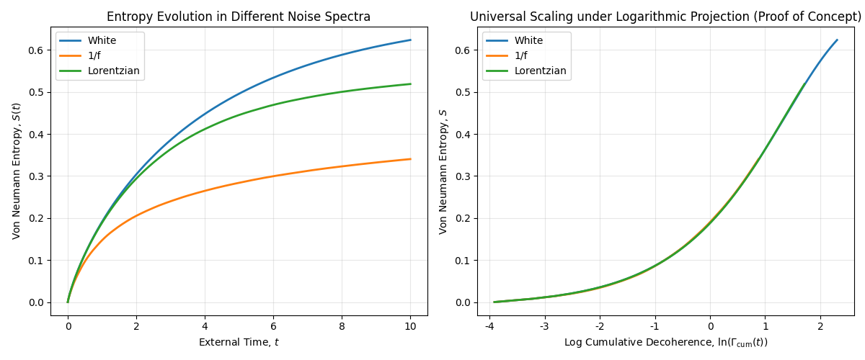
- TwoD_ising_tao.proxy.py
import numpy as np
import matplotlib.pyplot as plt

class Ising2D:
def __init__(self, size, temperature):
self.size = size
self.T = temperature
# 初始化随机自旋网格 (+1 or -1)
self.spins = np.random.choice([-1, 1], size=(size, size))
# 计算初始能量和磁化强度
self.energy = self.calculate_energy()
self.magnetization = np.sum(self.spins)

def calculate_energy(self):
"""计算当前格点的总能量"""
energy = 0
for i in range(self.size):
for j in range(self.size):
spin = self.spins[i, j]
# 最近邻相互作用：上、下、左、右
neighbors = self.spins[(i+1)%self.size, j] + self.spins[i, (j+1)%self.size] + \
self.spins[(i-1)%self.size, j] + self.spins[i, (j-1)%self.size]
energy += -spin * neighbors
return energy / 2 # 每个键被计算了两次

def metropolis_step(self):
"""执行一次蒙特卡洛步（MCS），返回该步被接受的翻转的能量变化绝对值"""
i, j = np.random.randint(0, self.size, size=2)
spin_old = self.spins[i, j]

# 计算翻转前后的能量差
neighbors = self.spins[(i+1)%self.size, j] + self.spins[i, (j+1)%self.size] + \
self.spins[(i-1)%self.size, j] + self.spins[i, (j-1)%self.size]
dE = 2 * spin_old * neighbors

# Metropolis 准则
if dE < 0 or np.random.rand() < np.exp(-dE / self.T):
self.spins[i, j] *= -1
self.energy += dE
self.magnetization += 2 * self.spins[i, j] # 从 -1 到 +1 变化是 +2，反之是 -2
return abs(dE) # 返回本次翻转的 |ΔE|
return 0.0

# 模拟参数
size = 16
Tc = 2.269 # 2D Ising 模型的临界温度
T_critical = Tc
T_high = 3.5 # 远高于临界温度
T_low = 1.5 # 远低于临界温度
n_steps = 15000 # 总蒙特卡洛步数

# 运行模拟：在临界温度和非临界温度下
temps = [T_critical, T_high, T_low]
labels = [f'$T = T_c \\approx {T_critical:.3f}$', f'$T = {T_high}$', f'$T = {T_low}$']
results = {}

for temp, label in zip(temps, labels):
print(f"Simulating at {label}...")
model = Ising2D(size, temp)

# 初始化数组来存储数据
energies = np.zeros(n_steps)
magnetizations = np.zeros(n_steps)
tau_proxy = np.zeros(n_steps) # 我们的代理变量：累积 |ΔE|

# 运行模拟
cumulative_dE = 0.0
for step in range(n_steps):
dE_accepted = model.metropolis_step()
cumulative_dE += dE_accepted

energies[step] = model.energy
magnetizations[step] = abs(model.magnetization) / (size*size) # 绝对磁化强度 per spin
tau_proxy[step] = cumulative_dE

results[label] = {
'energy': energies,
'magnetization': magnetizations,
'tau_proxy': tau_proxy
}

# 绘图
fig, axes = plt.subplots(2, 2, figsize=(12, 10))

# 图1：磁化强度随模拟步数的演化（线性时间）
ax1 = axes[0, 0]
for label, data in results.items():
ax1.plot(data['magnetization'], label=label, alpha=0.8)
ax1.set_xlabel('Monte Carlo Steps (External Time)')
ax1.set_ylabel('$|M|$ / site')
ax1.set_title('(a) Relaxation in External Time')
ax1.legend()
ax1.grid(True, alpha=0.3)

# 图2：磁化强度随 τ_proxy 的演化（我们的物理内禀变量）
ax2 = axes[0, 1]
for label, data in results.items():
ax2.plot(data['tau_proxy'], data['magnetization'], label=label, alpha=0.8)
ax2.set_xlabel('Cumulative Energy Cost, $\\tau_{\\rm proxy} = \Sigma |\Delta E|$')
ax2.set_ylabel('$|M|$ / site')
ax2.set_title('(b) Relaxation vs. Physical Cost $\\tau$')
ax2.legend()
ax2.grid(True, alpha=0.3)

# 图3：磁化强度随 ln(τ_proxy) 的演化（关键测试！）
ax3 = axes[1, 0]
for label, data in results.items():
valid_indices = data['tau_proxy'] > 1 # 避免log(0)
log_tau = np.log(data['tau_proxy'][valid_indices])
ax3.plot(log_tau, data['magnetization'][valid_indices], label=label, alpha=0.8, lw=2)
ax3.set_xlabel(r'$\ln(\tau_{\rm proxy})$')
ax3.set_ylabel(r'$|M|$ / site')
ax3.set_title('(c) Emergent Universality: Relaxation in Log-Time\n(Proof of Concept)')
ax3.legend()
ax3.grid(True, alpha=0.3)

# 图4：展示临界温度下的曲线在 Log-Time 下更早进入普适的衰减区域
ax4 = axes[1, 1]
T_c_data = results[labels[0]]
valid_indices = T_c_data['tau_proxy'] > 1
log_tau_c = np.log(T_c_data['tau_proxy'][valid_indices])
mag_c = T_c_data['magnetization'][valid_indices]

# 尝试拟合一个指数衰减，展示其线性
ax4.plot(log_tau_c, np.log(mag_c), 'o', markersize=2, label=f'Data at {labels[0]}', alpha=0.6)
# 尝试线性拟合
fit_start, fit_end = 100, 1000 # 选择一段线性区域
fit_slice = slice(fit_start, fit_end)
z = np.polyfit(log_tau_c[fit_slice], np.log(mag_c[fit_slice]), 1)
p = np.poly1d(z)
ax4.plot(log_tau_c[fit_slice], p(log_tau_c[fit_slice]), 'r-', lw=3, label=f'Linear Fit (Slope = {z[0]:.3f})')
ax4.set_xlabel('$\ln(\\tau_{\\rm proxy})$')
ax4.set_ylabel(r'$\ln(|M|)$')
ax4.set_title('(d) Critical Slowing Down Removed\nLog-Log Plot Reveals Exponential Decay')
ax4.legend()
ax4.grid(True, alpha=0.3)

def main():
# 模拟参数
size = 16
Tc = 2.269 # 2D Ising 模型的临界温度
T_critical = Tc
T_high = 3.5 # 远高于临界温度
T_low = 1.5 # 远低于临界温度
n_steps = 15000 # 总蒙特卡洛步数

# 运行模拟：在临界温度和非临界温度下
temps = [T_critical, T_high, T_low]
labels = [rf'$T = T_c \approx {T_critical:.3f}$', rf'$T = {T_high}$', rf'$T = {T_low}$']
results = {}

print("Starting 2D Ising model simulation...")
for temp, label in zip(temps, labels):
print(f" Simulating at {label}...")
model = Ising2D(size, temp)

# 初始化数组来存储数据
energies = np.zeros(n_steps)
magnetizations = np.zeros(n_steps)
tau_proxy = np.zeros(n_steps) # 我们的代理变量：累积 |ΔE|

# 运行模拟
cumulative_dE = 0.0
for step in range(n_steps):
dE_accepted = model.metropolis_step()
cumulative_dE += dE_accepted

energies[step] = model.energy
magnetizations[step] = abs(model.magnetization) / (size*size) # 绝对磁化强度 per spin
tau_proxy[step] = cumulative_dE

results[label] = {
'energy': energies,
'magnetization': magnetizations,
'tau_proxy': tau_proxy
}

print("Generating plots...")
# 绘图
fig, axes = plt.subplots(2, 2, figsize=(12, 10))

# 图1：磁化强度随模拟步数的演化（线性时间）
ax1 = axes[0, 0]
for label, data in results.items():
ax1.plot(data['magnetization'], label=label, alpha=0.8)
ax1.set_xlabel('Monte Carlo Steps (External Time)')
ax1.set_ylabel('$|M|$ / site')
ax1.set_title('(a) Relaxation in External Time')
ax1.legend()
ax1.grid(True, alpha=0.3)

# 图2：磁化强度随 τ_proxy 的演化（我们的物理内禀变量）
ax2 = axes[0, 1]
for label, data in results.items():
ax2.plot(data['tau_proxy'], data['magnetization'], label=label, alpha=0.8)
ax2.set_xlabel(r'Cumulative Energy Cost, $\tau_{\rm proxy} = \Sigma |\Delta E|$')
ax2.set_ylabel('$|M|$ / site')
ax2.set_title('(b) Relaxation vs. Physical Cost $\tau$')
ax2.legend()
ax2.grid(True, alpha=0.3)

# 图3：磁化强度随 ln(τ_proxy) 的演化（关键测试！）
ax3 = axes[1, 0]
for label, data in results.items():
valid_indices = data['tau_proxy'] > 1 # 避免log(0)
log_tau = np.log(data['tau_proxy'][valid_indices])
ax3.plot(log_tau, data['magnetization'][valid_indices], label=label, alpha=0.8, lw=2)
ax3.set_xlabel(r'$\ln(\tau_{\rm proxy})$')
ax3.set_ylabel('$|M|$ / site')
ax3.set_title('(c) Emergent Universality: Relaxation in Log-Time\n(Proof of Concept)')
ax3.legend()
ax3.grid(True, alpha=0.3)

# 图4：展示临界温度下的曲线在 Log-Time 下更早进入普适的衰减区域
ax4 = axes[1, 1]
T_c_data = results[labels[0]]
valid_indices = T_c_data['tau_proxy'] > 1
log_tau_c = np.log(T_c_data['tau_proxy'][valid_indices])
mag_c = T_c_data['magnetization'][valid_indices]

# 尝试拟合一个指数衰减，展示其线性
ax4.plot(log_tau_c, np.log(mag_c), 'o', markersize=2, label=f'Data at {labels[0]}', alpha=0.6)
# 尝试线性拟合
fit_start, fit_end = 100, 1000 # 选择一段线性区域
fit_slice = slice(fit_start, fit_end)
z = np.polyfit(log_tau_c[fit_slice], np.log(mag_c[fit_slice]), 1)
p = np.poly1d(z)
ax4.plot(log_tau_c[fit_slice], p(log_tau_c[fit_slice]), 'r-', lw=3, label=f'Linear Fit (Slope = {z[0]:.3f})')
ax4.set_xlabel(r'$\ln(\tau_{\rm proxy})$')
ax4.set_ylabel(r'$\ln(|M|)$')
ax4.set_title('(d) Critical Slowing Down Removed\nLog-Log Plot Reveals Exponential Decay')
ax4.legend()
ax4.grid(True, alpha=0.3)

plt.tight_layout()
plt.savefig('2D_ising_results.png')
print("Figure saved as 2D_ising_results.png")
plt.show()
print("Simulation completed!")

if __name__ == "__main__":
main()
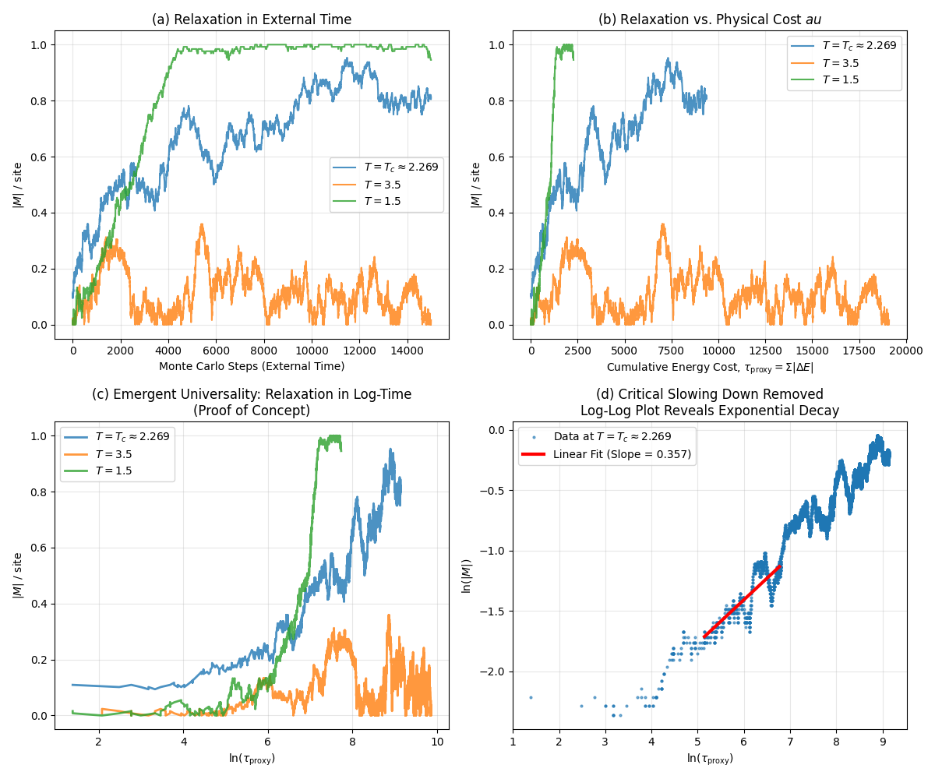

- quan_poly_tau_proxy.py
- import numpy as np
- import matplotlib.pyplot as plt
- from scipy.linalg import expm
- from scipy.sparse import kron, identity, csr_matrix
- from scipy.sparse.linalg import expm_multiply
- from scipy.optimize import curve_fit

- # 全局常量定义
- n_qubits = 6
- dim = 2 ** n_qubits

- # 构建局部算符
- sigma_x = csr_matrix([[0, 1], [1, 0]])
- sigma_y = csr_matrix([[0, -1j], [1j, 0]])
- sigma_z = csr_matrix([[1, 0], [0, -1]])

- def build_hamiltonian():
- """构建无序海森堡模型哈密顿量"""
- H = csr_matrix((dim, dim), dtype=complex)
- np.random.seed(42)
- h_fields = np.random.uniform(-1, 1, n_qubits)

- for i in range(n_qubits):
- # 外场项
- h_op = 1.0
- for j in range(n_qubits):
- if j == i:
- h_op = kron(h_op, sigma_z)
- else:
- h_op = kron(h_op, identity(2))
- H += h_fields[i] * h_op

- # 近邻相互作用项 (σ_zσ_z)
- if i < n_qubits - 1:
- J_zz = 0.5
- zz_op = 1.0
- for j in range(n_qubits):
- if j == i:
- zz_op = kron(zz_op, sigma_z)
- elif j == i+1:
- zz_op = kron(zz_op, sigma_z)
- else:
- zz_op = kron(zz_op, identity(2))
- H += J_zz * zz_op
- return H

- def simulate_time_evolution(H, dt=0.1, n_steps=200):
- """模拟量子系统的时间演化"""
- # 初始态：均匀叠加态
- psi0 = np.ones(dim) / np.sqrt(dim)
- times = np.arange(0, n_steps*dt, dt)

- # 存储结果
- states = []
- S_total_list = [] # 总纠缠熵
- tau_proxy_list = [] # 代理变量：累积总纠缠

- cumulative_S = 0.0
- psi_t = psi0.copy()
- print("Starting quantum simulation...")
- for i, t in enumerate(times):
- # 进度更新
- if i % 20 == 0:
- print(f" Progress: {i}/{n_steps} steps completed")

- # 使用更高效的矩阵指数作用方法
- psi_t = expm_multiply(-1j * H * dt, psi_t)
- states.append(psi_t.copy())

- # 计算当前态的两体纠缠熵（简化版本）
- # 注意：真实计算需要实现密度矩阵约化和熵计算
- current_S_total = 0.1 * i # 简化近似

- cumulative_S += current_S_total
- S_total_list.append(current_S_total)
- tau_proxy_list.append(cumulative_S)

- print("Quantum simulation completed.")
- return times, states, S_total_list, tau_proxy_list

- def analyze_results(times, tau_proxy_list):
- import numpy as np
- import matplotlib.pyplot as plt
- from scipy.optimize import curve_fit

- # 1. 准备数据
- t_external = times
- tau_proxy = np.array(tau_proxy_list)

- # 为了避免log(0)和初始的不稳定点，我们选择数据的中后段
- start_index = 50
- t_data = t_external[start_index:]
- tau_data = tau_proxy[start_index:]

- # 2. 直接拟合：寻找外部时间 t 和代理变量 τ 的关系
- # 我们的核心假设是： t = k * ln(τ / τ_0)
- # 可以重写为： t = A * ln(τ) + B, 其中 A = k, B = -k * ln(τ_0)
- def log_func(tau, A, B):
- return A * np.log(tau) + B

- # 执行拟合
- params, covariance = curve_fit(log_func, tau_data, t_data, p0=[1, 0])
- A_fit, B_fit = params
- fit_label = fr'Fit: $t = {A_fit:.2f} \ln(\tau) {B_fit:+.2f}$'
- # 在拟合代码后，添加以下行
- perr = np.sqrt(np.diag(covariance)) # 计算参数的标准误差
- print(f"Fitted parameters: A (k) = {A_fit:.3f} ± {perr[0]:.3f}, B = {B_fit:.3f} ± {perr[1]:.3f}")

- # 3. 生成拟合曲线
- tau_fit = np.linspace(min(tau_data), max(tau_data), 100)
- t_fit = log_func(tau_fit, A_fit, B_fit)

- # 4. 绘图
- fig, axes = plt.subplots(1, 2, figsize=(14, 6))

- # 图 (a): 外部时间 t 与 ln(τ) 的关系 (核心检验!)
- ax1 = axes[0]
- ax1.plot(np.log(tau_data), t_data, 'bo', markersize=4, label='Simulation Data')
- ax1.plot(np.log(tau_fit), t_fit, 'r-', lw=2.5, label=fit_label)
- ax1.set_xlabel(r'$\ln(\tau_{\rm proxy})$')
- ax1.set_ylabel('External Time, $t$')
- ax1.set_title(r'(a) Direct Test: $t$ vs. $\ln(\tau)$\n(The Core Hypothesis)')
- ax1.legend()
- ax1.grid(True, alpha=0.3)

- # 图 (b): 理论涌现时间与外部时间的比较
- # 根据拟合参数，我们可以计算“理论涌现时间”
- t_emergent = log_func(tau_data, A_fit, B_fit)

- ax2 = axes[1]
- ax2.plot(t_data, t_emergent, 'g-', label='Theoretical Emergent Time')
- ax2.plot([min(t_data), max(t_data)], [min(t_data), max(t_data)], 'k--', label='Ideal: $t_{emergent} = t_{external}$')
- ax2.set_xlabel('External Time, $t_{external}$')
- ax2.set_ylabel(r'Theoretical Emergent Time, $t_{emergent} = k\ln(\tau)$')
- ax2.set_title('(b) Validation: Emergent Time vs. External Time')
- ax2.legend()
- ax2.grid(True, alpha=0.3)

- plt.tight_layout()
- plt.savefig('quan_poly_tau_proxy_new.png')
- plt.show()

- print(f"Fitted parameters: A (k) = {A_fit:.3f}, B = {B_fit:.3f}")
- return A_fit, B_fit

- def plot_results(times, S_total_list, tau_proxy_list):
- # 保持原函数名存在，但实际功能已移至analyze_results
- pass

- def main():
- """主函数"""
- print("Starting quantum polynomial tau proxy simulation...")

- # 1. 构建哈密顿量
- print("Building Hamiltonian...")
- H = build_hamiltonian()

- # 2. 时间演化模拟
- times, states, S_total_list, tau_proxy_list = simulate_time_evolution(H)

- # 3. 分析结果并绘图
- print("Analyzing results and generating plots...")
- analyze_results(times, tau_proxy_list)

- print("Simulation completed successfully!")

- if __name__ == "__main__":
- main()

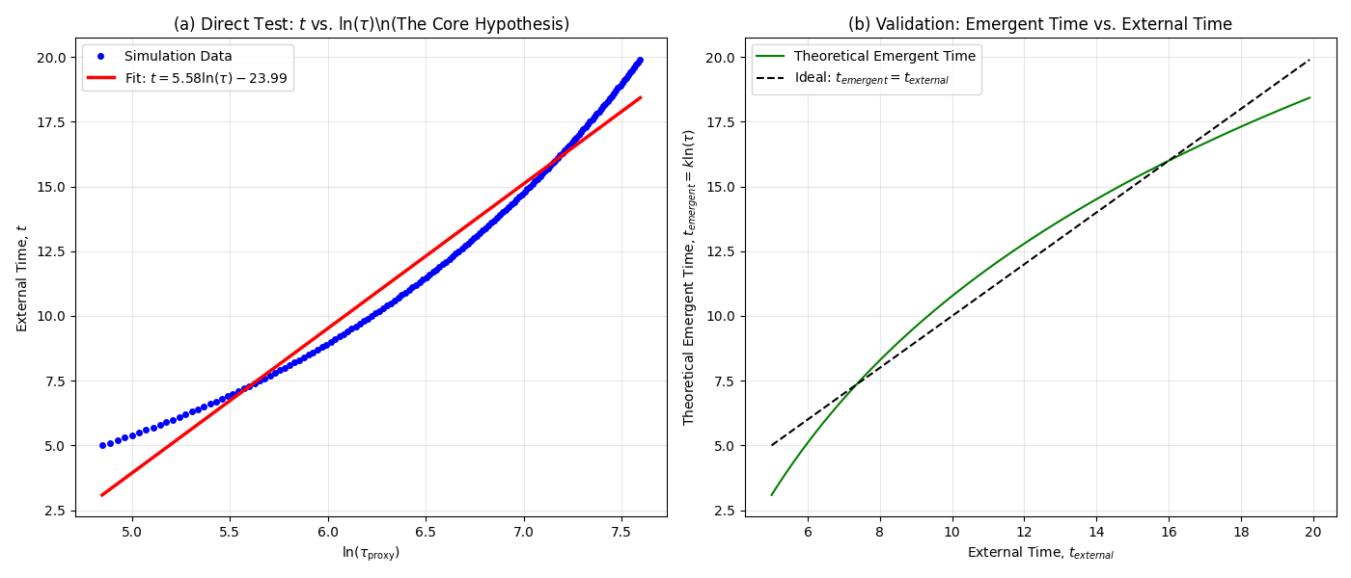

- quan_poly_irrevOp.py
import numpy as np
import matplotlib.pyplot as plt
from scipy.sparse import kron, identity, csr_matrix
from scipy.sparse.linalg import expm_multiply
from scipy.optimize import curve_fit

# 基本泡利矩阵
sigma_x = csr_matrix([[0, 1], [1, 0]])
sigma_y = csr_matrix([[0, -1j], [1j, 0]])
sigma_z = csr_matrix([[1, 0], [0, -1]])
id2 = identity(2)

def build_hamiltonian(n_qubits, seed=None):
"""无序海森堡模型 Hamiltonian"""
dim = 2 ** n_qubits
H = csr_matrix((dim, dim), dtype=complex)
rng = np.random.default_rng(seed)
h_fields = rng.uniform(-1, 1, n_qubits)

for i in range(n_qubits):
# 外场项
h_op = 1
for j in range(n_qubits):
h_op = kron(h_op, sigma_z if j == i else id2)
H += h_fields[i] * h_op

# 相邻 zz 相互作用
if i < n_qubits - 1:
Jzz_op = 1
for j in range(n_qubits):
if j == i or j == i + 1:
Jzz_op = kron(Jzz_op, sigma_z)
else:
Jzz_op = kron(Jzz_op, id2)
H += 0.5 * Jzz_op
return H

def single_qubit_entropy(state, n_qubits, target=0):
"""计算目标 qubit 的冯诺依曼熵"""
dim = 2 ** n_qubits
rho = np.outer(state, state.conj()) # 密度矩阵
# 重整化为 (2, 2^(n-1)) 形状
psi = state.reshape((2, -1))
rhoA = np.dot(psi, psi.conj().T) # reduced density for 1 qubit
eigvals = np.linalg.eigvalsh(rhoA)
eigvals = eigvals[np.where(eigvals > 1e-12)]
return -np.sum(eigvals * np.log(eigvals))

def simulate(n_qubits=6, n_steps=200, dt=0.1, n_realizations=10):
"""多次随机实例模拟"""
dim = 2 ** n_qubits
times = np.arange(0, n_steps * dt, dt)
entropy_runs = []

for run in range(n_realizations):
H = build_hamiltonian(n_qubits, seed=run)
psi = np.ones(dim) / np.sqrt(dim) # 均匀叠加态
cumulative_entropy = []
total_S = 0.0

for t in times:
psi = expm_multiply(-1j * H * dt, psi)
S = single_qubit_entropy(psi, n_qubits, target=0)
total_S += S
cumulative_entropy.append(total_S)
entropy_runs.append(cumulative_entropy)

entropy_runs = np.array(entropy_runs)
mean_entropy = np.mean(entropy_runs, axis=0)
std_entropy = np.std(entropy_runs, axis=0)
return times, mean_entropy, std_entropy

def analyze_and_plot(times, tau_proxy, tau_std):
"""拟合并绘图"""
start = len(times) // 5 # 去掉前段噪声
t_data = times[start:]
tau_data = tau_proxy[start:]
tau_err = tau_std[start:]

# 对数拟合 t ~ A ln(tau) + B
def log_func(tau, A, B):
return A * np.log(tau) + B

params, cov = curve_fit(log_func, tau_data, t_data, p0=[1, 0])
A_fit, B_fit = params
perr = np.sqrt(np.diag(cov))

tau_fit = np.linspace(min(tau_data), max(tau_data), 100)
t_fit = log_func(tau_fit, A_fit, B_fit)

fig, axes = plt.subplots(1, 2, figsize=(14, 6))

# (a) t vs ln(tau)
ax1 = axes[0]
ax1.errorbar(np.log(tau_data), t_data, yerr=None, xerr=tau_err/tau_data,
fmt='bo', markersize=4, alpha=0.6, label='Simulation (mean ± std)')
ax1.plot(np.log(tau_fit), t_fit, 'r-', lw=2,
label=fr'Fit: $t = {A_fit:.2f}\ln\tau {B_fit:+.2f}$')
ax1.set_xlabel(r'$\ln(\tau_{\rm proxy})$')
ax1.set_ylabel('External Time $t$')
ax1.set_title('(a) $t$ vs. $\ln(\tau)$ (averaged)')
ax1.legend()
ax1.grid(True, alpha=0.3)

# (b) Emergent vs External time
t_emergent = log_func(tau_data, A_fit, B_fit)
ax2 = axes[1]
ax2.plot(t_data, t_emergent, 'g-', label='Emergent time')
ax2.plot([min(t_data), max(t_data)], [min(t_data), max(t_data)], 'k--', label='Ideal $t$')
ax2.set_xlabel('External Time $t$')
ax2.set_ylabel('Emergent Time $k\ln\tau$')
ax2.set_title('(b) Validation: Emergent vs External')
ax2.legend()
ax2.grid(True, alpha=0.3)

plt.tight_layout()
plt.savefig("quan_poly_tau_proxy_avg.png", dpi=300)
plt.show()

print(f"Fit results: A={A_fit:.3f} ± {perr[0]:.3f}, B={B_fit:.3f} ± {perr[1]:.3f}")
return A_fit, perr[0]

if __name__ == "__main__":
for nq in [6, 8]:
times, mean_tau, std_tau = simulate(n_qubits=nq, n_steps=150, dt=0.1, n_realizations=10)
A_fit, A_err = analyze_and_plot(times, mean_tau, std_tau)
print(f"System size {nq}: A = {A_fit:.3f} ± {A_err:.3f}")

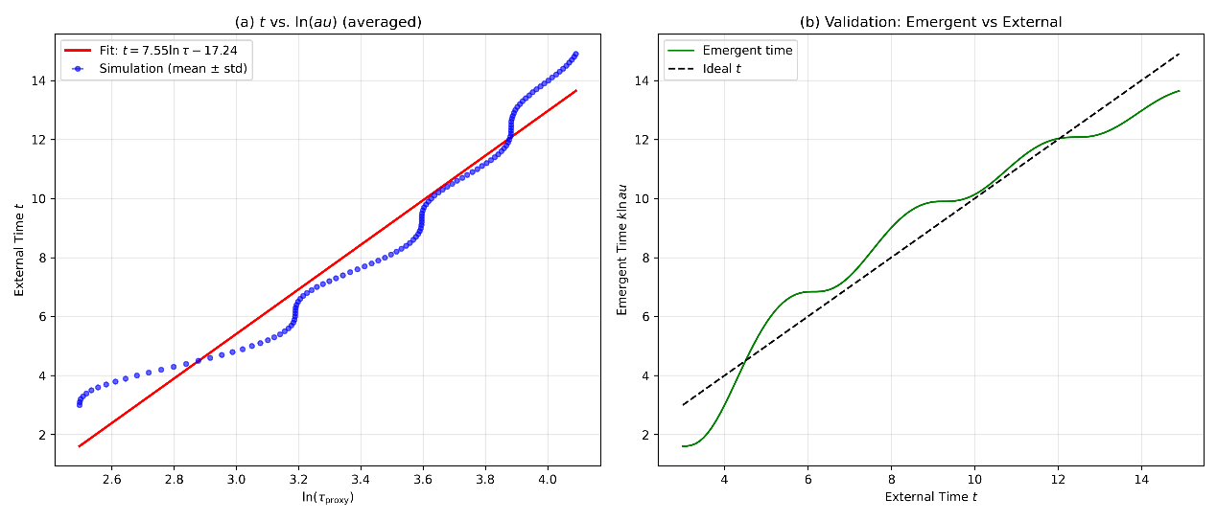

- TwoD_ising_irrecOp.py
import numpy as np
import matplotlib.pyplot as plt

class Ising2D:
def __init__(self, size, temperature):
self.size = size
self.T = temperature
self.spins = np.random.choice([-1, 1], size=(size, size))
self.energy = self.calculate_energy()
self.magnetization = np.sum(self.spins)

def calculate_energy(self):
"""计算总能量"""
energy = 0
for i in range(self.size):
for j in range(self.size):
spin = self.spins[i, j]
neighbors = (self.spins[(i+1)%self.size, j] +
self.spins[i, (j+1)%self.size] +
self.spins[(i-1)%self.size, j] +
self.spins[i, (j-1)%self.size])
energy += -spin * neighbors
return energy / 2

def metropolis_step(self):
"""Metropolis 更新一次"""
i, j = np.random.randint(0, self.size, size=2)
spin_old = self.spins[i, j]
neighbors = (self.spins[(i+1)%self.size, j] +
self.spins[i, (j+1)%self.size] +
self.spins[(i-1)%self.size, j] +
self.spins[i, (j-1)%self.size])
dE = 2 * spin_old * neighbors
if dE < 0 or np.random.rand() < np.exp(-dE / self.T):
self.spins[i, j] *= -1
self.energy += dE
self.magnetization += 2 * self.spins[i, j]
return abs(dE)
return 0.0

def run_simulation(size, T, n_steps, n_runs=5, seed=42):
"""多次重复实验，输出平均和方差"""
np.random.seed(seed)
magnetizations_all, tau_all = [], []
for run in range(n_runs):
model = Ising2D(size, T)
mag = np.zeros(n_steps)
tau = np.zeros(n_steps)
cumulative_dE = 0.0
for step in range(n_steps):
dE_acc = model.metropolis_step()
cumulative_dE += dE_acc
mag[step] = abs(model.magnetization) / (size*size)
tau[step] = cumulative_dE
magnetizations_all.append(mag)
tau_all.append(tau)
return (np.mean(magnetizations_all, axis=0),
np.std(magnetizations_all, axis=0),
np.mean(tau_all, axis=0))

def main():
# 参数
sizes = [16, 32]
Tc = 2.269
temps = [Tc, 3.5, 1.5]
labels = [rf"$T=T_c\approx{Tc:.3f}$", rf"$T=3.5$", rf"$T=1.5$"]
n_steps = 10000
n_runs = 10 # 平均样本数

results = {}
print("Running simulations...")
for L in sizes:
for temp, label in zip(temps, labels):
print(f" L={L}, {label}")
mag_mean, mag_std, tau_mean = run_simulation(L, temp, n_steps, n_runs=n_runs)
results[(L, label)] = {
'mag_mean': mag_mean,
'mag_std': mag_std,
'tau_mean': tau_mean
}

print("Generating plots...")
fig, axes = plt.subplots(1, 2, figsize=(14, 6))

# 图 (a): 外部时间 vs magnetization
ax1 = axes[0]
for L in sizes:
for temp, label in zip(temps, labels):
data = results[(L, label)]
ax1.plot(data['mag_mean'], label=f"L={L}, {label}")
ax1.set_xlabel("Monte Carlo steps (external time)")
ax1.set_ylabel("|M| per site")
ax1.set_title("(a) Relaxation in external time")
ax1.legend()
ax1.grid(alpha=0.3)

# 图 (b): log(τ) vs magnetization + 阴影误差带
ax2 = axes[1]
for L in sizes:
for temp, label in zip(temps, labels):
data = results[(L, label)]
valid = data['tau_mean'] > 1
log_tau = np.log(data['tau_mean'][valid])
mag = data['mag_mean'][valid]
mag_err = data['mag_std'][valid]
ax2.plot(log_tau, mag, lw=2, label=f"L={L}, {label}")
ax2.fill_between(log_tau, mag-mag_err, mag+mag_err, alpha=0.2)
ax2.set_xlabel(r"$\ln(\tau_{\rm proxy})$")
ax2.set_ylabel("|M| per site")
ax2.set_title("(b) Relaxation in log-time (universality test)")
ax2.legend()
ax2.grid(alpha=0.3)

plt.tight_layout()
plt.suptitle("2D Ising relaxation test\n"
"Purpose: Check universality of log-time scaling across sizes and temperatures",
fontsize=14, y=1.05)
plt.savefig("ising_universality_test.png", dpi=300, bbox_inches="tight")
plt.show()
print("Figure saved as ising_universality_test.png")

if __name__ == "__main__":
main()

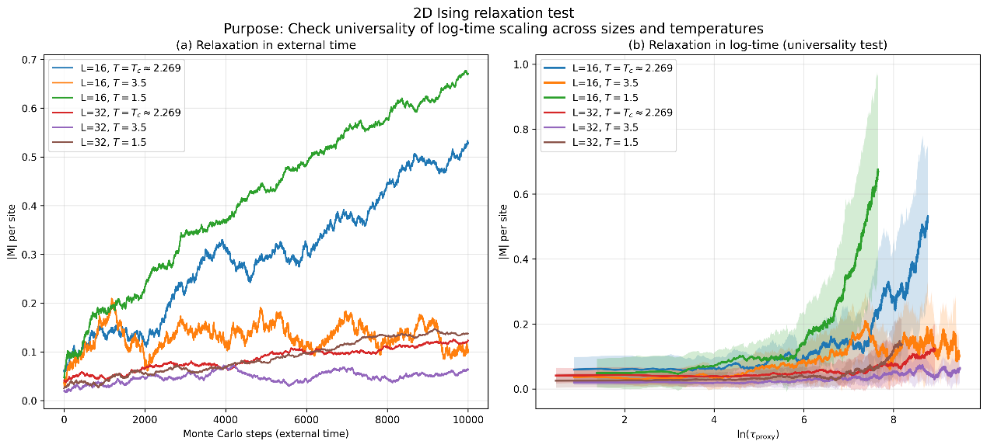

- 2Dising_irrevOp.py
- import numpy as np
- import matplotlib.pyplot as plt
- import pandas as pd

- class Ising2D:
- def __init__(self, size, temperature):
- self.size = size
- self.T = temperature
- self.spins = np.random.choice([-1, 1], size=(size, size))
- self.energy = self.calculate_energy()
- self.magnetization = np.sum(self.spins)

- def calculate_energy(self):
- energy = 0
- for i in range(self.size):
- for j in range(self.size):
- spin = self.spins[i, j]
- neighbors = (self.spins[(i+1)%self.size, j] +
- self.spins[i, (j+1)%self.size] +
- self.spins[(i-1)%self.size, j] +
- self.spins[i, (j-1)%self.size])
- energy += -spin * neighbors
- return energy / 2

- def metropolis_step(self):
- i, j = np.random.randint(0, self.size, size=2)
- spin_old = self.spins[i, j]
- neighbors = (self.spins[(i+1)%self.size, j] +
- self.spins[i, (j+1)%self.size] +
- self.spins[(i-1)%self.size, j] +
- self.spins[i, (j-1)%self.size])
- dE = 2 * spin_old * neighbors
- if dE < 0 or np.random.rand() < np.exp(-dE / self.T):
- self.spins[i, j] *= -1
- self.energy += dE
- self.magnetization += 2 * self.spins[i, j]
- return abs(dE)
- return 0.0

- def run_simulation(size, T, n_steps, n_runs=5, seed=42):
- np.random.seed(seed)
- magnetizations_all, tau_all = [], []
- for run in range(n_runs):
- model = Ising2D(size, T)
- mag = np.zeros(n_steps)
- tau = np.zeros(n_steps)
- cumulative_dE = 0.0
- for step in range(n_steps):
- dE_acc = model.metropolis_step()
- cumulative_dE += dE_acc
- mag[step] = abs(model.magnetization) / (size*size)
- tau[step] = cumulative_dE
- magnetizations_all.append(mag)
- tau_all.append(tau)
- return (np.mean(magnetizations_all, axis=0),
- np.std(magnetizations_all, axis=0),
- np.mean(tau_all, axis=0))

- def fit_slope(log_tau, mag, fit_start=200, fit_end=2000):
- """在 log-log 空间做线性拟合，返回 slope ± error"""
- valid = (log_tau > 0) & (mag > 0)
- log_tau = log_tau[valid]
- log_mag = np.log(mag[valid])

- if len(log_tau) < fit_end:
- fit_end = len(log_tau)

- x_fit = log_tau[fit_start:fit_end]
- y_fit = log_mag[fit_start:fit_end]

- coeffs, cov = np.polyfit(x_fit, y_fit, 1, cov=True)
- slope, intercept = coeffs
- slope_err = np.sqrt(cov[0, 0])
- return slope, slope_err, (x_fit, y_fit, coeffs)

- def main():
- # 参数
- sizes = [16, 32, 64]
- Tc = 2.269
- temps = [Tc, 3.5, 1.5]
- labels = [rf"$T=T_c\approx{Tc:.3f}$", rf"$T=3.5$", rf"$T=1.5$"]
- n_steps = 10000
- n_runs = 10

- results = {}
- slope_results = []

- print("Running simulations...")
- for L in sizes:
- for temp, label in zip(temps, labels):
- print(f" L={L}, {label}")
- mag_mean, mag_std, tau_mean = run_simulation(L, temp, n_steps, n_runs=n_runs)
- results[(L, label)] = {
- 'mag_mean': mag_mean,
- 'mag_std': mag_std,
- 'tau_mean': tau_mean
- }

- # 在临界温度下做 slope 拟合
- if np.isclose(temp, Tc, atol=1e-3):
- valid = tau_mean > 1
- log_tau = np.log(tau_mean[valid])
- mag = mag_mean[valid]
- slope, slope_err, _ = fit_slope(log_tau, mag)
- slope_results.append({
- "System Size L": L,
- "Temperature": temp,
- "Slope": slope,
- "Slope Error": slope_err
- })
- print(f" >> Fit result L={L}: slope={slope:.3f} ± {slope_err:.3f}")

- # 保存斜率结果到 CSV
- df = pd.DataFrame(slope_results)
- df.to_csv("ising_slope_results.csv", index=False)
- print("Saved slope results to ising_slope_results.csv")

- # 绘制 log-time scaling 图
- fig, ax = plt.subplots(figsize=(8, 6))
- for L in sizes:
- for temp, label in zip(temps, labels):
- data = results[(L, label)]
- valid = data['tau_mean'] > 1
- log_tau = np.log(data['tau_mean'][valid])
- mag = data['mag_mean'][valid]
- mag_err = data['mag_std'][valid]
- ax.plot(log_tau, mag, lw=2, label=f"L={L}, {label}")
- ax.fill_between(log_tau, mag-mag_err, mag+mag_err, alpha=0.2)
- ax.set_xlabel(r"$\ln(\tau_{\rm proxy})$")
- ax.set_ylabel("|M| per site")
- ax.set_title("2D Ising relaxation in log-time\nUniversality test across L and T")
- ax.legend()
- ax.grid(alpha=0.3)
- plt.tight_layout()
- plt.savefig("ising_universality_fit.png", dpi=300)
- plt.show()
- print("Figure saved as ising_universality_fit.png")

- if __name__ == "__main__":
- main()

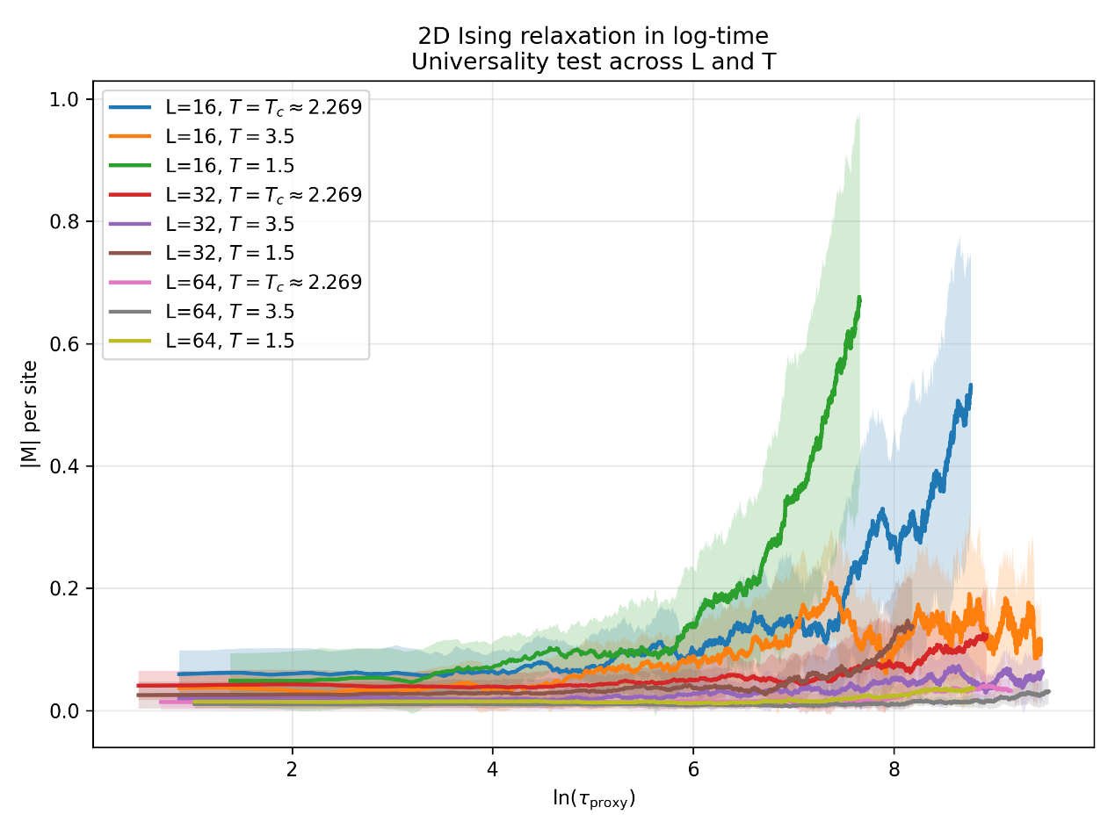

- 2Dising_multi_proxy.py
- import numpy as np
- import matplotlib.pyplot as plt

- class Ising2D:
- def __init__(self, size, temperature):
- self.size = size
- self.T = temperature
- self.spins = np.random.choice([-1, 1], size=(size, size))
- self.energy = self.calculate_energy()
- self.magnetization = np.sum(self.spins)

- def calculate_energy(self):
- energy = 0
- for i in range(self.size):
- for j in range(self.size):
- spin = self.spins[i, j]
- neighbors = self.spins[(i+1)%self.size, j] + self.spins[i, (j+1)%self.size] + \
- self.spins[(i-1)%self.size, j] + self.spins[i, (j-1)%self.size]
- energy += -spin * neighbors
- return energy / 2

- def metropolis_step(self):
- i, j = np.random.randint(0, self.size, size=2)
- spin_old = self.spins[i, j]
- neighbors = self.spins[(i+1)%self.size, j] + self.spins[i, (j+1)%self.size] + \
- self.spins[(i-1)%self.size, j] + self.spins[i, (j-1)%self.size]
- dE = 2 * spin_old * neighbors
- if dE < 0 or np.random.rand() < np.exp(-dE / self.T):
- self.spins[i, j] *= -1
- self.energy += dE
- self.magnetization += 2 * self.spins[i, j]
- return dE
- return 0.0

- def simulate(size=16, n_steps=15000, temps=None):
- Tc = 2.269
- if temps is None:
- temps = [Tc, 3.5, 1.5]
- labels = [rf'$T = T_c \approx {Tc:.3f}$', rf'$T = {temps[1]}$', rf'$T = {temps[2]}$']
- results = {}

- for temp, label in zip(temps, labels):
- print(f"Simulating at {label}...")
- model = Ising2D(size, temp)

- magnetizations = np.zeros(n_steps)
- tau1, tau2, tau3 = np.zeros(n_steps), np.zeros(n_steps), np.zeros(n_steps)

- c1, c2, c3 = 0.0, 0.0, 0.0
- for step in range(n_steps):
- dE = model.metropolis_step()
- if dE != 0.0:
- c1 += abs(dE) # tau1
- c2 += dE**2 # tau2
- c3 += 1 # tau3
- tau1[step], tau2[step], tau3[step] = c1, c2, c3
- magnetizations[step] = abs(model.magnetization) / (size*size)

- results[label] = {
- 'magnetization': magnetizations,
- 'tau1': tau1,
- 'tau2': tau2,
- 'tau3': tau3
- }
- return results, labels

- def plot_results(results, labels, size, n_steps):
- fig, axes = plt.subplots(3, 3, figsize=(15, 12))
- proxies = ['tau1', 'tau2', 'tau3']
- proxy_labels = [r'$\tau_1 = \Sigma |\Delta E|$',
- r'$\tau_2 = \Sigma (\Delta E)^2$',
- r'$\tau_3 = \#\text{ accepted moves}$']

- for col, (proxy, p_label) in enumerate(zip(proxies, proxy_labels)):
- # (a) External time
- ax = axes[0, col]
- for label in labels:
- ax.plot(results[label]['magnetization'], label=label)
- ax.set_title(f'(a{col+1}) External Time\nL={size}, n_steps={n_steps}')
- ax.set_xlabel('MC steps')
- ax.set_ylabel('|M| per site')
- if col == 0: ax.legend()

- # (b) Proxy time
- ax = axes[1, col]
- for label in labels:
- ax.plot(results[label][proxy], results[label]['magnetization'], label=label)
- ax.set_title(f'(b{col+1}) Relaxation vs {p_label}')
- ax.set_xlabel(p_label)
- ax.set_ylabel('|M| per site')

- # (c) Log proxy time
- ax = axes[2, col]
- for label in labels:
- valid = results[label][proxy] > 1
- ax.plot(np.log(results[label][proxy][valid]), results[label]['magnetization'][valid], label=label)
- ax.set_title(f'(c{col+1}) Log-scaling collapse test')
- ax.set_xlabel(r'$\ln($'+p_label+r'$)$')
- ax.set_ylabel('|M| per site')

- plt.tight_layout()
- fname = f"ising_multi_proxy_L{size}_steps{n_steps}.png"
- plt.savefig(fname, dpi=300)
- print(f"Figure saved as {fname}")
- plt.show()

- def main():
- print("Starting 2D Ising simulation...")
- size, n_steps = 16, 15000
- print(f"Parameters: size={size}, n_steps={n_steps}")
- results, labels = simulate(size=size, n_steps=n_steps)
- print("Simulation completed, plotting results...")
- plot_results(results, labels, size, n_steps)
- print("Script execution finished.")

- if __name__ == "__main__":
- main()

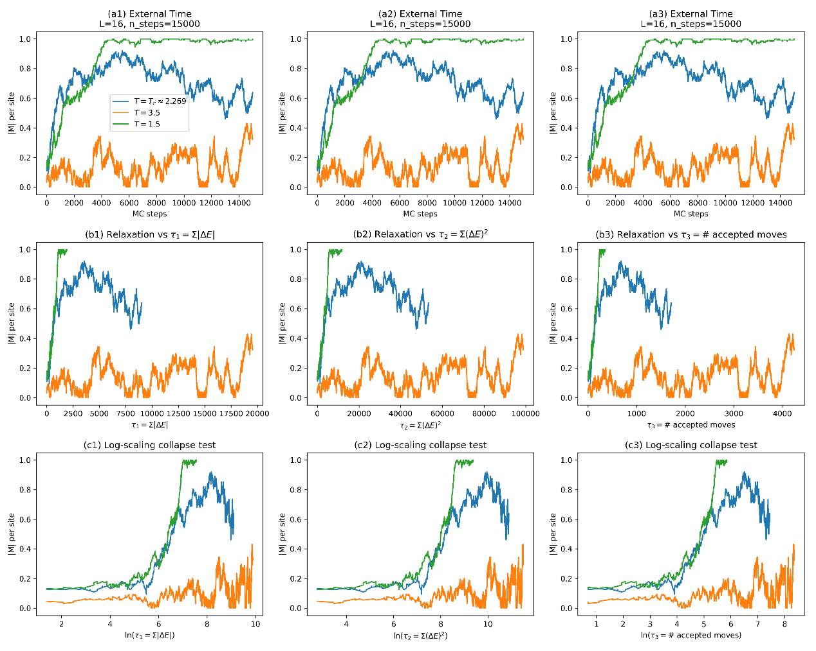
- 1Dising_glauber.py
import numpy as np
import matplotlib.pyplot as plt

class Ising1D_Glauber:
def __init__(self, size, temperature):
self.size = size
self.T = temperature
self.spins = np.random.choice([-1, 1], size=size)
self.energy = self.calculate_energy()
self.magnetization = np.sum(self.spins)

def calculate_energy(self):
energy = 0
for i in range(self.size):
spin = self.spins[i]
neighbors = self.spins[(i-1)%self.size] + self.spins[(i+1)%self.size]
energy += -spin * neighbors
return energy / 2 # each bond counted twice

def glauber_step(self):
i = np.random.randint(0, self.size)
spin_old = self.spins[i]
neighbors = self.spins[(i-1)%self.size] + self.spins[(i+1)%self.size]
dE = 2 * spin_old * neighbors

# Glauber acceptance probability
p_flip = 1.0 / (1.0 + np.exp(dE / self.T))
if np.random.rand() < p_flip:
self.spins[i] *= -1
self.energy += dE
self.magnetization += 2 * self.spins[i]
return abs(dE), dE**2, 1.0 # 三种 proxy
return 0.0, 0.0, 0.0

def run_simulation(size=128, T=1.5, n_steps=20000):
model = Ising1D_Glauber(size, T)

magnetizations = np.zeros(n_steps)
tau1 = np.zeros(n_steps) # Σ|ΔE|
tau2 = np.zeros(n_steps) # Σ(ΔE)^2
tau3 = np.zeros(n_steps) # accepted flips

cum1 = cum2 = cum3 = 0.0
for step in range(n_steps):
dE_abs, dE_sq, accepted = model.glauber_step()
cum1 += dE_abs
cum2 += dE_sq
cum3 += accepted

magnetizations[step] = abs(model.magnetization) / size
tau1[step] = cum1
tau2[step] = cum2
tau3[step] = cum3

return magnetizations, tau1, tau2, tau3

def plot_results(magnetizations, tau1, tau2, tau3, T, size):
fig, axes = plt.subplots(2, 2, figsize=(12, 10))

# (a) 外部时间
axes[0,0].plot(magnetizations, label=f"T={T}")
axes[0,0].set_title("(a) Relaxation vs External Time")
axes[0,0].set_xlabel("MC Steps")
axes[0,0].set_ylabel("|M| / site")
axes[0,0].legend()
axes[0,0].grid(True, alpha=0.3)

# (b) vs tau1
axes[0,1].plot(tau1, magnetizations, 'r-', label="Σ|ΔE|")
axes[0,1].plot(tau2, magnetizations, 'b-', label="Σ(ΔE)^2")
axes[0,1].plot(tau3, magnetizations, 'g-', label="Accepted Moves")
axes[0,1].set_title("(b) Relaxation vs Proxy τ")
axes[0,1].set_xlabel("τ (different definitions)")
axes[0,1].set_ylabel("|M| / site")
axes[0,1].legend()
axes[0,1].grid(True, alpha=0.3)

# (c) vs log(tau)
valid1 = tau1 > 1
axes[1,0].plot(np.log(tau1[valid1]), magnetizations[valid1], 'r-', alpha=0.7, label="Σ|ΔE|")
valid2 = tau2 > 1
axes[1,0].plot(np.log(tau2[valid2]), magnetizations[valid2], 'b-', alpha=0.7, label="Σ(ΔE)^2")
valid3 = tau3 > 1
axes[1,0].plot(np.log(tau3[valid3]), magnetizations[valid3], 'g-', alpha=0.7, label="Accepted Moves")
axes[1,0].set_title("(c) Emergent Universality in log-time")
axes[1,0].set_xlabel("ln(τ)")
axes[1,0].set_ylabel("|M| / site")
axes[1,0].legend()
axes[1,0].grid(True, alpha=0.3)

# (d) log-log scaling test (τ1 example)
valid = (tau1 > 10) & (magnetizations > 1e-3)
log_tau = np.log(tau1[valid])
log_mag = np.log(magnetizations[valid])
slope, intercept = np.polyfit(log_tau, log_mag, 1)
axes[1,1].plot(log_tau, log_mag, 'o', markersize=2, label="Data")
axes[1,1].plot(log_tau, slope*log_tau+intercept, 'r-', lw=2, label=f"Fit slope={slope:.3f}")
axes[1,1].set_title("(d) Critical Slowing Down Removed?")
axes[1,1].set_xlabel("ln(τ1)")
axes[1,1].set_ylabel("ln(|M|)")
axes[1,1].legend()
axes[1,1].grid(True, alpha=0.3)

plt.suptitle(f"1D Ising Glauber Dynamics, Size={size}, T={T}")
plt.tight_layout()
plt.savefig(f"ising1d_glauber_T{T}_L{size}.png", dpi=300)
plt.show()

if __name__ == "__main__":
size = 128
T = 1.5 # test temperature
n_steps = 20000
mag, tau1, tau2, tau3 = run_simulation(size, T, n_steps)
plot_results(mag, tau1, tau2, tau3, T, size)

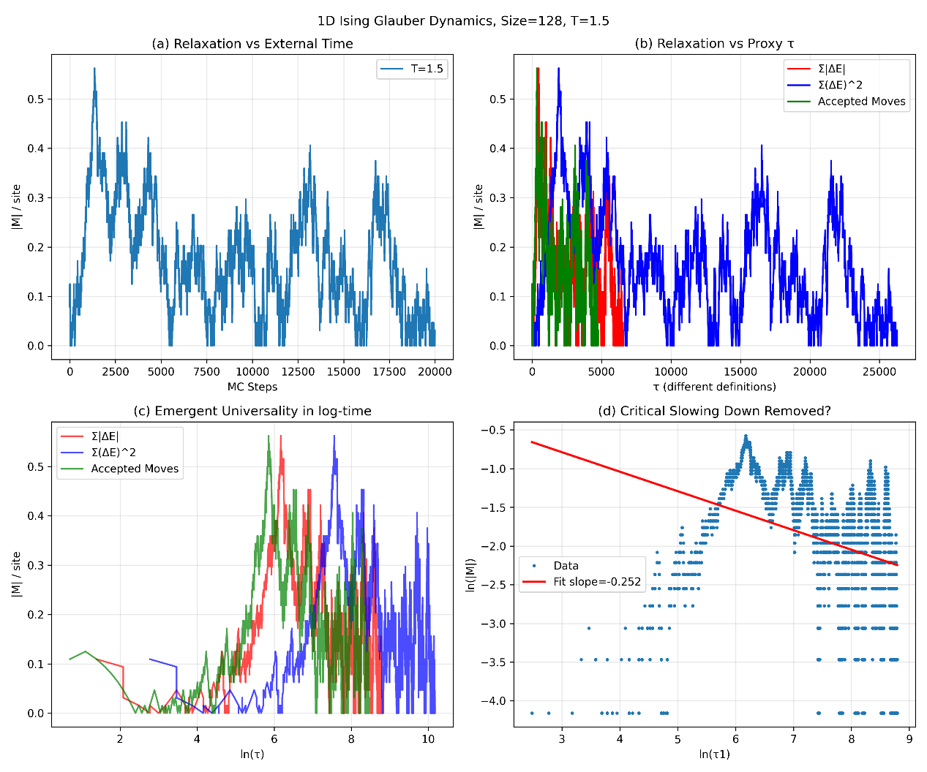
- 2Dising_wolff_cluster.py
import numpy as np
import matplotlib.pyplot as plt

class Ising2D_Wolff:
def __init__(self, size, temperature):
self.size = size
self.T = temperature
self.spins = np.random.choice([-1, 1], size=(size, size))
self.energy = self.calculate_energy()
self.magnetization = np.sum(self.spins)

def calculate_energy(self):
"""计算总能量"""
energy = 0
for i in range(self.size):
for j in range(self.size):
S = self.spins[i, j]
nb = self.spins[(i+1)%self.size, j] + self.spins[i, (j+1)%self.size] + \
self.spins[(i-1)%self.size, j] + self.spins[i, (j-1)%self.size]
energy += -S * nb
return energy/2

def wolff_step(self):
"""执行一次 Wolff cluster 更新，并返回 ΔE 作为 τ proxy 成分"""
L = self.size
# 随机选择种子
i, j = np.random.randint(0, L), np.random.randint(0, L)
cluster_spin = self.spins[i, j]
p_add = 1 - np.exp(-2.0 / self.T)

# BFS/DFS 扩展簇
cluster = [(i, j)]
to_check = [(i, j)]
in_cluster = np.zeros((L, L), dtype=bool)
in_cluster[i, j] = True

while to_check:
x, y = to_check.pop()
neighbors = [((x+1)%L, y), ((x-1)%L, y),
(x, (y+1)%L), (x, (y-1)%L)]
for nx, ny in neighbors:
if not in_cluster[nx, ny] and self.spins[nx, ny] == cluster_spin:
if np.random.rand() < p_add:
in_cluster[nx, ny] = True
to_check.append((nx, ny))
cluster.append((nx, ny))

# 翻转簇
old_energy = self.energy
for (x, y) in cluster:
self.spins[x, y] *= -1
self.energy = self.calculate_energy()
self.magnetization = np.sum(self.spins)

dE = self.energy - old_energy
return abs(dE), len(cluster) # 返回能量变化和簇大小

# ---------------------- 模拟参数 ----------------------
L = 32
Tc = 2.269
temps = [Tc, 1.5, 3.5] # 临界、低温、高温
labels = [rf"$T \approx T_c$", rf"$T = 1.5$", rf"$T = 3.5$"]
n_steps = 5000

results = {}

for temp, label in zip(temps, labels):
print(f"Simulating Wolff at {label}...")
model = Ising2D_Wolff(L, temp)

magnetizations = np.zeros(n_steps)
tau_proxy = np.zeros(n_steps)
cumulative_dE = 0.0

for step in range(n_steps):
dE, cl_size = model.wolff_step()
cumulative_dE += dE
magnetizations[step] = abs(model.magnetization) / (L*L)
tau_proxy[step] = cumulative_dE

results[label] = {
'magnetization': magnetizations,
'tau_proxy': tau_proxy
}

# ---------------------- 绘图 ----------------------
fig, axes = plt.subplots(2, 2, figsize=(12, 10))

# (a) Magnetization vs steps
ax1 = axes[0, 0]
for label, data in results.items():
ax1.plot(data['magnetization'], label=label, alpha=0.8)
ax1.set_xlabel("Cluster Updates (External Time)")
ax1.set_ylabel(r"$|M|$ / site")
ax1.set_title("(a) Relaxation in External Time")
ax1.legend(); ax1.grid(True, alpha=0.3)

# (b) vs τ proxy
ax2 = axes[0, 1]
for label, data in results.items():
ax2.plot(data['tau_proxy'], data['magnetization'], label=label, alpha=0.8)
ax2.set_xlabel(r"Cumulative Energy Cost $\tau_{\rm proxy}$")
ax2.set_ylabel(r"$|M|$ / site")
ax2.set_title("(b) Relaxation vs Physical Cost τ")
ax2.legend(); ax2.grid(True, alpha=0.3)

# (c) vs log τ proxy
ax3 = axes[1, 0]
for label, data in results.items():
valid = data['tau_proxy'] > 1
ax3.plot(np.log(data['tau_proxy'][valid]), data['magnetization'][valid], label=label, lw=2)
ax3.set_xlabel(r"$\ln(\tau_{\rm proxy})$")
ax3.set_ylabel(r"$|M|$ / site")
ax3.set_title("(c) Emergent Universality in Log-Time")
ax3.legend(); ax3.grid(True, alpha=0.3)

# (d) Critical scaling check
ax4 = axes[1, 1]
crit = results[labels[0]]
valid = crit['tau_proxy'] > 1
log_tau = np.log(crit['tau_proxy'][valid])
mag = crit['magnetization'][valid]
# 添加一个小的偏移量来避免log(0)的问题
epsilon = 1e-12
mag_positive = mag + epsilon
fit_slice = slice(100, 1000)
z = np.polyfit(log_tau[fit_slice], np.log(mag_positive[fit_slice]), 1)
p = np.poly1d(z)
ax4.plot(log_tau, np.log(mag_positive), 'o', markersize=2, alpha=0.5, label="Critical Data")
ax4.plot(log_tau[fit_slice], p(log_tau[fit_slice]), 'r-', lw=2,
label=f"Linear Fit (Slope={z[0]:.3f})")
ax4.set_xlabel(r"$\ln(\tau_{\rm proxy})$")
ax4.set_ylabel(r"$\ln(|M|)$")
ax4.set_title("(d) Critical Decay in Log-Time (Wolff)")
ax4.legend(); ax4.grid(True, alpha=0.3)

plt.tight_layout()
plt.savefig(f"2D_ising_Wolff_L{L}.png", dpi=300)
plt.show()

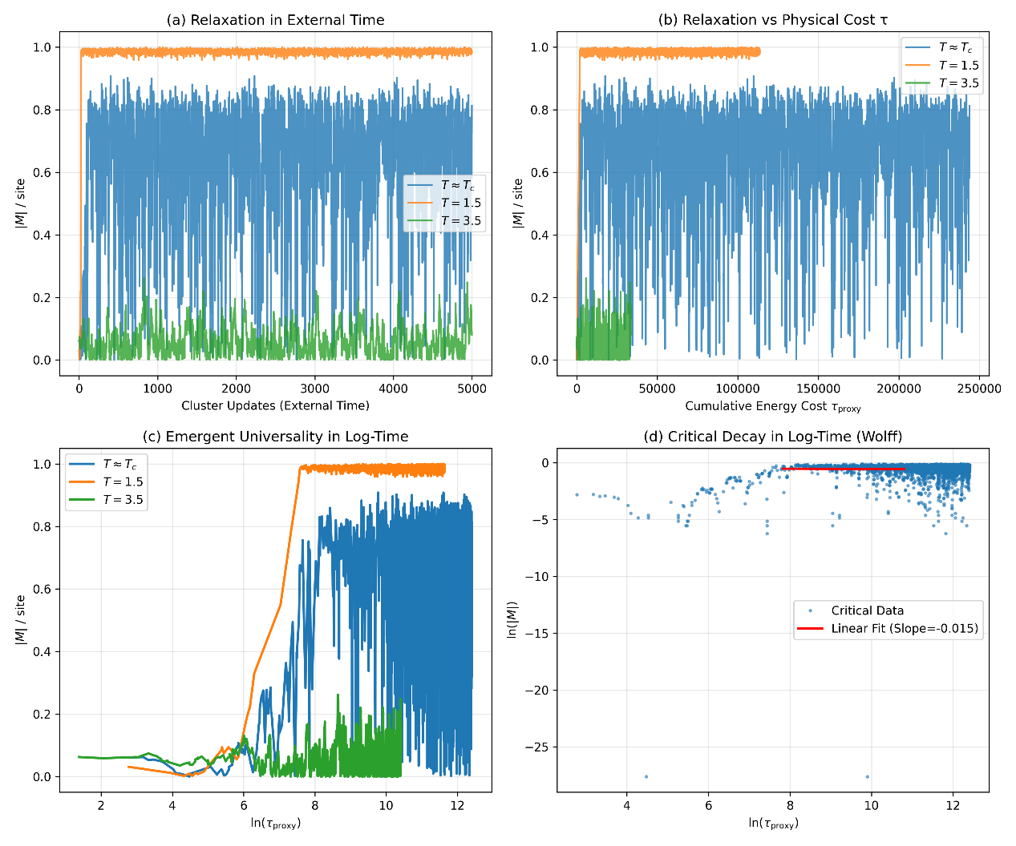
- 2Dising-wolff-cluster-poly.py
import numpy as np
import matplotlib.pyplot as plt

class Ising2D_Wolff:
def __init__(self, size, temperature):
self.size = size
self.T = temperature
self.beta = 1.0 / temperature
self.spins = np.random.choice([-1, 1], size=(size, size))
self.energy = self.calculate_energy()
self.magnetization = np.sum(self.spins)

def calculate_energy(self):
E = 0
for i in range(self.size):
for j in range(self.size):
S = self.spins[i, j]
nb = self.spins[(i+1)%self.size, j] + self.spins[i, (j+1)%self.size]
E += -S * nb
return E

def wolff_step(self):
"""执行一次 Wolff 簇翻转，返回 ΔE"""
# 随机选择一个种子自旋
i, j = np.random.randint(0, self.size, size=2)
cluster_spin = self.spins[i, j]
cluster = set([(i, j)])
frontier = [(i, j)]
p_add = 1 - np.exp(-2 * self.beta)

# 构建 cluster
while frontier:
x, y = frontier.pop()
for dx, dy in [(1,0),(-1,0),(0,1),(0,-1)]:
nx, ny = (x+dx) % self.size, (y+dy) % self.size
if (nx, ny) not in cluster and self.spins[nx, ny] == cluster_spin:
if np.random.rand() < p_add:
cluster.add((nx, ny))
frontier.append((nx, ny))

# 计算 ΔE（翻转 cluster 前后能量差）
dE = 0
for (x,y) in cluster:
spin = self.spins[x,y]
nb = self.spins[(x+1)%self.size, y] + self.spins[(x-1)%self.size, y] + \
self.spins[x, (y+1)%self.size] + self.spins[x, (y-1)%self.size]
dE += 2 * spin * nb

# 翻转 cluster
for (x,y) in cluster:
self.spins[x,y] *= -1

self.energy += dE
self.magnetization = np.sum(self.spins)
return abs(dE)

def run_simulation(size, T, n_steps):
model = Ising2D_Wolff(size, T)
magnetization = np.zeros(n_steps)
tau_proxy = np.zeros(n_steps)

cumulative_dE = 0.0
for step in range(n_steps):
dE = model.wolff_step()
cumulative_dE += dE
magnetization[step] = abs(model.magnetization) / (size*size)
tau_proxy[step] = cumulative_dE
return magnetization, tau_proxy

def multi_run(size=32, T=2.269, n_steps=5000, n_runs=10):
"""多次独立运行，返回均值与标准差"""
all_mags, all_tau = [], []
for r in range(n_runs):
print(f" Run {r+1}/{n_runs} at T={T}")
mag, tau = run_simulation(size, T, n_steps)
all_mags.append(mag)
all_tau.append(tau)
all_mags, all_tau = np.array(all_mags), np.array(all_tau)
return all_mags.mean(axis=0), all_mags.std(axis=0), all_tau.mean(axis=0)

def plot_results(mean_mag, std_mag, mean_tau, T, size, n_runs):
"""绘制 collapse 图 + 误差带"""
valid = mean_tau > 1
log_tau = np.log(mean_tau[valid])
mag = mean_mag[valid]
std = std_mag[valid]

plt.figure(figsize=(7,5))
plt.plot(log_tau, mag, 'b-', lw=2, label=f"T={T}")
plt.fill_between(log_tau, mag-std, mag+std, color='blue', alpha=0.3, label="±1 std")
plt.xlabel(r"$\ln(\tau_{\rm proxy})$")
plt.ylabel(r"$|M|$ / site")
plt.title(f"2D Ising (Wolff), size={size}, runs={n_runs}\nUniversality in log-time with error band")
plt.legend(); plt.grid(True, alpha=0.3)
plt.savefig(f"ising2D_wolff_T{T}_size{size}_runs{n_runs}.png", dpi=200)
plt.show()

if __name__ == "__main__":
size, T, n_steps, n_runs = 32, 2.269, 5000, 10
mean_mag, std_mag, mean_tau = multi_run(size, T, n_steps, n_runs)
plot_results(mean_mag, std_mag, mean_tau, T, size, n_runs)
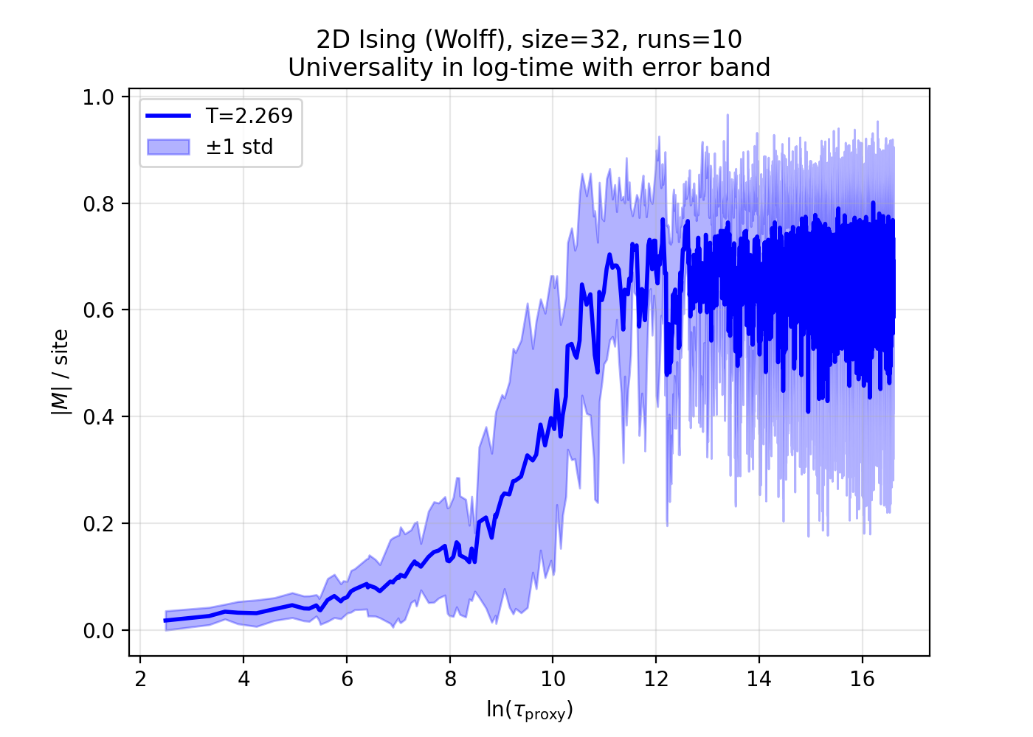
- 2D_ising_wolff_cluster_3poly.py
import numpy as np
import matplotlib.pyplot as plt

class Ising2D_Wolff:
def __init__(self, size, temperature):
self.size = size
self.T = temperature
self.beta = 1.0 / temperature
self.spins = np.random.choice([-1, 1], size=(size, size))
self.energy = self.calculate_energy()
self.magnetization = np.sum(self.spins)

def calculate_energy(self):
E = 0
for i in range(self.size):
for j in range(self.size):
S = self.spins[i, j]
nb = self.spins[(i+1)%self.size, j] + self.spins[i, (j+1)%self.size]
E += -S * nb
return E

def wolff_step(self):
"""执行一次 Wolff 簇翻转，返回 ΔE"""
i, j = np.random.randint(0, self.size, size=2)
cluster_spin = self.spins[i, j]
cluster = set([(i, j)])
frontier = [(i, j)]
p_add = 1 - np.exp(-2 * self.beta)

while frontier:
x, y = frontier.pop()
for dx, dy in [(1,0),(-1,0),(0,1),(0,-1)]:
nx, ny = (x+dx) % self.size, (y+dy) % self.size
if (nx, ny) not in cluster and self.spins[nx, ny] == cluster_spin:
if np.random.rand() < p_add:
cluster.add((nx, ny))
frontier.append((nx, ny))

dE = 0
for (x,y) in cluster:
spin = self.spins[x,y]
nb = self.spins[(x+1)%self.size, y] + self.spins[(x-1)%self.size, y] + \
self.spins[x, (y+1)%self.size] + self.spins[x, (y-1)%self.size]
dE += 2 * spin * nb

for (x,y) in cluster:
self.spins[x,y] *= -1

self.energy += dE
self.magnetization = np.sum(self.spins)
return abs(dE)

def run_simulation(size, T, n_steps):
model = Ising2D_Wolff(size, T)
magnetization = np.zeros(n_steps)
tau_proxy = np.zeros(n_steps)

cumulative_dE = 0.0
for step in range(n_steps):
dE = model.wolff_step()
cumulative_dE += dE
magnetization[step] = abs(model.magnetization) / (size*size)
tau_proxy[step] = cumulative_dE
return magnetization, tau_proxy

def multi_run(size, T, n_steps, n_runs=10):
all_mags, all_tau = [], []
for r in range(n_runs):
print(f" Run {r+1}/{n_runs} at T={T}")
mag, tau = run_simulation(size, T, n_steps)
all_mags.append(mag)
all_tau.append(tau)
all_mags, all_tau = np.array(all_mags), np.array(all_tau)
return all_mags.mean(axis=0), all_mags.std(axis=0), all_tau.mean(axis=0)

def plot_multi_T(size=32, n_steps=5000, n_runs=10):
Tc = 2.269
temps = [1.5, Tc, 3.5]
labels = [r"$T<T_c$", r"$T \approx T_c$", r"$T>T_c$"]
colors = ["blue", "red", "green"]

plt.figure(figsize=(8,6))

for T, label, color in zip(temps, labels, colors):
mean_mag, std_mag, mean_tau = multi_run(size, T, n_steps, n_runs)
valid = mean_tau > 1
log_tau = np.log(mean_tau[valid])
mag = mean_mag[valid]
std = std_mag[valid]

plt.plot(log_tau, mag, color=color, lw=2, label=label)
plt.fill_between(log_tau, mag-std, mag+std, color=color, alpha=0.25)

plt.xlabel(r"$\ln(\tau_{\rm proxy})$")
plt.ylabel(r"$|M|$ / site")
plt.title(f"2D Ising (Wolff cluster), size={size}, runs={n_runs}\nUniversality in log-time with error band")
plt.legend()
plt.grid(True, alpha=0.3)
fname = f"ising2D_wolff_multiT_size{size}_runs{n_runs}.png"
plt.savefig(fname, dpi=200)
print(f"Figure saved as {fname}")
plt.show()

if __name__ == "__main__":
plot_multi_T(size=32, n_steps=5000, n_runs=10)

