**📄 Project Overview Document**

**🏷️ Title:**

**Random Anime Suggestion Program**

**🔢 Code:**

**WWAL1**

**🎯 Purpose:**

To create a simple program that can suggest anime titles randomly to the user.

**✅ Goals:**

* To enhance my skills as a programmer.
* To work on real, practical projects instead of only theory.
* To create a program that is useful for myself and potentially for others.
* To build a basic structure that can be improved and expanded with more features over time.

**🧰 Functionality**

| **Feature** | **Description** |
| --- | --- |
| **Random Suggestion** | Selects one anime at random from a list and displays it. |
| **External File Use** | Uses a .txt file to store anime names; one anime per line. |
| **No User Input Needed** | The program runs and immediately prints a suggestion. |

we can work on inputs when we have more features to avail.

**Structure of Program**

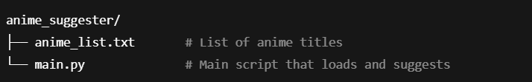

**⚙️ How It Works (Logic Flow)**

1. Load the list of anime titles from anime_list.txt.
2. Remove any blank lines or spaces.
3. Use Python's random.choice() to pick one title.
4. Display the result in the terminal as:  
   "Suggested anime: <title>"