Trajectories of mobility during England's first national COVID-19 lockdown

# Authors

Won Do Lee[1] ([wondo.lee@ouce.ox.ac.uk](mailto:wondo.lee@ouce.ox.ac.uk)), Matthias Qian[2], and Tim Schwanen2.

# Highlights

* People's mobility changed substantially in response to COVID-19 pandemic
* V-shaped trend in mobility shows sharp decline but gradual return over time
* The trajectories of mobility were different across local authorities in England at different stages of the lockdown.
* Further evidence of flexible responses to COVID-19 is provided by differences in mobility resilience

# Abstracts

The UK government imposed a lockdown across England in the spring of 2020 to reduce community transmission of COVID-19 and avoid health services becoming overwhelmed. The measures led to large reductions in everyday mobility, but not everywhere to the same extent. Using call detail records from more than 1.1m mobile phones, we explored spatial differences between local authorities in how people’s mobility changed during the first national lockdown in the initial phases. Four groups of local authorities are identified, which differ in trajectories of mobility, and their membership was mainly associated with their income level, self-employed workers, and car availability, although ethnic/racial make-up of the population and health-related neighbourhood features, estimated by the classification model. The analysis shows that the greatest reduction in mobility after the imposition of the lockdown, and the continuation of low levels of mobility afterwards occurred in high-income areas with comparatively high levels of self-employed workers and cumulative COVID-19 infection rates before stay-at-home orders. It thus indicates that the greatest reductions have been achieved in areas where it is relatively easy for people to stay at home or in areas the risk of infection and severe illness was relatively high. More generally, the results highlighted the need to consider differences in mobility resilience towards sustainable and resilient urban management is explicitly linked to the ability to restrict everyday mobility among people.

**Keywords**: COVID-19; Pandemic; Resilience; Time-series clustering; Classification model.

# Introduction

The COVID-19 pandemic has rapidly changed our everyday lives, particularly mobility. Implementing various social distancing policies, such as travel restrictions and compliance with stay-at-home orders, were correlated with the reduction in mobility (Hale et al., 2021; Kishore et al., 2021). Working from home has become the *new normal* to avoid social contact, and mitigate the risk while using public transport for work-related travel and on-site working (Beck & Hensher, 2020). Inevitably, transport mode use has been strongly affected by the risk of travellers being exposed to the virus during their journey (Barbieri et al., 2021; de Séjournet et al., 2022; De Vos, 2020). Transit attractiveness is down, and massive service cuts on public transport systems while uptake in private vehicle use and active travel, i.e., walking and cycling (Department for Transport, 2020; Vickerman, 2021). In short, the risk of COVID-19 and travel-related measures have rapidly reshaped our *mobility habits* (Cartenì et al., 2020). Although the magnitude of this change varies across and within cities and social groups.

In England, the UK government recognised the importance of rapid control and implemented countermeasures to tackle the outbreak since COVID-19 reached in late January 2020 (Scally et al., 2020). However, the nationwide lockdown was imposed as an emergency measure on 23 March 2020 to mitigate the transmission, and the new, more transmissible variant of COVID-19 continues to spread. As a result, people’s everyday mobility has to face new challenges and massive adaptions to COVID-19 (Borkowski et al., 2021; Lee et al., 2021; Marsden & Docherty, 2021), it ranged from travel restrictions to social distancing orders, curfews, quarantines, and finally, lockdown measures come into force to diminish the physical interactions and order people to “Stay-at-home”.

Greater attention should be paid to analysing changes in people’s mobility throughout the first COVID-19 lockdown, and a more detailed understanding of how mobility changes spatio-temporally is needed during the prolonged period of strict lockdown. Recent work has highlighted this by using examining changes in mobility over seven months or more (J. Kim & Kwan, 2021; Long & Ren, 2022; Molloy et al., 2021) and decomposing it into successive stages, i.e., *intra-pandemic dynamics* (Kellermann et al., 2022) through longitudinal perspective. Taking short-term effects by implemented travel restrictions or interventions and long-term effects under mobility circumstances, such as working from home or homeschooling, the way of *new normal* in mobility into account.

To this end, this research quantify and measure changes in mobility under the lockdown phases of COVID-19 pandemic, by using anonymised call-detail records (CDRs) data collected from mobile phones. By doing this, this research investigates the long-term effects of government-mandated lockdown on people’s mobility spanning seven months, by measuring changes in mobility over time and quantified how it evolved. This task is achieved by deploying data mining techniques to reveal different socioeconomic status likely to be correlated with different trajectories of mobility under England’s first nationwide lockdown. Specifically, the research addresses the following questions:

* How has mobility changed over the initial phases of the lockdown?
* What makes disparities in mobility recovery trends in lockdown phases?
* Does socioeconomic status associated with trajectories of mobility reduction throughout the lockdown?

# Related works

COVID-19 is transmitted between people in three main ways; contacts, droplets, and airborne transmission. A major transmission route is large infected droplets in line with the most respiratory virus (The Lancet Respiratory Medicine, 2020). The risk of droplet transmission by physical contact among people outlines scientific evidence suggesting social distancing guidelines to prevent the spread of COVID-19 (Rosti et al., 2020). Therefore, monitoring changes in mobility has become valuable in assessing the effectiveness of government-imposed social distancing policies (Oliver et al., 2020).

Academic literature on transport and COVID-19 has burgeoned since the Spring of 2020. Many papers have examined V-shaped mobility trends in the early stage of COVID-19 pandemic to reveal substantial changes in people’s mobility and travel behaviours with the support of large-scale mobile phone data and online panel surveys. There is abundant evidence that overall levels of people’s mobility dropped instantly but recovered rapidly based on longitudinal data analysis following longer than a year following the onset of the COVID-19 pandemic (Kellermann et al., 2022; J. Kim & Kwan, 2021; Long & Ren, 2022; Wang et al., 2022) by using traditional mobility metrics, such as daily distanced travelled per person (Hong et al., 2021; Lou et al., 2020; Pan et al., 2020; Weill et al., 2020; Xiong, Hu, Yang, Younes, et al., 2020), time spent travelling per person per day (Borkowski et al., 2021), and a total number of trips per day (Lou et al., 2020; Pan et al., 2020; Xiong, Hu, Yang, Younes, et al., 2020; Zhang et al., 2021).

There is now a substantial number of studies demonstrating the effects of government-mandated lockdowns on mobility. For instance, the share of stay-at-home depicts the percentage of people staying entirely at home and avoid leaving their house all day (Fu & Zhai, 2021; Hu et al., 2021; Jay et al., 2020; Pan et al., 2020; Weill et al., 2020) is robust evidence to assess the effectiveness of government interventions in people’s everyday lives. Traffic flows reconstructed from mobile phone data measured changes in population movements between city pairs (Beria & Lunkar, 2021; Schlosser et al., 2020; Xiong, Hu, Yang, Luo, et al., 2020). Also, the radius of gyration is popularly used to measure the radial distance moved within a certain time period, such as a day (Gauvin et al., 2020; Hernando et al., 2020; Lee et al., 2021; Park et al., 2021; Pepe et al., 2020; Santana et al., 2020; Yabe et al., 2020). As the study shows, using mobile data to generate mobility metrics was very helpful in evaluating the impact of containment and closure policies, in the form of various travel disruptions and restrictions. Interestingly, people’s mobility levels dropped sharply and then gradually bounced back to normal throughout the COVID-19 pandemic (J. Kim & Kwan, 2021; Lee et al., 2021). Recent studies also revealed how mobility changed in the different pandemic stages, and exhibited some notable differences in lockdown phases. *Voluntary social distancing* (Linka et al., 2020; Xiong, Hu, Yang, Younes, et al., 2020) was observed between pre-pandemic and implemented stay-at-home orders. It suggests that people would practice voluntary social distancing depending on their ability to self-regulate capacity (Cronin & Evans, 2020).

Also, increased mobility observed that people went outside more during the coming months after the lockdown, entitled to *Quarantine fatigue* (J. Kim & Kwan, 2021; Kwan, 2021; Pan et al., 2020; Zhao et al., 2020).

However, limited attention has been given to a consideration of how mobility changed over time and its variation in different phases alongside the shift in government response. People’s mobility has been influenced by the prevalence of government measures, and individually perceived risk and ability to restrict everyday mobility together, all of which are time-varying. To further elucidate this issue, we examined changes in mobility throughout government-mandated lockdowns added on pre-pandemic and post-lockdown periods (i.e., ±2 months) in this study.

# Data and methods

## Data

Measuring the change of mobility levels over time provides insight into the effect of the pandemic on people’s daily behaviour and compliance with government-mandated lockdowns (Grantz et al., 2020; J. Kim & Kwan, 2021; Kishore et al., 2020). In this study we measure mobility levels using anonymised and aggregated GDPR-compliant call detail records (CDRs)[3]. More specifically, we deploy CDRs for over one million users in January-June 2020 to compute the daily median radius of gyration for users in 315 Lower Tier Local Authority (LTLA) areas in England.[4] LTLAs correspond with Districts, Boroughs and City Councils and are the lowest level of government at which policies are developed and implemented in England. The radius of gyration is widely used to capture mobility patterns through density metrics using the timestamps in CDRs. t measures the spatial extent of individuals’ activity space (Lu et al., 2021) through summation of the distance of each time-stamped () location where individual I is on day from the trajectory’s mean location , which can be formulated as . Locations are approximated by the nearest mobile phone tower, and mobility will be underreported if individuals do not take their phone along. User-level values are aggregated to the LTLA areas in which individuals reside.[5] Formally, the radius of gyration can be expressed as:

|  |  |
| --- | --- |
|  | (1). |

This mobility metric has been aggregated to present the generalised mobility level of each LTLA level in England. We examine the trajectory of median mobility for each LTLA over time by calculating the (percentage) change in mobility levels compared to a reference day. To do this, we replicate the approach taken by Lee et al. (2021) who identified Tuesday 3 March as a robust reference day. The authors validated their approach by conducting the sensitivity analysis with an alternative reference period.

A wide range of contextual information on LTLAs have been collected from secondary data sources. Demographic and socioeconomic data have been retrieved from the 2011 Census and other sources provided by the Office for National Statistics (ONS). We have aggregated data from the Lower Layer Super Output Area (LSOA) level to the LTLA area. COVID-19 metrics have been retrieved from the UK official COVID-19 dashboard open data API service (UK government, 2020) and processed.

## Methods

### Time-series clustering analysis

A clustering analysis technique was used to classify lower-tier local authorities (LTLAs) into a small number of groups with similar trajectories of mobility during England’s first national lockdown between 23 March and 11 May 2020). To compute the optimal (warping) distances among all LTLA’s time-series, we used the dynamic time warping (DTW) algorithm suggested by Berndt & Clifford (1994). This algorithm is widely used for clustering time series (Aghabozorgi et al., 2015). because of its robustness compared to other conventional measures (Chen et al., 2017; Petitjean et al., 2011). Given two time-series, and , the DTW distance can be mathematically formulated as follows.

|  |  |
| --- | --- |
|  | (2). |

The sequence of and can be arranged to form a -by- grid, where is a distance function, to represent the magnitude of the difference between the sequence elements () to (). denotes a sequence of grid points (1 to ), is a warping function to find the path through the grid. The warping path aligns the elements of two sequences when the distance between them is minimised.

Hierarchical clustering methods have been deployed to test the performance of different agglomerative hierarchical clustering algorithms[6] on the constructed DTW distance (Dau et al., 2016; Sardá-Espinosa, 2019). We have used the *dtwclust* package for R to identify the optimal number of clusters within the [2,20] range with the help of the Silhouette index (*Sil*). This has been identified as the best-performing cluster validity index. Arbelaitz, (2013) and depicts how close each observation is to others in the same cluster (i.e. intra-cluster distances) by contrast to observations in the nearest cluster (i.e. inter-cluster distances). *Sil* values range from -1 to +1, with higher values denoting better overall clustering quality (Rousseeuw, 1987). If LTLA area belongs to cluster , can be expressed as:

|  |  |
| --- | --- |
|  | (3), |

where is the average distance between to other LTLA areas in the same cluster and is the smallest average distance from to other LTLA area(s) in the nearest cluster. A value for that is close to 1 requires . Thus, a small value of means that the cluster analysis performs well.

### Classification model

A penalised regression model is similar to linear regression but has an additional penalty term to constrain (or regularise) the estimated coefficients. It can reduce the variance and decrease sample error to help generalised models (Boehmke & Greenwell, 2019). The LASSO (Least Absolute Shrinkage and Selection Operator) regression is a penalised regression model, originally proposed by Tibshirani (1996). It minimises the residual sum of squared errors (RSS) while constraining the sum of the absolute values of the regression coefficients (Usai et al., 2009). In mathematical form, the penalised likelihood function is given by:

|  |  |
| --- | --- |
|  | (4). |

Here is a constraint as a tuning parameter (, is the number of predictors, and is the penalty parameter that controls the amount of regularisation (i.e., the size of the coefficients). Setting to 1 allows strong penalisation of the sum of the absolute values of regression coefficients , setting what is known as the 1 norm of coefficients. Using this norm results in sparse models with the coefficients of unimportant variables tending towards zero, and increasing the likelihood of those variable to be eliminated from the model (Friedman et al., 2010).

The multinomial logistic regression model (MLR) utilises the logit link function to model the logarithm of the odds ratio for multi-category response variables (Krishnapuram et al., 2005). If has the number of clusters as categories and a predictor vector is specified, then the linear logistic regression model can be generalised to a multi-logit model (Friedman et al., 2010). The probability for each cluster to generalise the linear logistic regression into logits as Equation (5), and modifying term as Equation (6).

|  |  |
| --- | --- |
| . | (5). |
|  | (6). |

Here is a vector of coefficients corresponding to cluster , is a constant, denotes the predictor variables, and indicates vector/matrix transpose. Friedman et al. (2010) suggest fitting the model by regularised maximum (multinomial) likelihood. If is the indicator response matrix, with elements , then the log-likelihood part of will be given by:

|  |  |
| --- | --- |
|  | (7). |

Krishnapuram et al. (2005) applied the 1 norm to the log-likelihood function by replacing the residual sum of squares with the corresponding negative log-likelihood function . For the multinomial LASSO logistic regression model (hereafter MLR LASSO), Hossain et al. (2014) summarised the penalised likelihood function as:

|  |  |
| --- | --- |
|  | (8). |

Finally, the MLR LASSO can shrink and delete the coefficients (Hossain et al., 2014). Another advantage of this approach is ranking model predictors based on the absolute value of the coefficients, using an embedded feature selection process (K. Kim, 2018). It confirms the difference in predictor importance between distinct clusters of time-series data. The MLR LASSO is constructed to exhibit the significant factors between clusters using *glmnet* package for R (Friedman et al., 2010).

# Results

## Mobility changes during England’s first national lockdown

The average level of mobility in England as a whole changed according to a well-documented pattern during the early stage of the COVID-19 pandemic (see, for instance, Lee et al. 2021). In the first 3 weeks of March 2020, the average level of mobility dropped significantly by about 50% compared to the pre-pandemic situation. Further reductions to less than 1km radial distance per day occurred after the first nationwide lockdown commenced on 23 March 2020. The fact that most of the reduction occurred before the start of the lockdown reflects that the UK government instituted the nationwide lockdown relatively late compared to many other European countries, even though it had encouraged people to start working from home and banned the mass gatherings and all unnecessary social contact since mid-March (Public Health England, 2020). Nonetheless, mobility levels started to bounce back from later April onwards and therefore even before the lockdown was officially lifted.

<*Figure 1 about here*>

Much less is known about variations around the mean trajectory in Figure across LTLA areas. That variation can be summarised into 4 broad patterns according to the cluster analysis. Figure 2 shows that the Silhouette Index is highest for the Ward method-1 algorithm and tends to peak at the values 4, 6 and 9. We have therefore selected 4 clusters with the Ward-1 algorithm as our preferred clustering solution.

<*Figure 2 about here*>

The patterns that can be observed in Figure 3 and Table 1 suggest that the LTLA clusters can be differentiated on the basis of three factors: the pace of reduction in mobility levels in LTLAs in the first weeks of the pandemic in England; the extent to which mobility levels were reduced during England’s first nationwide lockdown; and the pace of recovery in mobility levels from early April onwards. Based on these factors the four clusters can be labelled as follows:

* G1 = very fast-very large-very slow (VF-VL-VS, n=45): this cluster is characterised by the quickest drop in mobility levels, the greatest reduction and the slowest recovery of all four clusters;
* G2 = somewhat fast-somewhat large-somewhat slow (SF-SL-SS, n=xxx): this cluster is the moderate version of G1 with lower drops and reductions in mobility levels and faster recovery but substantially more different from the pre-pandemic normal than G3 and G4;
* G3 = somewhat slow-somewhat small, somewhat fast (SS-SS-SF, n=xxx): this cluster is on the opposite side of the national average compared to G2, with rather slow drops in March, fairly small reductions and reasonably fast recovery from April onwards;
* G4 = very slow-very small-very fast (VS-VS-VF, n=69): this cluster is on the opposite extreme compared to G1, with overall the smallest deviations from the pre-pandemic normal of all clusters.

There are some patterns in the internal heterogeneity of the four clusters. Overall, the variation around the mean is largest G1 and G4. This may reflect xxx. The level of variation increases over time in all clusters, in part because the intra-cluster homogeneity in the reduction in March is very small. However, the increase in variation around the mean is particularly pronounced in May and June in G1 and G2. In the other two clusters, the extent of variability remains more stable from mid-April onwards.

<*Figure 3 and Table 1 about here*>

The clusters show a rather distinct spatial distribution. Figure 4 suggests that most LTLA areas share borders with at least one other LTLA area that belongs to the same cluster. Spatial co-location of the clusters is also clear from Table 2, which shows rather distinct distribution patterns. G1 is clearly concentrated in London, whereas its opposite in terms of mobility trajectory, G4, is clearly overrepresented in the North West and Yorkshire and The Humber. G2 is more common in Outer London and Southern England, while G3 is concentrated in the North West and East Midlands.

<*Figure 4 and Table 2 about here*>

## Correlates of mobility trajectory cluster membership

In the following analysis, we deployed the classification model to examine the significant factors that help us to interpret the clusters identified through the time-series clustering analysis. MLR LASSO is applied to assess the effects of socioeconomic characteristics between clusters, which grouped into similar trajectories of mobility reduction during the lockdown. MLR LASSO can take advantage of reducing the dimension of input features or variable selection. Some socioeconomic characteristics might be irrelevant to explain that interpreting trajectories of mobility over time. It also outperformed to eliminate the redundant collinear features to avoid multicollinearity (Gao et al., 2020). In MLR LASSO, estimated coefficients yielded the penalised coefficients for the standardised variables. A positive or negative sign is indicated as the direction of the relationship. MLR LASSO has no built-in model for ranking the model predictors (Abdel Majeed et al., 2018). The model estimation results provided the estimated coefficients for selected factors between clusters. All explanatory variables were normalised to the range of [0,1] prior to model fitting. The best , penalty parameter, was selected by 10-fold cross-validation (CV). Seventeen factors remain through the embedded feature selection process in MLR LASSO.

In overview, usual residency shows the most effective variable for the classification, followed by share of self-employed workers, car availability, and income levels that estimated coefficients varied between clusters (see Figure 6). It reflects characteristics of each region in England that people living in London were more likely to experience an extensive reduction in mobility, with a sharp decline but a slow recovery during lockdown. In contrast, people living in Yorkshire and the Humber were more likely to experience a marginal reduction in mobility, with a gradual decline but a rapid recovery in the same period. The positive coefficients for the share of self-employed workers were observed in G1 and G2. Based on the sign of coefficients, it can be inferred that those local authorities with particularly high levels of affluent populations. Conversely, negative coefficients were indicated in G3 and G4 that high-income households were negligible. In addition, the positive coefficients for the share of households with one vehicle were observed in G4, while negative coefficients were indicated in G1.

Table 4 shows the estimated coefficients for selected factors correlated with the classification of generated clusters. People living in London were generally classified as G1, followed by high cumulative COVID-19 infection rates before the lockdown and relatively higher clinical capacity (i.e., density of hospitals). On the contrary, people living in Yorkshire and the Humber, and parts of East Midlands and South West were more likely classified as G4, where there were relatively lower self-employed workers and lower middle class (i.e., Social Grade C1). Among the remaining clusters, high levels of the share of high-income households and households with more than three vehicles were more likely classified as G2. Finally, G3 was more likely located in local authorities in the North East, where the share of median-income households and more than three bedrooms in the house were dominant. The five most significant features for classifying each cluster are described as follows:

* G1: residency in London (1.77) and share of self-employed (0.688) / household with one vehicle (-0.479), residency in West Midlands (-0.418) and South West (-0.561)
* G2: Percentage of Black African (0.493), Share of high-income households (0.408), social grade C1 (0.313), and more than three vehicles in household / Hospitals (-0.206)
* G3: residency in North East (0.439), Share of median-income households (0.403), and more than three bed rooms in house / Share of high-income households (-0.286) and residency in London (-0.148)
* G4: residency in Yorkshire and the Humber (1.665), South West (1.01), and East Midlands (0.356) / Share of more than three vehicles in household (-0.842) and self-employed worker (-0.533)

# Discussion

People make new daily decisions, which are rendered into their mobility behaviours, travelling between locations to carry out their daily activities. Pandemic has forced us to adapt to the *new normal* in our daily lives, the ways of working from home and homeschooling during waves of infection and government-mandated stay-at-home orders, lockdowns and social distancing, and longer-term impacts likely to outlast the COVID-19 pandemic. People have started to see new ways to restore activities differently in their everyday lives, such as relying on the internet for shopping (Mouratidis & Papagiannakis, 2021). However, on the one hand, people make journeys by walking or cycling to increase physical activity levels through active transport activity (Beck & Hensher, 2020).

In this vein, we examined changes in mobility over time using long-term mobile phone data, and then we demonstrated different trajectories of mobility in a spatially uneven manner using time-series clustering analysis. We quantified similarities according to changes in mobility throughout the initial phases of the lockdown by the mobility metric. It allows us to demonstrate the distinctive effects of socioeconomic and demographic factors between generated clusters. Whilst previous literature has highlighted examining spatio-temporal mobility patterns as an early observation in the pandemic. We believe this is the first study that seeks to unfold trajectories of mobility in view of the prolonged pandemic, and uncover its existence explicitly linked to socioeconomic status.

The results confirmed mobility reductions in the early stage of the pandemic, and the continuation of reductions following the national lockdown. However, mobility began to rise when the lockdown lifted. People start to go back to normal life (Sun et al., 2020), and more people will want or need to move more with the support of warmer weather, tiredness of staying at home, and cost-of-living issues in a pandemic, recognised as *Quarantine Fatigue* (Zhao et al., 2020). Pan et al. (2020) observed that people tend to practice less social distancing immediately when they indicated decreasing in the perceived risk of COVID-19. The evidence of post-lockdown mobility recovery appeared in line with England’s up-to-date general reopening of retail shops and public-facing businesses in the post-lockdown period (i.e., 15 June 2020).

We also indicated the voluntary mobility reduction before government-mandated lockdowns. Xiong et al. (2020) suggested that people might be acting more actively when they perceived the threat to COVID-19, such as the rise of daily new COVID-19 cases and deaths where they are living. As a result, *Spontaneous mobility reduction* is quantified before lockdown measures have been introduced to suppress the mobility. People start to practice voluntary social distancing, in terms of self-regulation in the early stage of the pandemic (Khataee et al., 2021) depending on their ability to isolate and risk aversion on mobility. In overview, lockdown measures were effective for restricting people’s everyday mobility, but only in the short term (J. Kim & Kwan, 2021). It is, however, a *nuclear option* that is “causing substantial collateral damages to society, the economy, trade and human rights” (Haug et al., 2020, p. 1309). Although the risk of new and more transmissible variant of the virus and the threat of second waves, people's mobility levels soon recovered throughout lockdown by considering people willing to socialise again and return to normality. It is plausible that the limited effectiveness of lockdown measures, even though travel restrictions and interventions to protect lives and communities under the lockdown. It is not a failure of policy but too late to contain the epidemic. People forecasted the ongoing and future situations cautiously in the wake of COVID-19 before social distancing policies were widely implemented. It might be making them regulate their social contacts and practice voluntary social distancing, which accounts for voluntary mobility reduction before the lockdown.

# Conclusions

This paper has sought to provide rigorous evidence that trajectories of mobility change under the lockdown, and contribute to the methodological development to characterise trajectories of mobility coping with socioeconomic and demographic factors. The research was founded on the integration of novel data and data mining techniques. In detail, employing longitudinal perspective to explore changes in mobility by using mobile phone data spanning seven months. And then, Clustering analysis and classification model were chosen to collect similar trajectories of mobility and find the significant factors to predict the clusters, respectively. Two main conclusions can be drawn.

First, people’s everyday mobility has been changed, and it could be the clear evidence of the effectiveness of government interventions in times of the pandemic. In England, mobility levels already falling about 50% compared to the pre-pandemic in the early stage of the pandemic (i.e., the first day of lockdown). Mobility levels continuously declined towards 80% (i.e., 7-day on lockdown) but soon bounced back up to 50% over the course of the national lockdown. Easing lockdown supported the mobility recovery so that mobility levels returned to normal in the post-lockdown period. However, the trajectory of mobility reduction under the lockdown is not the same extent. Group heterogeneity in trajectories of mobility change was exhibited throughout time-series clustering analysis. It revealed differences in the recovery of mobility levels during the lockdown between generated clusters. The finding that areas with the greatest reduction in mobility levels before the government-mandated lockdown and marginal recovery during the lockdown have been observed in Inner London. In contrast, areas with the lowest reduction in mobility and rapid mobility bound back can be found in North West, and Yorkshire and the Humber.

Second, people’s mobility levels have been influenced by government interventions, but it was also coupling with the individual ability to restrict everyday mobility (Lee et al., 2021). Unsurprisingly, high-income workers mainly were working from home, and felt to adapt successfully to the new normal (Office for National Statistics, 2021). Racial and ethnic minorities and poor people lived in crowded conditions and generally worked in essential industries (Huang et al., 2021). Additionally, Lou et al. (2020) found that stay-at-home orders did not significantly reduce low-income work trips. Thus, it is vital to demonstrate the effects of socioeconomic and demographic factors to predict the patterns of temporal evolution of mobility level in pandemic times. Our classification model, MLR LASSO, has examined the significant factors and assessed the importance of selected features between clusters. As a result, income, employment and accessibility are quantified as the most effective domains. Subsequently, housing type, perceived risk of COVID-19 (before the lockdown), and BAME (Black, Asian and minority ethnic) variables were also selected.

# Availability of data and materials

All source R code and data necessary for the replication of our results and figures are available at <https://github.com/wondolee/covid19-eng-lockdown>.

# Credit authorship contribution statement

Won Do Lee: Conceptualisation, Data Curation, Methodology, Formal analysis, Writing-Original draft preparation. Matthias Qian: Data Curation, Writing-Reviewing and Editing. Tim Schwanen: Conceptualisation, Writing-Original draft preparation, Supervision, Writing-Reviewing and Editing.

# Declaration of competing interest

The authors declare that they have no known competing financial interests or personal relationships that could have appeared to influence the work reported in this paper.

# Acknowledgement

This research did not receive any specific grant from funding agencies in the public, commercial, or not-for-profit sectors.

# References

Abdel Majeed, Y., Awadalla, S. S., & Patton, J. L. (2018). Regression techniques employing feature selection to predict clinical outcomes in stroke. *PLOS ONE*, *13*(10), e0205639. https://doi.org/10.1371/journal.pone.0205639

Aghabozorgi, S., Seyed Shirkhorshidi, A., & Ying Wah, T. (2015). Time-series clustering – A decade review. *Information Systems*, *53*, 16–38. https://doi.org/10.1016/j.is.2015.04.007

Arbelaitz, O., Gurrutxaga, I., Muguerza, J., Pérez, J. M., & Perona, I. (2013). An extensive comparative study of cluster validity indices. *Pattern Recognition*, *46*(1), 243–256. https://doi.org/10.1016/j.patcog.2012.07.021

Barbieri, D. M., Lou, B., Passavanti, M., Hui, C., Hoff, I., Lessa, D. A., Sikka, G., Chang, K., Gupta, A., Fang, K., Banerjee, A., Maharaj, B., Lam, L., Ghasemi, N., Naik, B., Wang, F., Foroutan Mirhosseini, A., Naseri, S., Liu, Z., … Rashidi, T. H. (2021). Impact of COVID-19 pandemic on mobility in ten countries and associated perceived risk for all transport modes. *PLOS ONE*, *16*(2), e0245886. https://doi.org/10.1371/journal.pone.0245886

Beck, M. J., & Hensher, D. A. (2020). Insights into the impact of COVID-19 on household travel and activities in Australia – The early days of easing restrictions. *Transport Policy*, *99*(July), 95–119. https://doi.org/10.1016/j.tranpol.2020.08.004

Beria, P., & Lunkar, V. (2021). Presence and mobility of the population during the first wave of Covid-19 outbreak and lockdown in Italy. *Sustainable Cities and Society*, *65*, 102616. https://doi.org/10.1016/j.scs.2020.102616

Berndt, D., & Clifford, J. (1994). Using dynamic time warping to find patterns in time series. *Workshop on Knowledge Knowledge Discovery in Databases*, *398*, 359–370. http://www.aaai.org/Papers/Workshops/1994/WS-94-03/WS94-03-031.pdf

Boehmke, B., & Greenwell, B. (2019). *Hands-On Machine Learning with R*. Chapman and Hall/CRC. https://doi.org/10.1201/9780367816377

Borkowski, P., Jażdżewska-Gutta, M., & Szmelter-Jarosz, A. (2021). Lockdowned: Everyday mobility changes in response to COVID-19. *Journal of Transport Geography*, *90*(14), 102906. https://doi.org/10.1016/j.jtrangeo.2020.102906

Cartenì, A., Di Francesco, L., & Martino, M. (2020). How mobility habits influenced the spread of the COVID-19 pandemic: Results from the Italian case study. *Science of The Total Environment*, *741*, 140489. https://doi.org/10.1016/j.scitotenv.2020.140489

Chen, Y., Liu, X., Li, X., Liu, X., Yao, Y., Hu, G., Xu, X., & Pei, F. (2017). Delineating urban functional areas with building-level social media data: A dynamic time warping (DTW) distance based k-medoids method. *Landscape and Urban Planning*, *160*, 48–60. https://doi.org/10.1016/j.landurbplan.2016.12.001

Cronin, C., & Evans, W. (2020). *Private Precaution and Public Restrictions: What Drives Social Distancing and Industry Foot Traffic in the COVID-19 Era?* https://doi.org/10.3386/w27531

Dau, H. A., Begum, N., & Keogh, E. (2016). Semi-Supervision Dramatically Improves Time Series Clustering under Dynamic Time Warping. *Proceedings of the 25th ACM International on Conference on Information and Knowledge Management*, 999–1008. https://doi.org/10.1145/2983323.2983855

de Séjournet, A., Macharis, C., Tori, S., & Vanhaverbeke, L. (2022). Evolution of urban mobility behaviour in Brussels as a result of the COVID‐19 pandemic. *Regional Science Policy & Practice*, *14*(S1), 107–121. https://doi.org/10.1111/rsp3.12525

De Vos, J. (2020). The effect of COVID-19 and subsequent social distancing on travel behavior. *Transportation Research Interdisciplinary Perspectives*, *5*, 100121. https://doi.org/10.1016/j.trip.2020.100121

Department for Transport. (2020). *Transport use during the coronavirus (COVID-19) pandemic*. Official Statistics. https://www.gov.uk/government/statistics/transport-use-during-the-coronavirus-covid-19-pandemic

Friedman, J., Hastie, T., & Tibshirani, R. (2010). Regularization Paths for Generalized Linear Models via Coordinate Descent. *Journal of Statistical Software*, *33*(1), 1–22. https://doi.org/10.1016/j.expneurol.2008.01.011

Fu, X., & Zhai, W. (2021). Examining the spatial and temporal relationship between social vulnerability and stay-at-home behaviors in New York City during the COVID-19 pandemic. *Sustainable Cities and Society*, *67*, 102757. https://doi.org/10.1016/j.scs.2021.102757

Gao, Y., Cai, G.-Y., Fang, W., Li, H.-Y., Wang, S.-Y., Chen, L., Yu, Y., Liu, D., Xu, S., Cui, P.-F., Zeng, S.-Q., Feng, X.-X., Yu, R.-D., Wang, Y., Yuan, Y., Jiao, X.-F., Chi, J.-H., Liu, J.-H., Li, R.-Y., … Gao, Q.-L. (2020). Machine learning based early warning system enables accurate mortality risk prediction for COVID-19. *Nature Communications*, *11*(1), 5033. https://doi.org/10.1038/s41467-020-18684-2

Gauvin, L., Bajardi, P., Pepe, E., Lake, B., Privitera, F., & Tizzoni, M. (2020). Socioeconomic determinants of mobility responses during the first wave of COVID-19 in Italy: from provinces to neighbourhoods. *MedRxiv*, 2020.11.16.20232413. https://doi.org/10.1101/2020.11.16.20232413

Grantz, K. H., Meredith, H. R., Cummings, D. A. T., Metcalf, C. J. E., Grenfell, B. T., Giles, J. R., Mehta, S., Solomon, S., Labrique, A., Kishore, N., Buckee, C. O., & Wesolowski, A. (2020). The use of mobile phone data to inform analysis of COVID-19 pandemic epidemiology. *Nature Communications*, *11*(1), 4961. https://doi.org/10.1038/s41467-020-18190-5

Hale, T., Angrist, N., Goldszmidt, R., Kira, B., Petherick, A., Phillips, T., Webster, S., Cameron-Blake, E., Hallas, L., Majumdar, S., & Tatlow, H. (2021). A global panel database of pandemic policies (Oxford COVID-19 Government Response Tracker). *Nature Human Behaviour*, *5*(4), 529–538. https://doi.org/10.1038/s41562-021-01079-8

Haug, N., Geyrhofer, L., Londei, A., Dervic, E., Desvars-Larrive, A., Loreto, V., Pinior, B., Thurner, S., & Klimek, P. (2020). Ranking the effectiveness of worldwide COVID-19 government interventions. *Nature Human Behaviour*, *4*(12), 1303–1312. https://doi.org/10.1038/s41562-020-01009-0

Hernando, A., Mateo, D., & Plastino, A. (2020). Social inequalities in human mobility during the Spanish lockdown and post-lockdown in the Covid-19 pandemic of 2020. *MedRxiv*, 1–7. https://doi.org/10.1101/2020.10.26.20219709

Hong, B., Bonczak, B. J., Gupta, A., Thorpe, L. E., & Kontokosta, C. E. (2021). Exposure density and neighborhood disparities in COVID-19 infection risk. *Proceedings of the National Academy of Sciences*, *118*(13), e2021258118. https://doi.org/10.1073/pnas.2021258118

Hossain, S., Ahmed, S. E., & Howlader, H. A. (2014). Model selection and parameter estimation of a multinomial logistic regression model. *Journal of Statistical Computation and Simulation*, *84*(7), 1412–1426. https://doi.org/10.1080/00949655.2012.746347

Hu, S., Xiong, C., Yang, M., Younes, H., Luo, W., & Zhang, L. (2021). A big-data driven approach to analyzing and modeling human mobility trend under non-pharmaceutical interventions during COVID-19 pandemic. *Transportation Research Part C: Emerging Technologies*, *124*(January), 102955. https://doi.org/10.1016/j.trc.2020.102955

Huang, X., Lu, J., Gao, S., Wang, S., Liu, Z., & Wei, H. (2021). Staying at Home Is a Privilege: Evidence from Fine-Grained Mobile Phone Location Data in the United States during the COVID-19 Pandemic. *Annals of the American Association of Geographers*, *0*(0), 1–20. https://doi.org/10.1080/24694452.2021.1904819

Jay, J., Bor, J., Nsoesie, E. O., Lipson, S. K., Jones, D. K., Galea, S., & Raifman, J. (2020). Neighbourhood income and physical distancing during the COVID-19 pandemic in the United States. *Nature Human Behaviour*, *4*(12), 1294–1302. https://doi.org/10.1038/s41562-020-00998-2

Kellermann, R., Sivizaca Conde, D., Rößler, D., Kliewer, N., & Dienel, H. L. (2022). Mobility in pandemic times: Exploring changes and long-term effects of COVID-19 on urban mobility behavior. *Transportation Research Interdisciplinary Perspectives*, *15*(July). https://doi.org/10.1016/j.trip.2022.100668

Khataee, H., Scheuring, I., Czirok, A., & Neufeld, Z. (2021). Effects of social distancing on the spreading of COVID-19 inferred from mobile phone data. *Scientific Reports*, *11*(1), 1661. https://doi.org/10.1038/s41598-021-81308-2

Kim, J., & Kwan, M.-P. (2021). The impact of the COVID-19 pandemic on people’s mobility: A longitudinal study of the U.S. from March to September of 2020. *Journal of Transport Geography*, *93*(March), 103039. https://doi.org/10.1016/j.jtrangeo.2021.103039

Kim, K. (2018). Exploring the difference between ridership patterns of subway and taxi: Case study in Seoul. *Journal of Transport Geography*, *66*(March 2017), 213–223. https://doi.org/10.1016/j.jtrangeo.2017.12.003

Kishore, N., Kahn, R., Martinez, P. P., De Salazar, P. M., Mahmud, A. S., & Buckee, C. O. (2021). Lockdowns result in changes in human mobility which may impact the epidemiologic dynamics of SARS-CoV-2. *Scientific Reports*, *11*(1), 6995. https://doi.org/10.1038/s41598-021-86297-w

Kishore, N., Kiang, M. V, Engø-Monsen, K., Vembar, N., Schroeder, A., Balsari, S., & Buckee, C. O. (2020). Measuring mobility to monitor travel and physical distancing interventions: a common framework for mobile phone data analysis. *The Lancet Digital Health*, *2*(11), e622–e628. https://doi.org/10.1016/S2589-7500(20)30193-X

Krishnapuram, B., Carin, L., Figueiredo, M. A. T., & Hartemink, A. J. (2005). Sparse multinomial logistic regression: fast algorithms and generalization bounds. *IEEE Transactions on Pattern Analysis and Machine Intelligence*, *27*(6), 957–968. https://doi.org/10.1109/TPAMI.2005.127

Kwan, M. (2021). The stationarity bias in research on the environmental determinants of health. *Health and Place*, *70*(June), 102609. https://doi.org/10.1016/j.healthplace.2021.102609

Lee, W. Do, Qian, M., & Schwanen, T. (2021). The association between socioeconomic status and mobility reductions in the early stage of England’s COVID-19 epidemic. *Health & Place*, *69*, 102563. https://doi.org/10.1016/j.healthplace.2021.102563

Linka, K., Goriely, A., & Kuhl, E. (2020). Global and local mobility as a barometer for COVID-19 dynamics. *MedRxiv*. https://doi.org/10.1101/2020.06.13.20130658

Long, J. A., & Ren, C. (2022). Associations between mobility and socio-economic indicators vary across the timeline of the Covid-19 pandemic. *Computers, Environment and Urban Systems*, *91*(July 2021), 101710. https://doi.org/10.1016/j.compenvurbsys.2021.101710

Lou, J., Shen, X., & Niemeier, D. (2020). Are stay-at-home orders more difficult to follow for low-income groups? *Journal of Transport Geography*, *89*(October), 102894. https://doi.org/10.1016/j.jtrangeo.2020.102894

Lu, J., Zhou, S., Liu, L., & Li, Q. (2021). You are where you go: Inferring residents’ income level through daily activity and geographic exposure. *Cities*, *111*(135), 102984. https://doi.org/10.1016/j.cities.2020.102984

Marsden, G., & Docherty, I. (2021). Mega-disruptions and policy change: Lessons from the mobility sector in response to the Covid-19 pandemic in the UK. *Transport Policy*, *110*, 86–97. https://doi.org/10.1016/j.tranpol.2021.05.015

Molloy, J., Schatzmann, T., Schoeman, B., Tchervenkov, C., Hintermann, B., & Axhausen, K. W. (2021). Observed impacts of the Covid-19 first wave on travel behaviour in Switzerland based on a large GPS panel. *Transport Policy*, *104*, 43–51. https://doi.org/10.1016/j.tranpol.2021.01.009

Mouratidis, K., & Papagiannakis, A. (2021). COVID-19, internet, and mobility: The rise of telework, telehealth, e-learning, and e-shopping. *Sustainable Cities and Society*, *74*, 103182. https://doi.org/10.1016/j.scs.2021.103182

Office for National Statistics. (2021). *Coronavirus and compliance with government guidance, UK : April 2021*. https://www.ons.gov.uk/peoplepopulationandcommunity/healthandsocialcare/conditionsanddiseases/bulletins/coronavirusandcompliancewithgovernmentguidanceuk/april2021

Oliver, N., Lepri, B., Sterly, H., Lambiotte, R., Deletaille, S., De Nadai, M., Letouzé, E., Salah, A. A., Benjamins, R., Cattuto, C., Colizza, V., de Cordes, N., Fraiberger, S. P., Koebe, T., Lehmann, S., Murillo, J., Pentland, A., Pham, P. N., Pivetta, F., … Vinck, P. (2020). Mobile phone data for informing public health actions across the COVID-19 pandemic life cycle. *Science Advances*, *6*(23), eabc0764. https://doi.org/10.1126/sciadv.abc0764

Pan, Y., Darzi, A., Kabiri, A., Zhao, G., Luo, W., Xiong, C., & Zhang, L. (2020). Quantifying human mobility behaviour changes during the COVID-19 outbreak in the United States. *Scientific Reports*, *10*(1), 20742. https://doi.org/10.1038/s41598-020-77751-2

Park, S., Oshan, T. M., El Ali, A., & Finamore, A. (2021). Are we breaking bubbles as we move? Using a large sample to explore the relationship between urban mobility and segregation. *Computers, Environment and Urban Systems*, *86*(April 2020), 101585. https://doi.org/10.1016/j.compenvurbsys.2020.101585

Pepe, E., Bajardi, P., Gauvin, L., Privitera, F., Lake, B., Cattuto, C., & Tizzoni, M. (2020). COVID-19 outbreak response, a dataset to assess mobility changes in Italy following national lockdown. *Scientific Data*, *7*(1), 230. https://doi.org/10.1038/s41597-020-00575-2

Petitjean, F., Ketterlin, A., & Gançarski, P. (2011). A global averaging method for dynamic time warping, with applications to clustering. *Pattern Recognition*, *44*(3), 678–693. https://doi.org/10.1016/j.patcog.2010.09.013

Public Health England. (2020). *Guidance on social distancing for everyone in the UK*. https://www.gov.uk/government/publications/covid-19-guidance-on-social-distancing-and-for-vulnerable-people/guidance-on-social-distancing-for-everyone-in-the-uk-and-protecting-older-people-and-vulnerable-adults

Rosti, M. E., Olivieri, S., Cavaiola, M., Seminara, A., & Mazzino, A. (2020). Fluid dynamics of COVID-19 airborne infection suggests urgent data for a scientific design of social distancing. *Scientific Reports*, *10*(1), 22426. https://doi.org/10.1038/s41598-020-80078-7

Rousseeuw, P. J. (1987). Silhouettes: A graphical aid to the interpretation and validation of cluster analysis. *Journal of Computational and Applied Mathematics*, *20*, 53–65. https://doi.org/10.1016/0377-0427(87)90125-7

Santana, C., Botta, F., Barbosa, H., Privitera, F., Menezes, R., & Clemente, R. Di. (2020). *Analysis of human mobility in the UK during the COVID-19 pandemic* (Issue June). https://covid19-uk-mobility.github.io/First-report.html

Sardá-Espinosa, A. (2019). Comparing time-series clustering algorithms in R using the dtwclust package. *R Journal*, *11*(1), 1–45.

Scally, G., Jacobson, B., & Abbasi, K. (2020). The UK’s public health response to covid-19. *BMJ*, *369*(May), m1932. https://doi.org/10.1136/bmj.m1932

Schlosser, F., Maier, B. F., Jack, O., Hinrichs, D., Zachariae, A., & Brockmann, D. (2020). COVID-19 lockdown induces disease-mitigating structural changes in mobility networks. *Proceedings of the National Academy of Sciences*, *117*(52), 32883–32890. https://doi.org/10.1073/pnas.2012326117

Sun, Z., Di, L., Sprigg, W., Tong, D., & Casal, M. (2020). Community venue exposure risk estimator for the COVID-19 pandemic. *Health and Place*, *66*(September), 102450. https://doi.org/10.1016/j.healthplace.2020.102450

The Lancet Respiratory Medicine. (2020). COVID-19 transmission—up in the air. *The Lancet Respiratory Medicine*, *8*(12), 1159. https://doi.org/10.1016/S2213-2600(20)30514-2

Tibshirani, R. (1996). Regression Shrinkage and Selection Via the Lasso. *Journal of the Royal Statistical Society: Series B (Methodological)*, *58*(1), 267–288. https://doi.org/10.1111/j.2517-6161.1996.tb02080.x

UK government. (2020). *Coronavirus in the UK*. https://coronavirus.data.gov.uk

Usai, M. G., Goddard, M. E., & Hayes, B. J. (2009). LASSO with cross-validation for genomic selection. *Genetics Research*, *91*(6), 427–436. https://doi.org/10.1017/S0016672309990334

Vickerman, R. (2021). Will Covid-19 put the public back in public transport? A UK perspective. *Transport Policy*, *103*, 95–102. https://doi.org/10.1016/j.tranpol.2021.01.005

Wang, J., Kaza, N., McDonald, N. C., & Khanal, K. (2022). Socio-economic disparities in activity-travel behavior adaptation during the COVID-19 pandemic in North Carolina. *Transport Policy*, *125*(May), 70–78. https://doi.org/10.1016/j.tranpol.2022.05.012

Weill, J. A., Stigler, M., Deschenes, O., & Springborn, M. R. (2020). Social distancing responses to COVID-19 emergency declarations strongly differentiated by income. *Proceedings of the National Academy of Sciences*, *117*(33), 19658–19660. https://doi.org/10.1073/pnas.2009412117

Xiong, C., Hu, S., Yang, M., Luo, W., & Zhang, L. (2020). Mobile device data reveal the dynamics in a positive relationship between human mobility and COVID-19 infections. *Proceedings of the National Academy of Sciences*, *117*(44), 27087–27089. https://doi.org/10.1073/pnas.2010836117

Xiong, C., Hu, S., Yang, M., Younes, H., Luo, W., Ghader, S., & Zhang, L. (2020). Mobile device location data reveal human mobility response to state-level stay-at-home orders during the COVID-19 pandemic in the USA. *Journal of The Royal Society Interface*, *17*(173), 20200344. https://doi.org/10.1098/rsif.2020.0344

Yabe, T., Tsubouchi, K., Fujiwara, N., Wada, T., Sekimoto, Y., & Ukkusuri, S. V. (2020). Non-compulsory measures sufficiently reduced human mobility in Tokyo during the COVID-19 epidemic. *Scientific Reports*, *10*(1), 1–9. https://doi.org/10.1038/s41598-020-75033-5

Zhang, N., Jia, W., Wang, P., Dung, C.-H., Zhao, P., Leung, K., Su, B., Cheng, R., & Li, Y. (2021). Changes in local travel behaviour before and during the COVID-19 pandemic in Hong Kong. *Cities*, *112*, 103139. https://doi.org/10.1016/j.cities.2021.103139

Zhao, J., Lee, M., Ghader, S., Younes, H., Darzi, A., Xiong, C., & Zhang, L. (2020). Quarantine Fatigue: first-ever decrease in social distancing measures after the COVID-19 outbreak before reopening United States. *ArXiv*, 1–15. http://arxiv.org/abs/2006.03716

Table 1. Extent and variability in reductions in mobility during lockdown, by cluster

|  |  |  |  |  |  |  |  |  |  |  |
| --- | --- | --- | --- | --- | --- | --- | --- | --- | --- | --- |
|  | **G1** | | **G2** | | **G3** | | **G4** | | **National level** | |
|  | **Average** | **IQR1** | **Average** | **IQR** | **Average** | **IQR** | **Average** | **IQR** | **Average** | **IQR** |
| Mar | -59.4% |  | -52.8% |  | -43.2% |  | -35.7% |  | -47.7% |  |
| Apr | -79.3% |  | -71.0% |  | -60.8% |  | -50.1% |  | -65.3% |  |
| May | -68.3% |  | -58.5% |  | -46.4% |  | -35.0% |  | -52.1% |  |
| Jun | -52.9% |  | -42.4% |  | -32.7% |  | -22.9% |  | -37.7% |  |

1 interquartile range

Table 2. Share of clusters across regions in England.

|  |  |  |  |  |
| --- | --- | --- | --- | --- |
| **Regions in England** | **G1** | **G2** | **G3** | **G4** |
| North East |  |  | **6 (50%)** | **6 (50%)** |
| North West | 3 (8%) | 6 (15%) | **17 (44%)** | **13 (33%)** |
| Yorkshire and The Humber | 2 (10%) | 1 (5%) | 4 (19%) | **14 (67%)** |
| East Midlands | 3 (8%) | 6 (15%) | **19 (48%)** | 12 (30%) |
| West Midlands | 1 (3%) | 8 (27%) | **17 (57%)** | 4 (13%) |
| East of England | 6 (13%) | **22 (49%)** | 12 (27%) | 5 (11%) |
| London | **16 (50%)** | **15 (47%)** | 1 (3%) | (0%) |
| South East | 11 (16%) | **32 (48%)** | 17 (25%) | 7 (10%) |
| South West | 2 (7%) | 6 (21%) | **13 (45%)** | 8 (28%) |

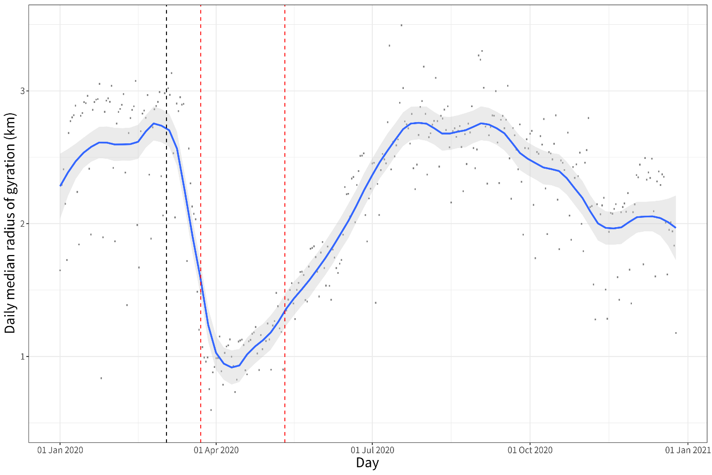

Figure 1. Changes in (the average levels of) mobility across England in 2020

Note: XXX. The trend over time in the daily median radius of gyration (km) was estimated with help of the local polynomial regression function (with span *s*=0.2). Dotted lines highlight important days: black – baseline (3 March 2020), and red – start and end of the 2020 Spring lockdown in England.

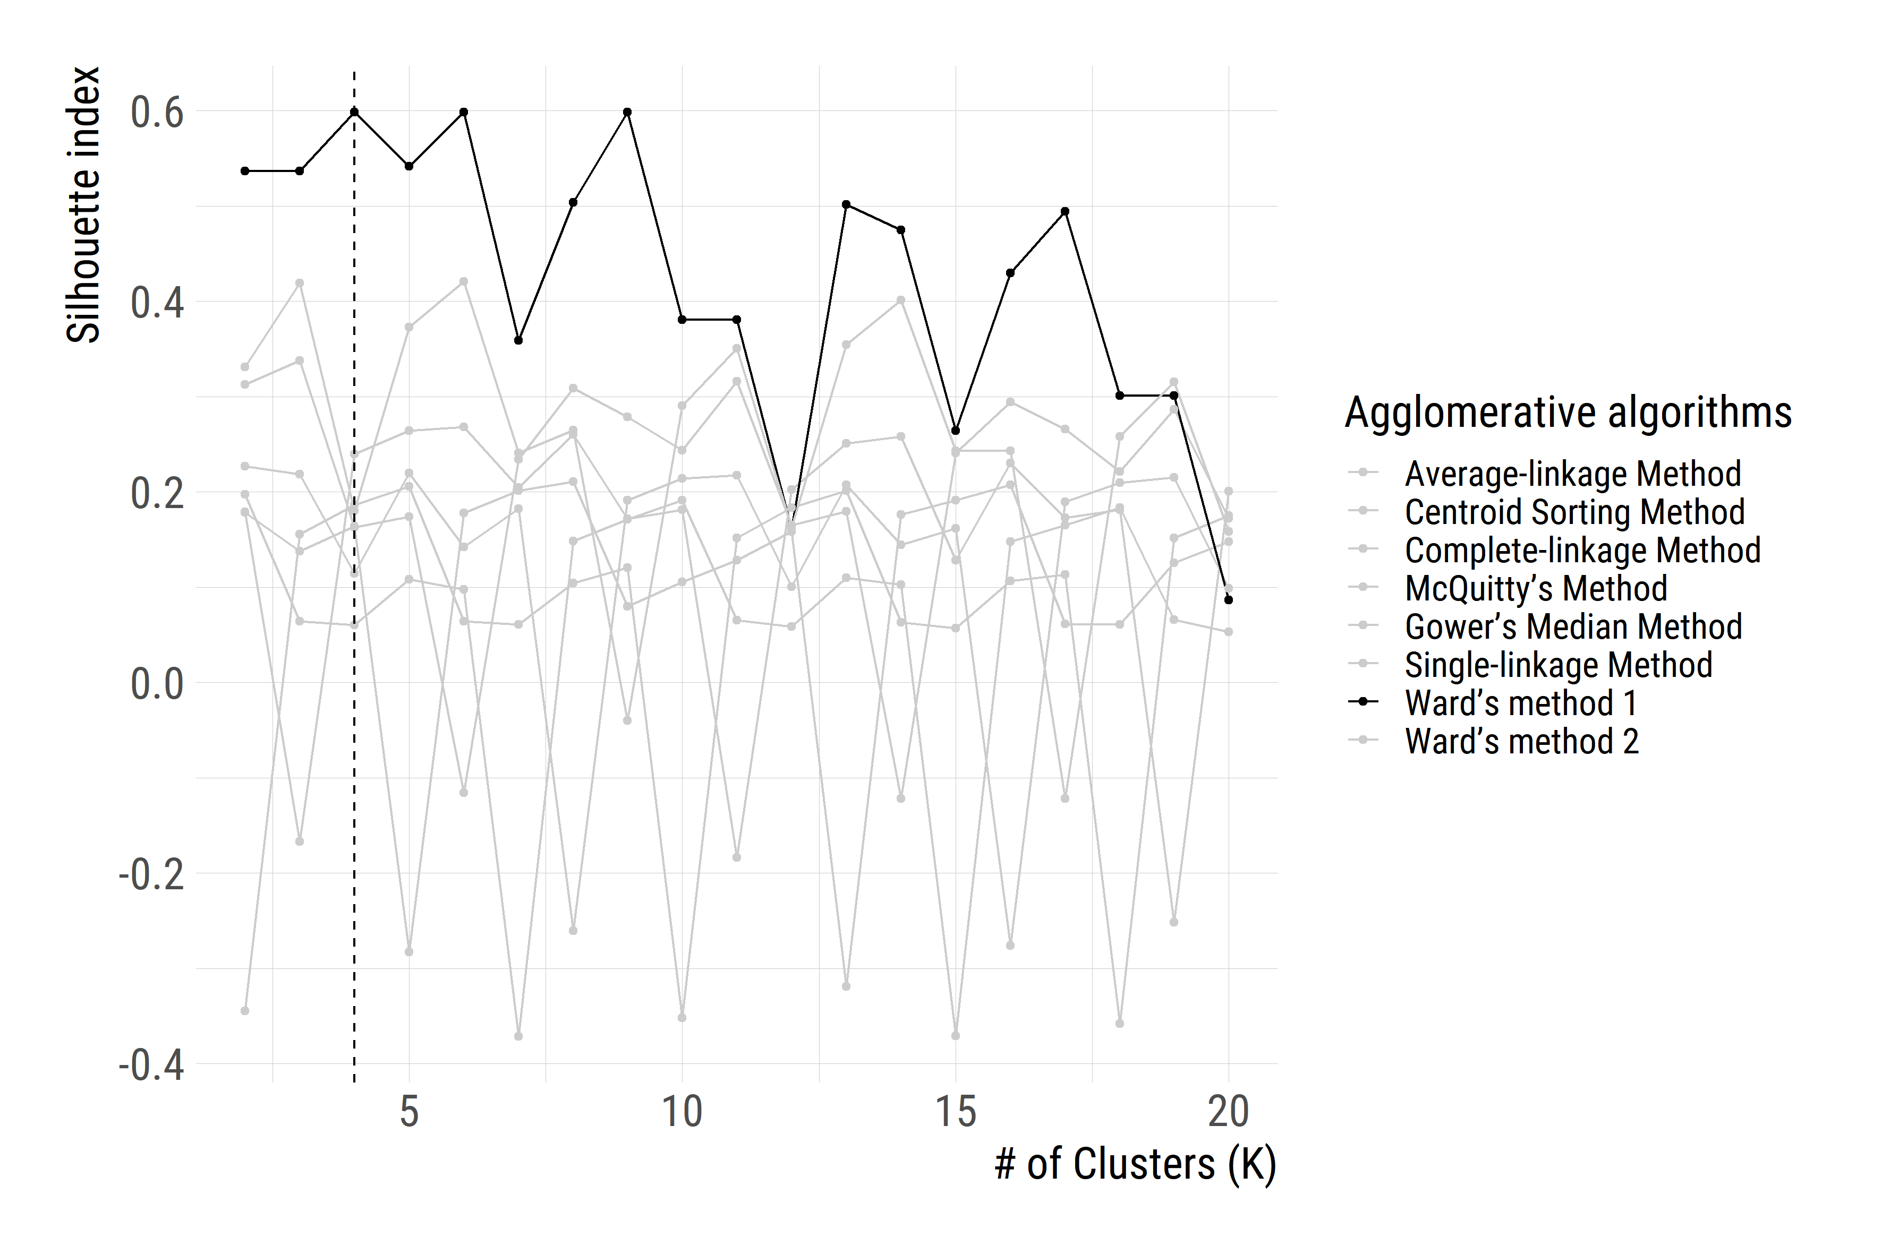Figure 2. Variations in the *Silhouette index* against the number of Clusters (*K*= 2 to 20).

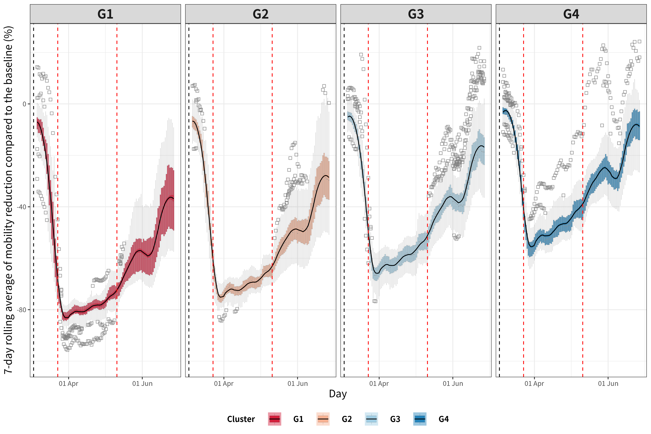

Figure 3. Average trajectory of mobility change in each cluster.

Note: The temporal trend has been estimated on the basis of 7-day rolling average mobility levels with the local polynomial regression function (with span *s*=0.2). XXX. Dotted vertical lines highlight important days: black – baseline (3 March 2020), and red – start and end of the 2020 Spring lockdown in England.

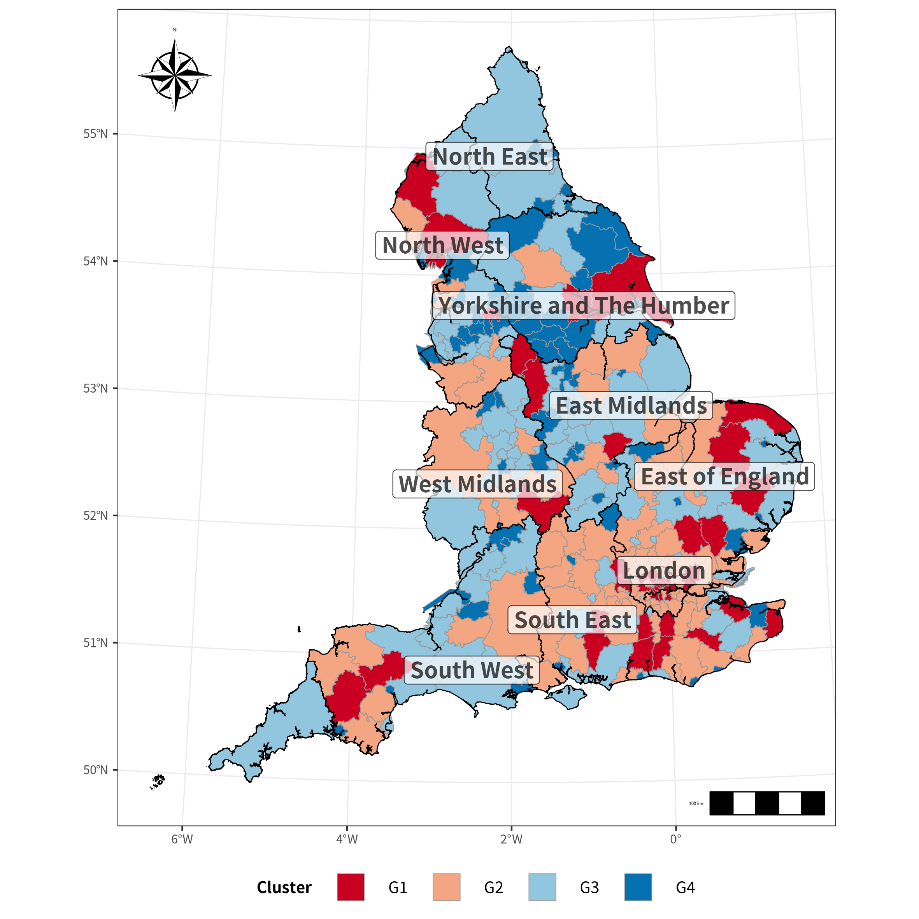

Figure 4. Spatial distribution of the clusters.

1. Transport Studies Unit, School of Geography and the Environment, University of Oxford.
2. Saïd Business School, University of Oxford.
3. Anonymised mobile phone location data provided by a large British mobile phone company.
4. For this study >2% percent of the population has been sub-sampled from the users of a large British mobile phone provider, stratified by Lower Tier Local Authorities in England. The London boroughs of *City of London* and *Hackney have been* combined due to small population sizes; the same has been done for *Cornwall* and *Isles of Scilly*.
5. The computation of home region of users exploits the night-time location when users are most likely to be at home. Home region detection followed three steps: a) filter observations from 10 pm to 6 am, b) finding the most common cell phone tower used at night-time, c) dropping users with fewer than 30 night-time observations per month. Each cell phone tower is assigned to an LTLA based on its location.
6. Nearest-neighbour or Single-linkage Method, Furthest-neighbour or Complete-linkage Method, Average-linkage Method, McQuitty’s Method, Centroid Sorting Method, Gower’s Median Method, and Ward’s method.