Trajectories of mobility during England's first national COVID-19 lockdown

# Authors

Won Do Lee[1] ([wondo.lee@ouce.ox.ac.uk](mailto:wondo.lee@ouce.ox.ac.uk)), Matthias Qian[2], and Tim Schwanen2.

# Highlights

* People's mobility changed substantially in response to COVID-19 pandemic
* V-shaped trend in mobility shows sharp decline but gradual return over time
* The trajectories of mobility were different across local authorities in England at different stages of the lockdown.
* Further evidence of flexible responses to COVID-19 is provided by differences in mobility resilience

# Abstracts

The UK government imposed a lockdown across England in the spring of 2020 to reduce community transmission of COVID-19 and avoid health services becoming overwhelmed. The measures led to large reductions in everyday mobility, but not everywhere to the same extent. Using call detail records from more than 1.1m mobile phones, we explored spatial differences between local authorities in how people’s mobility changed during the first national lockdown in the initial phases. Four groups of local authorities are identified, which differ in trajectories of mobility, and their membership was mainly associated with their income level, self-employed workers, and car availability, although ethnic/racial make-up of the population and health-related neighbourhood features, estimated by the classification model. The analysis shows that the greatest reduction in mobility after the imposition of the lockdown, and the continuation of low levels of mobility afterwards occurred in high-income areas with comparatively high levels of self-employed workers and cumulative COVID-19 infection rates before stay-at-home orders. It thus indicates that the greatest reductions have been achieved in areas where it is relatively easy for people to stay at home or in areas the risk of infection and severe illness was relatively high. More generally, the results highlighted the need to consider differences in mobility over space are explicitly linked to the ability to restrict everyday mobility among people.

**Keywords**: COVID-19; Pandemic; Human mobility; Time-series clustering; Classification model.

# Introduction

The COVID-19 pandemic has rapidly changed our everyday lives, particularly mobility. Implementing various social distancing policies, such as travel restrictions and compliance with stay-at-home orders, were correlated with the reduction in mobility (Hale et al., 2021; Kishore et al., 2021). Working from home has become the *new normal* when people were banned from mixing indoors. It also mitigates the risk while using public transport for work-related travel and on-site working (Beck & Hensher, 2020). Inevitably, transport mode use has been strongly affected by the risk of travellers being exposed to the virus during their journey (Barbieri et al., 2021; de Séjournet et al., 2022; De Vos, 2020). In short, the risk of COVID-19 and travel-related measures have rapidly reshaped our *mobility habits* (Cartenì et al., 2020). Although the magnitude of this change varies across and within cities and social groups.

In England, the UK government recognised the importance of rapid control and implemented countermeasures to tackle the outbreak since COVID-19 reached in late January 2020 (Scally et al., 2020). However, the nationwide lockdown was imposed as an emergency measure on 23 March 2020 to mitigate the transmission, and the new, more transmissible variant of COVID-19 continues to spread. As a result, people’s everyday mobility has to face new challenges and massive adaptions to COVID-19 (Borkowski et al., 2021; Lee et al., 2021; Marsden & Docherty, 2021), it ranged from travel restrictions to social distancing orders, curfews, quarantines, and finally, lockdown measures come into force to diminish the physical interactions and order people to “Stay-at-home”.

Greater attention should be paid to analysing changes in people’s mobility throughout the first COVID-19 lockdown, and a more detailed understanding of how mobility changes spatio-temporally is needed during the prolonged period of strict lockdown. Recent work has highlighted this by using examining changes in mobility over seven months or more (J. Kim & Kwan, 2021; Long & Ren, 2022; Molloy et al., 2021) and decomposing it into successive stages, i.e., *intra-pandemic dynamics* (Kellermann et al., 2022) through longitudinal perspective. Considering the short-term effects of implemented travel restrictions and other policy interventions, and also the long-term effects under mobility circumstances, such as working from home or homeschooling, the way of *new normal* in mobility into account.

To this end, this research quantifies and measures changes in mobility during England’s first nationwide lockdown in the phases of the COVID-19 pandemic, by using anonymised call-detail records (CDRs) data collected from mobile phones. By doing this, this research investigates the long-term effects of government-mandated lockdowns on people’s mobility spanning the five most tightly controlled months in 2020, by measuring changes in mobility over time and quantifying how it evolved. This task is achieved by deploying data mining techniques to reveal different socioeconomic statuses likely to be correlated with different trajectories of mobility under England’s first nationwide lockdown. Specifically, the research addresses the following questions:

* How has mobility changed over the initial phases of the lockdown?
* Which factors explain disparities in mobility recovery trends in lockdown phases?
* Does socioeconomic status associated with trajectories of mobility reduction throughout the lockdown?

# Related works

Academic literature on transport and COVID-19 has burgeoned since the Spring of 2020. Many papers have examined V-shaped mobility trends in the early stage of COVID-19 pandemic to reveal substantial changes in people’s mobility and travel behaviours with the support of large-scale mobile phone data and online panel surveys. There is abundant evidence that overall levels of people’s mobility dropped instantly but recovered rapidly based on longitudinal data analysis following longer than a year following the onset of the COVID-19 pandemic (Kellermann et al., 2022; J. Kim & Kwan, 2021; Long & Ren, 2022; Wang et al., 2022) by using traditional mobility metrics, such as daily distanced travelled per person (Hong et al., 2021; Lou et al., 2020; Pan et al., 2020; Weill et al., 2020; Xiong, Hu, Yang, Younes, et al., 2020), time spent travelling per person per day (Borkowski et al., 2021), and a total number of trips per day (Lou et al., 2020; Pan et al., 2020; Xiong, Hu, Yang, Younes, et al., 2020; Zhang et al., 2021).

There is now a substantial number of studies demonstrating the effects of government-mandated lockdowns on mobility. For instance, the share of stay-at-home depicts the percentage of people staying entirely at home and avoid leaving their house all day (Fu & Zhai, 2021; Hu et al., 2021; Jay et al., 2020; Pan et al., 2020; Weill et al., 2020) is robust evidence to assess the effectiveness of government interventions in people’s everyday lives. Traffic flows reconstructed from mobile phone data measured changes in population movements between city pairs (Beria & Lunkar, 2021; Schlosser et al., 2020; Xiong, Hu, Yang, Luo, et al., 2020). Also, the radius of gyration is popularly used to measure the radial distance moved within a certain time period, such as a day (Gauvin et al., 2020; Hernando et al., 2020; Lee et al., 2021; Park et al., 2021; Pepe et al., 2020; Santana et al., 2020; Yabe et al., 2020).

As the study shows, using mobile data to generate mobility metrics was very helpful in evaluating the impact of containment and closure policies, in the form of various travel disruptions and restrictions. Interestingly, people’s mobility levels dropped sharply and then gradually bounced back to normal throughout the COVID-19 pandemic (J. Kim & Kwan, 2021; Lee et al., 2021). Recent studies also revealed how mobility changed in the different pandemic stages, and exhibited some notable differences in lockdown phases. *Voluntary social distancing* (Linka et al., 2020; Xiong, Hu, Yang, Younes, et al., 2020) was observed between pre-pandemic and implemented stay-at-home orders. It suggests that people would practice voluntary social distancing depending on their ability to self-regulate capacity (Cronin & Evans, 2020).

Also, increased mobility observed that people went outside more during the coming months after the lockdown, entitled to *Quarantine fatigue* (J. Kim & Kwan, 2021; Kwan, 2021; Pan et al., 2020; Zhao et al., 2020).

However, limited attention has been given to a consideration of how mobility changed over time and its variation in different phases alongside the shift in government response. People’s mobility has been influenced by the prevalence of government measures, and individually perceived risk and ability to restrict everyday mobility together, all of which are time-varying. To further elucidate this issue, we examined changes in mobility throughout government-mandated lockdowns added on pre-pandemic and post-lockdown periods (i.e., ±2 months) in this study.

# Data and methods

## Data

Measuring the change of mobility levels over time provides insight into the effect of the pandemic on people’s daily behaviour and compliance with government-mandated lockdowns (Grantz et al., 2020; J. Kim & Kwan, 2021; Kishore et al., 2020). In this study we measure mobility levels using anonymised and aggregated GDPR-compliant call detail records (CDRs)[3]. More specifically, we deploy CDRs for over one million users in January-June 2020 to compute the daily median radius of gyration for users in 315 Lower Tier Local Authority (LTLA) areas in England.[4] LTLAs correspond with Districts, Boroughs and City Councils and are the lowest level of government at which policies are developed and implemented in England. The radius of gyration is widely used to capture mobility patterns through density metrics using the timestamps in CDRs. t measures the spatial extent of individuals’ activity space (Lu et al., 2021) through summation of the distance of each time-stamped () location where individual I is on day from the trajectory’s mean location , which can be formulated as . Locations are approximated by the nearest mobile phone tower, and mobility will be underreported if individuals do not take their phone along. User-level values are aggregated to the LTLA areas in which individuals reside.[5] Formally, the radius of gyration can be expressed as:

|  |  |
| --- | --- |
|  | (1). |

This mobility metric has been aggregated to present the generalised mobility level of each LTLA level in England. We examine the trajectory of median mobility for each LTLA over time by calculating the (percentage) change in mobility levels compared to a reference day. To do this, we replicate the approach taken by Lee et al. (2021) who identified Tuesday 3 March as a robust reference day. The authors validated their approach by conducting the sensitivity analysis with an alternative reference period.

A wide range of contextual information on LTLAs have been collected from secondary data sources. Demographic and socioeconomic data have been retrieved from the 2011 Census and other sources provided by the Office for National Statistics (ONS). We have aggregated data from the Lower Layer Super Output Area (LSOA) level to the LTLA area. COVID-19 metrics have been retrieved from the UK official COVID-19 dashboard open data API service (UK government, 2020) and processed.

## Methods

### Time-series clustering analysis

A clustering analysis technique was used to classify lower-tier local authorities (LTLAs) into a small number of groups with similar trajectories of mobility during England’s first national lockdown between 23 March and 11 May 2020). To compute the optimal (warping) distances among all LTLAs’ time-series, we used the dynamic time warping (DTW) algorithm suggested by Berndt and Clifford (1994). This algorithm is widely used for clustering time series (Aghabozorgi et al., 2015). because of its robustness compared to other conventional measures (Chen et al., 2017; Petitjean et al., 2011). Given two time-series, and , the DTW distance can be mathematically formulated as follows.

|  |  |
| --- | --- |
|  | (2). |

The sequence of and can be arranged to form a -by- grid, where is a distance function, to represent the magnitude of the difference between the sequence elements () to (). denotes a sequence of grid points (1 to ), is a warping function to find the path through the grid. The warping path aligns the elements of two sequences when the distance between them is minimised.

Hierarchical clustering methods have been deployed to test the performance of different agglomerative hierarchical clustering algorithms[6] on the constructed DTW distance (Dau et al., 2016; Sardá-Espinosa, 2019). We have used the *dtwclust* package for R to identify the optimal number of clusters within the [2,20] range with the help of the Silhouette index (*Sil*). This has been identified as the best-performing cluster validity index. Arbelaitz (2013) depicts how close each observation is to others in the same cluster (i.e. intra-cluster distances) by contrast to observations in the nearest cluster (i.e. inter-cluster distances). *Sil* values range from -1 to +1, with higher values denoting better overall clustering quality (Rousseeuw, 1987). If LTLA area belongs to cluster , can be expressed as:

|  |  |
| --- | --- |
|  | (3), |

where is the average distance between to other LTLA areas in the same cluster and is the smallest average distance from to other LTLA area(s) in the nearest cluster. A value for that is close to 1 requires . Thus, a small value of means that the cluster analysis performs well.

### Classification model

A penalised regression model is similar to linear regression model but it has an additional penalty term to constrain (or regularise) the estimated coefficients. It can reduce the variance and decrease sample error to help generalised models (Boehmke & Greenwell, 2019). The LASSO (Least Absolute Shrinkage and Selection Operator) regression is a penalised regression model, originally proposed by Tibshirani (1996). It minimises the residual sum of squared errors (RSS) while constraining the sum of the absolute values of the regression coefficients (Usai et al., 2009). In mathematical form, the penalised likelihood function is given by:

|  |  |
| --- | --- |
|  | (4). |

Here is a constraint as a tuning parameter (, is the number of predictors, and is the penalty parameter that controls the amount of regularisation (i.e., the size of the coefficients). Setting to 1 allows strong penalisation of the sum of the absolute values of regression coefficients , setting what is known as the 1 norm of coefficients. Using this norm results in sparse models with the coefficients of unimportant variables tending towards zero to increase the likelihood of those variable to be eliminated from the model (Friedman et al., 2010).

The multinomial logistic regression model (MLR) utilises the logit link function to model the logarithm of the odds ratio for multi-category response variables (Krishnapuram et al., 2005). If has categories ( > 2) and a vector of predictor variables is specified, then the linear logistic regression model can be generalised to a multi-logit model (Friedman et al., 2010). The maximum likelihood estimation approach is extended to -1 MLR as per Equation (5). This model requires the estimation of the conditional probability for each class in the range of as in Equation (6):

|  |  |
| --- | --- |
| . | (5), |
|  | (6). |

Here is a constant, is a vector of coefficients corresponding to cluster , denotes the predictor variables, and indicates vector/matrix transpose. Friedman et al. (2010) suggest fitting the model by regularised maximum (multinomial) likelihood. If is the indicator response matrix, with elements , then the log-likelihood part of will be given by:

|  |  |
| --- | --- |
|  | (7). |

Krishnapuram et al. (2005) applied the 1 norm to the log-likelihood function by replacing the residual sum of squares with the corresponding negative log-likelihood function . For the multinomial LASSO logistic regression model (hereafter MLR LASSO), Hossain et al. (2014) summarised the penalised likelihood function as:

|  |  |
| --- | --- |
|  | (8). |

Finally, the MLR LASSO can shrink and delete the insufficient coefficients by adding the *1* norm to the log-likelihood function (Hossain et al., 2014). It also reports cluster-varying estimated results. In other words, it helps to exhibit differences in estimated coefficients of differences across significant factors over clusters. The *glmnet* package in R has been used for estimation of the model coefficients presented below.

# Results

## Mobility changes during England’s first national lockdown

The average level of mobility in England as a whole changed according to a well-documented pattern during the early stage of the COVID-19 pandemic (see, for instance, Lee et al. 2021). In the first 3 weeks of March 2020, the average level of mobility dropped significantly by about 50% compared to the pre-pandemic situation. Further reductions to less than 1km radial distance per day occurred after the first nationwide lockdown commenced on 23 March 2020. The fact that most of the reduction occurred before the start of the lockdown reflects that the UK government instituted the nationwide lockdown relatively late compared to many other European countries, even though it had encouraged people to start working from home and banned the mass gatherings and all unnecessary social contact since mid-March (Public Health England, 2020). Nonetheless, mobility levels started to bounce back from later April onwards and therefore even before the lockdown was officially lifted.

<*Figure 1 about here*>

Much less is known about variations around the mean trajectory in Figure across LTLA areas. That variation can be summarised into 4 broad patterns according to the cluster analysis. Figure 2 shows that the Silhouette Index is highest for the Ward method-1 algorithm and tends to peak at the values 4, 6 and 9. We have therefore selected 4 clusters with the Ward-1 algorithm as our preferred clustering solution.

<*Figure 2 about here*>

The patterns that can be observed in Figure 3 and Table 1 suggest that the LTLA clusters can be differentiated on the basis of three factors: the pace of reduction in mobility levels in LTLAs in the first weeks of the pandemic in England; the extent to which mobility levels were reduced during England’s first nationwide lockdown; and the pace of recovery in mobility levels from early April onwards. Based on these factors the four clusters can be labelled as follows:

* G1 = very fast-very large-very slow (VF-VL-VS, n=45): this cluster is characterised by the quickest drop in mobility levels, the greatest reduction and the slowest recovery of all four clusters;
* G2 = somewhat fast-somewhat large-somewhat slow (SF-SL-SS, n=96): this cluster is the moderate version of G1 with lower drops and reductions in mobility levels and faster recovery but substantially more different from the pre-pandemic normal than G3 and G4;
* G3 = somewhat slow-somewhat small, somewhat fast (SS-SS-SF, n=106): this cluster is on the opposite side of the national average compared to G2, with rather slow drops in March, fairly small reductions and reasonably fast recovery from April onwards;
* G4 = very slow-very small-very fast (VS-VS-VF, n=69): this cluster is on the opposite extreme compared to G1, with overall the smallest deviations from the pre-pandemic normal of all clusters.

There are some patterns in the internal heterogeneity of the four clusters. Overall, the variation around the mean is largest G1 and G2. The level of variation increases over time in all clusters, in part because the intra-cluster homogeneity in the reduction in March is very small. However, the increase in variation around the mean is particularly pronounced in May and June in G1 and G2. In the other two clusters, the extent of variability remains more stable from mid-April onwards.

<*Figure 3 and Table 1 about here*>

The clusters show a rather distinct spatial distribution. Figure 4 suggests that most LTLA areas share borders with at least one other LTLA area that belongs to the same cluster. Spatial co-location of the clusters is also clear from Table 2, which shows rather distinct distribution patterns. G1 is clearly concentrated in London, whereas its opposite in terms of mobility trajectory, G4, is clearly overrepresented in the North West and Yorkshire and The Humber. G2 is more common in Outer London and Southern England, while G3 is concentrated in the North West and East Midlands.

<*Figure 4 and Table 2 about here*>

## Correlates of mobility trajectory cluster membership

MLR LASSO regression modelling offers further insight into the correlates of cluster membership. Table 3 summarises the results, highlighting that the penalisation embedded in the modelling results in the selection of different sets of correlates for each of the clusters. MLR LASSO has no built-in model for ranking the correlates in terms of importance (Abdel Majeed et al., 2018). To make the estimates as comparable as possible, we normalised the values for each correlate normalised to the [0,1] range prior to model fitting. The best penalty parameter was selected by 10-fold cross-validation (CV).

The model shows that sociodemographic profile, accessibility and COVID-19 risks all help to differentiate between the four clusters of mobility change in LTLAs during the first national lockdown in England. Sociodemographic factors are nonetheless more important than accessibility ad COVID-19 risk. Not only are more sociodemographic variables included in the model, the coefficient sizes for some of the sociodemographic variables are also larger. Based in the estimates, it would seem that share of self-employed workers in the resident population, car availability and household income are the most powerful differentiating variables, followed by ethnicity, shape of people with lower middle-class occupation, housing type and infection rates prior to the lockdown. Note that the pattern of relative importance of variables changes if dummy indicators for region of residence with the same categories as in Figure 4 are allowed to be included in the models. In that case, region of residence is associated with the largest coefficient estimates. Nonetheless, a model with region of residence has a lower classification accuracy (60.6% across the four clusters) than the model in Table 3 (62.2%), which is why that model is not included in the paper.

LTLAs in G1 (n=45) are characterised by the quickest drop, greatest reduction and slowest recovery in mobility levels across all clusters, as well as clear overrepresentation in London. The LASSO MLR analysis indicates that this pattern maps onto a high share of self-employed workers (coefficient estimate: +0.71), few households with one vehicle (-0.35), a large number of cumulative COVID-19 infections before the lockdown started (+0.24), many high-income households (+0.19), and many black individuals whose heritage is neither African nor Caribbean (+0.12).

LTLAs in G2 (n=96) resemble those in G1 when it comes to mobility changes though the degree of change is less extreme, and these LTLA are more likely to be found in Outer London and Southeast England. These LTLAs are relatively prosperous given that the LASSO MLR analysis shows they are characterised by high shares of high-income households (+0.47), Black Africans (+0.43) and households with three or more vehicles (+0.39). In contrast, the capacity of healthcare facilities, indicated by the number of hospitals per resident, is the lowest of all clusters. it should be pointed that the tenfold cross-validation accuracy is markedly lower for G2 than for the other clusters, indicating that the model final model is much less successful in accurately classifying LTLAs as belonging to G2.

Common to Northwest England, Yorkshire and the Humber region, LTLAs in G4 (n=69) exhibit the smallest deviations from the pre-pandemic normal mobility levels and therefore the smallest drop and reduction and fastest recovery during the lockdown. These LTLAs are in many ways the opposite of those in G1 and G2, given that they have the lowest shares of households with three or more vehicles (-0.64), self-employed workers (-0.26) and workers in lower middle-class occupations (-0.23). COVID-19 risk and overall black populations were also smallest, as evidenced by the negative coefficients for cumulative COVID-19 mortality rates before the official lockdown started (-0.20) and share of inhabitants identifying as Black Caribbean (-0.19). The model is also most successful in classifying LTLAs correctly as belonging to this cluster (70%).

Finally, G3 is the less extreme version of G4, akin to the relationship of G2 to G1. The 106 LTLAs in this cluster are characterised by middle and lower incomes as indicated by the coefficients for households in the median and top income quintiles (-0.38 and -0.23, respectively). LTLAs with many dwellings with 3 or more bedrooms are also overrepresented in this cluster.

# Discussion

The results of this study contribute to the by now substantial literature on the developments over time in mobility levels during the COVID-19 pandemic in various ways. Most significantly, the study highlights the usefulness of concentrating not only on temporal trends but on spatial-temporal dynamics. Focusing on the lowest spatial scale at which contextual data about sociodemographic profile, accessibility and COVID-19 risk from government sources are available, we have shown developments in mobility level over time to vary substantially across geographical space. This suggests that a focus on mobility changes during the pandemic in England as a whole occludes considerable heterogeneity and complexity. In fact, our analysis highlights that claims about how mobility evolved during the pandemic are strongly vulnerable to the Modifiable Areal Unit Problem (Fotheringham and Wong, 1991).

At a more detailed level, two more specific contributions stand out. The first of these relates to the correlation of speed and intensity of mobility reduction with recovery relative to pre-pandemic levels. The cluster analysis has highlighted how those lower-tier local government areas (LTLAs) that saw the fastest reduction in mobility also saw the deepest reduction and the slowest recovery. The opposite of slowest and smallest reduction and quickest recovery also holds. Adaptability in people’s everyday mobility to the pandemic had two faces. On the one hand, some areas, concentrated in/around London and in Southeast England, saw the fastest and largest reductions in the earliest stages of the pandemic. It is here that spontaneous mobility reductionbefore the lockdown measures through which national government sought to suppress mobility levels manifested first and mostly fiercely. On the other hand, LTLAs, particularly those in North England and to a lesser extent the Midlands, bounced back more quickly as the first national lockdown wore on and overall infection levels waned. It is in these areas that quarantine fatigue (Zhao et al., 2020) occurred earliest and most vigorously.

The finding of two dimensions in adaptability in people’s everyday mobility maps onto particular understandings of resilience in mobility, and more generally, that distinguish between ability to absorb shocks and ‘bouncebackability’ (Wan et al., 2018; Gonçalves and Ribeiro, 2020). On this view, the LTLAs in clusters G4, and to a lesser extent G3, demonstrated the greatest resilience in the overall everyday mobility of people. Interestingly, this conclusion is in tension with what was seen as normatively desirable and informing official government policy at the time – i.e., a fast and deep decline and cautious recover, much like the pattern captured in G1-G2. The place-based mobility challenges in England at the beginning of the COVID-19 pandemic highlights that strong resilience, understood in terms of ability to absorb shocks and fast recovery, may not always be as desirable or in line with national guidance as it is often taken to be.

Second, the two faces of adaptability are correlated with measurable differences between LTLAs in terms of sociodemographic profile and to a lesser extent accessibility and COVID-19 risk. In the very first phase of the pandemic, it was LTLAs with high levels of self-employment and prosperity (income, vehicle ownership) plus greater ethnic populations, both Black and Asian, that saw greater adaptability and lower resilience – i.e., greater speed and magnitude of reduction – in mobility levels. The greater burden of COVID-19 infections may also have played a role in driving down mobility levels, at least in those LTLAs belonging to G1. When the focus is on recovery, and resilience is positively correlated with (short-term) adaptability, the patterns look differently. Recovery to pre-pandemic mobility levels tended to be greatest in LTLAs with more low- and medium-income households, fewer self-employed workers, smaller ethnic minority populations, and slightly smaller exposure to COVID-19 infection and mortality prior to national lockdown policy.

The pattern emerging from these results develops and nuances narratives about how prosperous areas and better-off population groups were able to adapt everyday mobility better to the pandemic and comply more fully with government restrictions imposed through lockdown policies (REF). It is true that, in England, more prosperous local areas saw earlier and greater reductions in mobility and greater inhabitation in terms of returning to pre-pandemic mobility levels, but adaptability, compliance and caution along these lines were also related to ability to adapt work patterns – arguably higher among self-employed workers – and risk of adverse health consequences. By virtue of its incorporation in the global economy and international tourism, London and surrounding areas saw great infection levels in the pandemic’s earliest stages. Similarly, there was some public debate about ethnic minority populations being at greater risk of (severe) illness due to COVID-19 in the first wave of the pandemic. In short, the greater adaptations in overall mobility patterns in the pandemic’s early phases, observed through G1 and G2 above, appear not merely to be a function of ability to adapt but also of (perceived) necessity, urgency and risk.

The narrative for the northern regions of England, and to some extent the Midlands, emerges more strongly from G3-G4 than from G1 and G2. It is characterised by, in relative terms, more households on low and medium incomes, which suggests more people employed in roles where working from home was less easy or financially viable. Also relevant were lower (measured) prevalence of the virus in the very early stages of the pandemic, as suggested by the effects for the COVID-19 risk variables in Table 3. Overall, then, the results provide some evidence of a north-south divide in England in the ability to adapt and perceived necessity, urgency and risk during the first national lockdown. This divide should not be exaggerated, however, because LTLAs in clusters G1-G2 are not limited to London and the South East and G3-G4 are not restricted to the North or the Midlands.

Two further caveats are in order. Our analysis is limited to the first wave of infection. Spatiotemporal patterns in mobility levels during subsequent waves are likely to have been substantially different, not least because the second and third waves wreaked greater havoc in terms of infection and mortality rates in the northern parts of the country (and especially in Merseyside and Greater Manchester) (REF). Further research on the spatiotemporal patterning of mobility changes to later waves, when the willingness to reduce mobility also appeared to be lower (REF), remains an important topic for future research.[7] Readers should also be aware that our analysis refers to LTLA-wide trends and says little about what specific individuals did or did not do in terms of everyday mobility. Interpreting the analysis in this manner would be to commit the well-known ecological fallacy (Robinson, 1950). Analysis of the kind pursued here nonetheless remains valuable because public policy decisions about how to respond to future pandemics are not made on the basis of what particular individuals do but the behavioural tendencies within larger groups and populations in specific geographical settings.

# Conclusions

This paper has sought to provide rigorous evidence that trajectories of mobility change under the lockdown, and contribute to the methodological development to characterise trajectories of mobility coping with socioeconomic and demographic factors. The research was founded on the integration of novel data and data mining techniques. In detail, employing longitudinal perspective to explore changes in mobility by using mobile phone data spanning seven months. And then, Clustering analysis and classification model were chosen to collect similar trajectories of mobility and find the significant factors to predict the clusters, respectively. Two main conclusions can be drawn.

First, people’s everyday mobility has been changed, and it could be the clear evidence of the effectiveness of government interventions in times of the pandemic. In England, mobility levels already falling about 50% compared to the pre-pandemic in the early stage of the pandemic (i.e., the first day of lockdown). Mobility levels continuously declined towards 80% (i.e., 7-day on lockdown) but soon bounced back up to 50% over the course of the national lockdown. Easing lockdown supported the mobility recovery so that mobility levels returned to normal in the post-lockdown period. However, the trajectory of mobility reduction under the lockdown is not the same extent. Spatial heterogeneity in clusters relating to trajectories of mobility change was evident throughout time-series clustering analysis. It revealed differences in the recovery of mobility levels during the lockdown between the generated clusters. The finding that areas with the greatest reduction in mobility levels before the government-mandated lockdown and marginal recovery during the lockdown were observed in Inner London. In contrast, areas with the lowest reduction in mobility and rapid mobility bound back can be found in North West, and Yorkshire and the Humber.

Second, people’s mobility levels have been influenced by government interventions, but it was also coupling with the individual ability to restrict everyday mobility (Lee et al., 2021). Unsurprisingly, high-income workers mainly were working from home, and felt to adapt successfully to the new normal (Office for National Statistics, 2021). Racial and ethnic minorities and poor people lived in crowded conditions and generally worked in essential industries (Huang et al., 2021). Additionally, Lou et al. (2020) found that stay-at-home orders did not significantly reduce low-income work trips. Thus, it is vital to demonstrate the effects of socioeconomic and demographic factors to predict the patterns of temporal evolution of mobility level in pandemic times. Our classification model, MLR LASSO, has examined the significant factors and assessed the importance of selected features between clusters. As a result, income, employment and accessibility are quantified as the most effective domains. Subsequently, housing type, perceived risk of COVID-19 (before the lockdown), and BAME (Black, Asian and minority ethnic) variables were also selected.

# Availability of data and materials

All source R code and data necessary for the replication of our results and figures are available at <https://github.com/wondolee/covid19-eng-lockdown>.

# Credit authorship contribution statement

Won Do Lee: Conceptualisation, Data Curation, Methodology, Formal analysis, Writing-Original draft preparation. Matthias Qian: Data Curation, Writing-Reviewing and Editing. Tim Schwanen: Conceptualisation, Writing-Original draft preparation, Supervision, Writing-Reviewing and Editing.

# Declaration of competing interest

The authors declare that they have no known competing financial interests or personal relationships that could have appeared to influence the work reported in this paper.

# Acknowledgement

This research did not receive any specific grant from funding agencies in the public, commercial, or not-for-profit sectors.

# References

Abdel Majeed, Y., Awadalla, S. S., & Patton, J. L. (2018). Regression techniques employing feature selection to predict clinical outcomes in stroke. *PLOS ONE*, *13*(10), e0205639. https://doi.org/10.1371/journal.pone.0205639

Aghabozorgi, S., Seyed Shirkhorshidi, A., & Ying Wah, T. (2015). Time-series clustering – A decade review. *Information Systems*, *53*, 16–38. https://doi.org/10.1016/j.is.2015.04.007

Arbelaitz, O., Gurrutxaga, I., Muguerza, J., Pérez, J. M., & Perona, I. (2013). An extensive comparative study of cluster validity indices. *Pattern Recognition*, *46*(1), 243–256. https://doi.org/10.1016/j.patcog.2012.07.021

Barbieri, D. M., Lou, B., Passavanti, M., Hui, C., Hoff, I., Lessa, D. A., Sikka, G., Chang, K., Gupta, A., Fang, K., Banerjee, A., Maharaj, B., Lam, L., Ghasemi, N., Naik, B., Wang, F., Foroutan Mirhosseini, A., Naseri, S., Liu, Z., … Rashidi, T. H. (2021). Impact of COVID-19 pandemic on mobility in ten countries and associated perceived risk for all transport modes. *PLOS ONE*, *16*(2), e0245886. https://doi.org/10.1371/journal.pone.0245886

Beck, M. J., & Hensher, D. A. (2020). Insights into the impact of COVID-19 on household travel and activities in Australia – The early days of easing restrictions. *Transport Policy*, *99*(July), 95–119. https://doi.org/10.1016/j.tranpol.2020.08.004

Beria, P., & Lunkar, V. (2021). Presence and mobility of the population during the first wave of Covid-19 outbreak and lockdown in Italy. *Sustainable Cities and Society*, *65*, 102616. https://doi.org/10.1016/j.scs.2020.102616

Berndt, D., & Clifford, J. (1994). Using dynamic time warping to find patterns in time series. *Workshop on Knowledge Knowledge Discovery in Databases*, *398*, 359–370. http://www.aaai.org/Papers/Workshops/1994/WS-94-03/WS94-03-031.pdf

Boehmke, B., & Greenwell, B. (2019). *Hands-On Machine Learning with R*. Chapman and Hall/CRC. https://doi.org/10.1201/9780367816377

Borkowski, P., Jażdżewska-Gutta, M., & Szmelter-Jarosz, A. (2021). Lockdowned: Everyday mobility changes in response to COVID-19. *Journal of Transport Geography*, *90*(14), 102906. https://doi.org/10.1016/j.jtrangeo.2020.102906

Cartenì, A., Di Francesco, L., & Martino, M. (2020). How mobility habits influenced the spread of the COVID-19 pandemic: Results from the Italian case study. *Science of The Total Environment*, *741*, 140489. https://doi.org/10.1016/j.scitotenv.2020.140489

Chen, Y., Liu, X., Li, X., Liu, X., Yao, Y., Hu, G., Xu, X., & Pei, F. (2017). Delineating urban functional areas with building-level social media data: A dynamic time warping (DTW) distance based k-medoids method. *Landscape and Urban Planning*, *160*, 48–60. https://doi.org/10.1016/j.landurbplan.2016.12.001

Cronin, C., & Evans, W. (2020). *Private Precaution and Public Restrictions: What Drives Social Distancing and Industry Foot Traffic in the COVID-19 Era?* https://doi.org/10.3386/w27531

Dau, H. A., Begum, N., & Keogh, E. (2016). Semi-Supervision Dramatically Improves Time Series Clustering under Dynamic Time Warping. *Proceedings of the 25th ACM International on Conference on Information and Knowledge Management*, 999–1008. https://doi.org/10.1145/2983323.2983855

de Séjournet, A., Macharis, C., Tori, S., & Vanhaverbeke, L. (2022). Evolution of urban mobility behaviour in Brussels as a result of the COVID‐19 pandemic. *Regional Science Policy & Practice*, *14*(S1), 107–121. https://doi.org/10.1111/rsp3.12525

De Vos, J. (2020). The effect of COVID-19 and subsequent social distancing on travel behavior. *Transportation Research Interdisciplinary Perspectives*, *5*, 100121. https://doi.org/10.1016/j.trip.2020.100121

Department for Transport. (2020). *Transport use during the coronavirus (COVID-19) pandemic*. Official Statistics. https://www.gov.uk/government/statistics/transport-use-during-the-coronavirus-covid-19-pandemic

Friedman, J., Hastie, T., & Tibshirani, R. (2010). Regularization Paths for Generalized Linear Models via Coordinate Descent. *Journal of Statistical Software*, *33*(1), 1–22. https://doi.org/10.1016/j.expneurol.2008.01.011

Fu, X., & Zhai, W. (2021). Examining the spatial and temporal relationship between social vulnerability and stay-at-home behaviors in New York City during the COVID-19 pandemic. *Sustainable Cities and Society*, *67*, 102757. https://doi.org/10.1016/j.scs.2021.102757

Gao, Y., Cai, G.-Y., Fang, W., Li, H.-Y., Wang, S.-Y., Chen, L., Yu, Y., Liu, D., Xu, S., Cui, P.-F., Zeng, S.-Q., Feng, X.-X., Yu, R.-D., Wang, Y., Yuan, Y., Jiao, X.-F., Chi, J.-H., Liu, J.-H., Li, R.-Y., … Gao, Q.-L. (2020). Machine learning based early warning system enables accurate mortality risk prediction for COVID-19. *Nature Communications*, *11*(1), 5033. https://doi.org/10.1038/s41467-020-18684-2

Gauvin, L., Bajardi, P., Pepe, E., Lake, B., Privitera, F., & Tizzoni, M. (2020). Socioeconomic determinants of mobility responses during the first wave of COVID-19 in Italy: from provinces to neighbourhoods. *MedRxiv*, 2020.11.16.20232413. https://doi.org/10.1101/2020.11.16.20232413

Grantz, K. H., Meredith, H. R., Cummings, D. A. T., Metcalf, C. J. E., Grenfell, B. T., Giles, J. R., Mehta, S., Solomon, S., Labrique, A., Kishore, N., Buckee, C. O., & Wesolowski, A. (2020). The use of mobile phone data to inform analysis of COVID-19 pandemic epidemiology. *Nature Communications*, *11*(1), 4961. https://doi.org/10.1038/s41467-020-18190-5

Hale, T., Angrist, N., Goldszmidt, R., Kira, B., Petherick, A., Phillips, T., Webster, S., Cameron-Blake, E., Hallas, L., Majumdar, S., & Tatlow, H. (2021). A global panel database of pandemic policies (Oxford COVID-19 Government Response Tracker). *Nature Human Behaviour*, *5*(4), 529–538. https://doi.org/10.1038/s41562-021-01079-8

Haug, N., Geyrhofer, L., Londei, A., Dervic, E., Desvars-Larrive, A., Loreto, V., Pinior, B., Thurner, S., & Klimek, P. (2020). Ranking the effectiveness of worldwide COVID-19 government interventions. *Nature Human Behaviour*, *4*(12), 1303–1312. https://doi.org/10.1038/s41562-020-01009-0

Hernando, A., Mateo, D., & Plastino, A. (2020). Social inequalities in human mobility during the Spanish lockdown and post-lockdown in the Covid-19 pandemic of 2020. *MedRxiv*, 1–7. https://doi.org/10.1101/2020.10.26.20219709

Hong, B., Bonczak, B. J., Gupta, A., Thorpe, L. E., & Kontokosta, C. E. (2021). Exposure density and neighborhood disparities in COVID-19 infection risk. *Proceedings of the National Academy of Sciences*, *118*(13), e2021258118. https://doi.org/10.1073/pnas.2021258118

Hossain, S., Ahmed, S. E., & Howlader, H. A. (2014). Model selection and parameter estimation of a multinomial logistic regression model. *Journal of Statistical Computation and Simulation*, *84*(7), 1412–1426. https://doi.org/10.1080/00949655.2012.746347

Hu, S., Xiong, C., Yang, M., Younes, H., Luo, W., & Zhang, L. (2021). A big-data driven approach to analyzing and modeling human mobility trend under non-pharmaceutical interventions during COVID-19 pandemic. *Transportation Research Part C: Emerging Technologies*, *124*(January), 102955. https://doi.org/10.1016/j.trc.2020.102955

Huang, X., Lu, J., Gao, S., Wang, S., Liu, Z., & Wei, H. (2021). Staying at Home Is a Privilege: Evidence from Fine-Grained Mobile Phone Location Data in the United States during the COVID-19 Pandemic. *Annals of the American Association of Geographers*, *0*(0), 1–20. https://doi.org/10.1080/24694452.2021.1904819

Jay, J., Bor, J., Nsoesie, E. O., Lipson, S. K., Jones, D. K., Galea, S., & Raifman, J. (2020). Neighbourhood income and physical distancing during the COVID-19 pandemic in the United States. *Nature Human Behaviour*, *4*(12), 1294–1302. https://doi.org/10.1038/s41562-020-00998-2

Kellermann, R., Sivizaca Conde, D., Rößler, D., Kliewer, N., & Dienel, H. L. (2022). Mobility in pandemic times: Exploring changes and long-term effects of COVID-19 on urban mobility behavior. *Transportation Research Interdisciplinary Perspectives*, *15*(July). https://doi.org/10.1016/j.trip.2022.100668

Khataee, H., Scheuring, I., Czirok, A., & Neufeld, Z. (2021). Effects of social distancing on the spreading of COVID-19 inferred from mobile phone data. *Scientific Reports*, *11*(1), 1661. https://doi.org/10.1038/s41598-021-81308-2

Kim, J., & Kwan, M.-P. (2021). The impact of the COVID-19 pandemic on people’s mobility: A longitudinal study of the U.S. from March to September of 2020. *Journal of Transport Geography*, *93*(March), 103039. https://doi.org/10.1016/j.jtrangeo.2021.103039

Kim, K. (2018). Exploring the difference between ridership patterns of subway and taxi: Case study in Seoul. *Journal of Transport Geography*, *66*(March 2017), 213–223. https://doi.org/10.1016/j.jtrangeo.2017.12.003

Kishore, N., Kahn, R., Martinez, P. P., De Salazar, P. M., Mahmud, A. S., & Buckee, C. O. (2021). Lockdowns result in changes in human mobility which may impact the epidemiologic dynamics of SARS-CoV-2. *Scientific Reports*, *11*(1), 6995. https://doi.org/10.1038/s41598-021-86297-w

Kishore, N., Kiang, M. V, Engø-Monsen, K., Vembar, N., Schroeder, A., Balsari, S., & Buckee, C. O. (2020). Measuring mobility to monitor travel and physical distancing interventions: a common framework for mobile phone data analysis. *The Lancet Digital Health*, *2*(11), e622–e628. https://doi.org/10.1016/S2589-7500(20)30193-X

Krishnapuram, B., Carin, L., Figueiredo, M. A. T., & Hartemink, A. J. (2005). Sparse multinomial logistic regression: fast algorithms and generalization bounds. *IEEE Transactions on Pattern Analysis and Machine Intelligence*, *27*(6), 957–968. https://doi.org/10.1109/TPAMI.2005.127

Kwan, M. (2021). The stationarity bias in research on the environmental determinants of health. *Health and Place*, *70*(June), 102609. https://doi.org/10.1016/j.healthplace.2021.102609

Lee, W. Do, Qian, M., & Schwanen, T. (2021). The association between socioeconomic status and mobility reductions in the early stage of England’s COVID-19 epidemic. *Health & Place*, *69*, 102563. https://doi.org/10.1016/j.healthplace.2021.102563

Linka, K., Goriely, A., & Kuhl, E. (2020). Global and local mobility as a barometer for COVID-19 dynamics. *MedRxiv*. https://doi.org/10.1101/2020.06.13.20130658

Long, J. A., & Ren, C. (2022). Associations between mobility and socio-economic indicators vary across the timeline of the Covid-19 pandemic. *Computers, Environment and Urban Systems*, *91*(July 2021), 101710. https://doi.org/10.1016/j.compenvurbsys.2021.101710

Lou, J., Shen, X., & Niemeier, D. (2020). Are stay-at-home orders more difficult to follow for low-income groups? *Journal of Transport Geography*, *89*(October), 102894. https://doi.org/10.1016/j.jtrangeo.2020.102894

Lu, J., Zhou, S., Liu, L., & Li, Q. (2021). You are where you go: Inferring residents’ income level through daily activity and geographic exposure. *Cities*, *111*(135), 102984. https://doi.org/10.1016/j.cities.2020.102984

Marsden, G., & Docherty, I. (2021). Mega-disruptions and policy change: Lessons from the mobility sector in response to the Covid-19 pandemic in the UK. *Transport Policy*, *110*, 86–97. https://doi.org/10.1016/j.tranpol.2021.05.015

Molloy, J., Schatzmann, T., Schoeman, B., Tchervenkov, C., Hintermann, B., & Axhausen, K. W. (2021). Observed impacts of the Covid-19 first wave on travel behaviour in Switzerland based on a large GPS panel. *Transport Policy*, *104*, 43–51. https://doi.org/10.1016/j.tranpol.2021.01.009

Mouratidis, K., & Papagiannakis, A. (2021). COVID-19, internet, and mobility: The rise of telework, telehealth, e-learning, and e-shopping. *Sustainable Cities and Society*, *74*, 103182. https://doi.org/10.1016/j.scs.2021.103182

Office for National Statistics. (2021). *Coronavirus and compliance with government guidance, UK : April 2021*. https://www.ons.gov.uk/peoplepopulationandcommunity/healthandsocialcare/conditionsanddiseases/bulletins/coronavirusandcompliancewithgovernmentguidanceuk/april2021

Oliver, N., Lepri, B., Sterly, H., Lambiotte, R., Deletaille, S., De Nadai, M., Letouzé, E., Salah, A. A., Benjamins, R., Cattuto, C., Colizza, V., de Cordes, N., Fraiberger, S. P., Koebe, T., Lehmann, S., Murillo, J., Pentland, A., Pham, P. N., Pivetta, F., … Vinck, P. (2020). Mobile phone data for informing public health actions across the COVID-19 pandemic life cycle. *Science Advances*, *6*(23), eabc0764. https://doi.org/10.1126/sciadv.abc0764

Pan, Y., Darzi, A., Kabiri, A., Zhao, G., Luo, W., Xiong, C., & Zhang, L. (2020). Quantifying human mobility behaviour changes during the COVID-19 outbreak in the United States. *Scientific Reports*, *10*(1), 20742. https://doi.org/10.1038/s41598-020-77751-2

Park, S., Oshan, T. M., El Ali, A., & Finamore, A. (2021). Are we breaking bubbles as we move? Using a large sample to explore the relationship between urban mobility and segregation. *Computers, Environment and Urban Systems*, *86*(April 2020), 101585. https://doi.org/10.1016/j.compenvurbsys.2020.101585

Pepe, E., Bajardi, P., Gauvin, L., Privitera, F., Lake, B., Cattuto, C., & Tizzoni, M. (2020). COVID-19 outbreak response, a dataset to assess mobility changes in Italy following national lockdown. *Scientific Data*, *7*(1), 230. https://doi.org/10.1038/s41597-020-00575-2

Petitjean, F., Ketterlin, A., & Gançarski, P. (2011). A global averaging method for dynamic time warping, with applications to clustering. *Pattern Recognition*, *44*(3), 678–693. https://doi.org/10.1016/j.patcog.2010.09.013

Public Health England. (2020). *Guidance on social distancing for everyone in the UK*. https://www.gov.uk/government/publications/covid-19-guidance-on-social-distancing-and-for-vulnerable-people/guidance-on-social-distancing-for-everyone-in-the-uk-and-protecting-older-people-and-vulnerable-adults

Rosti, M. E., Olivieri, S., Cavaiola, M., Seminara, A., & Mazzino, A. (2020). Fluid dynamics of COVID-19 airborne infection suggests urgent data for a scientific design of social distancing. *Scientific Reports*, *10*(1), 22426. https://doi.org/10.1038/s41598-020-80078-7

Rousseeuw, P. J. (1987). Silhouettes: A graphical aid to the interpretation and validation of cluster analysis. *Journal of Computational and Applied Mathematics*, *20*, 53–65. https://doi.org/10.1016/0377-0427(87)90125-7

Santana, C., Botta, F., Barbosa, H., Privitera, F., Menezes, R., & Clemente, R. Di. (2020). *Analysis of human mobility in the UK during the COVID-19 pandemic* (Issue June). https://covid19-uk-mobility.github.io/First-report.html

Sardá-Espinosa, A. (2019). Comparing time-series clustering algorithms in R using the dtwclust package. *R Journal*, *11*(1), 1–45.

Scally, G., Jacobson, B., & Abbasi, K. (2020). The UK’s public health response to covid-19. *BMJ*, *369*(May), m1932. https://doi.org/10.1136/bmj.m1932

Schlosser, F., Maier, B. F., Jack, O., Hinrichs, D., Zachariae, A., & Brockmann, D. (2020). COVID-19 lockdown induces disease-mitigating structural changes in mobility networks. *Proceedings of the National Academy of Sciences*, *117*(52), 32883–32890. https://doi.org/10.1073/pnas.2012326117

Sun, Z., Di, L., Sprigg, W., Tong, D., & Casal, M. (2020). Community venue exposure risk estimator for the COVID-19 pandemic. *Health and Place*, *66*(September), 102450. https://doi.org/10.1016/j.healthplace.2020.102450

The Lancet Respiratory Medicine. (2020). COVID-19 transmission—up in the air. *The Lancet Respiratory Medicine*, *8*(12), 1159. https://doi.org/10.1016/S2213-2600(20)30514-2

Tibshirani, R. (1996). Regression Shrinkage and Selection Via the Lasso. *Journal of the Royal Statistical Society: Series B (Methodological)*, *58*(1), 267–288. https://doi.org/10.1111/j.2517-6161.1996.tb02080.x

UK government. (2020). *Coronavirus in the UK*. https://coronavirus.data.gov.uk

Usai, M. G., Goddard, M. E., & Hayes, B. J. (2009). LASSO with cross-validation for genomic selection. *Genetics Research*, *91*(6), 427–436. https://doi.org/10.1017/S0016672309990334

Vickerman, R. (2021). Will Covid-19 put the public back in public transport? A UK perspective. *Transport Policy*, *103*, 95–102. https://doi.org/10.1016/j.tranpol.2021.01.005

Wang, J., Kaza, N., McDonald, N. C., & Khanal, K. (2022). Socio-economic disparities in activity-travel behavior adaptation during the COVID-19 pandemic in North Carolina. *Transport Policy*, *125*(May), 70–78. https://doi.org/10.1016/j.tranpol.2022.05.012

Weill, J. A., Stigler, M., Deschenes, O., & Springborn, M. R. (2020). Social distancing responses to COVID-19 emergency declarations strongly differentiated by income. *Proceedings of the National Academy of Sciences*, *117*(33), 19658–19660. https://doi.org/10.1073/pnas.2009412117

Xiong, C., Hu, S., Yang, M., Luo, W., & Zhang, L. (2020). Mobile device data reveal the dynamics in a positive relationship between human mobility and COVID-19 infections. *Proceedings of the National Academy of Sciences*, *117*(44), 27087–27089. https://doi.org/10.1073/pnas.2010836117

Xiong, C., Hu, S., Yang, M., Younes, H., Luo, W., Ghader, S., & Zhang, L. (2020). Mobile device location data reveal human mobility response to state-level stay-at-home orders during the COVID-19 pandemic in the USA. *Journal of The Royal Society Interface*, *17*(173), 20200344. https://doi.org/10.1098/rsif.2020.0344

Yabe, T., Tsubouchi, K., Fujiwara, N., Wada, T., Sekimoto, Y., & Ukkusuri, S. V. (2020). Non-compulsory measures sufficiently reduced human mobility in Tokyo during the COVID-19 epidemic. *Scientific Reports*, *10*(1), 1–9. https://doi.org/10.1038/s41598-020-75033-5

Zhang, N., Jia, W., Wang, P., Dung, C.-H., Zhao, P., Leung, K., Su, B., Cheng, R., & Li, Y. (2021). Changes in local travel behaviour before and during the COVID-19 pandemic in Hong Kong. *Cities*, *112*, 103139. <https://doi.org/10.1016/j.cities.2021.103139>

Zhao, J., Lee, M., Ghader, S., Younes, H., Darzi, A., Xiong, C., & Zhang, L. (2020). Quarantine Fatigue: first-ever decrease in social distancing measures after the COVID-19 outbreak before reopening United States. *ArXiv*, 1–15. http://arxiv.org/abs/2006.03716

Zhu, J., & Hastie, T. (2004). Classification of gene microarrays by penalized logistic regression. *Biostatistics*, 5(3), 427–443. https://doi.org/10.1093/biostatistics/kxg046

Table . Extent and variability in reductions in mobility during lockdown, by cluster

|  |  |  |  |  |  |  |  |  |  |  |
| --- | --- | --- | --- | --- | --- | --- | --- | --- | --- | --- |
|  | **G1** | | **G2** | | **G3** | | **G4** | | **National level** | |
|  | **Average** | **IQR\*** | **Average** | **IQR** | **Average** | **IQR** | **Average** | **IQR** | **Average** | **IQR** |
| Mar | -41.1% | 72.1 | -36.4% | 64.7 | -29.2% | 55.6 | -23.5% | 47.2 | -31.8% | 55.8 |
| Apr | -79.8% | 4.5 | -71.1% | 5.9 | -61.0% | 8.4 | -49.2% | 8.4 | -64.2% | 17.2 |
| May | -67.2% | 11.5 | -58.2% | 12.3 | -46.2% | 13.5 | -34.0% | 13.7 | -50.2% | 22.3 |
| Jun | -47.2% | 22.6 | -38.2% | 19.8 | -26.9% | 18.4 | -18.0% | 18.1 | -31.3% | 23.9 |

* Interquartile range (lower Quantile *Q1* to Upper Quantile *Q3*)

Table . Share of clusters across regions in England.

|  |  |  |  |  |
| --- | --- | --- | --- | --- |
| **Regions in England** | **G1** | **G2** | **G3** | **G4** |
| North East |  |  | **6 (50%)** | **6 (50%)** |
| North West | 3 (8%) | 6 (15%) | **17 (44%)** | **13 (33%)** |
| Yorkshire and The Humber | 2 (10%) | 1 (5%) | 4 (19%) | **14 (67%)** |
| East Midlands | 3 (8%) | 6 (15%) | **19 (48%)** | 12 (30%) |
| West Midlands | 1 (3%) | 8 (27%) | **17 (57%)** | 4 (13%) |
| East of England | 6 (13%) | **22 (49%)** | 12 (27%) | 5 (11%) |
| London | **16 (50%)** | **15 (47%)** | 1 (3%) | (0%) |
| South East | 11 (16%) | **32 (48%)** | 17 (25%) | 7 (10%) |
| South West | 2 (7%) | 6 (21%) | **13 (45%)** | 8 (28%) |

**Table 3. Estimated coefficients in MLR LASSO model of cluster membership.**

|  |  |  |  |  |  |  |
| --- | --- | --- | --- | --- | --- | --- |
| Domains | | Variable | G1 | G2 | G3 | G4 |
| Constant | | | -0.59 | 0.41 | 0.53 | -0.34 |
| Sociodemographic profile | Income | Share of households in lowest household income quintile at national level |  |  |  | 0.03 |
| Share of households in median household income quintile at national level | -0.08 |  | 0.38 |  |
| Share of households in top household income quintile at national level | 0.19 | 0.47 | -0.23 | -0.19 |
| Occupation | Share of Social Grade C1 (lower middle class) |  | 0.3 |  | -0.23 |
| Housing type | Share of dwellings with ≥3 bedrooms |  |  | 0.25 |  |
| Residential density | Resident population density (1,000 inhabitants per km2) |  | -0.02 |  |  |
| Economic activity | Share of self-employed workers in the resident population aged 16-74 | 0.71 | 0.02 | -0.02 | -0.26 |
| Bangladeshi | Percentage Bangladeshi | 0.08 |  |  | -0.06 |
| Other Asian | Percentage Other Asian |  | 0.06 | -0.01 |  |
| African | Percentage Black African |  | 0.43 |  |  |
| Caribbean | Percentage Black Caribbean | 0.09 |  |  | -0.19 |
| Other Black | Percentage Other Black | 0.12 |  |  | -0.03 |
| Accessibility | Car availability | Share of households with 1 vehicle | -0.35 | 0.04 | -0.04 | 0.18 |
| Share of households with ≥3 vehicles |  | 0.39 |  | -0.64 |
| Healthcare facilities | Hospitals (per 1,000 inhabitants) | 0.07 | -0.15 |  |  |
| COVID-19 risk | Infection rates | Cumulative COVID-19 reported cases per 100,000 residents before lockdown | 0.24 |  |  | -0.01 |
| Mortality rates | Cumulative COVID-19 reported deaths per 100,000 residents before lockdown |  |  |  | -0.2 |
| Model goodness of fit | | | | | | |
| 10-fold cross validation accuracy (%) | |  | 44.4 | 15.8 | 55.2 | 70.1 |
| AICc (Akaike's Information Corrected Criterion) | | -222.91 | | | | |
| BIC (Bayesian information criterion) | | -161.18 | | | | |

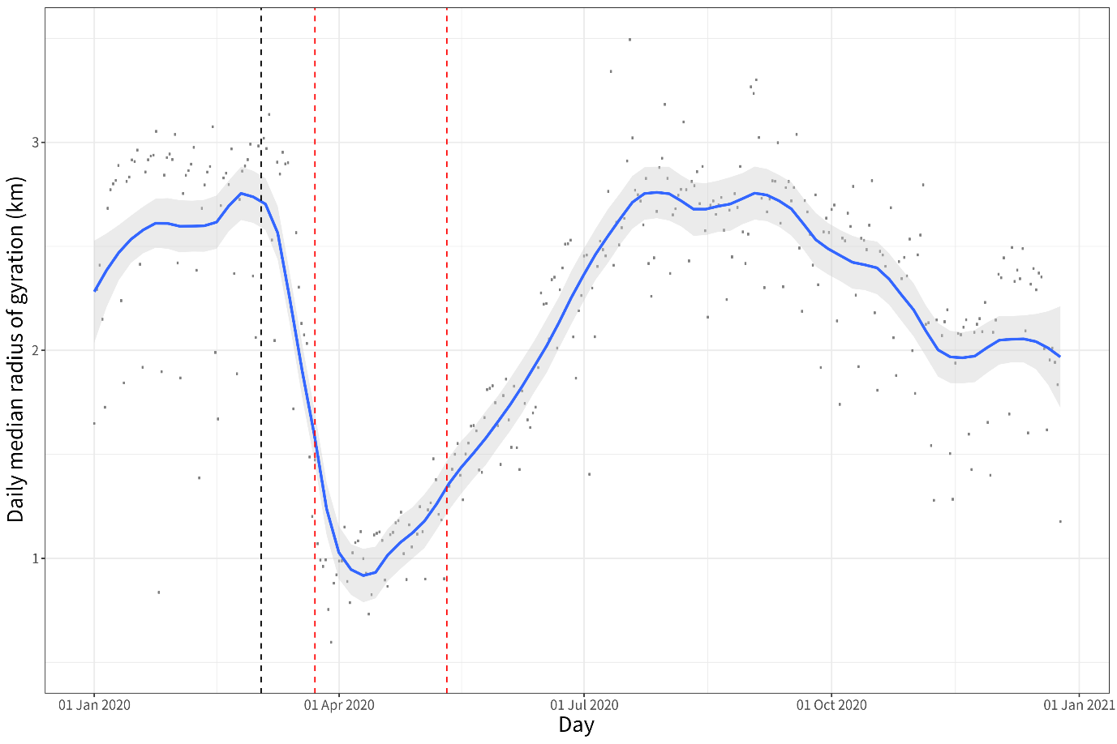

Figure . Changes in (the average levels of) mobility across England in 2020

Note: XXX. The trend over time in the daily median radius of gyration (km) was estimated with help of the local polynomial regression function (with span *s*=0.2). Dotted lines highlight important days: black – baseline (3 March 2020), and red – start and end of the 2020 Spring lockdown in England.

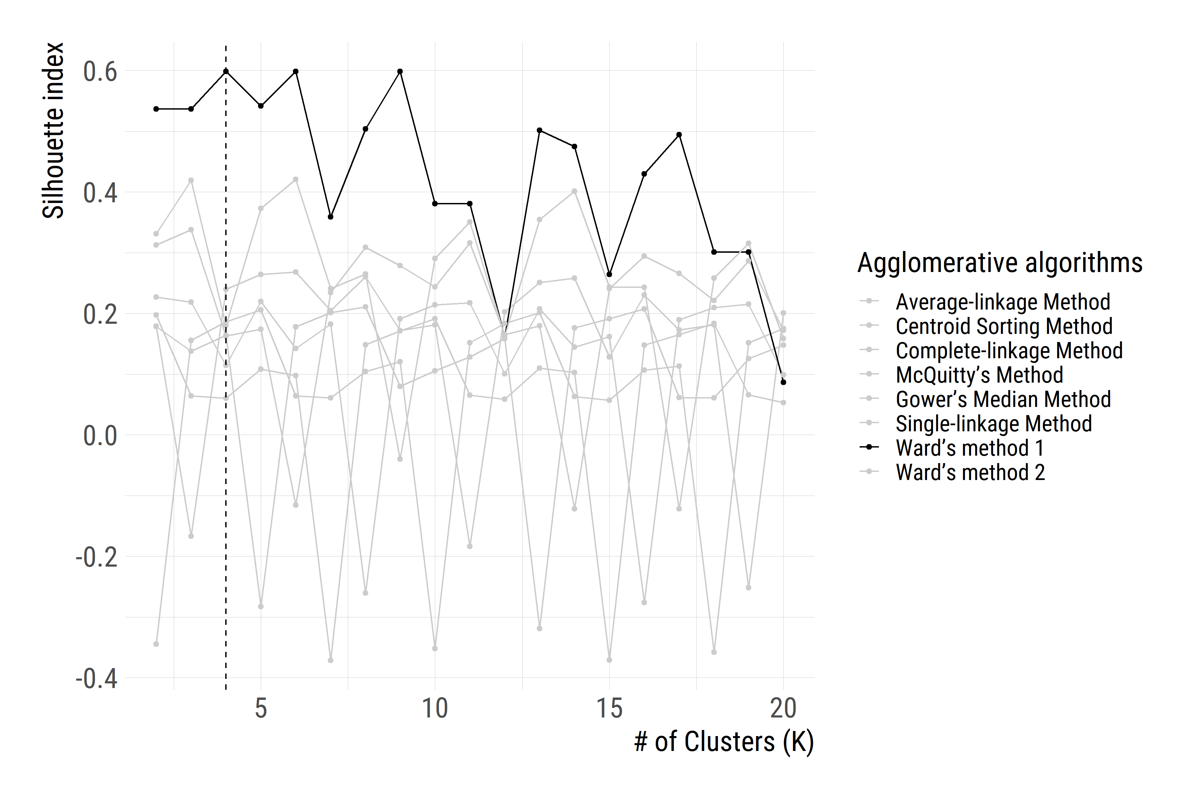Figure . Variations in the *Silhouette index* against the number of Clusters (*K*= 2 to 20).

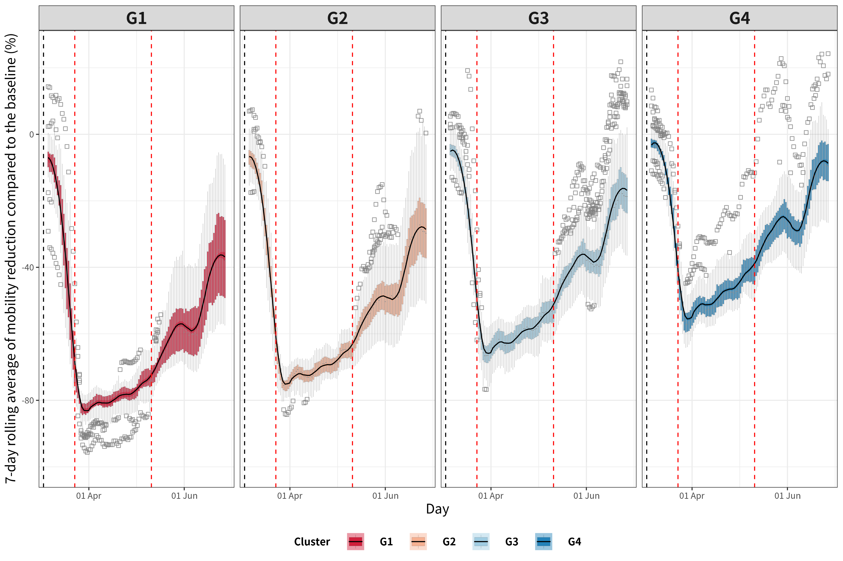

Figure . Average trajectory of mobility change in each cluster.

Note: The temporal trend has been estimated on the basis of 7-day rolling average mobility levels with the local polynomial regression function (with span *s*=0.2). XXX. Dotted vertical lines highlight important days: black – baseline (3 March 2020), and red – start and end of the 2020 Spring lockdown in England.

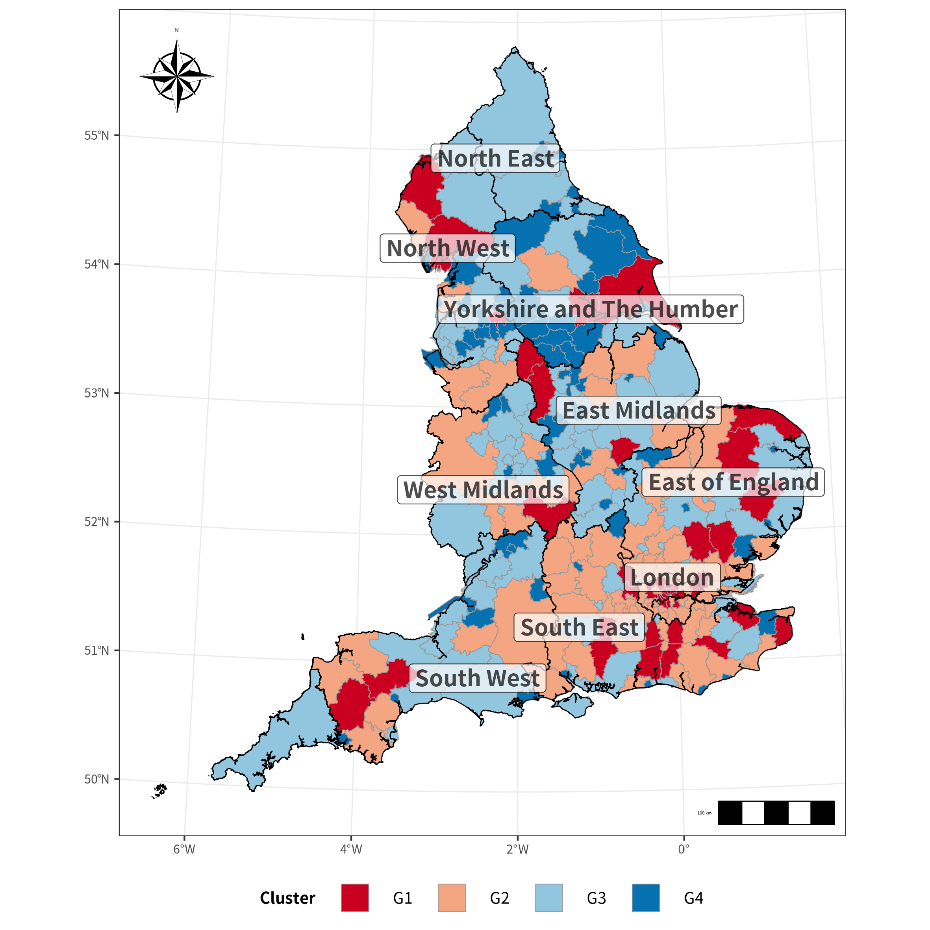

Figure 4. Spatial distribution of the clusters.

1. Transport Studies Unit, School of Geography and the Environment, University of Oxford.
2. Saïd Business School, University of Oxford.
3. Anonymised mobile phone location data provided by a large British mobile phone company.
4. For this study >2% percent of the population has been sub-sampled from the users of a large British mobile phone provider, stratified by Lower Tier Local Authorities in England. The London boroughs of *City of London* and *Hackney have been* combined due to small population sizes; the same has been done for *Cornwall* and *Isles of Scilly*.
5. The computation of home region of users exploits the night-time location when users are most likely to be at home. Home region detection followed three steps: a) filter observations from 10 pm to 6 am, b) finding the most common cell phone tower used at night-time, c) dropping users with fewer than 30 night-time observations per month. Each cell phone tower is assigned to an LTLA based on its location.
6. Nearest-neighbour or Single-linkage Method, Furthest-neighbour or Complete-linkage Method, Average-linkage Method, McQuitty’s Method, Centroid Sorting Method, Gower’s Median Method, and Ward’s method.
7. We were unable to consider those waves because of restrictions on the period for which CDRs were made available to us.