**Does accessibility to vaccination centres influencing vaccine uptake?[1]**

# Authors

Won Do Lee2, Hannah Budnitz[2][3], and Tim Schwanen2

# Abstract

In this study, we consider the number of mass vaccination centres in England accessible by car and by public transport according to the neighbourhoods where people live, and whether this influences vaccination rates among adults between the ages of 25 and 50 years. We account for both spatial variation in neighbourhood characteristics that contribute to vaccine hesitancy, such as income and education levels, as well as the likelihood of spatial dependency – that people in neighbouring areas are more likely to have similar vaccination rates. We therefore identify where lower rates of vaccination are more likely due to socio-demographic characteristics and vaccine hesitancy, and where they are due to poor accessibility by car or public transport. Our conclusions suggest that vaccine delivery and uptake has been influenced by assumptions of automobility – that vaccination services will be accessed by car. This has implications for the equity of vaccination services, particularly where there are more households without a car.

# Introduction

The UK was the first country to administer a COVID-19 vaccine after emergency approval on 8 December 2020, and the country’s vaccination programme was considered a front runner globally early in 2021 (Baraniuk, 2021). The roll-out met successive targets of not only offering vaccines to priority groups, including health and care workers, the population over 50, and those with underlying conditions in ‘Phase 1’, but also achieving vaccination rates of over 90% in these more vulnerable populations (Department of Health and Social Care, 2021a). However, this level of uptake was not maintained among adults under 50, with first dose vaccination rates plateauing at lower percentages for each subsequent age bracket. Whilst vaccine hesitancy is known to increase among younger age groups who are less at risk of severe disease from COVID-19 (Office for National Statistics, 2021), we consider in this paper whether spatial accessibility to the mass vaccination sites also influenced the rate of vaccination in adults under 50.

The volume and diversity of locations where vaccines are administered, or the ‘mixed model’ of vaccination sites that respond to the needs of different communities, was hailed as one of the success factors in the rollout in the UK (Department of Health and Social Care, 2021b, p. 31). Vaccines were delivered at hospital hubs, local vaccination services in primary care surgeries and community pharmacies, as well as mass vaccination centres set up in places such as sports venues and conference centres, with the aim of ensuring that no one lived more than 10 miles from a vaccination site. As set out in the UK’s Vaccine Delivery Plan, hospital hubs and local vaccination services were primarily aimed at the priority groups, especially those who work in health and social care or were deemed high risk due to age or underlying medical conditions. Mobile vaccination was reserved for those in the most remote parts of the country or in targeted groups, such as prisoners and care home residents, although this was kept under review in case communities with low vaccination and high case rates needed additional support. (Department of Health and Social Care, 2021b)

Mass vaccination centres, with slots made available through the online booking service, were opened in February 2021, during Phase 1. However, they became the primary option for the majority of adults under 50 as the UK moved into ‘Phase 2’ of the vaccination programme (Department of Health and Social Care, 2021a). The Vaccine Delivery Plan promised that no one should live more than 10 miles from such a vaccination centre, except for the most remote locations, but this distance was calculated as a radius around the centre. There was no formal consideration of the travel time by road or public transport routes to the location, or what in transport studies would be termed the ‘place-based accessibility’ of the sites. There was also little acknowledgement of ‘people-based accessibility’ – the space-time constraints faced by individuals seeking to be vaccinated, including personal capabilities to use particular types of transport (e.g. ability to drive / owning a car) or fixed activities such as full-time work (Neutens et al., 2010b). The only concessions to this were that the large vaccination centres offered extended hours (Department of Health and Social Care, 2021b), and individuals were not limited to appointments only within a catchment, but could seek availability at more accessible times of day further afield. And yet, even before the general population under 50 were invited to book a vaccination appointment, the government thanked transport operators for putting on extra services to vaccination sites (Department for Transport, 2021) – recognising that mass vaccination centres were not always easily accessible to nearby populations, especially to those without access to a car.

Therefore, we consider the actual accessibility of mass vaccination centres in England by car and by public transport according to the neighbourhoods where people live, and whether this influences vaccination rates among adults between the ages of 25 and 50 years. This builds on the work by Duffy et al. (2022), who use descriptive statistics to highlight inequity in access without considering how this correlates with vaccination uptake. We consider the development of more sophisticated methods for measuring people-based accessibility to healthcare facilities (Lee and Miller, 2020, 2019; Ryan and Pereira, 2021), which we can then combine with vaccination rate outcomes. We also include variables for every neighbourhood in the UK reflecting levels of car ownership and of part-time (temporally flexible) work alongside other socio-demographic characteristics associated with vaccine hesitancy. We use methods that account for both the spatial heterogeneity in accessibility to vaccination services and the spatial correlation between geographically neighbouring locations that are home to similar population groups. Finally, we draw conclusions about the extent to which accessibility has played a role in the spatial variation of vaccination rates.

# Literature Review

## Factors influencing vaccine uptake

As the COVID-19 pandemic continued to cause disruption and severe disease throughout 2021 despite the widespread availability of effective vaccines in countries like the UK, public health research has turned to investigating the predictors of vaccine hesitancy and resistance. One review paper of 35 studies from across Europe describes how, of various socio-demographic factors, such as income, education, and religion, vaccine uptake for seasonal influenzas was lower in immigrants (those with a different country of birth) and in more deprived areas (Jain et al., 2017). Likewise, recent research on COVID-19 vaccine uptake in the UK has highlighted the differences between socio-demographic groups, with vaccine hesitancy higher amongst younger age groups, those on lower incomes and with less education, those identifying as female, and many minority ethnic groups (Freeman et al., 2020; Paul et al., 2021; Robertson et al., 2021). The causes of hesitancy among minority groups has generated particular interest, with large surveys that have tried to reveal variation in levels of trust and receipt of misinformation for different socio-demographic groups (Freeman et al., 2020; Robertson et al., 2021; Woolf et al., 2021). Other highlighted predictors included pregnancy and previous lack of influenza vaccine uptake (Paul et al., 2021; Robertson et al., 2021).

There are spatial patterns to many of these factors of vaccine hesitancy and resistance. Ethnic minorities, those on lower incomes or those with more education are often clustered geographically in particular neighbourhoods. Neighbourhoods can also have disparate age profiles, and cities tend to have younger populations than more rural areas. Local social networks can also reinforce attitudes, e.g., of trust or mistrust in health services. Therefore, many of the findings of the selection of public health studies on vaccine hesitancy discussed above could manifest as spatial differences in vaccination rates. However, as Paul et al. (2021) note, a lack of practical accessibility to the vaccine may prevent some who want to be vaccinated from following through, independent of other reasons for avoiding vaccination. Furthermore, healthcare workers participating in the qualitative portion of one study noted that the equity with which vaccines are delivered is important in building trust in the vaccine in certain communities (Woolf et al., 2021). Thus, it is important to understand the impact on vaccine uptake of intersecting barriers of spatial accessibility and the economic and socio-demographic characteristics of a neighbourhood (Whitehead et al., 2021). Equity in access to healthcare is a multidimensional concept that includes assessing the affordability, appropriateness and acceptability of the health service available, as well as its geographic accessibility (Neutens, 2015). Our study aims to do this by addressing multiple variables known to influence vaccination rates, alongside key measures of accessibility to vaccination sites.

## Measuring accessibility to COVID-19 vaccination services

Transport research has developed many ways to measure geographic accessibility, incorporating different aspects of travel time and distance by different modes, expected delays (e.g., to change mode or to account for congestion), and temporal or spatial thresholds for the inclusion of opportunities as accessible to a given population (Geurs and van Wee, 2004). Various approaches also account for fixed barriers, such as individuals not having access to a car or a lack of public transport services, particularly in rural and remote areas (Shah et al., 2017). Fundamentally, accessibility is a function of utility – the presence and attractiveness of necessary or desired activities, goods and services weighed against the cost in time or distance of travelling to them. Neutens et al. (2010b) describes two broad categories of accessibility measurements: place-based and people-based; and empirically compares four of the former and six of the latter to evaluate their effectiveness at capturing heterogeneity in access to public services. They conclude that people-based measures are more effective at recognising whether a service is equally accessible to different groups within the population and the influence of personal characteristics on space-time constraints (Neutens et al., 2010a, 2010b)

We identified two people-based measures as relevant to our study. Cumulative opportunity measure (CUM) quantifies the number of opportunities within a specified travel time or distance threshold (Neutens et al., 2010b). It has been used to evaluate the equity of access to healthcare facilities in a number of studies (Apparicio et al., 2008; Haynes et al., 2003; Paez et al., 2010) because it is simpler to calculate, interpret and communicate (Boisjoly and El-Geneidy, 2017). The two-step floating catchment area (2SFCA) method has also been used in healthcare accessibility studies, and first estimates provider-to-population ratios or supply, and then in the second step calculates the total supply within a threshold travel time from the residential location or source of demand (Luo and Wang, 2003). Pereira et al. (2021) further extended this method to incorporate an indicator that accounts for and balances healthcare system capacity, whilst Kang et al. (2020) added congestion effects. Chen et al. (2020) proposed a reliability-based 2SFCA method combining various space-time constraints and travel time uncertainty.

The 2SFCA method has been popular among studies undertaken during the pandemic, including one study that investigates the relationship between vaccine uptake and access to COVID-19 vaccination services in Iran (Mohammadi et al., 2021). Other relevant studies include an investigation into the spatial accessibility of intensive care unit (ICU) beds in Florida, USA (Ghorbanzadeh et al., 2021), across Europe (Bauer et al., 2020), and of other hospitalisation services or supplies in Brazil (Pereira et al., 2021) and Chicago, USA (Kang et al., 2020). Efforts have been made in these studies to identify where vulnerable populations would benefit from improved access to the services within (delineated) catchment boundaries, including the elderly and those with disabilities. We believe it is useful to use this method to assess the role of accessibility in vaccination uptake because it allows us to consider not only supply of vaccination services, but also multiple factors or covariates that influence demand, including socio-demographics that often have their own spatial patterns and unevenness (Pereira et al., 2021). However, first we use CUM to both identify significant covariates, and also to set the thresholds for travel time and weights for accessibility measures within the 2SFCA method. This gives us a clearer picture of the interpersonal differences in travel times and the value and choice of different opportunities, yielding a more conservative indicator of the equity of vaccination accessibility in our model (Neutens et al., 2010b).

# Data & Method

## Data and variables

The data on vaccine uptake was taken from NHS (National Health Service) England[4], who have kept a rolling tally of first, second, and more recently third or booster doses. The NHS is a centralised, public medical care system, which keeps records of all vaccination and medical data, making it a reliable and comprehensive data source. The operations of the NHS are, however devolved, and vaccination roll-out was accelerated in Scotland and Wales, so only England is used for analysis. Our data is a cross-section of the cumulative uptake of first doses from the data released on 24 June 2021 for England. This date was chosen because it was the last data release preceding the introduction of walk-in vaccination sites (NHS Digital, 2021). Prior to this point, vaccinations were booked in advance, mainly through the NHS online interface, which offered vaccination services by distance in a straight line to home postcode. Those booking their vaccination in this manner were not constrained to choose the nearest opportunity, but could scroll through multiple options ordered by distance from their home. In other words, vaccination appointments were not limited to those within designated catchment areas, but could be chosen from further down the list according to available capacity at a given day and time. Thus, local knowledge of the spatial and temporal accessibility of a given site to the home location or another fixed activity location, such as work, may have been applied, but cannot be measured by our analysis. Instead, we assess the number of mass vaccination centres within a travel time threshold rather than travel time to the nearest one.

Figure 1 depicts the vaccination rates by age in three bands, bisected by the date of our dataset. The youngest adults without pre-existing medical conditions or jobs in health and social care were only invited to be vaccinated from 18 June, so our data does not capture the bulk of their acceleration in uptake, and we exclude those under 25 from the analysis. The start and end dates of Phase 1 (Jan to 13 Apr 2021) and Phase 2 (April to October 2021) of the COVID-19 vaccination roll-out are also shown in Figure 1, which thus presents not only the percentage of adults in successive age groups who received their vaccine before Phase 2, but also the acceleration in the vaccination rate following each invitation to a new age range. Since Phase 1 included health and social care workers and those with underlying medical conditions, a proportion of adults in every age group were offered the vaccine before this acceleration. (Department of Health and Social Care, 2021c).

**[Insert Figure 1 here]**

It is those under 50 booking their vaccines after this inflection in the graph that are most likely to be offered mass vaccination site options, and that are most likely to be affected by the spatial accessibility of these sites. As the majority of 25- to 50-year-olds in England are in this category up until the end of June, these are the ages chosen for analysis. Figure 2 shows the date each subsequent age group received their invitation to make a vaccination appointment as lines bisecting the vaccination rate of each age band. The inflection is much greater among the age groups in Phase 2 compared to the ones in Phase 1, despite inconsistency in the time between and number of years included in each invitation. There are also ever fewer who were vaccinated prior to receiving their invitation, the vaccination rate is not as rapid, and it plateaus sooner with each age group. Part of this pattern will be a product of age and other factors influencing vaccine hesitancy, but we also hypothesise that part will be a product of poor accessibility.

**[Insert Figure 2 here]**

## Measuring accessibility

We begin by measuring the accessibility to mass vaccination centres in England using the CUM approach in a manner that considers the temporal variation of accessibility inequity over the course of the day (Chen et al., 2020). This is similar to the analysis done by Duffy et al. (2022), who identify the travel times to the five closest vaccination sites, but we instead assess the number of vaccination sites within a certain temporal threshold by car and by public transport. To do this, we use the spatial unit of Middle layer Super Output Areas (MSOA)[5], which are designed for neighbourhood level analysis of areas between 2,000 and 6,000 households by the Office of National Statistics (Office for National Statistics, 2021). We calculated the mean, median and standard deviation of travel times from the centroid of each of the 6,791 MSOAs in England to estimate access to vaccination services for our target group of adults aged 25-50 according to the neighbourhood where they live. Only weekday travel is considered for accessibility by car. For public transport accessibility, we considered travelling at different times of day and on the weekend as well as a weekday (see Appendix A), as weekday travel is subject to greater time constraints for most working people than weekend travel, but there are often fewer public transport services on the weekend. We also assumed a maximum of 1,000m walking distance to access/egress public transport. This is over twice the distance often deemed acceptable for regular access to urban public transport, but enables our modelling to account for the longer travel times and transfers in more peripheral or rural locations that those keen to seek vaccination might experience (Kujala et al., 2018).

Although the mean and median travel times are much lower, we chose the number of mass vaccination centres within 45 minutes by car to take forward to the spatial regression modelling. We did this to reflect the choice available on the NHS England online booking system, which offered ever more distant vaccination sites depending upon appointment demand and capacity. Furthermore, a blog by an NHS Operations Director[6] revealed that vaccine invitation letters were sent to reflect capacity at centres within a 45-minute drive of the postcodes of those invited. For public transport, we chose the number of vaccination centres within 60 minutes’ travel, including access, egress and waiting time, at noon on a Tuesday, although again, the mean and median travel time to the nearest vaccination centre was lower. Indeed, Duffy et al. (2022) estimate that over 97% of the population do live within an hour’s travel time of a vaccination centre by public transport. However, we aimed to be conservative with our modelling. Our travel times were based on Open Trip Planner data on public transport schedules, OpenStreetMap© data on routing, and transport network accounts from General Transit Feed Specification feeds.

￼￼Figure 3 shows isochrone maps of the MSOAs within the travel time thresholds of 45 minutes by car and 60 minutes for public transportation.

**[Insert Figure 3 here]**

## Modelling

In order to assess the impact of socio-demographic factors alongside accessibility to vaccination services, we employ a negative binomial regression modelling (NBM) approach, which is considered more robust than OLS for dependent variables which are count-based (non-negative integers) such as first vaccine doses administered. NBM also controls for unobserved heterogeneity in the dependent variable and any over-dispersion, or greater than expected variance, that may exist. We also include spatial lag effects in the dependent variable, or in other words account for the likelihood that vaccination rates will be similar or correlate in neighbouring spatial areas independent of other explanatory variables. Spatial lag effects also help address modifiable areal unit bias, as any spatial unit used for analysis will have boundaries that are arbitrary in some way in how they aggregate and divide the population and how measured characteristics spill across boundaries.

As a first step, a global NBM was deployed to identify significant covariates and test for spatial autocorrelation in residuals. It can be expressed as:

|  |  |
| --- | --- |
|  | (1) |

where, is number of people who received first dose of COVID-19 vaccine, is (estimated) resident population offset, and is a vector of covariates at the MSOA level in England (. Thus, yields first dose vaccine uptake derived from a 1-unit change from in a given area. denotes the negative binomial regression distribution with mean and dispersion , or how much predicted values fluctuate relative to . We run the NBM four times: without and with accessibility measures, and without and with the spatial lag effects. Moran’s coefficient is used to assess how well each of the four models account for spatial autocorrelation, and measure the residual spatial dependency.



We next replicate a spatial modelling approach that simultaneously estimates regression coefficients and accounts for patterns of spatial dependence (Sugasawa and Murakami, 2021)[7]. Spatially clustered regression (SCR) and spatially fuzzy clustered regression (SFCR) models capture complex spatial relationships all twelve significant covariates from the NBM to estimate clusters of MSOAs with single, geographically smoothed coefficients for each covariate for each of the clusters (Lee et al., 2021). This approach assumes that the geographically neighbouring locations are likely to belong to the same clusters, thus accounting for the spatial dependence of first dose vaccination uptake across England in people aged 25-50. It also allows for both spatial heterogeneity in the relationship of socio-demographic factors and accessibility to vaccination services or clustering if MSOAs are similar statistically for other reasons. We estimate our SFCR using Equation 2:

|  |  |
| --- | --- |
|  | (2) |

where, is a set of spatial data encompassing MSOA centroids, is a vector of unknown regression coefficients by number of clusters , and is the parameter controlling for overdispersion.



SCR and SFCR have two tuning parameters, , determining the number of clusters, and strength of spatial dependence , corresponding to weak (0.1), moderate (0.6), and strong spatial correlation (1.0). [8] The models are estimated using maximum likelihood techniques, which impose penalties until they reach convergence (Li and Sang, 2019; Sugasawa and Murakami, 2021). The penalised likelihood function under SCR and SFCR can be calculated with Equation 3:

|  |  |
| --- | --- |
|  | (3), |

Here, is that represents first dose vaccination rates, is a spatial contingency matrix to generate the local weightings. The four nearest neighbours for each MSOA were used in this study. λ and are both part of a penalty function operating to shrink and regularise each the values of the coefficients for each cluster (Tibshirani, 1996; Sugasawa, 2021). This part of the equation allows coefficients to vary spatially, but smooths them in neighbouring areas so that they are more homogeneous within clusters (Li and Sang, 2019).

SFCR produces better estimates than SCR because regression coefficients for each cluster are based on both the similarity of the covariates as well as geographically neighbouring locations (Sugasawa and Murakami, 2021). Note that updating under SFCR can be expressed as:

|  |  |
| --- | --- |
|  | (4). |

where, denotes the conditional probability of using smoothed weight functions with the degree of fuzziness set at =1 (for more details, see Sugasawa and Murakami, 2021).



# Results

COVID-19 first dose vaccination coverage in England of people aged 25 to 50 varied extensively on 24 June 2021, as shown in Figure 4. The map suggests that most MSOAs in England had an estimated vaccination rate for this age group of over 60%, but there are lower levels of vaccine uptake in most English cities, especially Greater London and Birmingham. Rural areas showed only marginal differences from the national average vaccine uptake of 66.8% (NHS Digital, 2021). The ONS reported vaccine uptake in deprived areas was likely to be lower than wealthy areas (Office for National Statistics, 2021). Concerns were also raised about lower vaccination uptake in central urban areas where populations were more likely to live in overcrowded housing, suffer from deprivation, and identify as ethnic minority groups (Bailey and Minton, 2018; Zhang and Pryce, 2019). These existing inequalities and clustering or spatial dependence of certain socio-demographic groups affects the spatial variation in vaccine uptake, which may or may not relate to the accessibility of the vaccination services. Thus, we use a methodology that accounts for both and enables us to identify which variables are significant to vaccine uptake.

**[Insert Figure 4 here]**

## Indicators of vaccine uptake across England

Our series of NBM (see Equation 1) in Table 1 show that Model 4, which includes covariates for households without access to a car, for accessibility to mass vaccination centres by car and public transport, as well as a measure of spatial correlation of average vaccine uptake in adjacent areas provides the best model fit.[9] The Incidence Rate Ratios (IRR) or exponentials of the coefficients in Model 4 also confirm that all of our accessibility indicators are significantly associated with vaccine uptake. However, the effect size is small, with 0.8% increase in vaccination rate in adults aged 25 to 50 for each additional vaccination centre within 60 minutes by public transport, and a 0.6% decrease in vaccination rate for each additional vaccination centre within 45 minutes by car. The impact on vaccination rates for households without a car was greater, as a 1% increase in the share of households without a car correlates with a 2.8% decrease in vaccination uptake. This effect is still less, however, than the share of households in the lowest household income quintile in England, a unit change of which is associated with a 3.6% decrease in the first doses administered to the group under investigation.

**[Insert Table 1 here]**

Table 1 confirms that the wide array of factors unrelated to accessibility, such as inequalities in education levels, occupation types, and household income, have a greater influence on spatial variation in vaccination rates (Pereira et al., 2021). As discussed in the literature, greater proportions of low-income households and minority ethnic groups are associated with lower vaccination rates, whilst more highly educated residents, who are at least lower middle class, or more part-time workers, and a higher median age are significantly associated with increased vaccination rates. And yet, our results demonstrate that the greatest effect, at 6.3% increase, on vaccination uptake in any MSOA was a high vaccination rate in a neighbouring MSOA. To control for this in such a way as to gain further insight into where accessibility indicators or socio-demographic characteristics are more relevant at a neighbourhood level, we employ a spatially clustered model.

## Indicators of vaccine uptake at the neighbourhood level

Our SFCR model results in Table 2 show that all 12 covariates are significant for every cluster, but their relationship to vaccine uptake differs across our seven clusters (Bavel et al., 2020; Viswanath et al., 2021; Whitehead et al., 2021). The share of no-car households is negatively associated with vaccine uptake across all clusters, although the effect size varies greatly from a 7.8% decrease in vaccination rate in cluster G7 to a 0.9% decrease in cluster G3 for each additional 1% of households without access to a car. Meanwhile, increased accessibility by car and public transport are each positively associated with vaccine uptake in three clusters, and negatively associated in four. Having more vaccination centres accessible by public transport only has a significant positive relationship with vaccine uptake in about 40% of England’s MSOAs (see Table 3 for number of MSOAs per cluster).

**[Insert Table 2 here]**

To better understand the results in Table 2, the seven clusters are mapped in Figure 5, which illustrates their spatial distribution, and can be summarised thus:

* Cluster G1 is most prominent in the East and West Midlands, in both rural and urban areas.
* Cluster G2 is focused in southern England, including large rural MSOAs in Wiltshire, Gloucestershire, Somerset and Dorset, as well as urban neighbourhoods across most of Bristol and Southampton / Portsmouth.
* Cluster G3 includes a plurality of MSOAs in Greater London and surrounding areas of the South East.
* MSOAs in G4 are quite widely distributed across England, from urban Middlesbrough and Darlington in the Northeast, through suburban areas in the North West and West Midlands, to the mostly rural areas of Norfolk, Suffolk and Kent in the East.
* Cluster G5 includes large parts of the North West, both in rural Cumbria and urban neighbourhoods in Manchester and Liverpool, as well as scattered parts of Gloucestershire, counties around London, and neighbourhoods in inner East London.
* MSOAs in cluster G6 are concentrated in the North East, again in both rural areas like the Yorkshire Dales and Northumbria and urban areas such as Leeds and Newcastle.
* Cluster G7 dominates the mainly rural South West counties of Devon and Cornwall, but also includes the City of London, some of its surrounding neighbourhoods and large parts of Croydon and Hounslow.

**[Insert Figure 5 here]**

Despite the clusters mainly being focused in particular regions of the country, one can find MSOAs in each cluster in other regions of England as well, and all seven clusters include some MSOAs in London. Therefore, the spatial relationships captured by the model are not simply regional, nor do they follow clear rural-urban divides. Furthermore, when considering the coefficients in Table 2, it is not clear, for example, why accessibility to public transport is significant to higher rates of vaccination in clusters G1, G5 and G7, but to lower rates of vaccination in the other four clusters. To explore this further, in Table 3 we compare vaccination rates for each cluster to the number of MSOAs and mass vaccination centres in that cluster in total and in proportion to the population, as well as their accessibility by car and by public transport, and share of no-car households.

**[Insert Table 3 here]**

Clusters G1, G5 and G7 all have in common that not having a car is one of the greatest (G1) or the greatest (G5 and G7) influence on vaccination rates among adults aged 25-50 (see Table 2). And yet, G1 has both the highest average vaccination rate in our analysis, and the second lowest proportion of households without access to a car (see Table 3). Perhaps because there are few households without a car, vaccination rates do not appear to be limited by a lack of mass vaccination centres within our travel time thresholds. Another reason for high vaccination rates despite poor accessibility may be that MSOAs in G1 have the highest median age, and a slightly higher percentage of part-time workers (see Appendix C), two strongly positive influences on vaccine uptake in Table 2. In comparison, Table 3 shows that a greater proportion of households in MSOAs in clusters G5 and particularly G7, do not have access to a car, so accessibility by public transport to mass vaccination centres may be more important. The vaccination rate is above the national average in cluster G5, but it is below average in G7. Although Table 3 suggests that MSOAs in cluster G7 have the second highest number of vaccination centres accessible within an hour by public transport, Duffy et al., 2022 highlight the South West as having the highest average travel times of any region. In any case, it seems likely that more vaccination services accessible by public transport would increase vaccination uptake in both G5 and G7, where so many households lack a car.

The lowest car ownership levels are in Cluster G3, which is concentrated in London, where it has less impact on personal mobility, considering the extensive public transport network. Table 2 confirms that the share of no-car households has the smallest effect on vaccination rates of adults aged 25-50 of any cluster. MSOAs in G3 also have the greatest number of vaccination sites, both in total, accessible by car and by public transport within our travel time thresholds (see Table 3). And yet, MSOAs in this group have the lowest vaccination rates of any cluster, with just 62% of 25 to 50-year-olds vaccinated by 24 June 2021. Coefficients in Table 2 suggest that is due more to income, education and occupation. The share of lowest income households, for example, has a much greater negative effect than for those in any other cluster, despite the fact that MSOAs in cluster G3 have fewer low-income households on average (see Appendix C). Still, increased accessibility would make little difference to vaccine uptake. The results for cluster G3 show both the complexity of spatial relationships between socio-demographics, accessibility and vaccination, as well as how London does not reflect the situation across the country.

Finally, in clusters G2 and G4, accessibility by car, rather than public transport, is more important to vaccination rates, which as can be seen in Table 3, were below the national average. These clusters also had the worst or second-worst accessibility by public transport and car. In the neighbourhoods in G4, the coefficients in Table 2 suggest accessibility by car is more relevant to vaccination uptake than most socio-demographic covariates and any vaccine hesitancy attributed to them. The coefficients for most variables effect on vaccine uptake in cluster G2 are smaller, yet increased accessibility by car is still significant, whilst increased accessibility by public transport would reduce uptake in both clusters. This may imply that public transport is not seen as a viable option to access the mass vaccination centres, particularly for full-time workers or where the median age is younger in MSOAs in G4, or perhaps for certain ethnic minorities in G2. In any case, more mass vaccination centres within 60 minutes travel time by public transport is more likely to correlate with reduced vaccination uptake, perhaps confounded by other spatial patterns. High car ownership, especially in G2, which includes southern regions of England outside London, may explain why the private car is seen as the primary means of access to vaccination services. Or it may be due to car dependence in urban as well as rural neighbourhoods.

# Discussion and conclusions

Our study shows that accessibility affected vaccination rates among adults aged 25-50, as of 24 June 2021, when most of this age group were only offered appointments at mass vaccination centres, rather than their local GP or walk-in clinics. Initial exploration of the data suggests that major urban areas were most likely to be left behind by the vaccination drive, and the literature offered explanations related to income, ethnicity, education and age. Whilst these factors were significant, our study shows that accessibility by public transport and lack of car ownership also had significant, if smaller effects across England. Moreover, the greatest cause of spatial variation in our global model was the vaccination rates of neighbouring areas. Thus, we used SFCR to smooth the spatial variation across all the explanatory variables, including any spatial dependence, and gain insight into outcomes in particular areas. We demonstrate that not only was there uneven distribution of vaccination services and variation in average travel time to the nearest vaccination services by different modes of transport across England (Duffy et al., 2022), poor accessibility also contributed to some areas falling behind in terms of vaccine uptake.

Two of our clusters demonstrate the different ways that the accessibility of mass vaccination centres failed to meet local demand, resulting in lower vaccine uptake than the national average at that point in time. Although cluster G7, which we saw was concentrated in Devon and Cornwall had more mass vaccination centres within our travel time thresholds, the lack of accessibility by public transport and low car ownership significantly affected vaccine uptake. This may be partly a rural problem or one of relatively longer travel times, considering the results of Duffy et al. (2022), but there was a clear link between lower car ownership and the effect size and positive coefficients for public transport accessibility to vaccination centres in three of our clusters, and they weren’t all predominantly rural. In contrast, cluster G4 had objectively poorer accessibility by both car and public transport, but our model suggested that only increasing accessibility by car would be likely to increase uptake – by as much as 6% for each additional vaccination centre within our travel time threshold of 45 minutes. Increasing car ownership had a much smaller effect than for almost all other clusters and increasing public transport accessibility actually reduced likely vaccine uptake. Thus, for this cluster, and G2, accessibility was defined as automobility.

In its haste to set up mass vaccination centres, the Vaccine Delivery Plan used a 10-mile radius as a guide for accessibility without considering actual travel times or routes, particularly for those without a car. This approach clearly affected the Phase 2 vaccination uptake as of 24 June 2021. The Plan was also guided by available venues, and as many mass vaccination centres were in more suburban areas, located in sports venues for example, it may be that as in a study in Canada, both the more urban and more rural residents were subject to longer travel times, including by car (Paez and Higgins, 2021). Our study highlighted the consistent negative effect on vaccine uptake across England of the share of households without access to a car, but we did not measure all aspects of people-based accessibility, such as travel costs, workplace locations, or variations in travel time. We were also unable to directly measure regional variation in the implementation of vaccine delivery, or control for the overlapping and inconsistent coverage in different areas of clinical commissioning groups, NHS hospital trusts and primary care partnerships that may have taken different approaches. There are also confounding factors of vaccine hesitancy, such as pregnancy, or of vaccine willingness, such as high excess mortality in the pre-vaccination waves of the pandemic. Nonetheless, the lack of access to a car when automobility was assumed in both the appointment booking system and perhaps by residents themselves in clusters like G2 and G4 may have prevented some who wanted a vaccine from getting one.

It may be that individuals without access to a car expected to get a lift to a vaccination centre or that taxis were preferred to public transport for this purpose. Yet it may also be that the expectations of travel times are so much lower and more flexible in space and time by car that assumptions of automobility are internalised by individuals seeking vaccination (Schwanen and Lucas, 2011). Certainly, for some geographic areas of England, car accessibility only, not public transport accessibility, was significant to increasing vaccine uptake, no matter the share of car owning households. For other areas, lower car ownership and poor accessibility by public transport may have combined to create pockets of lower vaccination uptake. This has implications for both the equity of vaccine delivery and equity of health risk or outcomes. Even where vaccination rates are high, the introduction of walk-in vaccination services suggest a further realisation that accessibility, as well as hesitancy needed to be addressed (Rader et al., 2022).

Consistent with existing research (Diament et al., 2021), our models show that younger age groups, those on lower incomes, and certain minority ethnic groups are likely to have lower vaccination rates. However, unlike other studies, we also show that in some places, such as MSOAs concentrated in London (cluster G3), factors of accessibility were not as relevant as household income, but in other places (e.g. cluster G4), accessibility by car was one of the most important factors or lack of access to a car (e.g. cluster G7) was most influential on vaccination rates and outcomes. It is unclear whether analysis of spatial variation of vaccine uptake or evidence that geospatial as well as public health data were incorporated into the strategy for vaccine delivery (Utazi et al., 2019; Whitehead et al., 2021). Yet without identifying areas where accessibility rather than hesitancy had a greater influence on vaccination uptake, any strategy to increase vaccination sites or locate mobile or pop-up sites could miss the locations most likely to improve uptake (Krzysztofowicz and Osińska-Skotak, 2021). By measuring not only indicators of geographic access to vaccination centres, but also rigorously exploring how any links between accessibility and vaccination uptake in England may be confounded by other factors of vaccine hesitancy, we explore where spatial variation in vaccine uptake reflects poor accessibility or a lack of automobility, where vaccine hesitancy may be a more likely explanation, or a combination of both. Achieving equitable delivery and uptake of a vaccine to all age groups is essential for universal protection, and we conclude that poor accessibility can compound any vaccine hesitancy within the population.

# Acknowledgements

# References

Apparicio, P., Abdelmajid, M., Riva, M., Shearmur, R., 2008. Comparing alternative approaches to measuring the geographical accessibility of urban health services: Distance types and aggregation-error issues. Int. J. Health Geogr. 7, 7. https://doi.org/10.1186/1476-072X-7-7

Bailey, N., Minton, J., 2018. The suburbanisation of poverty in British cities, 2004-16: extent, processes and nature. Urban Geogr. 39, 892–915. https://doi.org/10.1080/02723638.2017.1405689

Baraniuk, C., 2021. Covid-19: How the UK vaccine rollout delivered success, so far. BMJ n421. https://doi.org/10.1136/bmj.n421

Bauer, J., Brüggmann, D., Klingelhöfer, D., Maier, W., Schwettmann, L., Weiss, D.J., Groneberg, D.A., 2020. Access to intensive care in 14 European countries: a spatial analysis of intensive care need and capacity in the light of COVID-19. Intensive Care Med. 46, 2026–2034. https://doi.org/10.1007/s00134-020-06229-6

Bavel, J.J. Van, Baicker, K., Boggio, P.S., Capraro, V., Cichocka, A., Cikara, M., Crockett, M.J., Crum, A.J., Douglas, K.M., Druckman, J.N., Drury, J., Dube, O., Ellemers, N., Finkel, E.J., Fowler, J.H., Gelfand, M., Han, S., Haslam, S.A., Jetten, J., Kitayama, S., Mobbs, D., Napper, L.E., Packer, D.J., Pennycook, G., Peters, E., Petty, R.E., Rand, D.G., Reicher, S.D., Schnall, S., Shariff, A., Skitka, L.J., Smith, S.S., Sunstein, C.R., Tabri, N., Tucker, J.A., Linden, S. van der, Lange, P. van, Weeden, K.A., Wohl, M.J.A., Zaki, J., Zion, S.R., Willer, R., 2020. Using social and behavioural science to support COVID-19 pandemic response. Nat. Hum. Behav. 4, 460–471. https://doi.org/10.1038/s41562-020-0884-z

Boisjoly, G., El-Geneidy, A.M., 2017. The insider: A planners’ perspective on accessibility. J. Transp. Geogr. 64, 33–43. https://doi.org/10.1016/j.jtrangeo.2017.08.006

Burnham, K.P., Anderson, D.R., 2004. Model Selection and Multimodel Inference. Springer New York, New York, NY. https://doi.org/10.1007/b97636

Chen, B.Y., Cheng, X.-P., Kwan, M.-P., Schwanen, T., 2020. Evaluating spatial accessibility to healthcare services under travel time uncertainty: A reliability-based floating catchment area approach. J. Transp. Geogr. 87, 102794. https://doi.org/10.1016/j.jtrangeo.2020.102794

Department for Transport, 2021. Transport Secretary hails work of transport industry in vaccination roll-out [WWW Document]. News story. URL https://www.gov.uk/government/news/transport-secretary-hails-work-of-transport-industry-in-vaccination-roll-out (accessed 2.7.22).

Department of Health and Social Care, 2021a. UK moves into next phase of vaccine roll-out as government target hit early [WWW Document]. URL https://www.gov.uk/government/news/uk-moves-into-next-phase-of-vaccine-roll-out-as-government-target-hit-early (accessed 1.3.22).

Department of Health and Social Care, 2021b. UK COVID-19 vaccines delivery plan [WWW Document]. URL https://assets.publishing.service.gov.uk/government/uploads/system/uploads/attachment_data/file/951928/uk-covid-19-vaccines-delivery-plan-final.pdf (accessed 1.3.22).

Department of Health and Social Care, 2021c. JCVI final statement on phase 2 of the COVID-19 vaccination programme: 13 April 2021 [WWW Document]. Indep. Rep. URL https://www.gov.uk/government/publications/priority-groups-for-phase-2-of-the-coronavirus-covid-19-vaccination-programme-advice-from-the-jcvi/jcvi-final-statement-on-phase-2-of-the-covid-19-vaccination-programme-13-april-2021 (accessed 2.7.22).

Diament, S.M., Kaya, A., Magenheim, E.B., 2021. Frames that matter: Increasing the willingness to get the Covid-19 vaccines. Soc. Sci. Med. 114562. https://doi.org/10.1016/j.socscimed.2021.114562

Duffy, C., Newing, A., Górska, J., 2022. Evaluating the Geographical Accessibility and Equity of COVID-19 Vaccination Sites in England. Vaccines 10, 50. https://doi.org/10.3390/vaccines10010050

Freeman, D., Loe, B.S., Chadwick, A., Vaccari, C., Waite, F., Rosebrock, L., Jenner, L., Petit, A., Lewandowsky, S., Vanderslott, S., Innocenti, S., Larkin, M., Giubilini, A., Yu, L.-M., McShane, H., Pollard, A.J., Lambe, S., 2020. COVID-19 vaccine hesitancy in the UK: the Oxford coronavirus explanations, attitudes, and narratives survey (Oceans) II. Psychol. Med. 1–15. https://doi.org/10.1017/S0033291720005188

Geurs, K.T., van Wee, B., 2004. Accessibility evaluation of land-use and transport strategies: Review and research directions. J. Transp. Geogr. 12, 127–140. https://doi.org/10.1016/j.jtrangeo.2003.10.005

Ghorbanzadeh, M., Kim, K., Erman Ozguven, E., Horner, M.W., 2021. Spatial accessibility assessment of COVID-19 patients to healthcare facilities: A case study of Florida. Travel Behav. Soc. 24, 95–101. https://doi.org/10.1016/j.tbs.2021.03.004

Haynes, R., Lovett, A., Sünnenberg, G., 2003. Potential Accessibility, Travel Time, and Consumer Choice: Geographical Variations in General Medical Practice Registrations in Eastern England. Environ. Plan. A Econ. Sp. 35, 1733–1750. https://doi.org/10.1068/a35165

Jain, A., van Hoek, A.J., Boccia, D., Thomas, S.L., 2017. Lower vaccine uptake amongst older individuals living alone: A systematic review and meta-analysis of social determinants of vaccine uptake. Vaccine 35, 2315–2328. https://doi.org/10.1016/j.vaccine.2017.03.013

Kang, J.-Y., Michels, A., Lyu, F., Wang, Shaohua, Agbodo, N., Freeman, V.L., Wang, Shaowen, 2020. Rapidly measuring spatial accessibility of COVID-19 healthcare resources: a case study of Illinois, USA. Int. J. Health Geogr. 19, 36. https://doi.org/10.1186/s12942-020-00229-x

Krzysztofowicz, S., Osińska-Skotak, K., 2021. The Use of GIS Technology to Optimize COVID-19 Vaccine Distribution: A Case Study of the City of Warsaw, Poland. Int. J. Environ. Res. Public Health 18, 5636. https://doi.org/10.3390/ijerph18115636

Kujala, R., Weckström, C., Mladenović, M. N., & Saramäki, J. (2018). Travel times and transfers in public transport: Comprehensive accessibility analysis based on Pareto-optimal journeys. Computers, Environment and Urban Systems, 67, 41–54. https://doi.org/10.1016/j.compenvurbsys.2017.08.012

Lee, J., Miller, H.J., 2019. Analyzing collective accessibility using average space-time prisms. Transp. Res. Part D Transp. Environ. 69, 250–264. https://doi.org/10.1016/j.trd.2019.02.004

Lee, J., Miller, H.J., 2020. Robust accessibility: Measuring accessibility based on travelers’ heterogeneous strategies for managing travel time uncertainty. J. Transp. Geogr. 86, 102747. https://doi.org/10.1016/j.jtrangeo.2020.102747

Lee, W. Do, Qian, M., Schwanen, T., 2021. The association between socioeconomic status and mobility reductions in the early stage of England’s COVID-19 epidemic. Health Place 69, 102563. https://doi.org/10.1016/j.healthplace.2021.102563

Li, F., Sang, H., 2019. Spatial Homogeneity Pursuit of Regression Coefficients for Large Datasets. J. Am. Stat. Assoc. 114, 1050–1062. https://doi.org/10.1080/01621459.2018.1529595

Luo, W., Wang, F., 2003. Measures of spatial accessibility to health care in a GIS environment: Synthesis and a case study in the Chicago region. Environ. Plan. B Plan. Des. 30, 865–884. https://doi.org/10.1068/b29120

Mohammadi, A., Mollalo, A., Bergquist, R., Kiani, B., 2021. Measuring COVID-19 vaccination coverage: an enhanced age-adjusted two-step floating catchment area model. Infect. Dis. Poverty 10, 118. https://doi.org/10.1186/s40249-021-00904-6

Neutens, T., 2015. Accessibility, equity and health care: review and research directions for transport geographers. J. Transp. Geogr. 43, 14–27. https://doi.org/10.1016/j.jtrangeo.2014.12.006

Neutens, T., Schwanen, T., Witlox, F., de Maeyer, P., 2010a. Evaluating the Temporal Organization of Public Service Provision Using Space-Time Accessibility Analysis. Urban Geogr. 31, 1039–1064. https://doi.org/10.2747/0272-3638.31.8.1039

Neutens, T., Schwanen, T., Witlox, F., De Maeyer, P., 2010b. Equity of Urban Service Delivery: A Comparison of Different Accessibility Measures. Environ. Plan. A Econ. Sp. 42, 1613–1635. https://doi.org/10.1068/a4230

NHS Digital, 2021. NHS walk-in vaccination sites open up in ‘Grab A Jab’ weekend. News.

Office for National Statistics, 2021. Coronavirus and changing attitudes towards vaccination, England [WWW Document]. Stat. Bull. URL https://www.ons.gov.uk/peoplepopulationandcommunity/healthandsocialcare/healthandwellbeing/bulletins/coronavirusandchangingattitudestowardsvaccinationengland/7to16september2021#vaccine-uptake (accessed 3.23.21).

Paez, A., Higgins, C.D., 2021. The Accessibility Implications of a Pilot COVID-19 Vaccination Program in Hamilton, Ontario. Findings. https://doi.org/10.32866/001c.24082

Paez, A., Mercado, R.G., Farber, S., Morency, C., Roorda, M., 2010. Accessibility to health care facilities in Montreal Island: an application of relative accessibility indicators from the perspective of senior and non-senior residents. Int. J. Health Geogr. 9, 52. https://doi.org/10.1186/1476-072X-9-52

Paul, E., Steptoe, A., Fancourt, D., 2021. Attitudes towards vaccines and intention to vaccinate against COVID-19: Implications for public health communications. Lancet Reg. Heal. - Eur. 1. https://doi.org/10.1016/j.lanepe.2020.100012

Pereira, R.H.M., Kau, C., Mendes, L., Serra, B., Amaral, P., Gouveia, N., Paez, A., 2021. Geographic access to COVID-19 healthcare in Brazil using a balanced float catchment area approach. Soc. Sci. Med. 273, 113773. https://doi.org/10.1016/j.socscimed.2021.113773

Rader, B., Astley, C. M., Sewalk, K., Delamater, P. L., Cordiano, K., Wronski, L., Rivera, J. M., Hallberg, K., Pera, M. F., Cantor, J., Whaley, C. M., Bravata, D. M., Lee, L., Patel, A., & Brownstein, J. S. (2022). Spatial modeling of vaccine deserts as barriers to controlling SARS-CoV-2. *Communications Medicine,* 2(1). https://doi.org/10.1038/s43856-022-00183-8

Robertson, E., Reeve, K.S., Niedzwiedz, C.L., Moore, J., Blake, M., Green, M., Katikireddi, S.V., Benzeval, M.J., 2021. Predictors of COVID-19 vaccine hesitancy in the UK household longitudinal study. Brain. Behav. Immun. 94, 41–50. https://doi.org/10.1016/j.bbi.2021.03.008

Ryan, J., Pereira, R.H.M., 2021. What are we missing when we measure accessibility? Comparing calculated and self-reported accounts among older people. J. Transp. Geogr. 93, 103086. https://doi.org/10.1016/j.jtrangeo.2021.103086

Schwanen, T., Lucas, K., 2011. Understanding Auto Motives, in: Lucas, K., Blumenberg, E., Weinberger, R. (Eds.), Auto Motives: Understanding Car Use Behaviours. Emerald Group Publishing Limited, pp. 3–38. https://doi.org/10.1108/9780857242341-001

Shah, T.I., Milosavljevic, S., Bath, B., 2017. Measuring geographical accessibility to rural and remote health care services: Challenges and considerations. Spat. Spatiotemporal. Epidemiol. 21, 87–96. https://doi.org/10.1016/j.sste.2017.04.002

Sugasawa, S., 2021. Grouped Heterogeneous Mixture Modeling for Clustered Data. J. Am. Stat. Assoc. 116, 999–1010. https://doi.org/10.1080/01621459.2020.1777136

Sugasawa, S., Murakami, D., 2021. Spatially clustered regression. Spat. Stat. 44, 100525. https://doi.org/10.1016/j.spasta.2021.100525

Tibshirani, R., 1996. Regression Shrinkage and Selection Via the Lasso. J. R. Stat. Soc. Ser. B 58, 267–288. https://doi.org/10.1111/j.2517-6161.1996.tb02080.x

UK Government, 2021. Every adult in UK offered COVID-19 vaccine [WWW Document]. Press release. URL https://www.gov.uk/government/news/every-adult-in-uk-offered-covid-19-vaccine (accessed 1.3.22).

Utazi, C.E., Thorley, J., Alegana, V.A., Ferrari, M.J., Takahashi, S., Metcalf, C.J.E., Lessler, J., Cutts, F.T., Tatem, A.J., 2019. Mapping vaccination coverage to explore the effects of delivery mechanisms and inform vaccination strategies. Nat. Commun. 10, 1633. https://doi.org/10.1038/s41467-019-09611-1

Viswanath, K., Bekalu, M., Dhawan, D., Pinnamaneni, R., Lang, J., McLoud, R., 2021. Individual and social determinants of COVID-19 vaccine uptake. BMC Public Health 21, 818. https://doi.org/10.1186/s12889-021-10862-1

Whitehead, J., Carr, P.A., Scott, N., Lawrenson, R., 2021. Spatial inequity in distribution of COVID-19 vaccination services in Aotearoa. medRxiv 2021.08.26.21262647. https://doi.org/10.1101/2021.08.26.21262647

Woolf, K., McManus, I.C., Martin, C.A., Nellums, L.B., Guyatt, A.L., Melbourne, C., Bryant, L., Gogoi, M., Wobi, F., Al-Oraibi, A., Hassan, O., Gupta, A., John, C., Tobin, M.D., Carr, S., Simpson, S., Gregary, B., Aujayeb, A., Zingwe, S., Reza, R., Gray, L.J., Khunti, K., Pareek, M., 2021. Ethnic differences in SARS-CoV-2 vaccine hesitancy in United Kingdom healthcare workers: Results from the UK-REACH prospective nationwide cohort study. Lancet Reg. Heal. - Eur. 9, 100180. https://doi.org/10.1016/j.lanepe.2021.100180

Zhang, M. Le, Pryce, G., 2019. The dynamics of poverty, employment and access to amenities in polycentric cities: Measuring the decentralisation of poverty and its impacts in England and Wales. Urban Stud. 106, 004209801986077. https://doi.org/10.1177/0042098019860776

### Figures

Note: Dotted black lines delineate the Phases of vaccine rollout, and the red line presents 24 June 2021.

Figure 1. Temporal changes in cumulative vaccine uptake of the first dose for England, by age groups.

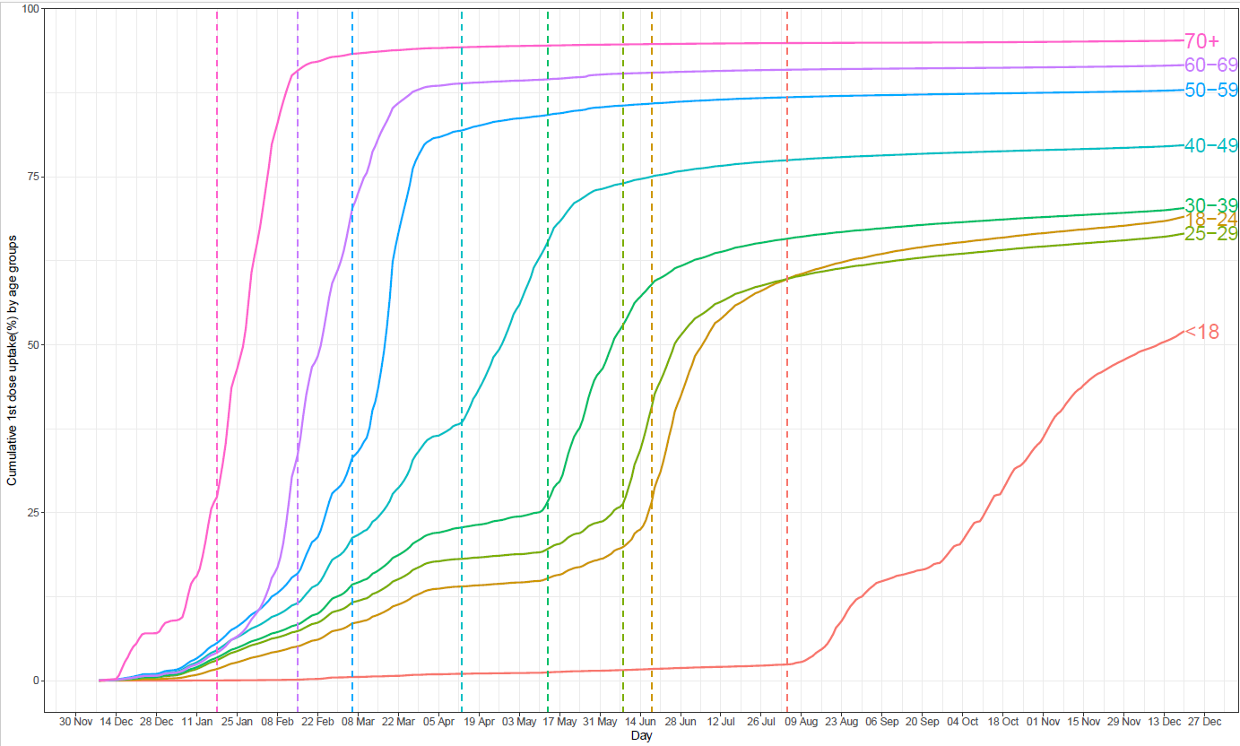

Figure 2. Temporal changes in age group to have first vaccine dose in England.

Note: Grey dots represent the location of 198 COVID-19 (mass) vaccination centres across England.

Figure 3. Number of accessible COVID-19 vaccination centres within 45 min by car (left) and 60 min by public transportation (right) for England (above) and zoomed to London (below).

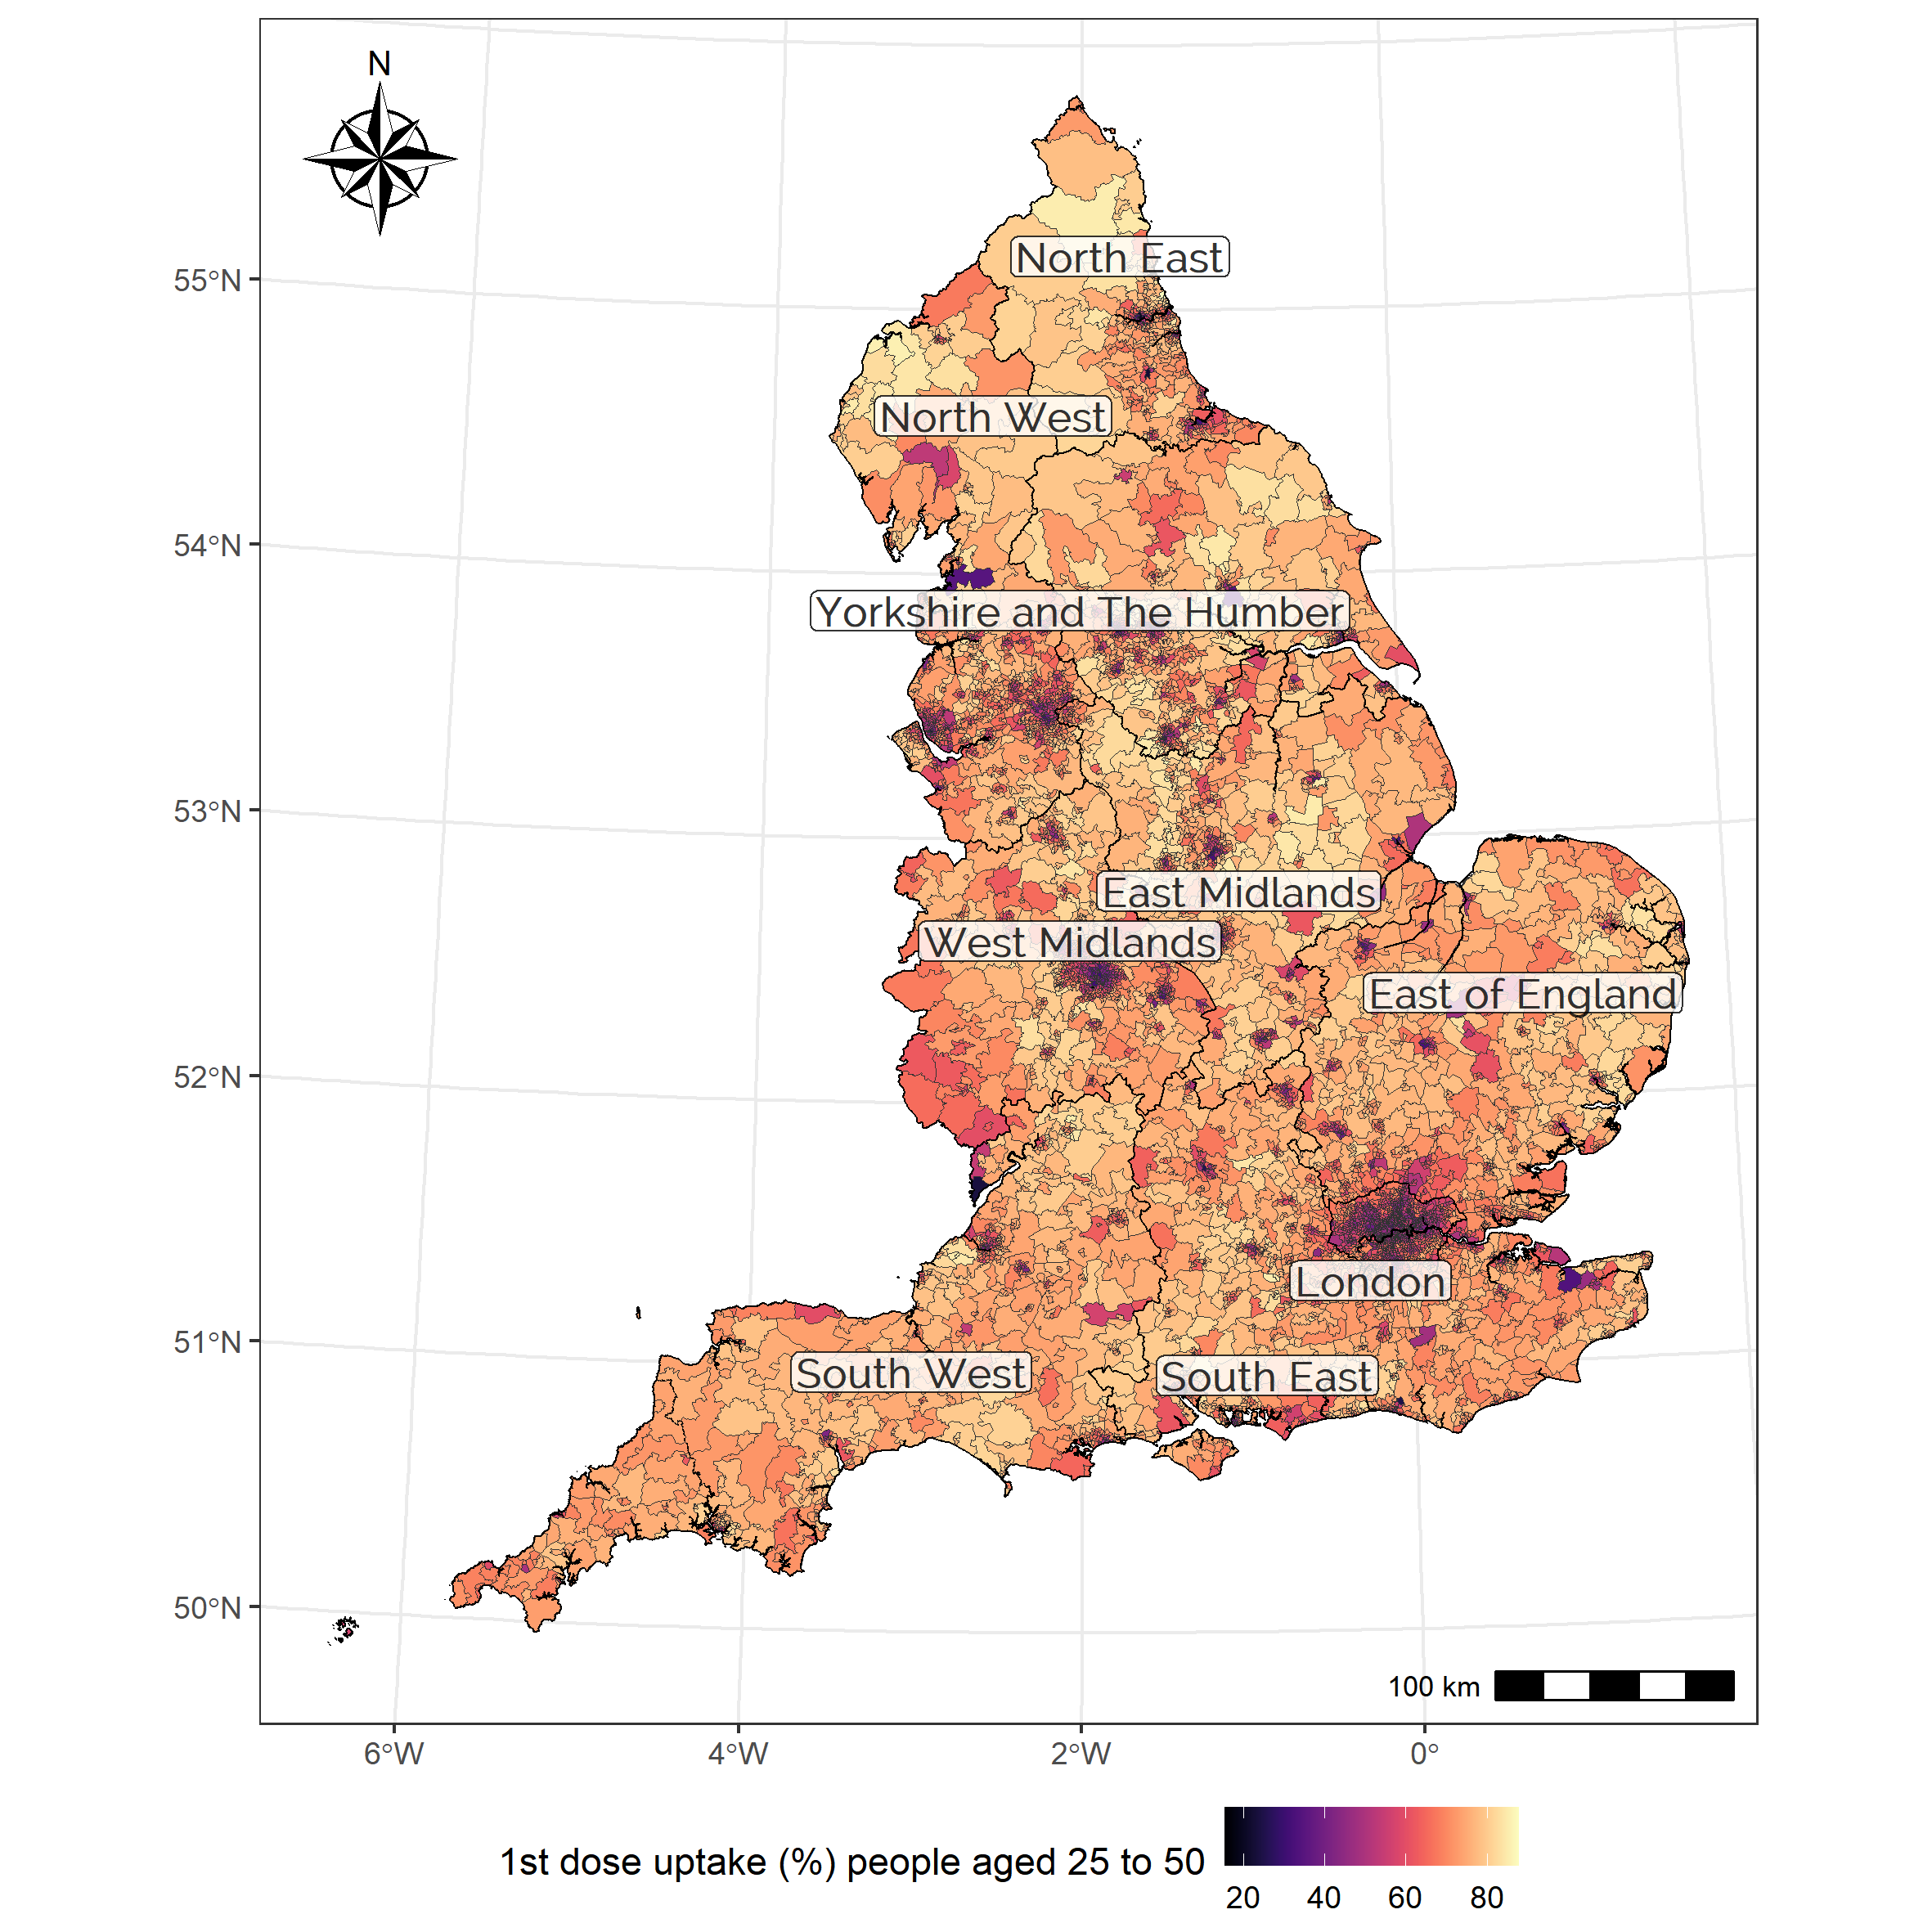

Figure 4. COVID-19 vaccination coverage on 24 June 2021 by MSOA level in England.

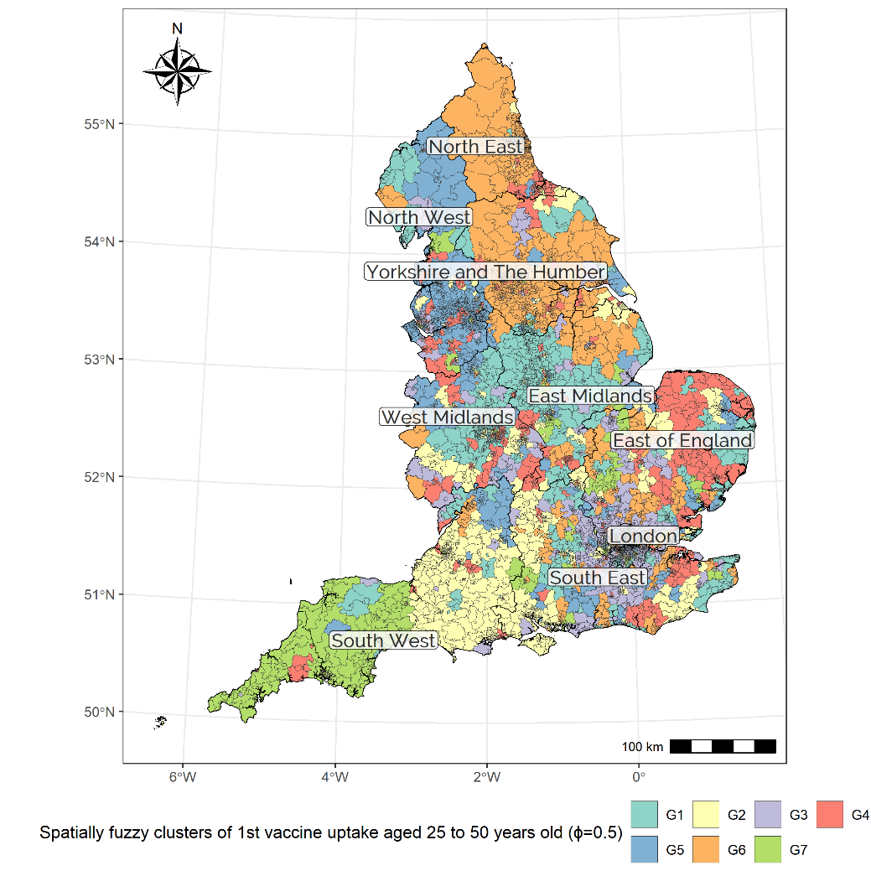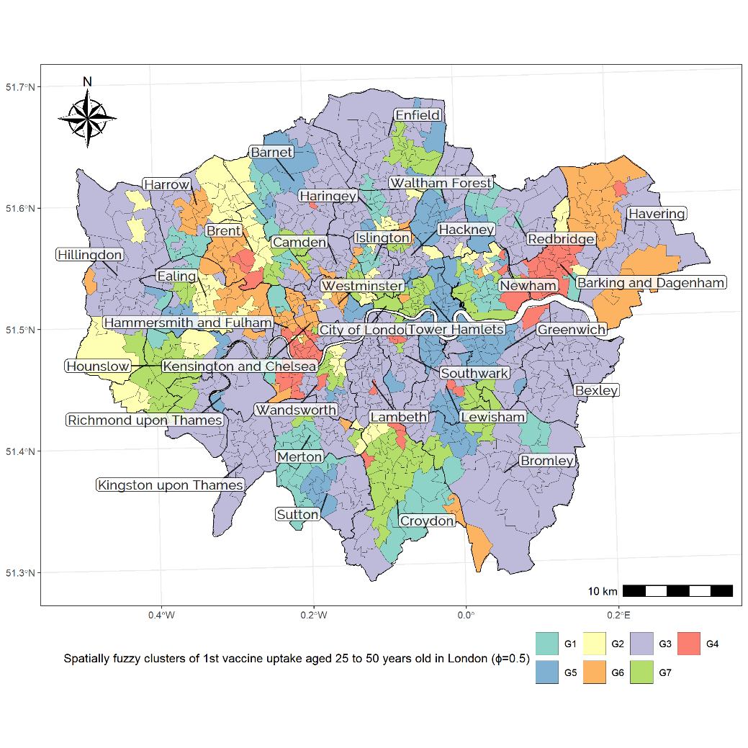

Figure 5. Spatial distribution of generated clusters for England (left) and zoomed to London (right) by the first dose vaccine uptake over 25.

### Tables

Table 1. IRRs (incident rate ratios) and model fit for the negative binomial regression models.

|  |  |  |  |  |  |
| --- | --- | --- | --- | --- | --- |
| **Domains** | **Variables** | **IRR (SE)** | | | |
| Model 1 | Model 2 | Model 3 | Model 4 |
| **Income** | Share of households in lowest household income quintile at national level | 0.959*** (0.001) | 0.957*** (0.001) | 0.964*** (0.001) | 0.964*** (0.001) |
| **Qualification** | Share of 3 & 4 or above | 1.029*** (0.002) | 1.029*** (0.002) | 1.027*** (0.001) | 1.025*** (0.001) |
| **Occupation** | Share of Social Grade C1 (lower middle class) | 1.006*** (0.002) | 1.008*** (0.002) | 1.008*** (0.002) | 1.008*** (0.002) |
| **Accessibility** | Number of accessible vaccination centres within 45 min on a weekday by car | - | 0.993** (0.002) | - | 0.994** (0.002) |
| Number of accessible vaccination centres within 60 min on a weekday at 12 pm by public transportation | - | 1.002 (0.002) | - | 1.008*** (0.002) |
| Share of households with no car | 0.96*** (0.002) | 0.961*** (0.002) | 0.975*** (0.002) | 0.972*** (0.002) |
| **Activity commitment** | Share of part-time workers in the resident population aged 16-74 | 1.038*** (0.002) | 1.036*** (0.002) | 1.03*** (0.002) | 1.03*** (0.002) |
| **Population Health** | Median ages of the resident population | 1.038*** (0.002) | 1.037*** (0.002) | 1.026*** (0.002) | 1.025*** (0.002) |
| **Ethnicity** | Share of Chinese resident population | 0.975*** (0.001) | 0.974*** (0.001) | 0.979*** (0.001) | 0.979*** (0.001) |
| Share of Other Asian resident population | 0.983*** (0.001) | 0.984*** (0.001) | 0.99*** (0.001) | 0.991*** (0.001) |
| Share of African resident population | 0.991*** (0.002) | 0.992*** (0.002) | 0.994*** (0.001) | 0.995** (0.001) |
| Share of Caribbean resident population | 0.978*** (0.002) | 0.978*** (0.002) | 0.988*** (0.001) | 0.988*** (0.001) |
| **Spatial lag effects** | Average vaccine uptake in adjacent areas |  |  | 1.063*** (0.001) | 1.063*** (0.002) |
| **Model criteria information** | Log-likelihood | -44006.57 | -44000.81 | -43183.36 | -43171.96 |
| AIC | 88037.000 | 88030.000 | 86393.000 | 86374.000 |
| BIC | 88062.955 | 88051.425 | 86416.525 | 86393.735 |
| Dispersion parameter | 162.770 | 163.060 | 212.060 | 212.830 |
| **Moran's I of residuals** | | 0.520 | 0.521 | 0.221 | 0.221 |

**Note: *p<0.5; **p<0.01; ***p<0.001.**

Table 2. IRRs (incident rate ratios) and model fit (at *G*=7 over 200 maximum iterations) for the spatially fuzzy clustered regression model.

|  |  |  |  |  |  |  |  |  |
| --- | --- | --- | --- | --- | --- | --- | --- | --- |
| **Domains** | **Variables** | **G1** | **G2** | **G3** | **G4** | **G5** | **G6** | **G7** |
| **Income** | Share of households in lowest household income quintile at national level | 0.980 | 0.971 | 0.896 | 0.965 | 0.978 | 0.937 | 0.964 |
| **Qualification** | Share of 3 & 4 or above | 1.016 | 1.031 | 1.091 | 1.034 | 1.028 | 1.014 | 1.013 |
| **Occupation** | Share of Social Grade C1 (lower middle class) | 0.985 | 1.007 | 1.061 | 1.044 | 1.001 | 1.000 | 0.994 |
| **Accessibility** | Number of accessible vaccination centres within 45 min on a weekday by car | 0.984 | 1.018 | 1.000 | 1.060 | 0.977 | 0.959 | 0.991 |
| Number of accessible vaccination centres within 60 min on a weekday at 12 pm by public transportation | 1.019 | 0.992 | 0.966 | 0.980 | 1.020 | 0.988 | 1.018 |
| Share of households owning no car | 0.949 | 0.958 | 0.991 | 0.983 | 0.930 | 0.974 | 0.923 |
| **Activity commitment** | Share of part-time workers in the resident population aged 16-74 | 1.039 | 1.038 | 1.046 | 1.069 | 1.021 | 0.995 | 1.023 |
| **Population Health** | Median ages of the resident population | 1.032 | 1.036 | 1.003 | 1.066 | 1.006 | 1.035 | 1.018 |
| **Ethnicity** | Share of Chinese resident population | 0.976 | 0.956 | 0.989 | 0.962 | 0.981 | 0.928 | 0.970 |
| Share of Other Asian resident population | 0.995 | 0.960 | 1.009 | 0.988 | 0.989 | 1.006 | 0.964 |
| Share of African resident population | 0.973 | 0.993 | 1.007 | 0.984 | 1.006 | 0.897 | 1.000 |
| Share of Caribbean resident population | 0.927 | 0.965 | 0.994 | 0.985 | 0.974 | 0.999 | 0.973 |
| **Model criteria information** | Log-likelihood | -38653.160 | | | | | | |
| AIC | 77330.320 | | | | | | |
| BIC | 77356.135 | | | | | | |
| Dispersion parameter | 913.129 | 587.355 | 430.199 | 424.243 | 831.948 | 819.016 | 869.485 |

**Note: heterogeneous responses (compared to Model 4) are shaded in darker grey.**

Table 3. Inequalities in access to vaccination services along and the difference in neighbourhood characteristics, by clusters.

|  |  |  |  |  |  |  |  |
| --- | --- | --- | --- | --- | --- | --- | --- |
| **Groups** | **People aged 25 to 50 received their first dose uptake (%)** | | **Geographic accessibility to access to vaccination services.** | | **Actual place-based accessibility** | | **% of households without access to a vehicle** |
| **Accessible centres by car within 45 min.** | **Accessible centres by public transportation within 60 min.** |
| Mean (SD) | Number of MSOAs | Number of COVID-19 vaccination centres | Vaccination centres per 100,000 inhabitants | Mean (SD) | Mean (SD) | Mean (SD) |
| **G1** | 0.71 (0.1) | 1098 | 21 | 0.67 | 6.35 (8.31) | 1.52 (2.58) | 0.232 (0.131) |
| **G2** | 0.66 (0.11) | 995 | 25 | 0.78 | 5.45 (8.77) | 1.35 (2.94) | 0.227 (0.142) |
| **G3** | 0.62 (0.1) | 1,114 | 47 | 1.14 | 18.62 (13.09) | 3.9 (5.04) | 0.269 (0.17) |
| **G4** | 0.63 (0.12) | 815 | 29 | 1.12 | 6.15 (7.76) | 1.27 (2.7) | 0.254 (0.143) |
| **G5** | 0.69 (0.09) | 1,054 | 22 | 0.67 | 6.61 (9.51) | 1.37 (3.06) | 0.26 (0.154) |
| **G6** | 0.7 (0.11) | 1,175 | 31 | 0.90 | 6.92 (8.57) | 1.45 (2.8) | 0.254 (0.138) |
| **G7** | 0.65 (0.12) | 540 | 23 | 1.25 | 9.28 (12.64) | 2.47 (4.31) | 0.278 (0.175) |
| **England** | 0.67 (0.11) | 6,791 | 198 | 0.91 | 8.58 (10.85) | 1.9 (3.54) | 0.252 (0.15) |

**Note: Grey shaded presents the above than average of England.**

## Appendix A. Selection of travel time thresholds

### Travel time and distance by car:

People living in all 6791 MSOAs can access at least one mass vaccination centre within 10 miles’ drive if measuring from the centroid of the MSOA (Department of Health and Social Care, 2021b).

|  |  |  |
| --- | --- | --- |
|  | **Distance (km)** | **Duration (min.)** |
| Median | 9.8 | 13.53 |
| Mean | **13.75** | **16.4** |
| SD | 12.51 | 11.44 |

### Travel time by public transportation

From the centroid of 6,791 MSOAs to nearest vaccination centres by public transportation was calculated for six different times of day on Tuesday and Saturday. Noon on Tuesdays was chosen as it captures both more MSOAs and more variation in accessibility than other times, except for 8:00, which is a clear outlier in terms of travel duration.

*Tuesday*

|  |  |  |  |  |  |  |
| --- | --- | --- | --- | --- | --- | --- |
| **Duration (min.)** | **8:00** | **10:00** | **12:00** | **14:00** | **16:00** | **18:00** |
| Median | 34.69 | 33.67 | 34.00 | 34.25 | 35.42 | 34.07 |
| Mean | 58.49 | 48.29 | 48.79 | 47.39 | 48.40 | 48.35 |
| SD | 107.31 | 65.23 | 66.07 | 50.43 | 51.31 | 34.07 |
| Coverage of MSOA | 5,688 | 5,786 | 5,830 | 5,831 | 5,827 | 5,820 |
| Coverage(%) | 0.84 | 0.85 | 0.86 | 0.86 | 0.86 | 0.86 |

*Saturday*

|  |  |  |  |  |  |  |
| --- | --- | --- | --- | --- | --- | --- |
| **Duration (min.)** | **8:00** | **10:00** | **12:00** | **14:00** | **16:00** | **18:00** |
| Median | 34.67 | 33.57 | 34.00 | 34.22 | 35.30 | 34.08 |
| Mean | 58.54 | 47.40 | 47.83 | 46.66 | 47.53 | 47.67 |
| SD | 110.27 | 60.18 | 57.81 | 41.60 | 42.22 | 45.32 |
| Coverage of MSOA | 5,681 | 5,773 | 5,820 | 5,821 | 5,817 | 5,813 |
| Coverage(%) | 0.84 | 0.85 | 0.86 | 0.86 | 0.86 | 0.86 |

## Appendix B. Selection of tuning parameters

Average BIC replicated 5 times by different tuning parameter by different number of groups .



|  |  |  |  |
| --- | --- | --- | --- |
| **Number of groups** | **Average BIC for replicated 5 times** | | |
| = 0.5 | = 0.6 | = 0.75 |
| 2 | 91999.2 | 92359.47 | 92840.06 |
| 3 | 89978.37 | 90963.87 | 91782.44 |
| 4 | 89180.07 | 90669.98 | 91567.91 |
| 5 | 87228.4 | 89082.56 | 90457.44 |
| 6 | 86578.02 | 88309.64 | 90082.85 |
| 7 | **84471.47** | 86016.96 | 88823.09 |
| 8 | 84719.21 | 86471.22 | 89758.65 |

|  |
| --- |
|  |
|  |
|  |

Changes in BIC criterion by tuning parameter in the range of pre-set numbers [2,8] on the maximum number of iterations.

## Appendix C. Descriptive information for (selected) sociodemographic attributes by clusters

|  |  |  |  |  |  |  |  |  |
| --- | --- | --- | --- | --- | --- | --- | --- | --- |
| **Variables** | **G1**  **Mean**  **(SD)** | **G2**  **Mean**  **(SD)** | **G3**  **Mean**  **(SD)** | **G4**  **Mean**  **(SD)** | **G5**  **Mean**  **(SD)** | **G6**  **Mean**  **(SD)** | **G7**  **Mean**  **(SD)** | **England**  **Mean**  **(SD)** |
| %Lowest 20% income HHs | 0.173  (0.04) | 0.177 (0.048) | 0.166  (0.035) | 0.181 (0.049) | 0.176 (0.046) | 0.178 (0.053) | 0.198 (0.056) | 0.177 (0.047) |
| %Qualification 3, 4, and above | 0.364 (0.108) | 0.404 (0.116) | 0.443  (0.125) | 0.366 (0.121) | 0.396 (0.124) | 0.367 (0.112) | 0.415 (0.127) | 0.393 (0.122) |
| %Social grade C1 | 0.225 (0.041) | 0.226 (0.046) | 0.229  (0.044) | 0.217 (0.047) | 0.224 (0.042) | 0.223 (0.044) | 0.226 (0.059) | 0.225 (0.045) |
| Median age of resident population | 56.678 (5.197) | 55.525 (6.751) | 53.516 (5.908) | 55.509 (6.186) | 55.458 (6.175) | 56.22 (5.416) | 54.298 (8.562) | 55.392 (6.262) |
| %Part-time worker | 0.144 (0.018) | 0.142 (0.024) | 0.127  (0.025) | 0.141 (0.024) | 0.138 (0.021) | 0.142 (0.021) | 0.137 (0.031) | 0.139 (0.024) |
| %Chinese / Chinese British | 0.005 (0.009) | 0.007 (0.011) | 0.009  (0.011) | 0.006 (0.009) | 0.008 (0.012) | 0.005 (0.007) | 0.009 (0.015) | 0.007 (0.011) |
| %Other Asian / Other Asian British | 0.013 (0.024) | 0.014 (0.019) | 0.024  (0.027) | 0.011 (0.017) | 0.011 (0.019) | 0.011 (0.021) | 0.018 (0.027) | 0.014 (0.022) |
| %African / African British | 0.012 (0.025) | 0.015  (0.03) | 0.033  (0.048) | 0.014 (0.034) | 0.015 (0.034) | 0.009 (0.017) | 0.024 (0.044) | 0.017 (0.035) |
| %Caribbean / Caribbean British | 0.01  (0.017) | 0.009  (0.02) | 0.02  (0.03) | 0.008 (0.019) | 0.008 (0.019) | 0.005 (0.013) | 0.016 (0.034) | 0.011 (0.022) |

**Note: Grey shaded presents the above than average of England.**

1. Paper prepared for submission to the Journal of [*Social Science & Medicine*](https://www.journals.elsevier.com/social-science-and-medicine).
2. Transport Studies Unit, School of Geography and the Environment, University of Oxford, UK
3. Corresponding author ([hannah.budnitz@ouce.ox.ac.uk](mailto:hannah.budnitz@ouce.ox.ac.uk)).
4. Weekly COVID-19 Vaccines COVID-19 (<https://www.england.nhs.uk/statistics/statistical-work-areas/covid-19-vaccinations>).
5. Census geography (https://www.ons.gov.uk/methodology/geography/ukgeographies/censusgeography)
6. [What's behind a simple letter? - NHS Digital](https://digital.nhs.uk/blog/transformation-blog/2021/whats-behind-a-simple-letter) Accessed 19 January 2022
7. We build the SFCR model using R code which can be retrieved from the following Github repository: (<https://github.com/sshonosuke/SCR>).
8. We tested three moderate spatial correlation parameters; 0.5, 0.6, and 0.75 in this study, and confirm *=*0.5 shows the best result while *G*=7 on the maximum number of iterations to 200 (see Appendix B).
9. Model 4 has the smallest log-likelihood (LL) and model criterion information – Akaike information criterion (AIC) and Bayesian information criterion (BIC) scores (Burnham and Anderson, 2004).