**Executive summary**

**MLR LASSO model performance**

* The model criteria for the reference and latest updated models were compared.
* Reference model showed a better fit to the data, but the difference was marginal.
* Also, updated model seemed to be **more interesting** to highlight that trajectory of mobility reductions during national lockdown are more likely to be influenced by **place of usual residence** (i.e., where they live), relative to other explanatory variables (e, g., socioeconomic characteristics, and accessibility indicators)
* Additionally, Figure 7 (ranking the relative importance to predict the clusters) would be excluded, as the update model one did not scale from 0 to 1.

*Reference model*

|  |  |
| --- | --- |
| Model criteria information | |
| AICc (Akaike's Information Corrected Criterion) | -222.91 |
| BIC (Bayesian information criterion) | -161.18 |

*Update model including 9 binary dummies (i.e., regions of England)*

|  |  |
| --- | --- |
| Model criteria information | |
| AICc (Akaike's Information Corrected Criterion) | -236.969 |
| BIC (Bayesian information criterion) | -147.653 |

*Contents of reference model (previous one)*

* G1: Share of self-employed workers (0.71), households with one vehicle (0.35), cumulative COVID-19 infection rates before lockdown (0.24), high-income households (0.19), and percentage Other Black (0.12).
* G2: Share of high-income households (0.47), percentage Black African (0.43), households with more than three vehicles (0.39), more than three bedrooms in the house (0.30), and Hospital density per 1,000 population (0.15).
* G3: Share of medium-income households (0.38), social grade C1 (0.25), high-income households (0.23), more than three bedrooms in the house (0.25), households with one vehicle (0.04), and self-employed workers (0.02).
* G4: Share of households with more than three vehicles (0.64), self-employed workers (0.26), more than three bedrooms in the house (0.23), cumulative COVID-19 mortality rates before lockdown (0.20), and percentage Black Caribbean (0.19).

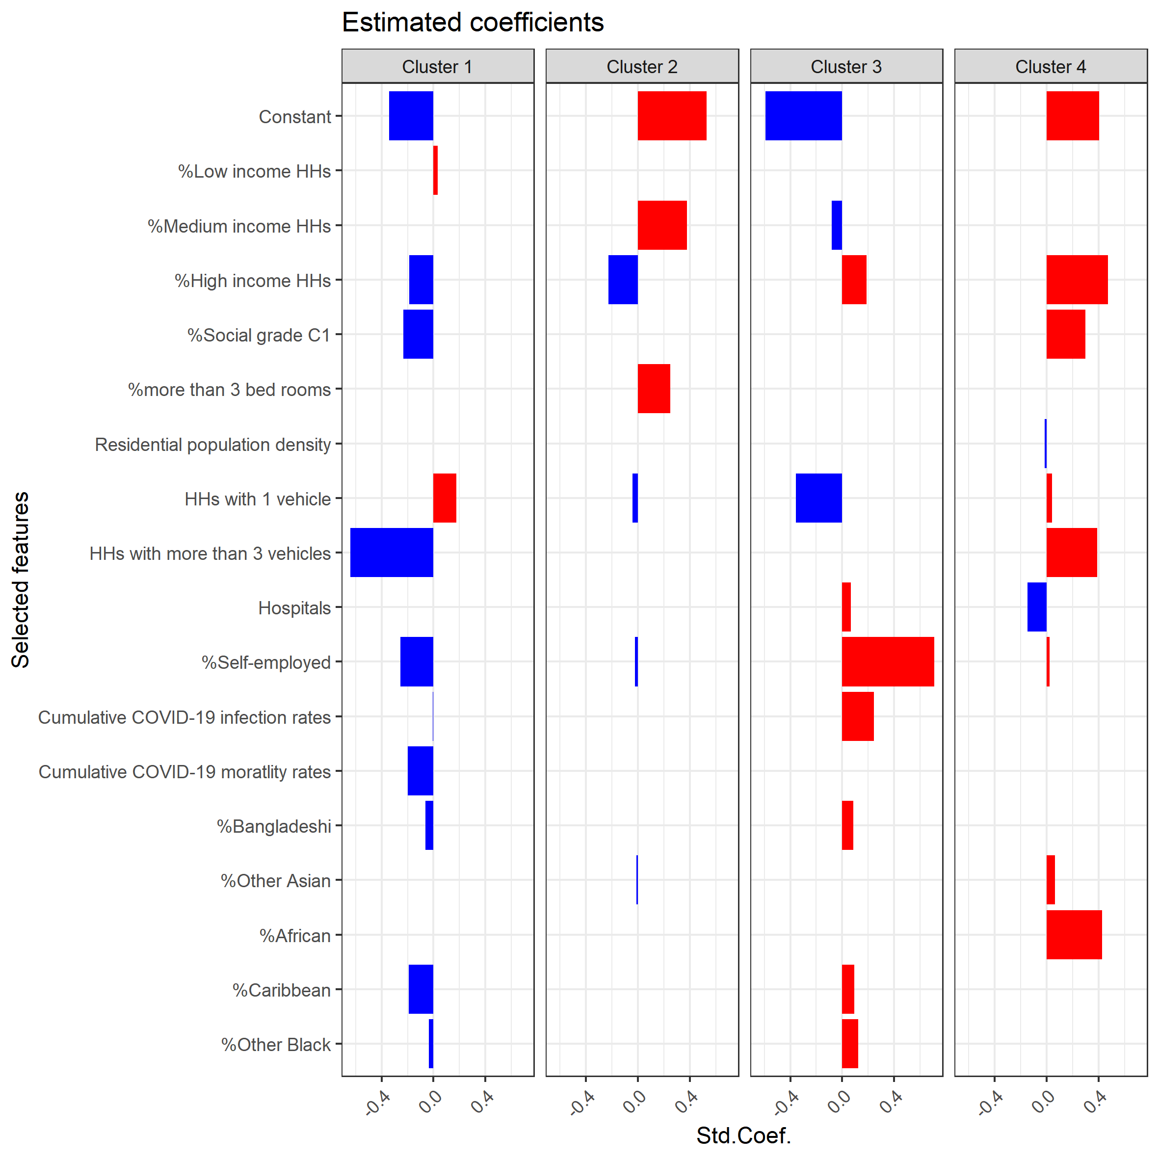

Figure 6. Estimated coefficients of explanatory variables to predict the clusters.

Figure 7. Ranking the relative feature importance to predict the clusters.

Table 3. Descriptive statistics of socioeconomic status by clusters.

|  |  |  |  |  |  |  |  |
| --- | --- | --- | --- | --- | --- | --- | --- |
| Domains | | Variable | G1 | G2 | G3 | G4 | National level |
| Mean (Std.) | Mean (Std.) | Mean (Std.) | Mean (Std.) | Mean (Std.) |
| Socioeconomic | **Income** | **Share of households in lowest household**  **income quintile at national level** | **0.17 (0.02)** | **0.16 (0.02)** | **0.17 (0.02)** | **0.19 (0.03)** | **0.17 (0.02)** |
| **Share of households in median household**  **income quintile at national level** | **0.21 (0.02)** | **0.22 (0.02)** | **0.23 (0.02)** | **0.22 (0.02)** | **0.22 (0.02)** |
| **Share of households in top household**  **income quintile at national level** | **0.24 (0.07)** | **0.17 (0.05)** | **0.17 (0.05)** | **0.14 (0.04)** | **0.19 (0.07)** |
| Education and skills | Share with no qualifications | 0.19 (0.05) | 0.21 (0.04) | 0.24 (0.04) | **0.25 (0.05)** | 0.22 (0.05) |
| Share of non-English speakers | 0.11 (0.12) | 0.07 (0.07) | 0.04 (0.04) | **0.06 (0.05)** | 0.06 (0.07) |
| **Occupation** | Share of Social Grade AB  (upper middle class) | 0.37 (0.07) | 0.35 (0.07) | 0.3 (0.06) | **0.27 (0.05)** | 0.32 (0.07) |
| **Share of Social Grade C1**  **(lower middle class)** | **0.23 (0.04)** | **0.24 (0.03)** | **0.23 (0.03)** | **0.21 (0.03)** | **0.23 (0.03)** |
| Share of Social Grade C2  (skilled working class) | 0.18 (0.05) | 0.2 (0.04) | 0.23 (0.03) | **0.23 (0.03)** | 0.21 (0.04) |
| Share of Social Grade DE  (semi-skilled working class and non-working) | 0.14 (0.04) | 0.14 (0.04) | 0.16 (0.04) | **0.19 (0.05)** | 0.16 (0.05) |
| **Housing type** | Share of social rented housing | 0.18 (0.09) | 0.15 (0.06) | 0.15 (0.05) | **0.18 (0.06)** | 0.16 (0.06) |
| **Share of dwellings with ≥3 bedrooms** | **0.56 (0.15)** | **0.63 (0.07)** | **0.65 (0.06)** | **0.6 (0.06)** | **0.62 (0.09)** |
| Accessibility | **Residential density** | **Resident population density**  **(1,000 inhabitants per km2)** | **0.03 (0.04)** | **0.01 (0.01)** | **0.01 (0.01)** | **0.01 (0.01)** | **0.01 (0.02)** |
| **Car availability** | Share of households with 0 vehicle | 0.28 (0.19) | 0.19 (0.08) | 0.21 (0.07) | **0.27 (0.07)** | 0.23 (0.11) |
| **Share of households with 1 vehicle** | **0.4 (0.04)** | **0.42 (0.03)** | **0.42 (0.02)** | **0.44 (0.02)** | **0.42 (0.03)** |
| Share of households with 2 vehicles | 0.24 (0.12) | 0.29 (0.07) | 0.28 (0.05) | **0.23 (0.05)** | 0.27 (0.07) |
| **Share of households with ≥3 vehicles** | **0.02 (0.02)** | **0.03 (0.01)** | **0.02 (0.01)** | **0.01 (0.01)** | **0.02 (0.01)** |
| Clinical capacity and Allowed premises | **Hospitals (per 1,000 inhabitants)** | **0.33 (0.2)** | **0.27 (0.11)** | **0.29 (0.16)** | **0.26 (0.15)** | **0.28 (0.15)** |
| Parks (per 1,000 inhabitants) | 25.5 (10.95) | 22.87 (10.32) | 22.89 (11.82) | **21.61 (10.54)** | 22.97 (10.98) |
| Activity commitment | **Economic activity** | Share of part-time workers  in the resident population aged 16-74 | 0.13 (0.03) | 0.14 (0.01) | 0.15 (0.01) | **0.14 (0.01)** | 0.14 (0.02) |
| Share of full-time worker  in the resident population aged 16-74 | 0.39 (0.04) | 0.4 (0.04) | 0.39 (0.03) | **0.38 (0.04)** | 0.39 (0.04) |
| **Share of self-employed workers**  **in the resident population aged 16-74** | **0.13 (0.02)** | **0.11 (0.02)** | **0.1 (0.02)** | **0.08 (0.02)** | **0.1 (0.03)** |
| Population Health | General health status | Share of population in good health | 0.83 (0.02) | 0.83 (0.03) | 0.81 (0.03) | **0.8 (0.03)** | 0.82 (0.03) |
| Share of population in fair health | 0.12 (0.02) | 0.12 (0.02) | 0.14 (0.02) | **0.14 (0.02)** | 0.13 (0.02) |
| Share of population in bad health | 0.05 (0.01) | 0.05 (0.01) | 0.05 (0.01) | **0.06 (0.01)** | 0.05 (0.01) |
| Perceived risk of COVID-19 | **Infection rates** | **Cumulative COVID-19 reported cases**  **per 100,000 population before lockdown** | **24.6 (19.65)** | **15.72 (12.14)** | **11.29 (7.04)** | **9.49 (8.57)** | **14.11 (12.40)** |
| **Mortality rates** | **Cumulative COVID-19 reported deaths**  **per 100,000 population before lockdown** | **1.83 (1.87)** | **1.25 (1.44)** | **0.93 (1.26)** | **0.61 (0.81)** | **1.08 (1.39)** |
| Ethnic composition | White | Percentage of the residential population  that identified as White British | 0.82 (0.2) | 0.88 (0.14) | 0.93 (0.08) | **0.9 (0.09)** | 0.89 (0.13) |
| Mixed/multiple groups | Percentage of Mixed (joint) and  Multiple ethnic groups | 0.03 (0.02) | 0.02 (0.01) | 0.01 (0.01) | **0.02 (0.01)** | 0.02 (0.01) |
| Indian | Percentage Indian | 0.03 (0.05) | 0.02 (0.04) | 0.02 (0.03) | **0.02 (0.04)** | 0.02 (0.04) |
| Pakistani | Percentage Pakistani | 0.01 (0.02) | 0.01 (0.03) | 0.01 (0.03) | **0.02 (0.04)** | 0.01 (0.03) |
| **Bangladeshi** | **Percentage Bangladeshi** | **0.02 (0.05)** | **0 (0.01)** | **0 (0.01)** | **0 (0.01)** | **0.01 (0.02)** |
| Chinese | Percentage Chinese | 0.01 (0.01) | 0.01 (0) | 0 (0) | **0.01 (0.01)** | 0.01 (0.01) |
| **Other Asian** | **Percentage Other Asian** | **0.02 (0.03)** | **0.02 (0.02)** | **0.01 (0.01)** | **0.01 (0.01)** | **0.01 (0.02)** |
| **African** | **Percentage Black African** | **0.03 (0.04)** | **0.02 (0.03)** | **0.01 (0.01)** | **0.01 (0.01)** | **0.01 (0.02)** |
| **Caribbean** | **Percentage Black Caribbean** | **0.02 (0.03)** | **0.01 (0.02)** | **0 (0.01)** | **0 (0.01)** | **0.01 (0.02)** |
| **Other Black** | **Percentage Other Black** | **0.01 (0.01)** | **0 (0.01)** | **0 (0)** | **0 (0)** | **0 (0.01)** |
| Other ethnic groups | Percentage of any other ethnic group | 0.02 (0.02) | 0.01 (0.01) | 0 (0) | **0.01 (0.01)** | 0.01 (0.01) |

*Notes*: Variables in bold (i.e., 17 selected features) have been included in the classification model below at least in one cluster.

Table 4. Estimated coefficients of explanatory variables to classify clusters.

|  |  |  |  |  |  |  |
| --- | --- | --- | --- | --- | --- | --- |
| Domains | | Variable | G1 | G2 | G3 | G4 |
| Constant | | | -0.59 | 0.41 | 0.53 | -0.34 |
| Socioeconomic | Income | Share of households in the lowest household  income quintile at the national level |  |  |  | 0.03 |
| Share of households in median household  income quintile at the national level | -0.08 |  | 0.38 |  |
| Share of households in top household  income quintile at national level | 0.19 | 0.47 | -0.23 | -0.19 |
| Occupation | Share of Social Grade C1 (lower middle class) |  | 0.3 |  | -0.23 |
| Housing type | Share of dwellings with ≥3 bedrooms |  |  | 0.25 |  |
| Residential density | Resident population density  (1,000 inhabitants per km2) |  | -0.02 |  |  |
| Accessibility | Car availability | Share of households with 1 vehicle | -0.35 | 0.04 | -0.04 | 0.18 |
| Share of households with ≥3 vehicles |  | 0.39 |  | -0.64 |
| Clinical capacity and Allowed premises | Hospitals (per 1,000 inhabitants) | 0.07 | -0.15 |  |  |
| Activity commitment | Economic activity | Share of self-employed workers in the resident  population aged 16-74 | 0.71 | 0.02 | -0.02 | -0.26 |
| Perceived risk of COVID-19 | Infection rates | Cumulative COVID-19 reported cases per 100,000  resident population before lockdown | 0.24 |  |  | -0.01 |
| Mortality rates | Cumulative COVID-19 reported deaths per 100,000  resident population before lockdown |  |  |  | -0.2 |
| Ethnic composition | Bangladeshi | Percentage Bangladeshi | 0.08 |  |  | -0.06 |
| Other Asian | Percentage Other Asian |  | 0.06 | -0.01 |  |
| African | Percentage Black African |  | 0.43 |  |  |
| Caribbean | Percentage Black Caribbean | 0.09 |  |  | -0.19 |
| Other Black | Percentage Other Black | 0.12 |  |  | -0.03 |
| Model criteria information | | | | | | |
| AICc (Akaike's Information Corrected Criterion) | | -222.91 | | | | |
| BIC (Bayesian information criterion) | | -161.18 | | | | |

*Contents of updated model (incl. 9 dummy variables)*

* G1: residency in London (1.643), Share of self-employed workers (0.648), cumulative COVID-19 mortality rates before lockdown (0.114), Hospital density per 1,000 population (0.067), and high-income households (0.066) / households with one vehicle (-0.454), South West (-0.237), and West Midlands (-0.053)
* G2: Shre of middle-income households (0.403), North East (0.271), more than three bedrooms in the house (0.193), residency in West Midlands (0.174) / high-income households (-0.178) and self-employed workers (-0.008)
* G3: residency in Yorkshire and the Humber (1.45), South West (0.655), Share of households with more than one vehicle (0.146), East Midlands (0.085) / households with more than three vehicles (-0.634), self-employed workers (-0.438), percentage of Caribbean (-0.134), social grade C1 (-0.082), cumulative COVID-19 mortality rates before lockdown (-0.076), high-income households (-0.066)
* G4: Share of high-income households (0.451), percentage of African (0.384), social grade C1 (0.351), households with more than three vehicles (0.264), percentage of Other Asian (0.115), residency in East of England, and self-employed workers (0.008) / Hospital density per 1,000 population (-0.142)

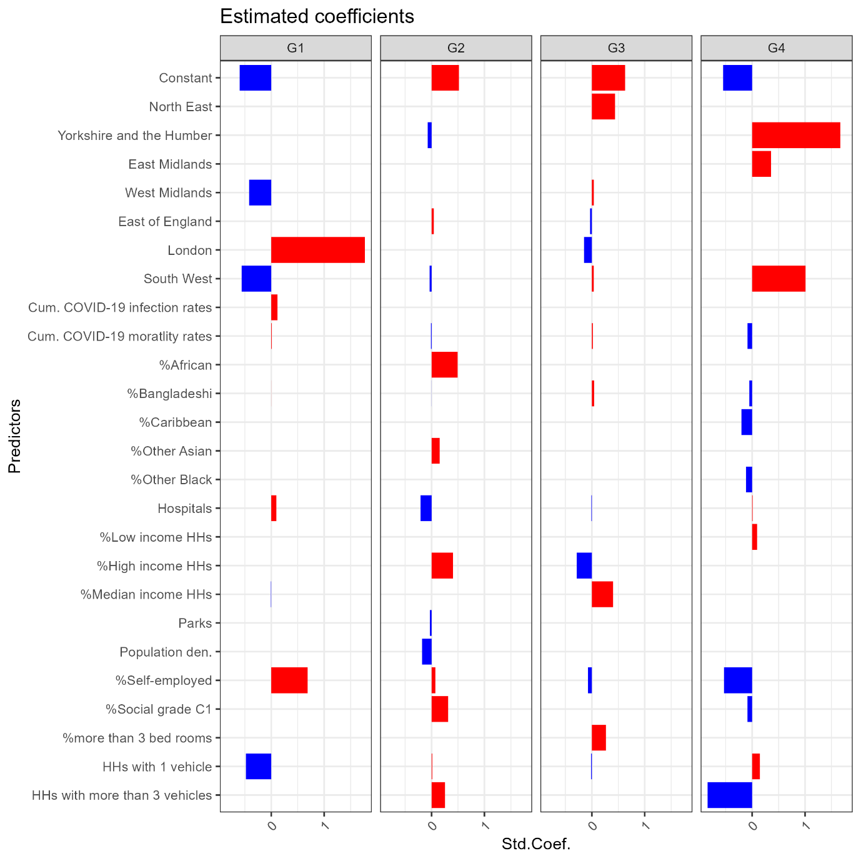

Figure 6. Estimated coefficients of explanatory variables to predict the clusters.

Table 3. Descriptive statistics of socioeconomic status by clusters.

|  |  |  |  |  |  |  |  |
| --- | --- | --- | --- | --- | --- | --- | --- |
| Domains | | Variable | G1 | G2 | G3 | G4 | National level |
| Mean (Std.) | Mean (Std.) | Mean (Std.) | Mean (Std.) | Mean (Std.) |
| Socioeconomic | **Income** | **Share of households in lowest household**  **income quintile at national level** | **0.17 (0.02)** | **0.16 (0.02)** | **0.17 (0.02)** | **0.19 (0.03)** | **0.17 (0.02)** |
| **Share of households in median household**  **income quintile at national level** | **0.21 (0.02)** | **0.22 (0.02)** | **0.23 (0.02)** | **0.22 (0.02)** | **0.22 (0.02)** |
| **Share of households in top household**  **income quintile at national level** | **0.24 (0.07)** | **0.17 (0.05)** | **0.17 (0.05)** | **0.14 (0.04)** | **0.19 (0.07)** |
| Education and skills | Share with no qualifications | 0.19 (0.05) | 0.21 (0.04) | 0.24 (0.04) | 0.25 (0.05) | 0.22 (0.05) |
| Share of non-English speakers | 0.11 (0.12) | 0.07 (0.07) | 0.04 (0.04) | 0.06 (0.05) | 0.06 (0.07) |
| **Occupation** | Share of Social Grade AB  (upper middle class) | 0.37 (0.07) | 0.35 (0.07) | 0.3 (0.06) | 0.27 (0.05) | 0.32 (0.07) |
| **Share of Social Grade C1**  **(lower middle class)** | **0.23 (0.04)** | **0.24 (0.03)** | **0.23 (0.03)** | **0.21 (0.03)** | **0.23 (0.03)** |
| Share of Social Grade C2  (skilled working class) | 0.18 (0.05) | 0.2 (0.04) | 0.23 (0.03) | 0.23 (0.03) | 0.21 (0.04) |
| Share of Social Grade DE  (semi-skilled working class and non-working) | 0.14 (0.04) | 0.14 (0.04) | 0.16 (0.04) | 0.19 (0.05) | 0.16 (0.05) |
| **Housing type** | Share of social rented housing | 0.18 (0.09) | 0.15 (0.06) | 0.15 (0.05) | 0.18 (0.06) | 0.16 (0.06) |
| **Share of dwellings with ≥3 bedrooms** | **0.56 (0.15)** | **0.63 (0.07)** | **0.65 (0.06)** | **0.6 (0.06)** | **0.62 (0.09)** |
| Accessibility | **Residential density** | **Resident population density**  **(1,000 inhabitants per km2)** | **0.03 (0.04)** | **0.01 (0.01)** | **0.01 (0.01)** | **0.01 (0.01)** | **0.01 (0.02)** |
| **Car availability** | Share of households with 0 vehicle | 0.28 (0.19) | 0.19 (0.08) | 0.21 (0.07) | 0.27 (0.07) | 0.23 (0.11) |
| **Share of households with 1 vehicle** | **0.4 (0.04)** | **0.42 (0.03)** | **0.42 (0.02)** | **0.44 (0.02)** | **0.42 (0.03)** |
| Share of households with 2 vehicles | 0.24 (0.12) | 0.29 (0.07) | 0.28 (0.05) | 0.23 (0.05) | 0.27 (0.07) |
| **Share of households with ≥3 vehicles** | **0.02 (0.02)** | **0.03 (0.01)** | **0.02 (0.01)** | **0.01 (0.01)** | **0.02 (0.01)** |
| **Clinical capacity and Allowed premises** | **Hospitals (per 1,000 inhabitants)** | **0.33 (0.2)** | **0.27 (0.11)** | **0.29 (0.16)** | **0.26 (0.15)** | **0.28 (0.15)** |
| **Parks (per 1,000 inhabitants)** | **25.5 (10.95)** | **22.87 (10.32)** | **22.89 (11.82)** | **21.61 (10.54)** | **22.97 (10.98)** |
| Activity commitment | **Economic activity** | Share of part-time workers  in the resident population aged 16-74 | 0.13 (0.03) | 0.14 (0.01) | 0.15 (0.01) | 0.14 (0.01) | 0.14 (0.02) |
| Share of full-time worker  in the resident population aged 16-74 | 0.39 (0.04) | 0.4 (0.04) | 0.39 (0.03) | 0.38 (0.04) | 0.39 (0.04) |
| **Share of self-employed workers**  **in the resident population aged 16-74** | **0.13 (0.02)** | **0.11 (0.02)** | **0.1 (0.02)** | **0.08 (0.02)** | **0.1 (0.03)** |
| Population Health | General health status | Share of population in good health | 0.83 (0.02) | 0.83 (0.03) | 0.81 (0.03) | 0.8 (0.03) | 0.82 (0.03) |
| Share of population in fair health | 0.12 (0.02) | 0.12 (0.02) | 0.14 (0.02) | 0.14 (0.02) | 0.13 (0.02) |
| Share of population in bad health | 0.05 (0.01) | 0.05 (0.01) | 0.05 (0.01) | 0.06 (0.01) | 0.05 (0.01) |
| Perceived risk of COVID-19 | **Infection rates** | **Cumulative COVID-19 reported cases**  **per 100,000 population before lockdown** | **24.6 (19.65)** | **15.72 (12.14)** | **11.29 (7.04)** | **9.49 (8.57)** | **14.11 (12.40)** |
| **Mortality rates** | **Cumulative COVID-19 reported deaths**  **per 100,000 population before lockdown** | **1.83 (1.87)** | **1.25 (1.44)** | **0.93 (1.26)** | **0.61 (0.81)** | **1.08 (1.39)** |
| Ethnic composition | White | Percentage of the residential population  that identified as White British | 0.82 (0.2) | 0.88 (0.14) | 0.93 (0.08) | 0.9 (0.09) | 0.89 (0.13) |
| Mixed/multiple groups | Percentage of Mixed (joint) and  Multiple ethnic groups | 0.03 (0.02) | 0.02 (0.01) | 0.01 (0.01) | 0.02 (0.01) | 0.02 (0.01) |
| Indian | Percentage Indian | 0.03 (0.05) | 0.02 (0.04) | 0.02 (0.03) | 0.02 (0.04) | 0.02 (0.04) |
| Pakistani | Percentage Pakistani | 0.01 (0.02) | 0.01 (0.03) | 0.01 (0.03) | 0.02 (0.04) | 0.01 (0.03) |
| **Bangladeshi** | **Percentage Bangladeshi** | **0.02 (0.05)** | **0 (0.01)** | **0 (0.01)** | **0 (0.01)** | **0.01 (0.02)** |
| Chinese | Percentage Chinese | 0.01 (0.01) | 0.01 (0) | 0 (0) | 0.01 (0.01) | 0.01 (0.01) |
| **Other Asian** | **Percentage Other Asian** | **0.02 (0.03)** | **0.02 (0.02)** | **0.01 (0.01)** | **0.01 (0.01)** | **0.01 (0.02)** |
| **African** | **Percentage Black African** | **0.03 (0.04)** | **0.02 (0.03)** | **0.01 (0.01)** | **0.01 (0.01)** | **0.01 (0.02)** |
| **Caribbean** | **Percentage Black Caribbean** | **0.02 (0.03)** | **0.01 (0.02)** | **0 (0.01)** | **0 (0.01)** | **0.01 (0.02)** |
| **Other Black** | **Percentage Other Black** | **0.01 (0.01)** | **0 (0.01)** | **0 (0)** | **0 (0)** | **0 (0.01)** |
| Other ethnic groups | Percentage of any other ethnic group | 0.02 (0.02) | 0.01 (0.01) | 0 (0) | 0.01 (0.01) | 0.01 (0.01) |

*Notes*: Variables in bold (i.e., 18 selected features) have been included in the classification model with 7 regional dummy variables below at least in one cluster.

Table 4. Estimated coefficients of explanatory variables to classify clusters.

|  |  |  |  |  |  |  |
| --- | --- | --- | --- | --- | --- | --- |
| **Domains** | | **Variable** | **G1** | **G2** | **G3** | **G4** |
| Constant | | | -0.597 | 0.518 | 0.628 | -0.549 |
| Regions in England | North East | |  |  | 0.439 |  |
| Yorkshire and the Humber | |  | -0.072 |  | 1.665 |
| East Midlands | |  |  |  | 0.356 |
| West Midlands | | -0.418 |  | 0.038 |  |
| East of England | |  | 0.044 | -0.034 |  |
| London | | 1.770 |  | -0.148 |  |
| South West | | -0.561 | -0.037 | 0.037 | 1.010 |
| Socioeconomic | Income | Share of households in lowest household income quintile at national level |  | 0.408 | -0.286 |  |
| Share of households in median household income quintile at national level | -0.006 |  | 0.403 |  |
| Share of households in top household income quintile at national level |  |  |  | 0.092 |
| Occupation | Share of Social Grade C1 (lower middle class) |  | 0.313 |  | -0.089 |
| Housing type | Share of dwellings with ≥3 bedrooms |  |  | 0.266 |  |
| Accessibility | Residential density | Resident population density (1,000 inhabitants per km2) |  | -0.180 |  |  |
| Car availability | Share of households with 1 vehicle | -0.479 | 0.013 | -0.013 | 0.145 |
| Share of households with ≥3 vehicles |  | 0.255 |  | -0.842 |
| Clinical capacity and  Allowed premises | Hospitals (per 1,000 inhabitants) | 0.097 | -0.206 | -0.009 | 0.009 |
| Parks (per 1,000 inhabitants) |  | -0.033 |  |  |
| Activity commitment | Economic activity | Share of self-employed workers in the resident population aged 16-74 | 0.688 | 0.073 | -0.073 | -0.533 |
| Perceived risk of COVID-19 | Infection rates | Cumulative COVID-19 reported cases per 100,000 population before lockdown | 0.117 |  |  |  |
| Mortality rates | Cumulative COVID-19 reported deaths per 100,000 population before lockdown | 0.011 | -0.011 | 0.020 | -0.088 |
| Ethnic composition | Bangladeshi | Percentage Bangladeshi | 0.001 | -0.001 | 0.043 | -0.054 |
| Other Asian | Percentage Other Asian |  | 0.153 |  |  |
| African | Percentage Black African |  | 0.493 |  |  |
| Caribbean | Percentage Black Caribbean |  |  |  | -0.203 |
| Other Black | Percentage Other Black |  |  |  | -0.114 |
| Model criteria information | | | | | | |
| AICc (Akaike's Information Corrected Criterion) | | | -236.969 | | | |
| BIC (Bayesian information criterion) | | | -147.653 | | | |