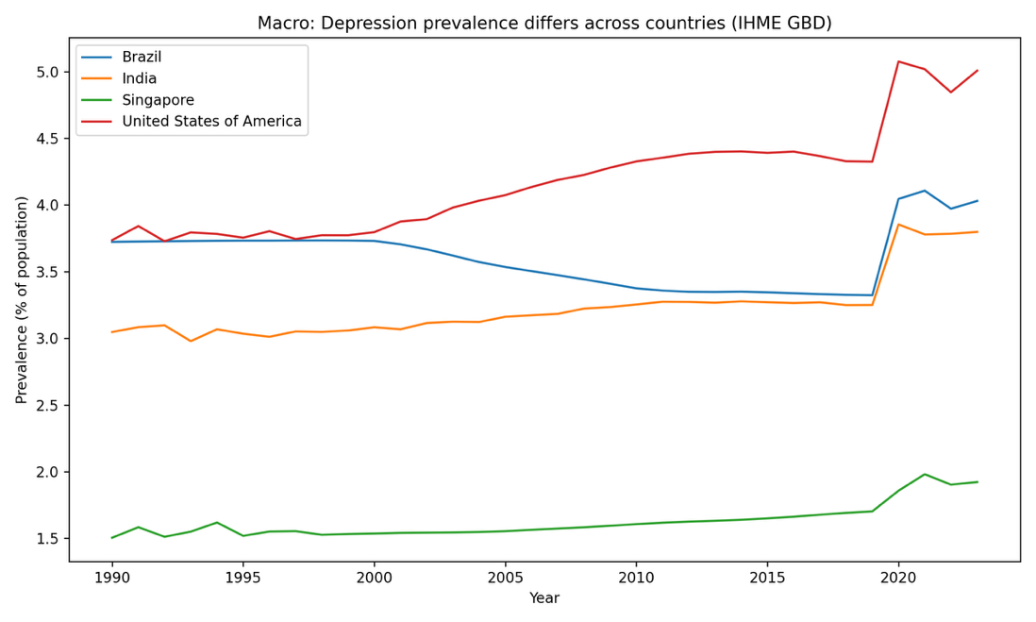

(Data obtained from Institute for Health Metrics and Evaluation (IHME), 2024.)
At a population level, depression has become a highly important subject because it is not just a clinical outcome but rather a systemic issue where even small percentage changes translate into large shifts in demand for primary care, referrals, and community support. To be able to know which sections of our society are victims of this issue, I constructed a multi-country time-series for countries from different socio-economic statuses and population sizes to develop a better understanding of the prevailing trend of “depression” across several countries and how this condition has progressed over the past 3 decades. The chart above shows that United States of America sits at a consistently higher prevalence than Brazil and India, while Singapore is substantially lower across the entire period. Interestingly, all prevalences jump upward around 2020, matching empirical evidences that depressive disorders increased globally in 2020 during the pandemic, which serves as a real-world reminder that mental health burden can surge rapidly, not just drift slowly with demographics. It must be well-noted that the data provided by IHME are estimates made, but still highly important as differences in depression prevalence across these countries can reflect the happiness and mental wellbeing of people in these countries. However, we cannot just look at this from a macro view, and diving deep into each of these countries in particular is also highly important to develop a better understanding of what factors are driving depression rates in each of these countries. 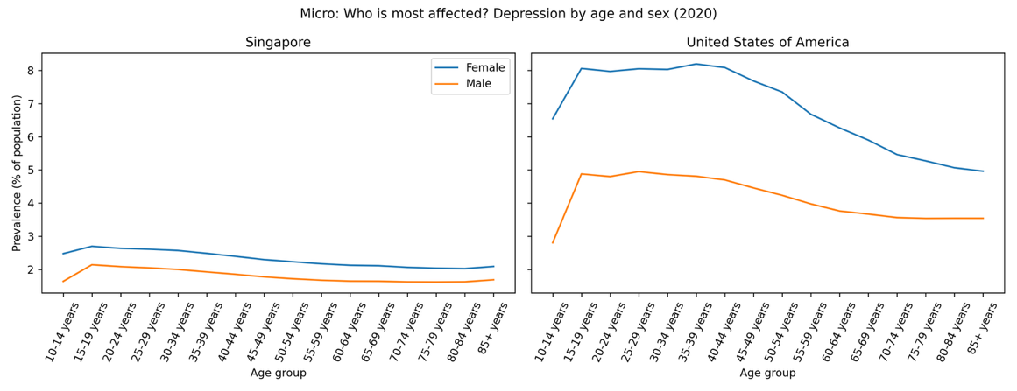

(Data obtained from Institute for Health Metrics and Evaluation (IHME), 2024.)
So, I dive into the 2 countries that demonstrate the highest and the lowest prevalences across the entire time period to try and develop a better understanding of the breakdown for depression prevalence across all ages. The reason why I chose both of these countries was because throughout majority of the time period were developed countries, which would typically correlate from a standard of living standpoint and also because it is able to tell me for which gender and what age groups is depression more prevalent and therefore allow me to develop a better understanding on who to target to cater solutions for depression.
To break it down, I decided to conduct an age-profile split by sex to better analyse the different curves for each sex. In both Singapore and US, female prevalence is higher than male across most ages, but the US profile shows a much higher plateau through adolescence/young adulthood, whereas Singapore’s profile is lower and flatter, with a mild plateau in the teenage years. This actually shows that for both countries, depression is more prevalent in general amongst the youth and females. This actually shows that targeted aid provided to these specific sections of society for these 2 countries will be highly beneficial in helping a country reduce its depression rates since burden concentrates in younger age bands (especially among females). A suggestion would be that in these countries, better support systems can be established at youth-friendly access points, and teachers should be trained to identify such signs early, while on a broader adult elevation, workplace pathways and continuity of care should also be provided should the country’s resources allow.However, it is important to note that the data provided does not measure access, diagnosis likelihood, stigma, or the rate where people seek help for mental health issues, which are other factors that will influence prevalence rates for depression.
So, what can we do from here? I felt that the outcome from the micro view earlier gave me the 2 most important groups that we should be targeting to help alleviate depression globally. With the youth and females being 2 groups within the population that demonstrated the greatest vulnerability to mental health issues, I felt that they should be the main groups where governments allocate resources to when dealing with mental health issues to see the greatest impact, especially for governments with a tight budget. Hence in order to capitalise on the new information discovered, I felt that there is a need to figure out which country has the greatest need for additional psychiatrist help. 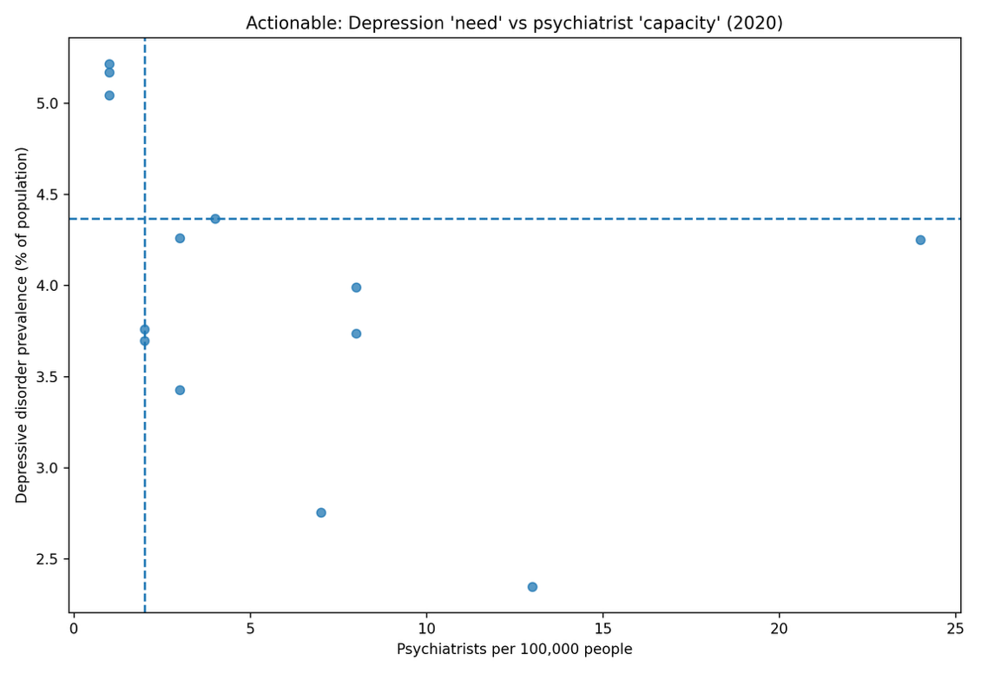
To do this, I did 2 plots using the same set of data, firstly a scatter plot because it reveals priority quadrants visually where countries above the horizontal and left of the vertical threshold are important candidates that require immediate expansion in its psychiatrist capacity that can start tackling this issue by catering such help to their youth and females. In fact to take this even further, I decided to rank countries in order of need to better understand the ranked list of countries that require immediate attention in descending order of need. One thing to note will be that I excluded psychiatrist density reported as 0 before ranking, since “0” can reflect missing reporting rather than true absence, which may disrupt the reliability of this list, but still good to have to start having these countries understand the needs of their people and how to better target the specific groups in their population to curb the pressing issue.

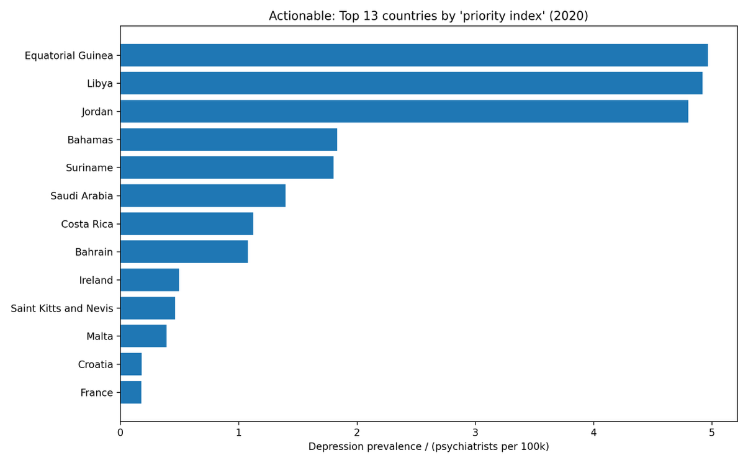

References
“Data Page: Psychiatrists per 100,000 people”, part of the following publication: Saloni Dattani, Lucas Rodés-Guirao, Hannah Ritchie, and Max Roser (2023) - “Mental Health”. Data adapted from WHO Mental Health Atlas 2020 via UNICEF. Retrieved from https://archive.ourworldindata.org/20250909-093708/grapher/psychiatrists-working-in-the-mental-health-sector.html [online resource] (archived on September 9, 2025).
Global Burden of Disease Collaborative Network. (2024). Global Burden of Disease Study 2023 (GBD 2023) results. Institute for Health Metrics and Evaluation (IHME). https://vizhub.healthdata.org/gbd-results/

Repository link: https://github.com/wongbenjamin25/dsa4262_assignment1_mentalhealth/tree/main

