Music Genre Prediction from Audio, Metadata and Text Features

1. Introduction

Nowadays, people have instant access to the terabytes of musical content via Internet and there are thousands of musics are published on music streaming platforms like Spotify, Apple Music and NetEase Music. Music can be categorized by its style and music genres are such categorical labels. These labels are related to the instrumentalization, rhythmic structure and harmonic content of the music[1]. Music genre is widely used and understood by people. People usually search musics by using music genre as keyword. And music genre is also essential for music streaming platforms making music collections and recommendation for users.

Traditionally, the music genres are labeled by human musical experts. However, human perception of music is dependent on a variety of personal, cultural and emotional aspects. Therefore its genre classiﬁcation results may avoid clear definition and the boundaries among genres are fuzzy[2].

The task of this report is attempt to build some supervised learning algorithms to automatically identify music genre with given dataset, and critically analyze the performance of these algorithms. Firstly, we explored the dataset and aimed to understand the relationship amongst features and the relationship between features and labels. Then, we decided to set up two models and develop multiple algorithms respectively to have automatic music genre classification. One is to extract lyrics as the feature vector, and the other is to extract all numeric features as new feature vectors. We also analyzed the relative advantages and disadvantages of each of the methods and finally reported our observations.

2.Related Work

Holistically there were two sides of the music genre classiﬁcation problem tackled by researchers; one side looked at lyrics of songs and constructed a model that would translate this into a genre, and one side looked at MFCC to create predictions[3].

Berton et al [4] used Radom Forest and Logistic Regression to make multi-class music emotion prediction. They found that Logistic Regression outperforms the Radom Forest for the lyrics analysis. Yunjing An et al [5] used Naive Bayes algorithm to make Chinese music emotion classification and their model achieved accuracy of 68%. Jayen Ram et al [3] used Naive Bayes, SVM to make lyrics-based music genre classification and used Neural Network to make prediction based on the frequency of th song, achieving accuracy of 88.5%, 88.2% and 95.6% respectively. Carlos N. Silla Jr. et al [1] proposed ensemble of classiﬁers. They combined the outputs provided by each individual classiﬁer such as SVM, Naive Bayes and MultiLayer Perceptron (MLP) through simple combination rules such as majority vote, max, sum and product rules. And they found the improvement in accuracy ranges from 1% to 7%.

3. Dataset

3.1 Data Analysis

Dataset is divided into two parts, one is features of songs, the other is labels of songs. The structure of features is track ID/title/tags/loudness/tempo/time signature/key/mode/duration and 148 columns containing pre-computed audio features of each song. And the structure of labels is corresponded track ID and genre.

After we analyzed the label datasets, we found that the distributions of genres in test dataset and validation dataset are different. Summarization shown in Figure 1. There is imbalance data distribution in test dataset; from Figure 1, we can see that in train dataset Jazz and Blues and Dance and Electronica are well below the mean, while Folk and Classic Pop and Rock are dominant in amount. And the data in validation dataset is in a relatively uniform distribution which is different from training dataset.

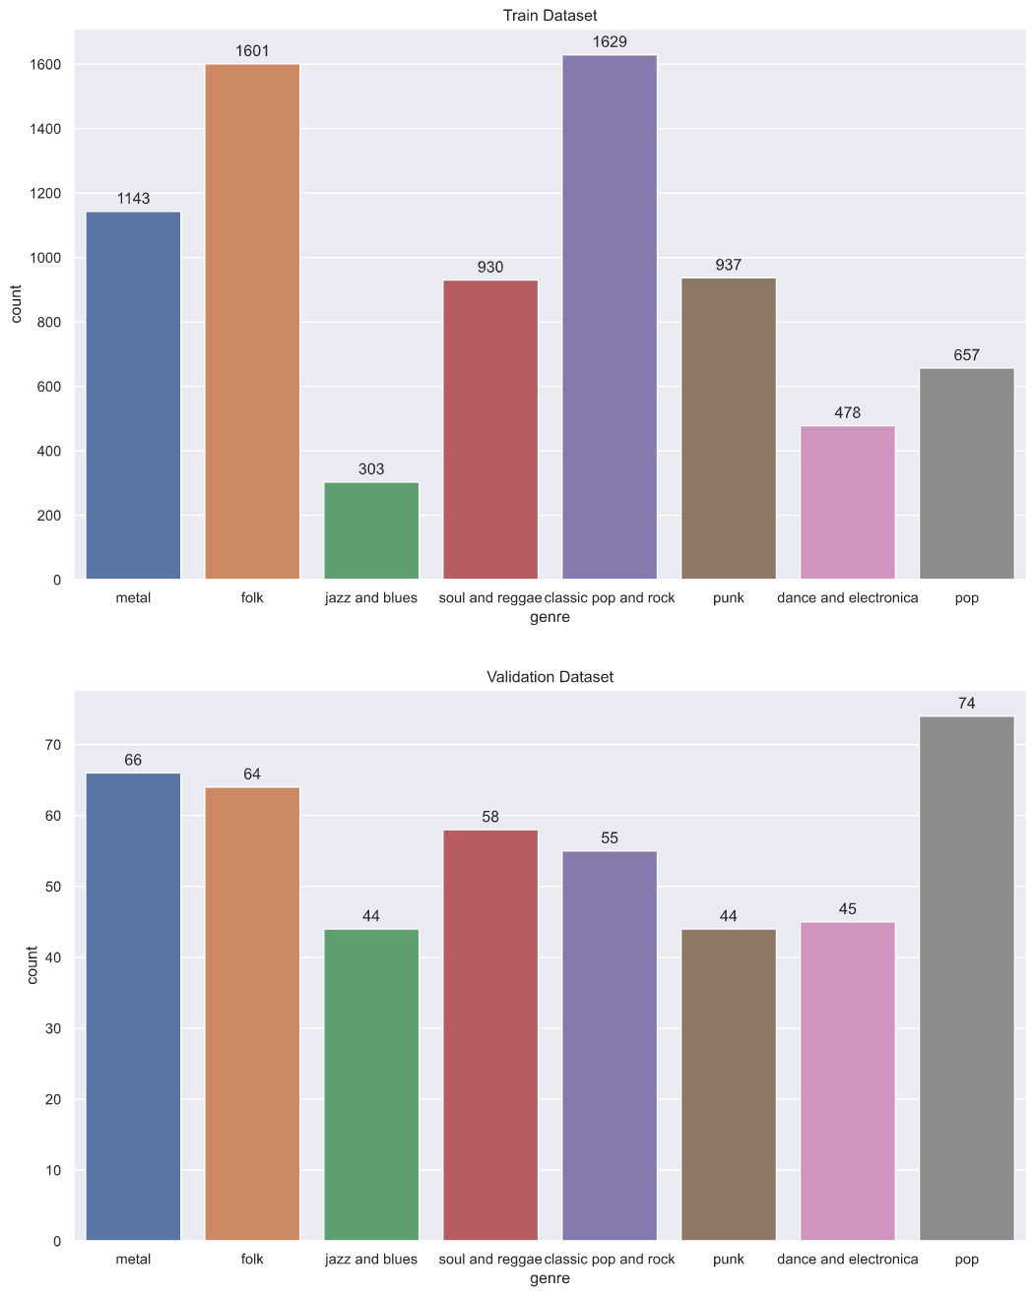

Figure 1: Analysis of data distribution in label dataset

4. Approches

We have taken two models to the problem. In our first model, we use text features (i.e. lyrics of songs) as our feature vector, and the genres as labels to identify. We implemented Bernoulli Naive Bayes, Multinomial Naive Bayes, Logistic Regression, Random Forest, MLP, KNN and Voting to classify musics into different genres. In our second model, we extracted numerical features as our feature vector and use it to identify the genre. We developed Gaussian Naive Bayes and KNN in this model.

4.1 Model I: Lyrics-based Classification

4.1.1 Preprocess

The tags , representing some words appeared in the lyrics of the songs, are stored in a list of comma-separated strings. In the preprocessing phase, we decided to have a text retrieval procedures for tags. Therefore, each unique item in tag is regarded as a feature. There are two approaches to describe the occurrence of word within a document. One simple approach is to count the word frequency in the whole lyrics collection, using CounterVectorizer in sklearn. Another approach is assigning a weight factor to each term in lyrics collection to reflect how important a word is, such as tf-idf, short for term frequency-inverse document frequency. Here, we use TfdifVectorizer in sklearn to implement tf-idf term weighting model. In this model, the tf-idf of a word in tags is computed as

$$\begin{matrix}\text{tf-idf(t,d)} & =\text{tf(t,d)}×\text{idf(t)} \\ \text{idf}(t) & =\text{log}\frac{1+n}{1+\text{df}(t)}+1\end{matrix}$$

, where $t$ is represented as term (i.e. the word), $n$ is the total number of tags in tag set, and $df(t)$ is the number of tags in the tag set that contain term $t$ [6]. After having a glance at tags, we observed that there are some words repeatedly occurs in multiple lyrics in different genre, such as "I". Hence, we decided to ignore those words appears in more than 25% of lyrics and those words appears in less than 4 lyrics.

4.1.2 Classifiers

We implement the following algorithms by using machine learning library for Python, sklearn, in hope of achieving high-fidelity music genre classification:

1. Bernoulli Naive Bayes
2. Multinomial Naive Bayes
3. Logistic Regression
4. Random Forest: the number of trees in forest is 100
5. Ensemble: Soft voting
6. MLP Model: having two hidden layers and both of them have 300 neurons using 'ReLU' activation function.
7. K-Nearest Neighbor: K is set to 30
8. Zero-R

Because there is data imbalance in training dataset, in order to solve this problem, for those classifiers which have class_weight parameter in their __init__ method, we set class_weight parameter to balanced to replicate minor classes until we have as many samples as in those majority classes. And for those classifiers which do not have class_weight parameter, we first estimated sample weights by class for each genre, then pass sample weights to sample_weight parameter in fit method when classifiers try to fit the features and labels in train dataset.

4.2 Model II: Audio-based Classification

4.2.1 Preprocess

In this model, we extract all numeric and audio-based features, including loudness, tempo, duration and all of audio features. We have also standardized our features by using StandardScaler from sklearn. Hence, we have two sets of features, one has been standardized and the other has not.

4.2.2 Classifiers

1. Gaussian Naive Bayes
2. KNN: K is set to 30
3. MLP Model: having two hidden layers and both of them have 110 neurons using 'ReLU' activation function.

5. Result and Conclusion

5.1 Model I

A summarization of result is demonstrated in the figure. We have tests for tf-idf vector and count vector, and we observed that tf-idf vector performs better in representation of words of lyrics. After transforming our lyrics into tf-idf vector, there are 4441 features in the vector. We used Zero-R as our baseline learner algorithm, and we can see its accuracy is quite low. Because there are 8 classes rather than 2 classes in our dataset and also there is no class that is overwhelmingly numerically dominant.

In singular classification algorithm, Logistic Regression performs better than any other algorithms. And the top four best performing algorithms are Logistic Regression, Multinomial Naive Bayes and Random Forest with the accuracy of 58.9%, 57.1%, 55.3% , 55.1% respectively.

Random Forest could handle large data sets with higher dimensionality. Also, Random Forest is an ensemble of Decision Trees, which can minimize the individual errors of trees and reduce overall variance and error. Therefore, it performs well in the prediction. However, Random Forest appears as a black box and we have little control on this algorithm. Logistic Regression is effective in this model using one-vs-rest policy. However, there is a high probability that some words are used in common in multiple song genres, which makes features in tf-idf vector correlated and less linear. And this could reduce the accuracy of Logistic Regression. Multinomial Naive Bayes can handle multiclass classification well., but the assumption of conditional independence of features does not hold. Because words in lyrics is natural language, it should be contextual and correlated.

We used soft Voting, which predicts the class label based on the *argmax* of the sums of the predicted probabilities, to combine Logistic Regression, Multinomial Naive Bayes and Random Forest, achieving accuracy of 61.6%.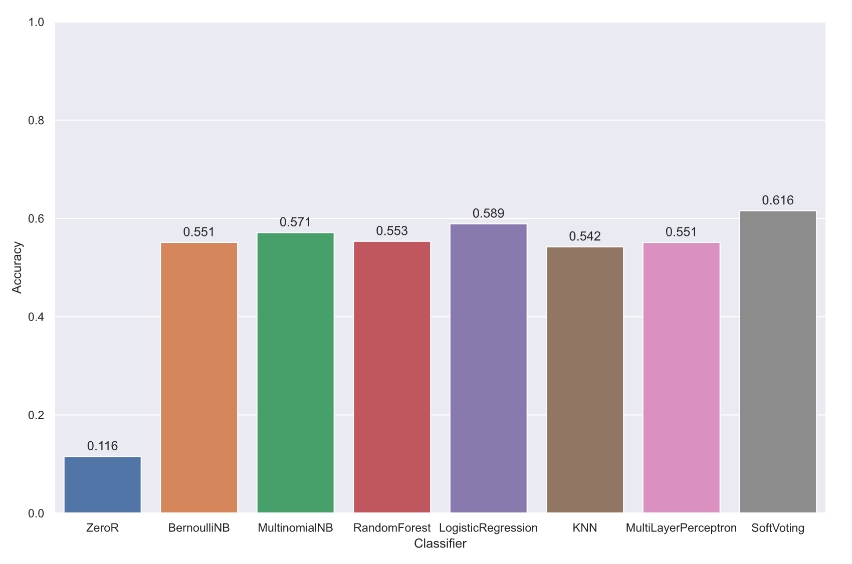

Figure 2: Comparison of Classifiers in Model I

5.2 Model II

In Figure 2, we observed that after having standardization in preprocessing phase, the accuracy of KNN and MLP increases from 32.4% to 45.6% and 29.6% to 49.6% respectively, while the accuracy of Gaussian Naive Bayes decreases from 49.1% to 37.8%.

From Figure 3, we found that standardization modified the distribution of data. So tha we conclude that with standardization, the accuracy of Gaussian Naive Bayes decreases because when having standardization is that Gaussian Naive Bayes makes assumption that the data has normal distribution while our data cannot retain normal distribution after having standardization scaling.

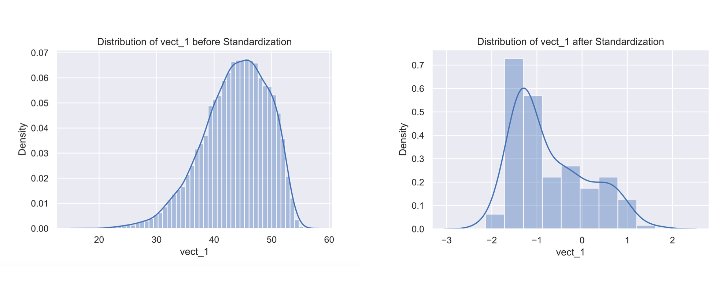

Figure 3: Standardization Affects Data Distribution

In KNN, the nearness of samples is typically based on Euclidean distance. And in our dataset, the ranges of our feature dimensions differ, and some may differ significantly from others. Those dimensions having small range may become uninformative and the algorithm would essentially rely on the single dimension whose values are substantially larger. After having standardization, we can map all of our feature dimensions to same range, and all features could make equal distribution to our KNN algorithm. Hence, the accuracy of KNN increases after we standardized our data.

In MLP, having standardization can make training faster and reduce the chances of getting stuck in local optima. Therefore, the accuracy of MLP also rise after having standardized inputs.



Figure 4: Comparison of Classifiers in Model II

References

[1] Silla Jr, C. N., Kaestner, C. A., & Koerich, A. L. (2007, October). Automatic music genre classification using ensemble of classifiers. In *2007 IEEE International Conference on Systems, Man and Cybernetics* (pp. 1687-1692). IEEE.

[2] Chathuranga, D., & Jayaratne, L. (2012, September). Musical genre classification using ensemble of classifiers. In *2012 Fourth International Conference on Computational Intelligence, Modelling and Simulation* (pp. 237-242). IEEE.

[3] Ram, J., & Salz, D. Using Song Lyrics and Frequency to Predict Genre.

[4] Berton, T., Delvenne, J. C., & Saerens, M. Importance of instrumentals, vocals and lyrics in music emotion classification: based on random forest and logistic regression.

[5] An, Y., Sun, S., & Wang, S. (2017, May). Naive Bayes classifiers for music emotion classification based on lyrics. In *2017 IEEE/ACIS 16th International Conference on Computer and Information Science (ICIS)* (pp. 635-638). IEEE.

[6] <https://scikit-learn.org/stable/modules/feature_extraction.html>

[7] Bertin-Mahieux, T., Ellis, D. P., Whitman, B., & Lamere, P. (2011). The million song dataset.

[8] Schindler, A., Mayer, R., & Rauber, A. (2012, October). Facilitating Comprehensive Benchmarking Experiments on the Million Song Dataset. In *ISMIR* (pp. 469-474).