OTHER SUPPORTING DOCUMENT (Page 1 of 4) — HKUST BEng in CS Application
Candidate: Hiu Tung Cheung (Esther / 張曉彤) | HKIIT / IVE (Lee Wai Lee) | CGPA: 3.91 / 4.0 | TIER 1: TECH COMMUNITY LEADERSHIP, INDUSTRY REPRESENTATION & ACADEMIC EXCELLENCE
Visual Evidence / Photo | Supporting Details & Relevance to HKUST CS (Re-Ranked by Impact)
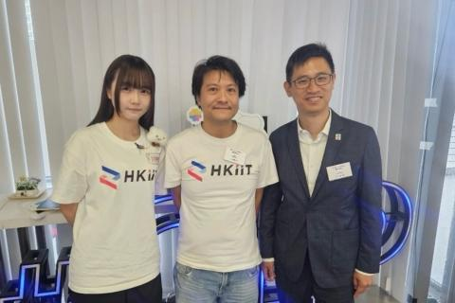  Esther with HKIIT Cloud Innovation Centre mentor Cyrus Wong & industry leadership | [RANK #1 — TRIPLE CAMPUS TECH COMMUNITY LEADERSHIP]  1st AWS Student Builder Leader, GDG on Campus Leader & Red Hat Ambassador  • Simultaneously leads three major developer communities at HKIIT: Inaugural AWS Student Builder Group Leader '26, Google Developer Group (GDG) on Campus Leader, and Hong Kong's first Red Hat Student Ambassador.  • Organizes campus Cloud Study Jams, AI workshops, and peer study groups—empowering fellow students to learn cloud computing, Linux, and container technologies.  • Why it matters for HKUST CS: Demonstrates rare initiative, peer mentorship, and ecosystem-building leadership that will enrich HKUST's student computing community.
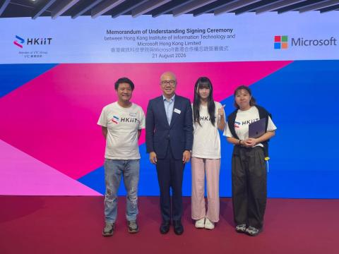  Official MoU Signing Ceremony between HKIIT and Microsoft Hong Kong (21 Aug 2026) | [RANK #2 — FLAGSHIP INSTITUTIONAL & ENTERPRISE REPRESENTATION]  Student Keynote Presenter — HKIIT × Microsoft Hong Kong MoU Signing Ceremony  • Selected as the sole student keynote presenter to represent HKIIT before Microsoft Hong Kong executives and VTC senior leadership.  • Delivered live demonstrations of student-built AI solutions (ProvePresent & AI Virtual Tutor), translating technical cloud workflows into clear, impactful presentations.  • Why it matters for HKUST CS: Proves exceptional communication poise, reliability under pressure, and ability to bridge academic projects with industry stakeholders.
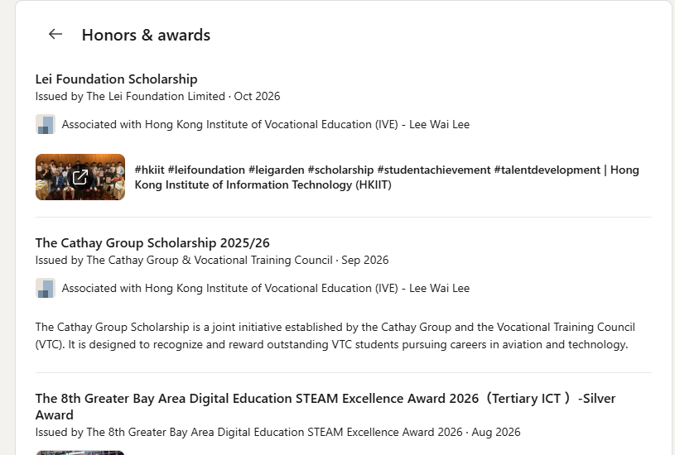  Verified LinkedIn Honors record: Lei Foundation & Cathay Group Scholarships | [RANK #3 — ACADEMIC EXCELLENCE & PRESTIGIOUS SCHOLARSHIPS]  3.91 / 4.0 CGPA, The Cathay Group Scholarship & Lei Foundation Scholarship  • Maintains a near-perfect Cumulative GPA of 3.91 / 4.0 in the Higher Diploma in Cloud and Data Centre Administration at HKIIT / IVE (Lee Wai Lee).  • Awarded both The Cathay Group Scholarship 2025/26 (recognizing top VTC talent in aviation and technology) and the Lei Foundation Scholarship for academic & leadership distinction.  • Why it matters for HKUST CS: Confirms her strong academic discipline, consistent work ethic, and readiness for rigorous university-level coursework.

OTHER SUPPORTING DOCUMENT (Page 2 of 4) — HKUST BEng in CS Application
Candidate: Hiu Tung Cheung (Esther / 張曉彤) | HKIIT / IVE (Lee Wai Lee) | CGPA: 3.91 / 4.0 | TIER 2: PUBLIC SPEAKING, OPEN-SOURCE CONFERENCES & DEVELOPER ADVOCACY
Visual Evidence / Photo | Supporting Details & Relevance to HKUST CS (Re-Ranked by Impact)
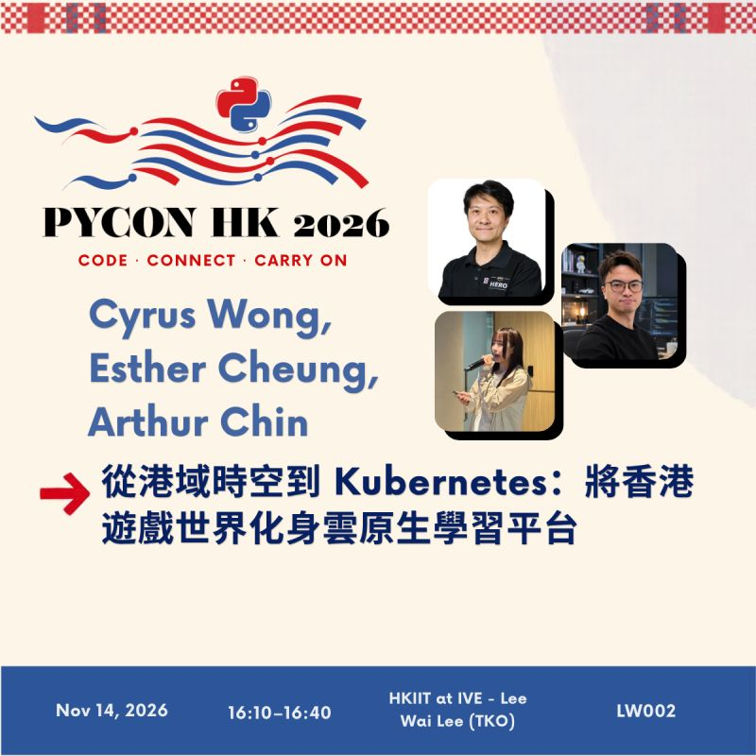  Official PyCon HK 2026 Speaker Poster (Cyrus Wong, Esther Cheung, Arthur Chin) | [RANK #4 — NATIONAL & REGIONAL CONFERENCE CO-SPEAKER (PYCON HK 2026)]  PyCon Hong Kong 2026: Transforming 'Hong Kong Zero' into a Kubernetes Learning Platform  • Invited co-speaker presenting '從港域時空到 Kubernetes：將香港遊戲世界化身雲原生學習平台' (From Hong Kong Zero to Kubernetes).  • Collaborated with mentors and teammates to validate the gamified student learning experience and demonstrate how in-game quests connect to live Kubernetes tasks.  • Why it matters for HKUST CS: Highlights her passion for making complex cloud-native concepts accessible and engaging for beginner developers.
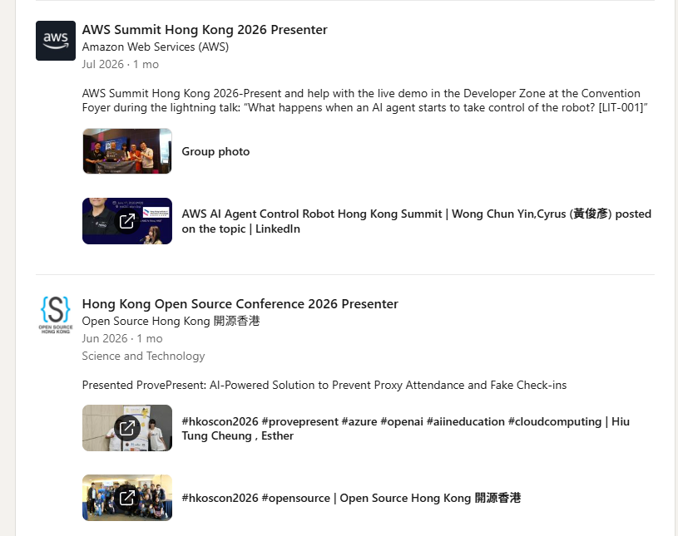  Verified presenter records for AWS Summit HK 2026 & HKOSCon 2026 | [RANK #5 — INDUSTRY SUMMIT & OPEN-SOURCE CONFERENCE PRESENTER]  AWS Summit Hong Kong 2026 & Hong Kong Open Source Conference (HKOSCon 2026)  • AWS Summit HK 2026 (Developer Zone): Co-presented and assisted with the live robotics demo for 'What Happens When an AI Agent Takes Control of a Robot? [LIT-001]'.  • HKOSCon 2026 Speaker: Presented 'ProvePresent (真出席) - AI Anti-Proxy Attendance Solution' to the Hong Kong open-source community.  • Why it matters for HKUST CS: Shows extraordinary confidence in stepping onto major public tech stages to share applied AI and cloud team projects.
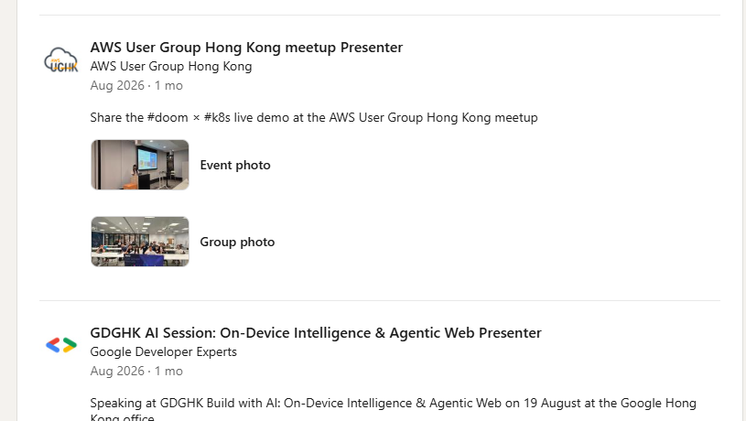  Verified speaking roles at AWS User Group HK & GDGHK AI Session | [RANK #6 — DEVELOPER MEETUP & GOOGLE HK COMMUNITY WORKSHOPS]  GDGHK Build with AI (Google HK Office) & AWS User Group Hong Kong Presenter  • Google Hong Kong Office ('GDGHK Build with AI'): Spoke on 'On-Device Intelligence & Agentic Web' and assisted at Google Cloud Leaders Connect HK 2026.  • AWS User Group HK Meetup: Shared the '#doom × #k8s' interactive live demonstration with local cloud engineers and practitioners.  • Why it matters for HKUST CS: Reflects sustained, active engagement with Hong Kong's professional practitioner communities beyond the classroom.

OTHER SUPPORTING DOCUMENT (Page 3 of 4) — HKUST BEng in CS Application
Candidate: Hiu Tung Cheung (Esther / 張曉彤) | HKIIT / IVE (Lee Wai Lee) | CGPA: 3.91 / 4.0 | TIER 3: TEAMWORK IN REGIONAL COMPETITIONS, SOCIAL IMPACT & CERTIFICATIONS
Visual Evidence / Photo | Supporting Details & Relevance to HKUST CS (Re-Ranked by Impact)
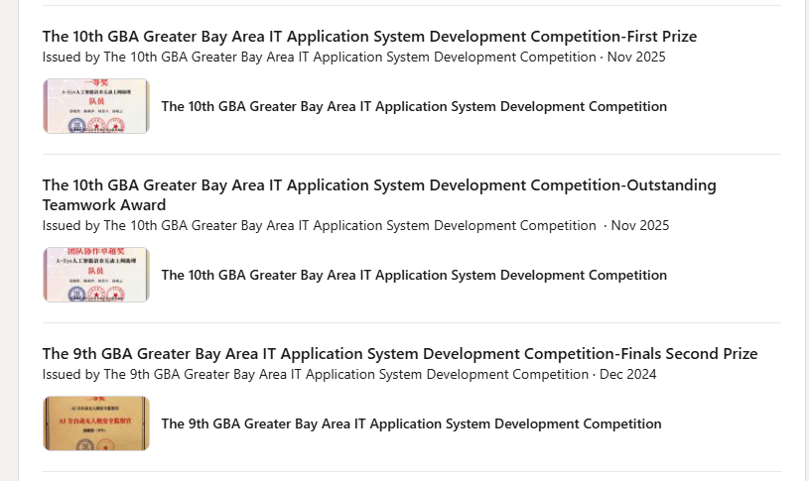  Verified certificates for 10th GBA First Prize, Outstanding Teamwork & 9th GBA Second Prize | [RANK #7 — GREATER BAY AREA (GBA) COMPETITION TEAMWORK & CHAMPIONSHIPS]  10th GBA IT Competition First Prize & Outstanding Teamwork Award (+ 9th & 8th GBA Awards)  • Won First Prize (一等獎) and the Outstanding Teamwork Award (團隊協作卓越獎) at the 10th GBA IT Application System Development Competition ('A-Eye' project).  • Also earned Finals Second Prize at the 9th GBA IT Competition, Silver Award at the 8th GBA STEAM Excellence Award (Tertiary ICT), and Best Application Award at the 8th GBA Finals.  • Why it matters for HKUST CS: Serves as the collaborative glue in project teams—excelling at coordination, user-centric design, testing, and pitching.
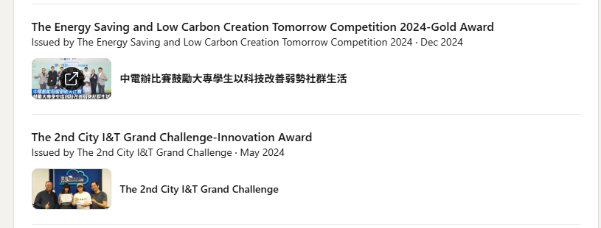  Media feature on CLP Gold Award & 2nd City I&T Grand Challenge Innovation Award | [RANK #8 — TECHNOLOGY FOR SOCIAL GOOD & SMART CITY INNOVATION]  CLP Energy Saving Competition Gold Award & 2nd City I&T Grand Challenge Innovation Award  • Gold Award (CLP Competition 2024): Recognized in local press ('中電辦比賽鼓勵大專學生以科技改善弱勢社群生活') for applying technology to improve the lives of underprivileged communities.  • Innovation Award (2nd City I&T Grand Challenge): Recognized by the HKSAR Innovation and Technology Commission (ITC) for community-focused smart city innovation.  • Why it matters for HKUST CS: Demonstrates strong empathy and a commitment to applying computing for social good and community well-being.
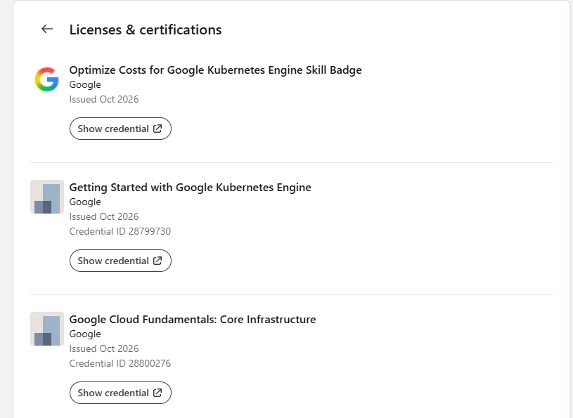  Verified Google Kubernetes Engine (GKE) & Cloud Infrastructure credentials | [RANK #9 — SELF-MOTIVATED MULTI-CLOUD & LINUX LEARNING (16 CREDENTIALS)]  16 Verified Certifications Across Google Cloud (GKE), Red Hat (Linux/Ansible) & AWS  • Proactively completed 16 industry certifications and skill badges to better understand the cloud and open-source technologies she advocates for.  • Includes AWS Certified Cloud Practitioner, Google Cloud GKE Skill Badges, and 4 Red Hat credentials (RH124 System Admin, RH294 Ansible, DO188 Podman/OpenShift, CL110 OpenStack).  • Why it matters for HKUST CS: Proves her self-discipline and eagerness to build solid technical foundations alongside her community work.

OTHER SUPPORTING DOCUMENT (Page 4 of 4) — HKUST BEng in CS Application
Candidate: Hiu Tung Cheung (Esther / 張曉彤) | HKIIT / IVE (Lee Wai Lee) | CGPA: 3.91 / 4.0 | TIER 4: PUBLIC AI OUTREACH, ACADEMIC TRANSFORMATION & ENDORSEMENT SUMMARY
Visual Evidence / Photo | Supporting Details & Relevance to HKUST CS (Re-Ranked by Impact)
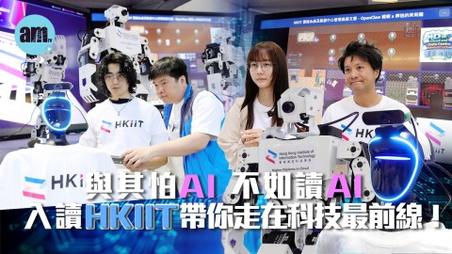  Featured media interview promoting AI & Cloud education at HKIIT | [RANK #10 — PUBLIC AI OUTREACH, MEDIA AMBASSADOR & ELDERLY TECH LITERACY]  Featured Student in '與其怕AI，不如讀AI' Media Series & CLP Elderly AI Workshops  • Featured in public media interviews ('與其怕AI，不如讀AI') and HKIIT Info Days, demystifying AI and cloud computing for secondary students and parents.  • Volunteered as a workshop presenter with CLP Power Hong Kong (Apr 2026) to teach elderly citizens practical, everyday uses of generative AI.  • Why it matters for HKUST CS: Embodies an inclusive, service-oriented mindset—sharing technology knowledge with both youth and senior citizens.
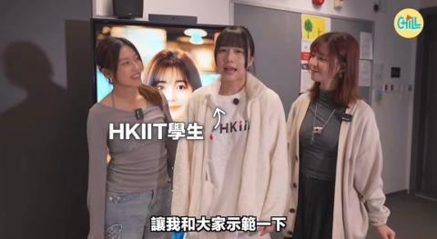  Esther demonstrating cloud & AI learning experiences in campus video series | [RANK #11 — CAMPUS AMBASSADOR & UPWARD ACADEMIC TRANSFORMATION]  From Youth College Outstanding Learning Award to 3.91 CGPA Higher Diploma Leader  • While earlier secondary public exam results did not reflect her potential, Esther blossomed completely once she found her passion in Information Technology.  • Earned the Youth College Outstanding Learning Award & Extracurricular Award (2023) before achieving a 3.91 / 4.0 CGPA and 13 honors in her Higher Diploma.  • Why it matters for HKUST CS: Her sustained tertiary excellence proves her true academic aptitude and determination to succeed at university.
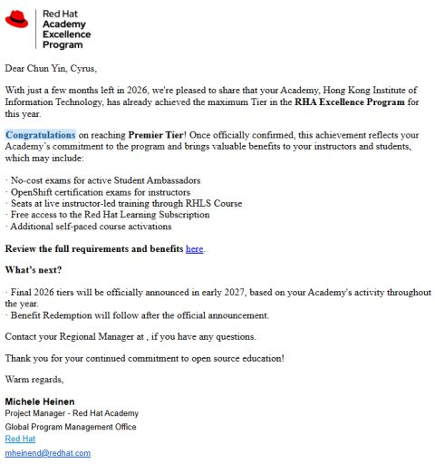  Official Red Hat Academy Premier Tier recognition supported by Esther's ambassadorship | [RANK #12 — INSTITUTIONAL IMPACT & WHY HKUST COMPUTER SCIENCE]  Driving HKIIT to Red Hat Premier Tier & Seeking Deeper CS Foundations at HKUST  • Her active student ambassadorship helped propel HKIIT to the highest 'Premier Tier' in the Red Hat Academy Excellence Program.  • Self-aware & growth-oriented: Having experienced the tech industry through community leadership and live demos, she is eager to strengthen her core coding and theoretical CS depth at HKUST.  • Mentor's Endorsement (Cyrus Wong, Senior Lecturer): 'Esther will bring unmatched energy, teamwork, and community leadership to HKUST CSE.'

