User manual

How to get started?

Go to http://35.200.104.44/src/retrieveMovie .

Please use Google Chrome.

The username of admin is admin.

The password of admin is 1234.

Some explanation:

- Source code of the file is stored at src folder.

- Unit tests are located at spec & tests foleder.

- This project is using a simple custom MVC framework

- Database script and sample data are stored at database folder

- The javascript validation code is stored at src/jslibs/validator.js

- The environment is defined in Docker, so if you have Docker installed, you can run the init-containers.sh to start the webserver. If not, just go to the hyperlink provided above.

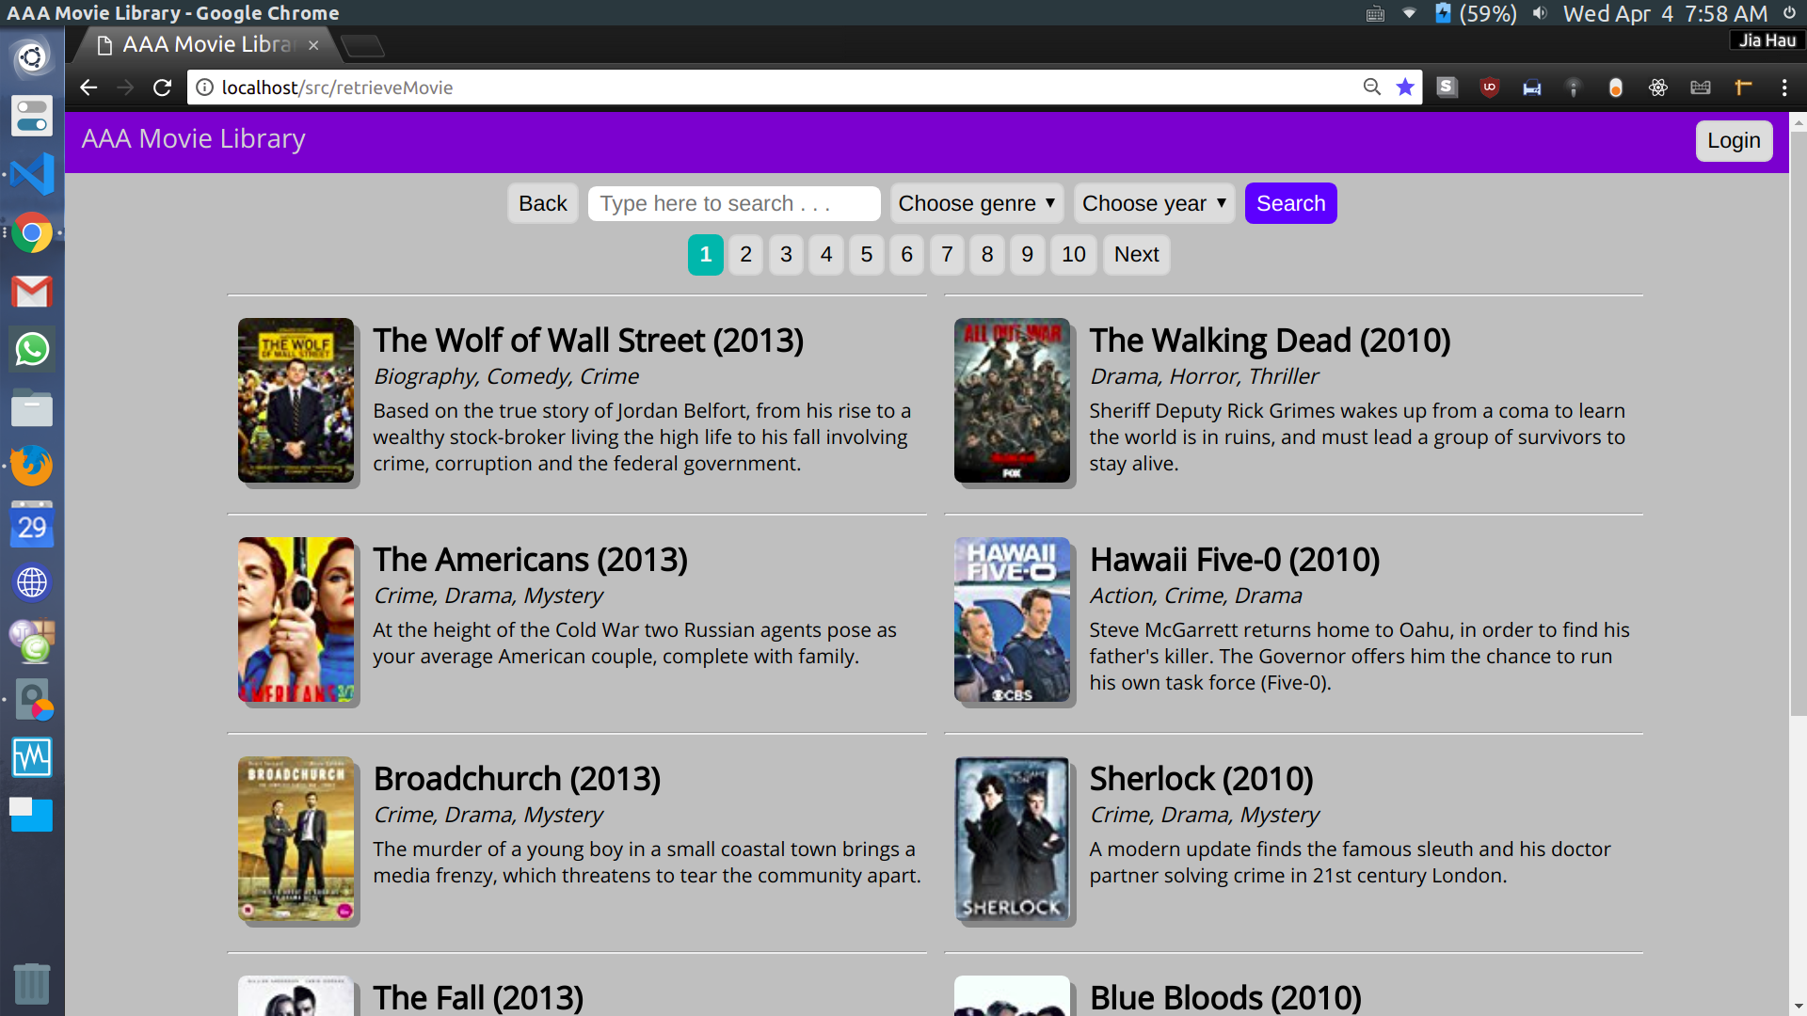
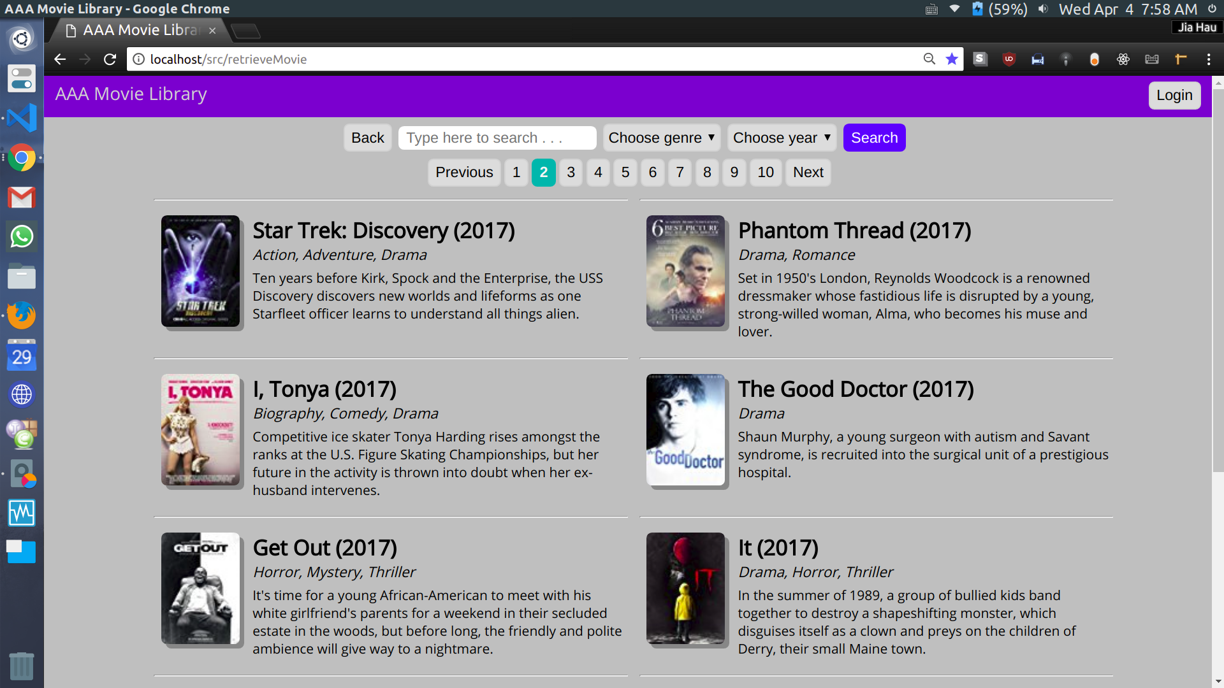
Display movies

Go to page 2

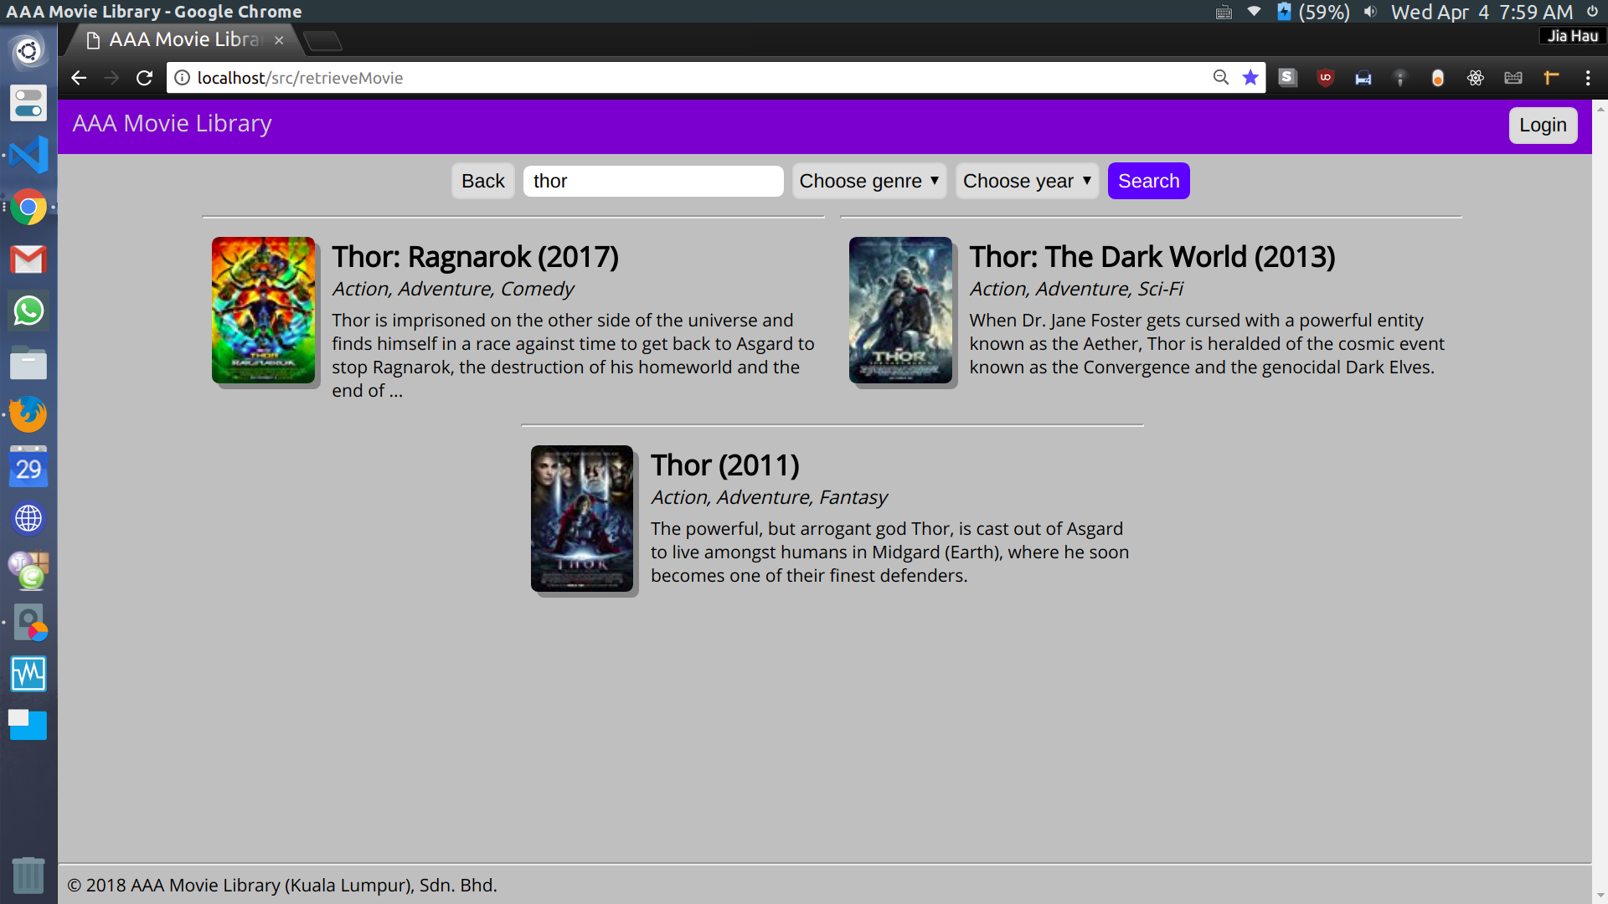
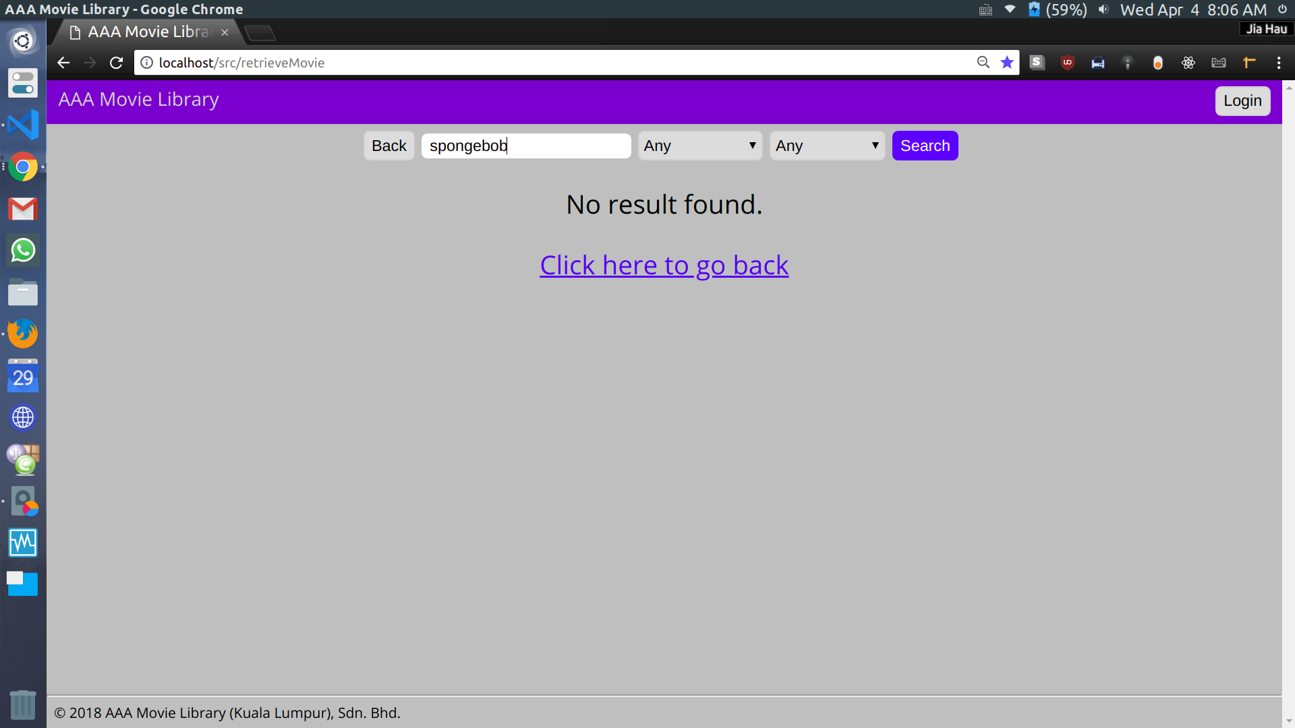
Search by title

Search by genre
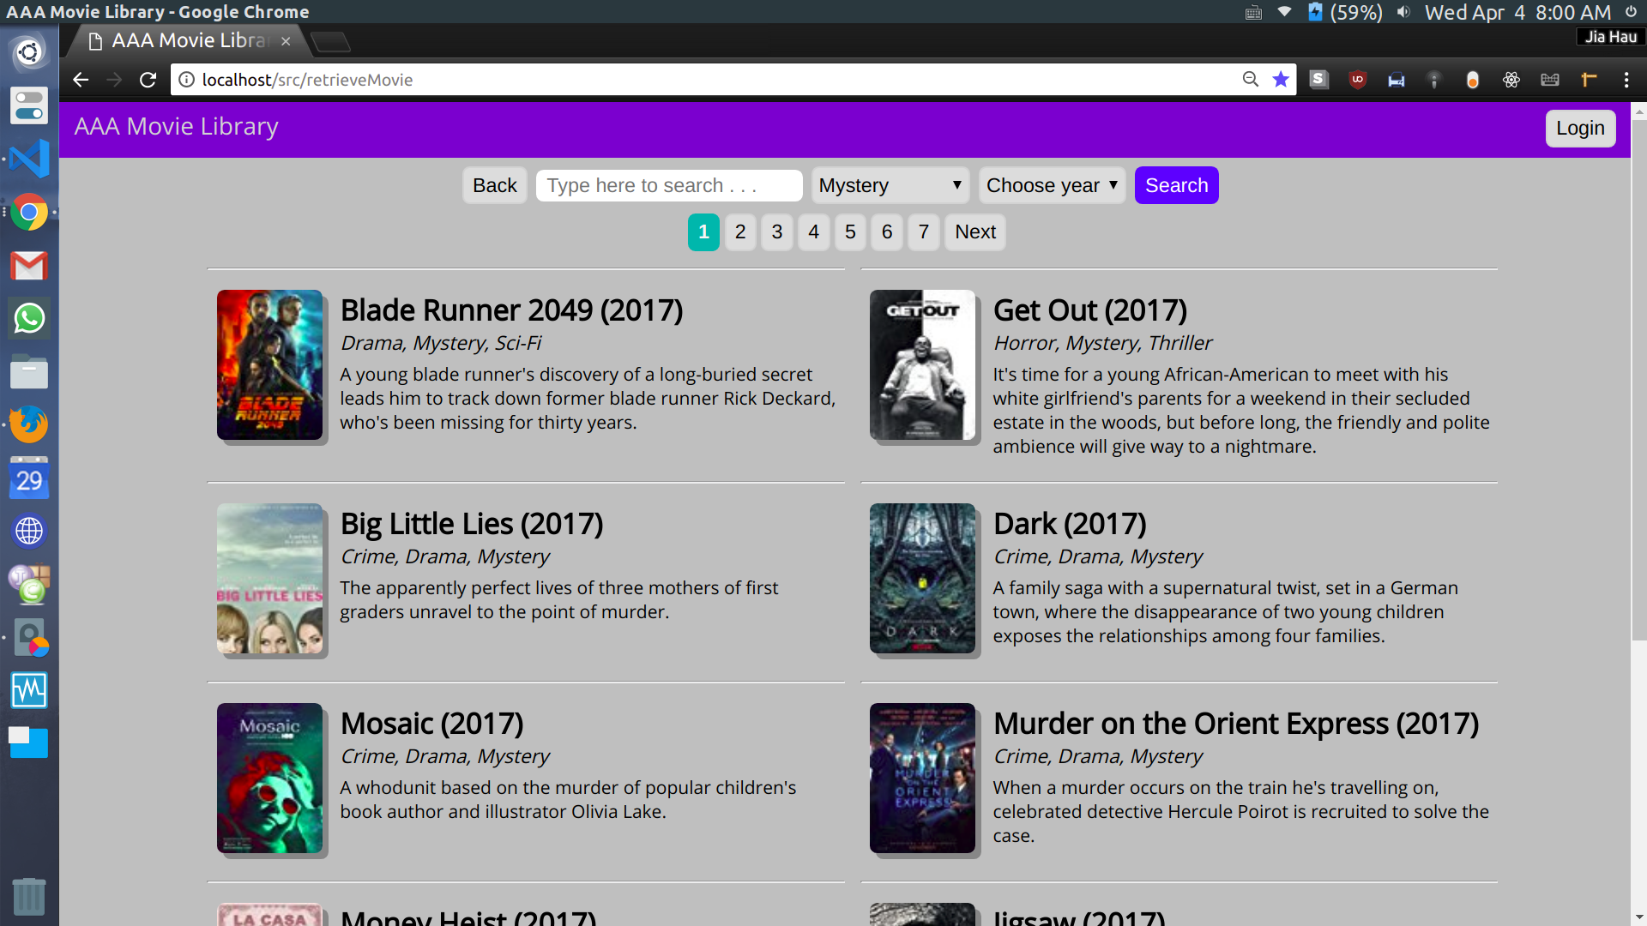
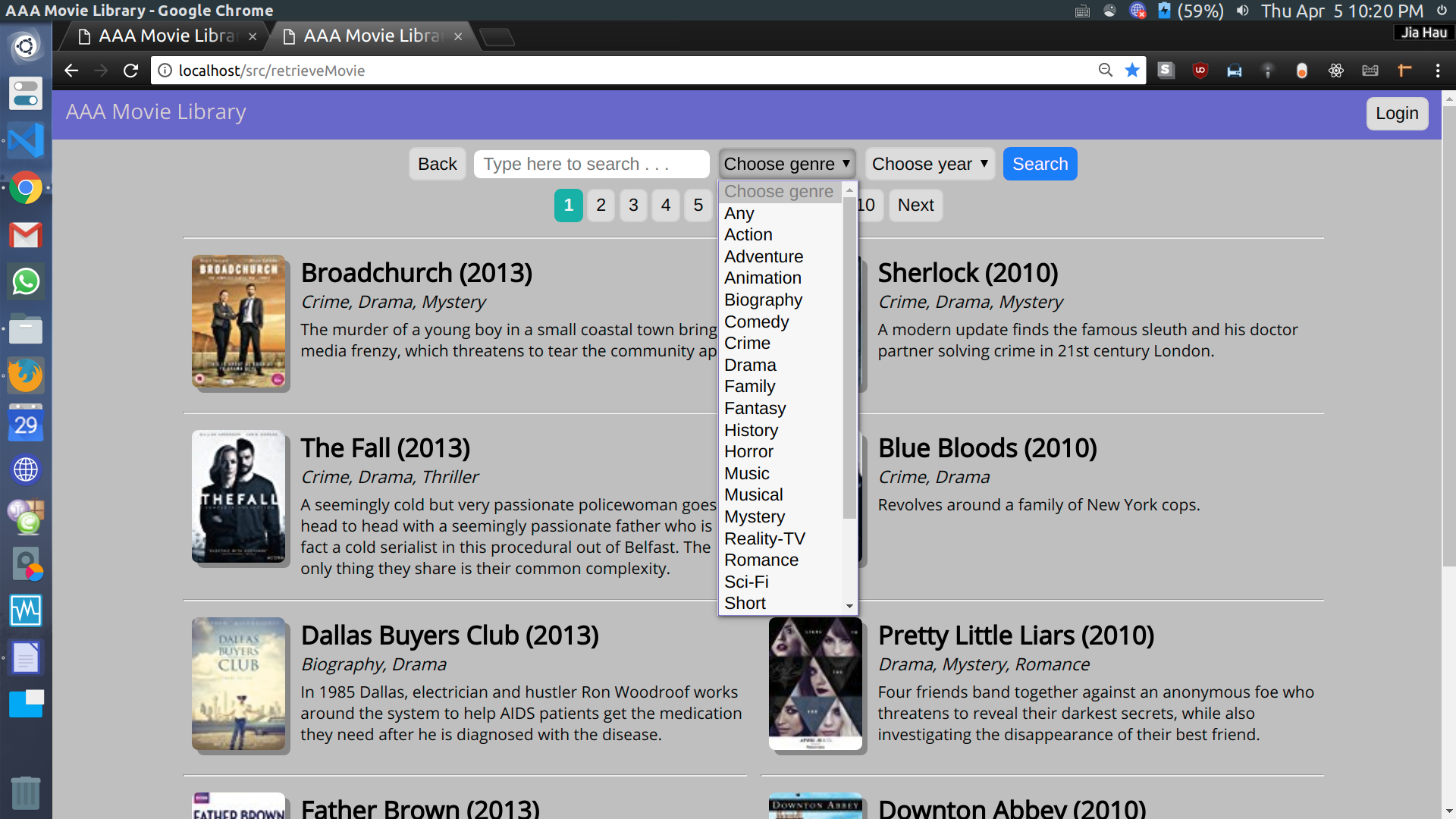

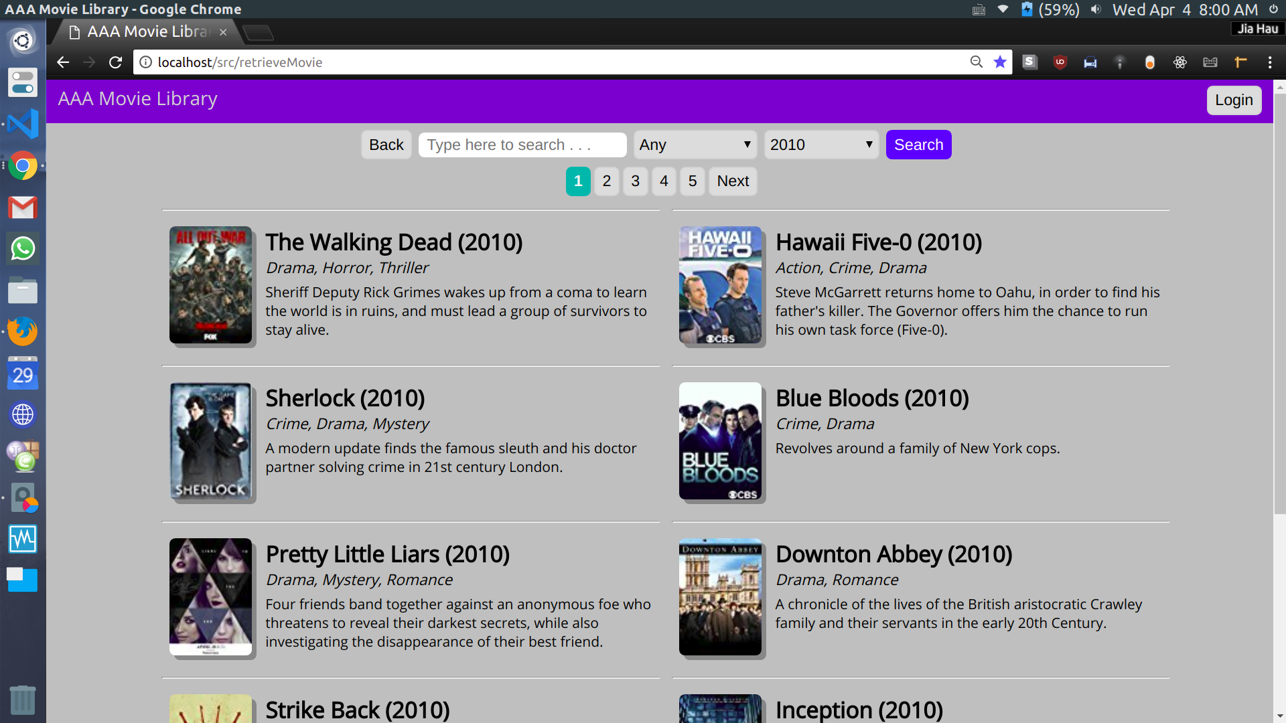
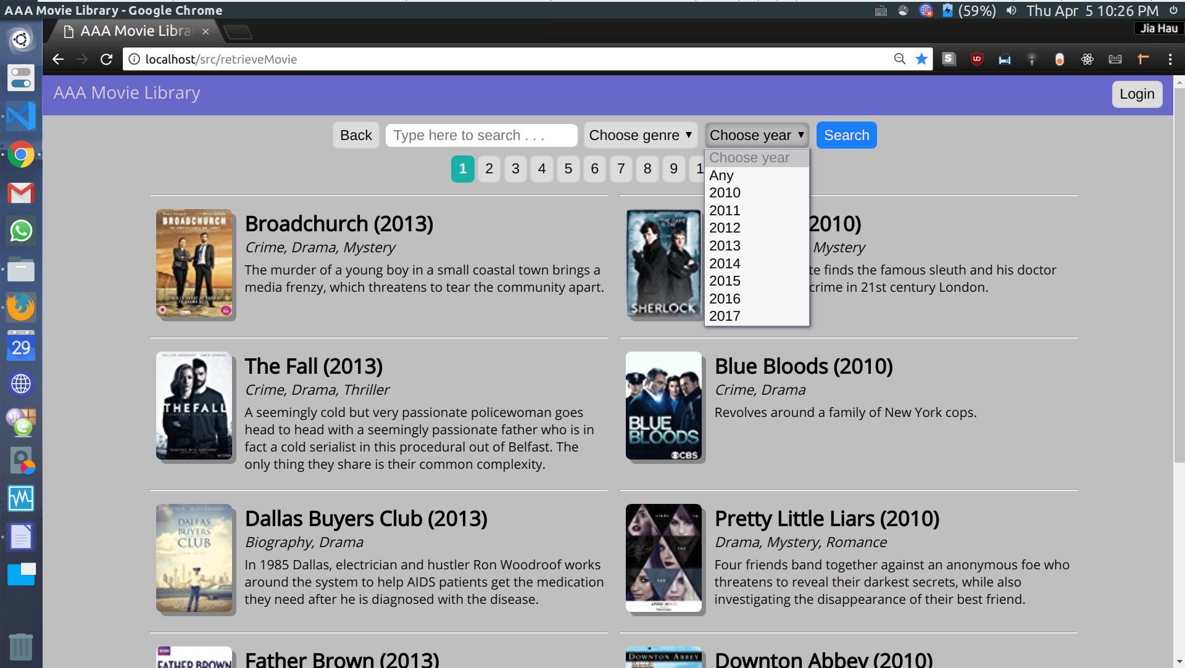
Search by year

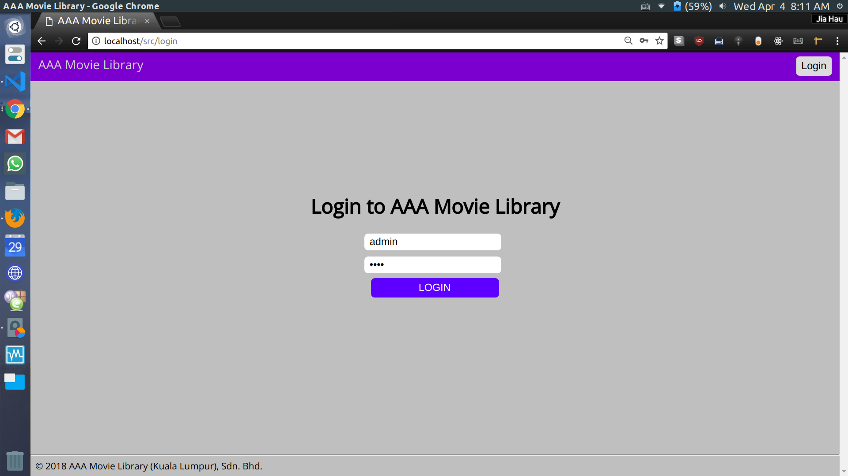
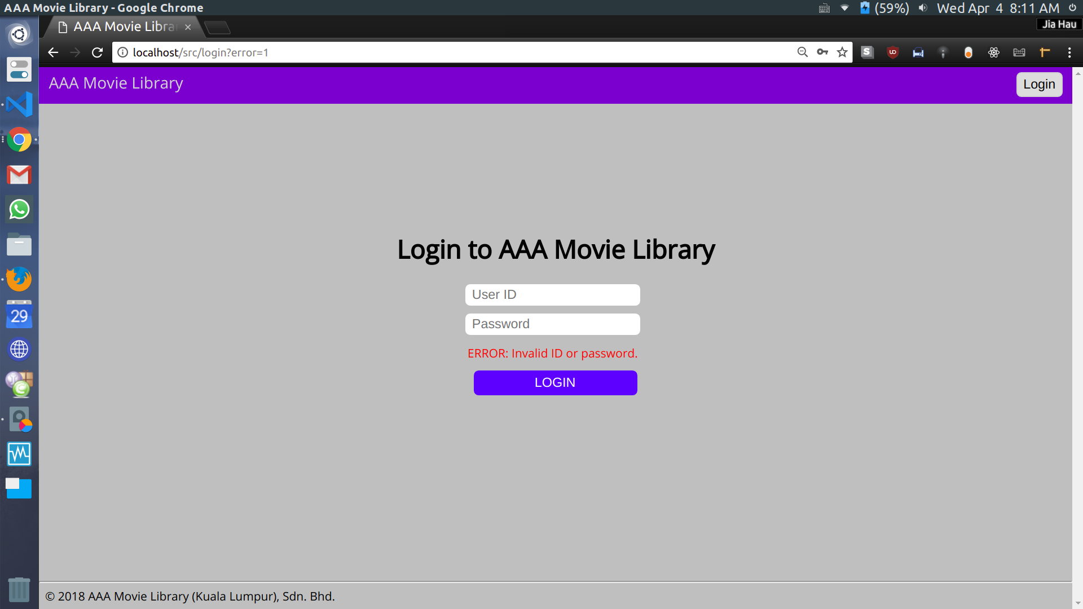
Admin login

Login failure

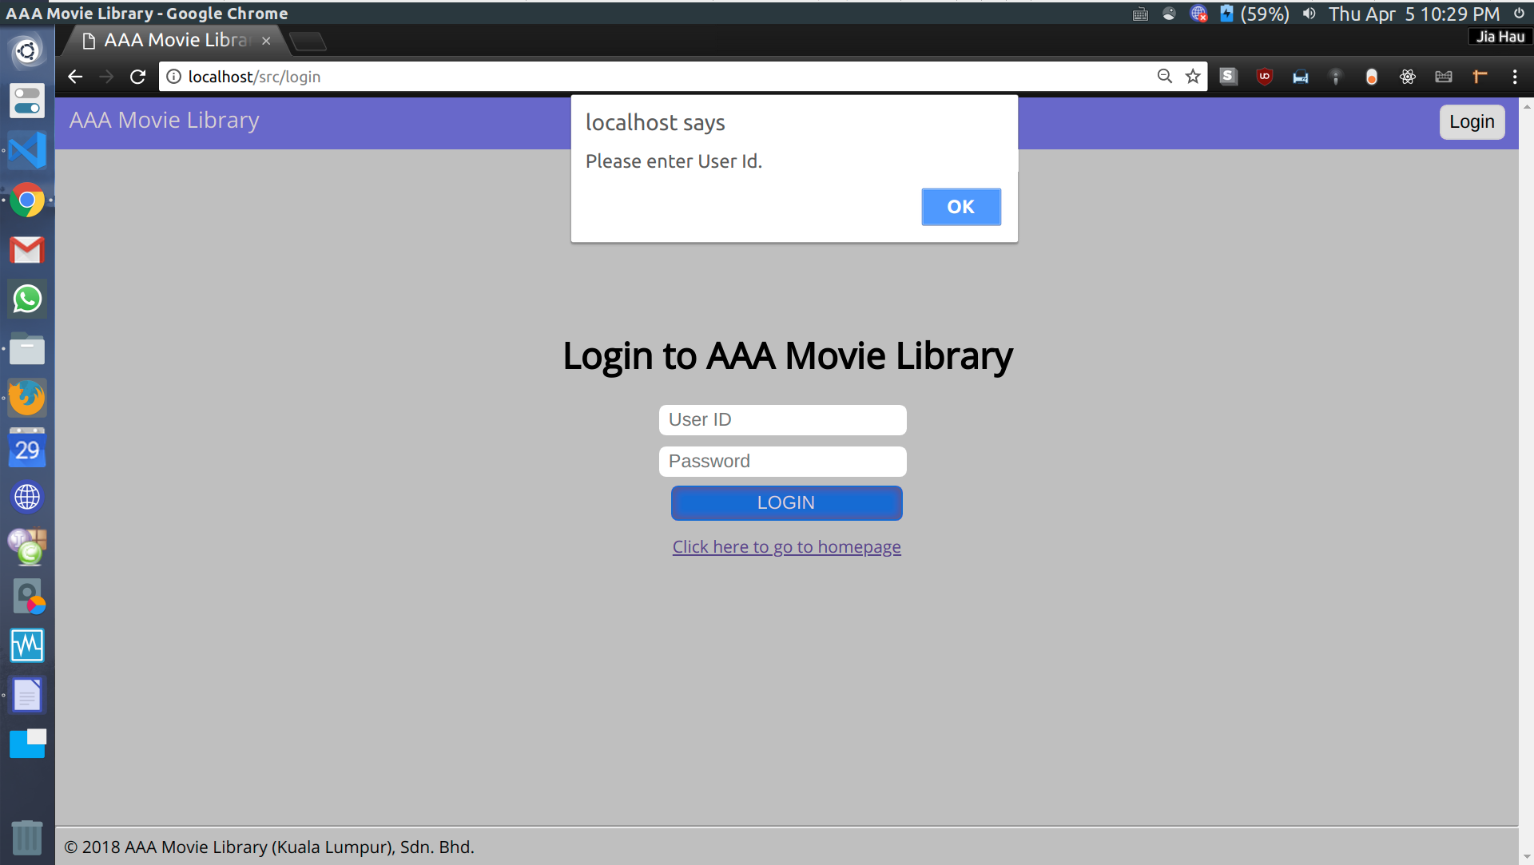
Login validation (1)

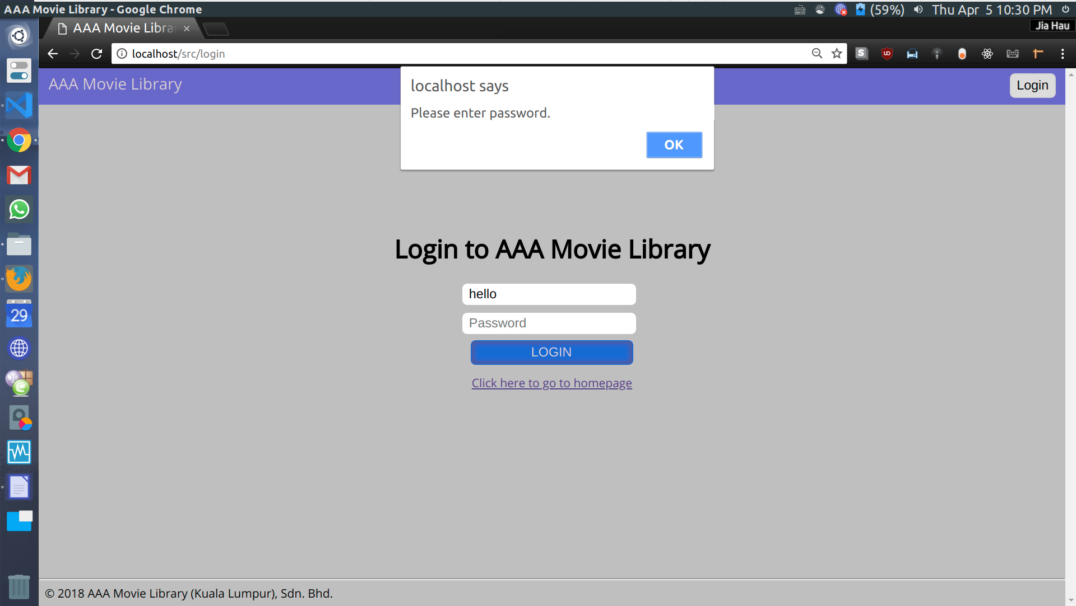
Login validation (2)

Admin panel
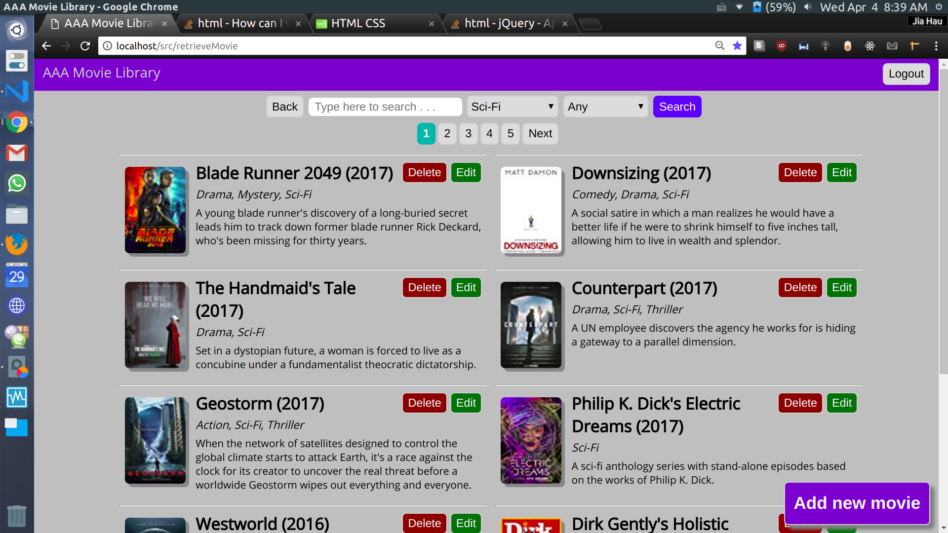

Add new movie (Step 1)
Click on the “Add new movie” button.
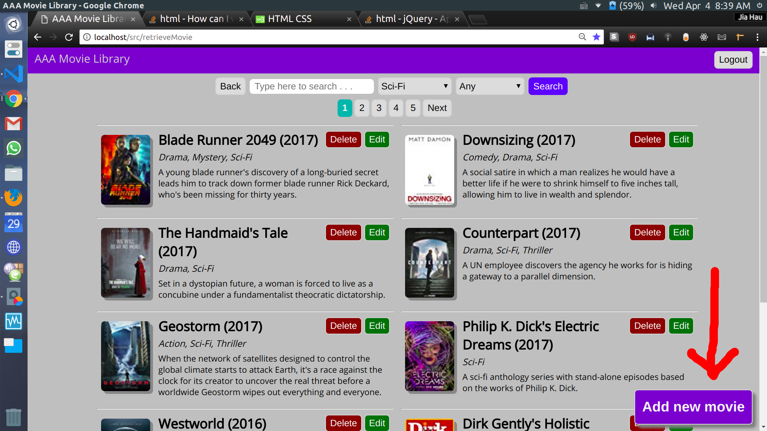

Add new movie (Step 2)
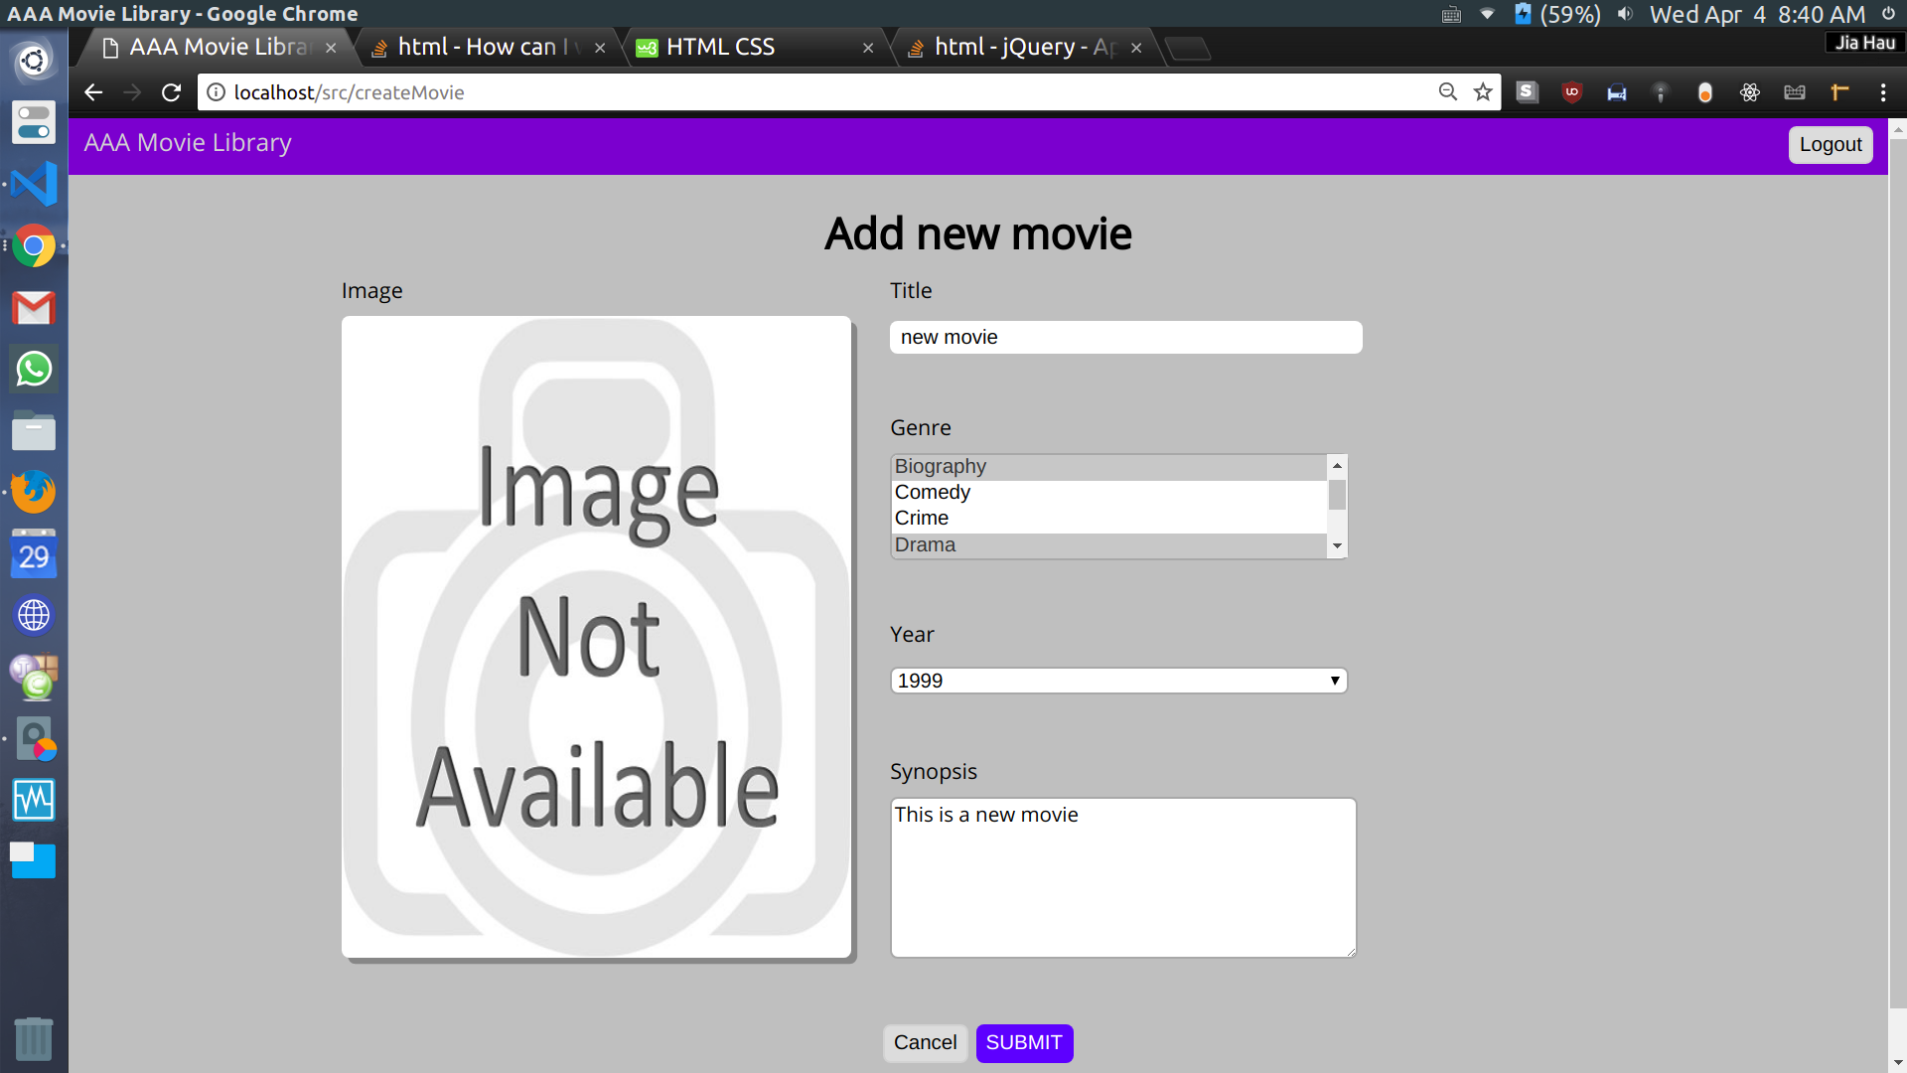
Enter details. You can select multiple genres.

Add new movie (Step 3)
Click on the image to select file to upload.
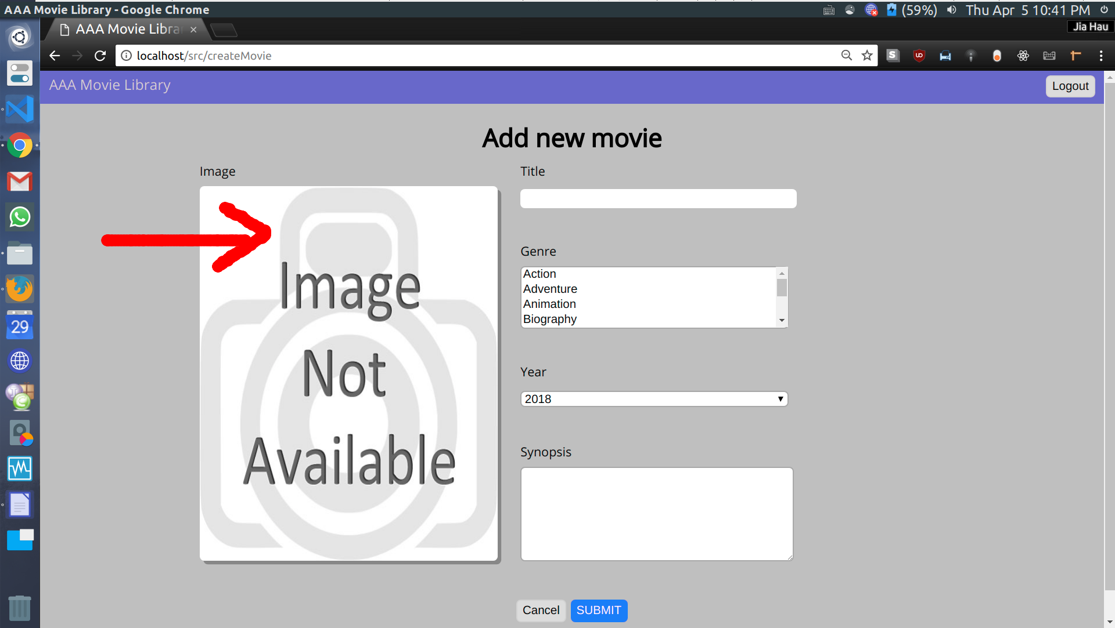

Add new movie (step 4)
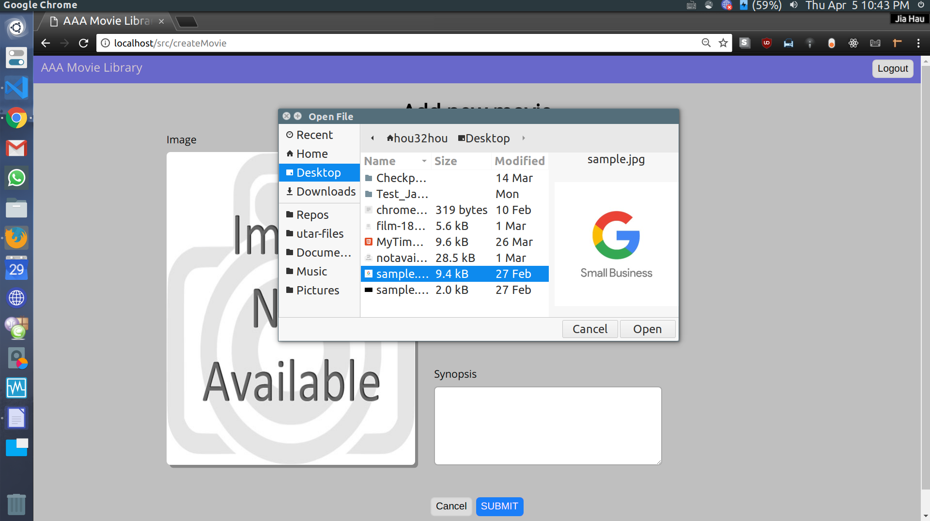
Select a file to upload.

Add new movie (Step 5)
Click on Submit button.
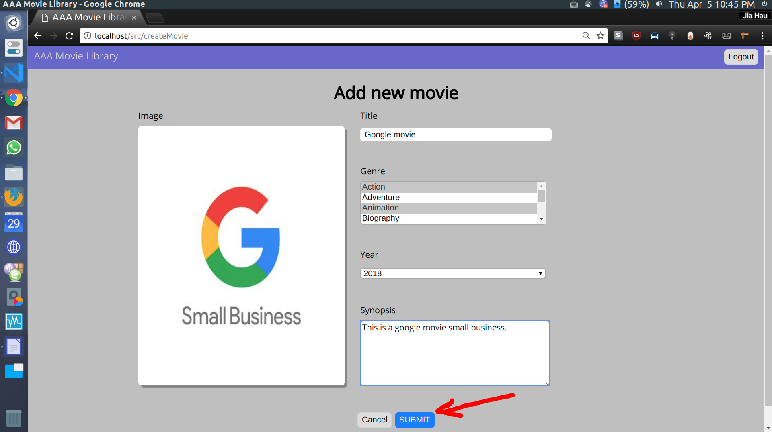

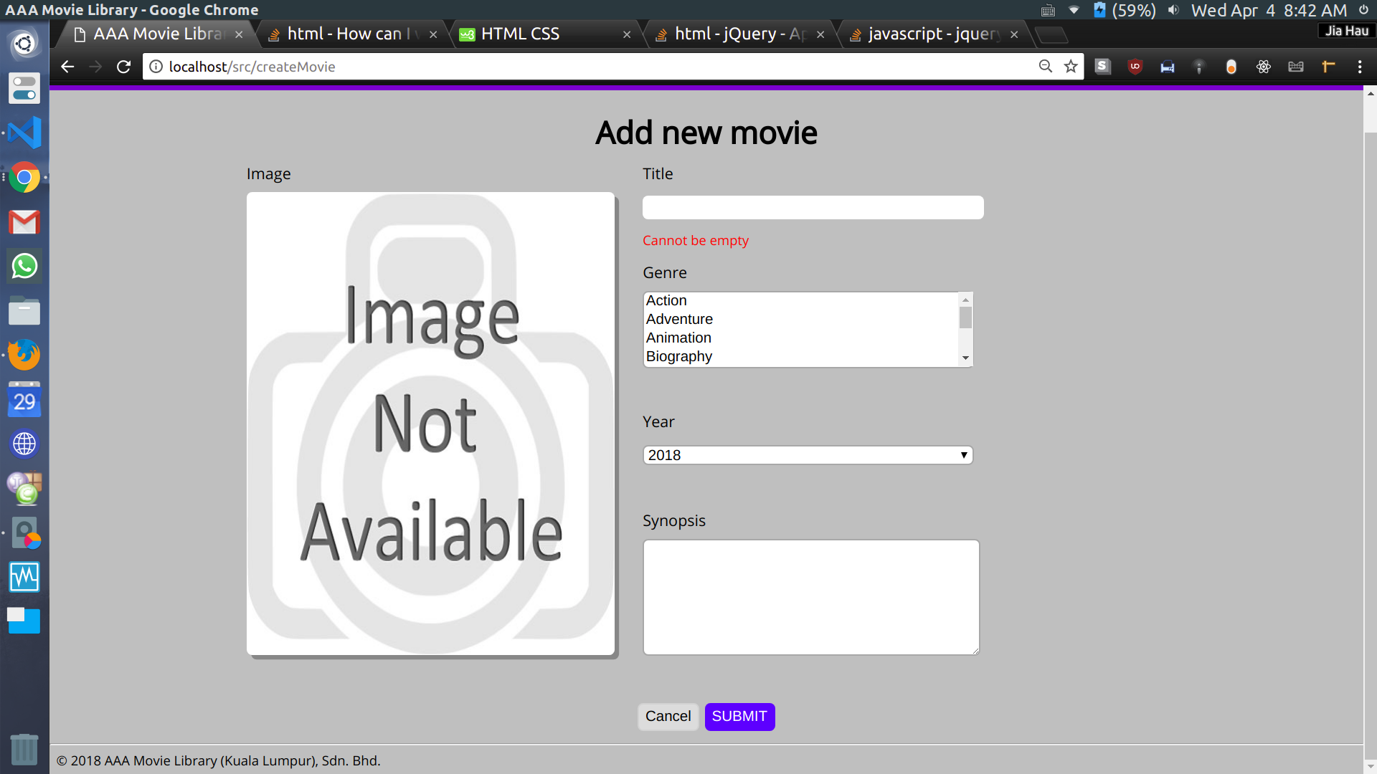
Form validation 1

Form validation 2
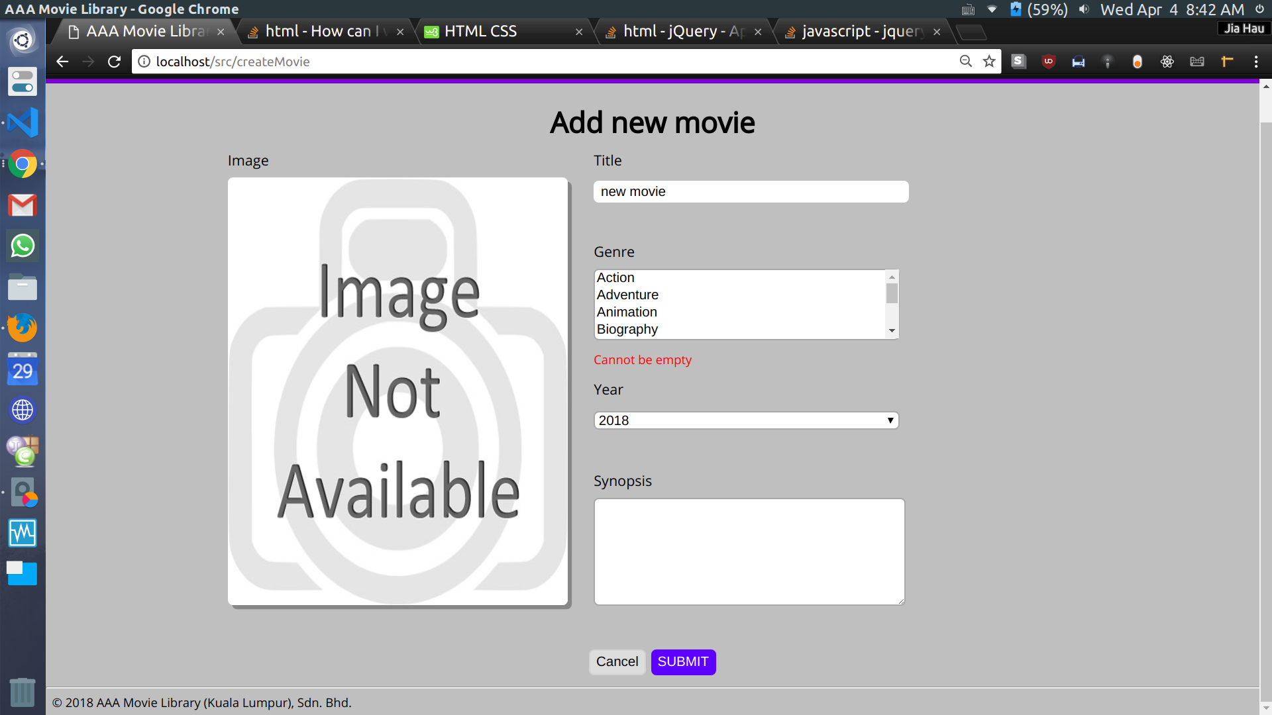

Form validation 3
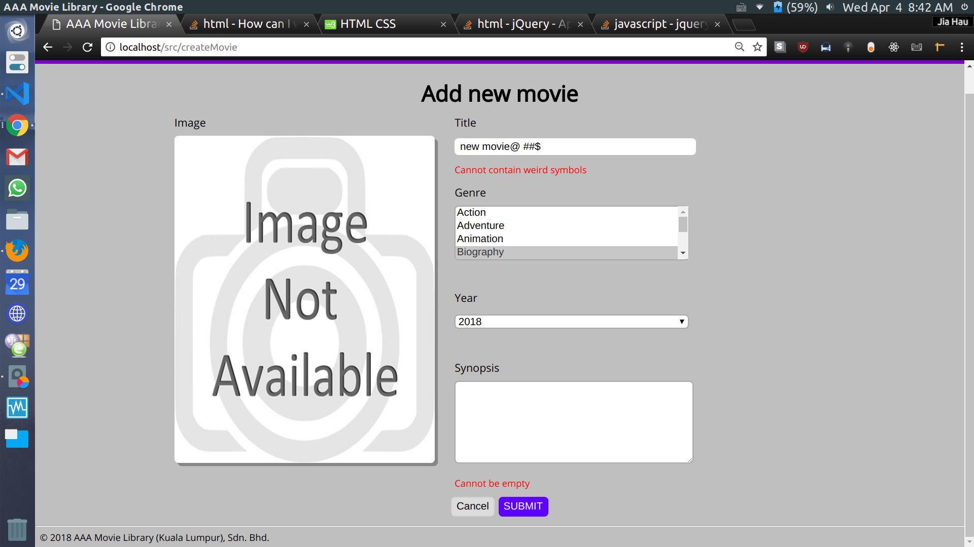

Form validation 4
User cannot upload non-image file.
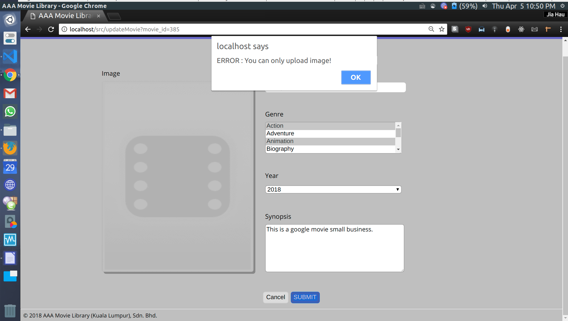

Update movie (Step 1)
Click on the Edit button.
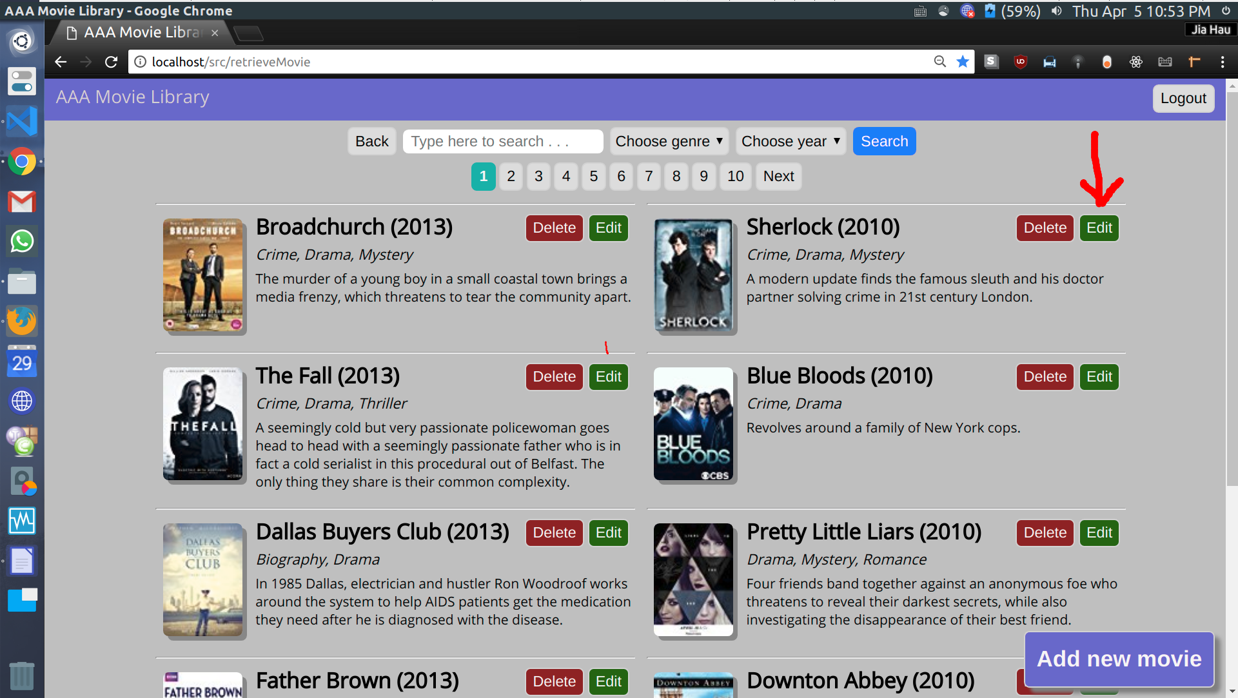

Update movie (Step 2)
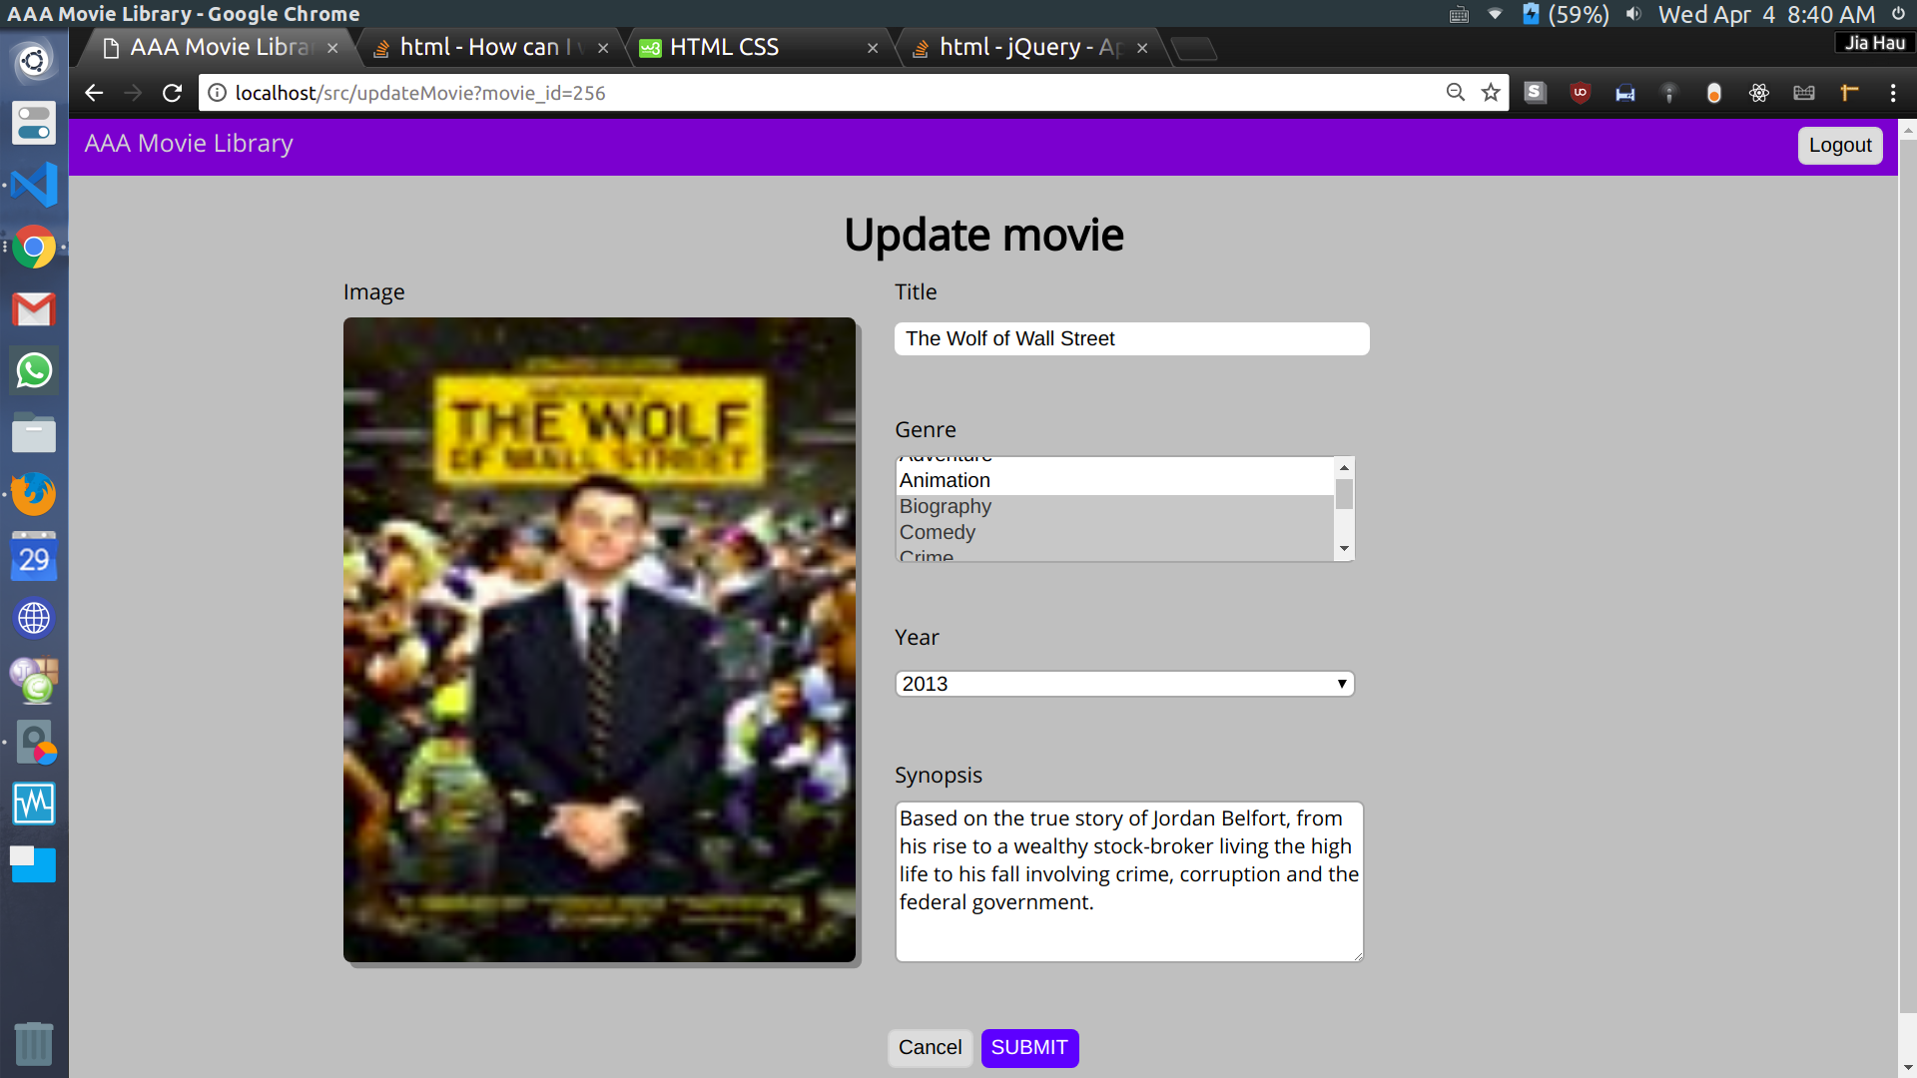
Change the field value and click on the Submit button

Delete movie (Step 1)
Click on the Delete button.
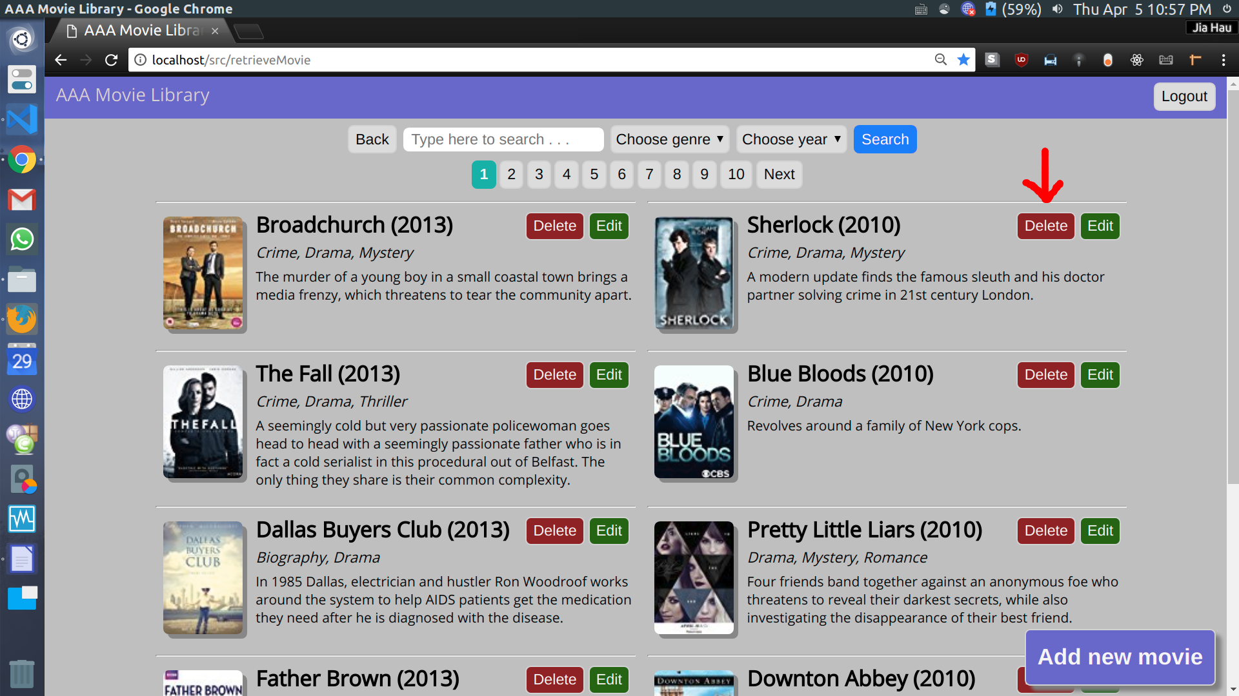

Delete movie (Step 2)
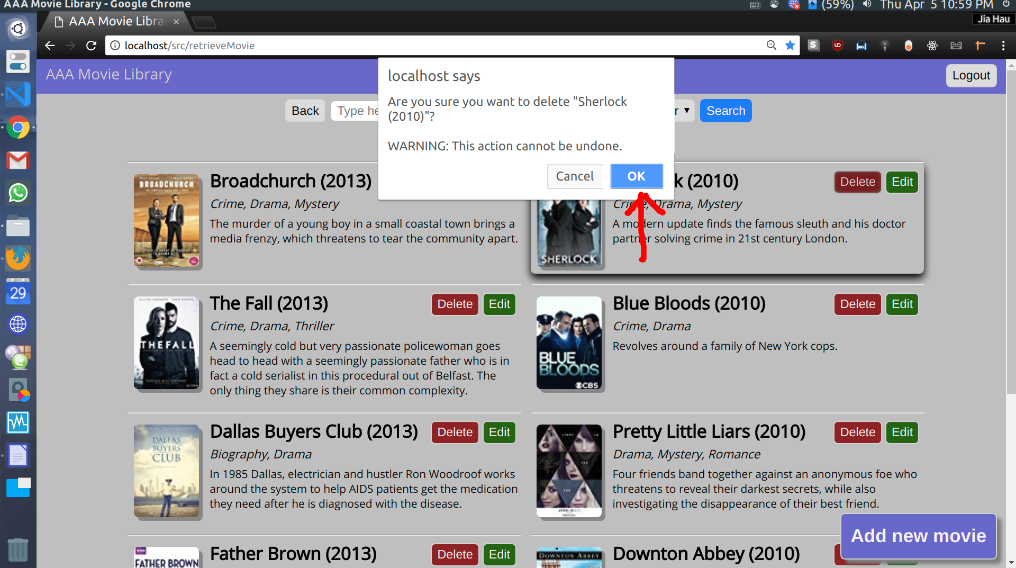
Confirm the dialog.

Delete movie (Step 3)
You’ll see the deleted movie to be marked as “DELETED”.
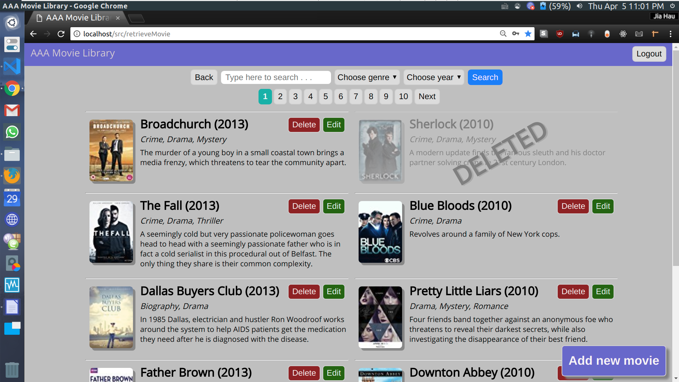

Delete movie (Step 4)
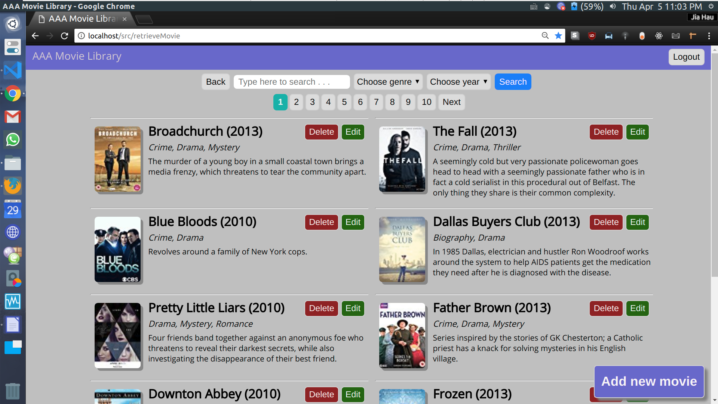
Refresh the page. Then you will see the that deleted movie is gone.

Security measure

1. Non-authorized user will be prevented from accessing admin function through URL injection.
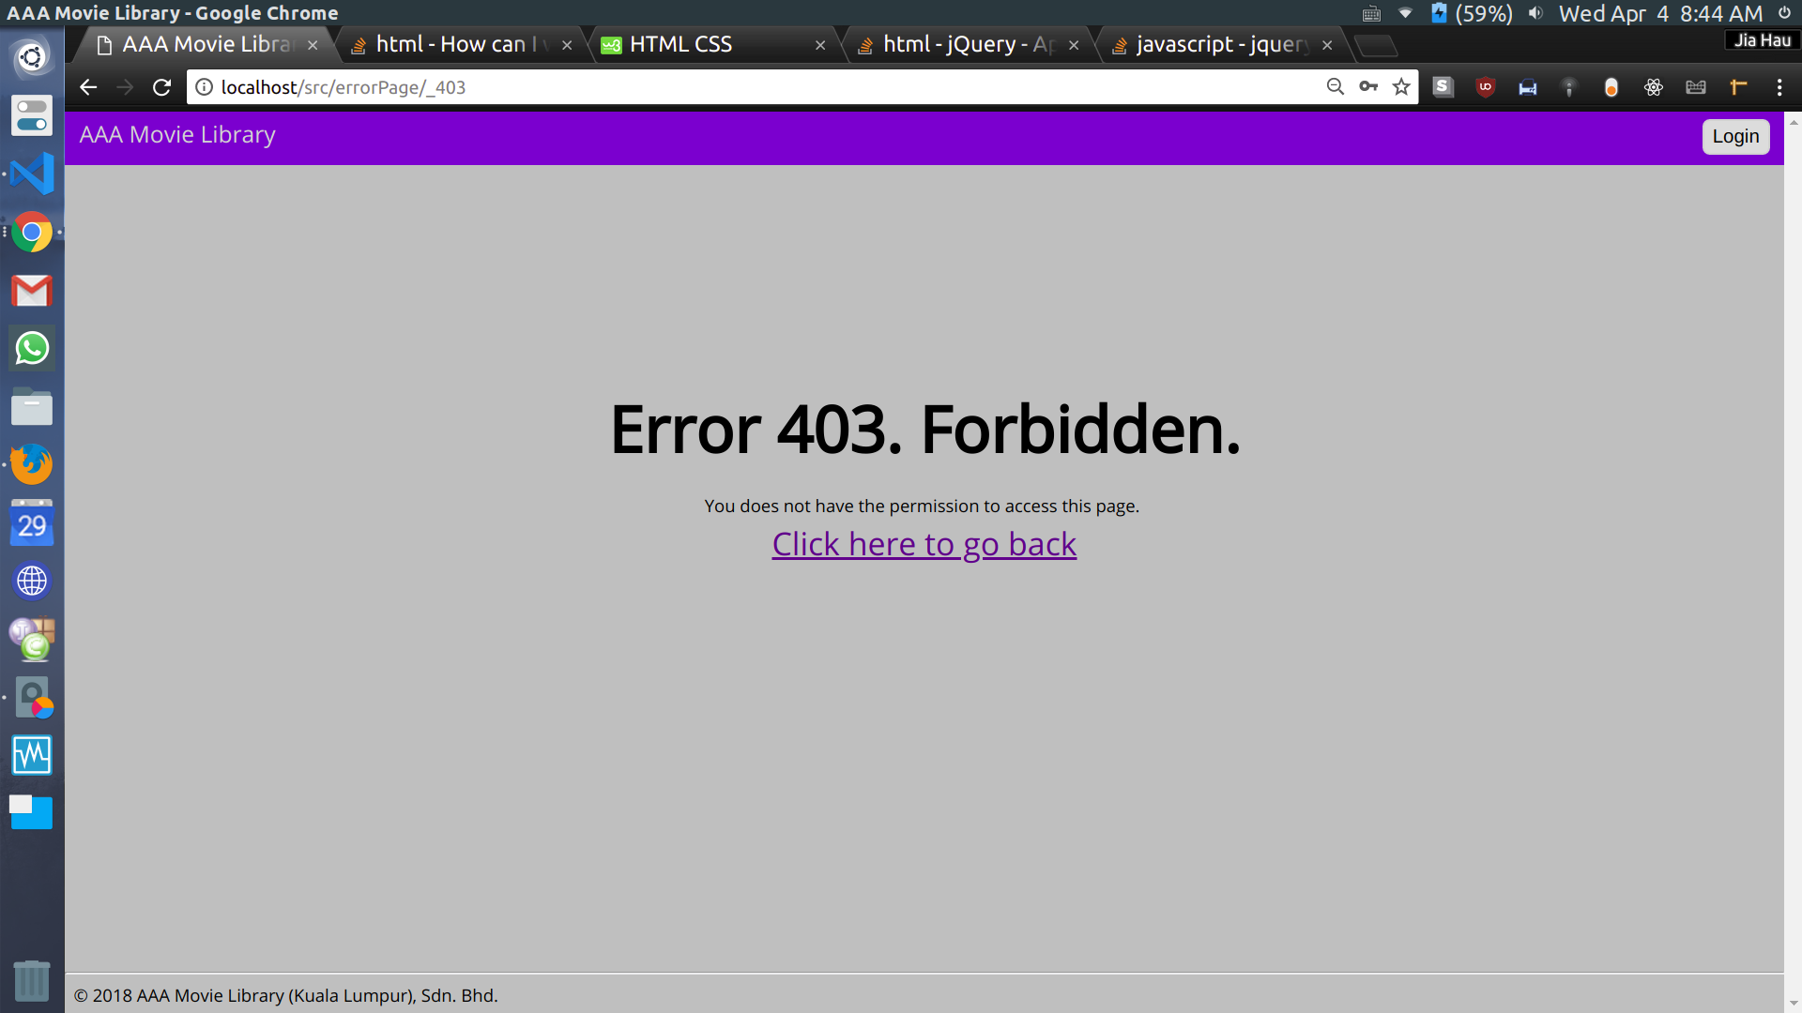

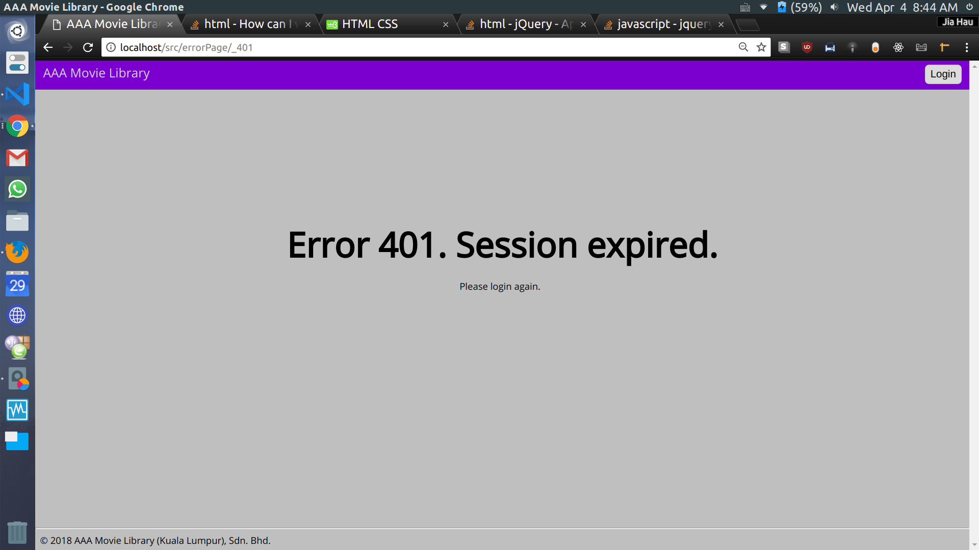
2. Admin session will be expired after 3 minutes of inactivity

3. User will be redirected to 404 if he/she tries to go to an unknown location.


