**COGS 101B Lecture Notes**

**iClicker Base: AC**

### 

**Topic 1: Intro and Syllabus** **2**

**Topic 2: Overview & History of Cognitive Psychology** **3**

**Topic 3: Modern Approaches to Studying the Mind; Neural Basis of Cognition** **8**

**Topic 4: Learning: Habituation, Sensitization** **15**

**Topic 5: Learning: Classical Conditioning** **18**

**Topic 6: Learning: Operant Conditioning** **23**

**Topic 7: Learning: Operant Conditioning continued** **28**

**Topic 8: Perception and Categorization / Mini-lab 1: Word Superiority** **29**

**Topic 9: Perception and Categorization** **31**

**Topic 10: Attention** **38**

**Topic 11: Short-term Memory and Working Memory** **49**

**Topic 12: Long-term Memory: Encoding, Retrieval, Consolidation** **57**

**Topic 13: Eyewitness Memory! Guest Speaker Professor John Wixted** **69**

**Topic 14: Everyday Memory and Memory Errors** **73**

**Topic 15: Memory Errors; Mini-lab** **82**

**Topic 16: Knowledge: Concepts and Categories** **83**

**Topic 16: Concepts and Categories; Mini-Lab** **93**

**Topic 17: Final Exam Review** **95**

### 

### Topic 1: Intro and Syllabus

1/8/2018

FIXME

### 

### 

### Topic 2: Overview & History of Cognitive Psychology

1/10/2018

1971: First meeting of the cognitive science society, held at UCSD

Beginning (1800s): “mental events are hidden; we can’t study them scientifically!”

1879-1913: “yes, we can!”

1913-1957: Behaviorism: “no, we can’t!”

1948-present: “yes, we can!” (Cognitive Revolution)

1. First Quantitative Measure of Memory
   1. Ebbinghaus (1885)
      1. Timed the course for forgetting
         1. Memorized nonsense syllables
         2. After a specified period of time, he re-learned whatever he forgot
         3. Relearned whatever he forgot to determine “savings”
      2. Demonstrated that **memory can be quantified**
         1. And behavior could be used to describe a property of the mind
2. Introspection - late 1800s
   1. = observing your own thoughts
      1. focus on conscious mental events
   2. **“Analytical Introspection”**: meticulous training on the self in how to describe and record mental experiences
   3. Contribution:
      1. attempt to study behavior in controlled conditions
      2. Generated first psychology labs and students
   4. Problems:
      1. some thoughts are undeniably unconscious
      2. There is no way to objectively test claims based on introspection
3. Behaviorism - Early to Mid 1900s
   1. Noted problems with introspection
      1. Advocated for abandoning the study of the mind
   2. **Observable behavior** should be the main focus of study, not mental processes
      1. **The mind is a black box**
   3. **Classical conditioning:** a neutral stimulus with a stimulus that elicits a response causes the neutral stimulus to elicit a response
      1. E.g. dog, food, and bell
   4. **Operant conditioning:** focuses on how behavior is strengthened by presentation of positive reinforcements, or withdrawal of negative reinforcements
      1. How BEHAVIOR is shaped by reward and punishment of that behavior
         1. E.g. **Thorndike’s puzzle box**
            1. Animal tries a bunch of things, then learns that the lever needs to be pressed, but sometimes they learn superstitious behaviors too (like spinning in a circle) before pressing the lever
         2. **The Pigeon Project**
            1. There were lens that projected where a bomb was needed to go
            2. Pigeon knew to peck on the target, which changed the tailfins of the bomb for directing the bomb
            3. *Walden Two* by B.F. Skinner: “we’re just faster pigeons”; everything reinforced in the world made us who we are
4. The Cognitive Revolution (1940s, 1950s)
   1. Shift from behaviorism to “yes, we can study the mind and mental events”
   2. Key things that spurred the revolution:
      1. Behavior is often best explained by **hypothesizing rich internal states**
         1. Looking into the black box and proposing complex things, not just reward/punishment
         2. Tolman (1948), Chromsky (1959)
      2. The Digital Computer
         1. It performs computations, so our brain may be doing something similar
      3. New methods/approaches to studying the mind
         1. Case study: Shepard and Meltzer (1971)
         2. Cognitive models
5. Tolman’s Maze (1948)
   1. Tolman: a behaviorist
   2. 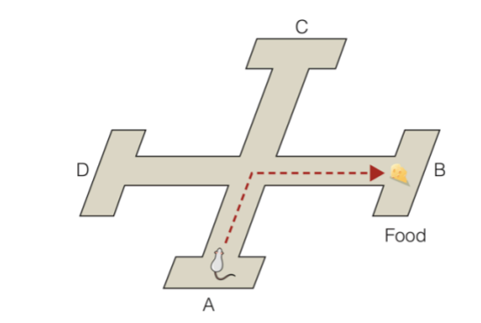
      1. Rat learned the maze
      2. Learned that turning right got him to the cheese
   3. Which finding would a simple behavioral theory (operant-conditioning) predict?
      1. When Start=A, rat→ B. When start = C, rat → D.
      2. *But this doesn’t happen!*
   4. Tolman proposed that the rat had formed a **cognitive map**
      1. Concept of the maze’s layout, inside the rat’s mind
6. Chomsky versus B.F. Skinner
   1. B.F. Skinner: language is learned through operant-conditioning, reinforcement
   2. Noam Chomsky publishes SCATHING review of this perspective
      1. Babies don’t learn language through reward/punishment
         1. They sometimes just say things just because they hear it
      2. Kids produce all sorts of speech they never hear and are never rewarded for
   3. *To understand complex abilities, it is necessary to consider what this observable behavior tells us about how the mind works*
7. Cognitive Revolution: The Digital Computer
   1. **Information-processing approach**: traces sequences of mental operations involved in cognition
   2. 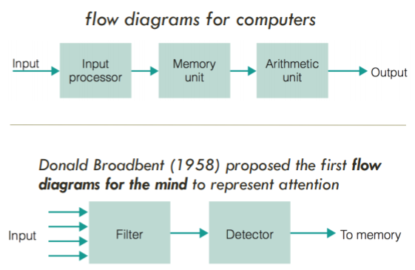
      1. Could we program a computer to mimic the operations of the human mind?
8. Cognitive Revolution: New Approaches
   1. Shepard and Metzler (1971)
      1. 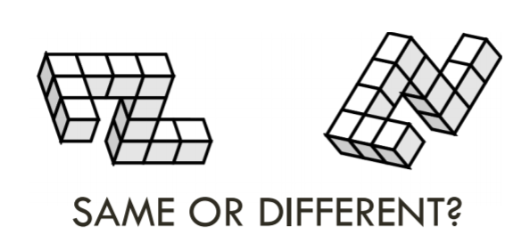
      2. People are slower to respond if the 2 figures are rotated further from each other
         1. And the angle of rotation versus mean reaction time is a LINEAR RELATIONSHIP
      3. **Quantitative measure of mental imagery**
         1. This was a case study in how mental events can be studied scientifically
   2. **We must study the mental world to understand behavior**
   3. **We cannot study the mental world directly**
   4. **Transcendental method:**
      1. “Inference to the best explanation”
      2. Reason backward from observations to infer the cause (observable effects from an unobservable cause)
   5. **Cognitive Models:**
      1. Representations of structures or processes that help us visualize or explain the structure or process
         1. Structural models
         2. Processes models
      2. *Models are not identical representations*
         1. “Essentially, all models are wrong, but some are useful” -- George Box
      3. **Structural models:** representation of a physical structure
         1. Plastic model of the brain
         2. Model of the visual system
      4. **Process models:** represent the processes that are involved in cognitive mechanisms, with boxes usually representing specific processes and arrows indicating connections between the processes
         1. 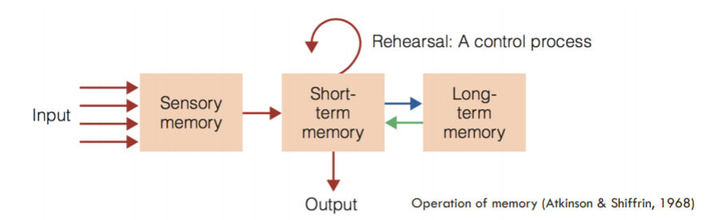

### 

### 

### Topic 3: Modern Approaches to Studying the Mind; Neural Basis of Cognition

1/12/2018

**iClicker Base: AC**

General Announcements:

* This week’s ZAPS will be accepted late
* Sections start next week, now technically mandatory
* Reading for next week will be posted online this evening

Assumptions that we are not covering in lecture:

* Basic structure and function of neurons
* Basic parts/organization of the brain

Cognitive Neuroscience:

* Not as interested in implementational level; just focusing on the first two levels of David Marr’s levels of analysis
* Cognitive neuroscience: the **physiological basis** for human mental processes
  + Aimed at understanding how brain structure is related to brain function

Methods used in cognitive neuroscience:

1. Basic assumptions of the methods in cognitive neuroscience
   1. Neurons send **electrical signals**
   2. **Localization:** Different areas of the brain are responsible for carrying out different functions
      1. Different cognitive processes may cause different areas to have more or less electrical activity
2. General techniques for studying brain function in cognitive neuroscience
   1. **Neuropsychology:** observe people with neurological damage and compare their function to healthy individuals
      1. Example: Phineas Cage, who had a pole go directly through his frontal lobe
   2. **Imaging techniques** to observe which regions are active during a task
      1. Non-invasive
   3. **Intervention techniques** to activate (**TMS**) or disable (TMS, surgery) and observe changes in the performance of the task
      1. TMS - transcranial magnetic stimulation
3. Necessary Background to Understand the Split-Brain Experiment
   1. Most parts of the brain come in pairs, located symmetrically in the left and right hemispheres
   2. **Lateralization**: there are often differences in function between the left and right side structures
      1. Left side of the brain processes language
   3. **Contralateral organization:** many of the brain’s circuits are crossed
      1. Sensations from the right side of the body are projected on the left hemisphere and vice versa
      2. Left hemisphere controls motor output for the right side of the body and vice versa
   4. Two halves of the brain work together
      1. Made possible by commissures, the largest being the **corpus callosum**, the major connective tissue between the two hemispheres
4. Split-Brain Experiments
   1. What happened in this experiment?
      1. The word of the object would show up on the left or the right side of the screen
      2. Use a specified hand to get the object they were asked to get on the screen
      3. Sometimes the patient could get the object correctly and not verbalize what they were supposed to get, sometimes they could be correct and verbalize what they were supposed to get, sometimes they were just completely wrong
   2. How does it show that language is lateralized?
      1. Since the right hand’s motor control is controlled with the left hemisphere of the brain, and language is processed in the left hemisphere of the brain, the person can correctly get the right object and verbalize the object
   3. *When the word is on the left visual field*
      1. Object info gets to the RIGHT hemisphere (vision contralateral)
      2. CAN’T VERBALIZE (demonstrating there is not as much language ability on the right)
      3. CAN execute motor movement and GRAB with left hand
   4. *When the word is on the right visual field*
      1. Object info gets to the LEFT hemisphere
      2. CAN VERBALIZE (demonstrating stronger language ability to the left)
      3. CAN execute motor movement with the right hand and GRAB
      4. No info gets to the right hemisphere, so they can’t get the correct object using the left hand
   5. Note: this is for the majority of people; it can vary sometimes, especially if you’re left-handed

Imaging Techniques

1. Imaging Techniques
   1. **Spatial resolution** - detail in terms of space
   2. **Temporal resolution** - accuracy in terms of timing
   3. Trade-off between these
2. Static Pictures of the Brain
   1. CT - Computed tomography
      1. Better for bony structures
   2. MRI - Magnetic Resonance Imaging
      1. better for soft tissue
3. Functional Pictures of the Brain
   1. PET - Positron Emission Tomography
      1. Produces 3D images
      2. Inject radiotracers, a radioactive glucose (through the blood, which makes its way to the brain)
      3. More active brain regions require more energy
      4. Down-side: spatial and temporal resolution are only okay-ish due to the physics involved
      5. More forgiving about movement of the head, but the fMRI requires the patient not to move at all
   2. fMRI - Functional Magnetic Resonance Imaging
      1. Blood increases in active brain regions
         1. Blood hemoglobin contains oxygen and iron
         2. Magnet causes iron to line up
         3. When active area uses oxygen in blood, results in higher concentration of iron which responds more to magnetic field
      2. Activity is recorded in **voxels**, cube-shaped units of analysis 2-3 sq. mm (like a pixel in a digital photo)
      3. Relies on **subtraction method**
      4. CANNOT use fMRI if you have metal in your body
      5. When neuroimaging techniques show us that a region of the brain is more active when completing a particular task, should we assume that that area is critical for completing that task?
         1. I think there’s a high likelihood that that region is involved, but it’s possible there’s confounding variables like being nervous. Good information, but must try to test it further.
         2. Analogy: the faster a car goes, the higher the speedometer reading. Is it appropriate to assume that the speedometer is critical for making the car accelerate?
         3. Most parts of the brain are active all the time
            1. THEREFORE it doesn’t mean that if you don’t have that part, you can’t do that task
   3. EEG - a measure of brain activity good for temporal resolution
      1. Used for talking about the time scale of information processing
      2. You wear an electroid cap that measure electrical activity
      3. BAD spatial activity though since the electrical activity is spread through the scalp (so accuracy is within centimeters)
4. Electrical Signals From the Brain (1/17/2018)
   1. Single-Unit recording
      1. Recording electrode and reference electrode
      2. When a neuron is at rest it has a charge that is 70mV more negative than outside (**resting potential**)
      3. **Action potential** - as nerve impulse is transmitted, inside rides to +40mVs compared to outside
         1. More stimulation means more action potentials
5. Testing Causal Claims about the Brain (functional regions of a brain)
   1. **Transcranial magnetic Stimulation (TMS)**
      1. Rapidly changing magnetic field induces electrical current in cortical neurons briefly disrupting brain function in a targeted area
      2. Temporarily disrupts brain function in a targeted area
      3. *If it disrupts your ability to complete a task, we infer that the targeted brain region is critical for completing that task*
      4. Can also create perceptions
         1. If TMS is done over the occipital lobe, the subject will see spots of light that are not there
6. Pros and Cons of Techniques in Cognitive Neuroscience

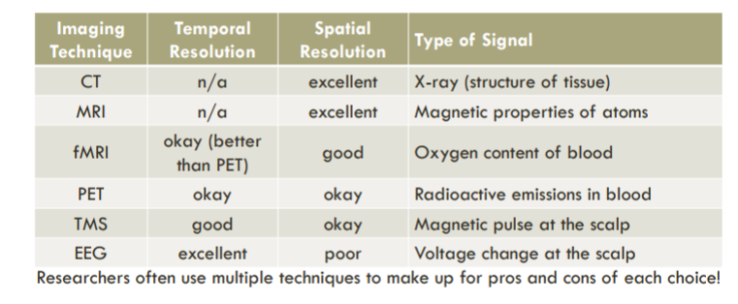

Neural Representation:

1. Representation
   1. A representation is anything that stands in for something else
   2. **Principle of neural representation**
      1. Everything we experience is based not on direct contact with stimuli, but on representation of it in the nervous system
   3. The mind is a system that creates representations of the world --internal symbols in our mind are responsible for our experience of external reality
   4. **Problem of sensory coding**
      1. How do neurons represent various characteristics of the environment
      2. If all nerve impulses are basically the same, how can these impulses stand for different qualities?
2. Representation in Single Neurons
   1. **Hierarchical processing:** the signals from neurons responding to simpler stimuli are pooled, creating neurons that respond to ever more complex stimuli
      1. Example: vision
         1. Neurons in visual cortex respond to specific simple stimuli features (orientation, movement, lengths)
         2. Neurons in the temporal lobe respond to complex geometrical stimuli
         3. Neurons in other areas of temporal lobe respond to even more complex objects (hands, faces)
3. Representation in Neurons
   1. Is every individual object in the world ultimately represented by one really high-level neuron?
   2. **Specificity coding**: the idea that an object could be represented by the firing of a specialization neuron that respond only to that object (e.g. the grandmother neuron)
   3. **Population coding:** representation of a particular object by the pattern of firing of a large number of neurons
      1. This is more likelier to be true
      2. “Most neurons in the system are active”
      3. One object is represented by multiple large amount of neurons
      4. Sometimes more spread out, but with more neurons
   4. **Sparse coding**: representation of a particular object by only a small number of neurons, with majority neurons remaining silent
      1. “Most neurons in the system are inactive”
      2. One object is represented by multiple fewer neurons (minority of neurons respond localized area)
4. Representation in Single Neurons
   1. Epilepsy surgery patients
      1. Found neurons that responded only to specific individuals
      2. Likely sparse coding rather than population coding
   2. Neural representation of things like a memory is even harder to study, but the same possibilities exist
5. Localization or Distributed Representation?
   1. Many areas with strong evidence for **localization**
      1. Modularity, kind of distinct representation (“map of the brain”, chunks in the brain) **FIXME**
      2. Examples:
         1. Broca’s area, Wernicke’s area (for language)
         2. Fusiform face area (faces)
         3. Parahippocampal place area (places)
         4. Extrastriate body area (bodies)
      3. Only one part of the brain is involved
   2. Also evidence for **distributed representation FIXME**
      1. Like localization but one part of the brain may be involved in lots of things (can have both localization and distributed representation)
      2. Specific cognitive functions activate many areas of the brain (e.g. faces, memory)
      3. many areas of the brain are involved
      4. Example:
         1. Memory
            1. Usually the whole cortex is activated rather than just one isolated chunk
6. What Neuroscience Can Tell Us About Cognition
   1. Attention
      1. Behavior: when you attend to something it is easier for you to find
      2. Neurological: this cortical map can expand or contract based on what you are attending to
   2. Memory
      1. Behavior: based on behavior
         1. Episodic and semantic memory
      2. Neurological: damage fo parahippocampal impairs semantic, damaged, entorhinal cortex episodic

### Topic 4: Learning: Habituation, Sensitization

1/17/2018

**iClicker Base: AC**

Overview of Learning

* What is learning?
  + Misconception: “PROFITING from experience”
    - Because: phobias (not always adaptive)
  + Misconception: “Any behavioral change based on experience”
    - Sometimes no performance changes
* Learning: storage of information in memory as a consequence of experience

Biological backdrop of learning

1. Constraints that Guide learning
   1. How do we figure out what goes with what when there are thousands of possible associations?
   2. Possibility: we’re born with certain biases that make learning some things easier
   3. **Simple reflexes**: automatic response to stimulus
      1. Startle response, orienting response, suckling, flexation response
   4. **Fixed-action pattern:** innate skills or behavior sequences that the animal does not have to learn
      1. Initiated by very specific stimuli known as **releasers**
         1. Once initiated, behavior patterns run automatically
         2. **Supernormal stimulus**: exaggerated artificial stimulus that acts as stronger releasers
            1. Example: really red buoy is attacked stronger by this fish compared to a real thing to attack
            2. Example: cowbird

Will lay eggs and protect the larger eggs, even if not their own

* + 1. Most rigid, built-in, and no learning involved
       1. BUT reflexes can bootstrap learning

1. Constraints that Guide Learning
   1. **Critical period**: most favorable (or necessary) period in development to which learning a particular behavior is easier
      1. **Imprinting**: forms the basis of young animals’ attachment to their parents
         1. Bird song - will only learn their species’ song only if they hear it during a time specific period
         2. Human language learning 1/19/2018
   2. **Preparedness**: certain associations are learned more readily than others (instinctive tendencies)
      1. Animals hardwired to approach desirable outcomes and retreat from undesirable outcomes
         1. Hard to condition animals to do the opposite
      2. Learning will happen more readily for certain cue-consequence combinations
         1. Taste aversions learned very quickly
            1. Rats with different stimulus and water

|  |  |  |
| --- | --- | --- |
| Stimulus | Paired with | Result |
| sweet water | nausea | aversion |
| bright/noisy water | nausea | No aversion |
| Sweet water | shock | No aversion |
| bright/noisy water | shock | aversion |

* + - * 1. Includes with humans too, chemotherapy patients associate nausea with some meals if they eat the meals before treatment, so now they associate it with lifesavers that are distinctively flavored
      1. Phobias related to the survival of “pre technology man” are the most common type

1. Non-Associative Learning
   1. **Non-associative learning**: change in response to a stimulus that does not involve associating the presented stimulus with another stimulus or event such as a reward or punishment
   2. **Habituation:** a *decrease* in the strength of a stimulus to elicit a response after repeated presentations
      1. **The Coolidge effect**: enhances sexual arousal in males of some species when presented with non-habituated females
      2. Tends to be very specific stimuli; usually just to one specific thing
      3. Low intensity stimuli
   3. **Sensitization:** an *increase* in the strength of a stimulus to elicit a response after repeated presentations
      1. Tends to generalize a lot (if you’re jumpy to artillery fire, you’ll be jumpy at any noise)
      2. High intensity stimuli

### 

### 

### Topic 5: Learning: Classical Conditioning

1/19/2018

1. Classical Conditioning: Pavlov’s Procedure
   1. Before conditioning:
      1. The unconditioned stimulus (US) automatically causes an unconditioned response (UR)
      2. Neutral stimulus (NS) causes no response
   2. During conditioning:
      1. Neutral stimulus (NS) is repeatedly paired with the unconditioned stimulus (US)
   3. After conditioning:
      1. Neutral stimulus (NS) becomes a conditioned stimulus, which evokes a conditioned response (CR)
   4. Before conditioning, salivation is an **unconditioned** **response**. After conditioning, the bell is **conditioned stimulus**.
   5. Before conditioning, salivation is an _________ response. After conditioning salivation is an ________ response.
      1. Either unconditioned; conditioned OR conditioned; unconditioned, depending on whether food or the bell triggered the salivation
2. Classical Conditioning: Basics
   1. **Acquisition**: the process of developing and strengthening a conditioned response
   2. **Asymptote of acquisition FIXME**
   3. **Acquisition happens more rapidly for** 
      1. More intense US
      2. More intense NS
3. Conditioning and Information Value
   1. **Information value:** the conditioned stimulus (CS) must be informative for learning to take place
      1. Not just pairing two stimuli and letting them just happen
   2. **Kamin (1969)**
      1. Experiment 1:
         1. Tone → Shock → fear* then later,
         2. Tone → fear
      2. Experiment 2:
         1. Tone + Light → shock → fear then later,
         2. Tone → fear response
         3. Light → fear response
      3. Experiment 3
         1. Tone → shock → fear then
         2. Tone + light → shock → fear then later,
         3. Tone → fear
         4. Light → nothing
      4. **Blocking**: failure to learn association between stimulus and outcome because of the presence of another stimulus that already predicts that outcome
         1. Adding the light provided no new information about when shock should be expected
         2. If you pair two stimuli (tone and tone predicts food), then you pair light with those tone and food, then the light does not become a conditioned stimulus for salivation b/c the tone was already doing that
   3. **Rescorla (1967)**
      1. Co-occurrence: stimuli happening together
      2. Contingency: stimuli happening together more often than independently
      3. *If it is information value that matters, contingency should lead to conditioning, but co-occurrence alone shouldn’t*

|  |  |  |
| --- | --- | --- |
| Group | Prop. US follows CS | Prob. US occurs by itself |
| 1 |  |  |
| 2 |  |  |
| 3 |  |  |
| 4 |  |  |

* + 1. Condition 1:
       1. Higher co-occurrence: the bell was paired with food on many trials
       2. Low-contingency: the animal received food as often after the bell as after no bell
          1. Getting the bell was not informative about whether there is a food
    2. Condition 2:
       1. Contingency: bell + food happened as often as no bell + food
          1. The bell needs to have some sort of predictive value
  1. **Not co-occurrence, but contingency that mattered**
  2. **Information value is more important than just pairing things**
  3. **Latent Inhibition:** a familiar stimulus is much harder to condition than a novel stimulus 1/22/2018
     1. Expose a dog to the bell many times before pairing the bell with food
     2. It will take many more pairings of the bell + food before the dog gets conditioned for the bell to predict food

1. Classical Conditioning: Temporal Arrangement
   * 1. Sometimes NS does not become CS
   1. **Delayed conditioning**: NS precedes US with SOME OVERLAP
      1. Neutral stimulus that will become a conditioned stimulus after the process of conditioning
      2. TENDS TO WORK BEST
   2. **Trace conditioning**: NS precedes US, gap between
      1. Almost as good as delayed conditioning, assuming gap isn’t too big
   3. **Simultaneous conditioning**: NS and US completely overlap
      1. DOES NOT WORK very well
   4. **Backward conditioning**: NS follows US
      1. DOES NOT WORK, except with some BIOLOGICALLY RELEVANT STIMULI
         1. Can condition rats to images of snakes in this way
         2. Shock then something and image with snake, then rat gets more scared of the snake
   5. Given what you know about conditioning and information value, which temporal arrangement do you think would work LEAST well?
      1. If neutral stimulus follows unconditioned stimulus, then it doesn’t provide any information value for predicting the US, so backward conditioning does not work that well
      2. What about stimulus conditioning? It doesn’t work that well either BUT It does work somewhat
2. Generalization and Discrimination
   1. **Little Albert**
      1. Little boy 11 months old; wanted to learn about fear conditioning
      2. Boy was unusually calm about things
         1. Did not like the gong
      3. So when they have a white rat doll, and he was reaching for the rat, they banged the gong
      4. Albert started fearing anything with fur
      5. Albert was gonna be conditioned not to be scared of them anymore but the mother left so they couldn’t….
      6. He died of tuberculosis
      7. Could also remove the fear by stopping the loud noise (extinction) and systematic desensitization
   2. **Generalization:** when similar stimuli evoke the same response as the conditioned stimulus
   3. *Evidence of phobias?*
      1. NO, bad
      2. Usually only 1 encounter, and if you aren’t exposed to the phobia for a long time, it increases the fear
   4. **Discrimination**: when only a specific (but not similar stimuli) evoke a conditioned response
3. Classical Conditioning: Extinction
   1. A conditioned response can be weakened and eliminated via **extinction**
      1. The conditioned stimulus (bell) → conditioned response (drool)
      2. Later on, if presented with nothing, no response
   2. **Spontaneous recovery**: reappearance of a conditioned response after a rest period from extinction
      1. But if it comes back, then the conditioned response comes back again
      2. Unless for a lonnnnger period of time the unconditioned response disappears
4. Classic Conditioning and Drug Overdose
   1. Sometimes a conditioned stimulus elicits a behavior that is identical to the unconditioned response, sometimes it elicits an unconditioned response that is different
   2. **Preparatory-response theory**: purpose of the CS is to PREPARE the body for US in whatever way is most adaptive
      1. Response is beneficial to the organism in some way
   3. **Compensatory response**: an automatic response that is in a direction OPPOSITE to the effect of an expected stimulus
      1. Heroine-related cues (NS) → heroine (US) → decreased blood pressure (UR) → increase in blood pressure (UR) b/c of homeostasis
      2. Then later: heroine-related cues (CS) → increased blood pressure (CR)
      3. The same amount of drug that would produce a mild effect in a familiar environment can produce overdose in a novel environment
         1. Body is prepared for this, so you can take on more heroine
         2. If you do the same amount in a different location without those cues, *you will overdose* because your body isn’t ready to compensate
            1. Anecdotes: Janis Joplin, Whiney Houston, Mitch Hedberg, Jimi Hendrix, Anna Nicole Smith, John Belushi, Cory Monteith
   4. Example of latent inhibition in real life: ???
   5. Example of generalization in real life:
      1. Horror movie jump scares from one soundtrack; so another different song in a different movie can also make you scared
   6. Example of discrimination in real life:
      1. Just scared of one kind of cat

### 

### 

### Topic 6: Learning: Operant Conditioning

1/22/2018

Announcements

ZAPS due Wednesday at midnight

First mini-lab in class this FRIDAY not WEDNESDAY

NO Review Session for the midterm

1. Classical v. Operant Conditioning
   1. **Respondent behavior**: involuntary, reflexive type behavior that occurs in response to a stimuli
   2. BUT an **operant behavior**: more voluntary and are controlled by their consequences
   3. **Operant conditioning:** type of learning in which the future probability of a behavior is affected by its consequences
      1. A behavior leading to positive outcomes will happen more
      2. A behavior leading to negative outcomes will happen less
      3. B.F. Skinner: gotta look at the behaviors too, not just classical conditioning though
   4. Thorndike’s puzzle box - cat pressing lever
2. Operant Conditioning Chamber (“Skinner Box”)
   1. **Operant conditioning chamber:** apparatus used to study operant behavior in a very controlled way
      1. Animal is taught to perform certain actions (pressing a lever, pecking at a key, etc) in response to a certain stimulus
      2. When the animal correctly performs the action a reward is delivered (or punishment is avoided)
      3. Example: lever press → food
      4. Effect: level pressing increases
3. Types of Consequences
   1. Defined entirely on their effect on a behavior
      1. **Reinforcer**: a consequence that
         1. Follows a behavior
         2. Future probability of the behavior increases
      2. **Punisher** 
         1. Follows a behavior
         2. Future probability of the behavior decreases
   2. Can think if it more like pleasure versus punishment in the simplest terms

|  |  |
| --- | --- |
| An undesirable outcome DOES NOT OCCUR as a consequence of behavior, and the BEHAVIOR INCREASES  (lever press → no shock) (*negative reinforcement*) | A desirable OUTCOME OCCURS as a consequence of behavior, and the BEHAVIOR INCREASES  (lever press → food) (*positive reinforcement*) |
| A desirable outcome DOES NOT OCCUR as a consequence of behavior, and the BEHAVIOR DECREASES  (lever press → no food) (*negative punishment*) | An undesirable OUTCOME OCCURS as a consequence of behavior, and the BEHAVIOR DECREASES  (lever press → shock) (*positive punishment*) |

* 1. Negative: Taking Away
  2. Positive: Adding
  3. Reinforcement: Increase behavior
  4. Punishment: Decrease behavior
  5. Meg doesn’t like it when her boyfriend Adam talks to other girls at parties. When Adam does this Meg ignores him all night. Eventually, Adam stops talking to other girls at parties.  
     → this is negative punishment (1/24/2018)
     1. To make this *positive punishment*: Meg lectures Adam and he stops talking to girls
     2. To make this *positive reinforcement*: Meg lectures Adam but he talks to girls more
     3. To make this *negative reinforcement*: Meg ignores Adam but he talks to girls more
  6. REINFORCEMENT/PUNISHMENT refers to the BEHAVIOR EXHIBITED, NOT THE INTENT

1. Discriminative Stimuli
   1. **Discriminative stimulus**: a behavior is reinforced (or punished) in the presence of the discriminative stimulus, but is not reinforced (or punished) when the discriminative stimuli is not present
      1. Dog knows exactly who will yell at him if he’s on the table, so doesn’t get on the table only if that specific human is not around
2. Schedules of Reinforcement
   1. Different schedules on which behavior is rewarded or punished; can have dramatically different effects on behavior
   2. **Continuous reinforcement:** every instance of the behavior is rewarded
   3. **Intermittent reinforcement:** only some instances of the behavior are rewarded

|  |  |
| --- | --- |
| FR: outcome contingent on a fixed number of response | VR: outcome contingent on a variable, unpredictable number of response  (like basketball, gambling--variable ratio schedule; hoping that the next one will be it)  *THIS IS POWERFUL* and represents most real world situations |
| FI: outcome contingent on a fixed amount of time (example: cramming to study schedule) | VI: outcome contingent on a variable amount of time  (increasing your response rate doesn’t really increase your reward because it’s of the time) |

* 1. Ratio: number of responses needed
  2. Interval: amount of time needed
  3. Fixed:
  4. Variable:
  5. 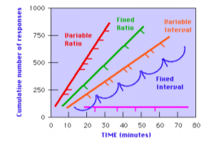
  6. A study found that although 84% of women respond negatively to men who use overtly sexual pick-up lines (e.g. “I’m easy, are you?”), a small minority of women said they responded favorably. Some men might persist at constantly using these pick-up lines because they have been reinforced on a…  
     → VARIABLE RATIO SCHEDULE  
     - not variable interval schedule because it would be like “about every 10 minutes at the bar, he gets positive response”

1. Coming Back to Cognitive Psychology
   1. Much of our progress in learning has come after overcoming limitations associated with ignoring the mind
2. Learning: Going Beyond Behaviorism
   1. **Strict Behaviorist Perspective:**
      1. We can only talk about stimulus-response relationships, not the mind
      2. Learning consists entirely of forming stimulus-response relationships, which are formed automatically
      3. Tend to view CAUSAL learning as simple ASSOCIATIVE learning -- storing info about the frequency of events and their outcomes
   2. **Cognitive Perspective: ???**
3. Learning: Observations that are better explained by the Cognitive View
   1. **Learning-performance distinction**: not everything learned is immediately manifest in performance
      1. Although learning is often inferred from performance, the absence of learning may not be inferred from the absence of performance
      2. Like the dog knows how to shake, but he just doesn’t do bit because he doesn’t see a need to do it
4. Expectancy Hypothesis
   1. Training task:
      1. Choose between two cards that differed in reward value
      2. Choose card and correct reward value
      3. Unknown to participant set up, so they would never guess correct reward value
         1. Not exactly random; only some selections the participant would be right
         2. So some high value cards were never given, so never reinforced
      4. Test:
         1. High value cards that had never been rewarded were chosen over lower value cards
   2. **Expectancy hypothesis:** the tendency for behavior to occur in a given situation is a function of the individual’s EXPECTATIONS, *not necessarily which behaviors have been reinforced in the past*
5. Hypotheses and Rule Learning
   1. Task:
      1. Is this card consistent with the rule?
         1. Sometimes complex rules, not always simple rules
   2. Test finding: participants learned the more complex rule, but often failed to learn the simple rule
      1. Because the simple rule wasn’t bothered to be learned because they were learning for more complex rule
   3. Conclusion: people seem to learn complex rules if they evaluate those hypotheses but not simpler rules if they don’t evaluate those hypotheses
6. How is the learning-performance distinction, the expectancy hypothesis, and hypothesis-driven rule learning incompatible with a strict behaviorist interpretation?
   1. Incompatible because learning doesn’t always show in the performance side
   2. We infer something the mind is doing based on the behavior (or strict behaviorists would just say “well you CAN’T know”)
   3. **Learning-performance distinction:** not everything learned is immediately manifest in performance
7. Cognitive perspective:
   1. In order to understand behavior, it is essential to talk about the mind
   2. People are more complicated
      1. Reinforcement acts a source of information about relations between actions and consequences but does not COMPEL behavior
      2. Our theories and expectations dominate observations, and in turn influence how we infer causation=

### 

### Topic 7: Learning: Operant Conditioning continued

1/24/2018

Announcements:

Study guide posted by Friday evening for the midterm on Monday

Bring a piece of paper for the mini-lab Friday

No assigned groups, just who you’re sitting next to

### 

### 

### Topic 8: Perception and Categorization / Mini-lab 1: Word Superiority

1/26/2018

1. Perception
   1. There is everything to do with perception!
   2. Strong illusion that we have a direct, veridical experience of what is “out there”
   3. *Perceptions are based on sensory input AND interpretations of those inputs*
2. Vision is Hard: Computers can’t nearly see as well as we do
   1. Computers confuse lots of things
   2. Humans can recognize one person’s face and match the left and right views of the same person easily
3. Vision is Hard: Sensory Input if Ambiguous
   1. Optical illusions
4. Vision is Hard: Inverse Projection Problem
   1. **Inverse projection problem**: idea that the stimulus on the receptors is ambiguous--it could have been created by many different objects in the environment
      1. Tilted rectangle, trapezoid, square
5. Vision is Hard: Objects Have Infinite Angles
   1. Same object can cast different images from different angles
6. Vision is Hard: Objects are Blurred and Occluded
   1. You can identify blurred faces even though they’re degraded
7. We resolve most ambiguity effortlessly and accurately
   1. Even though the stimulus on the receptors is ambiguous, we only perceive a single agreed-upon object, not many possible realities
   2. We recognize blurred objects, and that an occluded object is not TWO objects
   3. **Viewpoint invariance:** can recognize an object regardless of our perspective
8. Accumulated Knowledge Shapes our Perception
   1. **Bottom-up processing:** processing based on the “raw data” -- the information that reaches the sensory receptors
   2. **Top-down processing:** using knowledge, models, ideas, expectations to interpret sensory information
   3. **Unconscious inference**: interaction between bottom-up and top-down processing
      1. Our perceptions are the result of unconscious assumptions, or inferences, that we make about the environment
      2. We perceive those objects and events that under normal circumstances would be MOST LIKELY (top-down) to produce the received sensory stimulation (bottom-up)
   4. Examples:
      1. Spheres with different shading
      2. Perspective of 3D things in 2D
   5. **Bayesian inference**
      1. Raw data plus prior experience plus perception
      2. Sensory input (bottom-up) + knowledge (top-down) are processed in parallel toward PERCEPTION
   6. You are shown the animal “ANIMAL”. What is your INITIAL INTUITION about the steps your mind takes to perceive this word?
      1. Me: same time
9. Word Superiority Effect (Reicher, 1969)
   1. FORK is shown fast/flashed on the screen, then they’re shown a choice between two letters to see if that letter was there (WORD TRIAL)
   2. K was shown then they’re shown a choice between two letters to see if that letter was there (LETTER TRIAL)
   3. ENTIRE WORD makes it easier to identify the letter
      1. Accuracy is higher with entire words over single letters
      2. If they’re given just the letter, they can’t identify it as easily
   4. *This shows evidence for top-down processing as well; the context guides the recognition*

### 

### Topic 9: Perception and Categorization

1/31/2018

Knowledge Shapes Our Perception

Announcements:

Average was ~82% for midterm 1

1. Perceiving Coherent Objects is no Easy Task
   1. It’s hard to view things
2. Accumulated Knowledge Shapes Our Perception
   1. Bottom-up processing
      1. Processing based on the “raw data;” the information that reaches the sensory receptors
   2. Top-down processing
      1. Using knowledge, models, ideas, expectations to interpret sensory information
   3. We use a combination of both to determine perception
      1. Our perceptions are the result of unconscious assumptions, or inferences that we make about the environment
3. The Word Superiority Effect
   1. **Word-superiority effect**: letters within a word are processed more rapidly than single letters
      1. Depends on LANGUAGE EXPERIENCE
   2. Possible experiment procedure: there needs to be meaningful context versus not meaningful context for words given
   3. Or testing with people who are less comfortable with English
4. Degree of Well-Formedness
   1. How well the word is consistent with English spelling rules
   2. Non-words also produce the effect if they conform to standard spelling patterns (eg. KLANE), but not if words do not conform to standard spellings
5. Word Frequency & Repetition Priming
   1. **Frequent words** and **recently seen** words are more easily recognized
      1. When a stimulus is primed, its response threshold is LOWERED relative to other stimuli
         1. It takes LESS stimulation to produce a reaction
6. Feature Net
   1. 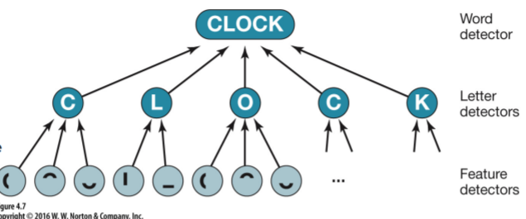
   2. **Activation level:** the current status or “energy level” of a detector; will determine how much more input is needed for detector to fire
   3. **Response threshold**: when this is reached the detectors will send a signal to the other detectors it is connected to
      1. How much activation needed to send signals
   4. Not specifying biological structures
      1. No neural network here
      2. The model is biologically sensible, though
   5. This can explain word frequency effects and repetition priming
      1. Common words or words you’ve recently seen will be more active
      2. Word is already activated, so it takes less stimulation for that word to be activated
         1. Takes more activation to detect words not commonly used
7. Bigram Detectors
   1. 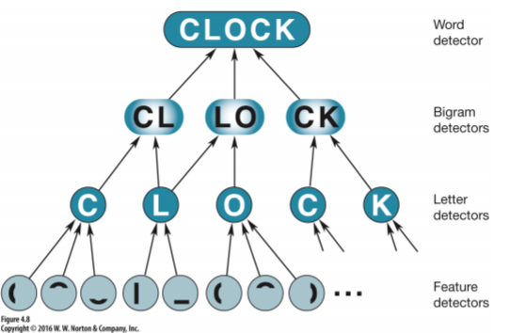
   2. Sensitive to the frequency of letter sequences in printed language
   3. Original model can’t account for the effects found with words that follow spelling conventions
   4. This can explain well-formedness: letter sequences “HICE” not recently activated, but “HI” and “CE” have been (e.g. “HILL”, “HIGH”, “FACE”)
      1. The more frequent bigrams will be more active, so more likely to achieve the response threshold
8. Resolving Ambiguity
   1. With only partial information, bigram detectors that are more primed are more likely to fire
      1. The network automatically recovers from its own confusion
      2. Easy to identify a word with only partial information *if you know something about how words are spelled*
      3. Let’s say in the diagram, only the bottom curve of the O was given, but the rest of the word was given.
   2. 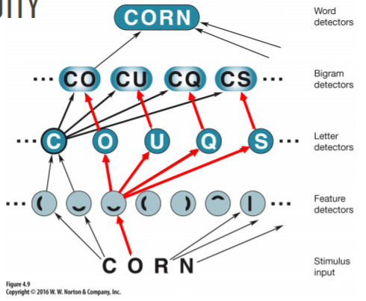
   3. All three thresholds are the same, but more activation for the CO bigram detectors (CO is the most commonly seen)
9. Distributed Knowledge
   1. **Distributed knowledge:** knowledge is represented in a fashion that’s distributed across the network and detectable only if we consider how the relative activity of entire network
10. Recognition Errors
    1. Network’s “knowledge” is not **locally represented** anywhere
    2. DISCUSSION: In the last example, the word shown was “CORN” but only the bottom curve of the “O” was visible. What would happen if instead the string shown was “CQRN” and only the bottom curve of the Q was detected? What would the person ultimately perceive?
       1. Me: I think they’ll still think it’s “CORN” and not “CQRN”
       2. Class: because CQ is not a common bigram, so the bigram CO has the highest point of activation, so it reaches its threshold, so the person still thinks it’s “CQRN”
    3. *The same mechanisms that make 99% of the world coherent are also the very same mechanisms that lead to illusions and errors*
    4. CQ requires more stimulation than CO to fire
11. DISCUSSION: Finding: If you tell participants “I am about to show you a word on the computer screen; the word is the name of something you can eat,” and then you flash the word “CELERY” you will observe a big priming effect--participants will be more likely to recognize the word than they would if they had if they had not been primed with the idea of food.
    1. Can *this* priming effect be explained by the the feature nets we discussed?
       1. Me: yes but it probably needs another layer
       2. Possibility brought up: this is more top-down processing, so you gotta draw on so many different information that you can’t really use this
    2. The person likely is drawing on a much broader, higher-level range of knowledge -- knowledge that the things you EAT are foods, memory of types of food that exist in the world. Many, many other top-down effects, require a different type of explanation than feature nets.
    3. **Need to increase the feature net with another layer or something**
12. Geons & Recognition By Components (RBC)
    1. Instead of letters, try feature-net for 3-D objects
    2. Just like words are composed of letters, objects are composed of “geons” (geometric ions)
    3. 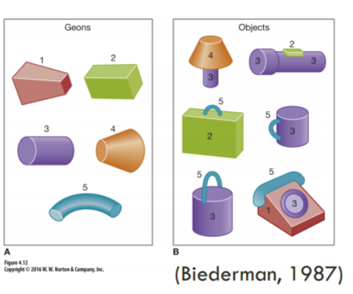
    4. Only 36 shapes that can compose any object
    5. THE FOUR ELEMENTS OF A GEON:
       1. Cross-section: straight or curved
       2. Axis: straight or curved
       3. Size of cross section: constant vs expand and contract vs expand
       4. Termination of geon when nonparallel: truncated vs pointed vs rounded
    6. Choice of shape may seem arbitrary, but it’s based on non=accidental properties, meaning they can be recognized across a variety of different perspectives
    7. According to RBC, recognition of objects **is viewpoint-independent**
    8. “T”-junctions, boundaries between parts, allow us to infer the geons, and in turn, the object
       1. When these critical components are removed, we cannot infer the geons or the object
       2. (occlusion but showing the key features)
13. Viewpoint-dependent Recognition
    1. Matching current view with views stored in memory
       1. Feature net builds up image of whole objects
       2. BUT object detectors represent what the object looks like from a SPECIFIC angle
       3. And you can only recognize the object if you can match current view with a stored memory -- mentally rotate object to find a match
    2. Unusual angles will take longer to recognize the objects because you gotta do a mental rotation to match the object to what you see
       1. 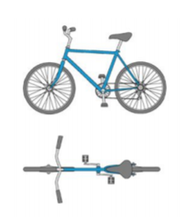
    3. According to **Recognition by Components** theory of object recognition, which image would take longer for you identify? 2/2/2018
       1. Dinosaur normal viewpoint
       2. Dinosaur from below
       3. Both would take the same amount of time to recognize
          1. BY THIS THEORY IN PARTICULAR, both viewpoints would take the same amount of time to recognize

Faces are a Special Objects

1. Face recognition can selectively break
   1. People with prosopagnosia cannot recognize individual faces
      1. Seems to imply the existence of special neural structures for recognition and discrimination of faces
2. We seem particularly attuned to faces
   1. We experience **pareidolia** for faces, which is perceiving a familiar pattern when it’s not really there
      1. Seeing faces on things that don’t have faces
   2. Does not seem learned
      1. Babies right from birth seem to prefer looking at faces
3. Faces are Definitely Viewpoint-Dependent
   1. When identifying objects:
      1. Faces much worse inverted and much better upright
      2. Houses not too different when upright and inverted
4. Face Inversion Effect
   1. When viewed right side up, feature changes have huge impacts on face perception
      1. Obama turned upside down and we’re oblivious that the eyes and the mouths didn’t invert with the rest of the face
5. Holistic Representation
   1. Face recognition depends on complex relationship created by the face’s overall configuration
   2. We are more sensitive to **changes in configuration** than changes in features for faces
      1. We are more sensitive to **changes in features** than changes in configuration for objects
   3. *Composition versus features/parts of the face or object*
6. Composite Face Effect
   1. Asked to identify whose top of the face does that belong to
      1. People have a hard time identifying halves
   2. *The relationship between parts that guide face recognition*
      1. Features still matter, but are not considered one by one apart from the whole composition
      2. Identifying a face by features alone is harder when it’s in the context of a coherent face than when the faces are offset
   3. Why does our perception of faces seem special, and different from our perception of other objects?
      1. Face perception can be very selectively impaired
      2. Orientation dramatically influence our perception of faces
      3. We are more sensitive to changes in configuration than to changes in individual features
7. Summary
   1. Perceiving the world is hard
      1. Constantly faced with ambiguity
   2. learning/memory/knowledge help resolve ambiguity through top-down processing/unconscious inference
      1. Word superiority effect
   3. We looked at specific models of how perceptual ambiguity might be resolevd
      1. Feature nets
      2. “Geons”
   4. Faces seem to be a special class of objects

### Topic 10: Attention

2/2/2018, 2/5/2018, 2/7/2018, 2/9/2018

Announcements 2/5/2018

Mini-lab Friday 2/9

Norton student set’s sudden and mysterious disappearance

1. What is Attention?
   1. Broad class of phenomenon
      1. Psychologists don’t really agree if it’s one thing or many things
   2. “Everyone knows what attention is. It is the taking possession by the mind, in clear and vivid form, of one out of what seem several simultaneously possible objects or trains of thought. [...] It implies withdrawal from some things in order to deal effectively with others.” --William James
2. Attention Allows Us to….
   1. Select and enhance relevant perceptual information
   2. Perceive a coherent world
   3. Sustain behavior and select appropriate actions

Selecting and Enhancing Relevant Information

1. DEMO:
   1. Instructions:
      1. A scene will flash
      2. Something in the image will change
      3. Raise your hand when you notice what’s changed
2. Selective Attention
   1. **Selective attention** refers to a process of attending to one thing while ignoring others
      1. We don’t realize how much we need it
      2. We have all this information in the world, and it allows us to pick something to focus on and allows us to not focus on the other things
   2. We are constantly bombarded by stimuli but we have a limited capacity to process and respond to stimuli
   3. *We have the impression of a complete representation of the world at all times but really,* ***you only perceive what you explicitly attend to and miss what you don’t explicitly attend to***
3. Dichotic Listening Task
   1. You have a conversation with someone, you hear the music and background conversations, but you don’t really know what’s going on in the background if you’re focusing on the conversation
   2. Experiment: headphones on person, different inputs in each ear
      1. Participants are instructed to repeat the message in specifically one ear and to ignore the message in the other ear
4. Perception in the Unattended Ear
   1. Participants are **aware of low level** information
      1. Non-speech sounds
      2. Gender of speaking
      3. Human versus robot voice
   2. Participants are **unaware of high level** information
      1. Semantic content (meaning of message)
      2. Syntax (sentences versus random words)
      3. Language (can’t tell if there’s a switch from English to German, but will notice accents)
   3. How is it possible to focus on one message and why is information not taken in from the other message?
5. Information Processing Models of Selective Attention
   1. Broadbent’s Filter Model
      1. This provided testable predictions about selective attention
      2. Its class is bottleneck model
      3. **Bottleneck model**: filter restricts the flow of information flow (like the neck of a bottle restricts liquid)
      4. Messages → Sensory memory → filter → detector → to memory
      5. Problems:
         1. Listener’s recognize their own name in the unattended ear
            1. Or other words that are very familiar to them
         2. Listeners form coherent sentences from both streams
            1. Attended message is dear 7 jane, unattended message is 8 and 9, but then they end up hearing “dear aunt jane”
   2. Treisman’s Attenuation Model (1964)
      1. Messages → attenuator → dictionary unit → to memory
      2. **Attenuator**: analyzes the incoming message in terms of
         1. Physical qualities
         2. Then language
         3. Meaning if needed
      3. Says that the attended message is STRONGER signal, but unattended messages also come through, which has a WEAKER signal
      4. **Dictionary unit**: contains words, stored in memory, each of which has a threshold for being activated
         1. Your name
            1. Strongly activated already, so just needs a little bit more activation to make it to memory
         2. What you heard recently
6. Early vs Late Selection Theories
   1. Mainly sensory analysis happens, does not reach conscious awareness
   2. The full meaning analysis makes it to consciousness
7. Evidence for Early Selection
   1. EEG data show attended inputs is distinguishable from unattended inputs, even when sensory processing is still underway
   2. There might be differences in how the signals are processed in the early part of processing
8. Early vs Late Selection Theories
   1. **Early Selection:** most of the unattended information is eliminated by the filter
      1. Sensory analysis is parsed early, then checked for memory
   2. **Late Selection**: all inputs receive relatively complete analysis
      1. Fully processed, but irrelevant information does not get sent to memory
9. Evidence for Late Selection
   1. Subjects listened to an ambiguous sentence
      1. Attended message: “they were throwing rocks toward the bank”
      2. Unattended message: “money”
      3. Unattended messages were not consciously perceived, but influenced the interpretation of the attended messages
         1. Biasing words played in the other ear
   2. Judge which line is longer
   3. Participants don’t report being consciously aware of the background stimuli
      1. Even though there is illusion
      2. So they still think the top line is longer when they aren’t aware of the context that influenced this perception (both lines are the same length)
10. Enhancing Relevant Information
    1. *Select and enhance relevant perceptual information*
    2. Does pre-cuing a relevant location (increase attention to a specific location) ENHANCE the PROCESSING of the target stimuli?
       1. 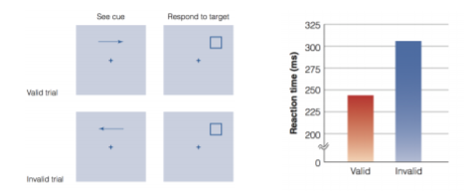
    3. Posner et al. (1978) interpreted this result as showing that information processing is more effective AT THE PLACE WHERE ATTENTION IS DIRECTED
11. Enhancing Relevant OBJECTS
    1. **Same object advantage** (Egly et al., 1994)
       1. Cue signaled where dark square would probably appear
       2. Press button if it appears anywhere on display
       3. 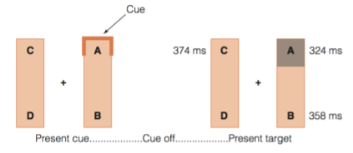
          1. (letters weren’t there, it’s for us to understand)
       4. C and B showed up the same rate
          1. BUT if A is cued, and the black square appears at B, the person is faster to respond than if it were shown at C
          2. Other parts of the SAME OBJECT also produces faster response times
12. Make you able to notice more subtle things
    1. Keep your eyes on the center, but attend to the spot with a circle
       1. When valid cue, the response time is faster and correct more often
       2. When invalid cue, the response time is slower and incorrect more often
13. Makes Things have more “Contrast”
    1. One experiment:
       1. Stare at a dot, tried to make someone pick a specific item
       2. To get people to pick the cued and uncued items the same amount, the uncued item has to have significantly more contrast than the uncued one
    2. Another:
       1. *HIGHER CONTRAST FACES APPEAR MORE ATTRACTIVE*
       2. Will an attentional cue make a face seem higher contrast and hence more attractive?
          1. Stared at fixation point, had to tell each other which face was more attractive
          2. **The cued face was judged more attractive >60% of the time**
14. The Spotlight Metaphor
    1. **Spotlight beam**: attention is like a spotlight beam that improves processing when directed toward a particular location or object
       1. Processing is enhanced due to ATTENTION, not eye movements
          1. **Overt attention:** selectively attending to an item or location over others by moving the eyes to point in that direction
             1. Searching for someone on a beach
          2. **Covert attention:** act to mentally shift one’s focus without moving one’s eyes
       2. So this is more relevant to covert attention
       3. It’s not where you’re looking, where you’re focusing your attention there even if you’re not looking there
    2. “Paying attention” - attention is a **limited-capacity system**
       1. We have a budget, gotta choose how to spend it
15. Movie Perception Test from Levin & Simons (1997)
    1. The weird video
    2. Other than the terrible acting and weird conversation, did you notice anything unusual?
       1. HOLY CRAP HER SCARF IS GONE AND THE FOOD SWITCHING AHHHH
16. Selective Attention is Surprisingly Selective
    1. **Change blindness**: difficulty in detecting changes in a scene when you are not looking for them
       1. Inattentional blindness
       2. Attentional blink
    2. Because of capacity-limitations we really need to be able to select relevant information at the cost of blocking out less relevant
17. Inattentional Blindness
    1. Task: indicate if vertical or horizontal longer for the cross-hair
    2. Fixation target disappeared and changed shape
    3. **Inattentional blindness:** people fail to see what they are not expecting
       1. Basketball passing hahahahaa with the gorilla
18. The researchers who coined the term “inattentional blindness” claim that in the ‘gorilla study’, the information was never perceived even though it was right in front of them. Is this early selection theory or late selection theory?
    1. **Early Selection:** most of the unattended information is eliminated by the filter
    2. **Late selection:** ALL inputs receive relatively complete analysis, but we don’t remember it
19. Attentional Blink
    1. Conditions:
       1. 1 number between target letters (180 ms between)
       2. 3 numbers between target letters (360 ms between)
       3. 7 numbers between target letters (720 ms between)
       4. No second target letter
    2. 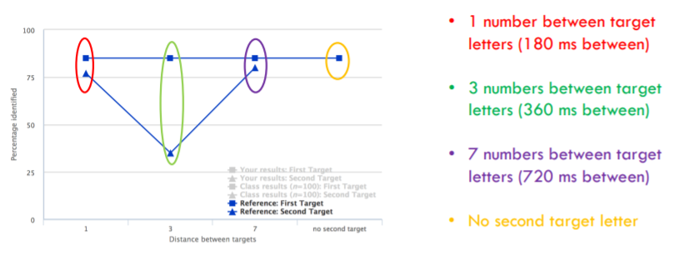
    3. Describe the results in plain English. What point on the graph is referred to as the attentional blink? What does the first (circled in red) data point imply? The third (purple)?
       1. The middle dig (green) is the attentional blink
       2. First data point implies we can see the two letters if it’s within 180 ms but not if it’s between 360 ms
       3. The third (purple) implies we can get both letters since there was an adequate enough gap
       4. Metaphor: like a fishing net getting some fish
          1. Red: like grabbing two fish when you put your net in
          2. Green: you already lifted the fish out of the water and miss the other fish
          3. Purple: you have enough time to put your net back in the water
    4. There are **individual differences** in attentional capture on these time scales
       1. Possibly retroactive interference
20. Attention in the Brain
    1. Parietal and frontal cortex are involved in attention
21. Unilateral Neglect
    1. With damage to the parietal lobe, the contralateral half of the visual field is neglected
       1. BILD 12!!! (there was an experiment where someone is asked to describe their neighborhood from one specific location, and the guy only described one half; then he was asked to describe their neighborhood from an opposite location, then the guy described the other half)
    2. They just draw the half that they can perceive
    3. Failure to attend, respond, or orient to a stimulus or side opposite the lesion which is not referrable to a sensory or motor deficit
    4. Patient is often unaware of the deficit

Perceive a Coherent World

1. Feature Binding
   1. Without attention, we cannot bind features together
   2. **Feature binding**: a process by which visual features--such as color, form, motion, location, are combined to create our perception of a coherent object
      1. Experiment: subjects report seeing objects that were made up of combinations of features from two different stimuli
   3. **Implication:** illusory conjunctions
   4. **Implication:** searches that require BINDING shouldn’t operate over the whole visual field at once (attention should be required)
   5. We perceive a red ball roll across a table. This experience requires separate brain regions that each processes specific features (form, color, motion, etc.). These facts are consistent with which idea(s)?
      1. Localization? Distributed representation? BOTH!!!! :)
         1. They’re not contradictory, you can have both
         2. You put the pieces together
         3. Lots of things processed in different parts of the brain, but all at once
      2. Localization: specialized brain regions for particular functions; Distributed representation: a particular function needs several different modules/locations in the brain for processing
   6. **Binding problem**: the question of how an individual object’s features become bound together
   7. **Feature integration theory**: two stage model that specifies the importance of attention in feature binding
      1. (e.g. Triesman, 1999)
      2. **Pre-attentive stage**: an object’s features are first analyzed separately and are “free floating”
         1. **Illusory conjunctions:** objects that are made up of a combination of features from two different stimuli
            1. Mix up of features since things are free-floating
      3. **Focused attention stage**: features are combined to create the percept of whole objects
         1. The more features that need to be combined, the longer it takes

Sustain Behavior and Select Appropriate Actions

1. Can attention be divided among several different tasks?
   1. Sometimes, depends on the task
2. Divided Attention
   1. **Divided attention:** the effort to split your focus between multiple tasks or multiple inputs
   2. You can perform concurrent tasks *only if you have the resources* needed for both
      1. If the two tasks, when combined, require more resources than you’ve got, divided attention will fail
         1. Resource: mental capacity required
      2. Depends on **nature of the task** and **novelty of the task**
         1. Walking and talking
3. Types of Resources Required
   1. **Specificity of resources**: similar tasks will compete for similar resources, diminishing performance
   2. **General resources:** dissimilar tasks can also compete and diminishing performance
      1. Some general resources seem to be required across all tasks
         1. Especially as they get more difficult
      2. Traffic survey found risk of collision 4 times higher on cell phone, no gain from hands-free devices
         1. 80% of crashes involved some sort of inattention, 22% of them involved cell phones
         2. Why do you think people are more successful at highway navigation when talking to a passenger compared to someone on the phone? (Remember this data is for hands-free devices too)
            1. 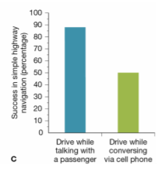
            2. When you have a passenger in the car, they can modulate and change the conversation to accommodate the situation

More invested in living

Or you try to drive more safely if there’s another person in there

1. Task-General Resources
   1. **Response selector:** mechanism that seems to be required for selecting and initiating responses (including both physical and mental, such as beginning a memory search or making a decision)prefrontal
      1. Selecting a response or initiating a motor response
      2. It could just be a thought we’re having
   2. **Executive control:** mechanisms that sets goals and priorities, chooses strategies, and controls the sequence of cognitive processes
2. Brain Damage and Executive Control
   1. Patients with damage to prefrontal cortex (PFC) show executive control deficits
      1. Make **perseveration errors:**
         1. First asked to sort cards by color
         2. Then asked to sort by number
         3. But they have trouble “turning off” the color rule
      2. And demonstrate **goal-neglect:**
         1. Fail to organize behavior with a goal in mind
         2. Cannot organize or plan their actions in some order
3. Divided Attention and Deja Vu?
   1. Study:
      1. Phase 1: flashed symbols extremely briefly, followed by a mask
      2. Phase 2: asked if they’d seen the first symbol prior to this study?
      3. 50% of participants reported feeling deja vu during the story
   2. Claim: when attention is divided we process stimuli, but are not aware of it; when we focus attention on the stimuli we have a sense of familiarity that we misattribute to much earlier time
   3. **Divided attention:** the effort to split your focus between multiple tasks or multiple inputs
4. Divided Attention: Practice
   1. With enough practice, it is possible to divide attention to deal with all of the target and test items simultaneously
   2. Experiment with target and distractors
5. Practice and Automaticity
   1. **Practice:** practice diminishes resource demands (e.g. executive function isn’t required for habits)
   2. **Automaticity:** processing that occurs
      1. (1) without intention (it happens automatically without the person intending to do it) and
      2. (2) at a cost of little or no cognitive resources
   3. Harder tasks never gets automatized
   4. **Automatic Tasks: “mental reflexes”**
      1. Little attention required
      2. Require little flexibility
      3. Run in parallel
      4. Resistant to interference
      5. Examples:
         1. Locking your door
         2. Reading words
   5. **Controlled Tasks**
      1. Attention required
      2. Require flexibility
      3. Run in serial
      4. Interferable
      5. Examples:
         1. Driving in traffic
         2. Taking quizzes
   6. Word Superiority Effect (Reicher, 1969)
      1. Letters within a word are processed more rapidly than single letters
6. Stroop Interference
   1. Reading words is an automatic process, which means it is not controllable--we can’t “turn off” this process
   2. Naming an ink color requires linguistic resources, but so does reading
   3. *When the color of the ink and word are in conflict, we are slower to name the color of the ink because we can’t stop ourselves from producing the color word*
7. Flanker Task
   1. When asked to indicate the direction of the center arrow, participants have trouble ignoring the flanking arrows

Mini-Lab 2/9/2018

Executive control, practice, automaticity - only if it is easy enough; does not use too much attention

Stroop Interference

→ Reading words is automatic; cannot “turn off” this process

* When letters don’t spell words and you have to say the color of those words, it’s easy to say it
* When the word spelled is a color not the color it is printed in

Executive control makes you able to do longer-term goals and strategies

* Inhibition is also in here

Today: Design a study to demonstrate interference in executive control in another way. Your study may rely on automatic processes or on unattended stimuli that are hard to ignore

### Topic 11: Short-term Memory and Working Memory

2/12/2018, 2/14/2018

What would it really be like if we were living in the present moment?

* Cannot finish a movie
* Might have to be driven by biological instinct b/c no sense of past or who you are

Video: a guy lost his memory; and his wife is the only person he recognizes

* Only has short-term memory

1. Memory
   1. “The means by which we **retain and draw on** our past experiences **to use information** in the present” -- Tulving (2000)
      1. Many ways we can partition types of memory (NOT gospel truth)
2. The “Modal” Model
   1. 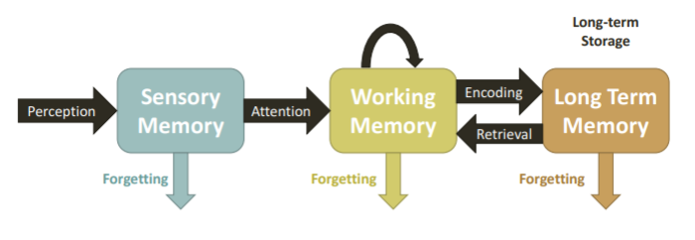
   2. Sensory memory: UNATTENDED information is lost in both sensory and working memory
   3. Maintenance and elaborative rehearsal keeps things in working memory
   4. Forgetting in long term memory: information is not lost but may become INACCESSIBLE
3. Memory - William James (Primary Memory)
   1. “Primary memory” used to describe memory and long term memory versus other stuff
      1. Distinction between short term memory and long term memory
4. Sperling’s Investigation of Short-Term Memory
   1. How much information can people take in from a briefly presented stimuli?
   2. Experiment:
      1. a grid of letters is going to appear REALLY FAST
      2. IMMEDIATELY after they disappear, write down all the letters you remembered
         1. Me: only got GFYL
   3. Subjects can report almost all of the letters correctly when the total number of letters is less than 5, but performance plateaus at about 4-5 letters
      1. 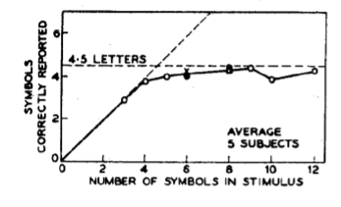
   4. Experiment:
      1. A grid of letters is going to be shown REALLY FAST
      2. After they disappear two arrows will appear
      3. 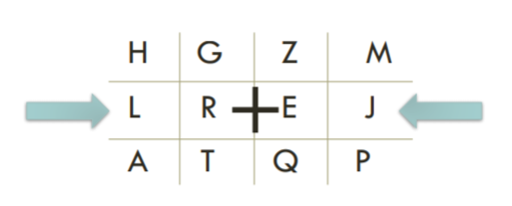
         1. Me: got LREJ
   5. PEOPLE COULD RECALL THE 4 LETTERS OF THE ROW but nothing else
      1. Concluded that people very temporarily retained everything, but very briefly (so the information was there, just very temporarily)
      2. **Partial-report:** asking people to recall part of the image
      3. **Delayed partial report:** asking people to recall part of the image after some time
         1. Increasing the delay decreased accuracy
5. The “Modal” Model
   1. **Sensory memory:** refers to the retention of sensory stimulation for a brief period of time (less than 1 second)
      1. If you wave a sparkler in the dark, you can still kinda see where it was previously
      2. **Iconic memory:** brief sensory memory for visual stimuli
         1. **Persistence of vision:** continued perception of a visual stimulus even after it is no longer present
      3. **Echoic memory:** brief sensory memory for auditory stimuli
         1. “What did you say?” but you check your sensory memory and you’re like “oh wait yeah I heard you”
      4. **Haptic memory:** brief sensory memory of touch information
      5. Duration: 0.5-3 seconds
      6. Capacity: 3-7 units
      7. *Unattended information is lost*
   2. **Short-term memory:** system involved in storing small amounts of information for a brief period of time
      1. Duration: 5-15 seconds
6. Duration of Short-Term Memory
   1. Experiment: string of letters, then a number; countdown from the number by 3s; report the letters
   2. Peterson and Peterson (1959): demonstrating memory decay due to the passage of time
   3. Keppel and Underwood (1962): **this decay was not due do decay of memory trace over time but interference**
      1. The first trial was doing just fine
      2. **Proactive interference:** old learning interferes with new learning
      3. **Retroactive interference:** new learning interferes with old learning
         1. Which of the following would be an example of retroactive interference?
            1. You can’t remember the name of the first person you met at a party, but you can remember the name of the most recent person you met
            2. NOT “You can remember the name of your 1st grade teacher, but not your 5th grade teacher”
7. Capacity of Short-Term Memory
   1. One measure: digit span
      1. The magic number seven, plus or minus two
   2. Capacity is limited not by how many ITEMS, but how many “MEANINGFUL UNITS”
   3. Things we can’t verbalize are harder to remember
   4. Able to retain ~4 items
   5. Generally 5-15 seconds due to interference
      1. Information learned previously affects the information learned later
8. Capacity of Short-Term Memory (2/14/2018)
   1. Maybe capacity needs to be defined as AMOUNT of INFORMATION instead of ITEMS (Alvarez & Cavanagh, 2004)
      1. Analogy: size of the picture that can be stored on a flash drive
      2. Use change detection, then found that the number of items depends on complexity
         1. Number of items they could detect decreased based on complexity
   2. Limited duration and limited capacity (**unrehearsed information is lost**)
   3. NOT JUST ABOUT REHEARSING but also maintaining information, how to manipulate and draw on previous memory
9. SHORT TERM MEMORY → WORKING MEMORY
   1. A limited-capacity system for temporary storage AND MANIPULATION OF INFORMATION FOR COMPLEX TASKS SUCH AS COMPREHENSION, LEARNING, AND REASONING
10. Working Memory (WM)
    1. 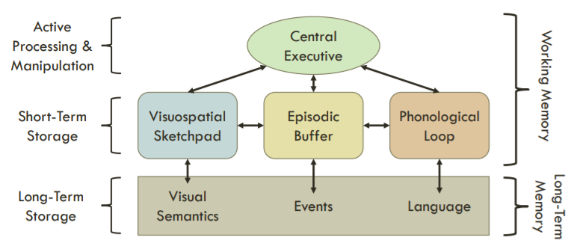
    2. *Active consciousness involves more than just rehearsal*
11. Components of Working Memory
    1. **Phonological loop**:
       1. Holds verbal and auditory information
       2. Limited capacity and holds information for only a few seconds
       3. Articulatory rehearsal process: keeps items in phonological store from decaying
    2. **Visuospatial sketch pad**
       1. Holds visual and spatial information
    3. **Episodic buffer**
       1. Process that brings information from phonological loop and visuospatial sketch pad
       2. Creates coherent, multidimensional representation of what’s in your conscious awareness
    4. **Central executive**
       1. Essentially attention
       2. Functionally the same thing as executive control
12. Evidence for the PHonological Loop
    1. **Phonological similarity effect:**
       1. Conrad and Hull (1964) flashed series of letters on screen and found that when people made errors they were more likely to report letters that SOUNDED similar
    2. **Word length effect**
       1. Baddeley et al. (1984)
       2. Experiment:
          1. People can remember more short words than long words because it takes longer for people to rehearse
             1. beast, limp, wolf, nopenopenope
             2. Alcohol, bricklayer
    3. **Articulatory suppression**
       1. Experiment:
          1. People repeating “the, the, the…” reduces the ability to remember a list of words
          2. Also eliminates word-length effect
             1. Dishwasher, hummingword, homelessness Catholicism
13. Visuospatial Sketch Pad
    1. **Visual imagery**
       1. Creation of visual images in the mind without a visual stimulus
          1. Mental rotation
          2. Holding a visual stimuli in mind even if it disappears
    2. Participants could complete patterns, on average, consisting of 9 shaded squares. This is far above Luck and Vogel’s demonstration that ~4 items is the limit for non-verbal stimuli in short-term memory. Can you think of an explanation that could make these accounts consistent?
       1. We’re not looking at each square individually, we’re looking at contiguous shapes
       2. Chunks
14. Evidence for the Visuospatial Sketch Pad
    1. Experiment:
       1. Visualize the F shape in your mind.
       2. Start at the upper corner and moving around the outline of the F in a clockwise direction in your mind either…
          1. Task 1: point to “Out” for an outside corner” and “in” for an inside corner
          2. Task 2: say “out” for an outside corner, and say “in” for an inside corner
       3. Walk along the F, report if it’s an outside or inside corner, report it by pointing or saying out or in
    2. Clicker: If there is a system in working memory that handles all visual-spatial representations (e.g. the visuospatial sketch pad), which should be the harder “F” task?
       1. **Tracing the “F” in your mind while pointing to the words “out” or “in”**
       2. Tracing the “F” in your mind and reciting the words “out” or “in”
    3. If you have verbal interference for a verbal task, then it’s interfering with the same resources
    4. Likewise, if you use visual-spatial working memory system, and you have to interfere with it, then you’re gonna find this suppression effect
15. Evidence for a Central Executive
    1. Background:
       1. Can memory capacity of working memory
          1. Reading a sentence task; report back the last few words of the sentence
          2. Working memory is strongly correlated with the number of words you can report
       2. Number of items in working memory determine ERP (event-related potential)
          1. Large # → large ERP
          2. Smaller # → less ERP
    2. Vogel et al (2005)
       1. Separated people based on low and high working memory capacity
       2. Gave a cue, pay attention to the red bars, ignore the blue bars
       3. Low capacity subjects had more items in their working memory compared to the higher working memory subjects
          1. BUT THEY SHOULDN’T HAVE
          2. They’re supposed to just look at red bars and inhibit blue bars
          3. High working memory people were able to ignore those distractor blue bars
          4. Low working memory people (higher ERP response), unable to inhibit all the blue bars
       4. 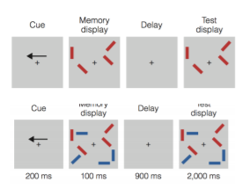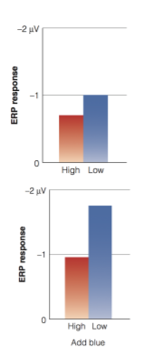
16. Episodic Buffer
    1. Episodic buffer represents and integrates input from all subcomponents of working memory and from long-term memory systems in a multidimensional code
       1. May fulfill the function of solving the binding problem
       2. Attention is involved in binding
          1. How do we know a red ball rolling is a red, ball, rolling?
    2. PL (phonological loop) and VSP (visuospatial sketch pad) cannot explain everything
    3. This one will pull all of these together
    4. Not much is done on the research for the episodic buffer
17. Brain Damage and Executive Control
    1. Patients with damage to prefrontal cortex (PFC) show executive control deficits
       1. No goal-directed behaviors
    2. **Perseveration errors:** 
       1. first asked to sort cards by color, then asked to sort by number, but have trouble turning off the color rule
    3. **Goal-neglect:**
       1. Failing to organize behavior with a goal in mind
18. Working Memory and Prefrontal Cortex
    1. Monkeys can be trained to remember which well a food treat is in, and retrieve after a delay
       1. Monkeys whose prefrontal cortex is lesioned cannot perform this task
    2. Monkeys trained to move their eyes to the location where a squad had been
       1. PF neurons that fire in response to the square continue to fire during the delay
19. Distributed Representation of WM
    1. **Neural mind reading:** using brain imaging (usually fMRI) to predict what a person is perceiving
       1. For visual working memory tasks, early visual areas also seem involved with holding information
          1. Measure voxel activity to different orientations
          2. Create decoder based on these patterns
          3. Test decoder by predicting what stimuli the person is looking at based on voxel activity
       2. Can use that decoder to do other things

### 

### Topic 12: Long-term Memory: Encoding, Retrieval, Consolidation

2/16/2018, 2/21/2018, 2/23/2018

ZAPS IS DUE TONIGHT 2/16/18

Exam Monday 2/26/18 - multiple choice, more material (study guide will be posted)

* Neural mind reading
* Different areas have different tasks but also distributed representation
* **Prefrontal cortex:** important for holding information for short periods of time

1. Do Prescription Stimulants Enhance Working Memory?
   1. ADHD: deficits in prefrontal cortex
      1. Abnormalities in catecholamine system (dopamine/norepinephrine)
      2. Adderall/Ritalin increases these neurotransmitters and improves symptoms in individuals
   2. But does Ritalin and Adderall actually improve working memory in HEALTHY adults?
      1. Mixed results, some positive, null effects, impairment
      2. Flanker tasks, digit span
   3. Intuition: it definitely helps
      1. Doesn’t seem to show, but there are some effects for more improvement in “less able” participants
      2. ADHD spectrum but not diagnosed
2. The “Modal” Model”
   1. 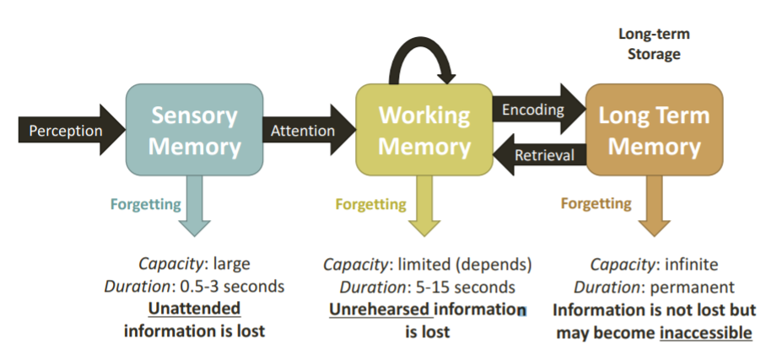
3. Distinction Between Long and Short-Term Memory
   1. **Serial position effect** (Murdoch, 1962)
      1. 30 words, each presented every second
      2. Free recall procedure
      3. Best results at the end and the beginning
      4. **Primacy effect** and **recency effect**
   2. Primacy effect as a result of **rehearsal** of the words at the beginning that is then transferred to long term memory
   3. Recency effect: most recently presented words are still in short term memory
   4. Clicker: An explanation for the primacy effect is that rehearsing the words at the beginning of the list allows them to be transferred to LTM. An explanation for the recency effect is that the most recent words are still in STM at the time of recall. How might you change the serial position experiment in order to test this explanation of the recency effect?
      1. After the last word is presented, but before recall, ask subjects to count backwards from 30
4. Recency Due to Info in STM?
   1. After the last word is presented, ask subjects to count backwards from 30 (Glanzer & Cunitz, 1966)
   2. 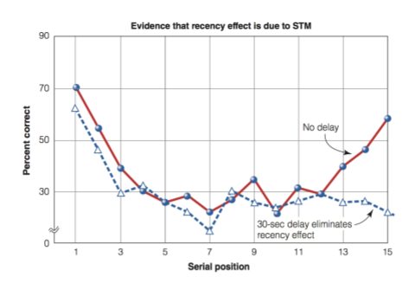
5. Primacy Due to Rehearsal?
   1. As subjects are viewing the list, ask them to repeat any words they would like aloud in order to see which words they repeat the most
   2. 1 word every 5 seconds, repeat aloud anything they would like in the 5 second delay
   3. Words at the beginning are rehearsed (and remembered) more
6. Information Coding in STM vs. LTM
   1. Coding == how is the information represented in the mind? (not in the brain, in abstract terms)
   2. 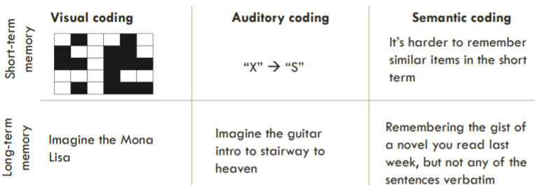
   3. **Visual coding:** visual representation, not how it’s instantiated in the brain
      1. Just that we knoowww we have visual imagery with behavioral evidence
      2. The type in coding you’d do in short term memory test and recall where the squares are
   4. **Auditory coding:**
      1. We mix up letters that sound similar, x instead of s
7. Semantic Coding in Long Term Memory: Sachs (1967)
   1. People confused similar sentences together that have the same meaning
   2. 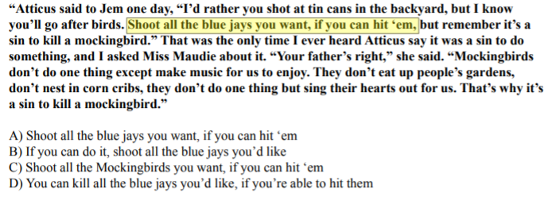
   3. The longer the time goes by, the more we semanticize things (just keep the meaning)
8. Semantic Coding in STM: Wickens et al (1976)
   1. They see 3 words, try to recall them
   2. If the three words are similar, did well first trial, but not subsequent trials of same condition
      1. PROACTIVE INTERFERENCE: the decrease in memory that occurs when previously learned information interferes with learning new information (retroactive is when new information interferes with previous information)
   3. 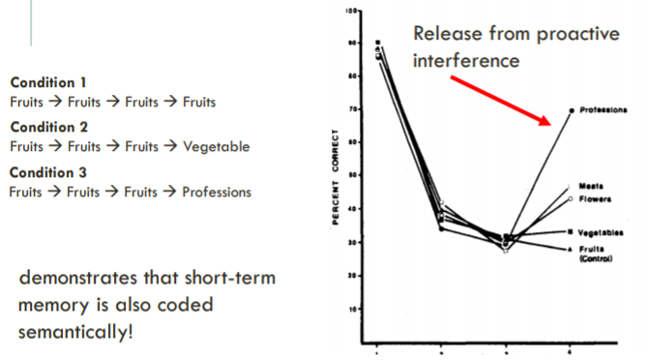
   4. Because proactive interference interfered with accuracy, it must affect the short term memory because the meaning shouldn’t matter but it did
9. Memory in the Brain: Amnestic Patient H.M.
   1. Hippocampus removed
   2. Could remember information in the short term, but lost ability to transfer this to long term memory
      1. As a child, had epileptic seizures that prevented him to go to school
      2. A surgeon agreed to have the origin of the seizures removed (hippocampus)
      3. *It worked in that after surgery, his epilepsy was gone, but he could not remember anything anymore*
   3. Different brain areas responsible for short and long term memory
   4. Can remember things for 15 minutes if he was actively going into it, but then it would be lost
   5. Now we know short term and long term memory are stored in different parts of the brain
   6. **Double dissociation:** damage to one area of the brain causes function A to be absent while function B is present, and damage to another area causes function B to be absent while function A is present
   7. Patient HM and Clive Wearing: STM was okay, LTM was impaired/unable to change
   8. Patient KF had impaired STM, but LTM was OK
10. Long-Term Memory
    1. THERE IS A DIFFERENCE BETWEEN TWO TYPES OF MEMORY IN LONG TERM MEMORY
    2. **Explicit memory:** conscious memories
    3. **Implicit memory:** not conscious memories
       1. Tested HM on implicit learning tasks
       2. Tracing the star in a mirror (really bad if you start, but after practice, you’d get better)
          1. HM did this many times and at first didn’t do well, at the end, did very well
          2. But he was not consciously aware of this
    4. 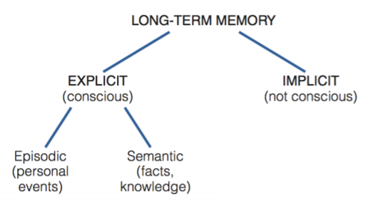
11. Explicit Memory
    1. **Episodic memory:** 
       1. Personal events
       2. Mental time travel; the experience of traveling back in time to reconnect with events that happened in the past
    2. **Semantic memory:**
       1. Facts, knowledge
       2. Accessing knowledge about the world that does not have to be tied to remembering a personal experience
       3. You know the 50 states, but don’t recall the source of this information or how you acquired this information
       4. Patient KC: cannot remember personal events with his brother, but can remember his brother died 2 years ago
       5. Patient Italian woman: can remember personal events, but not so much plain facts
    3. Subjects kept audio diaries, then they listened to them in fMRI scanner
       1. Either hearing episodic information, or semantic information
       2. Then different activation based on describing episodic information or semantic information
    4. **Autobiographical memory:** not necessarily episodic because we remember specific facts too
       1. Memory for specific experiences from our life, which can include both episodic and semantic components
       2. **Personal semantic memories** are facts associated with personal experiences
    5. **Remember/Know Procedure**
       1. *The more remote a memory, the more “semanticized” it becomes*
       2. Remember: stimulus is familiar AND the person remembers the circumstances of original encounter
       3. Know: familiar with the event but cannot recollect any personal experience or details
    6. Things tend to go from episodic to semantic memory
12. Future Imagining
    1. Similar neural mechanisms are involved in remembering the past and *imagining* the future
    2. Patients who have lost their episodic memory are unable to use their imagination to describe personal events that might happen to them in the future
       1. Describing a future thing with episodic memory
    3. In control patients, remembering the past events has similar brain areas active for imagining future episodic detail
    4. *Constructive episodic simulation hypothesis*
13. Types of Long-Term Memory
    1. Declarative/explicit memory
       1. semantic/facts
       2. events/episodic
    2. Nondeclarative/implicit memory
       1. Playing piano
       2. Tracing star in mirrored box
       3. **Priming:** when the presentation of one stimulus changes the way a person responds to another stimulus
          1. Can occur even though subjects may not remember the original presentation of the priming stimuli
          2. TAB_ _
             1. Prime for TABLE word
       4. Classical conditioning
14. How do we get information into LTM?
    1. **Encoding:** process of getting information into long-term memory
    2. **Retrieval:** accessing the information that you have stored in LTM, bringing it back to working-memory
    3. **Maintenance rehearsal:** repeated information to refresh it in STM store without adding additional info or connections
    4. **Elaborative rehearsal:** developing connections between what you’re rehearsing and what you already know
       1. Both maintenance and elaborative bring things into LTM later but elaborative is more organized and more distinguished
       2. Repeating a phone number could bring it into your brain but can’t always access it
       3. Elaborative rehearsal may enhance retrieval because we’re storing it in an organized way
    5. Encoding versus retrieval is difficult to test
       1. If you study with a substance, you better take the test with that substance because the physiological state matches
15. The Need for Active Encoding
    1. Repeated exposure to something is not enough to establish the information or item in memory (at least not in a retrievable way)
       1. Example: pennies
          1. We don’t really memorize a lot of the details even though we’re repeatedly exposed to this information
       2. Example: apple symbol
          1. Could not draw it
    2. In order to actually store it, we need to process it more deeply
16. Levels of Processing Theory
    1. **Levels of processing theory:** memory depends on the depth of processing an item receives
       1. A little circular but yeah
    2. Two levels:
       1. Shallow processing:
          1. Involves little attention to meaning
       2. Deep processing
          1. Lots of attention to meaning
    3. Is the word printed in capital letters? Does it rhyme with pain? Does ___ make sense in this sentence? ____
       1. Capital letters: very little meaning processing
       2. Rhyme: middle meaning processing
       3. Fill in the blanks: lots of meaning processing
17. Incidental vs Intentional Learning
    1. **Incidental learning:** learning in the absence of any intention to learn
    2. **Intentional learning:** learning that is deliberate, with an expectation that memory will be tested later
    3. *Intention* to learn doesn’t matter that much; instead what seems to matter is HOW the material is processed
18. Encoding Procedures that Enhance Retrieval
    1. Forming visual images
       1. Visualizing what should be there
       2. The word boat-tree versus the image boat in a tree
    2. Generating information
       1. Reading something versus generating words themselves
       2. People remember things they had to figure out more than what they just read
    3. Organizing information
       1. Organizing information in a way that is sensible
    4. *Linking words….*
       1. *To yourself*
       2. *To survival value*
    5. **Self-reference effect:** memory is better if you relate the information to yourself
    6. Experiment about information related to survival value:
       1. Condition #1: count the number of vowels….
       2. Condition #2: how useful would this be if you were stranded in grasslands of foreign land without any basic survival materials
       3. Do you see any flaws in this experimental design as presented? What effect have we learned about that could explain it? How could this study be improved?
          1. It’s just establishing that we’re processing the information even more
          2. It’s processing it more completely
       4. Actually… condition #3: stranded in foreign city...how useful to defend against attacker
          1. Even though if you’re stranded in foreign city, it creates a survival effect
          2. People can remember the words better in the grassland than the foreign city b/c it’s linked to ancestral path
    7. **Retrieval practice:** practicing getting information out of memory
       1. **Testing effect:** enhanced performance due to retrieval practice
          1. People remember things better based on whether or not they’ve been tested
          2. Re-reading versus testing group shows dramatic results
          3. So testing actually enhances performance
       2. **Spacing effect:** memory is better when encoding attempts are broken into short session
          1. Like… don’t cram everything at the end, but do a little bit every now and then
    8. **Retrieval cue:** any cue that helps us get information out of memory
       1. Memory is better when the conditional at encoding match the conditional at retrieval
    9. **Encoding specificity:** we encode information along with its context where it’s encoded (external context, like underwater, noisy environment)
       1. Learned stuff in water, learned stuff on land
          1. If they learned it in water, they performed better on the test in water than in land
          2. Same the other away
          3. If you study in a quiet environment, you’ll do better if you’re tested in a quiet environment
    10. **State dependent memory:** learning that is associated with a specific internal state
        1. Made participants sad with sad music
           1. If they learned in a sad mood then performed better in a sad mood
           2. If they learned in a sad mood then performed badly in a happy mood
           3. Hoffman: Study drunk, take the test drunk
           4. Study sober, take the test sober
    11. **Transfer appropriate processing**
        1. Encoding: meaning condition
           1. The ____ had a silver engine
           2. Does the word “train” make sense in here?
        2. Encoding: rhyming condition
        3. Based on *levels of processing theory,* which condition would we expect to result in better memory performance?
           1. **Meaning condition** (not rhyming condition)
           2. BUT in the rhyming condition is found to be done about the same or better for retrieval
           3. If you study in rhyming phase, you can retrieve it rhyming the same way
           4. Rhyming is a context itself
        4. Imagine you have a friend who is struggling in his classes. Based on the research we have discussed so far today, what are some ways you’d recommend to make his study time more effective?
           1. Study in the context you’ll be tested in, like in a quiet thing
           2. Practice tests that are similar to the tests, in timed environment (testing effect)
           3. If you study drunk, take the test drunk
           4. Study in the exact lecture hall (context-dependent learning)
           5. Relate things to things that are meaningful to themselves
           6. Don’t cram, study a little bit at a time
           7. Flashcards (for generation effect for making the flashcards)
           8. Making your own test questions that are similar to the exam (generation effect while replicating testing environment)
           9. Take the class, take the exam, drop the class, re-enroll in the class, take the exam again L O L
           10. SHERLOCK’S MIND PALACE - spatial environment where you learn everything (like in your own house, then place items along the path in that environment)
               1. This is how people memorize a deck of cards
               2. Memorize the cards that are linked to people in their mind palace
               3. So normal people can memorize things that are difficult to memorize
19. Memory Consolidation
    1. New memories are fragile and can be easily disrupted  
       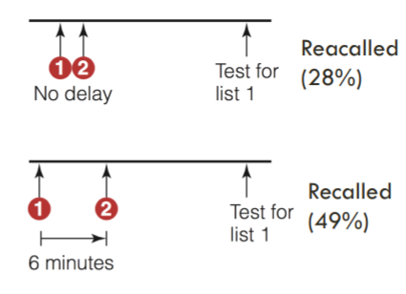
    2. **Memory consolidation:** the process that transforms new memories from a fragile state, in which they can be disrupted, to a more permanent state, in which they are resistant to disruption
       1. ...don’t take classes back to back so you give yourself time for your memory to consolidate
    3. **Donald Hebb:** proposed that learning and memory are represented in the brain by physiological changes that take place at the synapse
       1. **Synaptic consolidation:** structural changes at the synaptic level
          1. Neurons that fire together wire together
          2. **Long-term potentiation:** repeated activity can strengthen the synapse, cause structural changes, and increase transmitter release, and increased firing
             1. After long-term potentiation, it’s more active in response to that stimulus
          3. Short time scale
       2. **Systems consolidation:** gradual reorganization of neural circuits
          1. Takes place over months or year
          2. Happening while synaptic consolidation occurs
       3. Hippocampus’s involvement in consolidation:
          1. Areas in the cortex
          2. Hippocampus coordinates the activity between brain regions that were active during the experience
          3. **Reactivation:** hippocampus replays the activity associated with a memory
          4. Gets the memories to coordinate
          5. Then over time, the connection to hippocampus is broken and conditions in the cortex make conditions between each other instead
          6. Memory trace is now there without the hippocampus
          7. Hippocampus is no longer necessary for the memory
          8. Immediate learning is affected if hippocampus is damaged, but past memories are okay
20. Multiple Trace Model of Consolidation:
    1. Hippocampus is involved in retrieval of episodic memories,*even if they originated long ago* (Nadel & Moskovitch, 1997)
    2. The response of the hippocampus DOES change over time
       1. But only for stimuli that have lost their episodic character
    3. In experiment:
       1. They learn this alligator-candle association
       2. They know they saw it, but don’t remember the episodic memory associated with it
       3. Early on: more episodic memory than semantic, then it switches over time
       4. When you scan the hippocampus, items that they overtime say they remember, are still involved in hippocampal activity, but if they KNOW the item (just semantic) then the hippocampus is a lot less involved
       5. So hippocampus activity changes over time
       6. Memories that remain episodic are what hippocampus takes care of most

### Topic 13: Eyewitness Memory! Guest Speaker Professor John Wixted

2/28/2018

Eyewitness memory: police asked someone about something, that someone accuses someone incorrectly or correctly

* Unreliable?
* Reliable?

1. Eyewitness Memory and Wrongful Convictions
   1. 1990s the Innocence Project: used DNA testing to overturn more than 350 wrongful conviction
   2. What went wrong?
2. The Case of Ronald Cotton
   1. College student named Jennifer Thompson was raped 1984
   2. Picked Ronald Cotton
   3. Cotton was sentenced to life in prison plus 54 years, and he served almost 11 years in prison before being exonerated
   4. He was not the rapist! But she was so confident
3. Elizabeth Loftus and the malleability of memory
   1. The implicit assumption was that memory is a veridical record of past experiment 1970s
   2. Loftus: false memories can be created really easily
   3. *False memories in the lab + DNA exonerations in the real world →* **prevailing interpretation: eyewitness memory is inherently unreliable**
      1. **Alternative interpretation:** eyewitness memory can be contaminated...which is also true of DNA evidence
4. Forensic DNA evidence
   1. Crime is committed, suspect detained → evidence collected from crime scene → match to suspect?
      1. If yes (conclusive):
         1. prosecute
      2. If yes (inconclusive); like if dna was found on clothing of the crime scene, it was hot and humid, so the dna degraded a bit
         1. Just further investigate suspect
5. A DNA match is not always conclusive
   1. **Inconclusive:**
      1. Forensic sample (degraded) versus Suspect’s standard
      2. Mostly matched but just partial match
      3. Low confidence match
   2. **Conclusive:**
      1. Lower end of property
      2. All alleles match
      3. “Only would match someone’s dna EXACTLY
      4. High confidence match
6. Hypothetical: a misuse of DNA evidence
   1. What if they prosecute the guy even though it’s inconclusive?
   2. Allow the crime scene to be contaminated with the suspect DNA
   3. Then tell the jury that his DNA is conclusive since the evidence now has the suspect’s DNA
   4. This is messed up!!!! **But this is what they do with eyewitness memory!!!**
7. A misuse of eyewitness evidence (actually)
   1. If yes (inconclusive)--> Prosecute
   2. Then we allow the brain of the eyewitness to be contaminated with the memory trace of the suspect
   3. So at trial, the eyewitness is super confident in the guy!
8. Key point of the DNA analogy
   1. For DNA tests performed on uncontaminated evidence:
      1. Low confidence→ low accuracy (therefore, investigate not prosecute)
      2. High confidence → high accuracy (therefore, prosecute)
   2. For eyewitness memory, it’s a different story:
      1. **Experimental psychologists have argued that confidence is NEVER a good indicator of accuracy**
      2. **Psychologists got this wrong**
9. The relationship between eyewitness confidence and accuracy
   1. We have an indicator of reliability of an eyewitness memory like DNA!
   2. For many years:
      1. Eyewitness identification researchers concluded that even on an initial, uncontaminated memory test, eyewitness IDs are error-prone and eyewitness confidence does not inform accuracy
      2. **The confidence-accuracy correlation is weak**
   3. “Courts across the country now accept that there is at best a weak correlation between a witness’ confidence in his or her identification and its accuracy…”
10. Signal Detection Theory and (ROC) Analysis // **anecdote l o l**
    1. “How does this help people?” “LOL NO I’M DOING IT BECAUSE IT’S INTERESTING!”
    2. Curious driven research - we dig really deep so we’re a super expert in a field
    3. We’re writing the encyclopedia of knowledge
       1. Write the conceptual encyclopedia of knowledge because when later you’re faced with a real-world problem, you’re gonna have to look up what we know about recognition of memory or whatever
       2. **If no one goes deep into it, then you’ll get it wrong!**
       3. **You don’t know in advance what curious-driven research you’ll need in the future!**
11. The confidence-accuracy story has completely changed
    1. Those conclusions about a weak confidence-accuracy relationship were based on the **correlation coefficient** which is often low (about 0.2-0.4) in eyewitness witness
    2. But the confidence is actually HIGH!!!(????)
12. Mock-Crime Laboratory Studies
    1. Each participant (n = 200) watches a simulated crime
    2. Followed by a lineup memory test
    3. Given two lineups:
       1. Target-present lineup
       2. Target-absent lineup
    4. Every time someone lands on a suspect (choices: accept filler, reject lineup, accept suspect), they express their level of confidence
13. The Correlation coefficient
    1. Accuracy: each suspect is correct (1) or incorrect (0)
    2. Confidence: measured using a numerical scale (1 low, 5 high)
    3. Why the heck would you check the correlation coefficient between confidence and accuracy????
       1. So this is what you’re doing
       2. You’re putting a straight line between two separate things
       3. Accuracy 1 .. …. ….. …….. ….  
             
           0 … … . .  
           Confidence  
          Then the correlation coefficient r = 0.38 (they’re very separated)
       4. **HOWEVER, when they said their confidence is high, they were ALWAYS right!**
       5. **If they were guessing, they weren’t accurate**
14. Confidence Accuracy Characteristic Analysis
    1. Eyewitness confidence tells you whether or not their evidence is conclusive!!!!
15. Implications
    1. A high-confidence initial ID is very accurate!
    2. Low confidence initial ID is not as accurate
    3. In 57% of those cases, the record indicated how confident the eyewitness was on the initial ID
    4. **PAY ATTENTION TO THE INITIAL ID, THE ONLY ONE THAT MATTERS**
    5. *The wrongful convictions occurred not because of unreliable eyewitnesses but because the inconclusive nature of their IDs was ignored*
16. The Case of Ronald Cotton
    1. She examined those two pictures for 4-5 minutes AND THEN said “yeah. This is the one…. I think this is the guy”
    2. Jennifer Thompson’s low-confidence initial ID illustrates how RELIABLE eyewitness memory is
17. ***Eyewitness memory IS reliable!***
    1. Like DNA evidence,
       1. When not contaminated
       2. When proper procedures are followed
       3. Confidence something something FIXME TODO
    2. INITIAL IDENTIFICATION is the one to pay attention to!!!!

### Topic 14: Everyday Memory and Memory Errors

3/2/2018, 3/5/2018

Announcements 3/5/2018:

* EC opportunities: Paper for podcast reflection, plus CAPES for EC questions on the final

Memory for life events

1. Memory for Life Events
   1. **Transition points** in our lives are particularly memorable (e.g. Pillemer et al., 1996)
   2. People over 40 show a **reminiscence bump:** enhanced memory for events in adolescence and young adulthood
      1. Time of lots of life changes
      2. Different circumstances at that time
2. Hypothesis About the Reminiscence Bump
   1. **Self-image hypothesis:** when self-image or identity is being formed
   2. people’s self-defining features during this time, at around 25
      1. “I am a mother” ~25 years
   3. **Cognitive hypothesis:** rapid change followed by stability cause stronger encoding of memory
      1. You need more than just transitions, but also a period of stability afterward
   4. **Cultural life script hypothesis:** events in a person’s life become easier to recall when they fit the cultural life script for that person’s culture
3. Memory and Emotion
   1. Memory for emotional stimuli is enhanced
      1. Arousing words (LaBar & Phelps, 1998)
      2. Arousing pictures (Dolcos et al, 2005)
   2. When emotional memories, amygdala activity changes the most
      1. Patient BP with amygdala damage does not show enhanced memory for emotional parts of stories like controls
   3. Cortisol released after emotional events increases memory consolidation
      1. Ice water (stress) versus no ice water (no stress)
   4. *This only increases memory for what you are paying attention to!*
      1. **Weapon focus:** presence of a gun in a crime causes worse memory for other details of the crime
   5. **Flashbulb memories:** vivid memories for circumstances surrounding shocking, highly charged, unexpected events (Brown and Kulik, 1977)
      1. OUR experiences when hearing about a PUBLIC BIG EVENT
      2. We’re not necessarily there
      3. Like 9/11
      4. 2016 election l o l - what did you do when you heard about it? (Me, take a shot of wine)
   6. Think about it: In 1977 Brown and Kulik asked people where they were and what was happening when they heard JFK had been shot (this happened in 1962). They found that people were able to describe these things in great detail. Brown and Kulik thus described these memories as being *like a photograph of the event that doesn’t fade.*
      1. Do you think there is any problems with this conclusion?
         1. YEAH! They asked details about one particular event, so they’re going to give details about one particular event--also how do they know they were accurate?
         2. You can’t verify that these people accurately remembered things because we don’t exactly know what happened
4. Flashbulb Memories
   1. Not like photographs -- they change overtime
   2. Day of the catastrophic or flashbulb event -- tell us the details of what happened
      1. “I was in my religion class and some people walked in and started talking about [it]. I didn’t know any details except that it had exploded…”
   3. 2.5-3 years later, tell us the details of what happened
      1. “When I first heard the explosion I was sitting in my freshman dorm room with my roommate, and we were watching TV> It came on a news flash…”
   4. Roughly 20% of people said they heard it on TV, then later 40% said it was on tv
   5. Details and accuracy fade like normal memories, but people maintain a strong sense of vividness and accuracy (Talarico & Rubin, 2003)
   6. **Narrative rehearsal hypothesis:** we remember shocking public events not because of a special mechanisms, but because we rehearse these events after they occur (Neisser et al., 1996)
      1. Talked about it constantly, replayed endlessly on TV for months, etc
      2. Extensive TV coverage can influence memory
      3. Media can make us have false memories

Memory is constructive

1. Memory is constructive
   1. Most people believe that memory records the events of our life much like a video camera
   2. **Video memory:** “human memory works like a video camera, accurately recording the events we see that hear so that we can review and inspect them later”
   3. *Memory is NOT like a camera:* memories are **constructed** based on what actually happened plus additional factors, such as the person’s knowledge, experiences, and expectations
2. Memory is Constructed Using Knowledge of Our World
   1. **Schema:** a gift framework of the world based on preconceived ideas
      1. Like framework for going to a restaurant
      2. Subjects read Canadian Indian folklore “The War of the Ghosts” and were asked to recall at progressively longer intervals
         1. Story transformed to reflect their own culture
            1. Canoes → boats
            2. Hunting became sailing exhibition
         2. Original memory + schemas
      3. Subjects waited in office for 35 seconds, described the office in another room
         1. They reported items that were not present, but fit the schemas
            1. E.g. incorrectly said there were books
   2. We make these errors because we rely on these tools (that ARE absolutely necessary for us to have memory in the first place)
      1. They are absolutely necessary
         1. If we walk into a restaurant, we don’t want to have to relearn everything all again
      2. They free up our cognitive resources
      3. Without them, we wouldn’t be able to remember anything
   3. Constructive memory can lead to **false recall and recognition**
   4. **DRM Paradigm:** you see list of words with a critical lure (on the test list and not on the given list, but all the words are around there due to being on the same semantic network)
      1. Choosing the critical lure when it wasn’t a word that we were shown
      2. So we have a false memory the critical lure was tehre
      3. 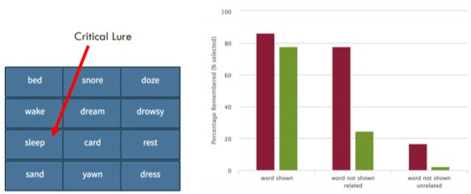
   5. 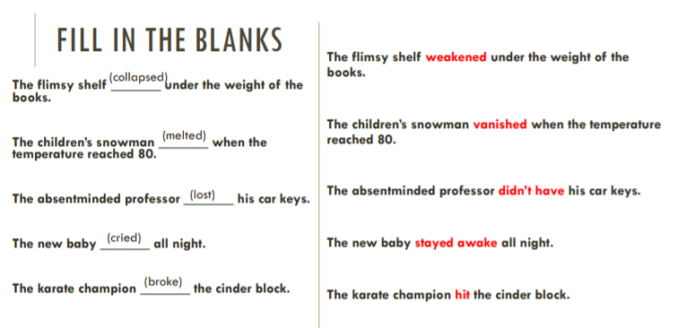
   6. **Pragmatic inference:** reader/listener expects something that is not explicitly stated or implied (Brewer, 1977)
      1. Baseball game
      2. Was the sentence “the batter was safe at first” part of the passage?
      3. Subjects who didn’t know much about baseball correctly said no, but baseball fans were more likely to incorrectly say the sentence had been part of the passage
3. Memory is Influenced by Preconceptions
   1. **Source misattribution:** when memory is attributed to the wrong source
      1. Source misattribution can occur due to stereotypes (e.g. Mickes, Walker, Perris & Mankoff, 2012)
      2. Stereotype: in media and also in our UCSD (94% of males, 89% females said men are funnier)
      3. Men and women roughly equal on humor task
      4. Memory task: misattributed non-funny captions to female authors and non-funny captions to male authors
4. Memory is Influenced by Knowledge of the World
   1. **Schemas:** mental models of how the world works
      1. Example: what our experience at a restaurant will be like
   2. Stereotypes are a *type of schema*: usually based on bias information
      1. Play into memory demonstrated by source misattribution
5. Accumulated Knowledge Shapes our Perception
   1. **Unconscious inference:** interaction between bottom-up and top-down processing
      1. Perceptions are the result of unconscious assumptions, or inferences that we make about the environment
      2. We perceive these objects and events that under normal circumstances would be most likely to produce the received sensory stimulation
6. Accumulated Knowledge Shapes our Memory
   1. When we have uncertainty in our memory:
      1. Our **memories** are influenced by unconscious assumptions, or inferences, that we’ve made about the world
      2. We **remember** events that we think under normal circumstances would be MOST LIKELY
7. Other Types of Misattribution
   1. **Cryptomnesia:** unconscious plagiarism of the work of others (misattributing the source to yourself)
      1. Got a large influence based on someone else’s work but thought it was their own idea
      2. Misattributing source information to yourself when it was an external source
8. Memory is Susceptible to Suggestion
   1. **Misinformation effect:** misleading information presented after a person witnesses an event can change how the person remembers the event
   2. Experiment: participants watched a video of a car
      1. “How fast were the cars going when they hit each other?”
         1. Average guess: 34mph
         2. One week later, “Did you see any broken glass?”
            1. 12% incorrectly said yes
      2. “How fast were the cars going when they smashed into each other?”
         1. Average guess: 41mph
         2. One week later, “Did you see any broken glass?”
            1. 32% incorrectly said yes
   3. Experiment: participants see a video of car stop at stop sign, turn and hit a pedestrian
      1. “Did another car pass the SUV when it was stopped at the STOP sign?”
      2. “Did another car pass the SUV when it was stopped at the YIELD sign?”
   4. Discuss: What causes the misinformation effect is still debated, but two hypotheses have been proposed to account for it. Both are concepts we have learned about before:  
       Retroactive interference  
       Source misattribution
      1. **Retroactive interference account:** more recent learning interferes with something that happened in the past
      2. **Source misattribution:** a person incorrectly concludes that the source of his memory for the incorrect event was from the video
9. Memory is Susceptible to Suggestion
   1. **Misinformation effect:** misleading information presented after a person witnesses an event can change how the person remembers the event
   2. Some attempts to manipulate memory are more successful than others
      1. **Imagination inflation:** planted information is more likely to stick if the person IMAGINES the event RATHER THAN JUST HEARING ABOUT IT
      2. Bogus evidence
10. False Memories for Events in Our Lives
    1. Experiment: Participants shown a fake photo created from a real childhood photo
       1. Then they were asked to describe this event that happened
       2. Many described vivid recollections of the balloon ride that never occurred
    2. Experiment: they’re “reminded” of a fake stunt they pulled in 2nd with a real photo of themselves in 2nd grade unrelated to a possible prank
       1. 80% “recalled” the event in vivid detail
    3. Experiment: Hymen et al., (1995) collected real accounts of events from parents and intermixed them with invented events, and asked subjects to elaborate on these events
       1. Lab day 1: I haven’t heard that before…
       2. 2 days later: large paragraph of recollection too
11. Real-World Implications
    1. False memories can be created by suggestions made to patients undergoing therapy
    2. Case: Holly Romano, treated for an eating disorder
       1. By psychotherapy with controversial, UNPROVEN concepts
       2. **Repressed memories:** memories that have been unconsciously blocked due to the event being associated with a high level of stress/trauma, but can still affect the person’s conscious behavior
       3. **Recovered-memory techniques:** a catch-all term for techniques supposed to bring these unconscious memories into consciousness, hypnosis, guided-imagery, leading questions, sedative-hypnotic drugs, etc
       4. *After this treatment, Holly “recovered” memories of her father repeatedly raping her*
          1. Months of therapy led to her thinking her father raped her
          2. Father lost jobs, ended up suing the psychotherapist, people agreed psychotherapist was messed up, got money
          3. Still sucks
12. Real-World Implications: Eyewitness Testimony
    1. After 2012, 341 people have been exonerated due to DNA evidence
    2. What increases errors in eye-witness memory?
       1. **Emotion** can cause NARROWING of attention
       2. **Weapon focus:** memory is better for relevant information when there is no weapon
          1. If there is weapon, we focus attention on the weapon and miss other details
          2. **Memory is even worse when the gun was fired**
       3. Misidentification due to **familiarity**
          1. Real world case: ticket agent who was robbed misidentified sailor as being perpetrator
          2. Looked familiar because he lived near the train station
          3. Experiment:
             1. Experimental: view film of male teacher reading to students
             2. Control: view film of female teacher reading to students
             3. Then both viewed film of female teacher being robbed
             4. Test: pick robber from photo spread
             5. People who saw the male teacher misattributed him to being the robber
       4. **Post-identification feedback effect:** increasing confidence due to confirming feedback
          1. Real eyewitness testimony:
             1. Eyewitness to a crime on viewing a lineup:

Witness: “Oh my god, I don’t know… it’s one of those two, but I don’t know, the guy’s a little bit taller than number 2, it’s still those 2, but I don’t know”

* + - * 1. Eyewitness 30 minutes later, still viewing the lineup:

Witness: “I don’t know… number two?”

Officer: “okay”

* + - * 1. Months later at trial:

“You were positive it was number 2? It wasn’t a maybe?”

Witness: “there was no maybe about it… I was absolutely positive”

* + - 1. Confidence immediately after lineup is reliable
      2. But confidence at trial is NOT as reliable
  1. 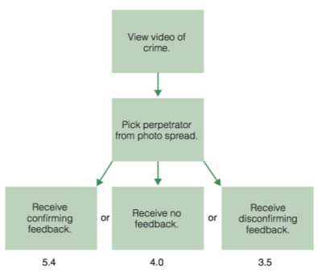 confidence out of 6
  2. Questioning a witness immediately after an event can INCREASE the misinformation effect
  3. **Attention hypothesis**: test draws attention to certain events → misinformation is attended to more
  4. **Reconsolidation hypothesis:** remembering causes reactivation, at which point memory is MOST SUSCEPTIBLE to being changed
     1. Being questioned can cause it to change because the memory is still fragile
  5. *Eyewitness confidence* ***expressed at trial*** *is not necessarily related to accuracy*
  6. *But at* ***initial uncontaminated memory tests*** *with good conditions, confidence is a very good indicator of accuracy*
  7. Discuss: Memory is a constructive process--our memories are a combination of actual experiences plus existing knowledge we have about the world. What is an example of how this is beneficial? When can it be harmful?
     1. Beneficial:
        1. It allows us to use our memory effectively
        2. If we stored everything, we wouldn’t have a coherent synthesis of what’s happening
     2. Harmful:
        1. stereotypes in media
        2. Misattributing what was scary
        3. All the false memory things lol

### Topic 15: Memory Errors; Mini-lab

3/7/2018

Announcements:

* Prompt and podcast reflection 1% extra credit is limited to just 1 time

1. Memory is Susceptible to Suggestion
   1. **Misinformation effect:** misleading information presented after a person witnesses an event can change how the person remembers the event
      1. The car crash (smash versus hit verbally asked)
      2. Stop sign, people misremembered yield or stop
   2. **Imagination inflation:**

### Topic 16: Knowledge: Concepts and Categories

3/9/2018, 3/12/2018

Announcements 3/9/2018:

fiNAl exam ~50 questions, level of difficulty similar to exam 1

Announcements 3/12/2018:

2 extra credit questions to the exam

Final study guide posted tonight

Last mini-lab Wednesday, review on Friday

1. Introduction to Concepts and Categories
   1. **Category:** a set of things in the world that are treated equivalently for some purpose
   2. **Concept:** a mental representation of a category (including all beliefs used to establish category membership)
2. Concepts and Categories
   1. Why do we have concepts and categories?
      1. What would you feed this? (dog)
      2. What is this likely to do if you get too close? (snake)
      3. Which would you take if you had a headache? (Advil, NyQuil)
   2. Dividing the world into classes of things to decrease the amount of information we need to learn, perceive, remember, recognize, predict, reason
      1. All of thinking depends on concepts
      2. (Schema, some template based on some experiences, it’ll be similar to concepts--some theories about concepts are consistent with schema, some aren’t)
   3. Categorization serves a **communication** purpose (concepts provide the meaning of words!!!!)
      1. What’s a ‘paper bee’?
      2. What’s a ‘paper committee’?
   4. How is our conceptual knowledge structured? Why do we have the categories that we do and not other ones?
      1. Classic View
      2. Prototype View
      3. Exemplar View
      4. Theory-theory
3. The Classic View
   1. Concepts are definitions in the head; a list of properties common to all the members of a category (necessary conditions) and ONLY the members of the category (sufficient conditions)
      1. Example: triangle
         1. Closed geometric form
         2. Three sides
         3. Sum of interior angles is 180 degrees
      2. **Conjunctive concepts**:
         1. ____ AND _____
         2. Relatively easy to learn
      3. **Disjunctive concepts:**
         1. _____ OR ______
         2. Relatively harder to learn
   2. PROBLEMS:
      1. What’s the definition of a “game”?
      2. “A bachelor is an unmarried adult male.”
         1. But what about Arthur has been living happily with Alic for the last five years. They have a two year old daughter but never officially married”
         2. “Charlie is 17 years old, lives at home with his parents and is in high school”
         3. “Father Gregory is the bishop of the local Catholic church”
      3. We shouldn’t have a sense of what is “more vehicle-ly”
      4. **It seems like there is more going on than just definitions**
4. Prototype Effects
   1. Typicality ratings are very consistent across people
   2. Ratings correlate with classification reaction time
      1. “Is a carrot a vegetable?” versus “Is a pumpkin a vegetable?”
   3. Items listed in a production task
      1. “Name as many fruits as you can”
         1. Apple tends to be first, olive tends to take a while
   4. Order in learning development
      1. Children learn apple before olive
   5. Linguistic hedges
      1. “*Technically* an olive is a fruit”
5. Prototype View
   1. **Category:** fuzzy set with a **graded membership**
   2. **Concept:** a prototype comprising characteristic features (an average representation of all the dogs you’ve seen)
6. Family Resemblance
   1. Members of a category have a “family resemblance” to one another
      1. Ideal member “prototype”
      2. Atylical member
7. Exemplar View
   1. We reason about new instances by comparing to remembered exemplars
   2. Example: you notice this creature is very similar to your friend Joe’s pet Rex, and you know Rex is a dog, this similar thing is likely also a dog
8. Prototype versus Exemplar View
   1. **Typicality effects support the prototype view**
   2. Some members are “better” than other members
   3. The “better” members are recognized faster
   4. We learn the “better” members before the others
      1. “Is this a fruit?” (green apple, then kiwi)
         1. Prototype: compare green apple to prototype (red apple) → then quickly say yes
            1. Compare kiwi to prototype (red apple) → slowly say yes
   5. **Typicality effects support the exemplar view too**
      1. “Is this a fruit?” (green apple, then kiwi)
         1. We have lots of examples of apples, so we quickly say yes to the green apple
         2. We don’t have as many examples of kiwis, so slowly say yes
9. Combining Prototypes and Exemplars Views
   1. We likely use BOTH prototypes and exemplars when classifying things
   2. This likely differs across individuals based on knowledge
      1. Example: horse expert: many specific, fresh exemplars
         1. Non-expert of horse: use prototype or schema of a horse and compare a new horse to that prototype
      2. So if you’re not an expert in it, you’ll probably refer to the prototype and not an example
   3. *Similar in crucial ways:* object triggers information in memory (either a prototype or an exemplar) and you assess resemblance
      1. Close resemblance is likely a member, no resemblance is likely not a member
   4. Is a category membership always just judged based on prototype/exemplar? (e.g. how far away from the prototypical dog something is indicates how likely it is to be a dog?)
      1. **NOT ALWAYS!**
         1. Is a 3-inch object a pizza or a quarter?
10. Concepts Seem to Depend on “Deeper” Features
    1. Examples:
       1. “Is lemon that has been painted, squashed flat, injected with sugar still a lemon?” - it doesn’t resemble the prototype
       2. Counterfeit money isn’t money (but it does resemble the prototype)
    2. **Resemblance itself depends on whether objects share important essential properties**
11. Theory-Theory
    1. “Theory” Theory
    2. We know more about categories than a list of their features or their values in dimensional space
    3. Categories provide explanations for how things work in the world
       1. Theories **provide explanations** for scientific phenomena
       2. They center on **causal relations** between entities in the world
       3. Theories **guide perception** by leading us to believe that particular features are interesting and others are not
12. What is a drunk?
    1. Situation: it’s late at night, you are walking home when you see someone jump into a swimming pool fully clothed. You think “that guy must be drunk!” Why do you think that?
       1. Features: stinky breath, wobbling walk, impaired speech…”jumps in pools at night”?
       2. Theory theory: the concept of drunk involves a theory of impaired judgment, which explains the man’s behavior, so you induce he must be drunk
          1. Knowledge-based causal theory
13. Evidence for Theory Theory
    1. Children reason differently about manufactured and natural things
       1. You could transform the coffee pot to a toaster
       2. You can’t paint a raccoon to become a skunk
       3. Different theories driving what coffee pots and skunks are
    2. (Springer and Keil 1989) children given a description of an object that belonged to a natural kind (an animal that looks, acts, and sounds like a horse), then later they were given new, plausible defining features of a different kind (like a horse-like cow)
       1. Older children consider the cows still cows
       2. Children under six thought these cows were horses
14. Concepts are Deeply Related to Semantic Memory
    1. 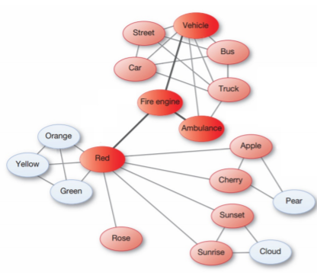
15. Knowledge Network and Semantic Distance
    1. **Sentence-verification task**
    2. Number of links
    3. 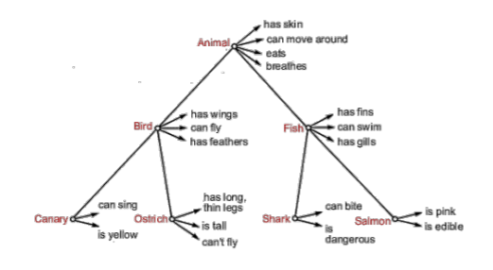
    4. “Salmon are pink” requires 0 links
16. Summary of Theories of Categorization:
    1. **Classical Theory:**
       1. Concepts and categories have definitions (necessary and sufficient conditions)
    2. **Prototype Theory:**
       1. There’s a summary representation for each category
       2. Average based on the previous experiences, different for different people
    3. **Exemplar Theory:**
       1. No summary representation - a concept is a collection of individual instances
       2. Was this animal similar to the specific dog my friend Joe has?
    4. **Theory Theory (theory-based categorization):**
       1. Categories include causal explanations
    5. Think About It: Emily sees an object. It triggers a representation of a car she has stored in memory. She decides that the object has a close resemblance to this stored representation and decides this object should be categorized as a car. This scenario is most consistent with which theory (or theories) of categorization?  
        A. Classic (definitional) theory  
        B. Prototype theory  
        C. Exemplar Theory  
        D. Theory-Theory  
        **E. Both B and C**
    6. Think About It: Emily sees an object. She knows that mops are man made items designed to clean floors, while dogs are living creatures, that have dog parents and dog genetics. She decides that the object is a dog, even though it now looks a lot like a mop. This scenario is most consistent with which theory (or theories) of categorization?  
        A. Classic (definitional) theory  
        B. Prototype theory  
        C. Exemplar Theory  
        **D. Theory-Theory**  
        E. Both B and C
17. Psychologically Privileged Levels
    1. What is this object?
       1. We say “chair” not “swivel chair”, not “furniture”
    2. We have a hierarchical organization of categories
       1. 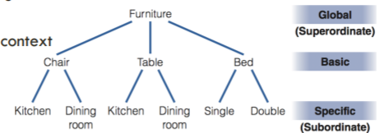
       2. The basic level is privileged
    3. Basic level of this hierarchy seem to be privileged
       1. Spontaneous level of “instinctive categorization”
       2. Children learn this level first
       3. Could change based on knowledge, context
    4. Experiment: list as many features as you can that would be common to all or most of the objects in the category (Rosch et al, 1976)
       1. Furniture, table, kitchen table
       2. 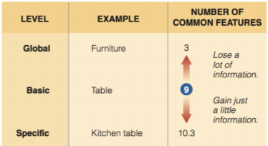
    5. **Basic level is psychologically special because going above it results in a large loss of information and going below it results in little gain of information**
18. Hierarchical Organization in the Mind
    1. How are concepts and categories organized in the mind, though?
    2. Collin and Quillian’s hierarchical model (1967, 1969)
       1. First **semantic network models**:
          1. Proposed that concepts are arranged in networks in the mind in a hierarchical way
          2. **Cognitive economy:** avoid inefficiency; store shared properties at higher node
       2. 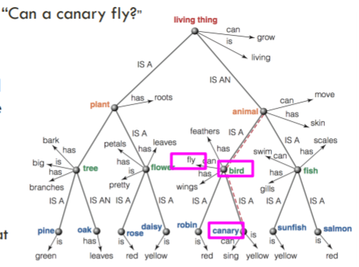
19. Support for Collin and Quillian’s Model
    1. Access canary → fast
       1. Canary is a bird - takes a little longer
       2. A canary is an animal - slightly longer
    2. There’s a lot of evidence here for how these distances are related to semantic distance
       1. But some caveats to this distance hypothesis
    3. **Spreading activation:** activity that spreads out along any link that is connected to an activated node
       1. Prediction: the “primed” (activated) words should be retrieved more readily from memory
    4. **Lexical decision task:** press “yes” if both items are words, no if it’s not
       1. Reaction time is faster if both are activated rather than words that are more distant in the network
          1. Because they don’t spread activation to each other if they’re too far apart
20. Criticism for Collin and Quillian’s Model
    1. *CANNOT explain the typicality effect*
       1. A pig is a mammal (slower)
          1. This model suggests that this should actually be faster
       2. A pig is an animal (faster)
    2. Pigs being mammals is not a typical example, so it’s inconsistent of the semantic network models
21. Connectionist Models
    1. More recently **connectionist models** have gained favor over traditional semantic networks
       1. Mental phenomenon emerges from an interconnected network of simple units
    2. Main difference:
       1. In the hierarchical model, activity is based on the distance
       2. But here, the relatedness is determined by **connection weights**
          1. How signals sent from one unit to another increase or decrease the activity of the next unit, and to varying degrees
          2. Like how neurons are
    3. A stimulus (e.g. the word “canary”) is represented in parallel by the pattern of activity in all the activated units in the network
       1. Not just how close they are in the network
22. How Are Concepts Represented in the Brain?
    1. No clear answer, but some observations
       1. Semantic category approach
       2. Artifacts versus living things
       3. The embodied approach
    2. **Semantic category approach:** specific neural circuits for specific categories
       1. Areas of the brain respond best to specific types of stimuli
       2. Limited number of categories that are innately determined because of their survival value (Mahon & Caramazza, 2011)
          1. There are only so many types of items related to survival, so we have this division of items along these lines
23. Representation of Artifacts versus Living Things
    1. Artifacts seem to be represented differently than living things (like animals)
    2. **Category-specific memory impairment:** ability to identify other types of objects
       1. Patients could identify non-animals but not animals (Warrington & Shallice, 1984)
    3. **Crowding:** the idea that animals and artifacts are distinguishable because animals tend to share many properties (eyes, legs, ability to move)
       1. Artifacts like cars and boats share fewer properties, other than that they are both vehicles
       2. Counterargument for sensory versus category??? FIXME
    4. Experiment: participant rated 160 items on how much they associate them with various features
       1. How much do you associate [object] with a particular [attribute]?
       2. 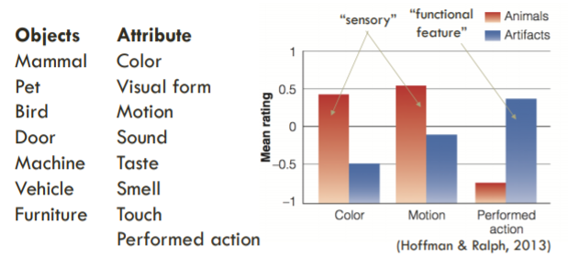
       3. Animals characterize more by sensory attributes while artifacts seem to be characterized by function
          1. Certain devices overlapped with both artifacts and animals
             1. Associated with actions AND sensory properties
24. The Embodied Approach to Concepts
    1. **Embodied approach:** our knowledge of concepts is based on sensory and motor processes that occur when we interact with the object
       1. Thinking about concepts reactivates these areas
    2. Seeing and doing could activate a single, unified concept
    3. **Mirror neurons:** neurons that respond both when we perform an action and when we observe another person perform the action
    4. Hauk et al (2004) measured brain activity:
       1. Measured brain activity when subjects
          1. Moved their foot, index finger, or tongue
          2. Read “action words” such as kick (foot action), pick (finger or hand action), or lick (tongue action)
       2. Reading actions related to a body part were represented by similar areas of the brain for that body part
    5. **Semantic somatotopy:** correspondence between words related to specific parts of the body and the location of brain activity
       1. *CRITICISM:* we have a lot of ideas that aren’t related to sensory or motor experiences
       2. *How can the embodied approach account for abstract concepts, like truth or democracy?*

### Topic 16: Concepts and Categories; Mini-Lab

3/14/2018

1. **Graded membership:** some items seem to be “better” members than others
   1. For prototype and exemplar theory
2. Evidence for Graded Membership
   1. Rating of “birdness”
   2. Production tasks
      1. More typical exemplars are produced/recalled first
      2. Some examples are “fruitier” than others
   3. Sentence verification task
      1. If sentences are true or false
      2. A robin is a bird - true, typical
      3. A penguin is a bird - true, atypical
      4. A butterfly is a bird - false
      5. *Response times are faster for more typical examples*
3. Today: come up with a new task that demonstrates that categories tend to have graded membership
   1. Modify something or come up with something new
4. Measurement Theory
   1. **Theoretical construct:**
      1. Concepts that we are interested in (such as depression, memory, attention, intelligence) but that are not directly observable
   2. **Operational definition:**
      1. An external behavior that “stands in” for the construct we are interested in
      2. We cannot measure a construct so we define a behavior that we believe corresponds to the construct
      3. Concrete thing that is measurable that stands in for the construct that cannot be directly observable

|  |  |
| --- | --- |
| Theoretical constructo | Operational definition |
| intelligence | Score on an IQ test, time to solve a puzzle |
| depression | Hours slept per week, self-reported mood level |
| Executive control | Reaction time on stroop task |

### Topic 17: Final Exam Review

3/16/2018

Announcements:

Final exam Wednesday 8am in this room

History of Studying the mind

The first experiments in cognitive psychology were based on the idea that mental events

1. Can only be studied directly by the person
2. **Inferred from a participant’s behavior**
3. Measured directly
4. Cannot be studied scientifically
5. **Introspection**: observing your own thoughts
6. **Behaviorism**: stimuli and behaviors are objectively observable, but the mind is a black box
7. **Cognitive Revolution:** to understand complex abilities it is necessary to consider what observable behavior tells us about how the mind works
   1. Computer metaphor
   2. Info processing
   3. Cognitive models

Learning: Classical and Operant conditioning

Which of the following is an example of classical conditioning?

1. After studying near a ticking clock for a while you start to ignore the clock
2. You are in a war zone and you start to jump to even the slightest sound
3. **After food is repeatedly paired with a bell, the bell alone starts to elicit salivation**
4. Your partner buys you a present whenever you get in a fight, so you get in fights more
5. All of the above are examples of classical conditioning
6. Reinforcement, punishment, negative, positive
   1. Reinforcement: behavior increase
   2. Punishment: behavior decreases
   3. Positive: adding something
   4. Negative: taking away something

Perception

Which of the following would pose serious problems for our ability to coherently interpret the visual world if it were not for top-down processing?

1. Occlusion
2. Different retinal images of same object
3. Image reversal problem
4. **All of them**
5. **Viewpoint invariance:** we recognize an object regardless of our perspective

Attention

Change blindness demonstrates that:

1. Divided attention is possible when both tasks are easy
2. Selective attention enhances perception
3. We need attention to bind features
4. **Attention is limited, we see much less than what we think we see**
5. Attention is limited capacity
6. **Change blindness**: difficulty in detecting changes in a scene when you are not looking for them
7. **Inattentional blindness:** people fail to see what they are not explicitly attending to, especially if it is unexpected
8. Divided attention:
   1. **Specificity of resources:** similar tasks will compete for similar resources, diminishing performance
   2. **General resources:** dissimilar tasks can also compete and diminish performance, especially as tasks get harder
9. Binding problem, to perceive a coherent world
   1. Illusory conjunctions

Short-term & working memory

Long-term memory

Sperling (1960) tic-tac-toe looking thing with letters in it

1. **Sensory memory has a capacity that is greater than 3 items, but fades really fast**
2. Sensory memory has a smaller capacity than short-term memory, but lasts a long time
3. Working memory should replace short-term memory
4. Short-term memory has a limited capacity, but long term memory does not
5. The “Modal” Model
   1. Maintenance and elaborative rehearsal:
      1. Maintenance: keeping it around, saying something over and over
      2. Elaborative rehearsal: connecting it to some other people of information
      3. Proactive interference
6. Working memory
   1. Phonological loop
   2. Visuospatial sketch pad
   3. Episodic buffer
   4. Central executive

-----

LTM: everyday memory & memory errors

Knowledge: concepts and categories

1. **Retrieval cue:** any cue that helps us get information out of the memory
2. **Encoding specificity:** we encode information along with its context
3. **State dependent memory:** learning that is associated with a specific internal state
4. Memory for life events
   1. **Reminiscence bump:** enhanced memory for events in adolescence and young adulthood (about 10 to 30 years)
   2. **Flashbulb memories:** vivid memories for circumstances surrounding shocking, highly charged, unexpected events