Nicole Wong

Prof. Randall Root

IT FDN 110 B Su22

22 Aug 2022

**Assignment 07**

**Introduction**

This week’s module was all about working with text and binary files, along with structured error handling, and finally creating advanced GitHub pages. We went in depth about read and append modes, and manipulating data to read and write into a file. Try-except was an old concept from last week that was reintroduced. We were able to use specific exceptions and raising custom errors for the user to be able to know precisely what went wrong.

**Task**

We were tasked with creating a script that demonstrates both pickling and also structured error handling work. To be able to pickle, an external file is required for the data to be loaded into. In this case, we were taught to use .dat files, so that is what I used.

**Procedure**

I started by importing pickle. Then I had the user input two integers to use for a quotient.

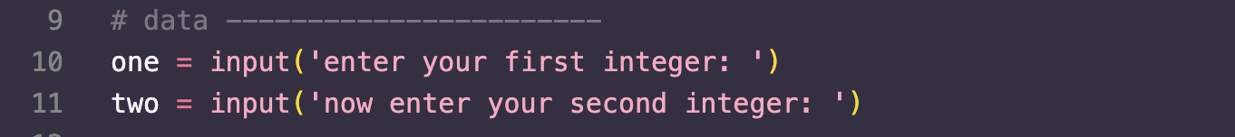

After that I put a try-except down. I had it try to divide the two integers, and from then I put down the pickling within the try to open up the .dat file and dump the quotient in. I closed out the try by printing the quotient.

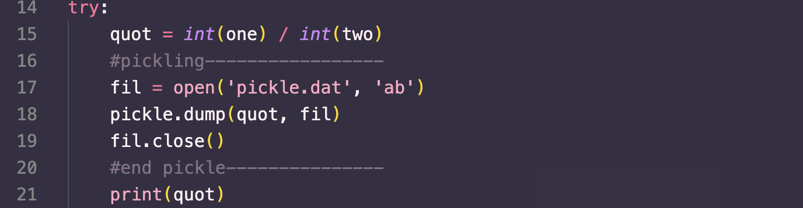

The except was set as an exception to a variable e, and I put down the same commands we learned this module that tells the error, class of error, and further information on the error.

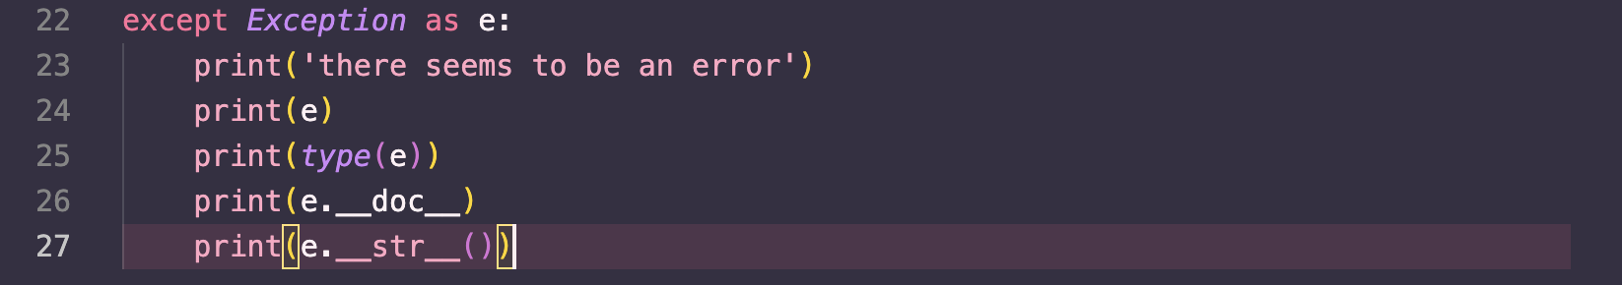

**Testing**

I tested my code by inputting two random integers, where the code worked. 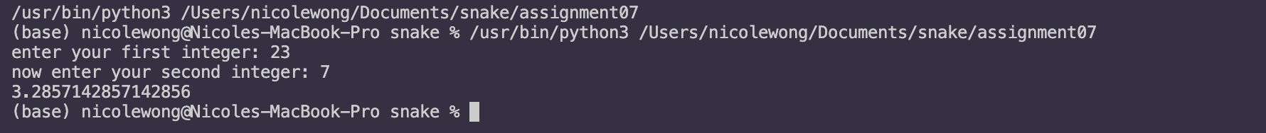

Then I decided to divide my numerator by zero, and it popped out the error message. 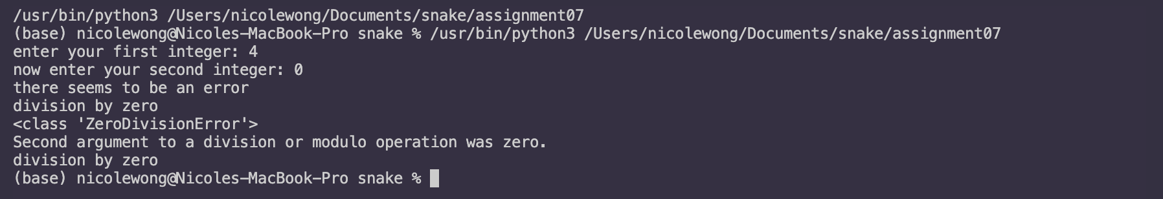

Lastly, I opened up the .dat file and it was the same encrypted letters as shown in lecture, meaning there *was* something written into the file. 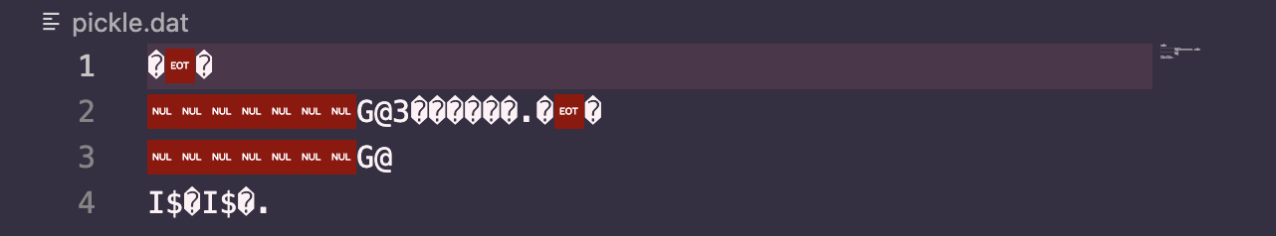

Summary

I learned a lot about how to use data from a separate file, whether it be reading or writing into the file. I also learned about how pickling works and how it stores data as binary information rather than text itself, which can save space. This module was very interesting and helpful as I can see myself using these skills and tools in the future for data analysis within my major.