Introduction
This report presents an analysis of the network traffic contained within the provided packet capture file (cw1.pcap) with the objective of identifying malicious activity and associated indicators of compromise. Network traffic analysis is a fundamental component of incident response, enabling analysts to reconstruct events, understand attacker behaviour, and assess potential impact based on observed communications.
The dataset was examined to determine whether suspicious or malicious activity occurred, including malware delivery, unauthorised file transfers, and potential command-and-control (C2) communications. Particular attention was given to protocol-level behaviour, abnormal connection patterns, and server responses indicative of exploitation or post-compromise activity.
To support this analysis, a combination of high-level traffic aggregation and detailed packet inspection was employed. The findings presented in this report are derived solely from independent inspection of the provided packet capture, with external standards and threat intelligence referenced only to assist in the interpretation of observed behaviours rather than to supply predetermined answers.
Git Hub: https://github.com/wongoining/COMP3010HK_oi

Methodology

Result
- Check for the alert
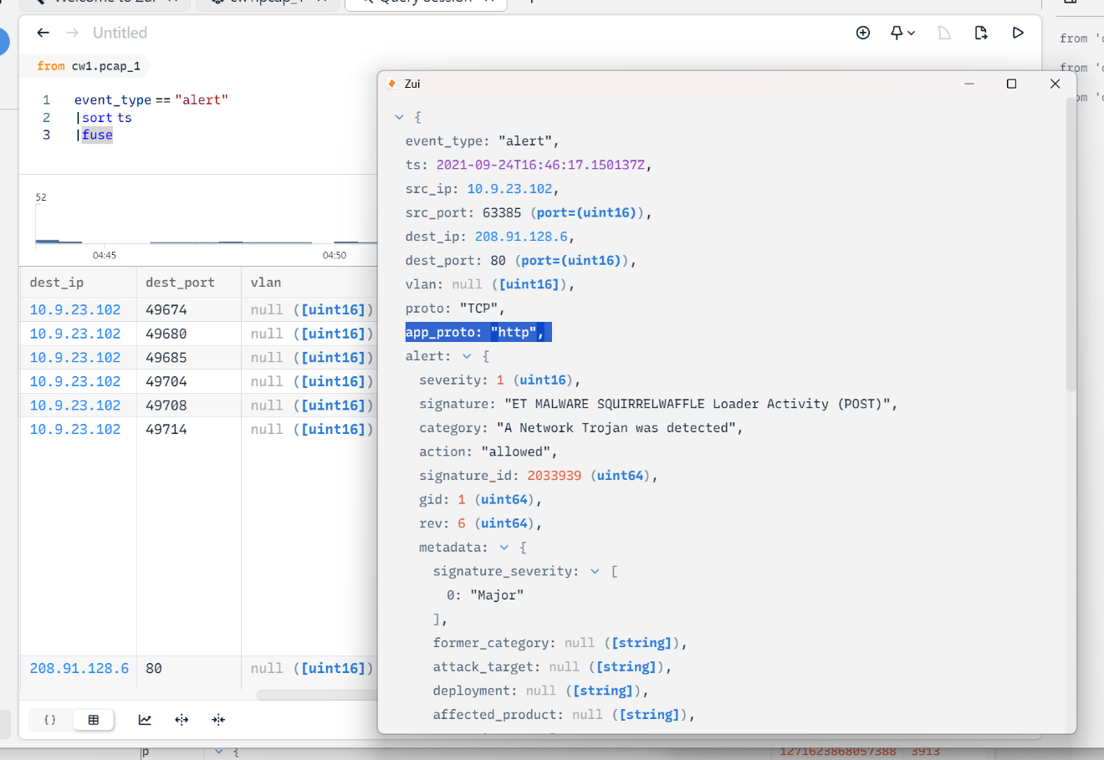
Source should come from http
- Check for http, and find out the possible ones (time earlier than first alert)
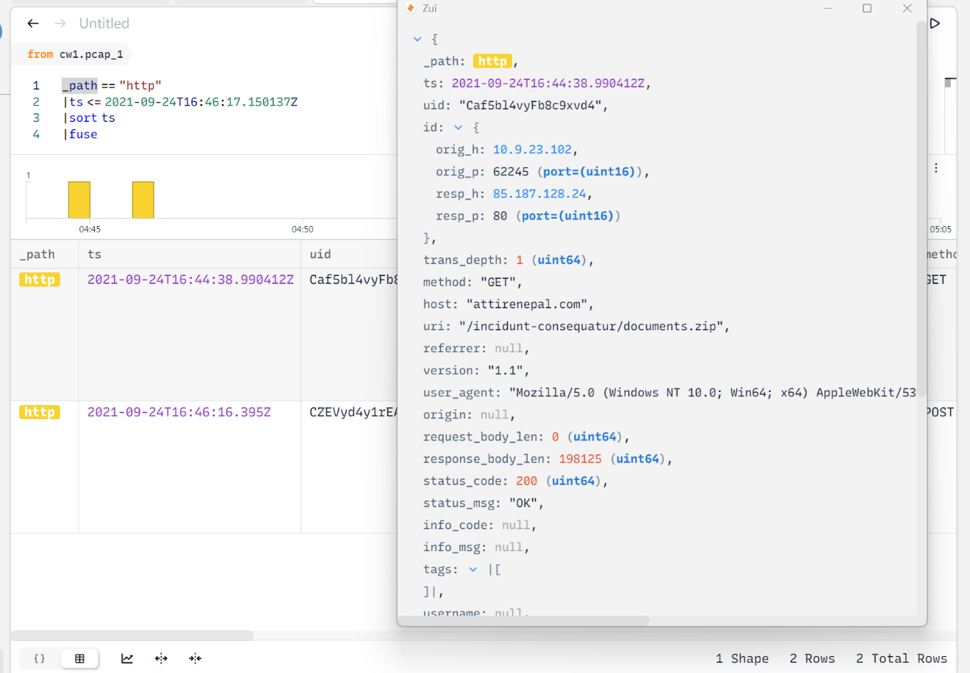
- Export to wireshark, download the file, review the file name inside the zip
- 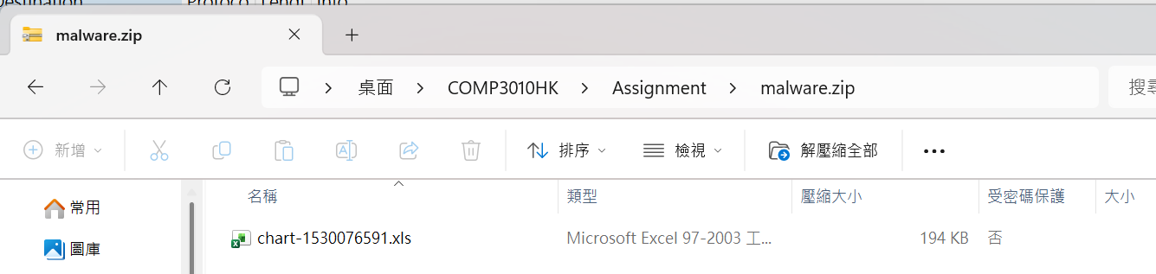
- Find the respond from 85.187.128.24, and check for header
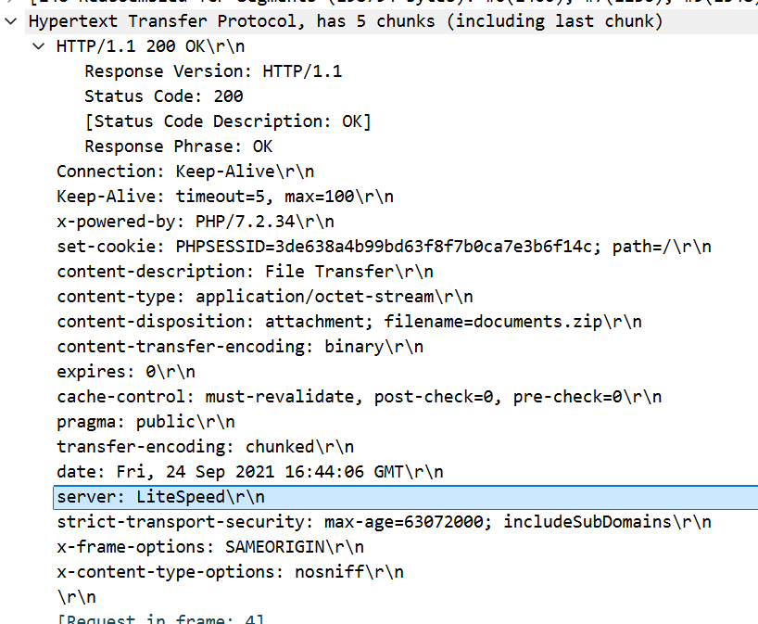
Server header shows the server is LiteSpeed, without version information
- Check for the TSL / SSL (HTTPS transfer)
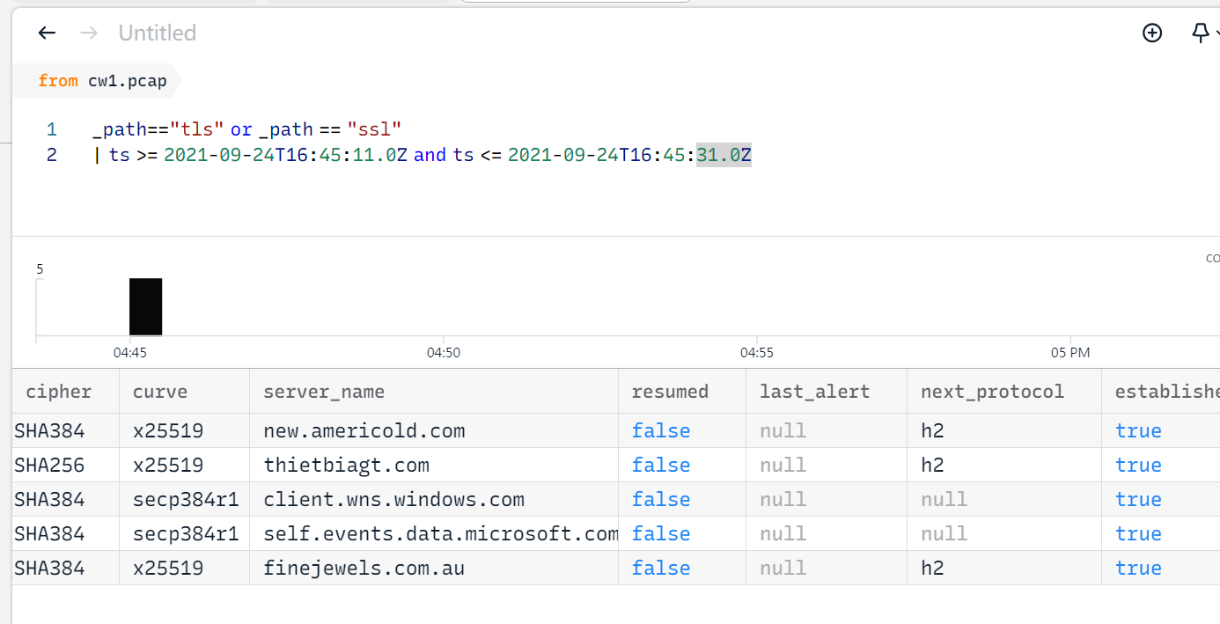
client.wns.windows.com / self.events.data.microsoft.com should be normal flow and no need to consider
有問題host: new.americold.com/thietbiagt.com / finejewels.com.au
- 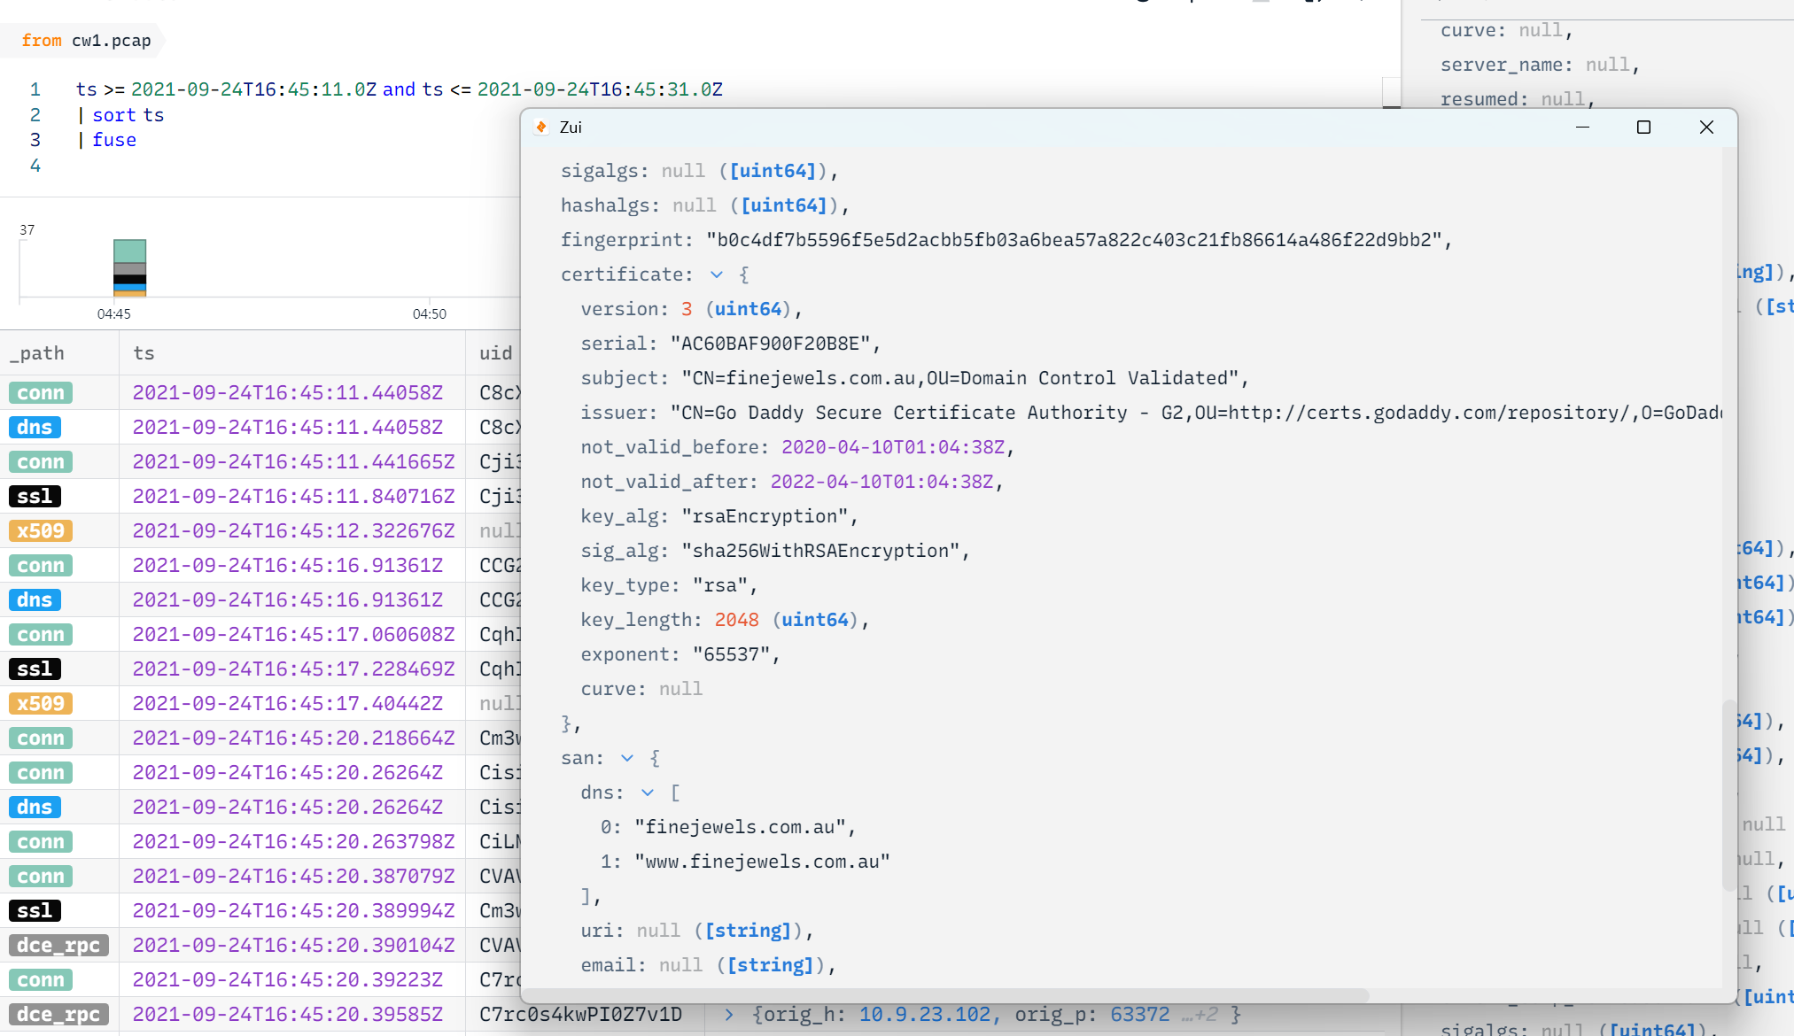
- 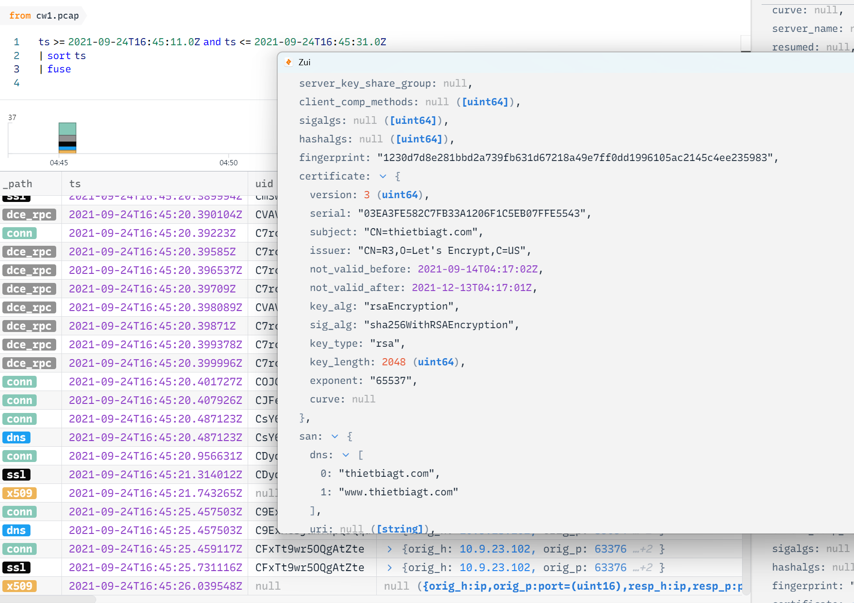
- 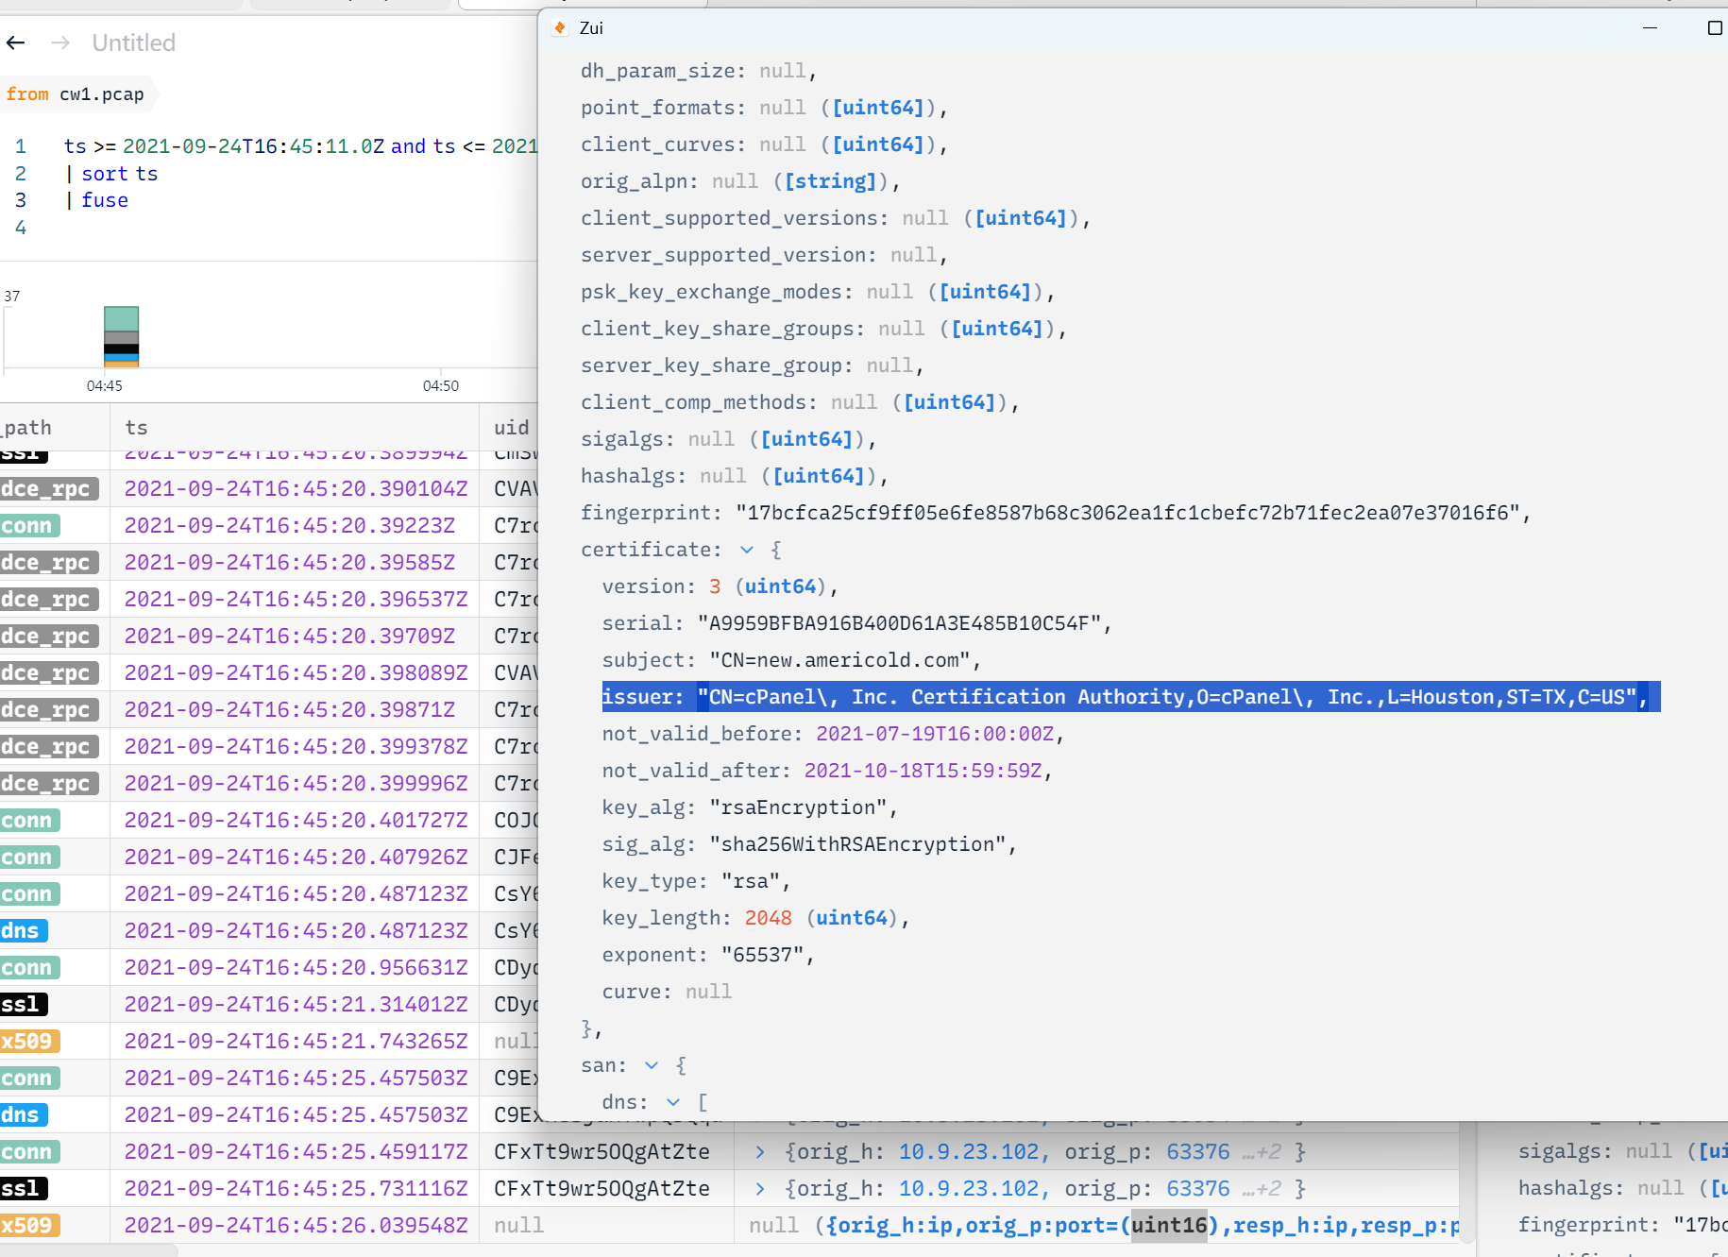

Conclusion

References
https://mysmtp.com/kb/sending-emails/smtp-status-codes-and-their-meanings

Appendix
A: Generative AI Declaration
- Suggestion of filter and method
- Confirm interpreting findings
- Polishing language
- Brian Strom of suggestion

