# Semi-automated Labelme

## Description

Labelme is an image annotation tool for machine learning and deep learning inspired by [1, 2]. This tool has great impact in the development of object detection and segmentation with deep learning. Thanks to Wada's contribution [3], Labelme is developed and many researchers enjoy great benefits from it.

This repo is an extension of Wada's work [3], we extend Labelme with Deep learning, consequently, we can speed up annotating images with the assistance of deep learning. In this repo, we use mmdetection [4], a famous detection toolbox, to achieve semi-automated annotating images so that users can use detector to get annotations without manually annotating.

## Installation

* Python environment and we recommand Python 3.7.

1. conda create -n semi_labelme python=3.7 -y
2. conda activate semi_labelme

* Install Pytorch and torchvision.

1. Following the [official instructions](https://pytorch.org/)

* Install [mmcv and mmdetection](https://github.com/open-mmlab/mmdetection/blob/master/docs/en/get_started.md) and we would recommend you install it with [MIM](https://github.com/open-mmlab/mim).

1. pip install openmim
2. mim install mmdet

* Install semi_labelme

1. # Under this repo
2. pip install -e .

* Launch semi_labelme

1. semi_labelme
2. Once the GUI of semi_labelme is launched, you have successfully installed this tool!

## Tutorials

It is easy to use semi_labelme which is the same as Labelme (please see [Labelme tutorials](https://github.com/wkentaro/labelme/tree/main/examples/tutorial#tutorial-single-image-example)). But in semi_labelme, you can just click 'Detect' button, then, the annotations are finished! Before you use detection function, you need to setup the config file which is in semi_labelme/config/default_config.yaml.

* Config Settings
  + You need to prepare a config_file to decide which detector you are going to use and its corresponding pre-trained model. please see [model zoo in mmdetection](https://github.com/open-mmlab/mmdetection/blob/master/docs/en/model_zoo.md).
  + Modify the config file in semi_labelme/config/default_config.yaml.
* Here we prepare an example for detecting manipulator UR10 which in ./work_dirs.
* Detect and annotate. Take these two picture for example, you just need to click the Detect button.  
  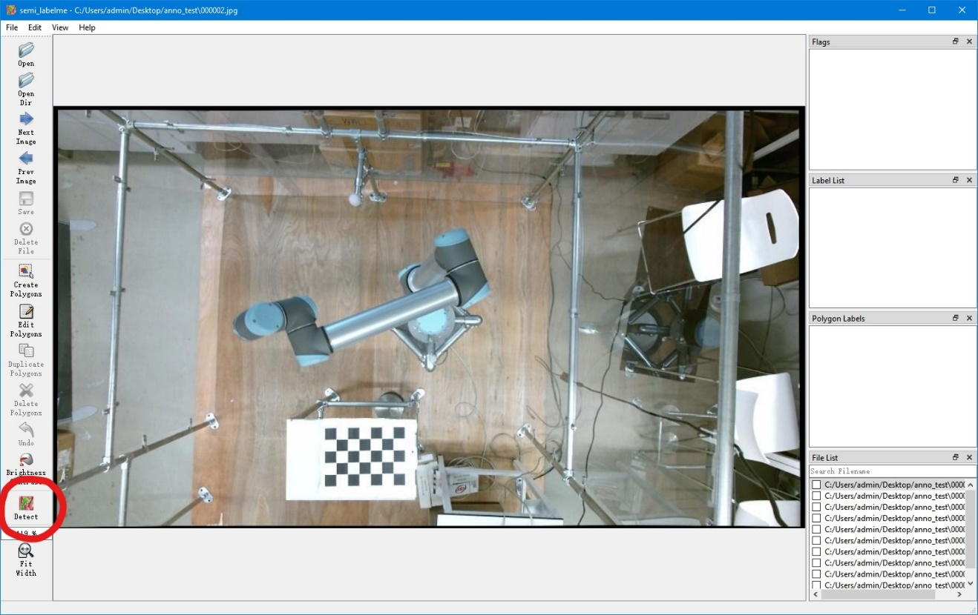

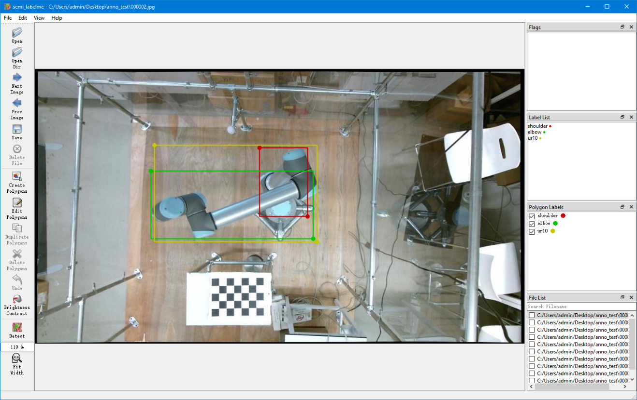

You can see the UR10 are annotated.

* Annotate all the images
  + you can also use batch_annotation.py to annotate all the images and use the tool to check to the annotation later.
* For more tutorials, please see [Labelme tutorials](https://github.com/wkentaro/labelme/tree/main/examples/tutorial#tutorial-single-image-example).

## Citation

If you use this tool in your research, plsease cite this repo.

@software{singlam_semi_labelme,

author = {Wang, Shenglin and Mihaylova, Lyudmila and Zhang, Jingqiong},

doi = {},

license = {GPL-3},

title = {Semi-Automated Labelme, A Deep Learning Based Annotation Tool},

url = {https://github.com/wongsinglam}

}

## Acknowledgements

[1] http://labelme.csail.mit.edu

[2] https://github.com/mpitid/pylabelme

[3] Wada, K. Labelme: Image Polygonal Annotation with Python [Computer software]. https://doi.org/10.5281/zenodo.5711226

[4] MMDetection Contributors. (2018). OpenMMLab Detection Toolbox and Benchmark [Computer software]. https://github.com/open-mmlab/mmdetection