**Smart Punching Bag**

Rachanon Bunphut1, Theerakarn Chokwattanapornchai1

Advisor : Thanabath Kongkaew1, Pracha Khamphakdi2

1Princess Chulabhorn Science High School Mukdahan

2Ubon Ratchathani University

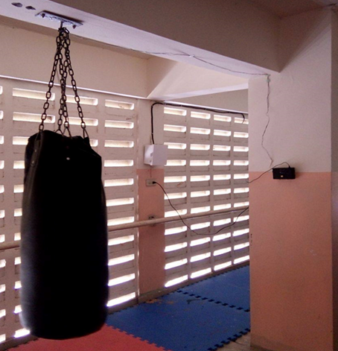

# Abstract

The objective is to create a smart punching bag by using microcontroller and piezoelectric sensors.   
It can display the functions offline on the device and uses in IoT format by displaying on the web browser Anto. 40 representative sample was asked for their opinion. These representatives included teachers, and students from Princess Chulabhorn Science High School Mukdahan. When the smart punching bag was finished and tested, we found that the smart punching bag could completely be used. There are indicators that show the effect of each exercise more clearly in the form of points accumulated sting. And tell time to punch, including the calories used to punch the boxing bag. While asking for opinions we found that many teachers and students thought the smart punching bag use was good. The average score was 3.89

**Keywords:** piezoelectric sensor, microcontroller, IoT