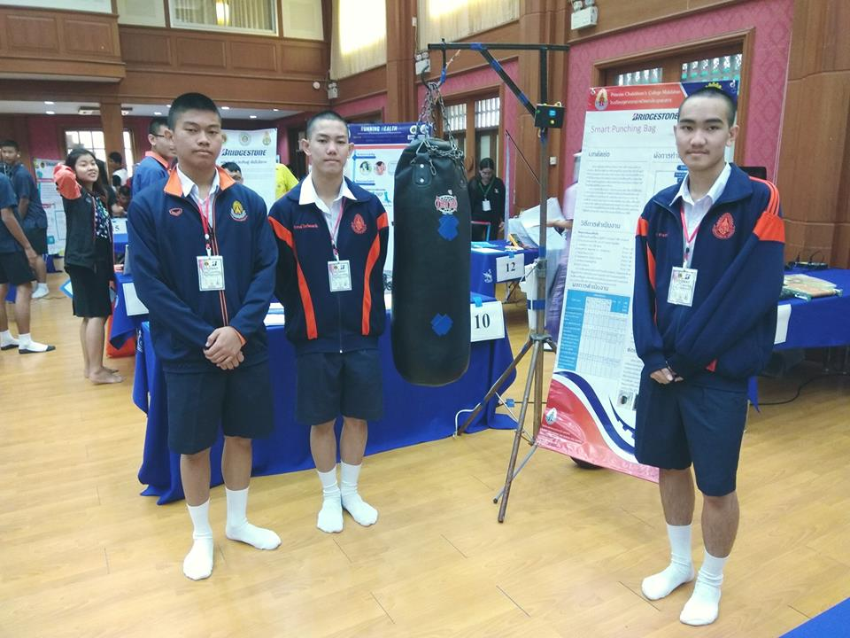

Rachanon Bunphut1 , Theerakarn Chokwattanapornchai1 Thanabath Kongkaew1

Pracha Khamphakdi2 1Princess Chulabhorn Science High School Bang Sai Yai, Mueang Mukdahan ditrict, Mukdahan 49000 2Ubon Ratchathani University,  Warin Chamrap, Ubon Ratchathani, Thailand

**Abstract**

The objective is to create a smart punching bag by using a microcontroller and piezoelectric sensors. It can display the functions offline on the device and uses in IOT format by displaying on the web browser Anto. From 40 representative samples were asked for their opinion. These representatives included teachers and students from Princess Chulabhorn Science High School Mukdahan. When the was finished and tested, we. There are indicators that show the effect of each exercise more clearly in the form of points accumulated sting. And tell the time to punch, including the calories used to punch the boxing bag. While asking for opinions we found that many teachers and students thought the smart punching bag use was good. The average score was 3.89.

**Keywords:** piezoelectric sensor, microcontroller, IoT

**Smart Punching Bag**

**Introduction**

Boxing is a sport that is widely known both for men and women. People are turning to exercise with more boxing. It is a sport that uses the strength and endurance of the body to a certain level, as well as the energy in the body. As a result, this sport has received attention from people who want to lose weight or lose fat as well as athletes and those who want more strength of the body. Often, the exerciser does not have much patience. This may be due to boredom in the practice or not seeing the achievement in the practice or exercise clear. Also known as "Over Train".

The developer has developed a device that will help solve this problem. Our goal was to create a new innovative, smart sport that answers about the Smart sport of Thailand in the current society.

**Materials and Methods**

**Materials and tools.**

1 Computer operating system Window7 or Window8.

2 Program Arduino IDE 1.8.2 IOT Addon Esp2866 number.

3 NodeMCU V3 + USB Cable number

4 NodeMCU Base Ver 1.0 + extension

5 Relay Board 4 CH

6 Piezoelectric Sensor Module number

7 Punching bags and equipment

8 Switch Module number

**Method**

1. Think of the project topics, study the details. Find a teacher Find out more.

2. Learn about NodeMCU and Piezo sensor. How to use and programmatically control or read.

3. Make a draft of the project to draft. Plan for working, and design prototype workflows.

4. Create a Smart Punching Bag based on design and planning.

5. Test the function of the workpiece after preparation. Modify the program and format as appropriate.

6. Prepare a project report.

7. Evaluation by teachers, students and interested persons.

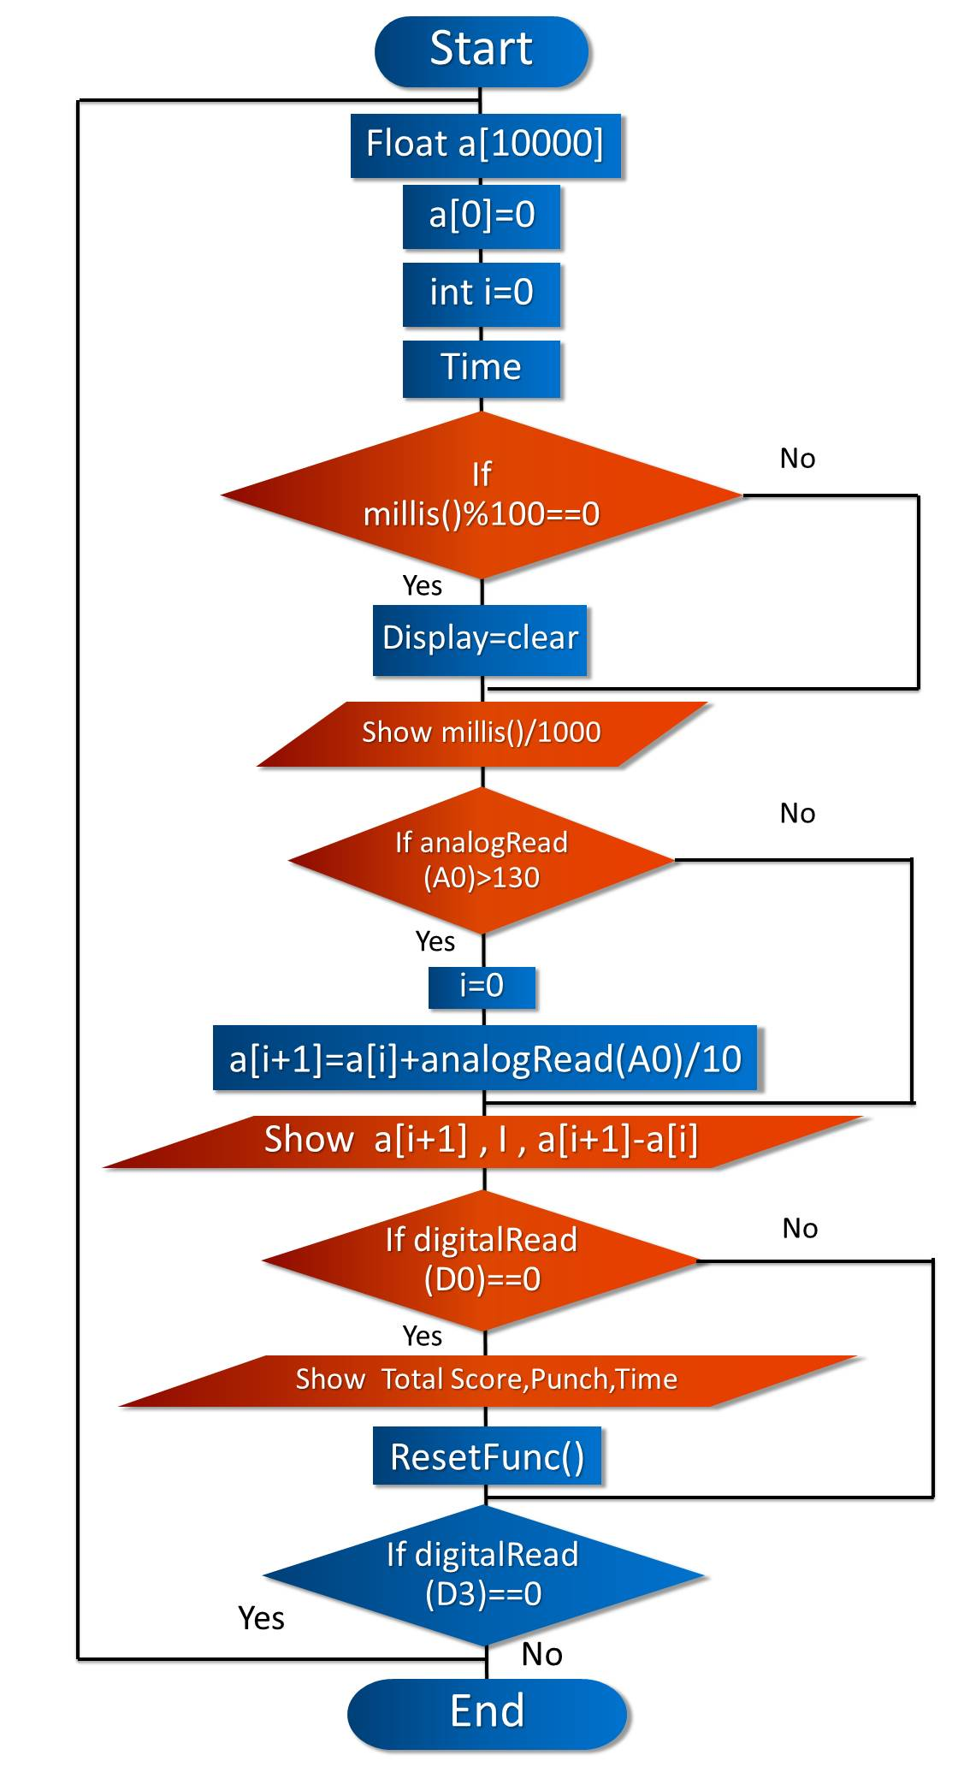

Figure 1. Process of devices.  
**Results and Discussion**

**Operation of Smart Punching Bag**

A smart punching bag starts when the device is turned on. The user has to select the punching mode. There are two modes to choose from. "Easy Mode" and "Training Mode" are the level of punching, then the user weight in kilograms in the device. The device then starts timing when the user punches with a certain force, reads the value and changes it to a pound, and then points the result to the accumulated points. It’s calculate the strength of punch, count the number of punches, and the time is right.

Display all results in real time and when the next hit. The device will then read the value and display the result by the total points will increase by the point of the punch. Plus, the points of the punch and the positive together, and when the user finishes punching. Press the end button on the side and the device will display. All points Number of punches Average strength per flea Time to fight, and the calories used in the round (approximation), then the user can press the reset button to return to punch in the next set, and the device can also be connected to Wi-Fi for display through the web browser Anto. It can display from the computer. Smartphone or LED screen for beautiful and realistic display of the screen to attract interest.

Table 1: Result of data analysis of smart punching bag.

|  |  |  |  |
| --- | --- | --- | --- |
| Opinion | Student and teacher(n=40) | | Opinion degree |
|  |  | S.D. |  |
| 1. The attractiveness of the product | 3.775 | 0.7743 | HIGH |
| 2. The integrity and readiness of the work piece. | 3.475 | 1.1993 | MODERATE |
| 3. Creativeness of the product | 3.9 | 0.64 | HIGH |
| 4. Used modern technology | 4.075 | 0.7193 | HIGH |
| 5. Suitability of equipment And the benefits. | 4.075 | 0.6193 | HIGH |
| 6. Can see the result (indicators) exercise more clearly. | 3.475 | 1.3993 | MODERATE |
| 7. Can be used in the development of fitness. | 4.5 | 0.35 | HIGHEST |
| Summary | 3.89 | 0.8145 | HIGH |

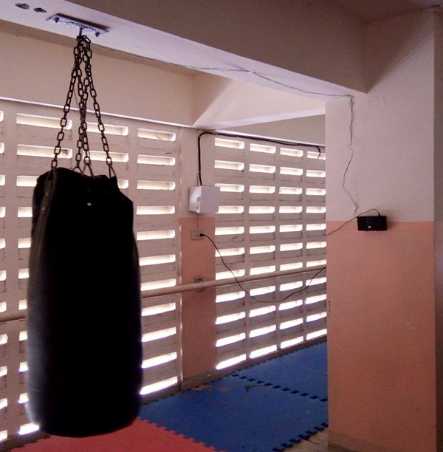

Figure 2. This is the Installation of equipment.

Figure 3. Display the functions offline on the device

There are indicators that show the effect of each exercise more clearly in the form of points accumulated sting. And tell the time to punch, including the calories used to punch the boxing bag. While asking for opinions we found that many teachers and students thought the smart punching bag use was good. The average score was 3.89

**Conclusions**

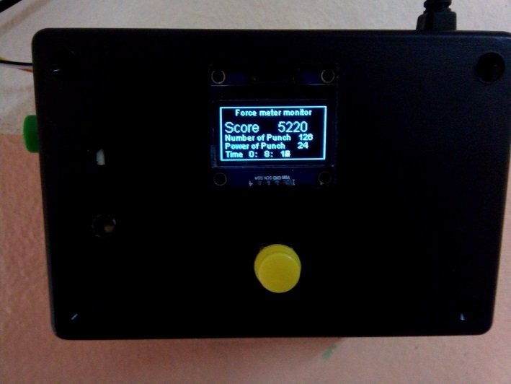1. The performance of the product is accurate.

2. Student’s and teacher’s opinions from the Smart punching bags overall were very high. The highest opinion is they can be used in the development of fitness. By an average of 4.5, second is used modern technology and suitability of the equipment and the benefits with an average of 4.075, third is creativeness of the product and suitability of the product with an average of 3.9. Then the attractiveness of the product with the average of 3.775. Then the integrity and readiness of the workpiece and can see the result (indicators) exercise more clearly and the overall average was 3.89.

**Acknowledgments**

This project is a computer project on the “Smart Punching Bag” that can be implemented effectively done with well. By the introducing and we are thankful for the encouragement from many people. Teacher Thanabath Kongkaew and teacher computer group a strong advocate. Thank you all for your patience and support.

**References**

1. Piezo sensor with Arduino From https://www.arduitronics.com/
2. Asst. Prof. Dejrit Maneetham, Arduino Microcontrollers, Bangkok, SE-EDUCATION, 2560.
3. OrapinPawatborisut.Full C Programming Program.Bangkok. SE-EDUCATION, PLC., 2559.