CREATE database student_examination_sys;

CREATE TABLE `student_examination_sys`.`student` (

`id` VARCHAR(45) NOT NULL,

`name` VARCHAR(45) NULL,

`age` VARCHAR(45) NULL,

`sex` VARCHAR(45) NULL,

PRIMARY KEY (`id`));

INSERT INTO `student_examination_sys`.`student` (`id`, `name`, `age`, `sex`) VALUES ('002', 'lisii', '20', 'female');

INSERT INTO `student_examination_sys`.`student` (`id`, `name`, `age`, `sex`) VALUES ('001', 'zhangsan', '18', 'male');

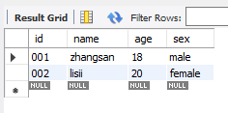

CREATE TABLE `student_examination_sys`.`subject` (

`id` VARCHAR(45) NOT NULL,

`subject` VARCHAR(45) NULL,

`teacher` VARCHAR(45) NULL,

`description` VARCHAR(45) NULL,

PRIMARY KEY (`id`));

INSERT INTO `student_examination_sys`.`subject` (`id`, `subject`, `teacher`, `description`) VALUES ('1002', 'math', 'Miss Liu', 'the exam is difficult');

INSERT INTO `student_examination_sys`.`subject` (`id`, `subject`, `teacher`, `description`) VALUES ('1001', 'Chinese', 'Mr. Wang', 'the exam is easy');  
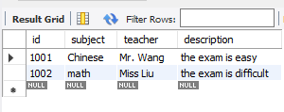

CREATE TABLE `student_examination_sys`.`score` (

`id` VARCHAR(45) NOT NULL,

`student_id` VARCHAR(45) NULL,

`subject_id` VARCHAR(45) NULL,

`score` VARCHAR(45) NULL,

PRIMARY KEY (`id`));

INSERT INTO `student_examination_sys`.`score` (`id`, `student_id`, `subject_id`, `score`) VALUES ('4', '002', '1002', '60.5');

INSERT INTO `student_examination_sys`.`score` (`id`, `student_id`, `subject_id`, `score`) VALUES ('3', '001', '1001', '70');

INSERT INTO `student_examination_sys`.`score` (`id`, `student_id`, `subject_id`, `score`) VALUES ('2', '002', '1002', '60');

INSERT INTO `student_examination_sys`.`score` (`id`, `student_id`, `subject_id`, `score`) VALUES ('1', '001', '1001', '80');  
  
