**Homework#17 – Visualizing Data with Leaflet Vincent Wong**

UC Berkeley Extension (6/24/2018)

**Step #1 – Basic Visualization**

* Get your data set – GeoJSON
* Import & visualize data

Deliverable:

Create a map using Leaflet that plots all of the earthquakes from your data set based on their longitude and latitude.

Your data markers should reflect the magnitude of the earthquake in their size and color. Earthquakes with higher magnitudes should appear larger and darker in color.

Include popups that provide additional information about the earthquake when a marker is clicked.

Create a legend that will provide context for your map data.

Your visualization should look something like the map above.

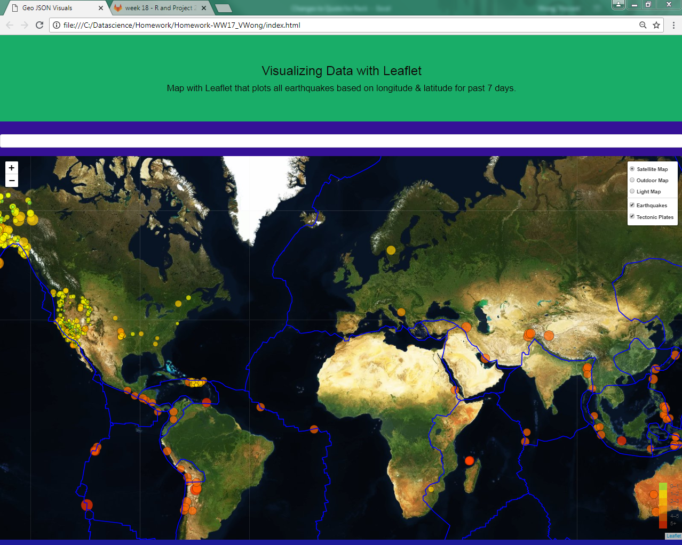

**Step#2 – More Data**

The USGS wants you to plot a second data set on your map to illustrate the relationship between tectonic plates and seismic activity. You will need to pull in a second data set and visualize it along side your original set of data. Data on tectonic plates can be found at https://github.com/fraxen/tectonicplates.

* Plot a second data set on our map
* Add a number of base maps to choose from as well as separate out our two different data sets into overlays that can be turned on and off independently
* Add layer controls to our map

