IST3134
BIG DATA ANALYTICS IN CLOUD
Group Assignment
Analyzing the Relationship Between Audio Features and Track Popularity Across Genres Using Apache Spark
by
Wong Yan Heng
22042394
Chan Yue Yan
22087845
BSc (Hons) in Data Analytics (BSDA)
School of Computing and Artificial Intelligence
Faculty of Engineering and Technology
Sunway University
May Semester 2026
Date: 15 August 2026

Table of Contents
1.0 Introduction to the Problem 3
2.0 Introduction to the Dataset 3
2.1 Structure and Contents 4
2.2 The Popularity Variable 4
2.3 Data Quality Characteristics 4
2.4 Suitability and Limitations 4
3.0 MapReduce / PySpark Approach 5
3.1 PySpark and MapReduce Implementation 5
3.2 MapReduce Interpretation 5
Map Stage 5
Shuffle Stage 6
Reduce Stage 6
3.3 Data Cleaning and Preparation 6
4.0 Analysis of Output 7
4.1 Dataset Results 7
4.2 Genre Popularity Analysis 7
4.3 Correlation Analysis 8
4.4 Genre Compared with Individual Audio Features 10
4.5 High- and Low-Popularity Groups 10
4.6 Danceability and Energy Across Genres 11
4.7 PySpark and Pandas Comparison 12
4.8 Spark Startup and Computation 14
4.9 Overall Interpretation of Results 15
4.10 Big Data and Cloud Advantages 16
5.0 Conclusion 16
Reflection 17
6.0 References 19
7.0 Source Code and Dataset 20

1.0 Introduction to the Problem
Music streaming is the primary way people listen to music now and platforms like Spotify are now streaming millions of songs in catalogues. In that kind of a catalogue, listeners' attention is hugely unequally spent: a tiny fraction of songs receives most of the plays, and the rest – the majority – receive relatively little attention. It's therefore of practical interest to artists, record labels, playlist curators—and, naturally, the streaming services themselves—to understand what makes the tracks that work, and what makes the ones that don't.
It is a common precept in the music industry that one can extract, at least somewhat, the financial success of a recording, as it relates to sales and marketing, from the quantifiable acoustic parameters of the recording. According to this perspective, more “danceable” and more energetic hits that are louder, or elicit greater emotion, should be more successful with listeners. For streaming platforms, the assumption can be tested, given that companies like Spotify release quantitative audio descriptors for each of their millions of songs and an engagement-informed song popularity score.
The following 3 research questions are explored in this project:
- Do some of the music types have systematically different track popularity averages?
- Can danceability, energy, valence, tempo and loudness in each song be linearly correlated with the popularity of the song?
- Does the genre a song is from or its acoustic properties by themselves provide more explanation for variations in popularity?
There are two reasons why the problem is very suitable for Big Data Analytics. First, answering these questions requires repeated aggregation and statistical computation across the entire dataset rather than the inspection of individual records, which is exactly the kind of workload the MapReduce programming model is well suited to express. Second, the analysis must be an aggregation of more than one hundred thousand records into a comparatively small number of genre level results, which is the natural form of a grouped aggregation, and is the form to which the map, shuffle and reduce stages of a distributed execution engine map directly.
A second goal of the project is methodological. In addition to implementing the analysis in Apache Spark, the identical workload was implemented using Pandas, a single-machine library that does not use distributed processing. The two implementations enable the project to assess the efficacy of using a distributed Big Data framework, not just in the view of the data, but in the context of when such a framework can be justified. The answer to this question is not the one that is first thought and is demonstrated by the results in Section 4.7.

2.0 Introduction to the Dataset
This analysis is based on the publicly available Spotify Tracks Dataset created by Maharshi Pandya that is available on Kaggle under a Database Contents License. The data set was built by the initial curator by leveraging the Spotify Web API that provides Spotify calculated audio descriptors for each song as well as catalogue information.
Dataset source: https://www.kaggle.com/datasets/maharshipandya/-spotify-tracks-dataset

2.1 Structure and Contents
The data is provided in the form of one CSV file with ~20MB of data covering 114000 records and 21 columns. Each record is one track that has a specific genre. There are 4 sets of columns:
- Identifiers and metadata: metadata like track_id, artists, album_name and track_name. If there are several artists whose music is included on a track, each name is entered in the same space, separated by a semicolon.
- The popularity Outcome variable (integer in the range 0-100).
- Here are the Spotify computed audio features: danceability, energy, valence, tempo, loudness, speechiness, acousticness, instrumentalness, liveness, key, mode and time_signature.
- Descriptive attributes – duration_ms, explicit and track_genre.
The data includes 114 unique genre codes, with the sampling design carefully weighted: One thousand records from each genre. This balance is analytically important as it implies that the number of records per genre is irrelevant and the finding per genre is based on the distribution of values within the genre and not on the frequency of the genre.

2.2 The Popularity Variable
Particular care must be taken in interpreting the popularity field as this is not a measure of musical quality. The data's doc says the popularity is based on Spotify's own algorithm that considers “mainly the total number of plays a track has received and how recent the plays are.” It is thus a measure of listener engagement weighted towards recency and influenced by other characteristics of distribution—such as the size of the audience, the age of the catalogue, and the promotion involved—which are not included in the dataset. This is important when considering the results in Section 4 and is the most probable explanation for the low correlations found between audio characteristics and popularity.

2.3 Data Quality Characteristics
The data had three attributes which had to be taken care of before analysis. First, the file contains 114,000 rows but only 89,741 distinct track_id values. If more than one genre is attached to a track, it will be reflected under each genre name and add up to 24,259 duplicate rows. The dataset documentation confirms that duplicate tracks are rated independently by the platform, so these repetitions are a genuine feature of the source data rather than a collection error. They are nevertheless problematic for track-level statistics, in which each track should be counted only once.
Second, a few records have values that are not physically meaningful: 157 records have a tempo of zero and one record has a duration of zero. Third, one record has missing artist, album and track name fields. These issues are addressed in Section 3.3.

2.4 Suitability and Limitations
The dataset chosen is suitable for this project as it has a high record count, a wide and evenly sampled quality of genres and including the audio descriptors and engagement measure required for the research questions to be directly tested. But two drawbacks should be noted. The dataset represents a single snapshot rather than a time series, therefore no trend of popularity can be judged. Moreover, the size of this file is only ~20 MB, small enough to be stored in the memory of a single machine in terms of Big Data. This second limitation is not incidental to the project: it is the direct cause of the performance results reported in Section 4.7, and it is treated in this report as a finding in its own right rather than as a shortcoming to be concealed.

3.0 MapReduce / PySpark Approach

3.1 PySpark and MapReduce Implementation
For this project, the choice of the main Big Data processing framework was the Apache PySpark. The dataset provided by Spotify has about 114,000 songs; it has several numerical characteristics from the music, including danceability, energy, valence, tempo and loudness. The aim of the use of PySpark was to illustrate how it is possible to use the distributed data-processing concepts to process, aggregate and analyse a relatively large number of music records in a distributed way using a Big Data framework.
Five audio features — danceability, energy, valence, tempo and loudness — were selected and analysed for their association with track popularity on Spotify. The track_genre attribute was used to investigate genre-level differences in popularity as well.
The primary usage was via the DataFrame API in Spark. After loading the dataset, the data was grouped according to track_genre. With the groupBy function, combined with other functions such as the average function (avg()), and the number of records counted (count()), the average popularity, average audio characteristics and number of tracks for each genre were found. The average popularity of these results was then used to rank them for identification of the genres with higher average popularity.
This is more appropriate for processing large amounts of data than for examining data on a one-by-one basis as Spark can break the task up into smaller parts and process data within the partitions.

3.2 MapReduce Interpretation
Another way to express the genre aggregation is through the traditional MapReduce model that uses a three step algorithm of Map, Shuffle and Reduce.

Map Stage
In the Map part, every Spotify record is a key-value pair, where the music genre is the key. A song with popularity score 59 that is part of the genre of “pop-film” could therefore be stored like:
("pop-film", (59, 1))

The first number is the popularity value and 1 represents one track.

Shuffle Stage
The Shuffle phase bucket groups together records that have the same key. So, before tackling the reduction operation, all records of pop-film are combined into one logical group.
For example:
pop-film → (59, 1)
pop-film → (61, 1)
pop-film → (58, 1)
This grouping is used to group information belonging to the same genre together.

Reduce Stage
In the Reduce phase, the popularity values are accumulated, as well as the number of tracks. The average popularity is then calculated using:
Average Popularity = Total Popularity / Number of Tracks

So if there are 1000 tracks in a genre, the reducer will gather popularity values of all 1000 tracks, and divide all this popularity by 1000 to get the average popularity. Here, you're presented with an example of how MapReduce can be useful when working with Big Data Analytics. Individual Map operations can be performed individually, and the Reduce can combine partial results. The aggregation can also be used for distributed processing as the partial totals and partial counts can be added together in any order.

To show the MapReduce concept, map(), reduceByKey(), and other PySpark RDD operations were used for actual execution. Additionally, the same analytical tasks were performed using Spark DataFrame operations, as they are structured and convenient for the same operations. The genre-level popularity result from the MapReduce-style aggregation confirmed that the aggregation logic was correctly implemented, as shown by the following results that were consistent with the aggregation results on the DataFrame.

3.3 Data Cleaning and Preparation
There were data-quality checks to identify missing data, duplicate track IDs, and any numbers that were out of range, prior to the main analysis.
The original data set contained 114,000 records in 21 columns. When checking track identifiers 24,259 tracks that were duplicated in the system were identified beyond their first sighting. We did not exclude these repeats from the genre-level analysis since one song may be a valid instance of multiple genres; eliminating all duplicate Ids at the genre level would otherwise have eliminated valid genre data.
To prevent the repetitions of the tracks from unduly influencing the result of the track-level analysis, the correlation analysis and the high versus low popularity comparison, duplicate track IDs were thus excluded from the track-level analysis.
The data quality analysis did also reveal values which are not physically meaningful - 157 records with a tempo of zero and one record with a duration of zero. These were rejected as they are not values that can correspond to actual tracks. An additional record which lacked the fields artist, album and track was also deleted. This resulted in 113,842 remaining records or the removal of 158 records in all.
Is an important note that the full dataset and deduped data set are NOT interchangeable. The deduplicated data was provided for track-level statistics, and the full data set for genre aggregation. Thus, the pre-processing could be tailored to the application of each analysis and not the one-size-fits-all solution.

4.0 Analysis of Output

4.1 Dataset Results
After cleaning the data there were 113,842 valid records in the final dataset for the analysis, with a total of 114,000 records in the original dataset. The main attributes selected for the analysis were: Track_id, track_name, artists, popularity, danceability, energy, loudness, valence, tempo and track_genre.
For the analysis, the main outcome was chosen, which was the variable of popularity of the music work/track on Spotify. The intent was to investigate if there were any significant difference in the audio features and the genre of music selected according to the popularity of the track/music work on Spotify.
In the data quality analysis it was established that the principal numerical analysis variables didn't have absent values. However, duplicate track IDs were found, as well as invalid numerical observations. The cleaning process thus guaranteed the reliability of the statistics and thus keeping the genre information germane to the study.

4.2 Genre Popularity Analysis
One of the analysis tasks was to determine the average popularity of a genre of tracks. Using groupBy() and aggregation functions in PySpark, the average popularity for all the track_genre was calculated.

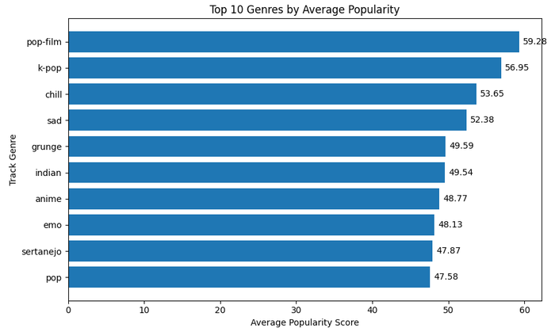Figure 4.1 Top 10 Genres by Average Popularity

The results show considerable variation in average popularity between genres. Pop-film recorded the highest average popularity at approximately 59.28, followed by K-pop at approximately 56.95 and chill at approximately 53.65. Other highly ranked genres included sad, grunge, Indian, anime, emo and sertanejo.
The difference between genres demonstrates that popularity is not distributed uniformly across the Spotify dataset. Genre-level aggregation therefore provides useful information that would be difficult to observe by examining individual tracks separately.
The MapReduce-style implementation produced the same genre-level aggregation results as the Spark DataFrame approach. This consistency demonstrates that the MapReduce implementation successfully performed the intended aggregation.
However, genre should not be interpreted as a direct cause of popularity. Other factors may be associated with genre, including playlist exposure, marketing, artist popularity, audience size, release trends and Spotify recommendation systems. Therefore, the results demonstrate an association between genre and popularity rather than causation.

4.3 Correlation Analysis
To check this, a correlation analysis was carried out to ascertain if any of the individual audio properties related linearly to the Spotify popularity. The following features were analysed:
- Danceability
- Energy
- Valence
- Tempo
- Loudness
The Pearson correlation coefficient can have values between -1 and +1. A large positive correlation is close to +1, a large negative correlation is close to -1, and a correlation close to zero is very weak linear correlation.

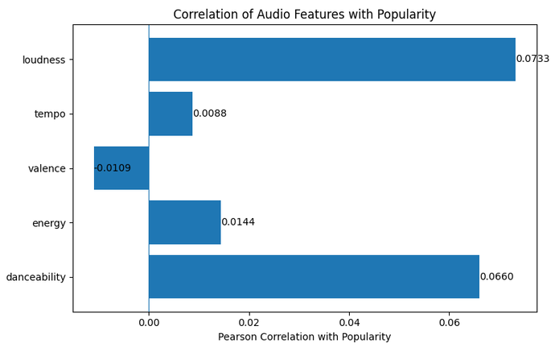
Figure 4.2 Correlation of Audio Features with Popularity

The results above indicated that after the removal of the duplicate trackIDs for the track-level analysis, the overall degrees of correlation of all the five audio features to the popularity were weak. Loudness showed the highest positive correlation (+0.0733) followed by danceability (+0.0660). Valence showed a very weak negative correlation of approximately −0.0109.
They are all numbers near to 0. So the linear relations of the selected audio features with popularity on Spotify are not strong on a global scale.
For example, although loudness shows a positive correlation, a value of approximately +0.0733 is very small. Hence, it wouldn't be appropriate to suggest that the popularizing of the track can be inferred from increasing its loudness.
This analysis also shows the difference between correlation and causation. A correlation coefficient only represents a statistical phenomenon (the relationship in data that was observed), not a direct relationship between the change of an audio feature and the change of popularity.

4.4 Genre Compared with Individual Audio Features
An important finding was where genre was compared to the individual audio characteristics.
This analysis showed that the genre factor accounts for about 32.59% of the variance in popularity using eta-squared. The most highly correlated individual audio feature was loudness (+0.0733) by contrast. Such a linear understanding of the correlation accounts for only approximately 0.54% of the variance when squaring the correlation result.
Thus, genre gave significantly more information about differences in popularity than did any individual item of the audio examined in the project.
This impacts the interpretation of the previous correlation results. The results do not only seem to indicate that 'audio features do not matter' but that it is the overarching genre identification that is more telling in terms of the differences in popularity than the features of a particular piece of music analysed in this project.
Several factors that are not measured in the data can be indirectly represented by genre, such as:
- playlist exposure;
- marketing and promotion;
- audience size;
- artist popularity;
- release trends;
- regional preferences; and
- Spotify recommendation and playlist placement.
So, genre could be an indicator of market and platform-specific effects not just covered by danceability, energy, valence and tempo/loudness.

4.5 High- and Low-Popularity Groups
The tracks were also split into two groups (low popular and high popular) with the 75th percentile of the popularity score as a threshold.
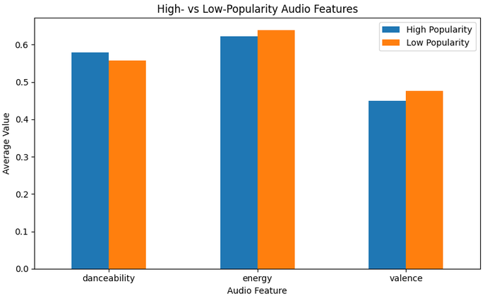
Figure 4.3 Comparison of Audio Features Between High- and Low-Popularity Tracks

The high-popularity group recorded approximately the following values:
Audio Feature | High Popularity
Danceability | 0.580
Energy | 0.623
Valence | 0.450

There was not much variation between the values found in the low-popularity group. The distinctions between the groups were not large and thus the chosen audio features were not very effective to distinguish highly popular and less popular tracks.
For instance, highly popular tracks are on average slightly more danceable with a score of around 0.580 versus less popular songs with a score of around 0.558. But this difference will not be enough to conclude that danceability is a major determinant of the popularity.
The comparison lends credit to the correlation analysis. Both suggest that individual audio features alone can't account for much of the explanation of significantly greater popularity of some tracks over others.

4.6 Danceability and Energy Across Genres

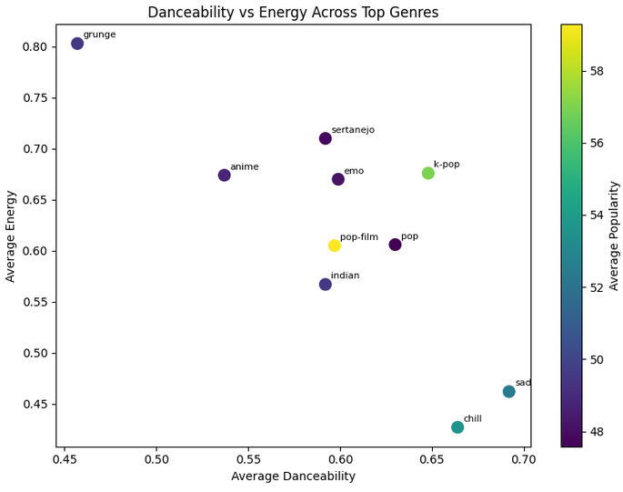
Figure 4.4 Danceability and Energy Across Top Genres

The visualisation shows the average danceability and average energy per genre of the selected ones, and their respective average popularity.
The results show that genres exhibit different audio characteristics. Certain music genres tend to be relatively high energy while low danceability and vice-versa. This means that the most popular genres don't necessarily have the same exact set of acoustic features.
This helps confirm the results of the correlation analysis made above as there is no one distinct audio characteristic that can be used to easily differentiate the more popular genres from the rest. Rather, genres can have varying combinations of danceability and energy without necessarily losing their relative popularity.
This provides another reason for considering genre as an important grouping variable when analysing Spotify popularity.

4.7 PySpark and Pandas Comparison
For comparison, the same analytical workloads were realized using Pandas, a no-Big-Data (single-machine) approach.
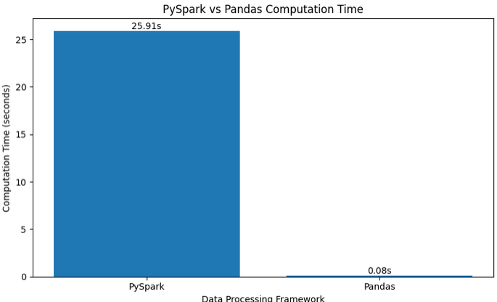
Figure 4.5 PySpark and Pandas Computation Time

Overall, the benchmark demonstrated that Pandas demonstrated a faster execution time than PySpark in the given platform. Such a result is not surprising, knowing that there are around 114,000 entries in the dataset which can still be processed efficiently on a single machine.
The difference measured was substantial. The Spark implementation took 29.16 seconds to complete the analytical workload, while the Pandas implementation completed the identical workload in 0.09 seconds — approximately 311 times faster. EBoth implementations processed the same 113,842 cleaned records and the same 89,583 unique tracks, and both produced correlation coefficients identical to four decimal places, so the difference is attributable to execution behaviour rather than to any difference in the work performed.
Examining the individual operations shows that the gap is not produced by uniformly slower execution. It is concentrated in the operations that require data to be redistributed between partitions. Removing duplicate track identifiers is the single largest contributor, because in Spark it requires a full shuffle in which records are exchanged across partitions so that all rows sharing a track identifier are brought together. Pandas performs the same deduplication as an in-memory hash operation at negligible cost. The correlation computation and the exact percentile calculation contribute further overhead for the same underlying reason.
This clarifies the nature of the result. Spark is not performing the same work inefficiently; it is performing additional work that exists solely to support datasets too large for a single machine. Partitioning, shuffling and fault-tolerant coordination are the mechanisms that make horizontal scaling possible, and they impose a fixed cost that must be paid regardless of the volume of data being processed. On a 20 MB dataset that fits entirely in memory, that cost purchases no benefit. The comparison therefore measures the price of scalability rather than a deficiency in the framework.
PySpark adds further overhead from Spark execution, task scheduling and distributed processing. On a dataset this small, that overhead exceeds any benefit gained from distributed computation.
That doesn't imply that, in general, Pandas is better than PySpark. Obviously, the main benefit of Spark is that it's scalable. Distributed processing becomes more valuable as datasets are considerably larger, and cannot reasonably fit into the processing facilities of a single piece of equipment.
Therefore, the decision on which one to use, PySpark or Pandas, should not be taken lightly based on the fact that a Big Data solution will always be faster and depends on the dataset size, computing resources at hand, scalability requirements, and processing complexity.

4.8 Spark Startup and Computation

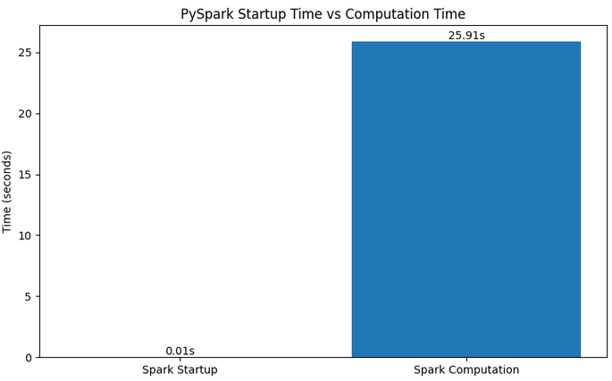
Figure 4.6 PySpark Startup Time and Computation Time
Separation of Spark session startup from time to do the analytical workload is done due to the fundamentally different behaviour of the both. These are the costs during startup, that is, the costs that occur when a Java Virtual Machine is started up and a SparkContext and executor resources are provisioned. All this work is independent of the dataset: the same initialisation is done when the session will go on to process one thousand records, or one billion.
Measured on a freshly restarted runtime, Spark session startup required 13.51 seconds, compared with 29.16 seconds for the analytical workload itself. Initialisation therefore accounted for roughly 32 per cent of the total 42.67 seconds, and the contrast with the single-machine implementation is stark: Spark spent 13.51 seconds merely preparing to read the data, approximately 150 times longer than the 0.09 seconds Pandas required to complete the entire analysis. It is important that this measurement is taken on a newly started runtime. If cells are re-executed within a session that already exists, getOrCreate() returns the existing session and the measured startup time falls to almost zero, which does not reflect the true cost of establishing the environment.
The significance of this fixed cost lies in how it scales. Since startup time takes the same amount regardless of dataset size but computation time increases with dataset size, the fraction of total run time devoted to startup time decreases as the dataset increases in size. Initialisation is a significant proportion of the total time taken for this analysis based on the 20 MB data set analysed, and has no analytical contribution. If the same workload had been performed on a dataset big enough to benefit from distributed processing, the same startup cost would be unnoticeable in comparison to the amount of computations performed by it.
This reinforces the conclusion drawn from the framework comparison in Section 4.7. The overheads that make Spark slower on this dataset, comprising both session initialisation and the partitioning and shuffling costs identified earlier, are not inefficiencies to be optimised away. They are the fixed price of an architecture designed to scale horizontally across many machines. The benchmark therefore illustrates a general principle of Big Data Analytics: the suitability of a technology is determined by the scale of the problem, and a distributed framework should be adopted when data volume demands it rather than by default.

4.9 Overall Interpretation of Results
Generally, the implementation successfully met the major analytical objectives. To begin, the aggregation of genres showed that there is a significant difference between each genre in their popularity on Spotify, with the average popularity of the pop-film being around 59.28.
Second, the correlation analysis revealed that the individual audio features selected were not highly correlated with the popularity globally. The correlation of Loudness was the strongest with about +0.0733, which is still very close to zero.
Thirdly genre analysis yielded a more robust result: around 32.59% of the variance in popularity could be explained by genre and this is actually significantly larger than the variance explained by each audio feature individually.
Fourth, comparison of high versus low popular songs indicated that the differences in Danceability, Energy and Valence were relatively small. This is further proof that popularity is not just a phenomenon of acoustic features.
One crucial caveat is that these are global correlations and thus encompass tracks from various genres. This can camouflage relationships within individual genres. In fact, the correlation between loudness and popularity is very different between genres, ranging from around −0.41 to +0.46. The near zero global correlation should therefore not be interpreted as that audio characteristics has no relationship with the popularity under any circumstances. Rather, it means that there is no linear relation overall that is sufficiently strong throughout the data set.

4.10 Big Data and Cloud Advantages
The project also illustrates why Big Data technologies like Spark gain their value beyond the point where data fitting into a single machine is impractical.
Scalability is provided by a cloud-based Spark environment, offering the option to scale up the computing power with larger datasets for processing and scale down when the work's done. Data may also be stored outside of the computing resources to provision the computing resources based on requirement.
The use of the current benchmark is a helpful example of this. For the Spotify data, which has around 114,000 records, Pandas was faster as the data could be handled by a single machine. As data sets grow to many millions, or even billions of records, however, Spark's ability to spread computation across multiple machines becomes more important.
Hence the project proves that the promise of Big Data Analytics is not that it allows to process any dataset faster. Rather, it is the scalability, distributed processing and workload management of efficiently processing workloads that may become too hard on a single machine that is its main value.

5.0 Conclusion
The purpose of this project was to make use of the Spotify Tracks Dataset using Big Data Analytics techniques to analyze if there are measurable differences in audio characteristics that can explain the track's popularity. The implementation was done in Apache Spark (DataFrame API and explicit RDD-based MapReduce), and the same workload was reimplemented in Pandas for comparison at a single-machine level.
Analytical results were uniform for all methods used. The mean popularity index is quite different among genres going from about 59.28 for pop-film, to as low as the low single digits in the least popular genres in the data set. In contrast, none of the five investigated audio features was found to be significantly linearly associated with popularity; with loudness being the most linear, around +0.0733, which translates to about 0.54 per cent of the variance in popularity under a simple linear interpretation. Similar results were found by comparing high- and low-popularity groups: the differences in mean values for danceability, energy and valence were too small to meaningfully differentiate the groups.
Given together, these results provide a clear answer to the third research question. The variance for genre was about sixty times larger than the largest of the individual acoustic features, and was 32.59 per cent of the variance on popularity. The practical implication there, is that the sound of a track – as measured by these descriptors – is not a great indicator of its popularity, but its category is. Genre itself does not seem to induce listening behaviour and is most likely a reflection of the distribution factors not captured in the dataset, including playlist placements, promotional spending, audience magnitude or even regional market penetration. This interpretation is consistent with the definition of the popularity variable itself, which measures recency-weighted listener engagement rather than any property of the recording.
The methodological comparison produced an equally instructive result. Pandas completed the identical workload approximately 311 times faster than Spark, and the difference was concentrated in the operations requiring data to be shuffled between partitions. This does not indicate a deficiency in Spark. Distributed frameworks impose a fixed coordination cost that is paid regardless of data volume, but which is recovered only once the data exceeds the capacity of a single machine. The right conclusion is that the utility of a Big Data platform must be judged by its scalability, and that, for such a small dataset size, it wouldn't be justified to choose a Big Data platform.
There are three caveats that should be recognized. The data are only snapshot data with no causal or temporal claims possible. The global correlations pool measures tracks from 114 genres, so there is a lot of variation within-genre; in particular, the loudness relationship varies from around −0.41 to +0.46 across the different genres analysed. Last, since an arbitrary genre label is used for each song with multiple genres, the genre variation measure will, to some extent, be dependent on labeling decisions.
Future work could address these limitations in three directions. First, computing correlations within genres rather than across the whole catalogue would recover relationships that aggregation currently conceals. Second, incorporating variables that capture distribution effects, such as the number of playlist appearances or the release date, would test the factors this analysis identifies as the likely drivers of popularity. Third, repeating the framework benchmark across progressively larger datasets would locate empirically the point at which distributed processing begins to outperform single-machine execution.

Reflection

Wong Yan Heng
This assignment helped me develop a better understanding of how Big Data Analytics can be applied to a real-world dataset using PySpark. Before completing this assignment, I had some knowledge of data analysis, but I was not very confident in using Big Data tools to process a large amount of data. Working with the Spotify dataset allowed me to experience the complete process of loading, checking, cleaning, analysing, visualising, and interpreting data.
One of the main things I learned was how to use PySpark DataFrame operations such as groupBy(), avg(), count(), filtering, and correlation analysis. The genre aggregation was especially useful because it showed me how a large number of records could be summarised into meaningful information about different music genres. I also gained a better understanding of MapReduce, as the implementation helped me connect the theoretical concept of mapping and reducing with actual data-processing operations.
Another important lesson was the importance of data quality checking. I learned that repeated records should not automatically be removed without first considering their impact on the analysis. I also learned how to interpret correlation results. Although some audio features had positive or negative correlations with popularity, the relationships were generally weak. This taught me that correlation does not necessarily mean that one variable causes another.
The comparison between PySpark and Pandas was also an important learning experience. I initially expected PySpark to be faster because it is designed for Big Data processing. However, my results showed that PySpark took 29.16 seconds, while Pandas took only 0.09 seconds. This helped me understand that a Big Data framework does not always provide better performance for smaller datasets because of processing overhead. PySpark becomes more useful when larger datasets and distributed processing are required.
Finally, creating visualisations helped me understand how analytical results can be communicated more effectively. The graphs allowed me to identify differences between genres, audio features, popularity groups, and processing times more easily than looking at tables alone. Overall, this assignment improved my technical and analytical skills in PySpark, MapReduce, data cleaning, data analysis, visualisation, and interpretation. Most importantly, I learned that the choice of technology should depend on the size and requirements of the dataset rather than assuming that one tool is always better than another.
Chan Yue Yan
I went into this assignment expecting the difficult part to be learning how to use PySpark. What I actually spent most of my time on was something I had not anticipated at all: verifying that the data going into the analysis was correct, and that both implementations were genuinely doing the same thing. The technical syntax turned out to be the easier half of the work.
It was the spaghetti behind it that surprised me. At first glance, it appeared clean: 114,000 rows, no missing values in any of the numerical data fields that were pertinent. However, when we looked at the track identifiers, we realized that only 89,741 of them were unique, and 24,259 of the rows were duplicates. Initially I thought this was due to a collecting error. I found out in the documentation for the data that it was by design with a tag to serve multiple genres appearing once for every genre. This completely changed the question. This was no longer a matter of deletion of records but a matter of to which analysis a particular record of data belonged. We thought it would be best to retain the entire data set for genre aggregation but remove the duplicate data for the track-level statistics to avoid over-representation of songs. This was more important than I thought: The loudness correlation transitioned from ~ +0.0504 to +0.0733 after the removal of repeated tracks.
The part I found hardest was getting the PySpark and Pandas implementations to produce identical results. I had assumed that writing the same logic twice would naturally give the same answer, but several small differences appeared that were easy to miss. Spark's count("*") counts every row, whereas the Pandas equivalent we had originally used skipped null values. Spark's approxQuantile is approximate unless the error parameter is set to zero, while the Pandas quantile function is exact and interpolates between values. Each difference was small enough to go unnoticed and large enough to make the two results disagree. Working through them taught me to check that two implementations agree on the data they process, not only on the code that looks similar. In the end both produced the same 113,842 cleaned records, the same 89,583 unique tracks, and correlation coefficients identical to four decimal places. That agreement became evidence supporting our results rather than just a check we had passed.
I would correct the data cleaning as the major tasks are done properly before starting any analysis. We only added the step to “clean” the data after we had collected the “dirty” data, so we had to re-calculate all figures afterwards, and we almost reported the results of an earlier run that were no longer right. We dropped 158 tracks that were with tempo ZERO, etc., due to invalid values, which was enough to shift our values being reported. It would have been better not to do the rework at all, so I would have preferred to scrub first, so that our report and our code are aligned.
On the whole, my impression of this assignment is that the effectiveness of an analysis is more closely tied to how disciplined one can be when performing an analysis, than to the degree of sophistication of the tools used during the analysis. Our most interesting result, that genre explains around 32.59 per cent of the variance in popularity while the strongest audio feature explains well under one per cent, would have been meaningless if the underlying records had been double counted. I also learned that a result which appears disappointing at first can be valuable once it is understood properly, both in the weak correlations and in the finding that Pandas outperformed Spark on a dataset of this size.

6.0 References
Apache Software Foundation (2024) Apache Spark documentation. Available at: https://spark.apache.org/docs/latest
(Accessed: 15 August 2026).
Dean, J. and Ghemawat, S. (2008) 'MapReduce: simplified data processing on large clusters', Communications of the ACM, 51(1), pp. 107-113.
McKinney, W. (2010) 'Data structures for statistical computing in Python', Proceedings of the 9th Python in Science Conference, pp. 56-61.
Pandya, M. (2022) Spotify Tracks Dataset. Kaggle. Available at: https://www.kaggle.com/datasets/maharshipandya/-spotify-tracks-dataset
(Accessed: 15 August 2026).
Spotify (2024) Web API reference: get track's audio features. Available at: https://developer.spotify.com/documentation/web-api
(Accessed: 15 August 2026).
Zaharia, M., Xin, R.S., Wendell, P., Das, T., Armbrust, M., Dave, A., Meng, X., Rosen, J., Venkataraman, S., Franklin, M.J., Ghodsi, A., Gonzalez, J., Shenker, S. and Stoica, I. (2016) 'Apache Spark: a unified engine for big data processing', Communications of the ACM, 59(11), pp. 56-65.

7.0 Source Code and Dataset
The complete source code for both the PySpark and Pandas implementations, together with the generated output files and visualisations, is available at the repository below.
GitHub repository: https://github.com/wongyanheng2004-web/spotifybigdataanalysis
Dataset: https://www.kaggle.com/datasets/maharshipandya/-spotify-tracks-dataset
The repository contains the analysis notebook, the output directory produced by the notebook, and a README file describing how to reproduce the results.

