**Table 1. Characteristics of the 1,962 probands and 16,270 first-degree relatives.**

|  |  |
| --- | --- |
| Characteristic | N |
| Sex of proband |  |
| Male | 1,153 (59.1 %) |
| Female | 799 (40.9 %) |
| Age of onset, Median(IQR) | 61.7, 63 (55 - 70) |
| Less than 50 | 229 (11.7 %) |
| Over 50 | 1,723 (88.3 %) |
| Total number of FDRs | 16,270 |
| Parents | 3,904 |
| Siblings | 7,649 |
| Offsprings | 4,717 |
| FDRs with affected colorectal cancer | 216 |
| Parents | 77 |
| Siblings | 132 |
| Offsprings | 7 |

**Table 2. Estimates for probability of being affected in CRC and relative risks**

|  |  |  |  |
| --- | --- | --- | --- |
| Age | Sex | Pr(CRC) | RR |
| Under 50 | Female | 0.00040 | 1.00 |
| Male | 0.00055 | 1.40 |
| Over 50 | Female | 0.00309 | 7.80 |
| Male | 0.00410 | 10.36 |

**Table 3. Increased risk of colorectal cancer according to positive family history in first-degree relatives**

|  |  |  |  |  |  |
| --- | --- | --- | --- | --- | --- |
| Factor | Number  of subjects | Covariate adjusted Hazard ratio | 95% Confidence Interval | P-value | |
| Family history of CRC |  |  |  |  | |
| No | 1,766 | 1.00 (ref) | - |  | |
| Yes (≥ 1 affected FDR) | 186 | 1.1998 | [1.0306 , 1.3968] | 0.0188 | |
| No. of affected FDRs |  |  |  |  | |
| 0 (no FH) | 1,766 | 1.00 (ref) |  |  | |
| 1 affected FDR | 160 | 1.2540 | [1.0657 , 1.4756] | 0.0064 | |
| ≥ 2 affected FDR | 26 | 0.9479 | [0.9133 , 1.0948] | 0.7865 | |
| Proportion of affected FDRs | |  |  |  |
| [0 – 0.125) | 1,843 | 1.00 (ref) |  |  | |
| [0.125 – 0.3) | 100 | 1.5949 | [1.3031 , 1.9519] | 5.9310-6 | |
| [0.3 – 1] | 9 | 2.7498 | [1.4246 , 5.3078] | 2.7510-3 | |

**Figure 1. Risk ratio of the probability of being affected to the CRC with the several numbers of affected FDRs to the baseline risk.** For the nuclear family consisting of the parents and two offsprings, we calculated the relative risk of the probabilities of being affected to the CRC for the first offspring when the affected relatives are added. The prevalence of the CRC in Korea was 0.002326.

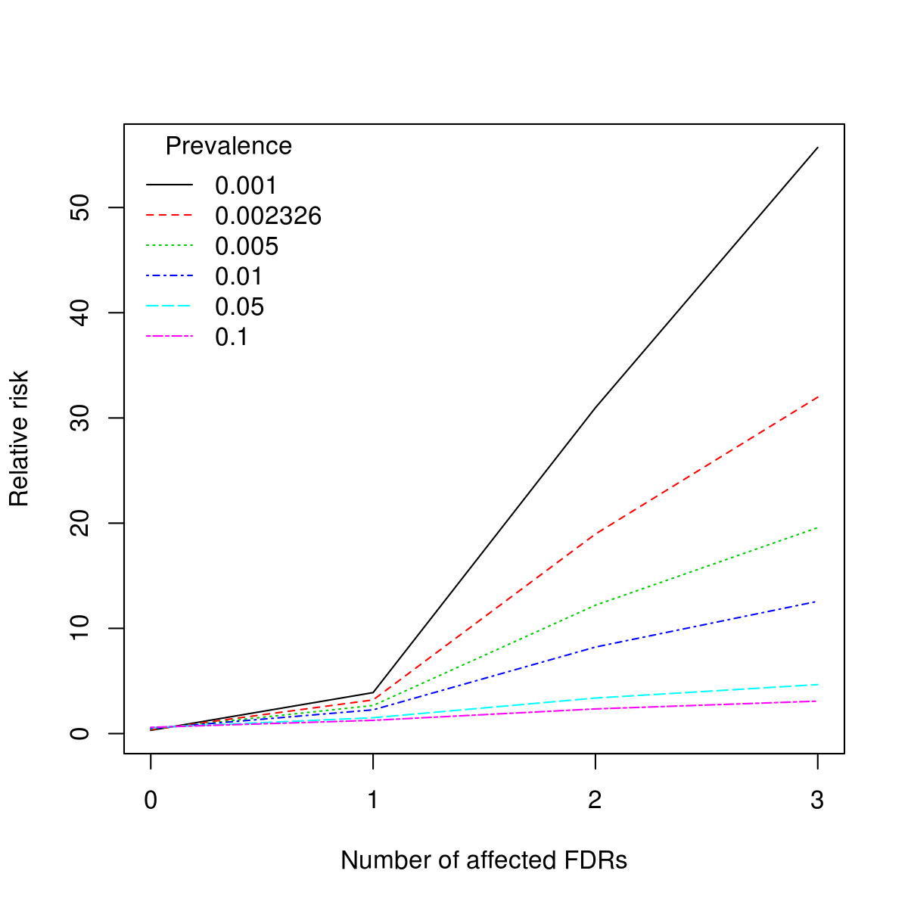

**Figure 2. Relative risk of the probability of being affected to the CRC with the different numbers of unaffected FDRs to the probability of being affected for the proband with no unaffected FDRs.** We considered probands having two affected FDRs and calculated risk probabilities when unaffected FDRs are added.

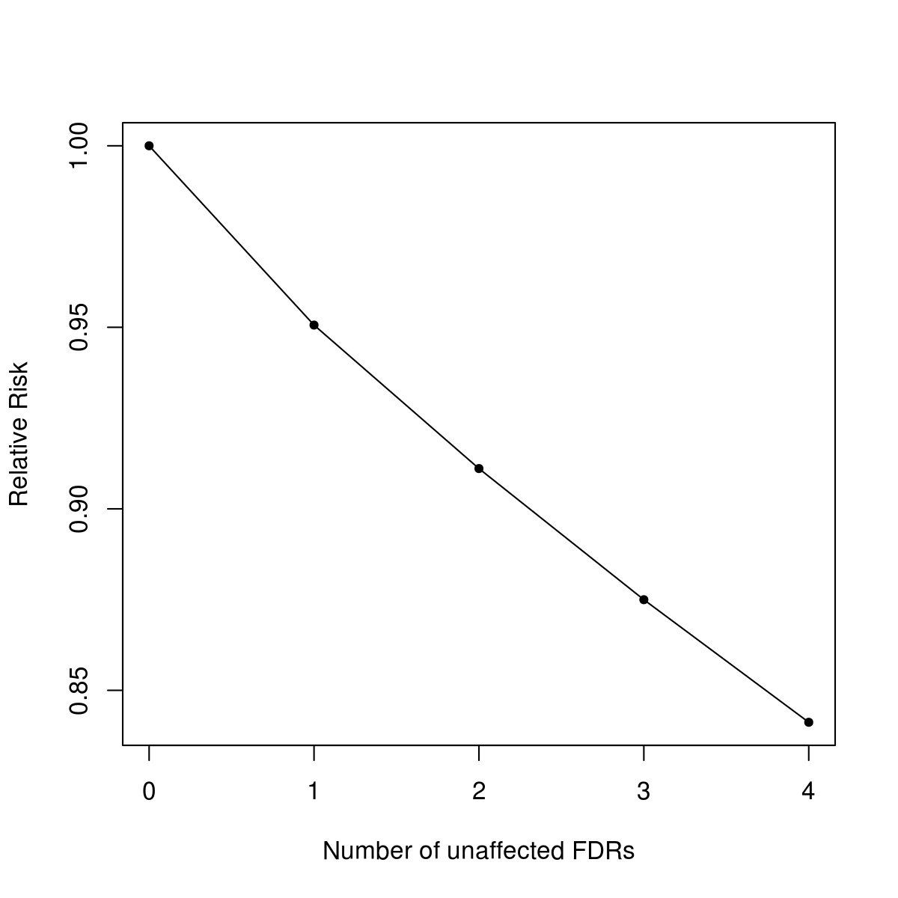

**Figure 3. Histogram of proportion of affected FDRs excluding those with no family history.**

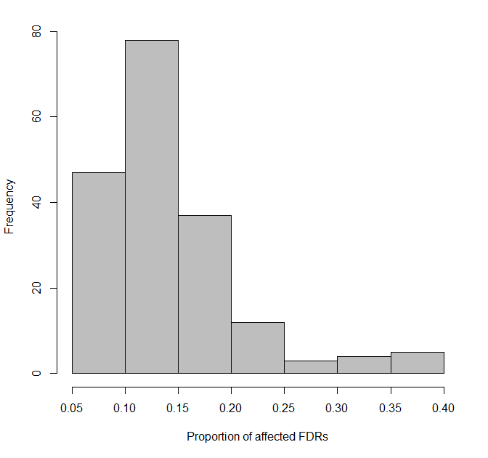

**Figure 4. AICs of Cox proportional hazard model for different cutoff values.** a) We divided the probands into two groups with the cutoff value of the proportion of the affected FDRs. The cutoff with the smallest AIC was 0.125. b) Setting 0.125 as the first cutoff values, we calculated AICs further categorizing probands into three groups with several second cutoff values. The smallest AIC was obtained at the cutoff values of 0.29 and 0.33, and we used 0.3 for the second cutoff values.

