**Supplementary Materials for “A Genome Wide Association Study implicates *NR2F2* in Lymphangioleiomyomatosis Pathogenesis”**

**Supplementary Table 1.** Distribution of LAM patients according to their nationality

|  |  |  |
| --- | --- | --- |
|  | Discovery  LAM | Replication  LAM |
| USA | 190 | 196 |
| France | 54 | 0 |
| Spain | 40 | 0 |
| Italy | 35 | 0 |
| United Kingdom | 32 | 0 |
| Germany | 21 | 0 |
| Australia | 20 | 0 |
| Poland | 15 | 0 |
| Israel | 7 | 0 |
| Canada | 4 | 0 |
| Panama | 1 | 0 |
| Puerto Rico | 1 | 0 |
| Scotland | 1 | 0 |
| Unknown | 5 | 0 |
| Total | 426 | 196 |

**Supplementary Table 4.** PICS analysis to identify probable causal SNPs in the chr 15q region.

|  |  |  |  |  |  |  |
| --- | --- | --- | --- | --- | --- | --- |
| CHR | SNP* | POS | P-value | † | ‡ | PICS probability |
| **15** | **rs41374846** | **96143559** | **3.43210-9** | 1.0000 | 1.0000 | 0.6485 |
| 15 | rs59125351 | 96144157 | 3.22910-10 | 0.9703 | 0.7941 | 0.0352 |
| 15 | rs55804812 | 96151256 | 4.17810-10 | 0.9557 | 0.7758 | 0.0290 |
| 15 | rs16975389 | 96153782 | 5.80110-10 | 0.9555 | 0.7700 | 0.0272 |
| 15 | rs10520790 | 96151040 | 3.57110-10 | 0.9486 | 0.7698 | 0.0271 |
| 15 | rs16975396 | 96158705 | 9.59210-10 | 0.9480 | 0.7581 | 0.0239 |
| 15 | rs58878263 | 96171069 | 6.36110-10 | 0.9328 | 0.7287 | 0.0172 |
| 15 | rs8029996 | 96168770 | 5.14710-10 | 0.9325 | 0.7230 | 0.0161 |
| 15 | rs6496128 | 96168303 | 5.14710-10 | 0.9325 | 0.7230 | 0.0161 |
| 15 | rs4628911 | 96167905 | 5.14710-10 | 0.9325 | 0.7230 | 0.0161 |
| 15 | rs8040665 | 96175692 | 7.35610-10 | 0.9254 | 0.7171 | 0.0151 |
| 15 | rs17581137 | 96146414 | 1.38410-10 | 0.9529 | 0.7125 | 0.0143 |
| 15 | rs4544201 | 96167827 | 5.14710-10 | 0.9317 | 0.7116 | 0.0142 |
| 15 | rs4551988 | 96169589 | 5.14710-10 | 0.9183 | 0.7113 | 0.0141 |
| 15 | rs2397810 | 96148765 | 1.81410-10 | 0.9451 | 0.7008 | 0.0125 |
| 15 | rs6496126 | 96148439 | 1.81410-10 | 0.9380 | 0.7005 | 0.0124 |
| 15 | rs8040168 | 96176096 | 5.22410-10 | 0.9233 | 0.6887 | 0.0108 |

Definition of abbreviations: CHR = Chromosome; POS = SNP Position according to NCBI genome build 37 (hg19); CLR = Conditional Logistic Regression.

SNP rs41374846 (shown in bold) was identified as the probable causal SNP, with the highest PICS probability. SNPs are sorted by PIC probability.

†  where : the frequency of the haplotype AB and : theoretical maximum difference between the observed and expected haplotype frequencies.

‡ : squared correlation coefficient

**Supplementary Table 2. P-values for SNPs associated with nicotine addiction.** P values are shown in comparison of allele frequencies for the S-LAM discovery cohort and the COPDGene controls.

|  |  |  |
| --- | --- | --- |
| CHR | SNP | P-value |
| 1 | rs1060061 | 0.4885 |
| 6 | rs9503551 | 0.0840 |
| 7 | rs4285401 | 0.3263 |
| 8 | rs804292 | 0.8145 |
| 8 | rs6470120 | 0.1152 |
| 9 | rs10491551 | 0.7217 |
| 4 | rs10517300 | 0.6066 |
| 15 | rs1051730 | 0.9759 |
| 21 | rs2836823 | 0.1560 |

**Supplementary Table 3. Minor allele frequencies for SNPs rs4544201 and rs2006950 in multiple populations.**

|  |  |  |  |  |  |  |
| --- | --- | --- | --- | --- | --- | --- |
| SNP | LAM patients | | | Normal | | |
| Data | N | MAF (95% CI) | Data | N | MAF  (95% CI) |
| rs4544201 | Discovery  (USA/NHW/females) | 190 | 0.1684  (0.131, 0.206) | COPDGene  (USA/NHW/females) | 1,258 | 0.2742  (0.257, 0.292) |
| Discovery  (EUR/NHW/females) | 233 | 0.1631  (0.130, 0.197) | COPDGene  (USA/NHW/males) | 1,224 | 0.2774  (0.260, 0.295) |
| Replication  (USA/NHW/females) | 186 | 0.1429  (0.107, 0178) | MESA-Lung*  (USA/NHW/females) | 1,153 | 0.2563  (0.238, 0.274) |
|  |  |  | 1000GP** (USA/NHW/females) | 50 | 0.2600  (0.174, 0.346) |
|  |  |  | 1000GP** (EUR/NHW/females) | 213 | 0.2300  (0.190, 0.270) |
|  |  |  | ECLIPSE***  (EUR/NHW/females) | 792 | 0.2563  (0.235, 0.278) |
|  |  |  | UKBiobank†  (EUR/NHW/both) | 337,199 | 0.2605  (0.259, 0.262) |
|  |  |  | GnomAD‡  (EUR/NHW/both) | 7,482 | 0.2601  (0.253, 0.267) |
| rs2006950 | Discovery  (USA/NHW/females) | 190 | 0.1474  (0.112, 0.183) | COPDGene  (USA/NHW/females) | 1,261 | 0.2546  (0.238, 0.272) |
| Discovery  (EUR/NHW/females) | 230 | 0.1377  (0.107, 0.169) | COPDGene  (EUR/NHW/males) | 1,226 | 0.2557  (0.238, 0.273) |
| Replication  (USA/NHW/females) | 186 | 0.1148  (0.082, 0.147) | MESA-Lung*  (USA/NHW/females) | 1,128 | 0.2283  (0.211, 0.246) |
|  |  |  | 1000GP** (USA/NHW/females) | 50 | 0.2300  (0.148, 0.312) |
|  |  |  | 1000GP** (EUR/NHW/females) | 213 | 0.2160  (0.177, 0.255) |
|  |  |  | ECLIPSE***  (EUR/NHW/females) | 792 | 0.2431  (0.222, 0.264) |
|  |  |  | UKBiobank†  (EUR/NHW/both) | 337,199 | 0.2432  (0.242, 0.244) |
|  |  |  | GnomAD‡  (EUR/NHW/both) | 7,496 | 0.2421  (0.235, 0.249) |

* MESA = Multi-Ethnic Study of Atherosclerosis. Nonhispanic whites females were chosen and MAFs were calculated.

** 1000GP = 1000 Genome Project

*** ECLIPSE = Evaluation of COPD Longitudinally to Identify Predictive Surrogate End-points

† http://pheweb.sph.umich.edu:5000/

‡ http://gnomad.broadinstitute.org

**Supplementary Table 5. TCGA tumor abbreviations**

|  |  |
| --- | --- |
| **Abbreviation** | **Cancer type** |
| **KIRP** | Kidney renal papillary cell carcinoma |
| **KIRC** | Kidney Renal Clear Cell Carcinoma |
| **SARC** | Sarcoma |
| **PAAD** | Pancreatic Adenocarcinoma |
| **OV** | Ovarian Serous Cystadenocarcinoma |
| **BRCA** | Breast Invasive Carcinoma |
| **UCS** | Uterine Carcinosarcoma |
| **KICH** | Kidney Chromophobe |
| **UCEC** | Uterine Corpus Endometrial Carcinoma |
| **LIHC** | Liver Hepatocellular Carcinoma |
| **SKCM** | Skin Cutaneous Melanoma |
| **ACC** | Adrenocortical Carcinoma |
| **BLCA** | Bladder Urothelial Carcinoma |
| **MESO** | Mesothelioma |
| **COAD** | Colon Adenocarcinoma |
| **LUAD** | Lung Adenocarcinoma |
| **THCA** | Thyroid Carcinoma |
| **READ** | Rectum Adenocarcinoma |
| **PCPG** | Pheochromocytoma and Paraganglioma |
| **LUSC** | Lung Squamous Cell Carcinoma |
| **GBM** | Glioblastoma Multiforme |
| **CESC** | Cervical Squamous Cell Carcinoma and Endocervical Adenocarcinoma |
| **HNSC** | Head and Neck Squamous Cell Carcinoma |
| **LGG** | Low Grade Glioma |
| **DLBC** | Lymphoid Neoplasm Diffuse Large B-cell Lymphoma |
| **LAML** | Acute Myeloid Leukemia |

**Supplementary Figure 1. Variance inflation factors according to the number of PC scores used for the discovery data.** Cases and controls were matched with different numbers of PC scores (2 – 10 PC scores) and age, and CLR was applied to matched cases and controls. Variance inflation factors were calculated for different numbers of PC scores, and plotted against the numbers of PC scores.

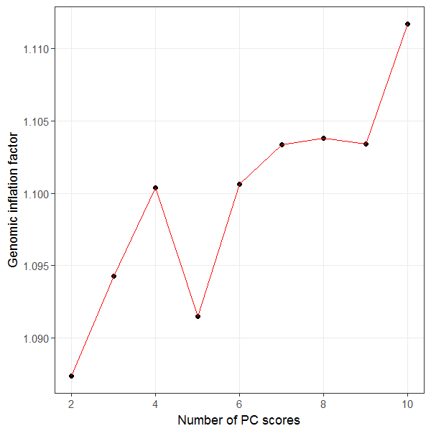

**Supplementary Figure 2. Multi-dimensional scaling plot.** Multi-dimensional scaling plots were generated using a pool of our Discovery S-LAM cohort, our COPDGene controls, and 1000 Genome project data. Red and blue circles indicate S-LAM and COPDGene samples used for our discovery analyses, respectively, and grey circles represent participants for 1000Genome projects.

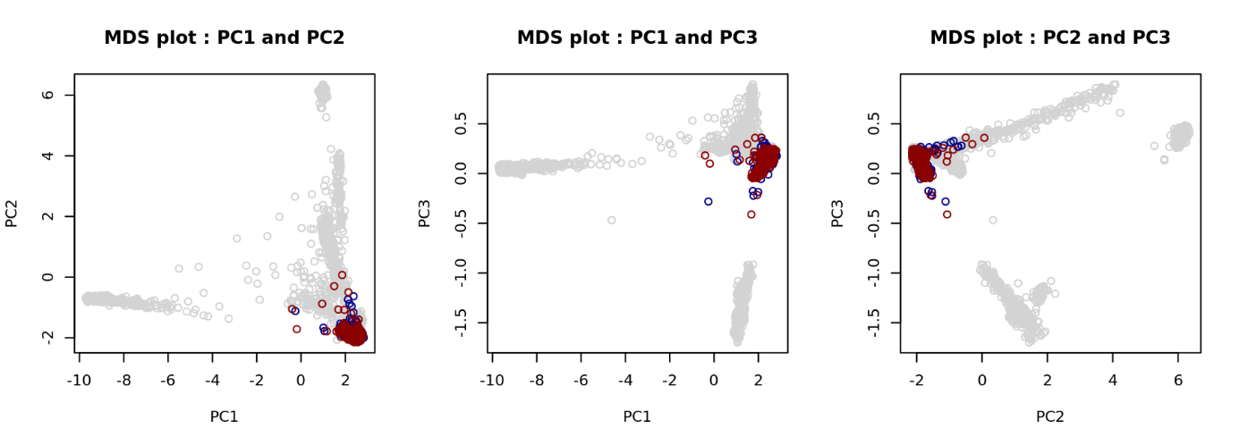

**Supplementary Figure 3. Linkage disequilibrium (LD) block around the two genome wide significant SNPs, rs4544201 and rs2006950.** Graph represents all genotyped SNPs in the 34kb LD block on chromosome 15q26.2. Each cell represents pair-wise LD relationship between two indexed SNPs, with a tight LD indicating a redder color. The number on each cell is % and blank means that % for two indexed SNPs is 100.

Pairwise analysis for LD was performed and What are the numbers? What does the color shading indicate?

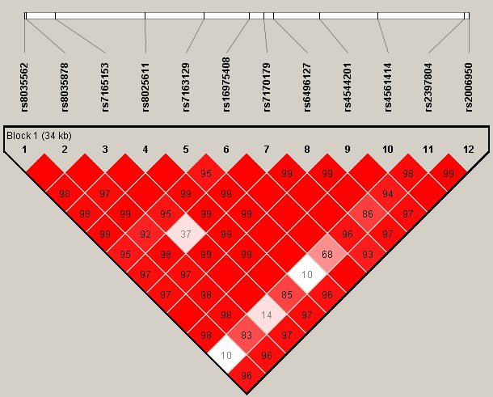

**Supplementary Figure 4. Hi-C heatmap and TADs defined in IMR90 cells.** The heatmap shows the degree of physical interaction defined by Hi-C analysis for genomic region pairs from a 3Mb region of chromosome 15q. A deeper red color at the intersection point reflects a greater degree of interaction between the two genomic regions. The dotted lines indicate probable TAD structures in this region. The two blue shaded regions at bottom indicate the genome wide significant SNP region (left) and *NR2F2* (right). The black circle reflects the interaction point between the SNP region and *NR2F2.*

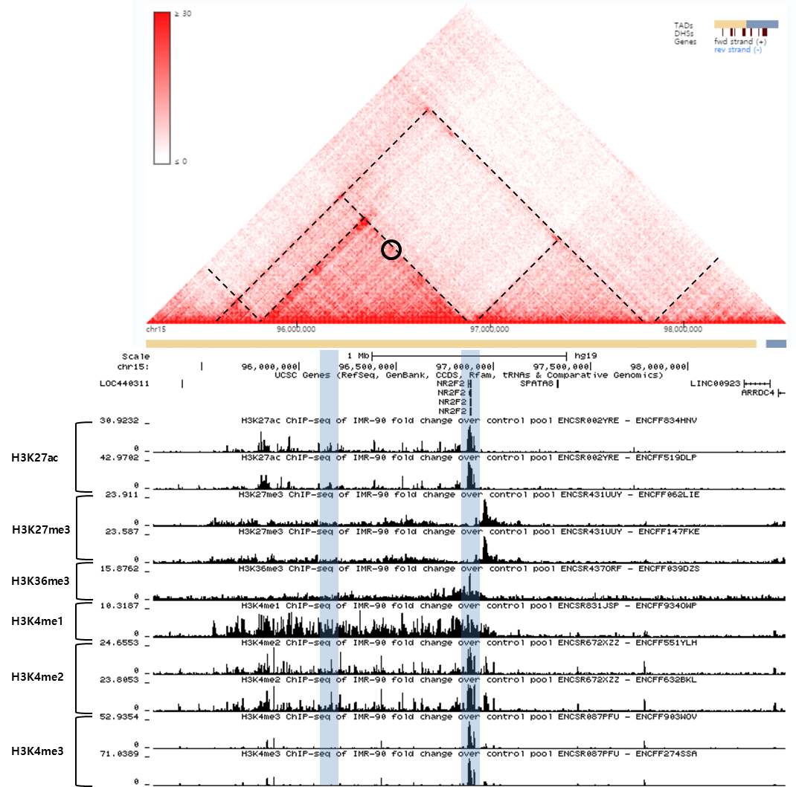

**Supplementary Figure 5. Hi-C heatmap and TADs defined in lung tissue.**

The heatmap shows the degree of physical interaction defined by Hi-C analysis for genomic region pairs from a 3Mb region of chromosome 15q. A deeper red color at the intersection point reflects a greater degree of interaction between the two genomic regions. The dotted lines indicate probable TAD structures in this region. The two blue shaded regions at bottom indicate the genome wide significant SNP region (left) and *NR2F2* (right). The black circle reflects the interaction point between the SNP region and *NR2F2.*

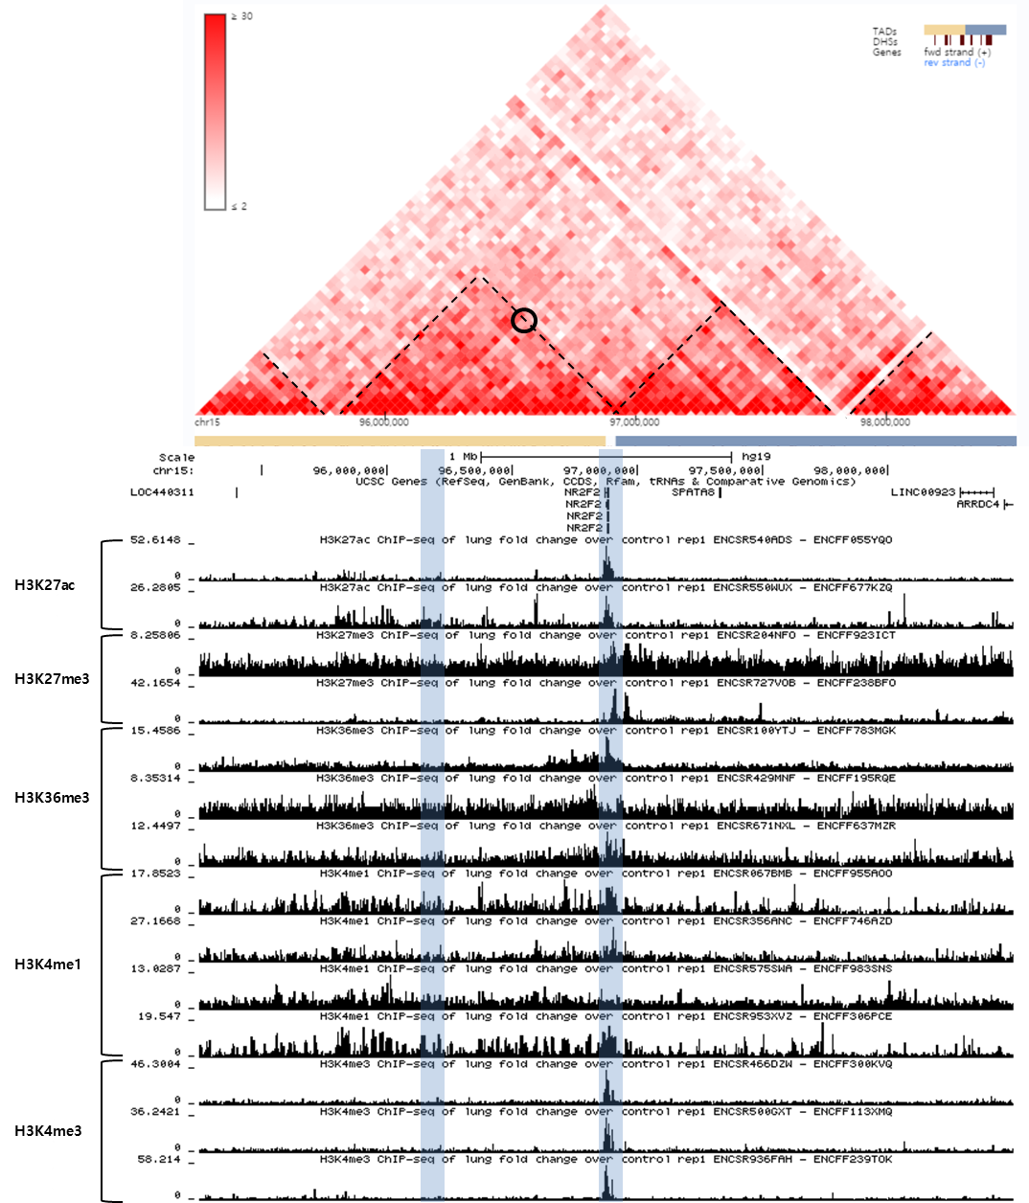

**Supplementary Figure 6. Hi-C heatmap and TADs defined in H1 derived mesenchymal stem cells (h1-MSC) cells.**

The heatmap shows the degree of physical interaction defined by Hi-C analysis for genomic region pairs from a 3Mb region of chromosome 15q. A deeper red color at the intersection point reflects a greater degree of interaction between the two genomic regions. The dotted lines indicate probable TAD structures in this region. The two blue shaded regions at bottom indicate the genome wide significant SNP region (left) and *NR2F2* (right). The black circle reflects the interaction point between the SNP region and *NR2F2.***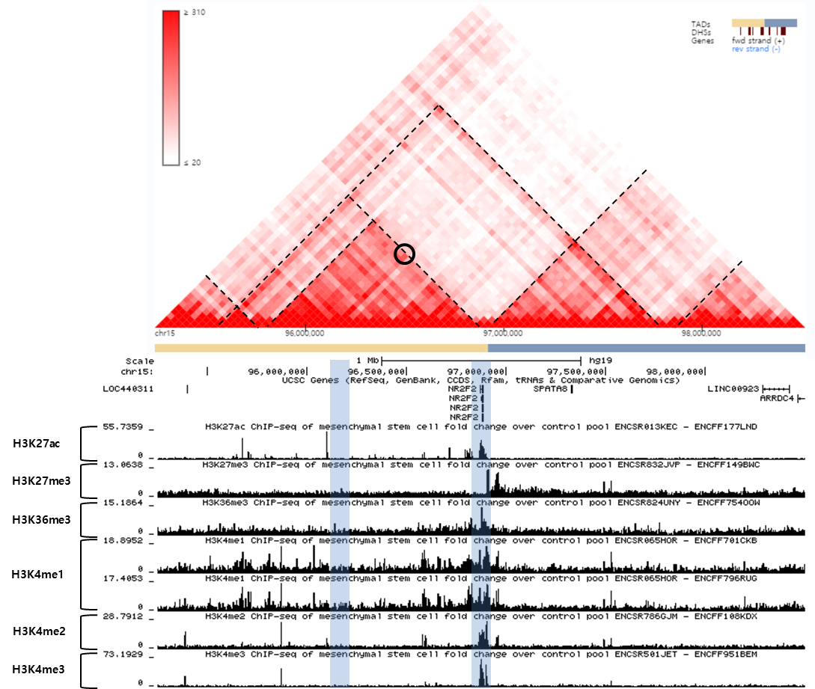**

**Supplementary Figure 7. Hi-C heatmap and TADs defined in HUVEC cells.**

The heatmap shows the degree of physical interaction defined by Hi-C analysis for genomic region pairs from a 3Mb region of chromosome 15q. A deeper red color at the intersection point reflects a greater degree of interaction between the two genomic regions. The dotted lines indicate probable TAD structures in this region. The two blue shaded regions at bottom indicate the genome wide significant SNP region (left) and *NR2F2* (right). The black circle reflects the interaction point between the SNP region and *NR2F2.***