**Supplementary Materials for “A Genome Wide Association Study implicates *NR2F2* in Lymphangioleiomyomatosis Pathogenesis”**

**Supplementary Table 1.** Distribution of LAM patients according to their nationality (discovery, replication data에 대하여 모두 정리할 것)

|  |  |  |
| --- | --- | --- |
|  | Discovery  LAM | Replication  LAM |
| USA | 190 | 196 |
| France | 54 | 0 |
| Spain | 40 | 0 |
| Italy | 35 | 0 |
| United Kingdom | 32 | 0 |
| Germany | 21 | 0 |
| Australia | 20 | 0 |
| Poland | 15 | 0 |
| Israel | 7 | 0 |
| Canada | 4 | 0 |
| Panama | 1 | 0 |
| Puerto Rico | 1 | 0 |
| Scotland | 1 | 0 |
| Unknown | 5 | 0 |
| Total | 426 | 196 |

**Supplementary Table 2.** PICS analysis to identify probable causal SNPs in the chr 15q region.

|  |  |  |  |  |  |  |
| --- | --- | --- | --- | --- | --- | --- |
| CHR | SNP* | POS | P-value | † | ‡ | PICS probability |
| **15** | **rs41374846** | **96143559** | **3.04410-9** | **1.0000** | **1.0000** | **0.6519** |
| 15 | rs59125351 | 96144157 | 3.47610-10 | 0.9703 | 0.7941 | 0.0350 |
| 15 | rs55804812 | 96151256 | 4.50110-10 | 0.9557 | 0.7758 | 0.0288 |
| 15 | rs16975389 | 96153782 | 6.23910-10 | 0.9555 | 0.7700 | 0.0270 |
| 15 | rs10520790 | 96151040 | 3.84810-10 | 0.9486 | 0.7698 | 0.0269 |
| 15 | rs16975396 | 96158705 | 1.03010-9 | 0.9480 | 0.7581 | 0.0237 |
| 15 | rs58878263 | 96171069 | 6.83510-10 | 0.9328 | 0.7287 | 0.0171 |
| 15 | rs8029996 | 96168770 | 5.54010-10 | 0.9325 | 0.7230 | 0.0160 |
| 15 | rs6496128 | 96168303 | 5.54010-10 | 0.9325 | 0.7230 | 0.0160 |
| 15 | rs4628911 | 96167905 | 5.54010-10 | 0.9325 | 0.7230 | 0.0160 |
| 15 | rs8040665 | 96175692 | 7.90410-10 | 0.9254 | 0.7171 | 0.0149 |
| 15 | rs17581137 | 96146414 | 1.50010-10 | 0.9529 | 0.7125 | 0.0142 |
| 15 | rs4544201 | 96167827 | 5.54010-10 | 0.9317 | 0.7116 | 0.0140 |
| 15 | rs4551988 | 96169589 | 5.54010-10 | 0.9183 | 0.7113 | 0.0140 |
| 15 | rs2397810 | 96148765 | 1.96310-10 | 0.9451 | 0.7008 | 0.0124 |
| 15 | rs6496126 | 96148439 | 1.96310-10 | 0.9380 | 0.7005 | 0.0123 |
| 15 | rs8040168 | 96176096 | 5.61610-10 | 0.9233 | 0.6887 | 0.0107 |

Definition of abbreviations: CHR = Chromosome; POS = SNP Position according to NCBI genome build 37 (hg19); CLR = Conditional Logistic Regression.

When the significant SNP rs41374846 was considered as the lead SNP, the largest PICS probabilities were calculated for nearby imputed SNPs.

* Candidate causal SNP

†  where : the frequency of the haplotype AB and : theoretical maximum difference between the observed and expected haplotype frequencies.

‡ : squared correlation coefficient

**Supplementary Table 3. P-values for SNPs associated with smoking addition and SNPs correlated with those (r2≥0.8)** P-values from discovery analysis were provided.

|  |  |  |
| --- | --- | --- |
| CHR | SNP | P-value |
| 1 | rs1060061 | 0.4885 |
| 6 | rs9503551 | 0.0840 |
| 7 | rs4285401 | 0.3263 |
| 8 | rs804292 | 0.8145 |
| 8 | rs6470120 | 0.1152 |
| 9 | rs10491551 | 0.7217 |
| 4 | rs10517300 | 0.6066 |
| 15 | rs1051730 | 0.9759 |
| 21 | rs2836823 | 0.1560 |

**Supplementary Table 4. MAFs** MAFs were calculated for the genome-wide significant SNPs from our discovery analysis with various cohort data.

|  |  |  |  |  |  |  |
| --- | --- | --- | --- | --- | --- | --- |
| SNP | LAM patients | | | Normal | | |
| Data | N | MAF (95% CI) | Data | N | MAF  (95% CI) |
| rs4544201 | discovery  (USA/NHW/  females) | 190 | 0.1684  (0.131,  0.206) | COPDGene  (USA/NHW/ females) |  |  |
| Discovery  (EUR/NHW/  females) | 233 | 0.1631  (0.130,  0.197) | COPDGene  (USA/NHW/  males) | 1,224 | 0.2774  (0.260, 0.295) |
| replication  (USA/NHW/  females) |  |  | MESA  (EUR/NHW/  females) | 1,153 | 0.2563  (0.238, 0.274) |
| replication  (EUR/NHW/  female) |  |  | 1000GP (EUR/NHW/  females) | 263 | 0.2357  (0.215, 0.257) |
|  |  |  | ECLIPSE  (EUR/NHW/  females) | 792 | 0.2563  (0.235, 0.278) |
|  |  |  | UKBiobank  (EUR/NHW/  males&females) | NA | 0.261  (0.261,  0.261) |
|  |  |  | GnomAD  (EUR/NHW/  Males&females) | 1,745 | 0.3424  (0.327, 0.358) |
| rs2006950 | Discovery  (USA/NHW/  females) | 190 | 0.1474  (0.112,  0.183) | COPDGene  (USA/NHW/ females) |  |  |
| Discovery  (EUR/NHW/  females) | 230 | 0.1377  (0.107,  0.169) | COPDGene  (EUR/NHW/  Males&females) | 1,226 | 0.2557  (0.238, 0.273) |
| replication  (USA/NHW/  females) |  |  | MESA  (EUR/NHW/  Males&females) | 1,128 | 0.2283  (0.211, 0.246) |
| replication  (EUR/NHW/  female) |  |  | 1000GP (EUR/NHW/  females) | 263 | 0.2186  (0.198, 0.239) |
|  |  |  | ECLIPSE  (EUR/NHW/  females) | 792 | 0.2431  (0.222, 0.264) |
|  |  |  | UKBiobank  (EUR/NHW/  Males&females) | NA | 0.241  (0.241,  0.241) |
|  |  |  | GnomAD  (EUR/NHW/  Males&females) | 1,747 | 0.3060  (0.289, 0.323) |

Definition of abbreviations: 1000GP = 1000 Genome project

**Supplementary Table 5. Full terms for TCGA tumor abbreviations**

|  |  |
| --- | --- |
| **Abbreviation** | **Full Term** |
| **KIRP** | Kidney renal papillary cell carcinoma |
| **KIRC** | Kidney Renal Clear Cell Carcinoma |
| **SARC** | Sarcoma |
| **PAAD** | Pancreatic Adenocarcinoma |
| **OV** | Ovarian Serous Cystadenocarcinoma |
| **BRCA** | Breast Invasive Carcinoma |
| **UCS** | Uterine Carcinosarcoma |
| **KICH** | Kidney Chromophobe |
| **UCEC** | Uterine Corpus Endometrial Carcinoma |
| **LIHC** | Liver Hepatocellular Carcinoma |
| **SKCM** | Skin Cutaneous Melanoma |
| **ACC** | Adrenocortical Carcinoma |
| **BLCA** | Bladder Urothelial Carcinoma |
| **MESO** | Mesothelioma |
| **COAD** | Colon Adenocarcinoma |
| **LUAD** | Lung Adenocarcinoma |
| **THCA** | Thyroid Carcinoma |
| **READ** | Rectum Adenocarcinoma |
| **PCPG** | Pheochromocytoma and Paraganglioma |
| **LUSC** | Lung Squamous Cell Carcinoma |
| **GBM** | Glioblastoma Multiforme |
| **CESC** | Cervical Squamous Cell Carcinoma and Endocervical Adenocarcinoma |
| **HNSC** | Head and Neck Squamous Cell Carcinoma |
| **LGG** | Low Grade Glioma |
| **DLBC** | Lymphoid Neoplasm Diffuse Large B-cell Lymphoma |
| **LAML** | Acute Myeloid Leukemia |

**Supplementary Figure 1. Variance inflation factors for the number of PC scores in the discovery data.** Cases and controls were matched with different numbers of PC scores (2 – 10 PC scores) and age, and CLR was applied to matched cases and controls. Variance inflation factors were calculated for different numbers of PC scores, and plotted against the numbers of PC scores.

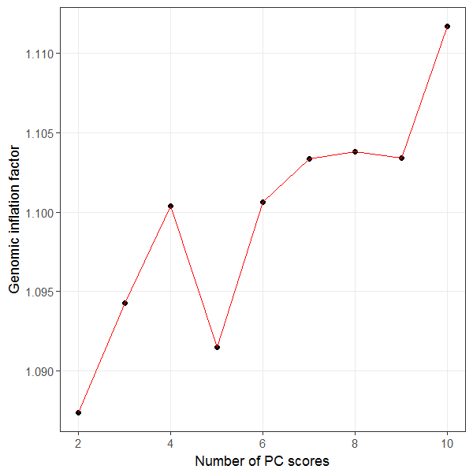

**Supplementary Figure 2. Mut-idimensional scaling plot** Multi-dimensional scaling plots were provided with discovery data and 1000 Genome project data. Red and blue circles indicate cases and controls used for our discovery analyses respectively, and grey circles do participants for 1000Genome projects.

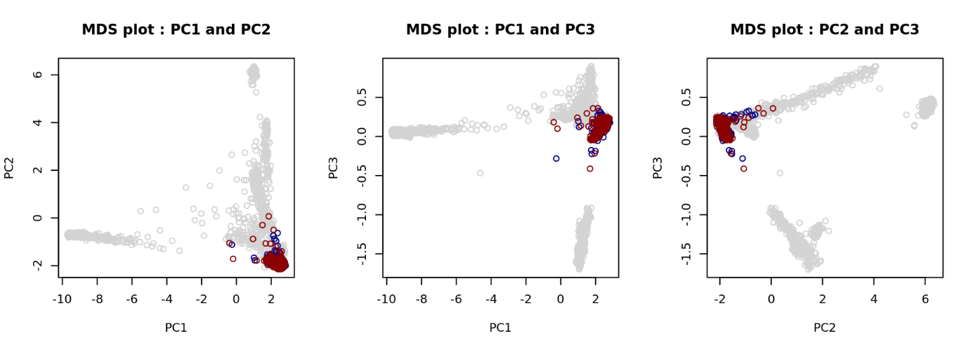

**Supplementary Figure 3. LD block around the two genome wide significant SNPs, rs4544201 and rs2006950.** Graph represents all genotyped SNPs in the 34kb LD block on chromosome 15.

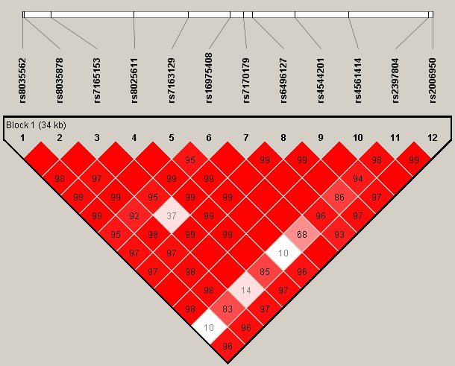

**Supplementary Figure 4. Hi-C heatmap and TADs defined in IMR90 cells.** The heatmap shows the degree of physical interaction defined by Hi-C analysis for genomic region pairs from a 3Mb region of chromosome 15q. A deeper red color at the intersection point reflects a greater degree of interaction between the two regions. The dotted lines indicate probable TAD structures in this region. The two blue bars at bottom indicate the SNP region (left) and *NR2F2* (right). The circle reflects interaction between the SNP region and *NR2F2.*

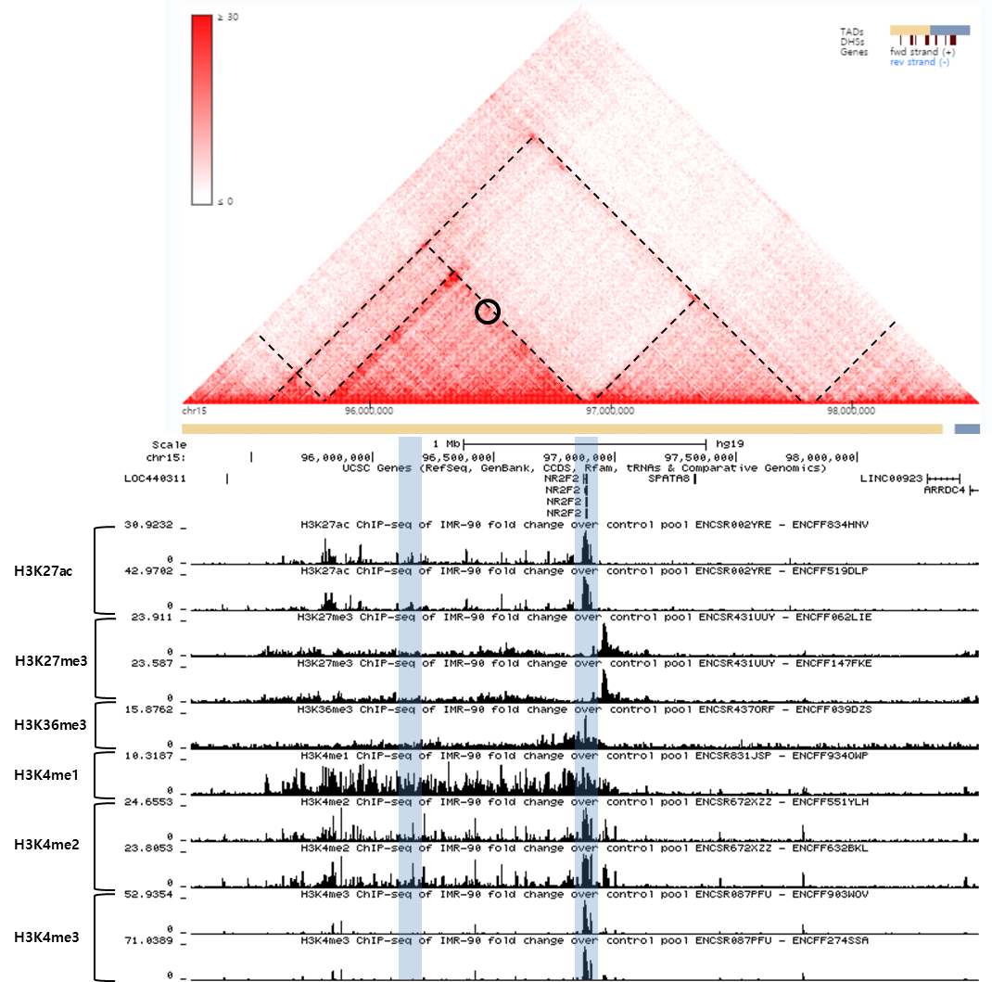

**Supplementary Figure 5. Hi-C heatmap and TADs defined in lung tissue.** The heatmap shows the degree of physical interaction defined by Hi-C analysis for genomic region pairs from a 3Mb region of chromosome 15q. A deeper red color at the intersection point reflects a greater degree of interaction between the two regions. The dotted lines indicate probable TAD structures in this region. The two blue bars at bottom indicate the SNP region (left) and *NR2F2* (right). The circle reflects interaction between the SNP region and *NR2F2.*

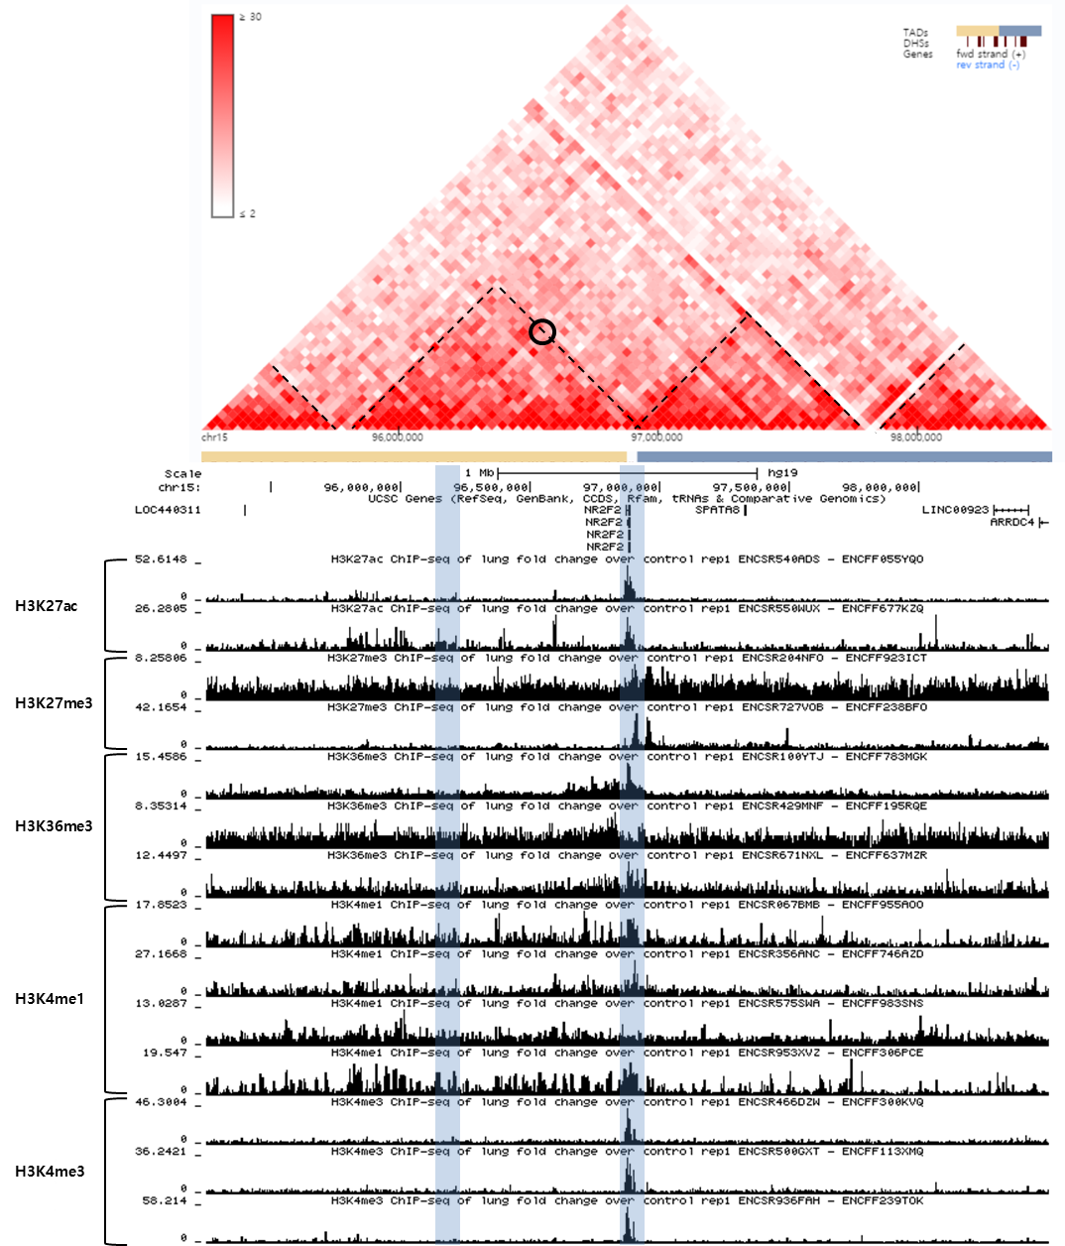

**Supplementary Figure 6. Hi-C heatmap and TADs defined in** H1 derived mesenchymal stem cells **(h1-MSC) cells.** The heatmap shows the degree of physical interaction defined by Hi-C analysis for genomic region pairs from a 3Mb region of chromosome 15q. A deeper red color at the intersection point reflects a greater degree of interaction between the two regions. The dotted lines indicate probable TAD structures in this region. The two blue bars at bottom indicate the SNP region (left) and *NR2F2* (right). The circle reflects interaction between the SNP region and *NR2F2.*

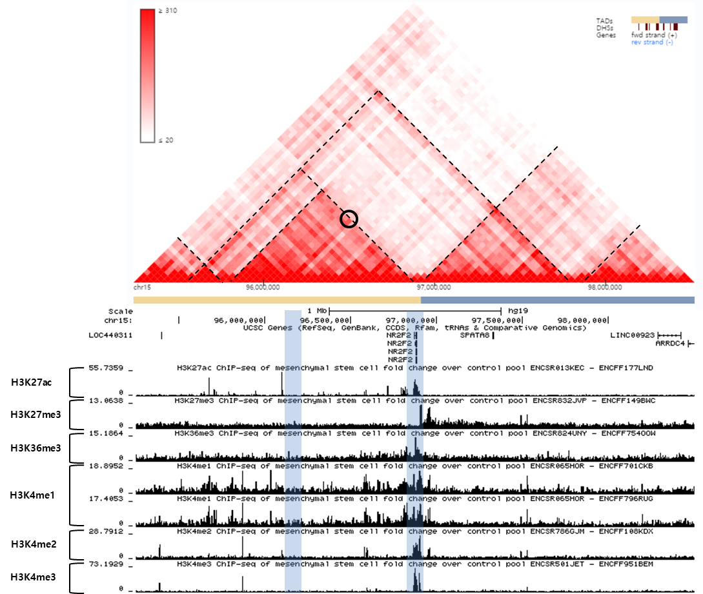

**Supplementary Figure 7. Hi-C heatmap and TADs defined in HUVEC cells.** The heatmap shows the degree of physical interaction defined by Hi-C analysis for genomic region pairs from a 3Mb region of chromosome 15q. A deeper red color at the intersection point reflects a greater degree of interaction between the two regions. The dotted lines indicate probable TAD structures in this region. The two blue bars at bottom indicate the SNP region (left) and *NR2F2* (right). The circle reflects interaction between the SNP region and *NR2F2.*

