Dear

We appreciate the insightful comments provided by the reviewers. They have helped us significantly improve the manuscript. In the revised version, we have addressed all the comments and modified minor typographical errors.

Reviewer Comments:

**# Reviewer 1**Comments to the Author  
This clearly written manuscript details the first GWAS of lymphangioeiomyomatosis (LAM), which used 479 LAM cases and compared them with 1261 controls from the COPDGene cohort, which are well-characterized for lung phenotypes. Cases and controls were genotyped on the same array, which reduces potential bias. Genome-wide significant association was observed for two genotyped SNPs in a novel locus on chr. 15 near the NR2F2 gene; importantly, the SNP associations were replicated in an independent cohort. Follow-up analyses were carried out to aid the biological interpretation of the statistical associations, including using gene-based association tests and chromatin TADs in the region surrounding the genome-wide significant SNPs that both pointed to NR2F2 as the most likely gene influenced by the associated SNPs. Additional functional data added further support to the plausibility of NR2F2, including RNA-seq showing higher expression levels of NR2F2 in LAM and related tumors compared to other cancers and immunohistochemistry showing strong nuclear expression of NR2F2 in tumor samples. A caveat to the functional connection is that there is presently no evidence of the LAM-associated SNPs exerting eQTL effects on NR2F2, but the author appropriately address this limitation in the Discussion.   
  
Major Comments  
1. Given that there is “no precedent for genetic influence on the development of S-LAM,” the authors might consider determining the SNP heritability of S-LAM using their GWAS results to provide the field with this foundational information.

**(RESPONSE)** We agree with your comment in that the proportion of phenotypic variance explained by SNPs can be used to determine the contribution of genetic factors to S-LAM. We calculated SNP heritability of S-LAM based on both entire genotyped SNPs and SNPs within the LD block for the top associated SNPs using GCTA, and added the following paragraph:

→ We calculated the proportion of phenotypic variance explained by the genotyped SNPs, $h_{SNP}^{2}$. Estimates of $h_{SNP}^{2}$ vary according to disease prevalence (Supplementary Figure 4). With prevalence set at 1 in 100,000 women, $h_{SNP}^{2}$ is very low at 0.76%, and the proportion of phenotypic variance explained by the LD block containing genome-wide significant SNPs is 3.04% suggesting that other genetic or environmental components contribute to disease susceptibility.

2. Further details are needed on the source of cases used for both discovery and replication.

**(RESPONSE)**

3. Running GWAS using conditional logistic regression is unique, and it isn’t clear what is being conditioned in the model.  Please clarify the model and provide the rationale for conditioning.

**(RESPONSE)** We would appreciate this comment. Conditional logistic regression (CLR) controls for confounding by conditioning on the number of cases in each strata which consists of matched cases and controls using confounding variables. In this study, subjects are from several different countries and might have genetic heterogeneity. In general, the genetic heterogeneity can be adjusted by adding some principal component (PC) scores as covariates. To find the number of PC scores which minimizes genetic heterogeneity, we matched cases and controls based several choice of PC scores and calculated a genomic inflation factor. As a result, we obtained the minimum genomic inflation factor when we use matched cases and controls with two PC scores corresponding to the two largest eigenvalues for GWAS. We have clarified what is being conditioned on for CLR and modified sentences as follows:

→ Thus CLR was conducted conditioning on the SNP and the number of cases in each strata consisting of cases and controls matched with 2 PC scores. In this study where each case was matched two controls, this can be expressed as follows:

for th strata,

$$\operatorname{Pr}\left(Y_{i1}=1, Y_{i2}=0, Y_{i3}=0|X_{i1},X_{i2},X_{i3},\sum_{j=1}^{3}{Y_{ij}}=1\right)=\frac{\operatorname{Pr}\left(Y_{i1}=1|X_{i1}\right)\operatorname{Pr}\left(Y_{i2}=0|X_{i2}\right)\operatorname{Pr}\left(Y_{i3}=0|X_{i3}\right)}{\sum_{y_{ij}∈\left(y_{i1}+y_{i2}+y_{i3}=1\right)}{\operatorname{Pr}\left(Y_{i1}=y_{i1}|X_{i1}\right)\operatorname{Pr}\left(Y_{i2}=y_{i2}|X_{i2}\right)\operatorname{Pr}\left(Y_{i3}=y_{i3}|X_{i3}\right)}}=\frac{\exp\left(X_{i1}β\right)}{\sum_{j=1}^{3}{\exp\left(X_{ij}β\right)}}$$

where $Y_{ij}$ is the phenotype and $X_{ij}$ is the genotype.

4. GWAS analyses focused only on ~550,000 genotyped SNPs, with imputation using Haplotype Reference Consortium for fine-mapping the genome-wide significant locus. It is unclear why imputation was not carried out for the discovery GWAS, as it is feasible to perform with cases vs. controls obtained from a different dataset. Lack of imputation doesn’t invalidate the current findings but means that the study may have missed other novel loci across the genome.

**(RESPONSE)** We appreciate your insightful comment. We performed whole genome imputation with the same strategy in the text and there were 5,427,337 SNPs after quality control. At the genome-wide significant level of 510-8, there were significant SNPs only at the locus where we identified in the discovery study (See the following figures). We updated the manuscript with the whole-genome imputation results.

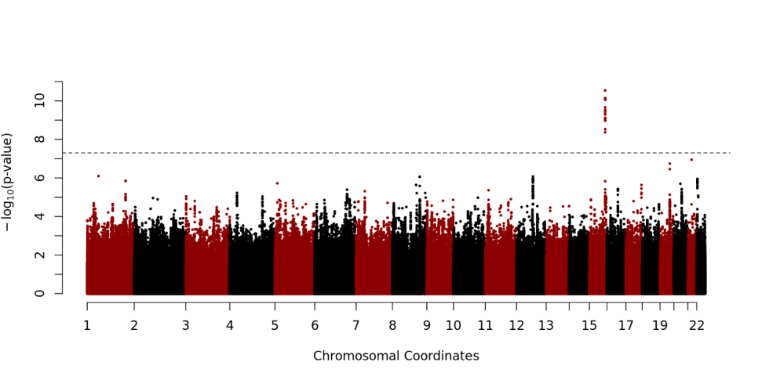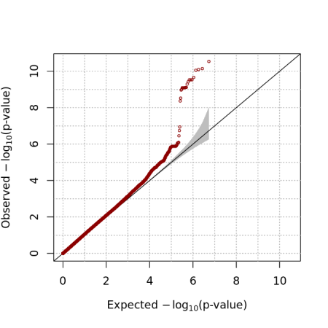

Minor comment  
1. There are several instances in the manuscript where the text are incorrectly shown in sub/superscript (see for example Table 2).

*Easy.*

2. Adding gene annotations to the SNPs presented in Supplementary Table 2 would be helpful. Also, the SNP on chr. 4 might not be listed correctly (rs10517300 is not found in the GWAS catalogue).   
**(RESPONSE)** We would thank for this excellent observation. This was a mistake and it has been removed from the table. And also, rs10491551 is not found in the GWAS catalogue but it was chosen due to high correlation with rs12348139 on chromosome 9 (r2 = 1). We added mapped gene information and SNP and described the reason why rs10491551 is included to Supplementary Table 2.

**# Reviewer 2**Comments to the Author  
I appreciate the opportunity to review the manuscript submitted by Kim and colleagues entitled “A Genome-wide Association Study implicates NR2F2 in Lymphangioleiomyomatosis Pathogenesis” for the European Respiratory Journal. This manuscript summarizes a GWAS of 549,000 SNPs (MAF>0.05) in 479 European descent and White (unclear of Hispanic ethnicity although there were US and Puerto Rican samples) LAM female cases and 852 matched controls with replication in 196 non-Hispanic White females and 409 controls. GWAS in the discovery cohort identified two SNPs in a gene desert that reached genome-wide significance for LAM susceptibility closest to the gene encoding NR2F2 which also replicated successfully. Fine mapping of imputed genotype data within the LD blocks for the top associated SNPs identified a possible causative locus associated with LAM while gene-based SKAT-O testing within the Chr15 region only found a significant association for NR2F2 and no other genes. Additional database searches for genotype and RNA expression data revealed that (1) the associated SNPs were within the boundaries of a topologically-associated domain for NR2F2 and no other genes, (2) the allele frequency of these SNPs in these US and European LAM cohorts were remarkably different from that of different general populations, and (3) NR2F2 gene expression was significantly higher in LAM-affected tissues compared to other cancer and normal tissue from TCGA and GTEx. Finally, immunohistochemistry showed strong nuclear expression of NR2F2 in LAM lung and renal angiomyolipoma cells.   
This is the largest genetic study of LAM cases and unaffected controls assembled to date from an international effort which identified a locus not related to the TSC1 and 2 genes. In addition, this study used appropriate fine-mapping of genotyped and imputed data complemented by different bioinformatics and molecular phenotyping approaches on LAM-affected tissues to validate the role of the top GWAS associations that reach genome-wide significance. This study provides insight into a novel pathogenic mechanism for a largely fatal pulmonary disease which was well substantiated in a relatively large cohort of individuals with a rare disease that primarily impacts women. This study is also a good and uncommon example of a GWAS of individuals with a rare disease related to a known gene (TSC1/2) that was able to find a strongly associated novel gene locus. There are several concerns which I recommend the authors address or clarify.

I recommend the following major revisions:  
1) The authors should clarify what was the “careful scrutiny” used to prevent overlapping subjects between the discovery and replication cohorts since GWAS data wasn’t available in the replication cohort to assess IBD.

**(RESPONSE)**

2) It is unclear whether the cases and controls in the discovery cohort were NON-Hispanic White? It is clear from Figure 1, supplementary table 1, and the text that the cohort consisted of European Whites, but the issue of Hispanic ethnicity was not clearly outlined for the discovery cohort and could have implications on environmental/cultural exposures and ancestral background confounding genetic associations. The authors should at least provide the proportion of Hispanic subjects, if this data is available and an explanation of how well the PC approach has accounted for confounding by variable ancestral backgrounds which I suspect it did based on the detailed descriptions of the PC’s for this cohort.

**(RESPONSE)**

3) It was not clear whether fine-mapping covered lower frequency variants across the Chr 15q LD blocks containing the top associations. The authors outline in Figure 1, that allele frequencies <0.05 were excluded from the initial discovery GWAS, but should outline whether low frequency or rare variants were considered during the fine mapping steps, including SKAT-O. Was there a MAF threshold? If these variants were otherwise excluded, specify the obvious reasons why a MAF threshold was selected (ie poor imputation quality, inability to genotype any associations identified, etc.). Since LAM is considered to be caused by rare pathogenic TSC1/2 gene variants and LAM is a rare disease, this is an important consideration.  
**(RESPONSE)** We agree that rare variants have to be considered for identifying susceptibility loci for S-LAM since it occurs rarely. As you pointed out, we excluded rare variants in discovery analysis in order to figure out candidate loci. However, all SNPs including rare variants in three genes were considered for SKAT-O. We have provided additional explanation about MAF threshold for fine-mapping as follows:

→ We also conducted gene-based analyses to identify genes with significant association with S-LAM using the SKAT-O statistic [22]. All SNPs after QC except MAF crieteria within each gene were included for SKAT-O analysis, and age, squared age and 10 PC scores were included as covariates.

4) Diagnostic criteria for a diagnosis of LAM were not outlined in the manuscript nor summarized in a baseline characteristics table. This data would be good to see in the methods as diagnostic criteria and in a table.

**(RESPONSE)**

5) It’s unclear how variation in the TSC genes were considered in this GWAS. Were patients with known variants excluded from analysis or were these genes sequenced/genotyped for known pathogenic variants? If not, was TSC variation associated with LAM at the level of any individual SNPs or at the gene-level using imputed data or SNP data not filtered for a low allele frequency? I presume that identifying associations at these known loci would be tough since pathogenic variants were rare and excluded from GWAS, but also difficult to impute. However, more common SNPs in LD with pathogenic variants might be associated or gene-level associations could also represent LD-tagged SNP associations for strongly association pathogenic loci (TSC genes). These questions are more to address whether the NR2F2 associates with LAM risk through interactions with TSC genes or independently and might not be addressable in a study based on GWAS genotyping and imputed data alone (a limitation to outline in the discussion section). Candidate gene/SNP studies are performed many time with GWAS and should be considered here if the quality of data is appropriate (ie genotyping coverage, imputation quality).

**(RESPONSE)***.*

5) Increased expression of *NR2F2* was found in a small number of LAM-related tissues compared to tissue from TCGA and GTEx which is not the same thing as an eQTL analysis of the top associated SNPs. In the discussion, the authors states that the novel SNP loci were not eQTL’s when evaluated. However, the authors should outline if and how this analysis was performed in more detail the methods or results sections.

**(RESPONSE)** Thank you for this direction. Due to lack of RNA-seq samples for LAM, we could not perform eQTL analysis directly. Instead of it, we used GTEx database in order to find eQTL of SNPs in LD block. We have described analysis method and results for eQTL mapping briefly in Method section and Result section as follows:

→ We also searched the single-tissue cis-eQTL of all SNPs in the LD block from public database provided by GTEx in release v7. They provide results of eQTL analysis for each SNP-gene pair consisting of all SNPs within 1 Mb upstream and downstream of transcription start site of each gene. FastQTL was used for cis-eQTL mapping [31] including top three PC scores, genotyping platform, sex and a set of relavant variables identified using PEER method [32] as covariates. The detailed workflow can be found on the GTEx website (<https://www.gtexportal.org/home>).

→ We queried the GTEx database for SNPs in the LD block to find SNP-gene associations in eQTL studies. Unfortunately, there was no significant association with an FDR threshold of 0.05.

Minor revisions:   
1) Some of the tables and text throughout have font that is unnecessarily superscripted.

**(RESPONSE)**

2) The term long-non coding RNAs should be defined before the use of the term “lncRNA” on page 11.

**(RESPONSE)** We have added the term ‘long-non coding RNA’ in the manuscript.

3) Number of SNPs for GWAS on page 7 of the methods does not match the numbers on Figure 1. This might be related to the exclusion of nicotine dependence genes.

**(RESPONSE)** We thank the reviewer for this observation. The problem has been fixed.

4) In the abstract, please provide a sample size for the replication cohort and state that the controls in the discovery were matched.

*Easy.*

**# Reviewer 3 (Statistical Reviewer Comments)**:  
1. The lack of genome-wide imputation is a major limitation – what was the justification for not performing this prior to the GWAS?

**(RESPONSE)** We would like to thank the reviewer for pointing out this important omission of checking other associations for un-genotyped loci. We focused on the region near the significant SNPs on chromosome 15 to identify the genetic mechanism for development of S-LAM. Although the LD block was located in the intergenic region and any putative function of the loci has not been discovered yet, we successfully discovered the relevance between *NR2F2* and the LD block via TAD analysis, RNA-seq analysis, SKAT-O and IHC analysis. Nevertheless, we totally agree that the lack of genome-wide imputation is a major limitation in that we could miss other un-genotyped novel loci in discovery study. We performed genome-wide imputation and CLR with the same strategy we did, and the results show some loci in the LD block met genome-wide significant level. Method and result have been updated with these results accordingly.

2. Page 8 of 47, line 14: How were “non-white” LAM subjects excluded?

**(RESPONSE)**

3. Page 9 of 47, line 23: Controls from a source entirely independent of the discovery would add more confidence to the results of the replication. Although the authors provide strong evidence that smoking behaviour is unlikely to account for the signals, there is still uncertainty as to whether other differences between the case and control populations, besides LAM status, might be accounting for the differences.

**(RESPONSE)** The observations of the reviewer are exact. Since controls for both discovery and replication studies are from the same population, the difference between case and control (S-LAM vs normal) is nested to the difference between populations (S-LAM vs COPDGene). In an effort to get rid of the population effect, we excluded relevant SNPs to nicotine dependence from the analysis. Nonetheless, we agree with the concern of the reviewer that potential effects may not be completely removed. Therefore, we used two additional external datasets, MESA and UK Biobank, as controls for replication studies, and results were similar with previous one. The following paragraph has been added in the paper to address this point:

## MESA (using only female & no covariates)

CHR SNP BP A1 TEST NMISS OR STAT P

15 rs4544201 96167827 A ADD 1317 0.507 -4.434 9.247e-06

15 rs2006950 96179390 A ADD 1317 0.4448 -4.884 1.038e-06

##

4. Page 9 of 47, line 24: what is the pre-specified threshold for replication?

**(RESPONSE)** We used almost same thresholds of quality control used in the discovery study. We only included NHW females first, and then excluded variants if the Hardy-Weinberg equilibrium (HWE) test gave P < 1×10-5; minor allele frequency (MAF) was < 0.05; or genotype call rates were less than 95%. However, there was no variant satisfied QC standards. According to the comment of reviewer, we would like to clarify QC standards for replication study and following paragraph has been added to the Method section:

→ For each control dataset, we used genotype data when rs4544201 and rs2006950 were available or imputed data with 1000 Genomes Project [19] when they were not. We included only NHW female and excluded variants if P-value of HWE test is less than 1×10-5, MAF is less than 0.05 or missing genotype rate is greater than 5%. With these quality control (QC) criteria, no variants were excluded for all datasets.

5. Page 10 of 47, line 24 and Table 2 legend – please clarify the method used for imputation (was it IMPUTE2?)

**(RESPONSE)** We used the Positional Burrows–Wheeler Transform (PBWT) package for imputation. Prior to imputation with PBWT, EAGLE2 was utilized for pre-phasing according to the recommendation of the Sanger Imputation Service in terms of speed and accuracy. We modified sentences to be specific as follows:

→ Before imputation, pre-phasing was conducted with EAGLE2 v2.0.5 [24], and then the Positional Burrows–Wheeler Transform (PBWT) package [25] was used for the imputation according to the imputation pipeline recommended by Sanger Imputation Service in terms of speed and accuracy.

→ **Table 2. Statistical analyses of imputed SNPs with CLR.** Imputation was conducted using EAGEL2 (pre-phasing) and PBWT (Imputation) with the Haplotype Reference Consortium as reference panel.

6. Page 10 of 47, line10 – please justify the use of CLR as this is non-standard in GWAS.

**(RESPONSE)** The main reason for using conditional logistic regression (CLR) is to overcome the limitation of the samples size of S-LAM. According to the earlier literature, CLR is known to be more efficient than unconditional logistic regression (LR) if the matching variables are true confounders and the number of controls excluded from the analysis due to matching is moderate. In particular, under these conditions, efficiency is improved for the same sample size rather than LR. In the discovery study, we controlled sex effect by excluding males from controls. Moreover, since S-LAM patients have been collected from several countries, we can consider PC scores as the confounder. In an effort to find the most appropriate number of PC scores, we conducted CLRs using matched case-control based on several numbers of PC scores and chose PC scores that brought the variance inflation factor closer to 1. In fact, our result using LR was less efficient than CLR (see following QQ plots). We would appreciate your insightful comment and following paragraph has been added to clarify the rationale of using CLR in the Discussion:

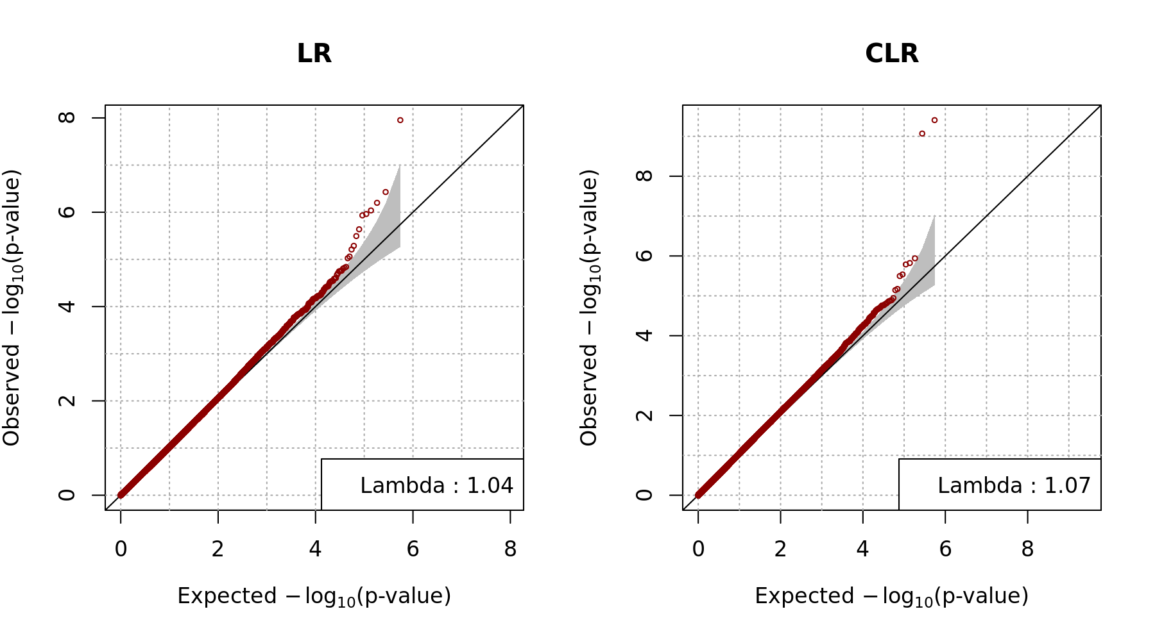

→ There are potential limitations to our study. Although our cohort of samples was large for a rare disease like S-LAM, it was of only moderate size for GWAS. In order to overcome this issue, we used CLR rather than the classical logistic regression (LR). According to the some literatures, CLR can improve the efficiency of the study rather than LR for the same sample size if the variables used for matching are true confounding variables and moderate number of controls were excluded from the analysis as a result of matching [53-58]. In this study, we considered sex and population substructure as the potential confounders because S-LAM occurs almost exclusively for women and S-LAM patients were collected from several countries. To control confounders, we only included women for both discovery and replication studies, and included two PC scores as matching variables. Even though we dropped some controls out after matching, CLR was more efficient than LR to identify significant SNPs on chromosome 15 (Supplementary Figure 10).

7. Page 12 of 47, line 24: Please make clear here that these two SNPs are highly correlated and represent one signal.

**(RESPONSE)** We would like to appreciate the observation of the reviewer. We have added the following sentence to clarify that two significant SNPs are derived from one signal:

→ Based on the location of the two SNPs and their LD relationship, these two associations might be derived from a unique signal.

8. Page 13 of 47, lines 9 and 13: Nicotine addiction cannot be a confounder in a genetic study as it does not influence both exposure (SNP) and outcome. Nicotine addiction can be on the causal pathway between an exposure and outcome (i.e. the SNP is influencing disease risk via nicotine addiction). Please correct this wording in the manuscript.

**(RESPONSE)** We thank the reviewer for pointing out this important terminological error. Since controls consist of only smokers, there might be a selection bias not a confounder effect. We have modified the sentence as follows:

→ Since the control COPDGene cohort were smokers, this association analysis might have selection bias caused by SNP alleles associated with nicotine addiction. We checked p-values for SNPs associated with nicotine addiction from the GWAS catalog [36] and other SNPs correlated with those (r2 >0.8) (Supplementary Table 2). None of those SNPs showed a significant difference in allele frequency in the LAM and COPDGene cohorts, indicating that our findings are not affected by nicotine addiction SNPs.

9. Page 13 of 47, line 5: Please present the genomic inflation factor lambda. A visual inspection of the QQ plot is insufficient to prove that there is no inflation.

**(RESPONSE)** We appreciate your insightful comment and have indicated the genomic inflation factor in the manuscript as follows:

→ Quantile-quantile plots for CLRs and Manhattan plots demonstrated that the distribution of observed P-values met the expected distribution, with the exception of the two SNPs (Figure 2ab), indicating that the analyses were free of systematic P-value inflation **(genomic inflation factor = 1.07)**.

10. Page 15 of 47, lines 1 to 9; more clarity is needed here to explain how the data presented in Supplementary Figures 4 to 7 demonstrate an interaction between the LAM-associated SNPs and NR2F2.

**(RESPONSE)** We thank the reviewer for pointing out this problem. We have added the following paragraph to clarify the interpretation of the heatmap:

→ In Supplementary Figures 6-9, Hi-C heatmaps display about 1 Mb sub-TADs containing the GWAS SNPs and NR2F2 near the boundary of the sub-TAD within a larger TAD in all four of these cells/tissues, and NR2F2 was the only protein-coding gene.

11. SKAT-O analysis: please clarify the criteria for SNP inclusion. Were both intronic and exonic SNPs included? Was there any MAF filter? Gene-based approaches such as SKAT-O are usually intended to look for the cumulative effect of rare variants within a gene, however, it is stated in the methods that SNPs with MAF<5% were excluded.

**(RESPONSE)** Both you and the other reviewer commented on this information, and we agree that additional information about the criteria for SNP inclusion is needed. In discovery analysis we excluded rare variants with MAF<5%, but we did not consider MAF standard for SKAT-O. Moreover, we included all SNPs in three genes regardless intronic or exonic region. We have provided additional explanation about criteria for SNP inclusion as follows:

→ We also conducted gene-based analyses to identify genes with significant association with S-LAM using the SKAT-O statistic [22]. All SNPs after QC except MAF crieteria within each gene were included for SKAT-O analysis, and age, squared age and 10 PC scores were included as covariates.

Yours sincerely,  
  
Prof. Louise Wain  
European Respiratory Journal  
  
Prof. M. Kolb  
ERJ Chief Editor  
  
Prof. J. Chalmers  
Deputy Chief Editor