**1. 모듈명: 분류분석 – 지도학습 – K최근접이웃기법**

**2. 디버깅 일시: 20171123**

**3. 사용데이터: birth_NA**

**4. UI 캡쳐:**

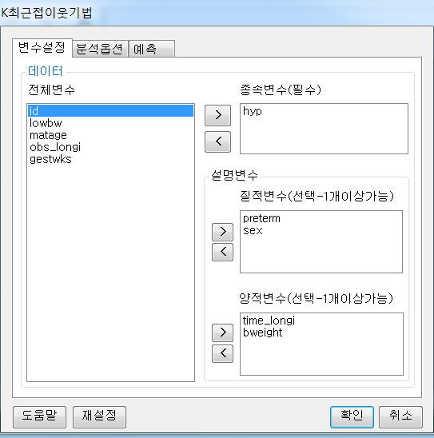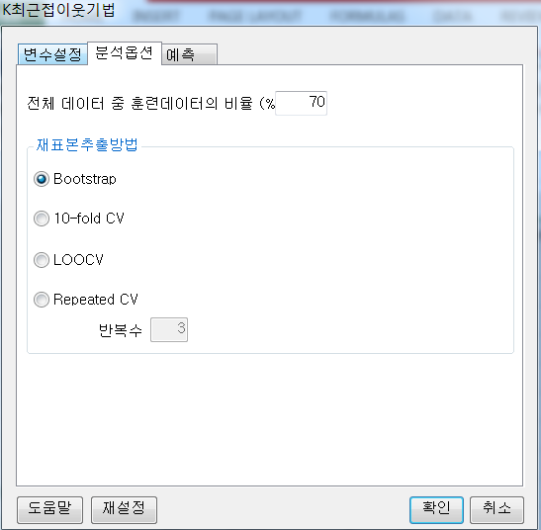

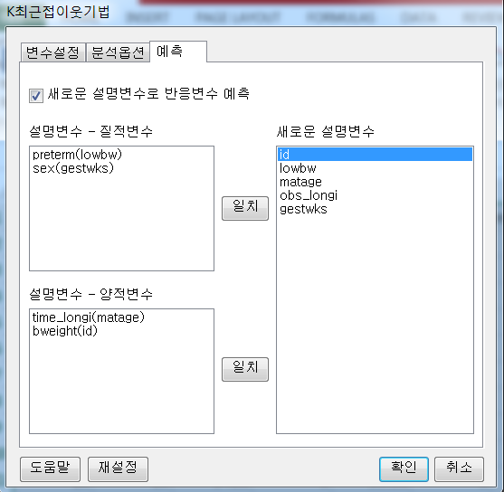

**5. 로그창:**

> REx_KNN(df20171123153928, y='hyp', quan_x=c('time_longi','bweight'), qual_x=c('preterm','sex'), train_percent=0.7, resample_method='boot', resample_repeat=3, new_predict=TRUE, new_quan_x=c('matage','id'), new_qual_x=c('lowbw','gestwks'));

**ERROR! factor sex has new levels 24.69000053, 26.95000076, 27.32999992, 27.98999977, 28.04000092, 30.52000046, 30.64999962, 30.70999908, 30.85000038, 31.29000092, 31.37000084, 31.70999908, 32.40999985, 32.47000122, 32.52999878, 32.79999924, 32.81000137, 33.22999954, 33.66999817, 34.02000046, 34.06000137, 34.18999863, 34.34000015, 34.59000015, 34.63999939, 34.66999817, 34.70000076, 34.86999893, 35.13999939, 35.27000046, 35.40999985, 35.5, 35.61999893, 35.68000031, 35.70000076, 35.72999954, 35.95000076, 35.97000122, 36.09000015, 36.15999985, 36.22999954, 36.27000046, 36.27999878, 36.34999847, 36.36999893, 36.40000153, 36.40999985, 36.43999863, 36.45000076, 36.47999954, 36.52999878, 36.54000092, 36.81999969, 36.84999847, 36.91999817, 36.93999863, 36.99000168, 37.04000092, 37.04999924, 37.08000183, 37.09999847, 37.11000061, 37.13000107, 37.16999817, 37.22000122, 37.25999832, 37.27000046, 37.33000183, 37.36000061, 37.38999939, 37.40000153, 37.41999817, 37.43000031, 37.43999863, 37.45999908, 37.47000122, 37.49000168, 37.52999878, 37.54000092, 37.54999924, 37.56999969, 37.58000183, 37.59000015, 37.61999893, 37.63000107, 37.65000153, 37.66999817, 37.68000031, 37.70000076, 37.74000168, 37.77999878, 37.79000092, 37.81999969, 37.83000183, 37.84000015, 37.84999847, 37.86000061, 37.86999893, 37.88000107, 37.88999939, 37.90000153, 37.90999985, 37.93999863, 37.95999908, 37.97000122, 38.02000046, 38.02999878, 38.04000092, 38.04999924, 38.06000137, 38.06999969, 38.09000015, 38.13999939, 38.15000153, 38.18000031, 38.20999908, 38.22999954, 38.25, 38.25999832, 38.27000046, 38.29000092, 38.33000183, 38.34000015, 38.36000061, 38.36999893, 38.43999863, 38.45000076, 38.47999954, 38.5, 38.50999832, 38.52000046, 38.54999924, 38.56000137, 38.58000183, 38.59999847, 38.63000107, 38.63999939, 38.65999985, 38.66999817, 38.68000031, 38.68999863, 38.72000122, 38.74000168, 38.75, 38.77000046, 38.77999878, 38.79999924, 38.83000183, 38.84999847, 38.86999893, 38.88000107, 38.88999939, 38.90000153, 38.90999985, 38.91999817, 38.93000031, 38.93999863, 38.95000076, 38.95999908, 38.97000122, 38.97999954, 38.99000168, 39.00999832, 39.02000046, 39.04000092, 39.04999924, 39.06000137, 39.09000015, 39.09999847, 39.11000061, 39.11999893, 39.13000107, 39.13999939, 39.16999817, 39.18000031, 39.18999863, 39.20000076, 39.20999908, 39.22000122, 39.22999954, 39.27000046, 39.33000183, 39.34999847, 39.38000107, 39.40000153, 39.41999817, 39.43000031, 39.43999863, 39.45000076, 39.45999908, 39.47000122, 39.49000168, 39.50999832, 39.52000046, 39.54000092, 39.54999924, 39.56000137, 39.56999969, 39.58000183, 39.59999847, 39.61000061, 39.61999893, 39.63000107, 39.63999939, 39.65000153, 39.65999985, 39.66999817, 39.70000076, 39.70999908, 39.74000168, 39.75, 39.75999832, 39.77000046, 39.79999924, 39.81000137, 39.83000183, 39.84000015, 39.84999847, 39.86000061, 39.88000107, 39.90000153, 39.91999817, 39.93000031, 39.93999863, 39.95000076, 39.95999908, 39.97000122, 39.97999954, 40, 40.02999878, 40.04000092, 40.04999924, 40.06000137, 40.06999969, 40.08000183, 40.09000015, 40.09999847, 40.11000061, 40.11999893, 40.13000107, 40.13999939, 40.15000153, 40.18000031, 40.18999863, 40.20000076, 40.20999908, 40.22999954, 40.25, 40.27000046, 40.29000092, 40.29999924, 40.33000183, 40.34000015, 40.34999847, 40.36000061, 40.36999893, 40.38000107, 40.40999985, 40.41999817, 40.43999863, 40.45000076, 40.45999908, 40.47999954, 40.5, 40.54999924, 40.56000137, 40.56999969, 40.58000183, 40.59000015, 40.61999893, 40.63000107, 40.63999939, 40.65999985, 40.66999817, 40.70000076, 40.72999954, 40.74000168, 40.75, 40.77999878, 40.79000092, 40.79999924, 40.81999969, 40.84000015, 40.88999939, 40.90000153, 40.91999817, 40.93000031, 40.95000076, 40.97000122, 40.99000168, 41, 41.00999832, 41.02000046, 41.02999878, 41.04000092, 41.04999924, 41.09999847, 41.11000061, 41.13000107, 41.16999817, 41.18000031, 41.22000122, 41.24000168, 41.25999832, 41.29000092, 41.31000137, 41.38000107, 41.65999985, 41.68000031, 41.70999908, 41.79000092, 41.84000015, 41.88000107, 41.95999908, 41.99000168, 42.02999878, 42.04999924, 42.06000137, 42.13999939, 42.20000076, 42.29999924, 42.86000061, 43.15999985**

**6. 에러메세지:**

**예측** 탭에서 **새로운 설명변수로 반응변수 예측** 옵션을 체크하고 설정했을때,

설명변수에 질적 변수로 sex와 새로운 설명변수 gestwks 같은 것을 일치시켰을때, bweight을 factor로 봤을때 요인 수준이 너무 많아서 발생하는 에러로 보임

다른 모듈의 **예측** 탭에서도 이런식으로 매칭시키면 에러발생할수 있음.

**1. 모듈명: 분류분석 – 지도학습 – K최근접이웃기법**

**2. 디버깅 일시: 20171123**

**3. 사용데이터: birth_NA**

**4. UI 캡쳐:**

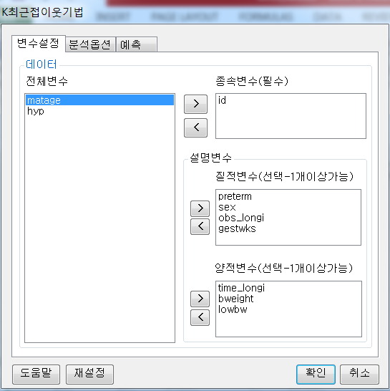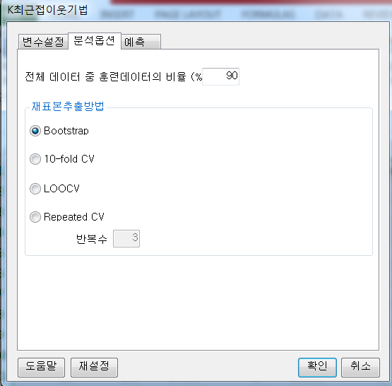

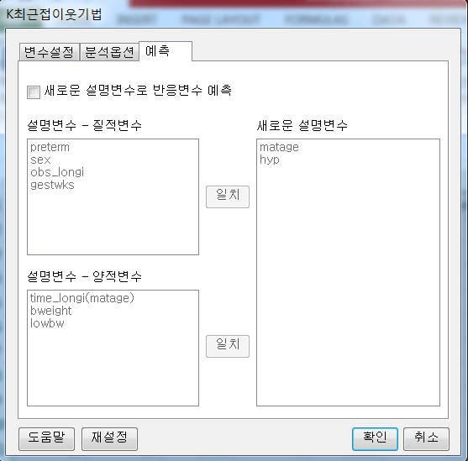

**5. 로그창:**

> REx_KNN(df20171123153928, y='id', quan_x=c('time_longi','bweight','lowbw'), qual_x=c('preterm','sex','obs_longi','gestwks'), train_percent=0.9, resample_method='boot', resample_repeat=3, new_predict=FALSE);

**ERROR! Stopping**

**6. 에러메세지:**

**변수설정** 탭에서 질적변수와 양적변수에 이항 변수와 연속형 변수를 섞어넣고

종속변수를 id로 설정하니까 발생. 종속변수를 hyp(이항변수)로 바꾸면 발생하지 않음