Wonjohn Choi

23123143

Homework 8 #44

a) Graphical comparison

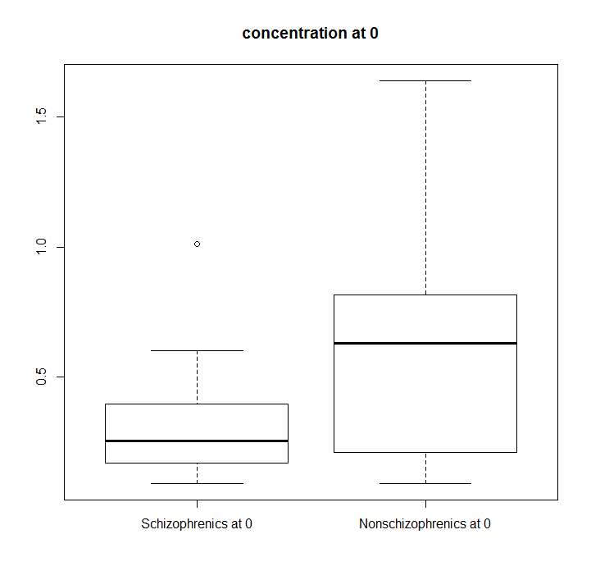

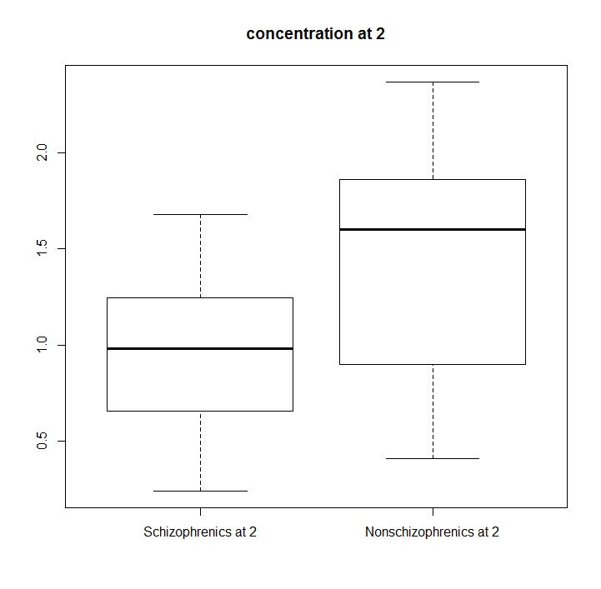

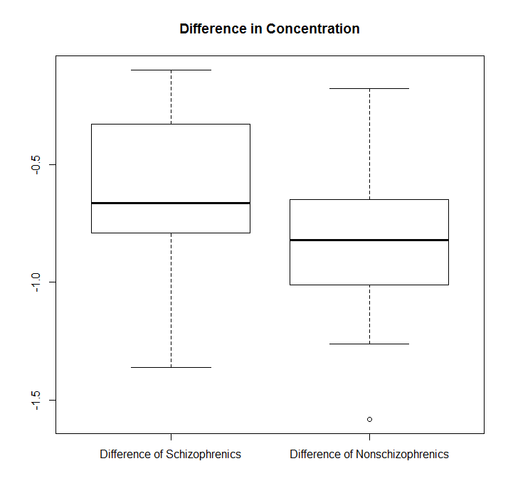

b)

For 0, p-value = 0.03701

This is rejected for alpha of 0.5. Hence, evidence of difference is strong.

For 2, p-value = 0.01275

This is rejected for alpha of 0.5. Hence, evidence of difference is strong.

For difference, p-value = 0.07919

This is not rejected for alpha of 0.5. Hence, evidence of difference is not strong.

c)

For 0, p-value = 0.07439

This is not rejected for alpha of 0.5. Hence, evidence of difference is not strong.

For 2, p-value = 0.01298

This is rejected for alpha of 0.5. Hence, evidence of difference is strong.

For difference, p-value = 0.1059

This is not rejected for alpha of 0.5. Hence, evidence of difference is not strong.

d)

Descriptive Statistics

For Schizophrenics Total,

# Min. 1st Qu. Median Mean 3rd Qu. Max.

# 0.00 0.10 6.30 35.78 32.40 359.30

For Nonschizophrenics Total,

# Min. 1st Qu. Median Mean 3rd Qu. Max.

# 0.0 22.7 101.9 123.0 117.9 620.4

For Schizophrenics mg/kg,

# Min. 1st Qu. Median Mean 3rd Qu. Max.

# 0.0000 0.0100 0.1000 0.5295 0.3975 5.9900

For Nonschizophrenics mg/kg,

# Min. 1st Qu. Median Mean 3rd Qu. Max.

# 0.000 0.295 1.500 1.779 1.995 7.950

Graphical presentation

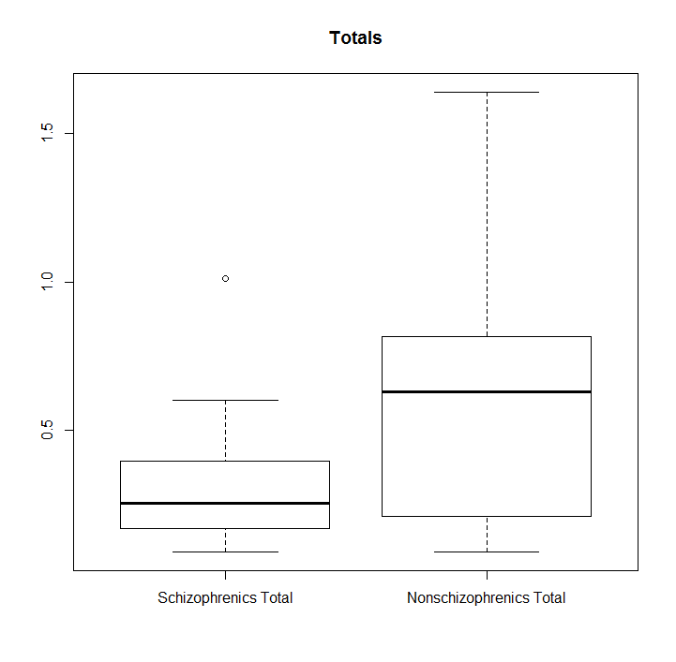

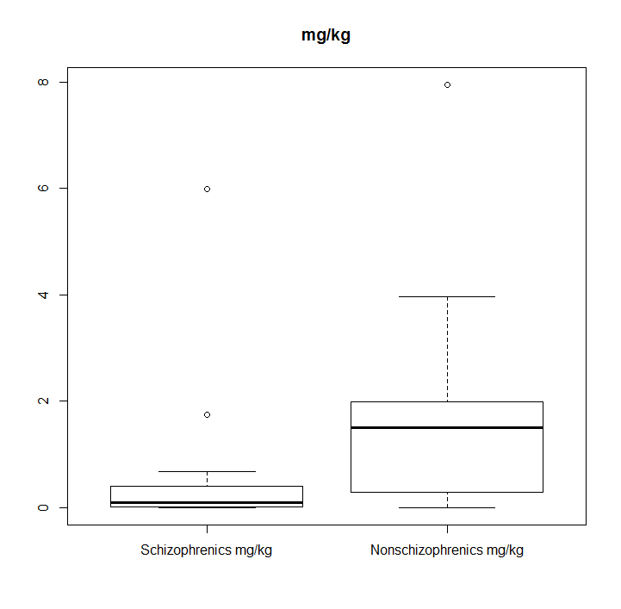

Histograms to see if data is normally distributed

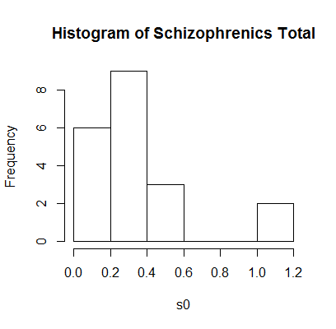

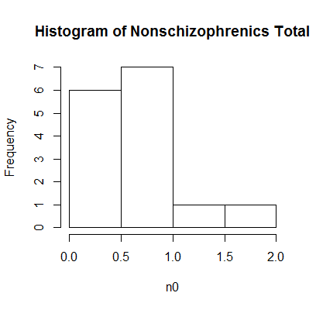

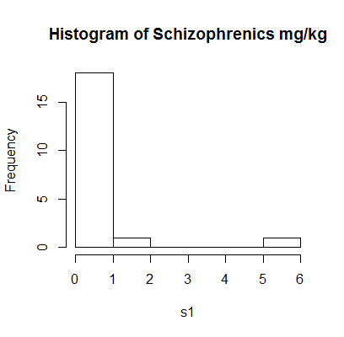

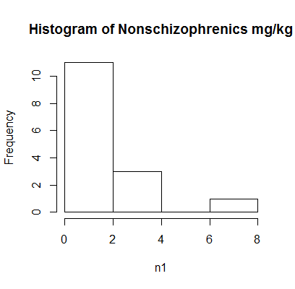

Data does not look normally distributed.

e)

For total, p-value = 0.06694

This is not rejected for alpha of 0.05, so evidence of difference is not strong.

But normality assumption was not reasonable from d).

For mg/kg, p-value = 0.05487

This is not rejected for alpha of 0.05, so evidence of difference is not strong.

But normality assumption was not reasonable from d).

f)

For total, p-value = 0.01404

This is rejected for alpha of 0.05, so evidence of difference is strong.

For mg/kg, p-value = 0.01156

This is rejected for alpha of 0.05, so evidence of difference is strong.

The result is exactly opposite how it was in e).

g)

Descriptive statistics

Schizophrenics Plasma

# Min. 1st Qu. Median Mean 3rd Qu. Max.

# 0.5100 0.6950 0.7700 0.8907 1.1100 1.2800

Schizophrenics Urine

# Min. 1st Qu. Median Mean 3rd Qu. Max.

# 0.09 27.97 86.20 80.86 111.10 182.10

Control Plasma

# Min. 1st Qu. Median Mean 3rd Qu. Max.

# 0.470 0.770 0.860 0.878 1.005 1.380

Control Urine

# Min. 1st Qu. Median Mean 3rd Qu. Max.

# 28.26 130.50 149.80 160.30 187.30 285.30

Graphical presentation

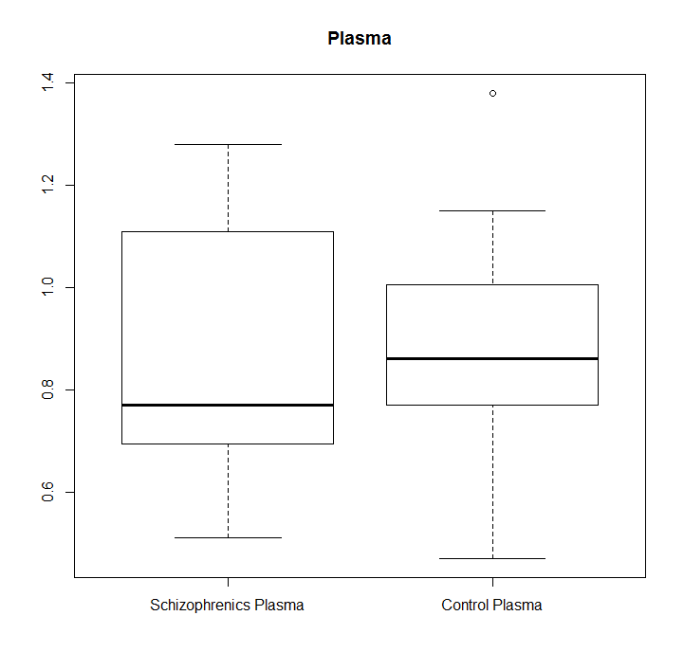

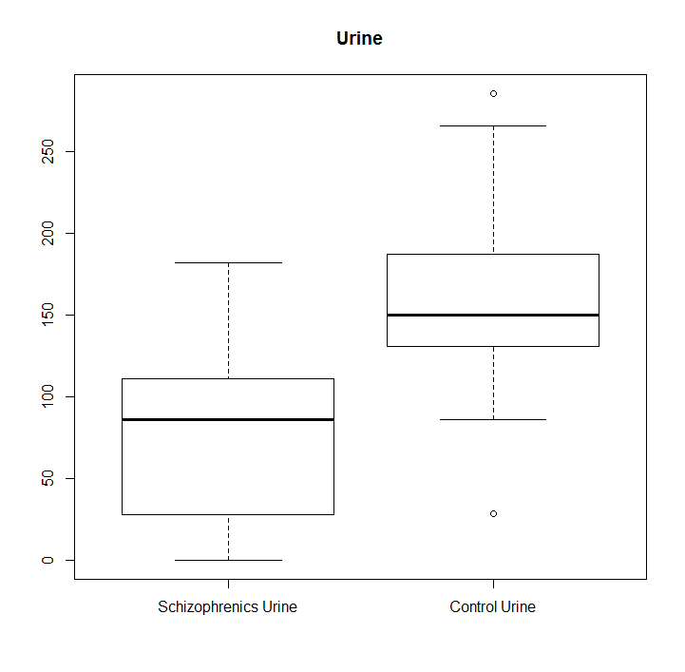

h)

For plasma, p-value: 0.8899

This is not rejected for alpha of 0.05, so evidence of difference is weak.

For urine, p-value: 0.001876

This is rejected for alpha of 0.05, so evidence of difference is strong.

Histograms to see if data is normally distributed

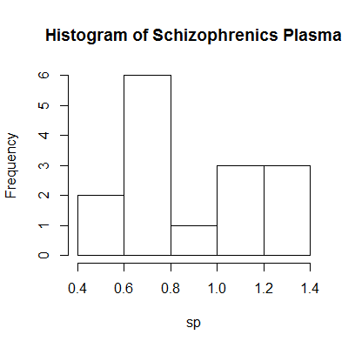

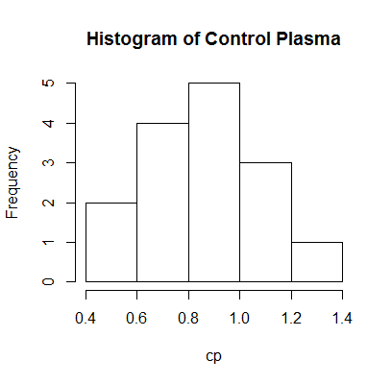

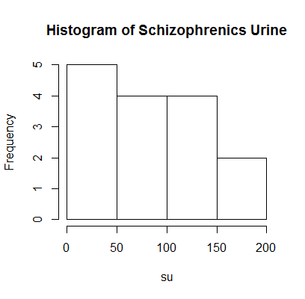

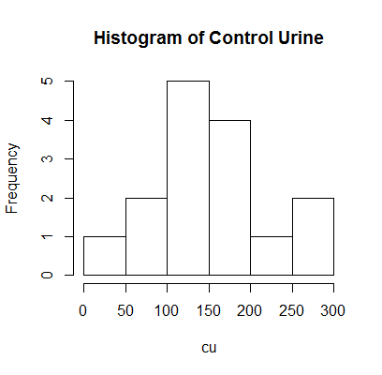

Schizophrenics is not normally distributed.

Control data is normally distributed.

Since both distributions must be normally distributed for normality assumption for t-test, it is not reasonable to assume so.

i)

For plasma, p-value=1

This is not rejected for alpha of 0.05, so evidence of difference is weak.

For urine, p-value=0.00323

This is rejected for alpha of 0.05, so evidence of difference is strong.