Wonjohn Choi

23123143

Stat135 Lab #1

Problem 1

Estimated Proportion: 0.236

Estimated SE: 0.0189001

Confidence Interval: 0.1989558 0.2730442

Problem 2

(b) Average: 41503.18

SD: 1539.565

Histogram:

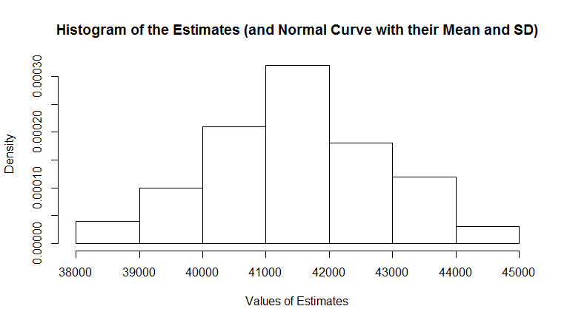

(c) Plot:

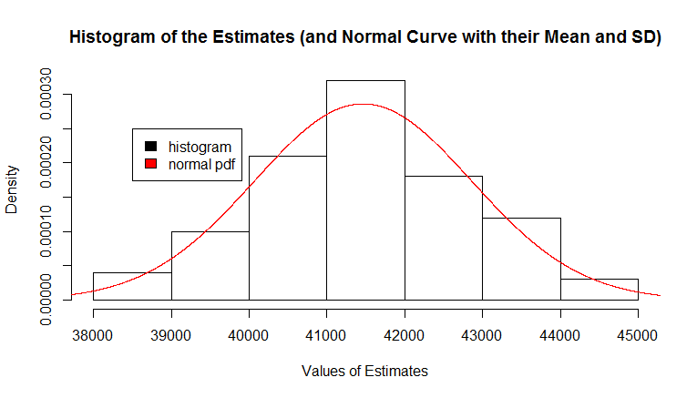

Comment: The curve of normal density fits the histogram very well.

(d) ECDF, Normal CDF:

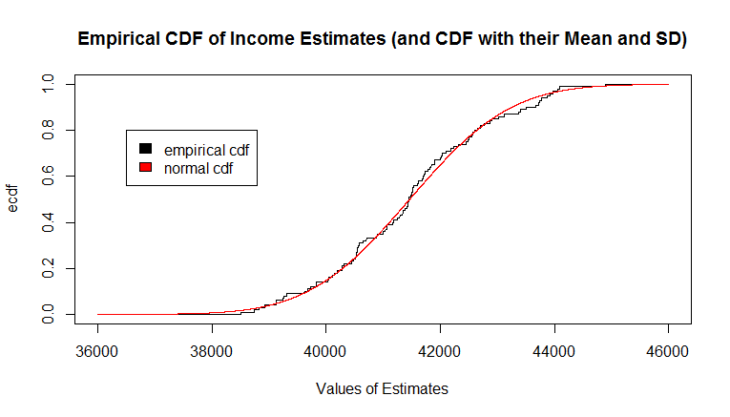

Comment: The curve of normal cdf fits the curve of empirical cdf very well.

(e) Plot:

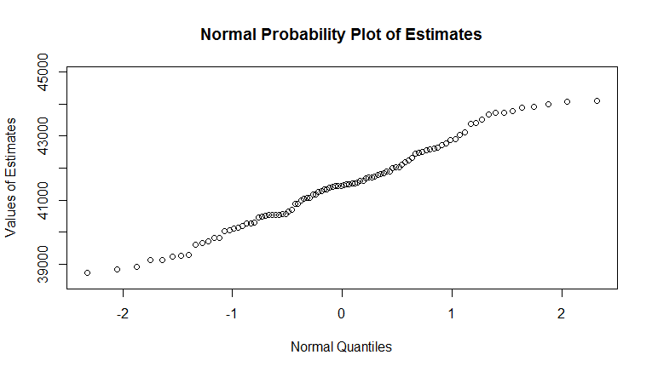

Comment: Since the plot roughly forms a straight line, the approximation is normally distributed.

(f) Number of intervals: 95

Problem 3

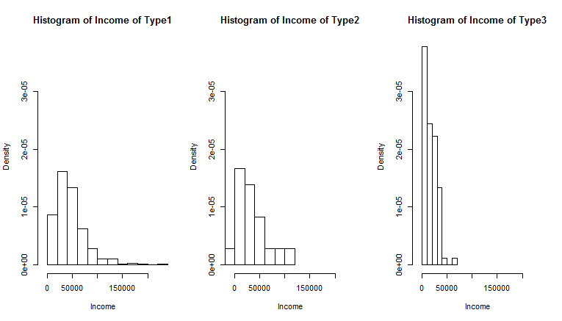

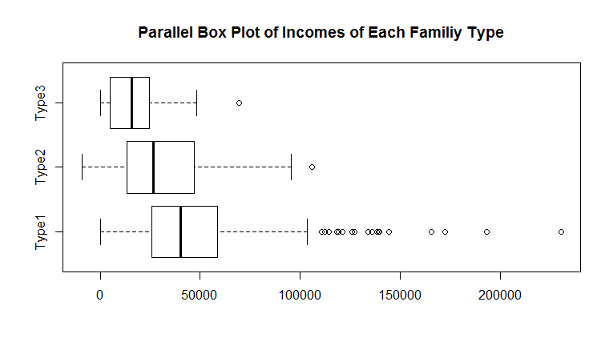

Type1 has some families with income over 100000, so it may be because two people in this family earn money. Type3 has the most families with low incomes ranging from 0 to 50000. Type2's families are distributed similar to Type1's families but Type2's families with highest income has lower income than Type1's families with highest income. Also, Type2's families with lowest income has lower income than Type1's families with lowest income.

Problem 4

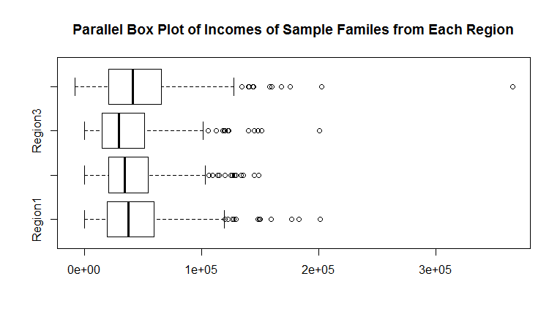

Region1 has the highest median while Region3 has the lowest median. Also, Region1 has the highest upper quartile and lower quartile. Region3 has the lowest upper quartile and lower quartile.

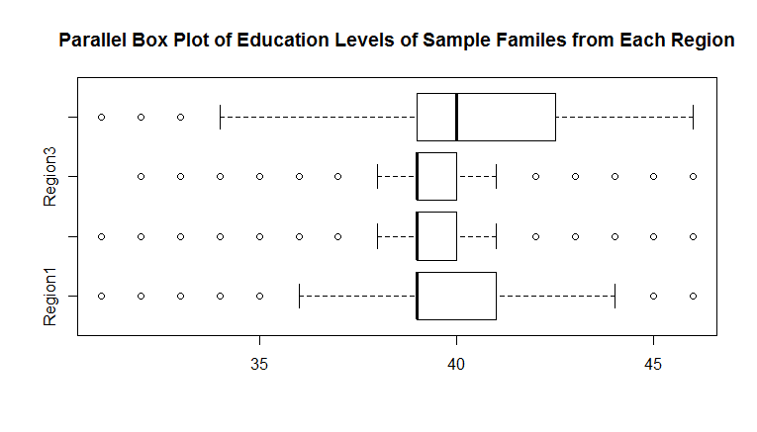

For Region1, Region2, and Region4, 75% of sample have high school diploma (see lower quartile). For Region3, 50% of sample have high school diploma (see median). Region1 and Region2's upper quartile's education level is higher than upper quartile of Region4. Region4's upper quartile's education level is higher than that of Region3.