Wonjohn Choi

2013-11-19

101 LAB (Nanyu Chen)

Stat135: Lab2 Cont’d

d.

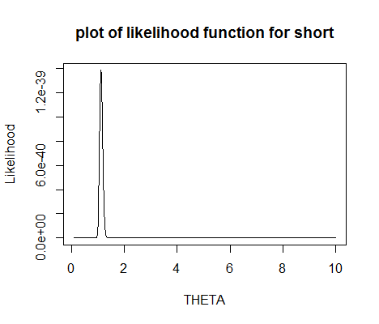

For short,

MLE: 1.117

Approximate Variance: 0.00329

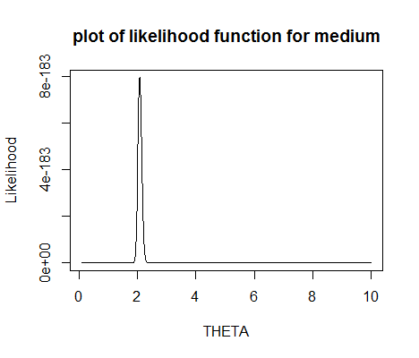

For medium,

MLE: 2.076

Approximate Variance: 0.00434

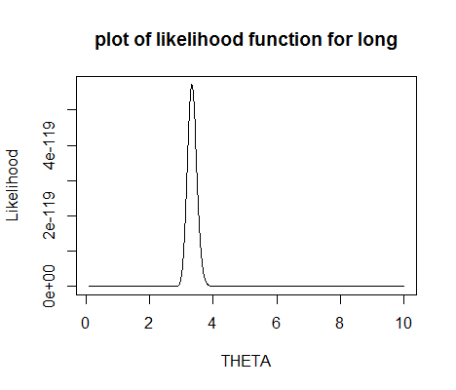

For long,

MLE: 3.324

Approximate Variance: 0.0211

e.

For short,

Method of Moment Estimate: 1.1637

Approximate Variance: 0.0039

For medium,

Method of Moment Estimate: 2.069

Approximate Variance: 0.00472

For long,

Method of Moment Estimate: 3.4124

Approximate Variance: 0.02429

f.

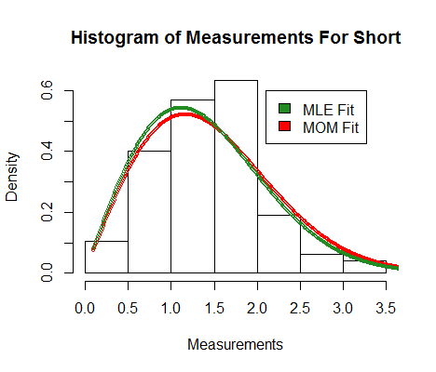

Yes, the fits look reasonable. No, there is no appreciable difference between the maximum likelihood fits and the method of moments fits.

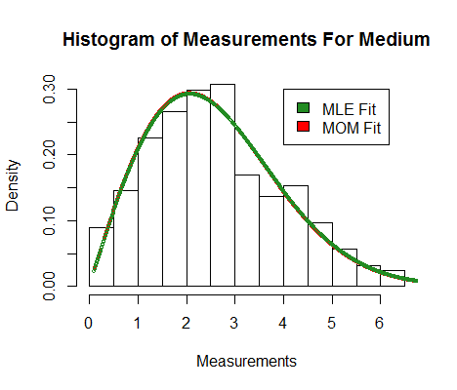

Yes, the fits look reasonable. No, there is no appreciable difference between the maximum likelihood fits and the method of moments fits.

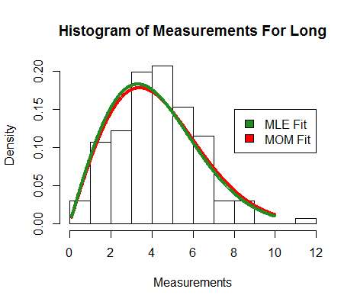

Yes, the fits look reasonable. No, there is no appreciable difference between the maximum likelihood fits and the method of moments fits.

g. There seems to be a relationship between my estimates and the genomic separation of the point because Rayleigh plot with estimated parameters fit the histogram very well.

h.

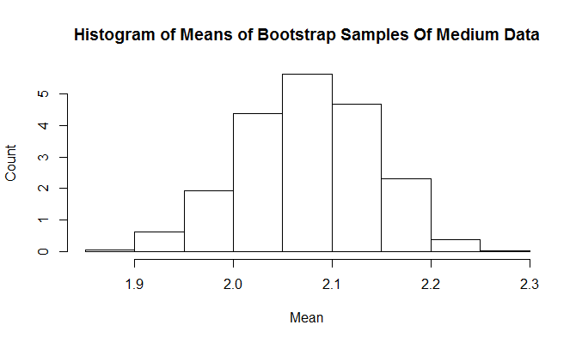

Yes, histogram looks approximately normal.

Yes, I think Large Sample Theory can be reasonably applied here because means of i.i.d. bootstrap samples is approximately normal for large B. Indeed, histogram of MLE of simulated Rayleigh samples is roughly normal and appears to be more normal as I increase B. This means that MLES of simulation are asymptotically normal.

Previously, we got sqrt(0.00434)==0.0659 as the approximate standard error for medium. I got 0.06635215 as the standard deviation of MLE’s from the bootstrap. These values are very close.

i.

95% Confidence interval from bootstrap method is (1.952830, 2.196689). The interval from Large Sample Theory is (1.946794, 2.205171) Bootstrap confidence interval is very similar to the interval found by large sample theory.