1. **What is our independent variable? What is our dependent variable?**

Independent variable: Sets of words: incongruent and congruent.

Dependent variable: The length of time to finish the task.

1. **What is an appropriate set of hypotheses for this task? What kind of statistical test do you expect to perform? Justify your choices.**

Null hypothesis: H0: µCongruence = µIncongruence.

The mean of congruent words condition is equal to the mean of incongruent words condition.

Alternate hypothesis: HA: µCongruence < µIncongruence.

The mean of congruent words condition is lower than the mean of incongruent words condition.

One-tailed in negative direction dependent t-test for paired samples.

Since there is no information of the population parameters and we are comparing a mean of a data set from the other mean of a data set, dependent one-tail t-test will be a good choice.

Now it’s your chance to try out the Stroop task for yourself. Go to [this link](https://www.google.com/url?q=https://faculty.washington.edu/chudler/java/ready.html&sa=D&ust=1461465445357000&usg=AFQjCNHgYBbf_jrSOum3o597cQ9zYpDk3Q), which has a Java-based applet for performing the Stroop task. Record the times that you received on the task (you do not need to submit your times to the site.) Now, download [this dataset](https://www.google.com/url?q=https://drive.google.com/file/d/0B9Yf01UaIbUgQXpYb2NhZ29yX1U/view?usp%3Dsharing&sa=D&ust=1461465445357000&usg=AFQjCNHJBTwOwOTwZbDrdUUV27CgCnksWw) which contains results from a number of participants in the task. Each row of the dataset contains the performance for one participant, with the first number their results on the congruent task and the second number their performance on the incongruent task.

1. **Report some descriptive statistics regarding this dataset. Include at least one measure of central tendency and at least one measure of variability.**

Mean of congruent words: 14.05

Mean of incongruent words: 22.02

Standard Deviation of congruent words: 3.56

Standard Deviation of incongruent words: 4.80

1. **Provide one or two visualizations that show the distribution of the sample data. Write one or two sentences noting what you observe about the plot or plots.**

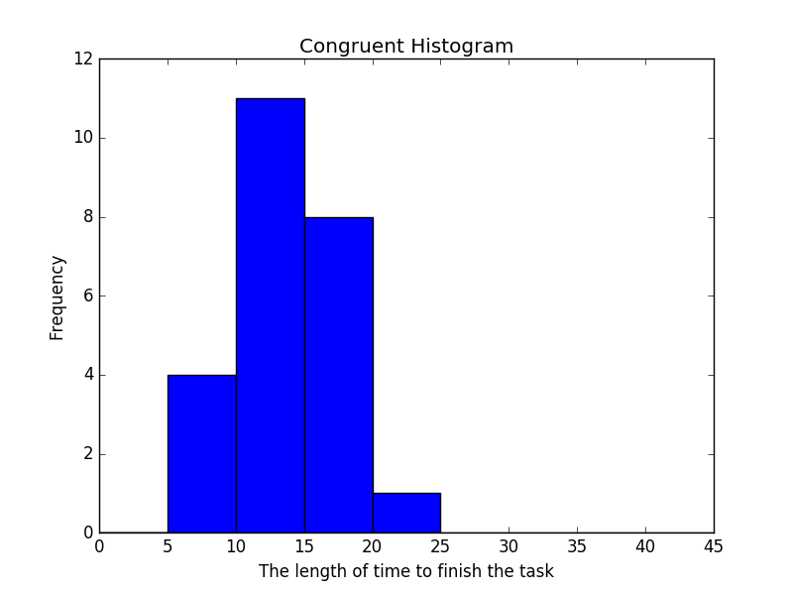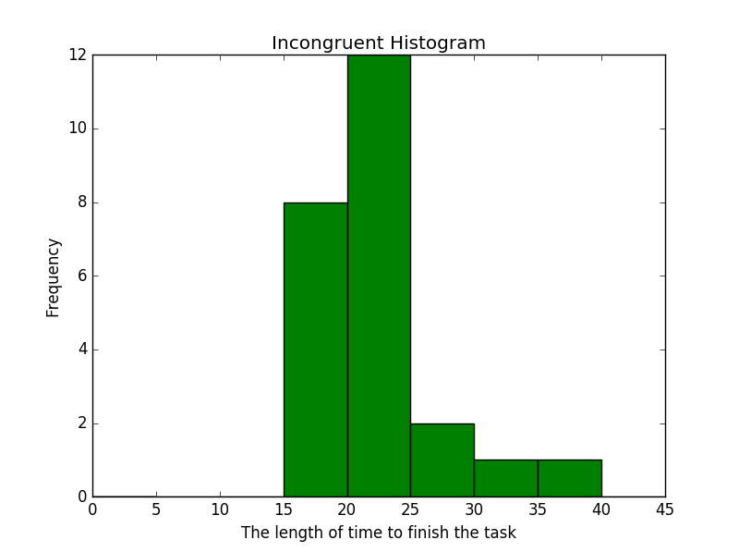

Same bin lengths are used for both of these histograms and one can see clearly and the center of incongruent is about 20~25, which is greater than that of congruent which is about 10~15.

1. **Now, perform the statistical test and report your results. What is your confidence level and your critical statistic value? Do you reject the null hypothesis or fail to reject it? Come to a conclusion in terms of the experiment task. Did the results match up with your expectations?**

Mean difference = -7.96

Degree of Freedom = number of differences -1 = 24 - 1 = 23

Standard Deviation of difference = sqrt(sum(differences)/degree of freedom) = 4.86

Standard Error of the mean Difference SE(d) = 4.86/sqrt(24) = 0.99

t-statistics = Mean Difference / Standard Error = -8.02

alpha = 0.05

t-critical with 23 degree of freedom = -1.71

Since t-statistics is less than t-critical, we can reject the null hypothesis. Thus, the mean of congruent word conditions is lower than the mean of incongruent word conditions. The result matches my expectation.

1. **Optional: What do you think is responsible for the effects observed? Can you think of an alternative or similar task that would result in a similar effect? Some research about the problem will be helpful for thinking about these two questions!**

In my opinion, our brains read words and interpret the color almost at the similar time, so when we see the incongruent words, then our brains need to take some time to differentiate the word and the color. If we use a set of boxes with different color and perform the same experiment, the result will be similar to the result of the congruent words.

Similar task would be to use the set of shapes instead of colors. For example, we can draw a triangle and put a word “rectangle” inside the shape. This will show the similar result.