**Computer Graphics Class Assignment1**

2017029470 김종원

1. **Orbit: Rotate the camera around the target point by changing azimuth / elevation angles. (MMB (mouse middle button) in Blender)**

To rotate the camera, change the azimuth and elevation angles, and calculate the changed eye point of the camera. At this time, change the azimuth and elevation angles using the changed mouse pointer position.

If you **hold down the left mouse button and drag the mouse point** to the desired location in the window, then pos is calculated in the **mouse_button_callback** function, and using this pos, azimuth and elevation angles are changed in the **cursor_callback** function.

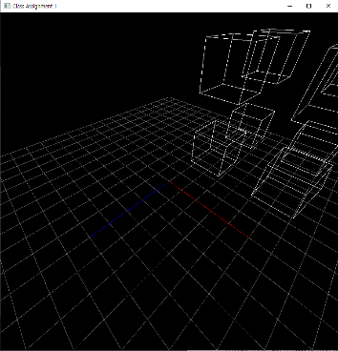 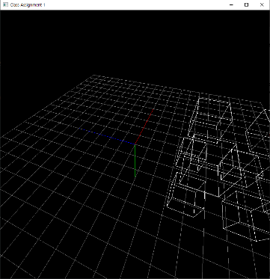

1. **Panning: Move both the target point and camera in left, right, up and down direction of the camera. (Shift-MMB in Blender)**

Panning is translating the camera and the target point along u axis and v axis of the camera frame. To translating, I calculated the u axis and v axis of the camera frame. And the target point and eye point were moved using the changed mouse pointer position. (To be precise, the value of the eye point and the target point does not change, but x, y, z variables are added to those points.)

If you **hold down the right mouse button and drag the mouse point** to the desired location in the window, then pos is calculated in the **mouse_button_callback** function, and using this pos, the value of x, y, z variables are changed in the **cursor_callback** function.

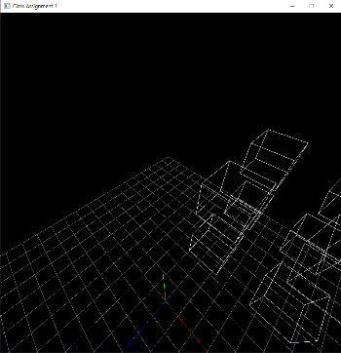 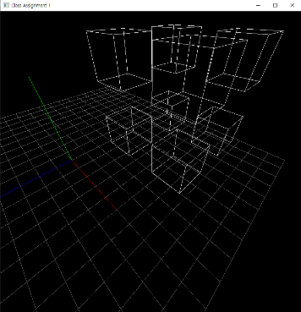

1. **Zooming: Move the camera forward toward the target point (zoom in) and backward away from the target point (zoom out) (Ctrl-MMB in Blender)**

Zooming is to reduce or increase the distance between the camera and the target. When the distance decreases, it is called zoom in, and when the distance increases, it is called zoom out.

When you **rotate the mouse wheel** upside, the value of yoffset is 1, and downside is -1. Using this distance value was changed in the **scroll_callback** function.

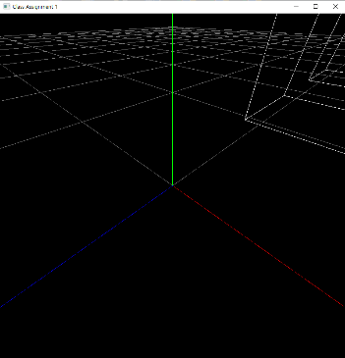 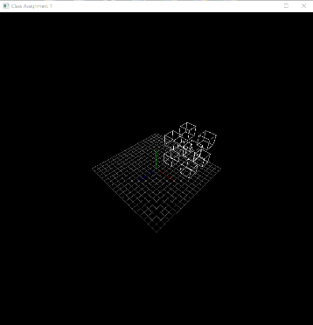

1. **Toggle perspective projection / orthogonal perspective projection by pressing ‘v’ key. When the program is executed, it starts in perspective projection mode.**

v was created as a global variable. When you **press v** the value of v is changed from 0 to 1 and from 1 to 0 in the **key_callback** function.

1. **Draw a rectangular grid with lines (not polygons) on xz plane as a reference ground plane (similar to Blender).**

I made a grid by drawing 21 horizontal lines and 21 vertical lines, and the distance between the lines Is 0.2.